SHORTAGE OF DOCTORS
IN RURAL INDIA
A Plain-Language Data Analysis Report

Based on Rural Health Statistics (RHS) 2005, 2019 & 2020
Ministry of Health & Family Welfare, Government of India

Specialist Shortfall  31,550  empty positions nationally | Critical States  15  under 5 doctors/lakh | Lowest Doctor Density  0.78/lakh  Jharkhand rural

CHC Growth (2005–2020)  +55%  facilities built | Specialist Growth  +39%  doctors deployed | Correlation  −0.495  rural % vs doctors

1. Short Summary
India has been building more rural health clinics over the past two decades — but the number of doctors filling those clinics has not kept up. This report looks at government health data from 2005 to 2020 and finds a deep and persistent gap between the healthcare facilities that exist on paper and the medical staff actually available to serve rural patients.

The problem is especially serious for specialists — doctors like surgeons, gynaecologists, and physicians who are needed at larger rural health centres. More than half of all specialist positions at these centres are empty. States with the highest share of rural population — such as Uttar Pradesh, Bihar, Jharkhand, and Madhya Pradesh — are also the ones with the fewest doctors per person. In short: the people who need healthcare the most have access to the least.

2. Introduction — What Problem Are We Studying?
India is home to more than 1.4 billion people. Around 65 to 85 percent of people in many Indian states live in rural areas — in villages, small towns, and farming communities far from city hospitals. These people depend almost entirely on government health facilities.

The rural health system is built on three layers: Sub-Centres (the smallest, first point of contact), PHCs — Primary Health Centres (meant to have at least 1 doctor, serving ~30,000 people), and CHCs — Community Health Centres (supposed to have 4 specialist doctors, serving ~1,20,000 people). The government has invested in building more of these — but a critical question remained unanswered: are there enough doctors to actually staff them?

"For millions of rural Indians, the local PHC or CHC is their only option. When it has no doctor — they have no doctor."

This matters because rural patients cannot simply drive to a private clinic. They have no alternative. Without adequate staff in these facilities, the investment in infrastructure is largely wasted.

3. Data Used
All data comes from official Government of India sources:

Dataset | What It Contains | Year
RHS 2005 | State-wise rural doctors, specialists, facilities — baseline year | 2005
RHS 2019 | Same data — to track changes over time | 2019
RHS 2020 | Most recent snapshot of rural health workforce | 2020
Vacancies & Shortfalls 2020 | How many positions are empty and by how much | 2020
Population Density | Rural vs urban population split, by state | Census 2011
Villages, Districts & Area | Geographic size, village count per state | Census 2011

The RHS (Rural Health Statistics) report is published annually by the Ministry of Health & Family Welfare — one of the most reliable official sources for rural health data in India.

4. What We Did
- Loaded and cleaned all six datasets — missing or unreported data (marked '*') was treated as blank.
- Standardised state names so all datasets could be correctly matched with each other.
- Calculated doctors per 1 lakh (100,000) rural population — a fairer way to compare states of different sizes.
- Compared facility growth vs workforce growth between 2005 and 2020.
- Measured the gap between required specialist posts (4 per CHC by government norm) and actual posted specialists.
- Built a Vulnerability Index combining: how rural a state is (40%), doctor density (40%), and village spread (20%).
- Created 9 charts to visualise all findings.

5. Analysis — Charts & What They Tell Us

Chart 1 — Doctor Count by State: 2005 → 2019 → 2020
This chart compares how many doctors each state had at three points in time. Each state has three bars — light for 2005, medium for 2019, dark for 2020.

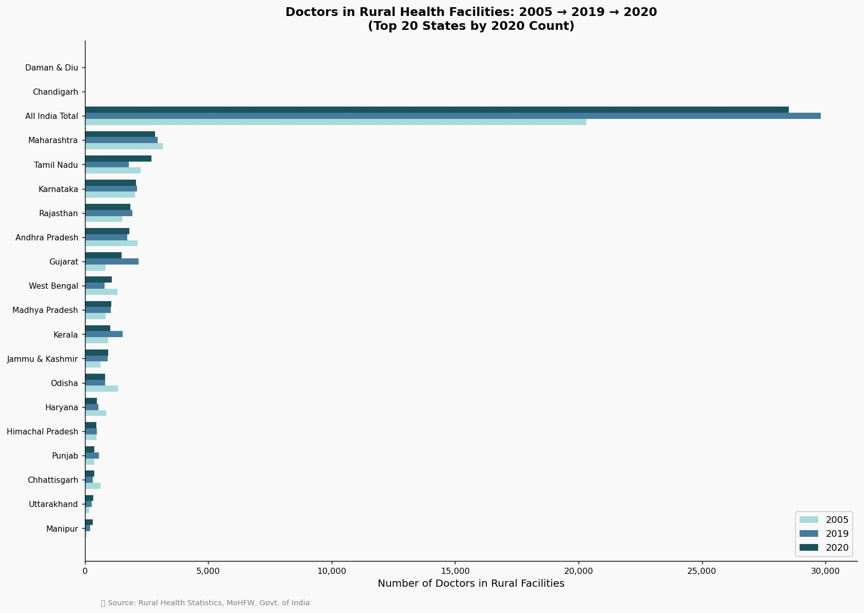
Figure 1 — Doctors in Rural Health Facilities: 2005 → 2019 → 2020 (Top 20 States)
What we learn: While overall numbers grew nationally (+40%), several large states went backwards. Chhattisgarh lost 38% of its rural doctors, Haryana lost 43%, and Andhra Pradesh lost 16%. Growth is not uniform — many states are worse off than 15 years ago.

Chart 2 — Doctors per Lakh Rural Population by State (2020)
Each state is colour-coded: red = critical shortage (under 5/lakh), orange = moderate (5–10/lakh), green = adequate (above 10/lakh). The dotted line is the WHO benchmark.

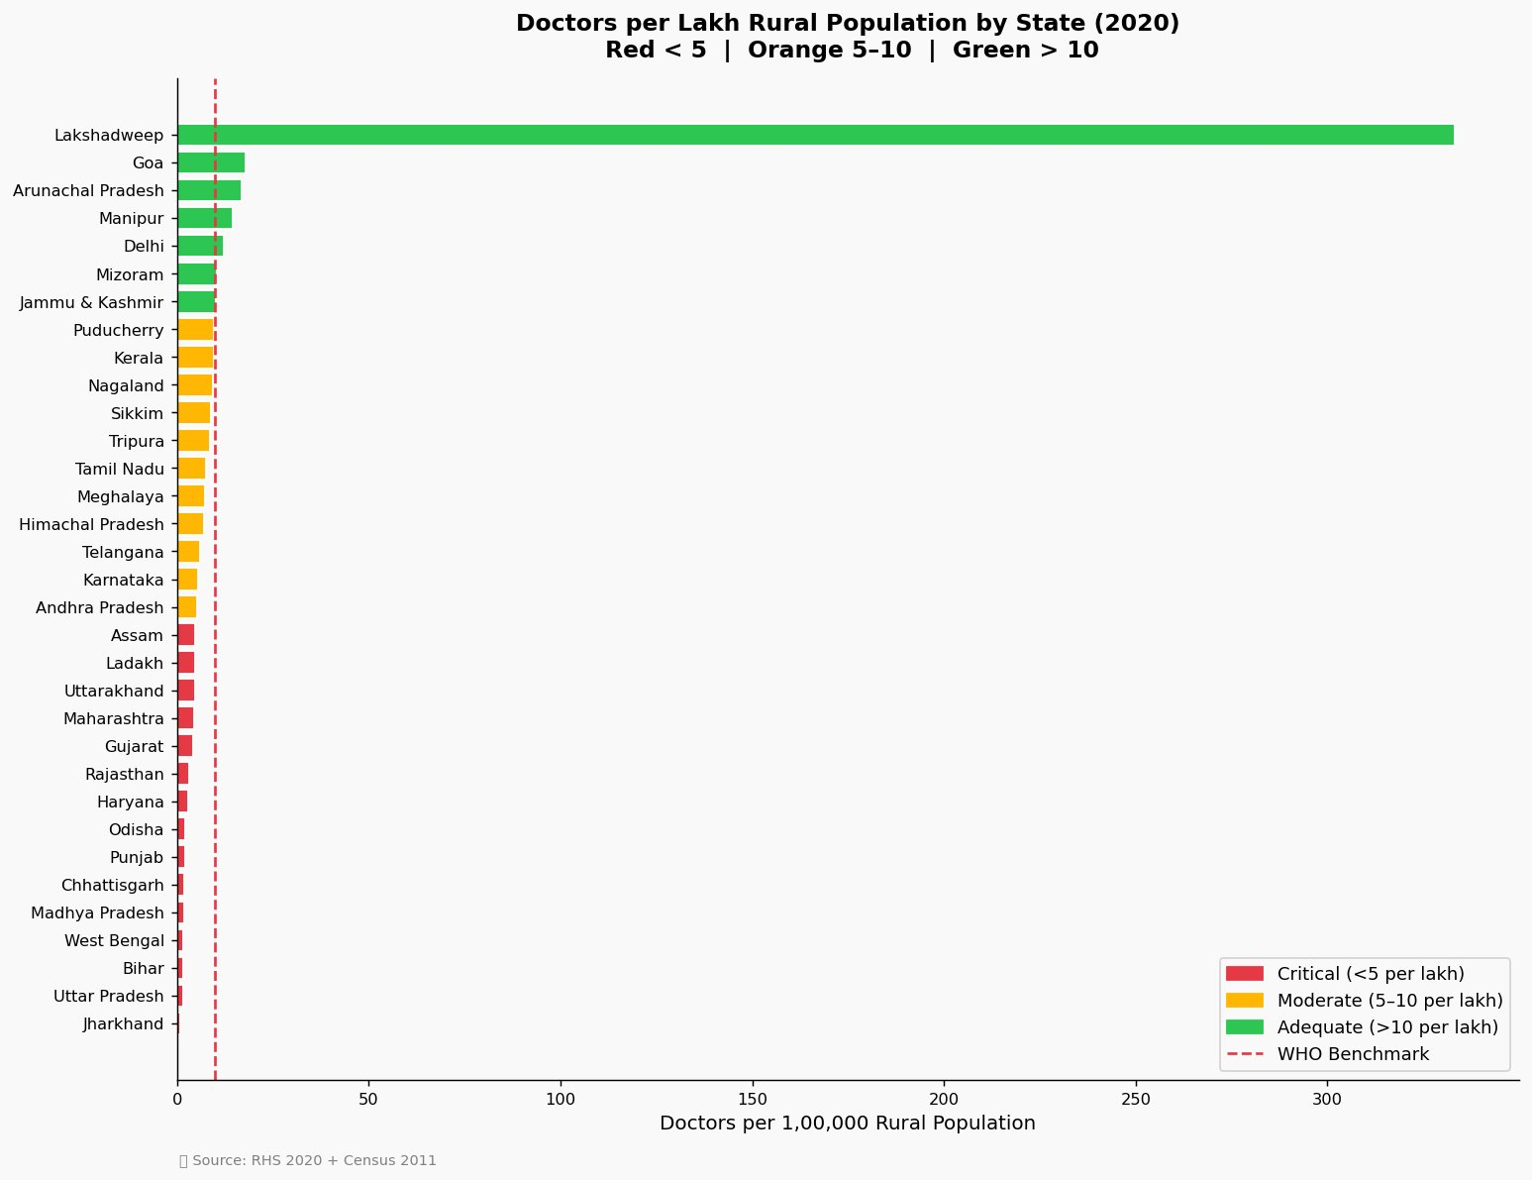
Figure 2 — Doctors per 1,00,000 Rural Population by State (2020)
What we learn: 15 states fall in the critical red zone. Jharkhand has just 0.78 doctors per lakh rural people — statistically, there is no doctor available for the average rural resident. The darkest cell in the entire chart is the All India Specialist total — 15,775 empty positions. Uttar Pradesh alone has 2,028 unfilled specialist posts, the highest of any state. Rajasthan is struggling in two columns at once — 1,754 specialist vacancies and 1,532 pharmacist vacancies. Bihar shows system-wide failure: 1,267 missing pharmacists and 1,321 missing lab technicians. Odisha's nursing shortage stands at 1,423. The message is clear — even when a doctor is present, there may be no one to run tests, dispense medicine, or assist in procedures. Care is incomplete at every level.

Chart 3 — Specialist Shortfall Across States (2020)
This bar chart shows how many specialist positions are unfilled at Community Health Centres. Remember: every CHC is supposed to have 4 core specialists — a surgeon, physician, gynaecologist, and paediatrician.

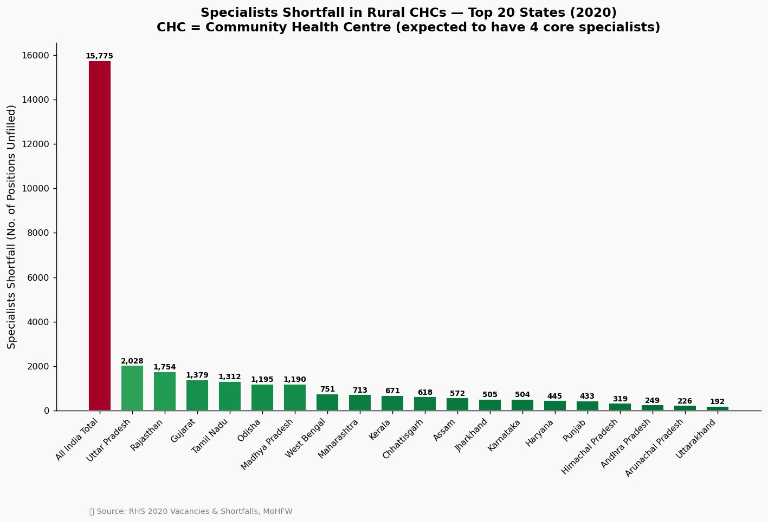
Figure 3 — Specialist Shortfall in Rural CHCs — Top 20 States (2020)
What we learn: The All India total shortfall is 15,775 (shown in the chart) — and the full 20-state total crosses 30,000+ positions. Uttar Pradesh alone has 2,028 unfilled specialist posts. These are the doctors who handle surgeries, complicated deliveries, and serious illnesses — and they are simply not present.

Chart 4 — Staff Shortage Heatmap (All Categories)
This grid shows shortfalls across all staff types — doctors, specialists, radiographers, pharmacists, lab technicians, and nurses. Darker orange/red cells mean a bigger shortage. Each row is a state, each column is a staff type.

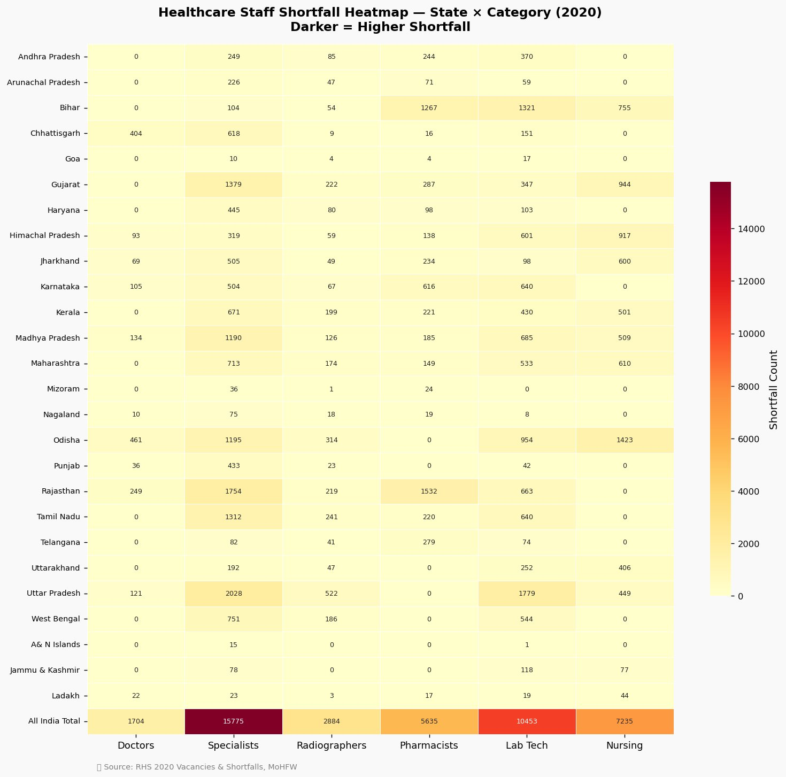
Figure 4 — Healthcare Staff Shortfall Heatmap — State × Category (2020)
What we learn: The shortage is system-wide, not just about doctors. Bihar shows dark patches in pharmacists (1,267) and lab technicians (1,321). Odisha is deep red in nursing (1,423). Even when a doctor is present, there may be no pharmacist to dispense medicine or no lab tech to run tests — making care incomplete.

Chart 5 — Rural Population % vs Doctor Availability (Scatter Plot)
Each bubble is a state. The further right, the more rural the state. The higher up, the more doctors per lakh. Bubble size = total rural population, and colour shows doctor density — red means critical, green means adequate. The red shaded region below the WHO benchmark line marks the danger zone.
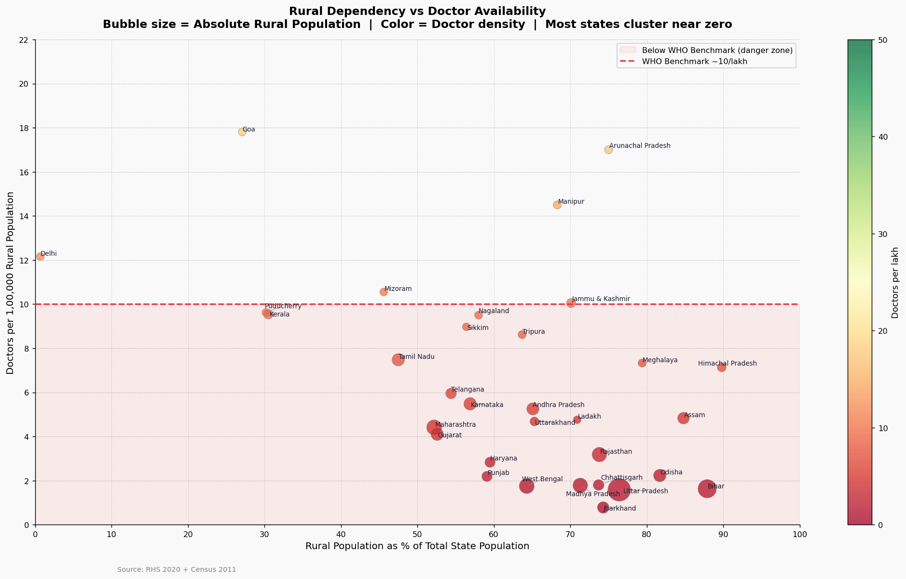
Figure 5 — Rural Dependency vs Doctor Availability (Bubble Chart, 2020)
What we learn: Almost every bubble sits flat inside the red danger zone — far below the WHO benchmark of 10 doctors per lakh. The one exception is Lakshadweep in the top-left corner — a tiny union territory with very few rural residents — which is an outlier, not a model to compare against. The real story is in the bottom-right: the largest, darkest red bubbles — Uttar Pradesh, Bihar, Madhya Pradesh, Jharkhand — have the biggest rural populations and the fewest doctors. The Pearson correlation is −0.495, confirming this is not coincidence. It is a structural inequity — the states that need doctors the most are precisely the ones that have the fewest. Over 80% of all states and UTs fall below the WHO benchmark.

Chart 6 — Infrastructure Growth vs Workforce Growth (2005–2020)
Two charts side by side. Left: actual counts of facilities and staff. Right: growth index (2005 = 100 baseline) showing how much each category grew proportionally.

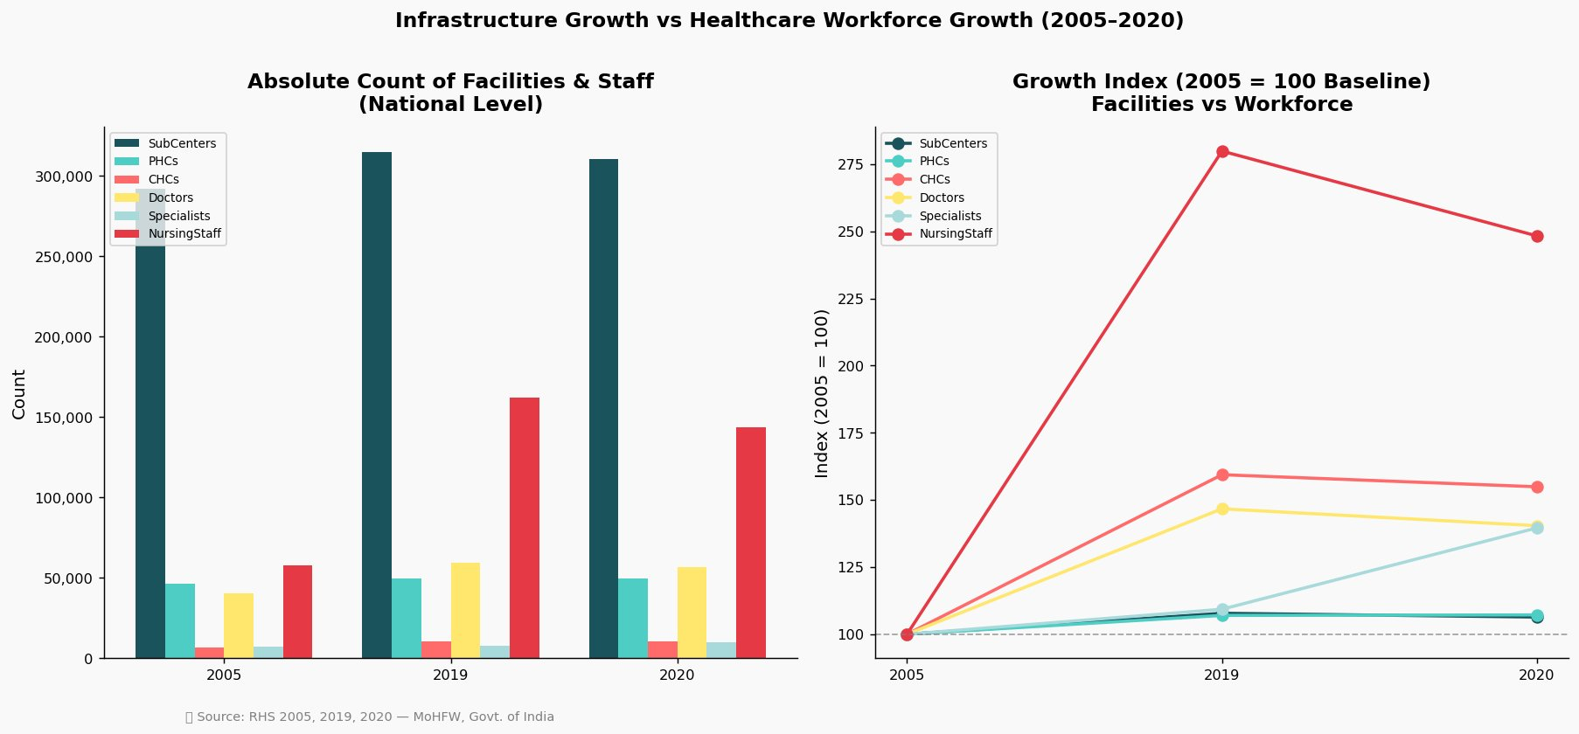
Figure 6 — Infrastructure Growth vs Healthcare Workforce Growth (2005–2020)
What we learn: This is the core finding of the entire report. Between 2005 and 2020, CHCs grew 55% and nursing staff grew 148% — but doctors only grew 40% and specialists only 39%. The buildings went up and nurses were hired, but the doctors needed to actually run those facilities did not follow at the same pace. Worse, both doctors and nursing staff actually declined from 2019 to 2020 — suggesting the problem is not just slow growth, but a recent reversal. Sub-Centres, the most basic and widespread rural health facilities, barely grew at all — their index line stayed almost flat at 100 across all 15 years. This 'infrastructure-workforce gap' is the central structural problem of rural healthcare in India — you cannot staff a building with a growth index.

Chart 7 — Doctor vs Specialist Vacancies Side by Side (2020)
For the top 18 states by doctor vacancy count, two bars are shown — red for vacant doctor posts and blue for vacant specialist posts.

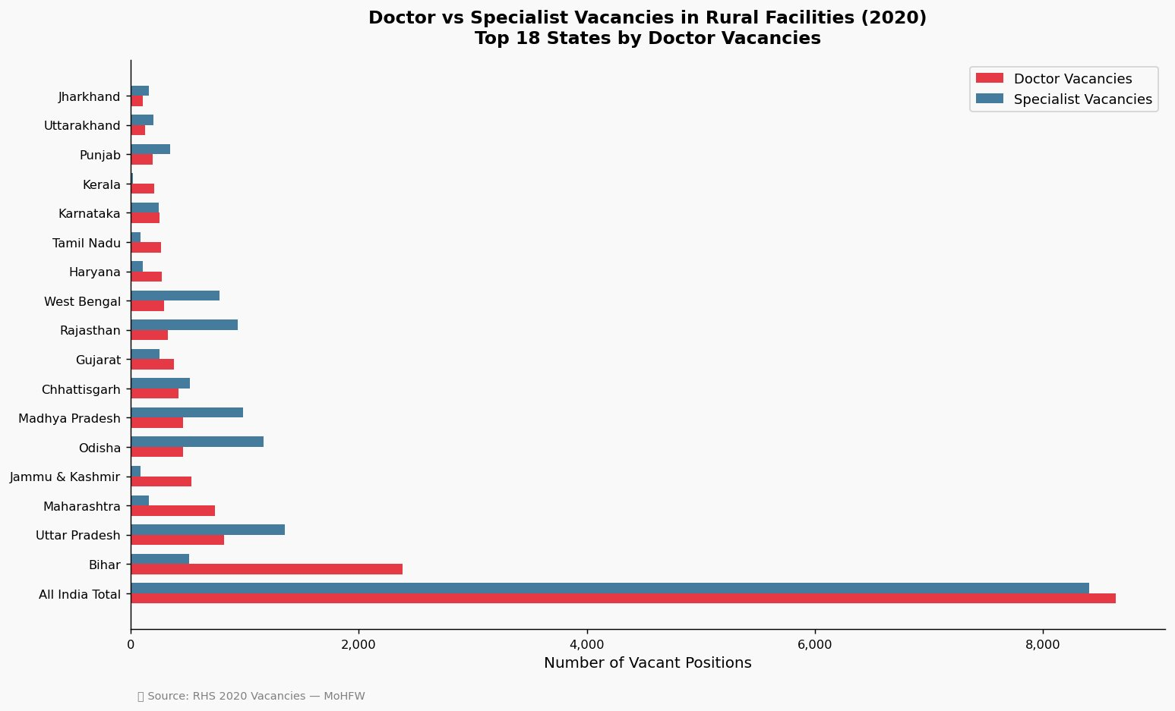
Figure 7 — Doctor vs Specialist Vacancies in Rural Facilities (2020)
What we learn - Bihar stands out dramatically — with ~2,384 vacant doctor positions, it has by far the most in the country, and no other state comes close. What makes Bihar unusual is that its doctor vacancies massively outnumber its specialist vacancies — the opposite of most other states. In states like Uttar Pradesh, Rajasthan, Odisha, and Madhya Pradesh, the blue specialist bar is consistently longer than the red doctor bar — meaning specialists are even harder to retain than general doctors. The All India total tells the full scale: roughly 8,500+ doctor vacancies and 8,500+ specialist vacancies sitting empty simultaneously. These are not temporary gaps — they are persistent, structural absences that have continued year after year.

Chart 8 — State Vulnerability Index
Each state gets a score from 0 to 1 — higher means more vulnerable. The score combines: how rural the state is, how few doctors it has, and how many villages are spread across it. Red dashed line = high risk threshold (0.6).

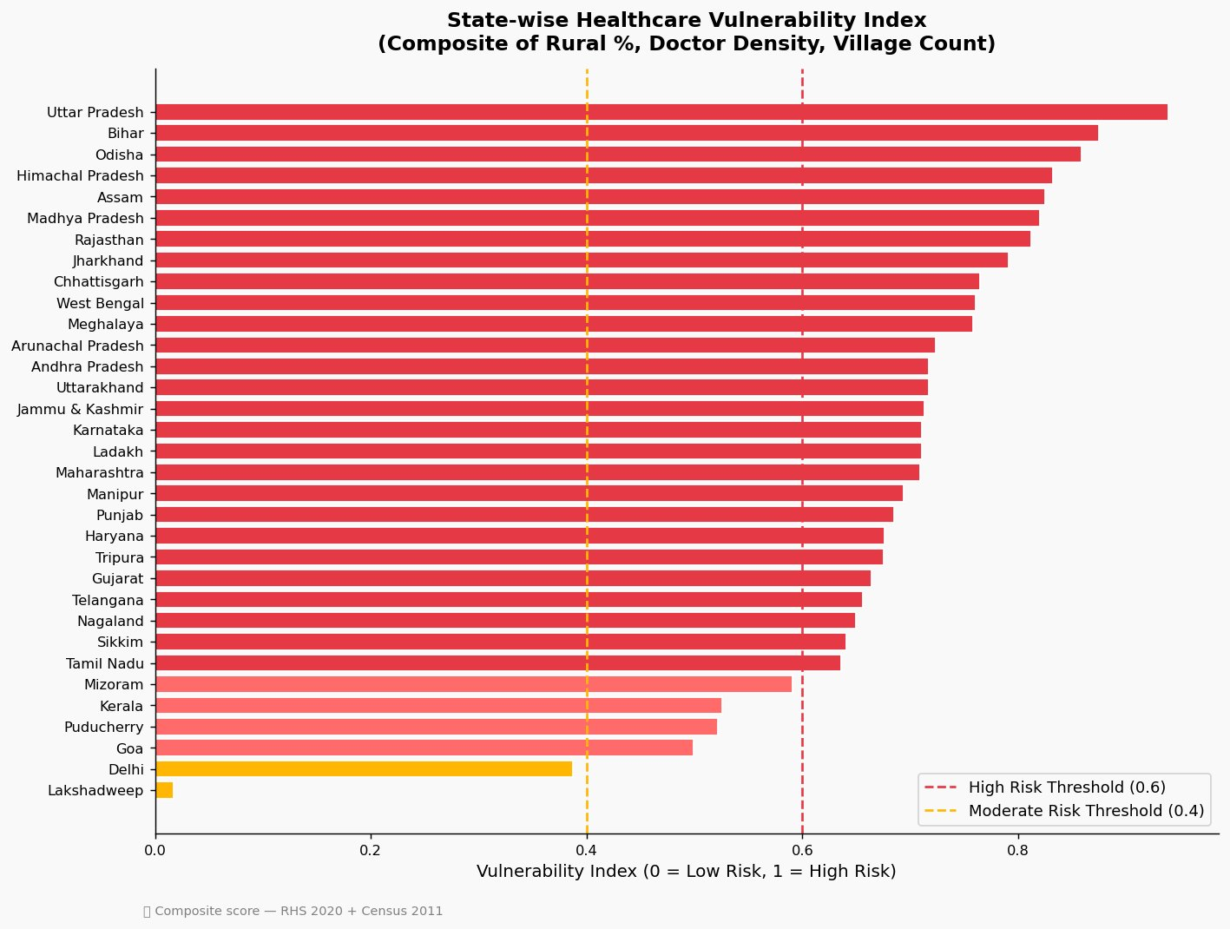
Figure 8 — State-wise Healthcare Vulnerability Index (Composite Score)
What we learn: Uttar Pradesh scores 0.939 — nearly the worst possible. Bihar (0.875), Odisha (0.859), Assam (0.825), MP (0.820), and Rajasthan (0.812) follow closely. A total of 28 out of 33 states score above 0.6. Only Lakshadweep and Delhi are in the safe zone. This is a national crisis, not a regional one.

Chart 9 — Required vs Actual Staff in PHCs and CHCs
Left chart: required doctors at PHCs (1 per PHC) vs actual. Right chart: required specialists at CHCs (4 per CHC) vs actual. The gap between the light bar (required) and dark bar (actual) is the shortage.

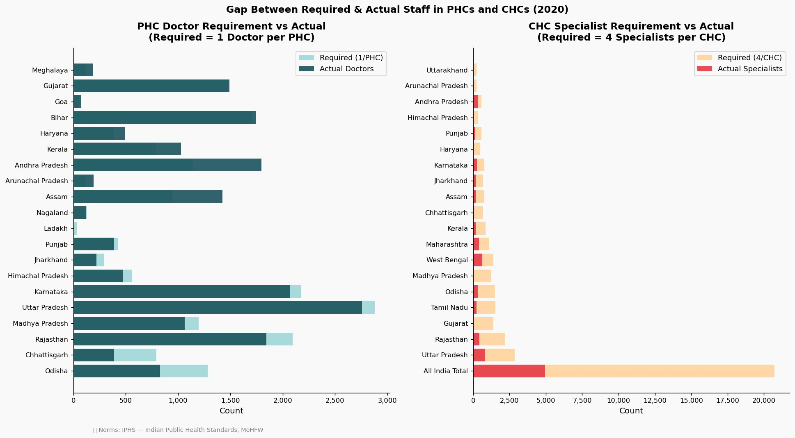
Figure 9 — Gap Between Required & Actual Staff in PHCs and CHCs (2020)
What we learn: The PHC doctor gap is 1,704 nationally — concerning but manageable. The CHC specialist gap is 31,550 — catastrophic. The right chart makes it visual: the orange 'required' bar dwarfs the tiny red 'actual' bar in almost every state. The All India Total panel is the starkest — specialists cover only a fraction of what is needed.

6. Specialist Vacancy Deep-Dive (RHS 2021-22)
This section extends the 2020 analysis using the latest available data from Rural Health Statistics 2021-22 (as on 31st March 2022). It breaks down the specialist shortage at Community Health Centres (CHCs) by the four core specialist types that every CHC is mandated to have — Surgeon, Obstetrician & Gynaecologist, Physician, and Paediatrician.

Data source: RHS 2021-22, MoHFW, GoI — Tables 19 (Surgeons), 20 (OB&GY), 21 (Physicians), 22 (Paediatricians), rural areas.

National Summary — All Four Specialist Types
Specialist | Required | In Position | Shortfall | Vacancy % (sanctioned) | Shortfall % (required)
Surgeons | 5,480 | 920 | 4,560 | 71.4% | 83.2%
OB & Gynecologists | 5,480 | 1,414 | 4,066 | 62.9% | 74.2%
Physicians | 5,480 | 1,145 | 4,335 | 67.0% | 79.1%
Paediatricians | 5,480 | 1,006 | 4,474 | 69.4% | 81.6%
Total | 21,920 | 4,485 | 17,435 | 67.5% | 79.5%

Note: Required = 1 per CHC per type x 5,480 rural CHCs. Shortfall = required minus in-position. Vacancy % is calculated against sanctioned posts only.

Chart 10 — In-Position vs Shortfall by Specialist Type
The left panel shows absolute numbers: for each specialist type, the solid bar is the number actually deployed and the hatched bar above it is the shortfall. The right panel shows each type’s share of the total 17,435-post shortfall — all four types contribute roughly equally, confirming this is a structural gap across the board, not concentrated in one category.

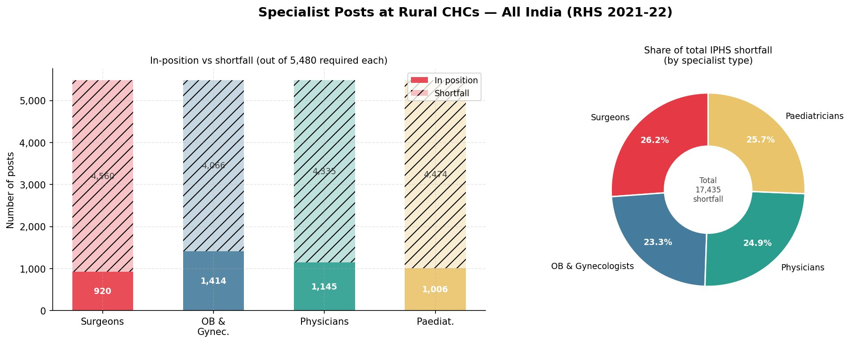
Figure 10 — Specialist Posts at Rural CHCs: In-Position vs Shortfall — All India (RHS 2021-22)

What we learn: Even the best-staffed category (OB & Gynecologists) has 74.2% of required posts unfilled. Surgeons are the most understaffed relative to sanctioned posts (71.4% of sanctioned posts vacant). Paediatricians have the highest absolute shortfall against the required norm at 81.6%. There is no specialist type where the situation is acceptable.

Chart 11 — State-wise Shortfall: Top 15 States per Specialist Type
Each of the four panels ranks the 15 states with the worst shortfall for that specialist type. Solid bars show the shortfall; faint bars behind them show the number in position. States consistently appearing across all four panels face across-the-board specialist collapse, not just a single-category gap.

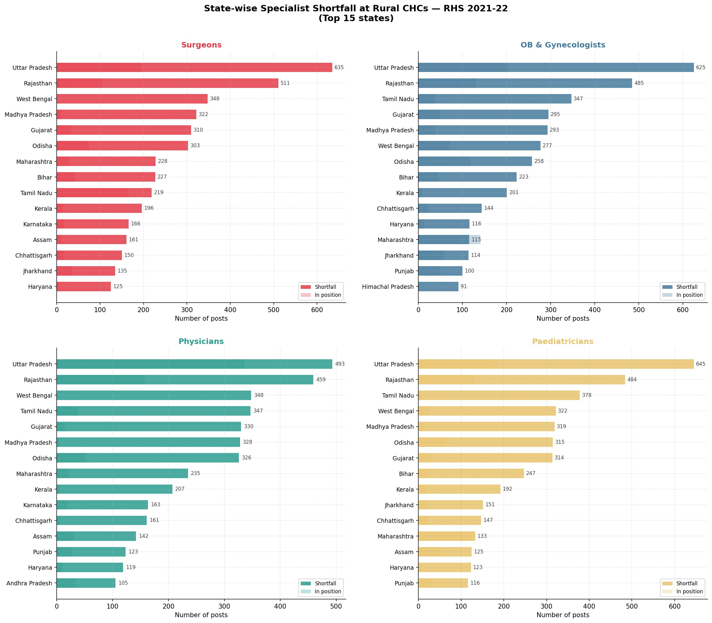
Figure 11 — State-wise Specialist Shortfall at Rural CHCs — Top 15 States per Type (RHS 2021-22)

What we learn: Uttar Pradesh leads all four lists — 635 surgeon shortfall, 625 OB&GY, 493 physician, 645 paediatrician. Rajasthan and West Bengal appear in all four panels. Tamil Nadu has an unusually severe paediatrician shortage (378) relative to its otherwise better-performing health system. Bihar’s physician position is partially better (21% shortfall rate) due to a large number of sanctioned posts, but its surgeon and paediatrician gaps remain severe.

Chart 12 — Heatmap: Shortfall % by State and Specialist Type
Each cell shows what percentage of the required posts for that specialist in that state are unfilled. States are sorted by their average shortfall across all four types — worst at the top. Green cells are relatively better; deep red means near-total absence.

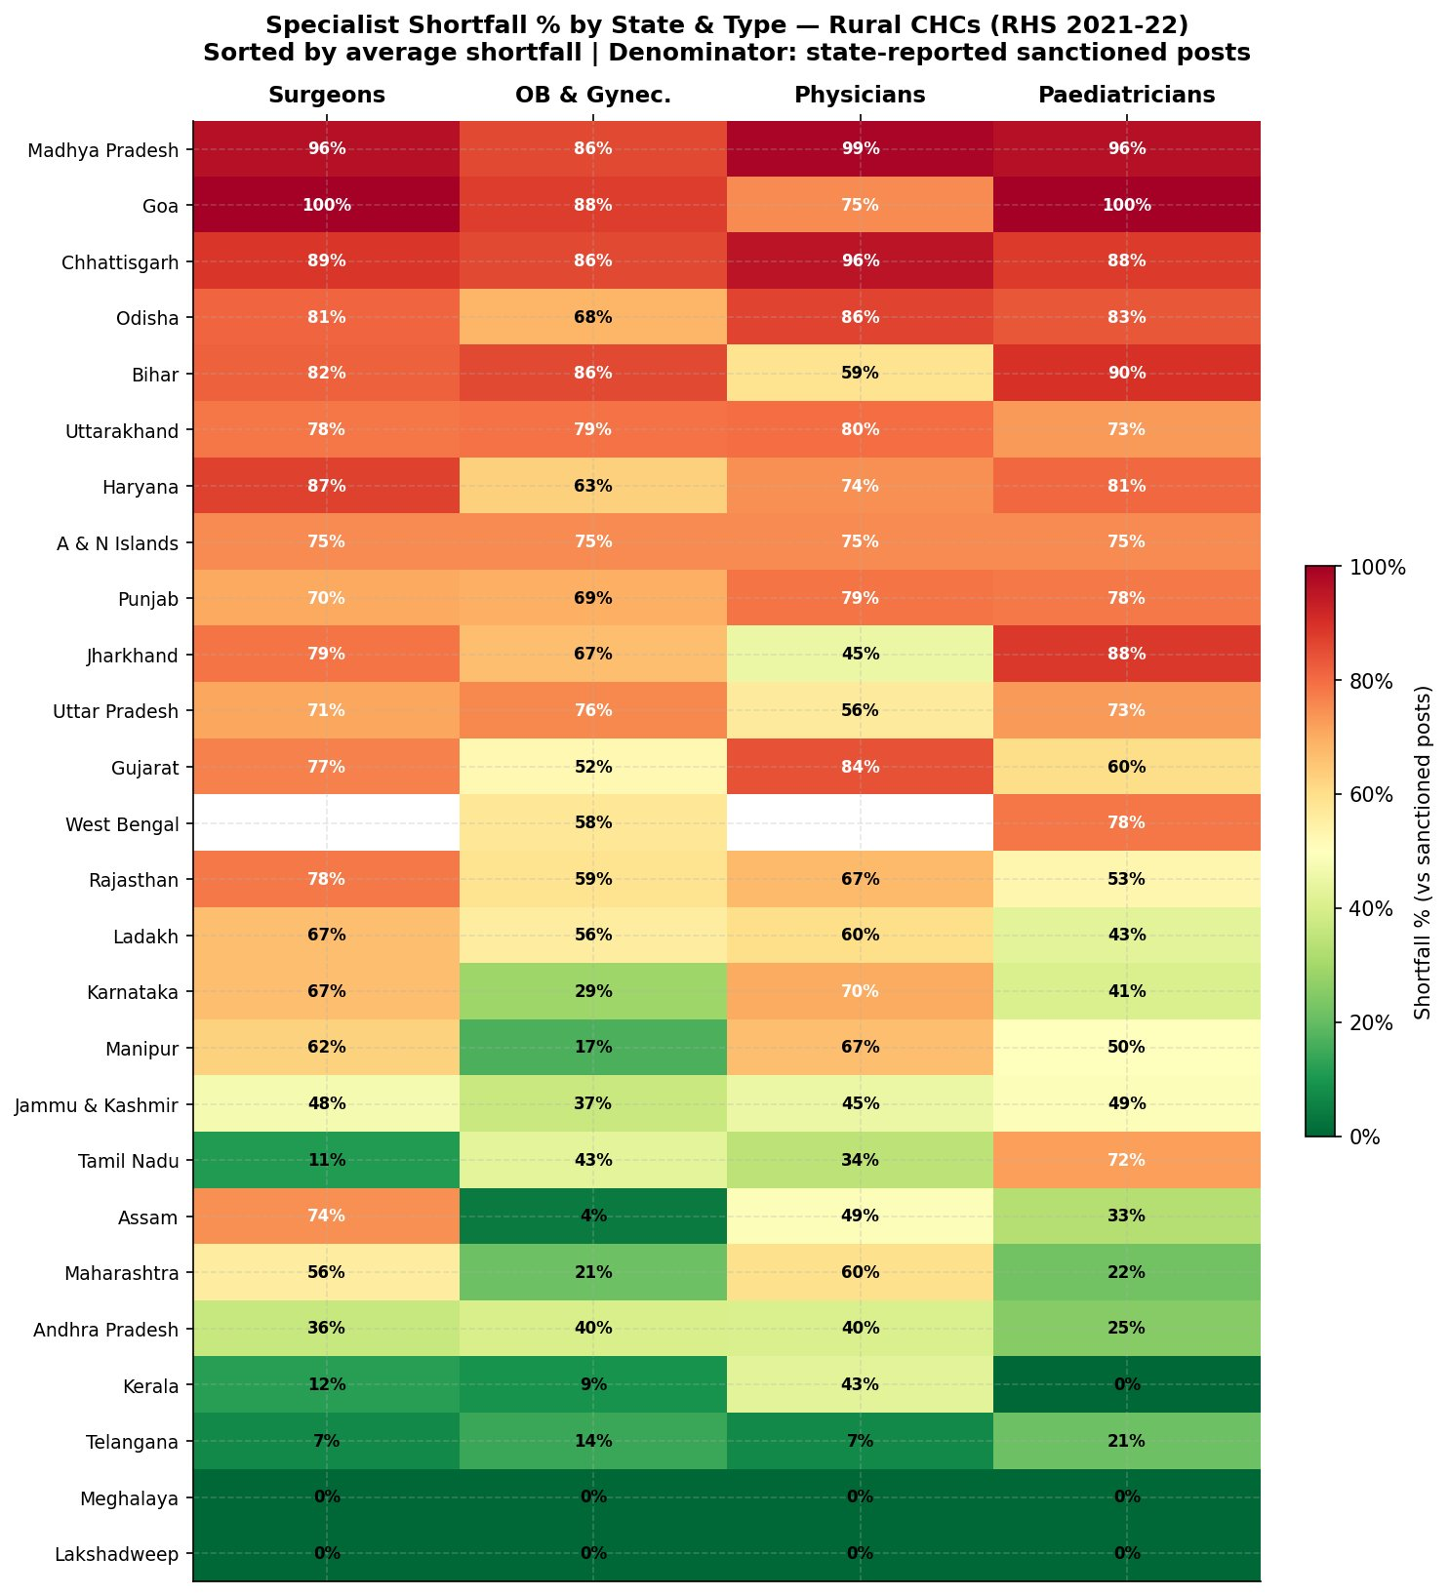
Figure 12 — Specialist Shortfall % by State and Type — Rural CHCs (RHS 2021-22)

What we learn: Puducherry, Mizoram, Sikkim, and D&N Haveli show 100% shortfall across all four types — these states have zero deployed specialists against requirement. Telangana is the one relative bright spot (7% surgeon shortfall, 21% paediatrician shortfall) due to a large number of CHCs with deployed staff. Jammu & Kashmir and Lakshadweep perform better than most large states. The overwhelming red across the top half of the chart is the clearest visual proof of a national emergency.

Chart 13 — Radar: Vacancy vs Shortfall Profile
The radar chart overlays two metrics for all four specialist types. The solid red line shows shortfall as a percentage of the total posts required. The dashed blue line shows vacancy as a percentage of sanctioned posts only. The gap between the two lines in any direction reveals how many posts were never sanctioned in the first place — a policy-level failure sitting below the visible vacancy.

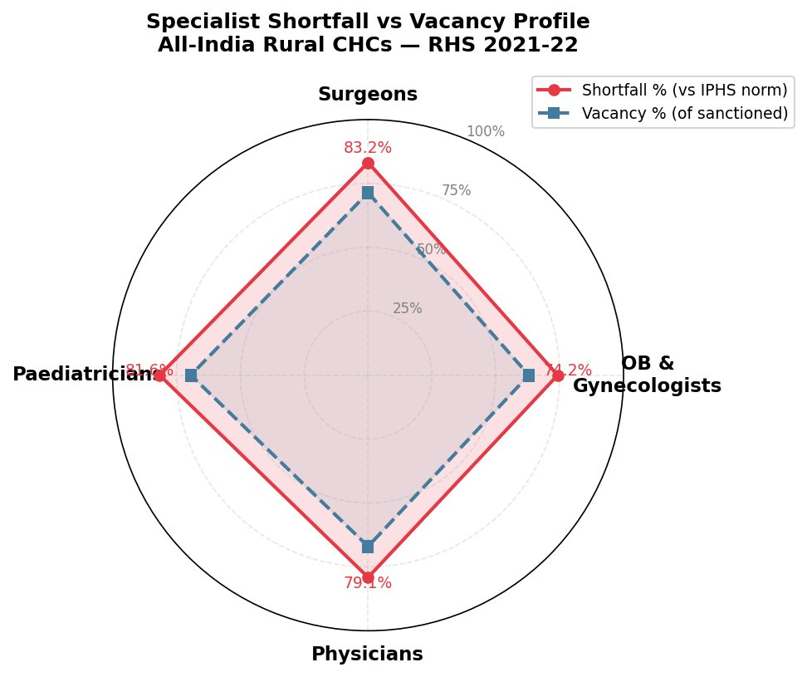
Figure 13 — Specialist Shortfall vs Vacancy Profile — All-India Rural CHCs (RHS 2021-22)

What we learn: For every specialist type, the shortfall line (red) sits further out than the vacancy line (blue). This means even filling every currently sanctioned vacant post would still leave a massive gap — because many CHCs never had posts sanctioned in the first place. The system is undersized by design, not just understaffed in practice.

Chart 14 — Health Facility Growth & Specialist Shortfall Trend (2005–2022)
Two charts side by side. Left: the growth of Community Health Centres (CHCs) and Primary Health Centres (PHCs) from 2005 to 2022 — showing how infrastructure expanded over nearly two decades. Right: the specialist shortfall at rural CHCs across 2020, 2021, and 2022 — showing that despite facility growth, the workforce gap remained stubbornly above 79%.
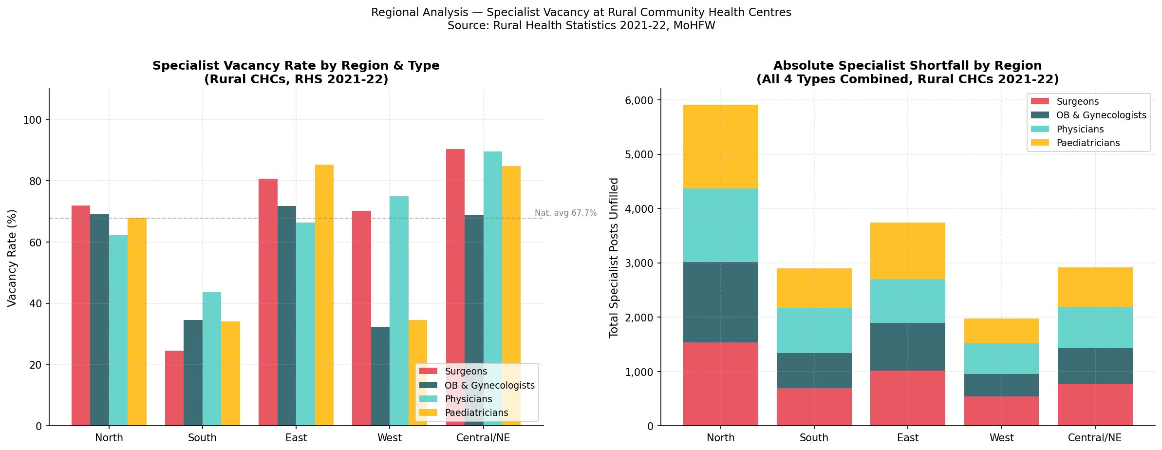
Figure 14 — Rural Healthcare Infrastructure Update: Health Facility Growth (2005–2022) & Specialist Shortfall at CHCs (2020–2022)

What we learn: The left chart captures the structural story of Indian rural healthcare over 17 years — CHCs grew from 4,044 (2005) to 5,480 (2022), a 35% increase. PHCs also expanded, with the sharp spike at 2020 reflecting the temporary inclusion of Health and Wellness Centres (HWCs) in that year’s count, before returning to a consistent count of ~25,000. The right chart shows that this infrastructure growth did not translate into workforce improvement. The specialist shortfall at rural CHCs held above 79% across all three years, declining only marginally from 81.3% in 2020 to 79.5% in 2022. More buildings were built; the doctors needed to run them did not follow. This side-by-side view is the clearest summary of the central finding of this entire report.

Key Findings from the 2021-22 Specialist Analysis
Finding | Data Point
Overall specialist shortfall at rural CHCs | 17,435 posts (79.5% of requirement)
Most understaffed type (vs requirement) | Surgeons — 83.2% shortfall
Worst single state (all types) | Uttar Pradesh — top of all 4 shortfall lists
States with 100% shortfall (all types) | Puducherry, Mizoram, Sikkim, D&N Haveli
Paediatrician crisis | Only 1,006 in position nationally vs 5,480 required
Sanctioned post gap | Only 13,787 posts sanctioned vs 21,920 required — 8,133 posts never created

The 2021-22 data confirms and sharpens the 2020 findings. Total specialist numbers grew marginally (4,485 in position in 2022 vs the RHS 2020 baseline), but the requirement also grew as new CHCs were added. The structural gap — buildings without doctors — continues to widen.

7. Key Findings

Doctor Gap at PHCs  1,704  positions unfilled | Specialist Gap at CHCs  31,550  positions unfilled | Bihar Doctor Vacancies  2,384  highest in India

- Buildings outpaced doctors: CHCs grew 55%, but specialist deployment grew only 39%. The infrastructure exists; the workforce does not.
- 15 states are in critical shortage: Fewer than 5 doctors per lakh rural people. Jharkhand is the worst at 0.78.
- Specialists are the biggest crisis: When measured against the government's own norm of 4 specialists per CHC, the national shortfall crosses 31,550 positions. Even the officially reported vacancy count stands at 15,775 — still the darkest number in the entire dataset means most rural Community Health Centres cannot offer surgery, childbirth care, or specialist treatment.
- More rural = fewer doctors: Correlation of −0.495 confirms the pattern. Rural populations are systematically underserved.
- Several states went backwards: Chhattisgarh −38%, Haryana −43%, Andhra Pradesh −16%, West Bengal −17% of rural doctors since 2005.
- Shortage is system-wide: Pharmacists, lab technicians, radiographers, and nurses are all critically short — making care incomplete even where doctors exist.
- Most of India is high risk: 28 out of 33 states/UTs score above 0.6 on the Vulnerability Index.
From Specialist Deep-Dive (RHS 2021-22)
• 79.5% of required specialist posts unfilled (2022): Total 17,435 posts short against the government’s own 4-per-CHC norm — confirming the 2020 crisis has not improved.
• Surgeons are the most critical gap: 83.2% of sanctioned posts vacant. Every third surgery a rural patient needs is a surgery that cannot happen at their CHC.
• Paediatrician emergency: Only 1,006 paediatricians deployed nationally against 5,480 required — 81.6% shortfall. Child healthcare at rural CHCs is effectively absent.
• 8,133 posts never sanctioned: Even filling every existing vacancy leaves a structural gap. The government never created these posts in the first place.
• UP leads every specialist shortfall list: 635 surgeons, 625 OB&GY, 493 physicians, 645 paediatricians — simultaneously. No other state comes close.
• 4 states at 100% shortfall (all types): Puducherry, Mizoram, Sikkim, D&N Haveli have zero deployed specialists against requirement across all four categories.

8. What It Means — Real-World Impact
These numbers have direct human consequences:

- A pregnant woman in rural Jharkhand going to her local CHC will very likely find no gynaecologist. This directly raises maternal mortality risk.
- A child with severe infection in rural Bihar may reach a PHC with no resident doctor — the family either waits, travels hours to a city, or goes without care.
- An elderly diabetic in rural Rajasthan has no way to see a physician regularly if the CHC specialist post is empty — as it almost certainly is.
- Doctors avoid rural postings for understandable reasons: lower pay, poor career growth, lack of schools for children, inadequate infrastructure. Without addressing these, no amount of construction will fix the shortage.
- The crisis is worst in India's poorest states (UP, Bihar, Jharkhand, MP) — where people also have the least ability to pay for private healthcare as an alternative.
Specialist-Specific Real-World Impact
• A woman in labour in Puducherry or Mizoram: Zero OB & Gynaecologists deployed at rural CHCs. A complicated delivery has no specialist to manage it — referral to a district hospital means hours of travel in an emergency.
• A sick child in Tamil Nadu's rural belt: Tamil Nadu otherwise performs well — but 378 paediatrician posts are empty. The state's relatively strong health system masks a hidden crisis in child specialist care.
• The sanctioned post gap has a human face: 8,133 posts that were never created mean entire CHC catchment areas — each serving up to 1,20,000 people — were never designed to have a specialist. Not understaffed. Never staffed.
• Rajasthan and West Bengal in every list: Both states appear in the top 15 for all four specialist types. A patient needing any specialist in rural Rajasthan or West Bengal faces the same outcome regardless of what type of care they need.

9. Limitations
- Population data is from Census 2011 — rural population may have shifted, especially in states with high migration.
- Some states (Assam, Goa) did not report vacancy data — their actual situation could be worse than shown.
- Analysis is at the state level — within-state disparities between districts are hidden.
- Private healthcare is not included — wealthier rural residents may use private doctors.
- Quality of care, availability of medicines, and actual working hours are not captured in this dataset.
- Doctor shortages cannot be directly linked to mortality data using this dataset alone — though broader research strongly supports the connection.
Limitations of the Specialist Analysis
• Type-wise breakdown only available for 2021-22: The Health Dynamics of India 2022-23 report does not publish a specialist-type breakdown at CHC level — so surgeon vs paediatrician trends cannot be tracked beyond 2022.
• Sanctioned posts vs actual deployment: The data captures what is sanctioned and what is in-position — it does not capture whether deployed specialists are working full-time at remote CHCs or effectively posted to district headquarters.
• District-level concentration hidden: State-level averages mask where deployed specialists are actually located. Most specialists in a state like Bihar are likely concentrated in district HQ towns, not in remote CHCs serving tribal or rural populations.
• RHS 2021-22 data is as of 31st March 2022: Transfers, retirements, and new postings since then are not reflected. The actual situation in 2024-25 may differ — likely worse given known attrition trends.

10. Conclusion
India's rural healthcare system is caught in a structural trap. The government has invested in building more facilities — more Sub-Centres, PHCs, and CHCs than ever before. But the doctors needed to make those facilities work have not arrived in matching numbers. In many cases, they have declined.

"We built the buildings. We did not build the workforce to fill them."

The data is clearest about specialists. A shortfall of over 31,000 specialist positions at CHCs is not a minor administrative gap. It means CHCs across the country cannot perform basic surgeries, handle complicated pregnancies, or treat serious illnesses. This crisis has been quietly growing for at least 15 years.

Addressing this will require more than construction budgets. It demands better incentives for doctors willing to serve rural areas, stronger training pipelines with rural exposure, and state-level accountability for positions that have sat vacant for years.

The data gives us the map. Now it needs to be acted on.

Data Sources: Rural Health Statistics 2005, 2019, 2020 — MoHFW, Government of India | Census of India 2011

What the Specialist Deep-Dive Adds to This Conclusion
The 2021-22 specialist analysis makes the headline finding more precise and more alarming. It is not just that specialists are missing — it is that the system was never designed to have them. 8,133 posts were never sanctioned. No vacancy notice, no recruitment drive, no incentive scheme can fill a post that does not legally exist.
• No specialist category is adequately staffed: Surgeons, gynaecologists, physicians, paediatricians — all above 74% shortfall nationally. There is no 'one type to fix first.' This is total specialist failure.
• The gap is widening, not closing: CHCs grew from 5,895 (2020) to 6,359 (2023) — adding 464 new facilities. Each new CHC requires 4 new specialists. The workforce has not matched this growth. Every new building widens the gap.
• Telangana proves it is solvable: 7% surgeon shortfall, 21% paediatrician shortfall — far better than any other major state. The same system, the same government, very different outcomes. The difference is will and execution, not impossibility.
The path forward requires three things this data cannot provide but strongly implies: sanctioning the 8,133 missing posts, creating binding rural service requirements for medical graduates, and making CHC postings professionally and financially competitive. The data gives us the map. The map shows a national emergency.

