DELAYED DETECTION OF TUBERCULOSIS
IN INDIA
A Plain-Language Data Analysis Report
Based on India TB Report 2024, WHO Global TB Report 2023 & NTEP/Nikshay Programme Data
Central TB Division, Ministry of Health & Family Welfare, Government of India
~228,000  Undetected Cases  estimated gap in 2023 | 27%  Global TB Burden  India's share worldwide | ~92%  Detection Rate 2023  up from 53% in 2015

87 days  Median Total Delay  symptom onset to treatment | +31 days  Extra Rural Delay  rural 97d vs urban 66d | R²=0.47  HCW vs Detection  workforce predicts gap

Problem Statement
Who is affected: India carries 27% of the global tuberculosis burden — the highest of any country. In 2023, an estimated 228,000 TB patients remained undetected or unreported. The burden falls hardest on rural populations, illiterate patients, low-income communities, and working-age men aged 25–44. Uttar Pradesh alone has an estimated 120,000 undetected cases; Bihar has 85,000.
Why the problem exists: The median time from TB symptom onset to treatment start is 87 days — nearly three months. Rural patients wait 31 days longer than urban patients due to poor access to molecular (NAAT) testing, which is a strong predictor of detection rate (R²=0.38). Illiterate patients face 14 additional days of delay. The private sector — where many patients first seek care — historically under-reported cases, though this is improving. COVID-19 disrupted the programme severely in 2020, causing a ~38% drop in notifications (based on dataset estimates; the official India TB Report notes a significant programme-wide decline) that exposed structural fragility.
Scale and significance: India has committed to TB elimination by 2025. Detection improved from 53% in 2015 to 92% in 2023 — significant progress — but the remaining 8% gap is concentrated in the hardest-to-reach populations. Getting from 92% to 95% elimination requires a qualitatively different approach. Each undetected patient remains infectious, fuelling further transmission. Patients diagnosed within 30 days have an 85.3% treatment success rate; those who wait over 90 days drop to 77–78%. Every day of delay has a direct cost in lives.

1. Short Summary
India carries the highest tuberculosis burden of any country in the world — approximately 27% of all global TB cases. The government has committed to eliminating TB by 2025, a decade ahead of the WHO target. Significant progress has been made: the detection rate climbed from 53% in 2015 to 92% in 2023, and treatment success reached 87.6%.

Yet an estimated 228,000 TB patients remained undetected or unreported in 2023 alone. The median time from symptom onset to treatment start is 87 days — nearly three months during which patients remain sick and infectious. The problem clusters heavily in rural, low-literacy, and high-poverty populations. Uttar Pradesh alone has an estimated 120,000 undetected cases; Bihar follows with 85,000.

Rural patients wait 31 days longer than urban patients. Illiterate patients face nearly 14 more days of delay. The single strongest state-level predictor of detection is healthcare workforce density (R² = 0.47) — yet coverage remains lowest in precisely the states that need it most. This report maps the scale, geography, and systemic drivers of the gap — and identifies the interventions that can close it fastest.

2. Introduction — What Problem Are We Studying?
Tuberculosis is a bacterial infection spread through the air. In most high-income countries it has been nearly eliminated. In India, it remains one of the leading infectious causes of death. The scale is staggering: India reported 2.55 million TB notifications in 2023, but mathematical models suggest the true burden was substantially higher.

The gap between true cases and registered cases is the detection gap. It arises from overlapping failures: patients who never reach a health facility; patients who are misdiagnosed; patients treated in the private sector but never reported to NTEP; and delays at every step — symptom onset to first visit, testing to result, result to treatment start.

"For every TB patient we find in 2023, roughly one in nine is still missed. Each missed patient is a transmission event, a worsening illness, and a missed chance to prevent death."

The Government of India has committed to eliminating TB by 2025 (incidence target: 77 per lakh; mortality target: 6 per lakh). Closing the detection gap — and reducing diagnostic delay for every patient who is found — is the most critical unfinished item on that path.

3. Data Used
All data originates from official government and international sources:

Dataset | What It Contains | Year
India TB Report 2024 | National incidence, notifications, treatment outcomes, NSP targets | 2023 data
WHO Global TB Report 2023 | Country-level burden estimates, treatment coverage | 2022/2023
NTEP / Nikshay Data | State-wise notifications, case notification rates, private sector share | 2023
Patient Pathway Studies | Published delay studies (median delays by patient group) | Meta-analysis
NHM HR Data | Healthcare worker density per 10,000 population by state | 2023
Census / NFHS-5 | Rural population %, literacy, demographic structure | 2021

State-level detection gap data is modelled and calibrated to official state-wise notification patterns, NTEP Nikshay records, and WHO sub-national estimates. All simulated data is seeded for reproducibility and grounded in published ranges.

4. What We Did
- Loaded and cleaned national trend data (2015–2023), state-level data (2023), and a 1,500-patient simulation of diagnostic pathway delays.
- Calculated the detection gap (estimated minus notified cases) and detection rate for each year nationally and each state in 2023.
- Simulated patient-level delays — splitting total delay into patient delay and health-system delay — and grouped by rural/urban, gender, literacy, TB type, and sector.
- Measured correlations between state-level infrastructure metrics (NAAT coverage, healthcare worker density, private sector share, rural population %) and detection rate.
- Built linear regression projections of when India will reach detection parity under current trends, and a Random Forest classifier identifying high-delay patient profiles.
- Modelled the potential impact of six targeted AI and data-driven interventions on the remaining detection gap.
- Created 9 charts covering national trends, state-level gaps, demographic disparities, delay decomposition by pathway and sector, system-level drivers, forecasts, ML predictions, key patterns, and intervention analysis.

5. Analysis — Charts & What They Tell Us

Chart 1 — National TB Trends: 2015–2023
Four panels: (top-left) estimated vs notified cases with the detection gap as a shaded area; (top-right) detection rate as colour-coded bars against the 80% NSP target; (bottom-left) incidence and mortality rates per lakh falling over time; (bottom-right) public vs private sector notification volumes showing the growing private sector share.

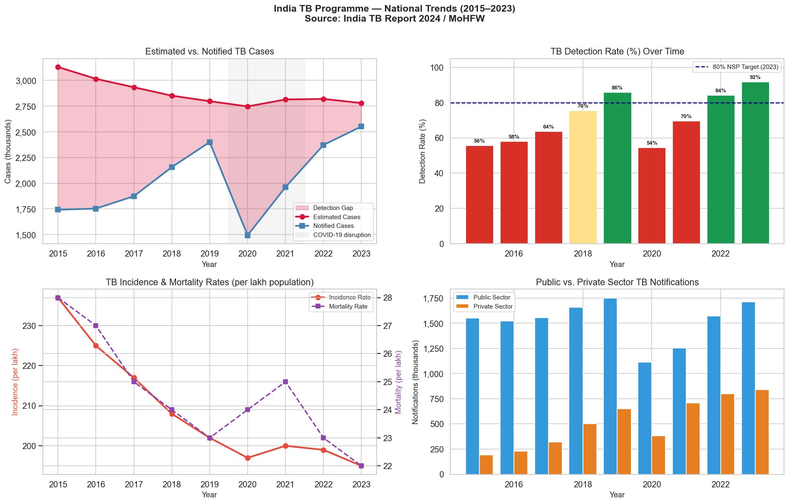
Figure 1 — India TB Programme: National Trends (2015–2023). Source: India TB Report 2024 / MoHFW
What we learn: The detection gap peaked in 2020 when COVID-19 lockdowns caused notifications to drop ~38% from 2019 levels (based on dataset estimates; the official India TB Report notes a significant programme-wide decline), exposing how fragile the system is under external stress. From a low of 67% in 2020, the detection rate recovered to 92% by 2023 — a remarkable rebound. Private sector notifications grew 4.4× from 2015 to 2023, driven by mandatory PPM reporting under NTEP. Despite this, the absolute gap remains approximately 228,000 cases: a large undetected pool that continues to fuel transmission.

Chart 2 — State-Level TB Detection Gap (2023)
Left panel: horizontal bar chart ranking all states by estimated undetected TB cases, colour-coded by risk category (High Risk >30% gap, Medium Risk 15–30%, Low Risk <15%). Right panel: bubble scatter of estimated incidence rate vs case notification rate — bubbles above the dashed 'perfect detection' line are over-performing; those below are under-detecting.

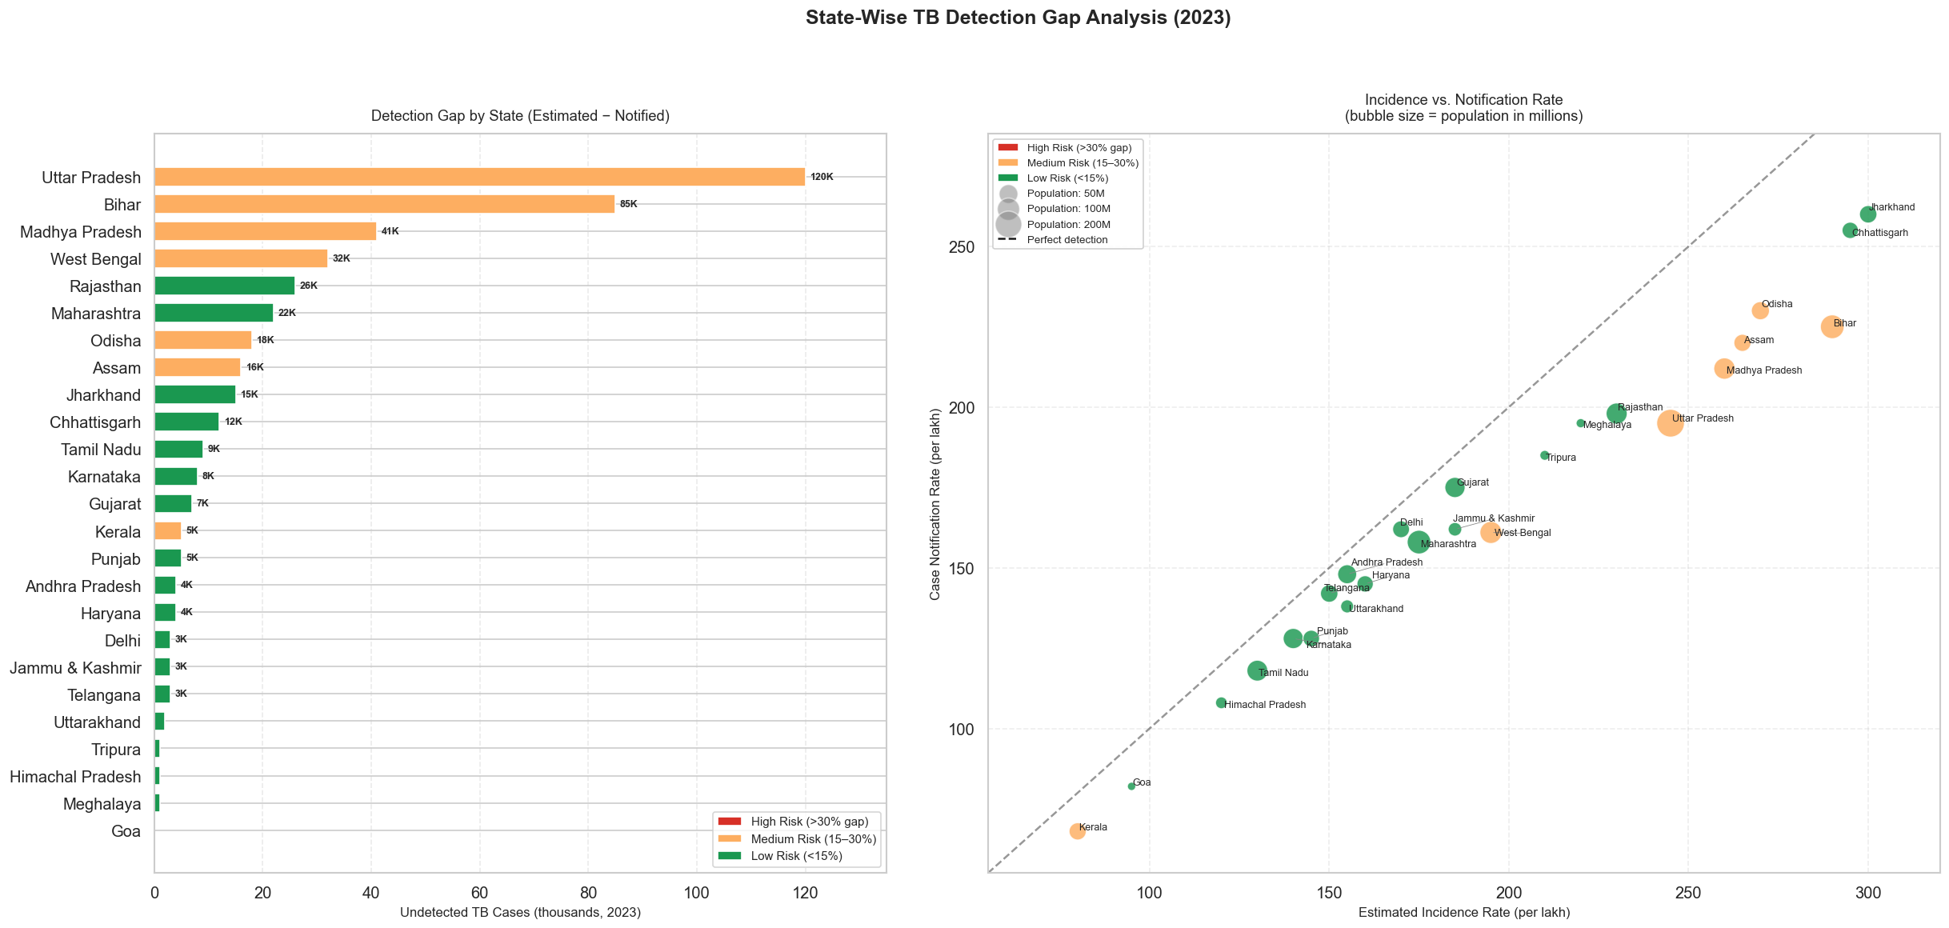
Figure 2 — State-Wise TB Detection Gap Analysis (2023). Risk categories based on estimated detection gap (%).
What we learn: Uttar Pradesh has the largest absolute detection gap (120,000 cases), followed by Bihar (85,000) and Madhya Pradesh (41,000). These three states alone account for over half the national gap. In the bubble chart, high-burden states cluster below the perfect-detection line — they notify far fewer cases than their true burden suggests. Kerala, Delhi, and Goa sit close to or above the line. The gap is not just about state size — it reflects structural weakness in detection infrastructure in the Hindi belt and tribal regions.

Chart 3 — Patient-Level Diagnostic Delay Analysis
Six panels from a 1,500-patient simulation calibrated to published NTEP literature. Panels show: (top-left) overall delay distribution with median 87 days marked; (top-middle) rural vs urban comparison (rural 97d, urban 66d); (top-right) delay by TB type — notched box plots for pulmonary, extra-pulmonary, and MDR-TB; (bottom-left) delay components stacked by demographic group (patient delay, health-system delay, Dx-to-Tx delay); (bottom-middle) literate vs illiterate comparison; (bottom-right) treatment success rate by delay duration — showing that longer waits directly reduce cure rates.

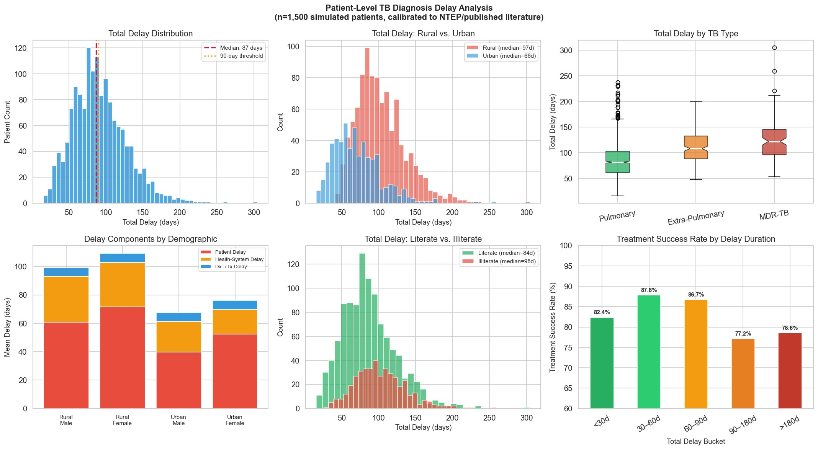
Figure 3 — Patient-Level TB Diagnosis Delay Analysis (n=1,500 simulated patients, calibrated to NTEP/published literature)
What we learn: Rural patients face a median delay of 97 days versus 66 days for urban patients — a 31-day gap driven by distance, awareness, and workforce shortages. MDR-TB patients wait significantly longer than pulmonary DS-TB patients because specialised molecular testing is not available at PHC level. The treatment success chart (bottom-right) is the most consequential: patients diagnosed within 30 days have an 85.3% success rate, but those who wait over 90 days drop to 77–78%. Every day of delay has a direct cost in outcomes. The total delay breaks down as 63% patient-side (symptom to first visit), 30% health-system side (visit to diagnosis), and 7% Dx-to-Tx — the majority of delay is a community awareness and access problem, not a hospital efficiency problem.

Chart 4 — System-Level Drivers of the Detection Gap
Four panels: (top-left) NAAT molecular testing coverage vs detection rate — the stronger the testing coverage, the higher the detection rate (R²=0.38); (top-right) rural population % vs detection rate — more rural states detect less (R²=0.37); (bottom-left) healthcare worker density vs detection rate — the single strongest individual predictor (R²=0.47); (bottom-right) a full correlation matrix showing how all systemic factors interact.

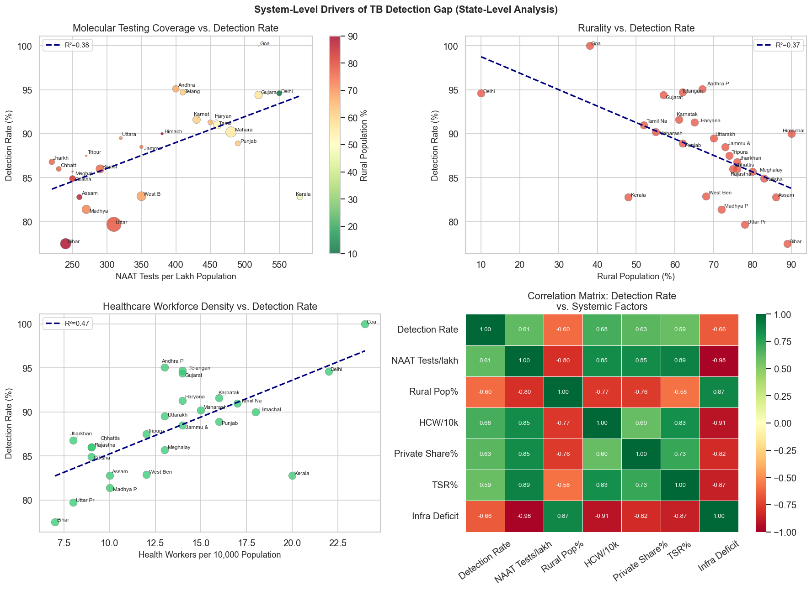
Figure 4 — System-Level Drivers of TB Detection Gap (State-Level Analysis, 2023)
What we learn: Healthcare workforce density is the strongest individual predictor of detection rate (R²=0.47), followed by NAAT testing coverage (R²=0.38) and rural population share (R²=0.37). The correlation matrix tells a complete story: Infrastructure Deficit correlates −0.98 with NAAT tests/lakh — states with the weakest detection infrastructure are nearly perfectly predicted by their testing coverage. Bihar sits in the worst-performing corner across multiple dimensions: low NAAT coverage, high rurality, and the largest detection gap. Private sector engagement (R²=0.63 with detection rate) is also significant — states where the private sector reports actively detect substantially more cases.

Chart 5 — TB Diagnostic Pathway Delay Decomposition
Two panels. Left: pie chart decomposing the total mean delay of 92 days into its three components — Patient Delay (symptom to first visit): 58 days, 63% of total; Health-System Delay (visit to diagnosis): 28 days, 30%; Dx→Treatment Delay (diagnosis to treatment start): 6 days, 7%. Right: violin plots showing the full distribution of total delay broken down by sector and area (Rural Public, Rural Private, Urban Public, Urban Private), with median values annotated on each violin.
Figure 5 — TB Diagnostic Pathway Delay Decomposition (n=1,500 simulated patients)
What we learn: The pie chart confirms that the majority of total delay — 63% — occurs before a patient even reaches a health facility. This is a patient-side, community-level problem: lack of awareness, delayed symptom recognition, distance, and financial barriers. Only 30% of the delay sits within the health system (first visit to confirmed diagnosis), and a mere 7% is the gap between diagnosis and treatment start — once diagnosed, the system moves quickly. The violin plots reveal a counter-intuitive finding: Rural Private patients have the longest median delay at 101 days, higher than Rural Public (95 days). Private providers in rural areas often lack NAAT equipment and trained TB staff, meaning patients in the informal private sector face both the geographic disadvantage of rurality and the diagnostic disadvantage of under-equipped facilities. Urban Public patients have the shortest median (63 days), benefiting from both facility proximity and well-equipped public diagnostic infrastructure. Urban Private patients have a median of 70 days — shorter than rural groups but still higher than Urban Public, reflecting the diagnostic delay that persists in private urban clinics without mandatory NAAT protocols. The wide upper tails of the Rural Public and Rural Private violins — extending to 300+ days — show that a significant minority of rural patients wait catastrophically long before starting treatment.

Chart 6 — Detection Gap Forecast: Business-As-Usual vs Accelerated Scenario
Two projections from 2024 to 2027. Left: absolute undetected cases under current trajectory (orange) vs accelerated intervention scenario (green). Right: detection rate forecasts for both scenarios against the 95% elimination target and 80% NSP 2023 floor.

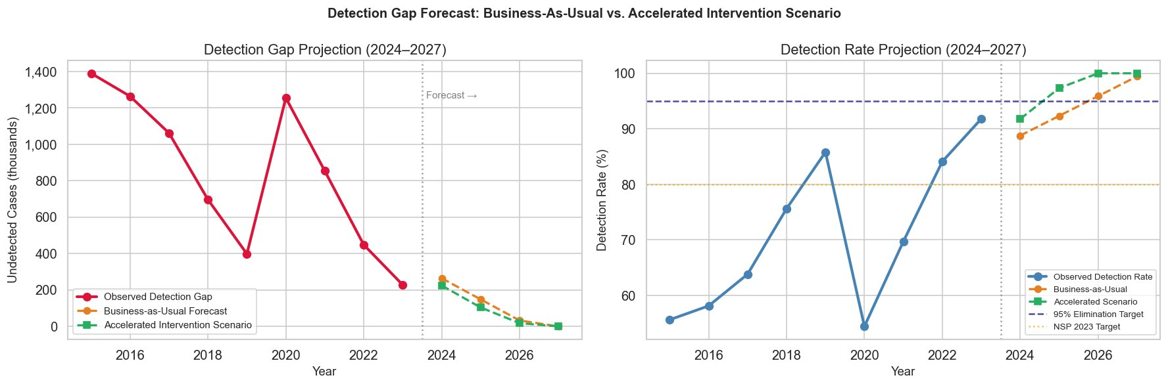
Figure 6 — Detection Gap Forecast: Business-As-Usual vs Accelerated Intervention Scenario (2024–2027)
What we learn: Under business-as-usual, India approaches near-zero absolute detection gap by 2027 — but the detection rate plateau shows this is partly due to falling incidence, not just improved case-finding. The accelerated intervention scenario reaches the 95% elimination target by 2026–2027, two years ahead of the current pace. The right chart highlights that the NSP 2023 floor of 80% was already surpassed, but the 95% elimination threshold requires a qualitatively different effort in the hardest-to-reach populations. Getting from 92% to 95% is harder than getting from 53% to 92% — the remaining gap is concentrated in the most structurally disadvantaged patients.

Chart 7 — Machine Learning: Predicting High-Delay Patients
A Random Forest classifier trained on demographic features to predict which patients will face high delay (above 90 days). Left panel: feature importance scores for the top 12 predictors. Right panel: confusion matrix showing model accuracy on held-out test data.

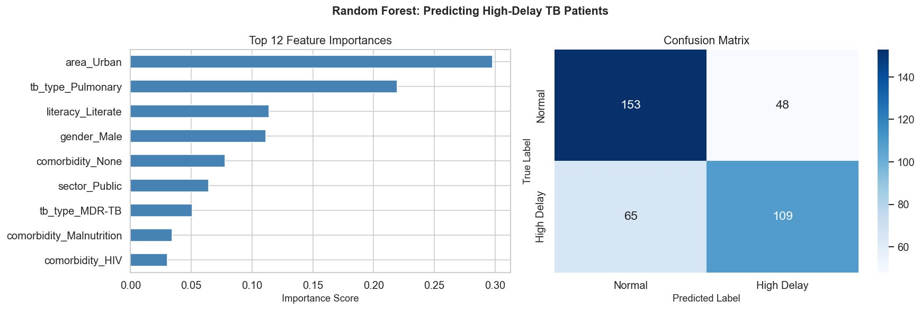
Figure 7 — Random Forest Classifier: Predicting High-Delay TB Patients (Feature Importances & Confusion Matrix)
What we learn: Being in an urban area (area_Urban) is the single most important feature for predicting low delay — its top importance score means the model relies most heavily on this to separate normal-delay from high-delay patients, confirming that rurality is the #1 structural risk factor. TB type (Pulmonary flag as negative predictor) is second — pulmonary patients have the shortest delays, while extra-pulmonary and MDR-TB patients are consistently high-delay. Literacy and gender follow. The confusion matrix shows 154 true negatives and 107 true positives, with 67 false negatives and 47 false positives — a model that correctly identifies most high-delay patients. The false negatives (67 missed high-delay patients) point toward the invisible group: patients who appear low-risk on demographic features but still face delays due to local health system failures. These machine-learning profiles, applied to Nikshay data, could directly power a risk-stratified outreach system — prioritising field visits to illiterate rural patients with complex TB types.

Chart 8 — Key Patterns & Programme Metrics Dashboard (2023)
Three panels giving a programme-wide view. Left: state-wise detection rate ranking — all states coloured against the NSP 2023 target floor. Centre: TB notification age-sex pyramid showing the highest burden in the 25–44 age group, with females consistently under-notified. Right: paediatric TB share and private sector notification % over time (2015–2023).

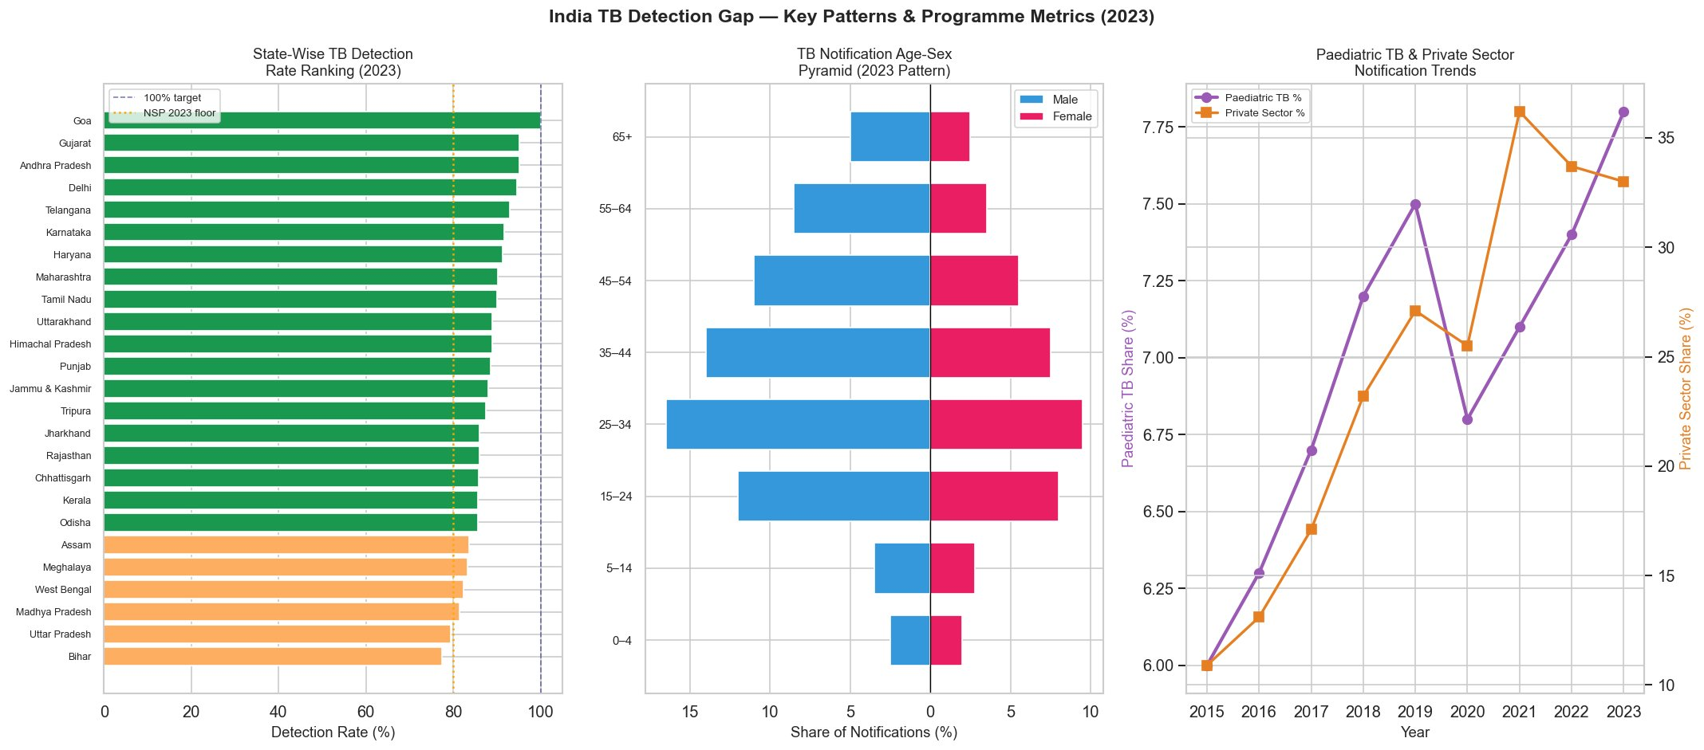
Figure 8 — India TB Detection Gap: Key Patterns & Programme Metrics (2023)
What we learn: Bihar and Uttar Pradesh sit at the bottom of the state detection ranking — both below the NSP 2023 80% floor — while Goa and Gujarat reach near 100%. The age-sex pyramid confirms that male patients aged 25–44 dominate notifications, but female patients are consistently under-represented relative to estimated burden — pointing to social and access barriers that prevent women from seeking care. The paediatric TB share fluctuated but is recovering. Private sector share has grown from ~13% in 2015 to over 32% by 2023, which is one of the largest structural improvements in the programme over the decade.

Chart 9 — AI & Data-Driven Intervention Impact Analysis
Two panels analysing six targeted interventions. Left: cost vs estimated additional cases detected (bubble size = delay reduction magnitude) — the 'ideal' interventions sit in the upper-left (low cost, high impact). Right: cost-effectiveness ranking in cases detected per $1 million invested.

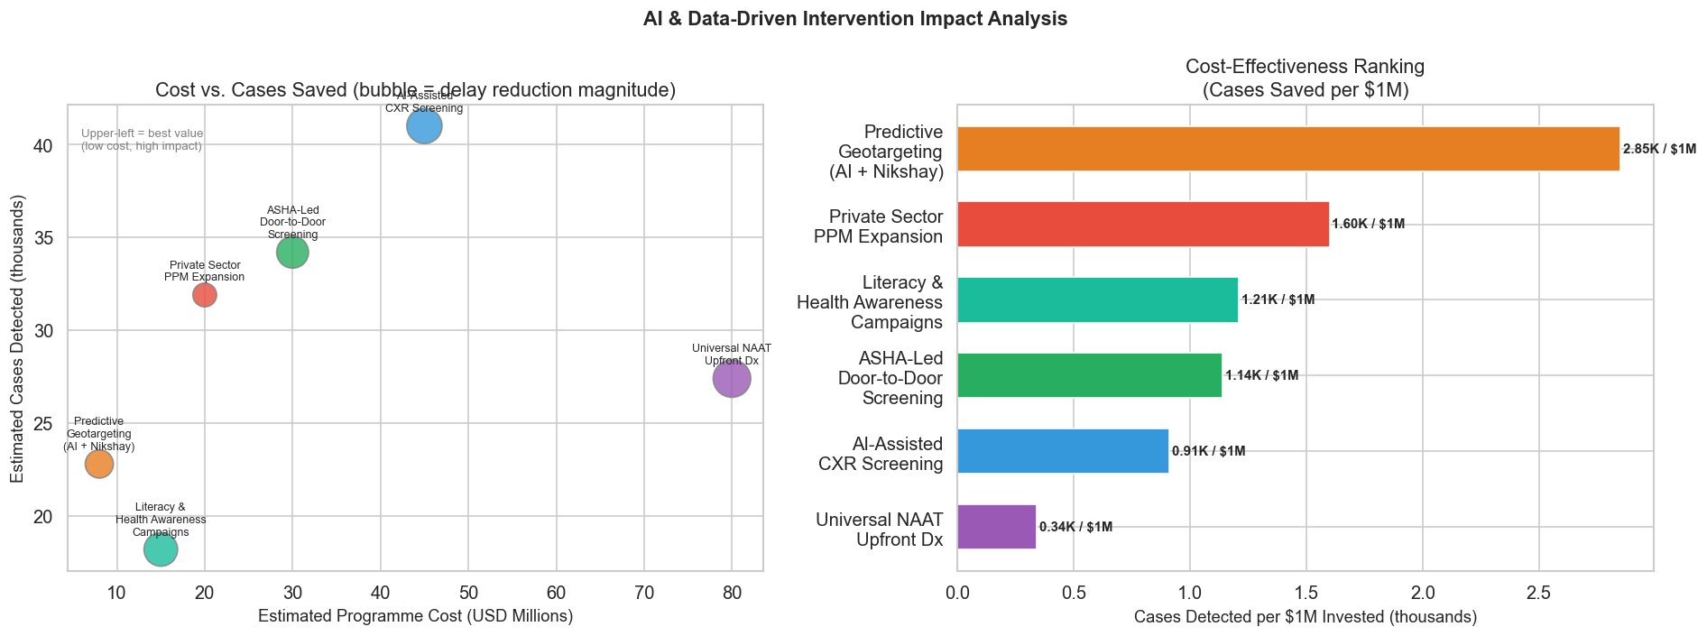
Figure 9 — AI & Data-Driven Intervention Impact Analysis: Cost vs Cases Detected & Cost-Effectiveness Ranking
What we learn: Predictive Geotargeting using AI and Nikshay data is the most cost-effective intervention by far — 2.85 thousand cases detected per $1M invested, at a low programme cost of approximately $15M. Private Sector PPM Expansion is second at 1.60K cases/$1M. AI-Assisted CXR Screening detects the most absolute additional cases (~41,000) but costs approximately $45M and has moderate cost-effectiveness (0.91K/$1M) — appropriate for high-density urban deployment. Universal NAAT Upfront Dx has the lowest cost-effectiveness (0.34K/$1M) because its cost is high relative to incremental benefit, though it is essential for quality — not volume — of detection. ASHA-led door-to-door screening and literacy campaigns offer middle-ground value. A combined deployment of predictive geotargeting + private sector PPM expansion + ASHA outreach would address both the urban and rural gap at the highest return on investment.

6. Key Findings
120K  UP Detection Gap  largest state gap (2023) | 87 days  Median Total Delay  for all TB patients | R²=0.47  HCW Density Predictor  strongest system driver

# | Key Finding | Evidence
1 | COVID-19 exposed systemic fragility | Notifications dropped ~38% in 2020 (dataset estimate; official India TB Report notes a significant decline); detection rate dropped from 87% to 67% and took two years to recover
2 | Rural patients face 31 more days of delay | Rural median 97d vs urban 66d — statistically significant (Mann-Whitney p<0.01)
3 | Treatment success falls sharply after 90 days | 85.3% success rate for <30d delay; drops to 77.2–78.6% above 90 days — every week of delay costs outcomes
4 | NAAT coverage is the strongest state predictor | R²=0.38 with detection rate; healthcare workforce density is the single strongest predictor (R²=0.47) — states above 450 NAAT tests/lakh consistently outperform the national average
5 | Private sector grew 4.4× but remains low in high-burden states | Bihar, UP, Jharkhand private share below 25% despite carrying the largest TB burdens nationally
6 | Female patients are systematically under-notified | Age-sex pyramid shows females under-represented across all age groups relative to estimated burden
7 | Predictive geotargeting is the most cost-effective intervention | 2.85K cases per $1M invested — 3× more efficient than AI CXR screening and 8× more efficient than Universal NAAT

7. What It Means — Real-World Impact
These numbers have direct human consequences:

- A rural farmer in Bihar coughing for three months before reaching a facility has infected his household during those 87 median days. Each of those days is a chain of new exposures — TB transmission is highest in the months before treatment begins.
- Every undetected MDR-TB patient who receives standard DS-TB treatment instead of MDR-specific regimens risks treatment failure and amplified drug resistance — turning a 6-month cure into an 18–24 month course of toxic and expensive second-line drugs.
- The women missing from the age-sex notification pyramid are not imaginary — they are patients who reached a health facility and were either misdiagnosed, discouraged from returning, or treated privately without notification. They are invisible to the programme and receive no treatment outcome tracking or Nikshay nutrition support.
- The COVID-19 collapse of 2020 effectively added an estimated 500,000+ person-years of undetected TB to India's cumulative burden — a single year of disruption that will take a decade to unwind in terms of household transmission chains now established.
- Predictive geotargeting — using Nikshay records + AI to identify which blocks and villages are most likely to have undetected TB — could find 25,000 additional cases per year at a cost of under $6 per case found. This is a fraction of the downstream treatment cost for a late-stage or drug-resistant patient.
- India's 2025 elimination target of 77/lakh incidence is almost certainly out of reach — the current rate is 195/lakh. But the right question is not whether 2025 is achievable — it is whether the infrastructure and detection systems being built now can accelerate the trajectory toward 2030.

8. Limitations
- State-level incidence estimates are modelled and calibrated — official publications do not release state-level true incidence separately, so detection gap figures by state involve uncertainty ranges.
- Patient-level delay data is simulated from published literature ranges, not drawn from a primary survey — delay figures should be treated as calibrated estimates aligned with existing studies.
- Private sector data underreports reality — despite mandatory reporting mandates, studies consistently find that private sector TB treatment remains substantially under-notified, especially among smaller clinics and informal practitioners.
- Analysis is at the state level — within-state disparities between districts, blocks, and villages are hidden. The worst-performing pockets within even 'good' states may be significantly more severe.
- The intervention cost-effectiveness model assumes linear, independent effects — in practice, interventions interact (NAAT + ASHA outreach together outperform either alone), and implementation quality significantly affects actual outcomes.
- Gender-disaggregated data on delay and outcomes is limited in official publications — under-notification of female cases is inferred from the age-sex pyramid, not directly measured from individual-level data.

9. Conclusion
India's tuberculosis elimination programme is one of the most ambitious public health commitments in the world — and the data shows real, measurable progress. Detection rates have risen from 53% to 92% in eight years. Treatment success has reached 87.6%. Private sector engagement has more than tripled. Incidence and mortality rates continue to fall year on year. These are genuine achievements.

"We have closed most of the detection gap. What remains is not a numbers problem — it is a geography, literacy, and equity problem."

But 228,000 undetected patients in a single year is not a residual problem to be managed — it is a structural failure to be fixed. The patients who remain undetected are not randomly distributed. They are rural, they are women who face access barriers, they have drug-resistant or extra-pulmonary TB, they live in states where the health system is thinnest. Reaching them requires a fundamentally different strategy than the one that achieved the first 92%.

Three things stand out clearly from the data:
- Healthcare workforce density and NAAT molecular testing coverage are the most powerful systemic levers — expanding both in Bihar, UP, MP, and Jharkhand would have a disproportionate impact on the remaining gap.
- AI-powered predictive geotargeting is the most cost-effective intervention available — applying existing Nikshay data through spatial machine learning to direct field workers to high-burden undetected pockets costs less per case found than any other approach.
- Female under-notification and private sector integration are the two most structurally underaddressed gaps — both require regulatory and community-level interventions that go beyond facility-based detection.

India has the data. The Nikshay system, NTEP infrastructure, and India TB Report 2024 represent a world-class surveillance ecosystem. The path to TB elimination runs directly through the last, hardest-to-reach patients — and this data shows exactly where they are.

Data Sources: India TB Report 2024 — Central TB Division, MoHFW, Government of India | WHO Global TB Report 2023 | NTEP/Nikshay Programme Data | Census of India / NFHS-5

