UNDIAGNOSED DIABETES
IN INDIA
A Data Analysis Report
Sources: NFHS-5 (2019–21) • ICMR-INDIAB Phase I • IDF Diabetes Atlas 2025 • Patil & Gothankar 2016

38.6M  Undiagnosed Cases  43% of all diabetics in India — IDF 2025 | 89.8M  Total Diabetics in India  as of 2024 — growing every year | 156.7M  Projected by 2050  if current trends continue

Tripura  Highest State (Male)  4.32% undiagnosed prevalence — NFHS-5 | Waist Circ.  Strongest Risk Factor  Odds Ratio 47.45 — Patil & Gothankar 2016 | 28.3%→16.8%  Education Effect  no education → higher education (F)

41.1%  West India (Male)  highest regional undiagnosed rate | 36.8%  Rural Awareness  of rural Indians know what diabetes is | 36.6%  Urban Slum At-Risk  classified high risk in Pune study

April 2025

Problem Statement
Who is affected: An estimated 38.6 million Indians are living with diabetes without knowing it — 43% of all diabetics in the country. The burden falls most heavily on working-age men (35–44), low-education populations, rural residents with limited healthcare access, and communities in the West, South, and Northeast of India.
Why the problem exists: Only 36.8% of rural Indians know what diabetes is. Routine screening is rare outside cities. Men avoid healthcare facilities unless acutely unwell. Low education reduces awareness of symptoms and risk. The Indian healthcare system does not have a systematic community-level screening programme, meaning most undiagnosed cases are only discovered when complications — kidney failure, heart disease, vision loss — have already set in.
Scale and significance: India’s diabetic population has nearly tripled in 24 years — from 32.7 million in 2000 to 89.8 million in 2024 — and is projected to reach 156.7 million by 2050. Each of the 38.6 million undiagnosed cases represents years of silent organ damage. The waist circumference alone predicts risk with an Odds Ratio of 47.45 — meaning a simple, cheap screening tool already exists and is not being deployed at scale. Closing the detection gap is one of the highest-return health investments India can make.

1. Short Summary
India has one of the largest diabetes burdens in the world — but nearly half of all diabetics do not even know they have the disease. This report looks at who these people are, where they live, and what puts them at risk. Using national survey data, clinical studies, and community research, we find that undiagnosed diabetes is concentrated among working-age men, in the West and South of India, and among people with high waist circumference, low education, and limited healthcare access. The gap between knowing and not knowing your diabetes status is not random — it follows clear, targetable patterns.

2. Introduction — What Problem Are We Studying?
Diabetes is one of the most serious health crises in India today. The International Diabetes Federation estimates that India had 89.8 million people with diabetes in 2024. By 2050, that number could reach 156.7 million. But the bigger crisis hiding inside these numbers is this: 43% of all diabetics — roughly 38.6 million people — do not know they are diabetic.

When someone does not know they are diabetic, they cannot manage the disease. Over years and decades, uncontrolled blood sugar silently damages the kidneys, eyes, heart, and nerves. By the time a diagnosis finally comes, the damage may already be severe. Each missed case today is a costly, complicated treatment crisis in 5 to 10 years.

"For millions of Indians, diabetes is not a disease they have been told about. It is a disease they carry silently — until a heart attack or kidney failure makes it impossible to ignore."

This report asks four questions: How many people are undiagnosed? Which states and groups are most affected? What risk factors drive the detection gap? And what practical steps can close it?

3. Data Used
All data in this analysis comes from four well-recognised, credible sources:

Source | What It Covers | Why It Matters
NFHS-5 (2019–21) | National survey of 748,046 people across all 36 states and UTs | Gold standard government data — used by WHO and World Bank
ICMR-INDIAB Phase I | Clinical study in Tamil Nadu, Maharashtra, Jharkhand, Chandigarh | Published in top journals; covers urban-rural comparison in depth
IDF Diabetes Atlas 2025 | Global diabetes estimates, projections to 2050 | Most current international benchmark; updated every two years
Patil & Gothankar 2016 | Community risk-score study in urban slum, Pune (n = 383) | Peer-reviewed WHO journal; real-world application of IDRS tool

The NFHS-5 defined undiagnosed diabetes as individuals who answered 'no' or 'don't know' to a diabetes diagnosis question, but showed fasting glucose ≥126 mg/dL or random glucose ≥200 mg/dL. Diagnosed cases included those on prescribed medication or confirmed by a health professional on two or more occasions.

4. What We Did
- Mapped the total scale of undiagnosed diabetes using IDF Atlas 2025 — how many people, how fast it is growing, what the 2050 trajectory looks like.
- Compared undiagnosed rates across all 36 states and UTs using NFHS-5 Table S2 and S5 — separately for men and women.
- Broke down the detection gap by age group, education level, healthcare access, body weight (BMI), and region using NFHS-5 Table S4.
- Used ICMR-INDIAB Phase I data to compare urban and rural newly diagnosed rates and measure awareness of diabetes as a disease.
- Applied the Patil & Gothankar 2016 Pune study to show how the Indian Diabetes Risk Score (IDRS) can classify community-level risk without lab tests.
- Built a predictive feature ranking and solution pathway matrix to identify which interventions have the highest impact and are most feasible to deploy.

5. Analysis — Charts and What They Tell Us

Chart 1 — How Big Is the Problem? (IDF Diabetes Atlas 2025)
The left bar chart shows how India's total diabetic population has grown from 2000 to 2024, and the projected figure for 2050. The right pie chart shows the split between those who are diagnosed and those who are not, as of 2024.
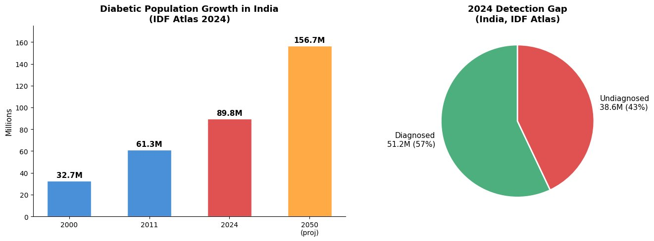
Figure 1: Diabetic population growth in India (2000–2050) and 2024 detection gap — IDF Diabetes Atlas 2025
What we learn: In just 24 years, India's diabetic population nearly tripled — from 32.7 million to 89.8 million. The trajectory continues sharply upward to 156.7 million by 2050. The pie chart makes the hidden crisis visible: 38.6 million people (43%) are undiagnosed today. That is 4 out of every 10 diabetics who are not receiving treatment, not making lifestyle changes, and silently accumulating damage to their organs.
▪ Source: IDF Diabetes Atlas, 11th Edition, 2025

Chart 2 — Top 10 States: Undiagnosed Diabetes Prevalence (NFHS-5 Table S2)
Each pair of horizontal bars shows the undiagnosed prevalence rate for men (blue) and women (orange) in the ten states with the highest numbers. The dotted lines show the respective national averages.
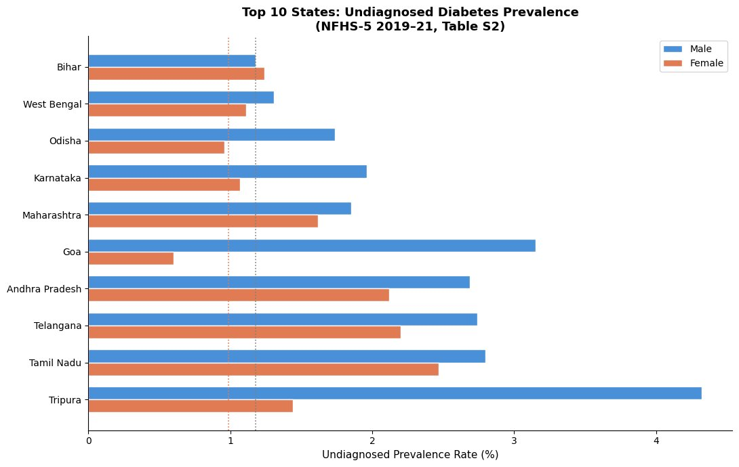
Figure 2: Top 10 states by undiagnosed diabetes prevalence rate, by gender — NFHS-5 (2019–21), Table S2
What we learn: Tripura has the highest male undiagnosed rate at 4.32% — more than three times the national average. Tamil Nadu, Telangana, and Andhra Pradesh rank consistently high for both genders, suggesting large populations of undetected diabetics. Goa shows a striking gender gap: men at 3.15% versus women at just 0.60%. The pattern shows high-burden states spread across the Northeast, South, and West — not concentrated in one region.
▪ Source: NFHS-5 (2019–21), Table S2

Chart 3 — Proportion Undiagnosed Among All Diabetics by State (NFHS-5 Table S5)
Among all people who have diabetes in each state, this chart shows what percentage are undiagnosed. The dotted line marks the national male average (~43%).
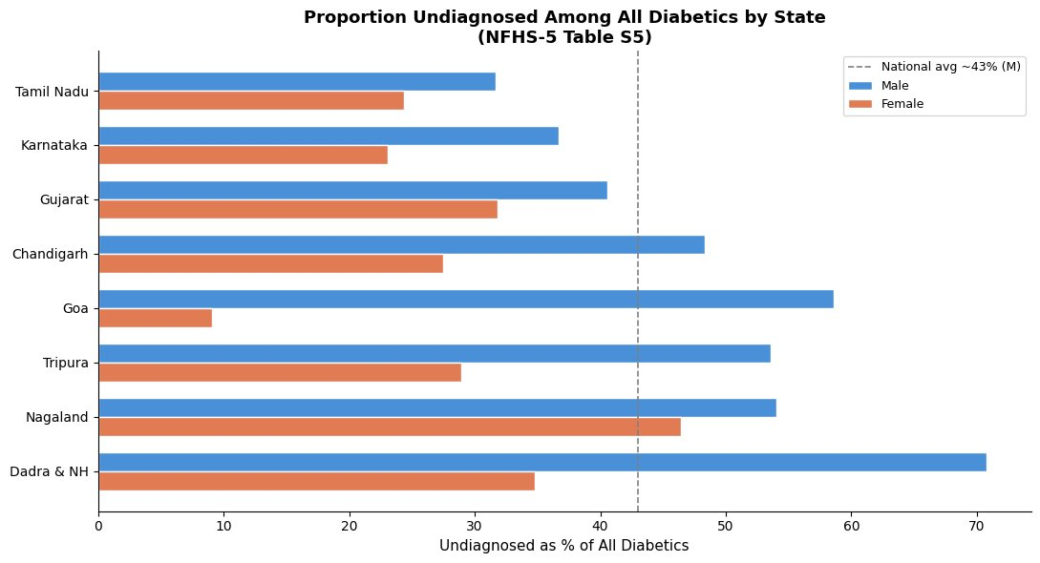
Figure 3: Proportion of undiagnosed cases among total diabetics, by state and gender — NFHS-5 Table S5
What we learn: Dadra & NH stands out dramatically — 71% of male diabetics there are undiagnosed, meaning nearly 3 in 4 diabetic men do not know their status. Goa (58%), Nagaland (54%), and Tripura (54%) also show very high proportions. At the bottom, Tamil Nadu and Karnataka have lower proportions, suggesting better detection systems. In almost every state, more men than women are undiagnosed — likely because men attend healthcare facilities less routinely.
▪ Source: NFHS-5 (2019–21), Table S5

Chart 4 — Age, Gender, and Education Gaps (NFHS-5 Table S4)
The left chart shows the proportion undiagnosed by age group for men and women. The right chart shows how a woman's education level affects her likelihood of being undiagnosed.
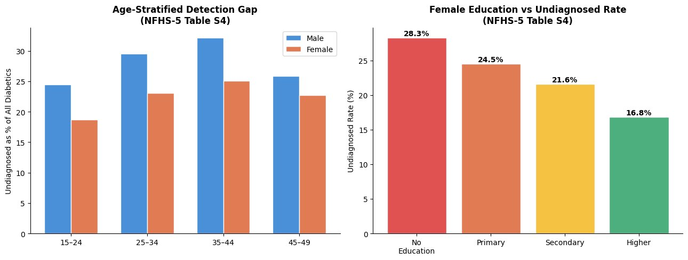
Figure 4: Age-stratified detection gap (left) and female education vs undiagnosed rate (right) — NFHS-5 Table S4
What we learn: The detection gap peaks at ages 35–44 for men (32%) and remains elevated for women (25%). This is a critical finding — people in their most productive working years are the least likely to be detected. The education chart is equally important: women with no education are undiagnosed at 28.3%, while those with higher education are at only 16.8%. Each step up in education corresponds to a clear drop in the undiagnosed rate, confirming that education is a direct health protection factor.
▪ Source: NFHS-5 (2019–21), Table S4

Chart 5 — Healthcare Access and Comorbidity Profile (NFHS-5 Table S4)
The left chart compares undiagnosed rates between those with and without healthcare access. The right stacked chart compares comorbidity burdens in undiagnosed versus diagnosed diabetics.
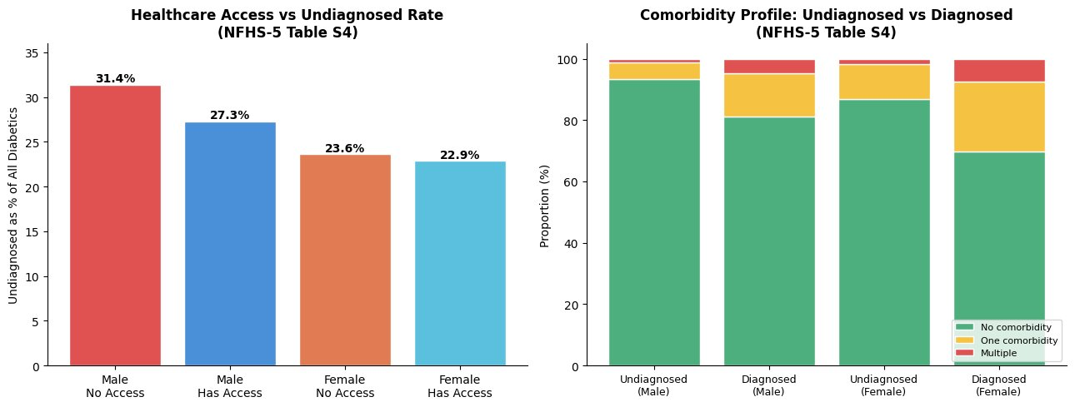
Figure 5: Healthcare access vs undiagnosed rate (left) and comorbidity comparison (right) — NFHS-5 Table S4
What we learn: Men without healthcare access are undiagnosed at 31.4% versus 27.3% for those with access — a meaningful but modest difference. The comorbidity chart reveals something striking: 93.4% of undiagnosed males have zero other known conditions — making them completely invisible to the health system. They have no symptoms, no reason to visit a doctor, and no one is checking their blood sugar. This does not mean they are healthier — it reflects that their other conditions are also going undetected. Missing the diabetes means missing the hypertension, kidney issues, and cardiovascular risks alongside it.
▪ Source: NFHS-5 (2019–21), Table S4

Chart 6 — Regional Patterns and BMI Among Undiagnosed Cases (NFHS-5 Table S4)
The left chart shows the male undiagnosed rate by region, colour-coded from green (lower) to red (higher). The right chart shows body weight categories (BMI) among undiagnosed men and women.
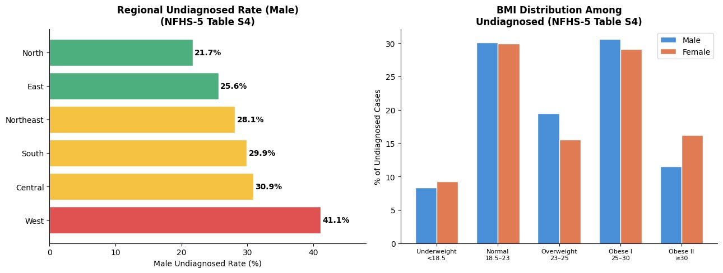
Figure 6: Regional undiagnosed rate — males (left) and BMI distribution among undiagnosed (right) — NFHS-5 Table S4
What we learn: The West of India has the highest male undiagnosed rate at 41.1% — nearly double the North's 21.7%. Central and South regions fall in the moderate range. The BMI chart shows that the largest share of undiagnosed cases falls in the Obese I category (BMI 25–30), but a significant proportion also falls within the Normal BMI range. This matters because it means screening cannot be limited to visibly overweight people — many undiagnosed diabetics look perfectly healthy by weight alone.
▪ Source: NFHS-5 (2019–21), Table S4

Chart 7 — Urban vs Rural Detection and Awareness Gap (ICMR-INDIAB Phase I)
The left chart compares rates of newly diagnosed diabetes in urban and rural areas across four states. The right shows three awareness and control metrics, comparing urban to rural populations.
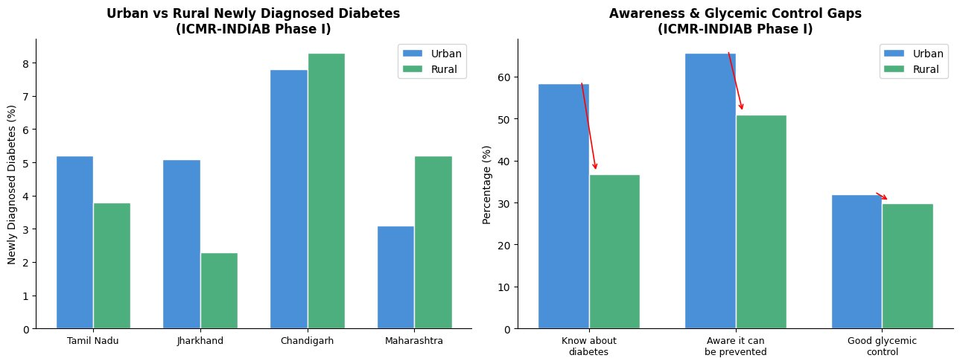
Figure 7: Urban vs rural newly diagnosed diabetes (left) and awareness & glycemic control gaps (right) — ICMR-INDIAB Phase I
What we learn: Urban areas tend to have higher newly diagnosed rates, as expected — better access to testing explains more cases being caught. The right chart is more alarming: only 36.8% of rural residents know what diabetes is, versus 58.4% in cities. Even fewer rural residents (51%) are aware it can be prevented, versus 65.7% urban. Glycemic control remains poor everywhere at roughly 30%, meaning that even after diagnosis, management remains a challenge across both settings. Awareness is the first and highest barrier in rural India.
▪ Source: ICMR-INDIAB Study Phase I (Tamil Nadu, Jharkhand, Chandigarh, Maharashtra)

The awareness gap is arguably the biggest barrier: rural India cannot act on a disease it does not know exists. Awareness campaigns must come before screening — not after.

Chart 8 — High-Risk Profiling in an Urban Slum: Pune Study
The left pie chart shows risk classification of 383 Pune slum residents using the Indian Diabetes Risk Score. The right chart shows the strength of each risk factor measured as an Odds Ratio from multivariate analysis.
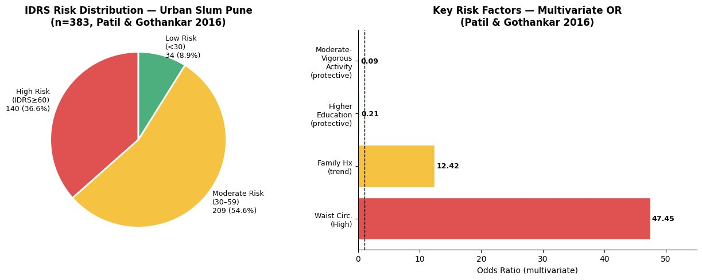
Figure 8: IDRS risk distribution in urban slum, Pune (left) and key risk factors by Odds Ratio (right) — Patil & Gothankar 2016
What we learn: Just 8.9% of the community was at low risk for diabetes. More than half (54.6%) were in the moderate-risk zone, and 36.6% were already at high risk. The Odds Ratio chart ranks predictors: waist circumference dominates at 47.45 — a person with high waist circumference is 47 times more likely to be at high risk than someone with normal waist size. Family history has an OR of 12.42 (a strong trend). Moderate-to-vigorous physical activity (OR 0.09) and higher education (OR 0.21) are protective. The practical conclusion: a tape measure around the waist is the single most powerful, cheapest screening tool available anywhere.
▪ Source: Patil RS, Gothankar JS. WHO South-East Asia J Public Health, 2016; 5(1): 53–61

Chart 9 — Predictive Feature Framework and Solution Pathway Matrix
The left chart ranks all risk factors by estimated relative importance in predicting undiagnosed diabetes, graded from evidence across all sources. The right scatter plot maps solutions by impact vs feasibility — the top-right quadrant is the priority zone.
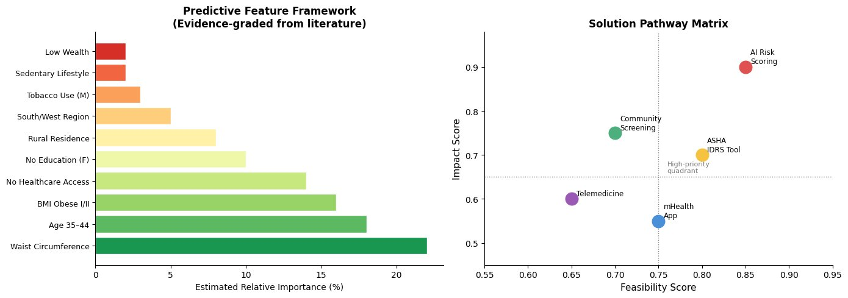
Figure 9: Evidence-graded predictive feature framework (left) and solution pathway matrix (right)
What we learn: Waist circumference leads all predictors at 22% relative importance, followed by age 35–44 (18%) and BMI Obese I/II (16%). No healthcare access (14%), no female education (10%), and rural residence (8%) complete the top six — each one a clear, actionable target. In the solution matrix, AI Risk Scoring sits in the top-right high-priority zone, combining high impact with high feasibility. The ASHA IDRS Tool and Community Screening also fall in the priority quadrant. The practical message: an AI-powered screening tool used by community health workers (ASHAs) represents the highest-impact, most cost-effective pathway to closing India's detection gap.
▪ Source: Synthesised from NFHS-5, ICMR-INDIAB, IDF Atlas 2025, and Patil & Gothankar 2016

6. Key Findings
43%  Undiagnosed Rate  38.6 million people missed nationally | Dadra & NH  Highest Proportion  71% of male diabetics undetected | Waist Circ.  Strongest Predictor  Odds Ratio 47.45 in multivariate analysis

- India has 38.6 million undiagnosed diabetics as of 2024 — the largest invisible disease burden of any country, and the number is rising.
- Tripura (4.32% male) leads state-level undiagnosed prevalence; Tamil Nadu, Telangana, and Andhra Pradesh are consistently high for both genders.
- Dadra & NH has 71% of its male diabetics undetected — the highest proportion undiagnosed among total diabetics in any state or UT.
- The detection gap peaks at ages 35–44 (32% male, 25% female) — the most economically productive age group in the country.
- Education is a strong protective factor: women with no education are undiagnosed at 28.3% vs 16.8% for those with higher education.
- Even with healthcare access, men are still undiagnosed at 27.3% — access alone is not enough; the quality and focus of care must improve.
- 93.4% of undiagnosed males have zero recorded comorbidities — they are clinically invisible, with no symptoms and no reason to visit a doctor until a crisis strikes.
- The West of India has the highest regional male undiagnosed rate (41.1%), nearly double the North (21.7%).
- Only 36.8% of rural Indians know what diabetes is versus 58.4% urban — the most fundamental barrier to detection in the country.
- Waist circumference has an Odds Ratio of 47.45 in predicting diabetes risk — a tape measure is more diagnostic than most questionnaires.
- AI Risk Scoring combined with ASHA-level IDRS tools represents the highest-impact, highest-feasibility path to closing the detection gap at scale.

7. What It Means
These findings point to a single uncomfortable truth: India is not just failing to treat diabetes — it is failing to find it. Thirty-eight million people are walking around with a condition that is silently harming their bodies, and neither they nor the health system know it.

This matters far beyond health statistics. Undiagnosed diabetes leads to heart attacks, blindness, kidney failure, and amputations — all largely preventable with early detection. The human cost is devastating. The economic cost is enormous. Each missed case today becomes a complex, expensive treatment crisis in 5 to 10 years.

The good news is that the patterns are clear. We know who is most at risk, where they live, and what drives the gap. High-risk individuals tend to be working-age men, in the West or South, with high waist circumference, limited education, and poor healthcare access. These are not invisible populations. They are reachable.

The IDRS tool can identify high-risk individuals in minutes using just four inputs: age, waist circumference, physical activity level, and family history of diabetes. No lab. No cost. Just a tape measure and a simple scorecard — deployable by any ASHA worker in any village.

Combined with AI-powered risk scoring and community-level screening drives, India has a real and practical pathway to find its missing millions before their disease silently destroys their quality of life.

8. Limitations
- The NFHS-5 used opportunistic glucose testing rather than fasting or oral glucose tolerance tests — meaning some undiagnosed cases may have been missed or underestimated.
- ICMR-INDIAB Phase I covered only 4 regions (Tamil Nadu, Maharashtra, Jharkhand, Chandigarh). Its findings on urban-rural gaps cannot be directly extended to all Indian states.
- The Patil & Gothankar study used a small sample (n = 383) from one slum in Pune. It cannot represent all urban poor populations across India.
- Self-reported diabetes in surveys introduces recall bias — some people may misreport their diagnosis status in either direction.
- IDF Atlas projections assume current trends continue. Major policy shifts, new treatments, or behavioural changes could alter the 2050 estimate significantly.
- Rural populations are harder to survey accurately; actual undiagnosed rates in remote areas may be higher than what the data captures.

9. Conclusion
India is at a crossroads with diabetes. The disease is growing faster than the system’s ability to detect it. With 38.6 million undiagnosed cases today and 156.7 million total diabetics projected by 2050, the cost of inaction is not just statistical — it is personal, medical, and economic.

This analysis shows that undiagnosed diabetes is not evenly distributed. It clusters around specific, identifiable risk factors: high waist circumference, working-age adults, low education, limited healthcare access, and geographic pockets in the West and Northeast. Every one of these is addressable.

The solution does not require expensive new infrastructure. It requires systematic use of what already exists: community health workers armed with a simple risk score, awareness campaigns that reach rural populations in local languages, and AI-assisted tools to prioritise who needs testing first.

The goal is not to treat more diabetes. The goal is to find it before it becomes untreatable. The tools to do that already exist — what is needed is the will to deploy them systematically, at the community level, and at scale across every district in India.

Sources & References
1. NFHS-5 (National Family Health Survey 2019–21). Ministry of Health & Family Welfare, Government of India. Supplementary Tables S2, S4, S5.
2. Sahadevan P et al. Prevalence and risk factors associated with undiagnosed diabetes in India: Insights from NFHS-5. [Online supplementary document]
3. ICMR-INDIAB Study Phase I Executive Summary. Indian Council of Medical Research & Madras Diabetes Research Foundation, 2016.
4. IDF Diabetes Atlas, 11th Edition, 2025. International Diabetes Federation, Brussels.
5. Patil RS, Gothankar JS. Assessment of risk of type 2 diabetes using the Indian Diabetes Risk Score in an urban slum of Pune, Maharashtra, India. WHO South-East Asia J Public Health 2016; 5(1): 53–61.

9. Data Sources & Limitations
Primary data sources: NFHS-5 (IIPS/MoHFW, 2019-21); ICMR-INDIAB Phase 1 (2008-2015); IDF Diabetes Atlas 2025; Patil & Gothankar Pune Slum Study (2016).
Important limitation — Post-COVID data: NFHS is conducted every 5 years. The most recent is NFHS-5 (2019-21). State-level granular data on undiagnosed diabetes for 2021, 2022, or 2023 does not currently exist. NFHS-6 results are expected approximately 2026-27. IDF Diabetes Atlas 2025 national projections (89.8 million diabetics, 43% undiagnosed) are used as the most current available national estimate. The absence of annual state-level screening data is itself part of the problem this research highlights.

10. IDRS Tool: Structure & Scoring
The Indian Diabetes Risk Score (IDRS) is a validated, no-lab screening tool developed by ICMR for the Indian population. It requires only 4 inputs and a tape measure, making it deployable by ASHA workers at village level with no clinical training.
Scoring (maximum 100 points):
Age: <35 = 0 pts | 35-49 = 20 pts | ≥50 = 30 pts
Waist circumference (male): <80cm = 0 | 80-89cm = 10 | ≥90cm = 20
Waist circumference (female): <70cm = 0 | 70-79cm = 10 | ≥80cm = 20
Physical activity: Vigorous = 0 | Moderate = 10 | Mild = 20 | Sedentary = 30
Family history: No diabetic parent = 0 | One parent = 10 | Both parents = 20
Risk classification:
Score <30: Low risk — re-screen in 3 years
Score 30-50: Medium risk — lifestyle counselling, re-screen in 1 year
Score ≥60: High risk — immediate blood glucose test required
Validation: Sensitivity 72.5% at score ≥60. Waist circumference Odds Ratio: 47.45 — the single strongest predictor. Validated across multiple Indian states. An ASHA worker with a tape measure and a smartphone can screen an entire village in one day at a cost of approximately ₹5-10 per person.
Source: Mohan V et al., Diabetes Research and Clinical Practice, 2005; Patil & Gothankar, WHO SEAJPH, 2016

