

American International University-Bangladesh (AIUB)  
 **Department of Computer Science  
Faculty of Science &Technology (FST)  
Fall 23-24**

**<** **Smart Irrigation System>**

Software Requirement Engineering

Sec: **A**

Project submitted

By

*SAJJAD HOSSEIN (20-43639-2)*

*THAJIB NASIR (20-43247-1)*

*MD RIHAN UDDIN SHAGOR (20-42909-1)*

*NOMAN BHUYAN (20-43830-1)*

**Checked By Industry Personnel**

Name:

Designation:

Company:

Sign:

Date:

Table of Contents

**1.** PROBLEM DOMAIN 3

1.1 Background to the Problem 3

1.2 Solution to the Problem 3

**2.** SOLUTION DESCRIPTION 3

2.1 System Features 4

2.1.1 Software Login 4

2.1.2 Scheduling 4

2.1.3 Automated Irrigation 5

2.1.4 Soil Moisture Sensor 5

2.1.5 Water Flow Monitoring 6

2.1.6 Mobile App Control 6

2.2 QUALITY ATTRIBUTES 7

2.3 UML Diagrams 8

**Fig 1**: class diagram 8

**Fig** **2**: Process Activity Diagram 9

**Fig** **3**: System Activity Diagram 9

**3.** SOCIAL IMPACT 9

**4.** DEVELOPMENT PLAN WITH PROJECT SCHEDULE 10

**5.** MARKETING PLAN 10

**6.** COST AND PROFIT ANALYSIS 10

**7.** REFERENCES 10

# PROBLEM DOMAIN

## 1.1 background to the problem

An automated system that makes use of contemporary technology to improve crop and plant watering is called a smart irrigation system. The system makes sure that each plant receives an adequate amount of water at the right time by taking into account soil moisture, weather, and type of plant. The specifications for a smart irrigation system are outlined in this Software Requirements Specification (SRS) paper. This article aims to provide a comprehensive and understandable overview of the features, capabilities, and specifications of the system. Farmers will have access to real-time crop health data through the smart irrigation system, which is expected to increase crop yields, reduce water waste, and enhance water management.

## 1.2 solution to the problem

The reason for a smart irrigation system is to expand plant and harvest watering by utilizing current innovation to give the right amount of water with correct timing. As well as further improving water management, the smart water system likewise gives farmers a helpful and easy to understand method for controlling their water system framework. Farmers might monitor and change their water system from anyplace utilizing the system's web or smart phone interface.

The purpose of the Smart Irrigation System is to automate irrigation in agricultural. The system will accumulate information from weather conditions and soil dampness sensors to decide when and how much water to apply to crops.

The system will have a UI that will permit the client to design the water system , monitor sensor information, and control water system schedule. Also, the system will advise the client in the event that the irrigation system has issues or the soil dampness levels are excessively low.

# SOLUTION DESCRIPTION

## 2.1 system features

### 2.1.1 Software Login

**Functional Requirements (FRs)**

* + - * **User authentication**: The user's identity should be verified by the system when they try to log in with a valid phone number and password.
      * **Password strength validation**: The system should enforce password strength requirements, such as minimum length, special characters, and uppercase and lowercase letters, to ensure that users choose strong and secure passwords.
      * **Password reset**: The system should allow users to reset their password if they forget it or need to change it for security reasons.
      * **User role-based access control**: The system should restrict access to certain features and functionalities based on the user's role and permissions.
      * **Session management**: The system should manage user sessions and automatically logout users after a specified period of inactivity.
      * **Secure transmission**: The system should encrypt user credentials and other sensitive information during transmission to prevent unauthorized access.
      * **Account lockout**: The system should temporarily lock user accounts after a certain number of unsuccessful login attempts to prevent brute force attacks.
      * **Multi-factor authentication**: The system should support multi-factor authentication to provide an extra layer of security, such as using a code sent to the user's phone in addition to their Phone Number and password.
      * **Logging and auditing**: The system should log all login attempts and user activity for auditing and security purposes.
      * **Password expiration**: The system should prompt users to change their password periodically to ensure ongoing security.

These FRs ensure that the login functionality of the software is secure, user-friendly, and meets the needs of both users and administrators.

**Priority Level**: High

**Precondition:** user have valid phone number and password.

### 2.1.2 Scheduling

**Functional Requirements (FRs)**

* + - * **Flexibility**: The system should be able to create flexible watering schedules based on the needs of the plants and the environmental conditions.
      * **Customization**: The system should allow users to customize watering schedules based on their specific preferences and requirements.
      * **Easy-to-use interface**: The system should have an easy-to-use interface for setting up and adjusting watering schedules.
      * **Multiple schedules:** The system should be able to create and manage multiple watering schedules for different zones or areas of the garden.
      * **Time of day**: The system should be able to schedule watering sessions at specific times of the day or night to avoid evaporation and optimize water absorption.
      * **Watering duration**: The system should be able to adjust the duration of watering sessions based on the needs of the plants and the environmental conditions.

**Priority Level**: High

### 2.1.3 Automated Irrigation

**Functional Requirements (FRs)**

* + - * **Automated sensors**: The system should be equipped with automated sensors that detect the moisture levels in the soil, temperature, humidity, and weather conditions.
      * **Real-time data analysis**: The system should analyze the data collected from the sensors in real-time to determine the appropriate watering levels and timing.
      * **Watering levels**: The system should be able to adjust watering levels based on the needs of the plants and the amount of rainfall.
      * **Irrigation zones**: The system should be able to divide the garden or lawn into irrigation zones, with each zone having its own watering schedule and settings.
      * **Flow control**: The system should be able to control the flow of water to ensure that the plants receive the appropriate amount of water without wasting it.
      * **Watering duration**: The system should be able to adjust the duration of watering sessions based on the needs of the plants and the environmental conditions.

**Priority Level**: High

### 2.1.4 Soil Moisture sensor

**Functional Requirements (FRs)**

* + - * **Accuracy**: The soil moisture sensor should be accurate in measuring the moisture level of the soil to provide reliable data for irrigation purposes.
      * **Calibration**: The sensor should be easily calibrated to ensure that it provides accurate readings under different soil and environmental conditions.
      * **Sensitivity**: The sensor should be sensitive enough to detect changes in soil moisture levels and provide real-time data.
      * **Durability**: The sensor should be durable and able to withstand outdoor conditions such as rain, wind, and temperature fluctuations.
      * **Wireless communication**: The sensor should be able to communicate wirelessly with the irrigation system to transmit real-time data for analysis and decision-making.

**Priority Level**: High

### 2.1.5 Water Flow Monitoring

**Functional Requirements (FRs)**

* + - * **Flow rate measurement**: The water flow monitoring system should be able to measure the flow rate of water accurately and reliably.
      * **Real-time monitoring**: The system should be able to monitor water flow in real-time to detect any abnormalities or leaks.
      * **Flow threshold settings**: The system should allow for setting flow thresholds to alert the user when water flow is too high or too low.
      * **Wireless communication**: The water flow monitoring system should be able to communicate wirelessly with the irrigation system and the user interface to transmit real- time data for analysis and decision-making.
      * **Integration**: The system should be able to integrate with other sensors and devices in the irrigation system to provide comprehensive data for analysis and decision-making.

**Priority Level:** Medium

### 2.1.6 Mobile App Control

**Functional Requirements (FRs)**

* + - * **User-friendly interface**: The mobile app should have a user-friendly interface that is easy to navigate and understand.
      * **Compatibility**: The app should be compatible with different mobile devices, including both iOS and Android platforms.
      * **Remote control**: The app should allow users to remotely control the irrigation system from their mobile devices, including scheduling, turning on/off, and adjusting settings.
      * **Real-time data**: The app should display real-time data from the sensors in the irrigation system, such as soil moisture levels and water flow rates.
      * **Alerts and notifications**: The app should provide alerts and notifications to users, such as when watering is complete or if there are any abnormalities or leaks detected in the irrigation system.
      * **Customizable settings**: The app should allow users to customize the irrigation settings, such as scheduling, duration, and frequency, to meet their specific needs.

**Priority Level**: Low

## 2.2 QUALITY ATTRIBUTES

**QA:1 Reliability:** The irrigation system should be dependable and operate without fail, ensuring that the plants receive the appropriate amount of water to grow and thrive.

**Priority Level:** Medium

**QA:2 Scalability:** The system should be able to handle different scales of irrigation needs, from a small backyard garden to a large agricultural field.

**Priority Level:** Low

**QA:3 Efficiency:** The system should be designed to minimize water usage and reduce wastage, maximizing the efficiency of irrigation.

**Priority Level:** High

**QA:4 Security:** The system should be secure against cyber-attacks or unauthorized access, ensuring the data privacy and system functionality.

**Priority Level:** High

**QA:5 Interoperability:** The system should be able to integrate and communicate with different sensors, devices, and platforms, making it easier to manage and operate.

**Priority Level:** Medium

**QA:6 Maintainability:** The system should be easy to maintain and update, with clear documentation and user-friendly interfaces.

**Priority Level:** Low

## 2.3 UML Diagrams

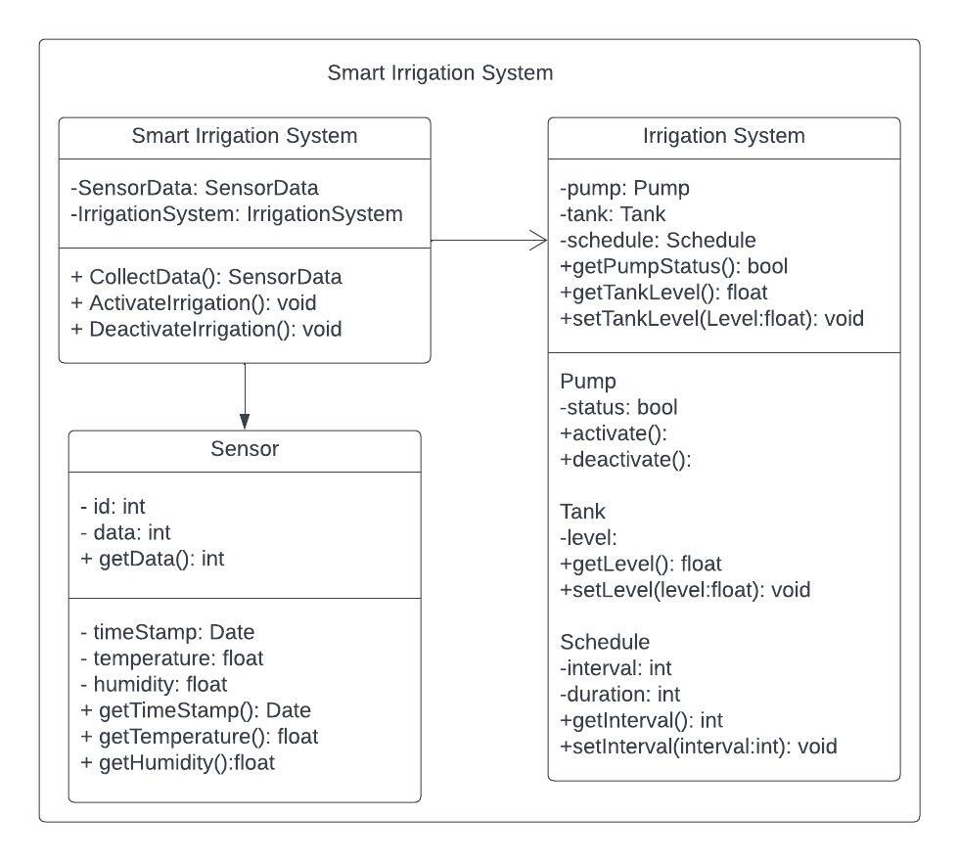

### Fig 1: class diagram

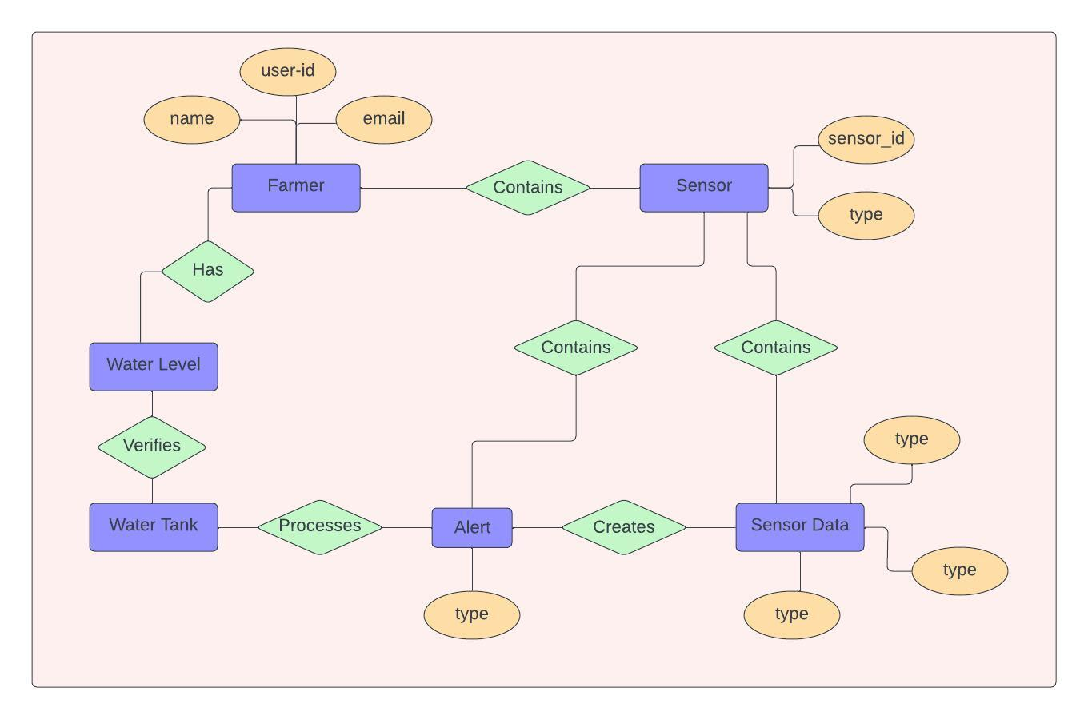

### Fig 2: Process Activity Diagram

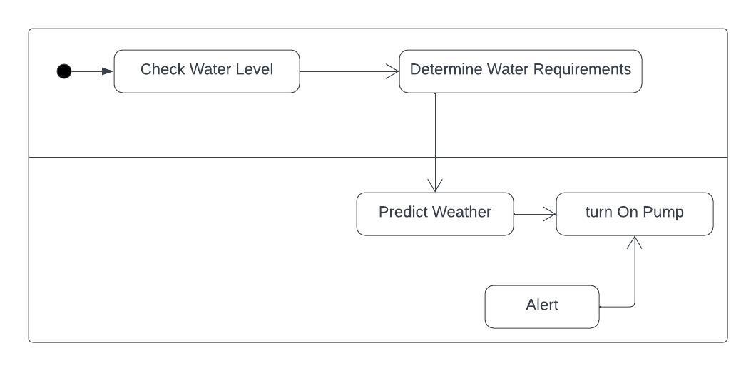

### Fig 3: System Activity Diagram

# SOCIAL IMPACT

The Smart Irrigation System delivers significant social impact by promoting water conservation, enhancing agricultural productivity, reducing costs for farmers, and empowering communities through accessibility minimizing health risks and providing educational opportunities for agricultural sector. Smart irrigation systems use advanced technologies such as soil moisture sensors, weather data and evapro–transpiration modelling to determine the exact watering needs of plants. This prevents over-watering and ensures plants get the right amount of water, leading to significant water savings for the society. Reduced exposure to harmful chemicals enhances the health and well-being of farmers and surrounding communities. So this smart irrigation system has significant impact for the society.

# DEVELOPMENT PLAN WITH PROJECT SCHEDULE

Jira

# MARKETING PLAN

In your document you should provide proper marketing plan that will make your idea popular among the community so that you can make business. Marketing plan should have short term, long term and continuous plan.

# COST AND PROFIT ANALYSIS

In your document you should provide proper cost analysis including development and marketing cost. Then you can show profit analysis. Based on your profit analysis investors will be agreed to invest on your idea.

# REFERENCES

1. "Smart Irrigation: A Review on the Use of Advanced Information and Communication Technologies for Improving Irrigation Management" by P. I. Blumetti, M. Campolo, A. Molinaro, and A. V. Vasilakos (2017).
2. <https://www.hydropoint.com/what-is-smart-irrigation/>
3. Priandana, K. and Wahyu, R.A.F., 2020, February. Development of automatic plant irrigation system using soil moisture sensors for precision agriculture of chili. In *2020 International Conference on Smart Technology and Applications (ICoSTA)* (pp. 1-4). IEEE.