Iteration 1: Communication interface between HW blocks

Objective
A dedicated communication interface between the different hardware networking blocks.

Requirements
- Transmission and reception independent from each other
- Data rate minimum 1Gbit/s for both sending and receiving
- Priority mechanism
  - Based on individual packets or based on identity of sender
  - Preemption of burst transmissions with lower priority?
- All blocks are able to send data to all other blocks
- Only unicast
- Data rate independent of the number of blocks

Quality Measures
- Data rate (5)
- Communication latency (2)
  - Due to busy receiver
- Chip area (3)
- Power consumption (2)
- Routing / configuration effort (1)
- Engineering effort (2)
- Scalability in all the above mentioned measures (5)

Design Antipodes
Global Bus:
- Data rate and latency scale very bad
- Chip area scales very well
- No engineering effort (use PLB)
Full Point to Point interconnection (P2P):
- Data rate and latency optimum
- Chip area scales very bad
Individual Dedicated Bus for all Receivers:
- Data rate near optimum
  - All blocks can receive with full rate
  - Do parasitic capacities and long signal lines influence performance?
- Latency near optimum
  - Bus arbiter response time
  - Wait for completion of ongoing transmission with lower priority
- Needs infrastructure for routing / configuration in all sending blocks
- Scalability of area comparable to P2P???
Network on Chip (NoC)
- Scalability of data rate comparable to P2P [Lee et al., 2007]
- Scalability of area better than P2P, better than dedicated Bus???
- Higher engineering effort than dedicated bus
- Distribution of routing / configuration information over routing protocol
- Latency probably worse then dedicated bus due to multiple hops

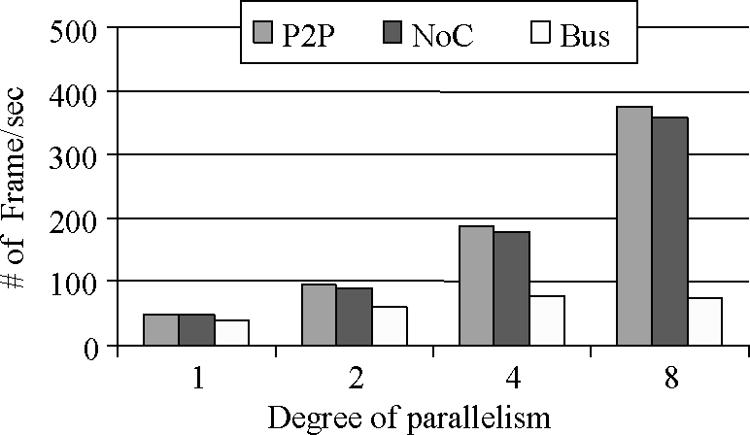
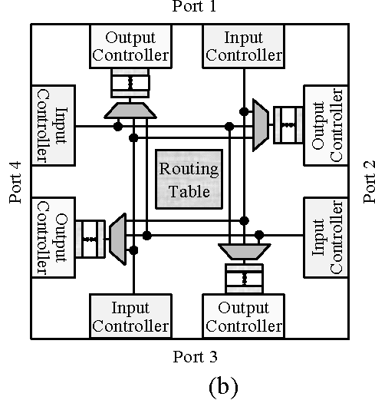
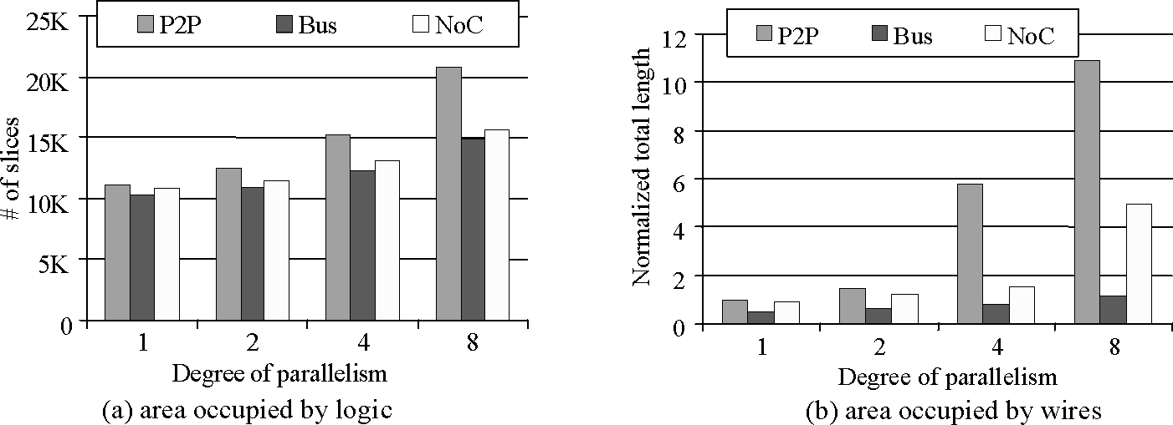
Pictures form [Lee et al., 2007]

