The text of Article 6 - 8 pp
UDC 004.ххх (choosing by youself)

STRUCTURAL AND PETROCHEMICAL INVESTIGATIONS ON OIL-RESERVOIR ROCKS WITHIN THE SALT SCALING ZONE OIL REGION

СТРУКТУРНО-ПЕТРОХИМИЧЕСКИЕ ИССЛЕДОВАНИЯ НЕФТЯНЫХ КОЛЛЕКТОРОВ В ЗОНЕ СОЛЕОТЛОЖЕНИЯ НЕФТЯНОГО РАЙОНА

A.М. Ivanov, K.S. Sydorow,
Ltd. “RN-Purneftegas”,
FSBEI НРЕ “Ufa state petroleum technological university”,
Ufa, Russian Federation
Иванов А.М., Сидоров К.С.,
ООО «РН-Пурнефтегаз»,
ФГБОУ ВПО «Уфимский государственный нефтяной технический университет» г. Уфа, Российская Федерация

e-mail: kafedraYGL@yandex.ru

Abstract. Basing on the field and petrochemical investigations of oil-reservoir rocks at the East Yangtin area of the Gubkinsky oil region we have clarified the effect of mineral components, their matrix and associated waters on the enrichment of the reservoir water system with salt-forming Ca and Fe ions. Reservoir rocks of the BC-10 and BC-11 horizons are briefly characterized, and the data on roentgen-structural analysis of matrices and reservoir sandstones are given.
(150-250 words)
Аннотация. На основе промысловых и петрохимических исследований нефтяных коллекторов Восточно-Янгтинской площади Губкинского нефтяного района АНАО установлено влияние минеральных компонентов, их цемента и попутно-добываемых вод на обогащение водной системы пластов солеобразующими ионами кальция и железа. Приведены краткие характеристики коллекторов.
(150-250 words)
Keywords: oil field, reservoir rocks, matrix, mineralogical composition, salt-forming ions, scaling inhibitors, bottom-hole pressure, water saturation, inorganic salts.
(5-7 words)
Ключевые слова: месторождение, породы-коллекторы, цемент, минералогический состав, солеобразующие ионы, ингибиторы солеотложения, забойное давление, обводненность, неорганические соли.
(5-7 words)

During his time (since 2007) in the workshop production of oil and gas and gas condensate of “RN – Purneftegas” on the south dome of the New Purpeisky field (now East Yangtinskoye), the author became convinced that one of the major problems encountered in the process manual injection system is deposited on the surface of the downhole equipment and pipelines of inorganic salts, mainly of calcium carbonate (CaCO 3) (Figure 1).

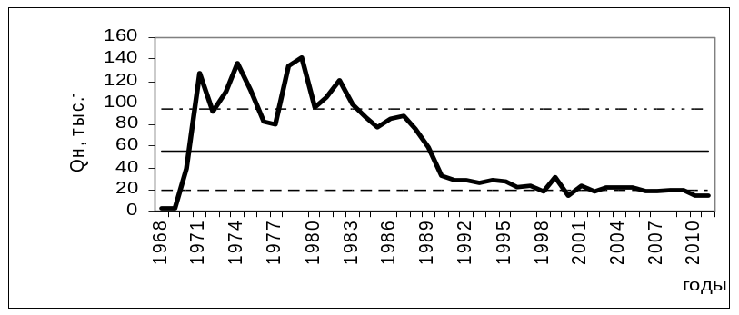
Figure 1. Map of annual oil production

Technical characteristics of the technical equipment of the stand are shown in Table 1.

Table 1. Specifications of measuring instruments of the laboratory bench
№№  nn | parameter name | device  Type | The limits of measurement  tions | Number of points of measurement of | absolute error
1. | The water temperature at the inlet and outlet tubes T1, °C | Digital Temperature Sensor | from 0  to 100 | 1 | ±0,5
2. | The air temperature at the inlet of the aerodynamic section t1, °C | Digital Temperature Sensor | from 0  to 100 | 1 | ±0,5
3. | The air temperature at the outlet of the wind section t2, °C | Digital Temperature Sensor | from 0  to 100 | 9 | ±0,5
Earlier research conducted in a number of oil companies – “Yuganskneftegaz”, “Surgutneftegas”, “Bashneft”, “Inkom-Oil” and others to identify the causes of repairs electric centrifugal pumps showed that, to prevent scaling on all technological system inhibitor should be served in the bottom of the perforated interval of production wells. Only in these circumstances is reached believed VV Shaidakov, AV Bukhartsev IS Garifullin et al, the greatest efficiency with the minimum dosage of the inhibitor. [2, P. 175-178]

Findings

The study of the inorganic salts of many wells in many shows their identity. Calcite crust (CaCO3) is usually represented by units of short-prismatic crystals of light gray color. On the inner side of the cover is often observed uneven coating of iron hydroxides mainly limonite (hydrogoethite) within which Fe2O3 (90%) and H2O (10%). This is - or colloform metakollomorfnye mass. They are formed by hydrolysis of salts arising from the oxidation and decomposition of iron-containing minerals ferrobakteriyami (Figure 1).

References (number of sources to 10)
ONE OR TWO LINKS TO ARTICLES FROM THE MAGAZINE "INFORMATION TECHNOLOGIES. PROBLEMS AND SOLUTIONS" ARE REQUIRED!
- Schlumberger, 1974. Log interpretation manual: Vol. II (Application), Schlumberger Limited, New York, pp 116.
- Abd El-Gawad, E.A., 2007. The use of well logs to determine the reservoir characteristics of Miocene rocks at the Bahar North East field, Gulf of Sues, Egypt. Journal of Petroleum Geology, 30(2). Р. 175–188.

At the end of the article, in the same file, you must insert a review of the article and an Expert Opinion in scanned form!

