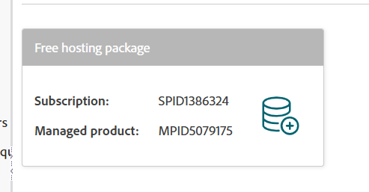
nekocoffee.mssql.somee.com
login name: thanhnho_SQLLogin_1
passw: gtrngqe9zg

