**#Q. What is the total amount each customer has paid for gold membership**

SELECT s.userid, SUM(p.price) AS total_amount

FROM sales s

JOIN product p

ON s.product_id=p.product_id

GROUP BY s.userid;

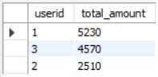

**#Q. what is the first product bought by each customer**

SELECT * FROM

(SELECT *, rank() OVER (partition by userid order by created_date) AS rnk

FROM sales) a

WHERE rnk=1;

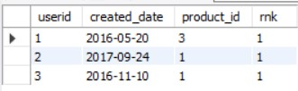

**# Q. how many times the most popular product was bought by each customers?**

SELECT userid, count(product_id) AS no_of_times

FROM sales

WHERE product_id=

(SELECT s.product_id

FROM sales s

JOIN product p

ON s.product_id=p.product_id

GROUP BY s.product_id

ORDER BY COUNT(s.product_id) desc

LIMIT 1)

group by userid

order by userid;

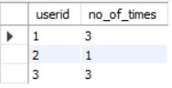

**# Q which items are users buying first after becoming gold member ?**

SELECT userid, created_date, product_id, rnk

FROM

(

SELECT a.userid, a.created_date , a.product_id , RANK() OVER (PARTITION BY a.userid order by a.created_date ) AS rnk

FROM sales a

JOIN goldusers_signup b

ON a.userid=b.userid

WHERE a.created_date>=b.gold_signup_date ) AS d

WHERE rnk=1;

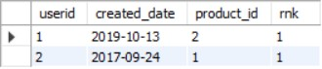

**#Q . Which item was purchases just before the customer became the member ?**

SELECT a.userid,a.created_date,a.product_id

FROM sales a

JOIN goldusers_signup b

ON a.userid=b.userid

WHERE a.created_date<=b.gold_signup_date

ORDER BY created_date DESC

LIMIT 1;



**# Q . What is the total order and amount spent for each member before they became a member ?**

SELECT a.userid,created_date,c.product_id,price,COUNT(c.product_id) AS total_order, SUM(price) AS total_price

FROM sales a

JOIN goldusers_signup b

ON a.userid=b.userid

JOIN product c

ON a.product_id=c.product_id

WHERE created_date<=gold_signup_date

GROUP BY userid;



**#Q . Rank all the transaction of customers**

SELECT c.* , rank() over (partition by total_price order by user ) AS rnk

FROM

(SELECT a.userid , SUM(price) AS total_price

FROM sales a

JOIN product b

ON a.product_id=b.product_id

GROUP BY userid) AS c;

SELECT *, rank() OVER ( partition by userid order by created_date) AS rnk

FROM sales;



**# Q . rank all the transactions of a gold member and for every non gold member mark it as N.A**.

SELECT c.* ,

CASE

WHEN gold_signup_date is null then 0 else rank() OVER (partition by userid ORDER BY created_date DESC)end AS rnk

FROM

(SELECT a.userid,a.created_date,a.product_id,b.gold_signup_date

FROM sales a

LEFT JOIN goldusers_signup b

ON a.userid=b.userid AND created_date>=gold_signup_date) AS c;

