1. **Server-side Program**

Buat database tempat dimana data akan kamu simpan. Misal seperti dibawah ini (nama DB : nodemcu_log, nama tabel: station1). Dalam percobaan ini, data yang akan disimpan adalah suhu dan kelembaban.

\**pembuatan data base juga dapat dilakukan melalui file yang ada di link Download*

CREATE DATABASE `nodemcu_log`;

CREATE TABLE `station1` (

`id` int(20) unsigned NOT NULL AUTO_INCREMENT,

`suhu` double NOT NULL,

`kelembaban` double NOT NULL,

`created_at` timestamp NOT NULL DEFAULT current_timestamp() ON UPDATE current_timestamp(),

PRIMARY KEY (`id`)

)

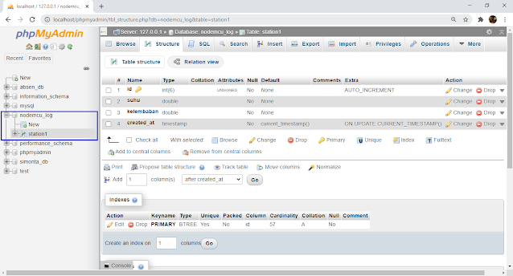

Selanjutnya membuat program PHP API. Untuk lokasi file yang akan dibuat dapat menyesuaikan dan bauat folder **arducoding_tutorial**di htdocs

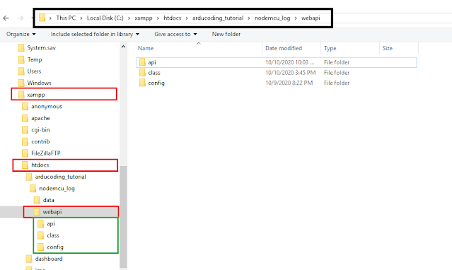

Dimulai dari file **database.php** simpan di directory C:\xampp\htdocs\**arducoding_tutorial**\**nodemcu_log**\**webapi**\**config**

<?php

**class** **Database** {

**private** $host = "localhost";

**private** $database_name = "nodemcu_log";

**private** $username = "root";

**private** $password = "";

**public** $conn;

**public** **function** **getConnection**(){

$this->conn = **null**;

**try**{

$this->conn = **new** PDO("mysql:host=" . $this->host . ";dbname=" . $this->database_name, $this->username, $this->password);

$this->conn->exec("set names utf8");

}**catch**(PDOException $exception){

**echo** "Database could not be connected: " . $exception->getMessage();

}

**return** $this->conn;

}

}

?>

Selanjutnya buat file **nodemcu_log.php**di directory

C:\xampp\htdocs\**arducoding_tutorial**\**nodemcu_log**\**webapi**\**class**

<?php

**class** **Nodemcu_log**{

// Connection

**private** $conn;

// Table

**private** $db_table = "station1";

// Columns

**public** $id;

**public** $suhu;

**public** $kelembaban;

**public** $created_at;

// Db connection

**public** **function** **__construct**($db){

$this->conn = $db;

}

// CREATE

**public** **function** **createLogData**(){

$sqlQuery = "INSERT INTO

". $this->db_table ."

SET

suhu = :suhu,

kelembaban = :kelembaban";

$stmt = $this->conn->prepare($sqlQuery);

// sanitize

$this->suhu=htmlspecialchars(strip_tags($this->suhu));

$this->kelembaban=htmlspecialchars(strip_tags($this->kelembaban));

// bind data

$stmt->bindParam(":suhu", $this->suhu);

$stmt->bindParam(":kelembaban", $this->kelembaban);

**if**($stmt->execute()){

**return** **true**;

}

**return** **false**;

}

}

?>

Terakhir buat file **create.php**di directory

C:\xampp\htdocs\**arducoding_tutorial**\**nodemcu_log**\**webapi**\**api**

<?php

header("Access-Control-Allow-Origin: *");

header("Content-Type: application/json; charset=UTF-8");

**include_once** '../config/database.php';

**include_once** '../class/nodemcu_log.php';

$database = **new** Database();

$db = $database->getConnection();

$item = **new** Nodemcu_log($db);

**if** ($_SERVER['REQUEST_METHOD'] === 'POST') {

// The request is using the POST method

$data = json_decode(file_get_contents("php://input"));

$item->suhu = $data->suhu;

$item->kelembaban = $data->kelembaban;

}

**elseif** ($_SERVER['REQUEST_METHOD'] === 'GET'){

// The request is using the GET method

$item->suhu = isset($_GET['suhu']) ? $_GET['suhu'] : **die**('wrong structure!');

$item->kelembaban = isset($_GET['kelembaban']) ? $_GET['kelembaban'] : **die**('wrong structure!');

}**else** {

**die**('wrong request method');

}

**if**($item->createLogData()){

**echo** 'Data created successfully.';

} **else**{

**echo** 'Data could not be created.';

}

?>

Ok, service rest API udah siap di gunakan. Untuk menyimpan data ke database mysql, kita dapat menggunakan metode POST atau GET, tinggal disesuaikan dengan kebutuhan. Untuk format requestnya sebagai berikut (pada program nodemcu ganti localhost dengan ip address pc kamu):

GET - http://localhost/arducoding_tutorial/nodemcu_log/webapi/api/create.php?suhu=20.82&kelembaban=88.99

POST - http://localhost/arducoding_tutorial/nodemcu_log/webapi/api/create.php

 Kita dapat melakukan test apakah API dapat berfungsi melalui aplikasi postman

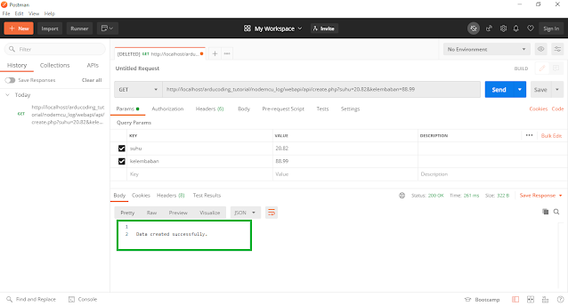

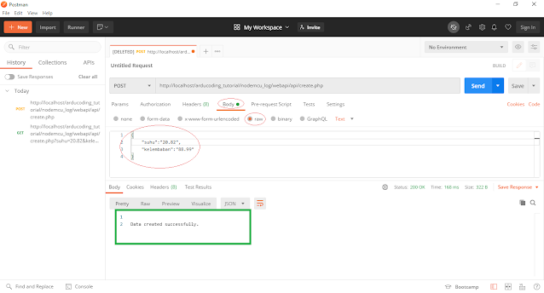

Program php rest API ini dapat dikembangkan lagi untuk fungsi-fungsinya. Misal untuk request data yang telah tersimpan di database, menghapus data, atau mengedit/update data yang biasa disingkat sebagai CRUD.

Sekarang mari lanjut untuk pengaturan hardwarenya (nodeMCU).

1. **Wiring Diagram**

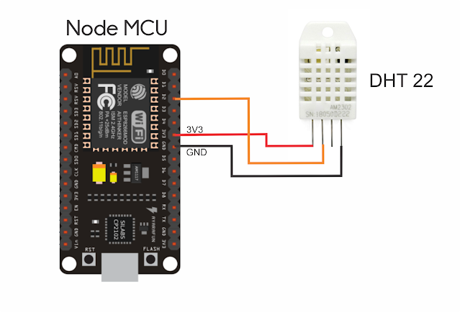

1. **NodeMCU Program**
2. **Library**

Sebelum melakukan pemrograman, pastikan beberapa library berikut sudah terinstall yaitu: Adafruit Unified Sensor, DHT sensor Library, dan ArduinoJSON. Sesuaikan versinya seperti yang ada di gambar.

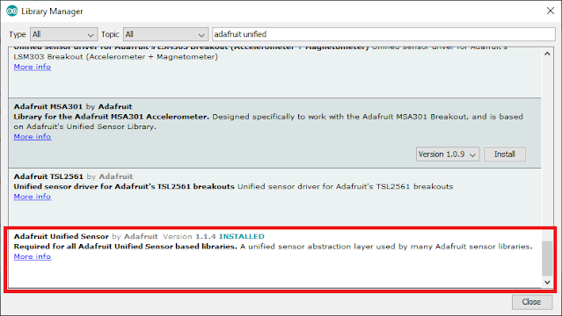

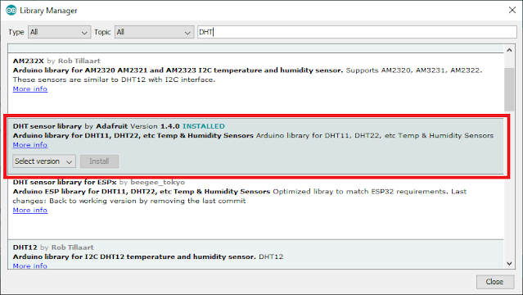

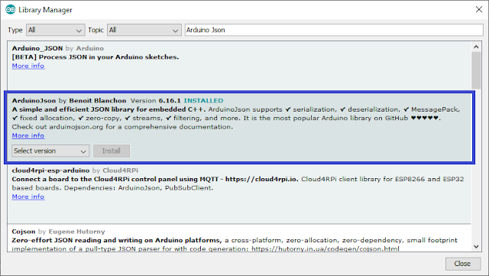

Selanjutnya untuk menyimpan data ke database, program nodeMCU disesuaikan dengan metode yang akan digunakan.

1. **Menyimpan data nodeMCU ke database MySQL dengan metode GET**

Metode GET sangat umum digunakan untuk request data tapi juga dapat digunakan untuk proses menyimpan data. Seluruh data ditampung di URL yang selanjutnya diparsing untuk proses di server.

// NodeMCU esp8266 save data to mysql database with GET methode

// www.arducoding.com

#include <ESP8266WiFi.h>

#include <ESP8266HTTPClient.h>

#include "DHT.h"

#define DHTPIN 4

//#define DHTTYPE DHT11 // DHT 11

#define DHTTYPE DHT22 // DHT 22 (AM2302), AM2321

//#define DHTTYPE DHT21 // DHT 21 (AM2301)

**const** **char**\* ssid = "Your Wifi SSID";

**const** **char**\* password = "Your Wifi Password";

DHT **dht**(DHTPIN, DHTTYPE);

**void** **setup**() {

Serial.begin(**9600**);

//Serial.println(F("DHTxx test!"));

dht.begin();

WiFi.mode(WIFI_STA);

WiFi.begin(ssid, password);

**int** i=**0**;

**while**(WiFi.status() != WL_CONNECTED){

Serial.print(".");

delay(**1000**);

}

Serial.println("");

Serial.println("WiFi connected");

Serial.println("IP address: ");

Serial.println(WiFi.localIP());

Serial.println();

delay(**2000**);

}

**void** **loop**() {

**double** kelembaban = dht.readHumidity();

// Read temperature as Celsius (the default)

**double** suhu = dht.readTemperature();

// Check if any reads failed and exit early (to try again).

**if** (isnan(kelembaban) || isnan(suhu)) {

Serial.println(F("Failed to read from DHT sensor!"));

**return**;

}

Serial.print(F("Temperature:"));

Serial.print(suhu);

Serial.print(F("°C Humidity:"));

Serial.print(kelembaban);

Serial.println(F("%"));

**if** ((WiFi.status() == WL_CONNECTED)) {

WiFiClient client;

HTTPClient http;

String address;

//equate with your computer's IP address and your directory application

// C:\xampp\htdocs\arducoding_tutorial\nodemcu_log\webapi\api\create.php

address ="http://192.168.0.8/arducoding_tutorial/nodemcu_log/webapi/api/create.php?suhu=";

address += String(suhu);

address += "&kelembaban=";

address += String(kelembaban) ;

http.begin(client,address); //Specify request destination

**int** httpCode = http.GET();//Send the request

String payload;

**if** (httpCode > **0**) { //Check the returning code

payload = http.getString(); //Get the request response payload

payload.trim();

**if**( payload.length() > **0** ){

Serial.println(payload + "**\n**");

}

}

http.end(); //Close connection

}**else**{

Serial.print("Not connected to wifi ");Serial.println(ssid);

}

delay(**60000**); //interval 60s

}

hasil dari program diatas kurang lebih sebagai berikut:

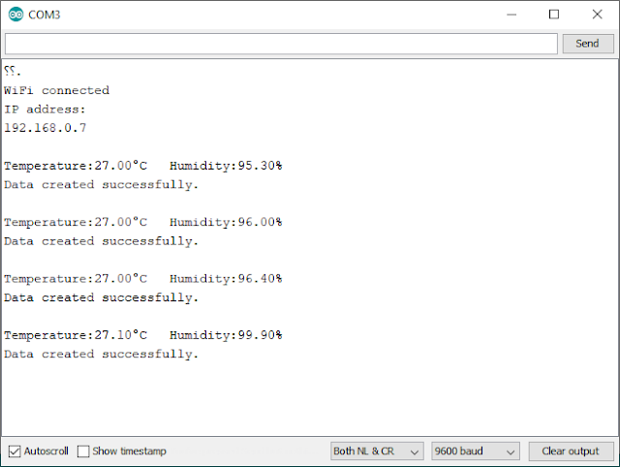

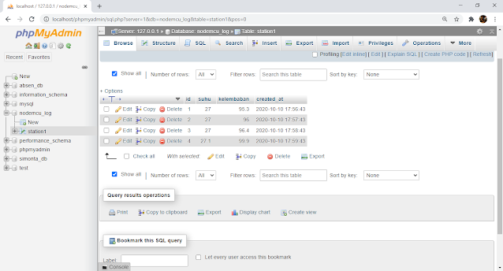

**Menyimpan data nodeMCU ke database MySQL dengan metode POST**

Untuk metode POST, data yang akan disimpan di database dikirim dalam format JSON. nah untuk mempermudah pembuatan data berformat JSON, maka digunakan library Arduino JSON

// NodeMCU esp8266 save data to mysql database with POST methode

// www.arducoding.com

#include <ESP8266WiFi.h>

#include <ESP8266HTTPClient.h>

#include <ArduinoJson.h>

#include "DHT.h"

#define DHTPIN 4

//#define DHTTYPE DHT11 // DHT 11

#define DHTTYPE DHT22 // DHT 22 (AM2302), AM2321

//#define DHTTYPE DHT21 // DHT 21 (AM2301)

**const** **char**\* ssid = "Your Wifi SSID";

**const** **char**\* password = "Your Wifi Password";

DHT **dht**(DHTPIN, DHTTYPE);

**void** **setup**() {

Serial.begin(**9600**);

//Serial.println(F("DHTxx test!"));

dht.begin();

WiFi.mode(WIFI_STA);

WiFi.begin(ssid, password);

**int** i=**0**;

**while**(WiFi.status() != WL_CONNECTED){

Serial.print(".");

delay(**1000**);

}

Serial.println("");

Serial.println("WiFi connected");

Serial.println("IP address: ");

Serial.println(WiFi.localIP());

Serial.println();

delay(**2000**);

}

**void** **loop**() {

**double** kelembaban = dht.readHumidity();

// Read temperature as Celsius (the default)

**double** suhu = dht.readTemperature();

// Check if any reads failed and exit early (to try again).

**if** (isnan(kelembaban) || isnan(suhu)) {

Serial.println(F("Failed to read from DHT sensor!"));

**return**;

}

Serial.print(F("Temperature:"));

Serial.print(suhu);

Serial.print(F("°C Humidity:"));

Serial.print(kelembaban);

Serial.println(F("%"));

**if** ((WiFi.status() == WL_CONNECTED)) {

WiFiClient client;

HTTPClient http;

StaticJsonDocument<**200**> doc;

String url, nodemcuData;

//equate with your computer's IP address and your directory application

// C:\xampp\htdocs\arducoding_tutorial\nodemcu_log\webapi\api\create.php

url ="http://192.168.0.8/arducoding_tutorial/nodemcu_log/webapi/api/create.php";

doc["suhu"] = String(suhu);

doc["kelembaban"] = String(kelembaban);

http.begin(client,url);

http.addHeader("Content-Type", "application/json");

serializeJson(doc, nodemcuData);

Serial.print("POST data >> ");

Serial.println(nodemcuData);

**int** httpCode = http.POST(nodemcuData);//Send the request

String payload;

**if** (httpCode > **0**) { //Check the returning code

payload = http.getString(); //Get the request response payload

payload.trim();

**if**( payload.length() > **0** ){

Serial.println(payload + "**\n**");

}

}

http.end(); //Close connection

}**else**{

Serial.print("Not connected to wifi ");Serial.println(ssid);

}

delay(**60000**); //interval 60s

}

Hasil dari program diatas kurang lebih akan sama dengan yang metode GET sebagaimana ditunjukkan gambar berikut

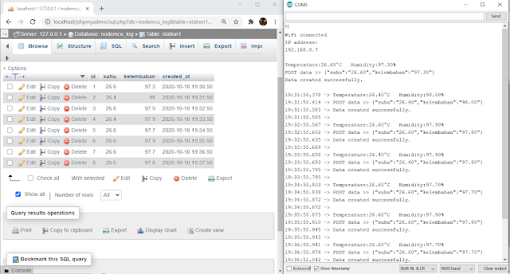

<https://www.mediafire.com/file/pvgc2ncmt0gn2tt/arducoding_tutorial_php_rest_api.rar/file>