Config Ref: SE_16_DS_02

Date: 26/11/2015

Version: 1.5

Status: Released

Department of Computer Science Aberystwyth University Aberystwyth Ceredigion SY23 3DB Copyright © Aberystwyth 2015

|  |
| --- |
| Group 16 |
| Design Specification for the Final System |
| Author: Richard Price-Jones, Archie Strange, Greg Sharpe, Rhodri Pearce, Emil Ramsdal, Robert Mouncer |

|  |
| --- |
|  |

Contents

1.0 Introduction 3

1.1 Purpose of this document 3

1.2 Scope 3

1.3 Objectives 3

2.0 Deployment Description 3

2.1 Applications in the system 3

2.2 Applications Interactions 4

3.0 Interaction Design 5

3.1 Use Case Diagrams 5

3.2 User Interface Design 7

3.2.1 Template 9

3.2.2 Home Page 9

3.2.3 Members Page 10

3.2.4 Members Information Page 11

3.2.5 Edit Members Information Page 12

3.2.6 Create Task Page 13

3.2.7 View Tasks Page 14

3.2.8 View Task Page 15

3.2.9 Edit Task Page 16

3.2.10 Login page 18

3.2.11 User Application 19

3.2.12 Editor 20

4.0 Significant Classes and Component Description 21

4.1 MainFrame.java 21

4.2 Load.java 21

4.3 Task.java 21

4.4 DatabaseConnect.java 21

4.5 TaskerLogin.java 22

4.6 TaskerPage.java 22

4.7 TaskerEditor.java 22

5.0 Detailed Design 24

5.1 Schema Design 24

5.2 Format of Data Transmitted 24

References 25

Change History 25

# Introduction

## 1.1 Purpose of this document

The purpose of this document is to describe and illustrate the specification for the design of our system. It contains all the descriptions that will be necessary for the implementation phase of the project.

## 1.2 Scope

This document specifies the high level for our system. It includes designs for interfaces, software structure, components and data. It describes how our applications will look for the user and how they will interact with the each other.

## 1.3 Objectives

The objective of this document is to provide a framework design that will be used throughout the entire project. It will ensure that the applications have the all the functionality requirements set out by the client. It will also be crucial during the implementation phase as it shows how everything should work and it will be used as a plan.

# 2.0 Deployment Description

## 2.1 Applications in the system

The deployment of this software requires the user’s computer system to have a modern web browser and the installation of the Java virtual machine. A Web server is required to support PHP which is used to communicate with the database. The database server is required to be running MySQL, the database is also required to allow remote login.

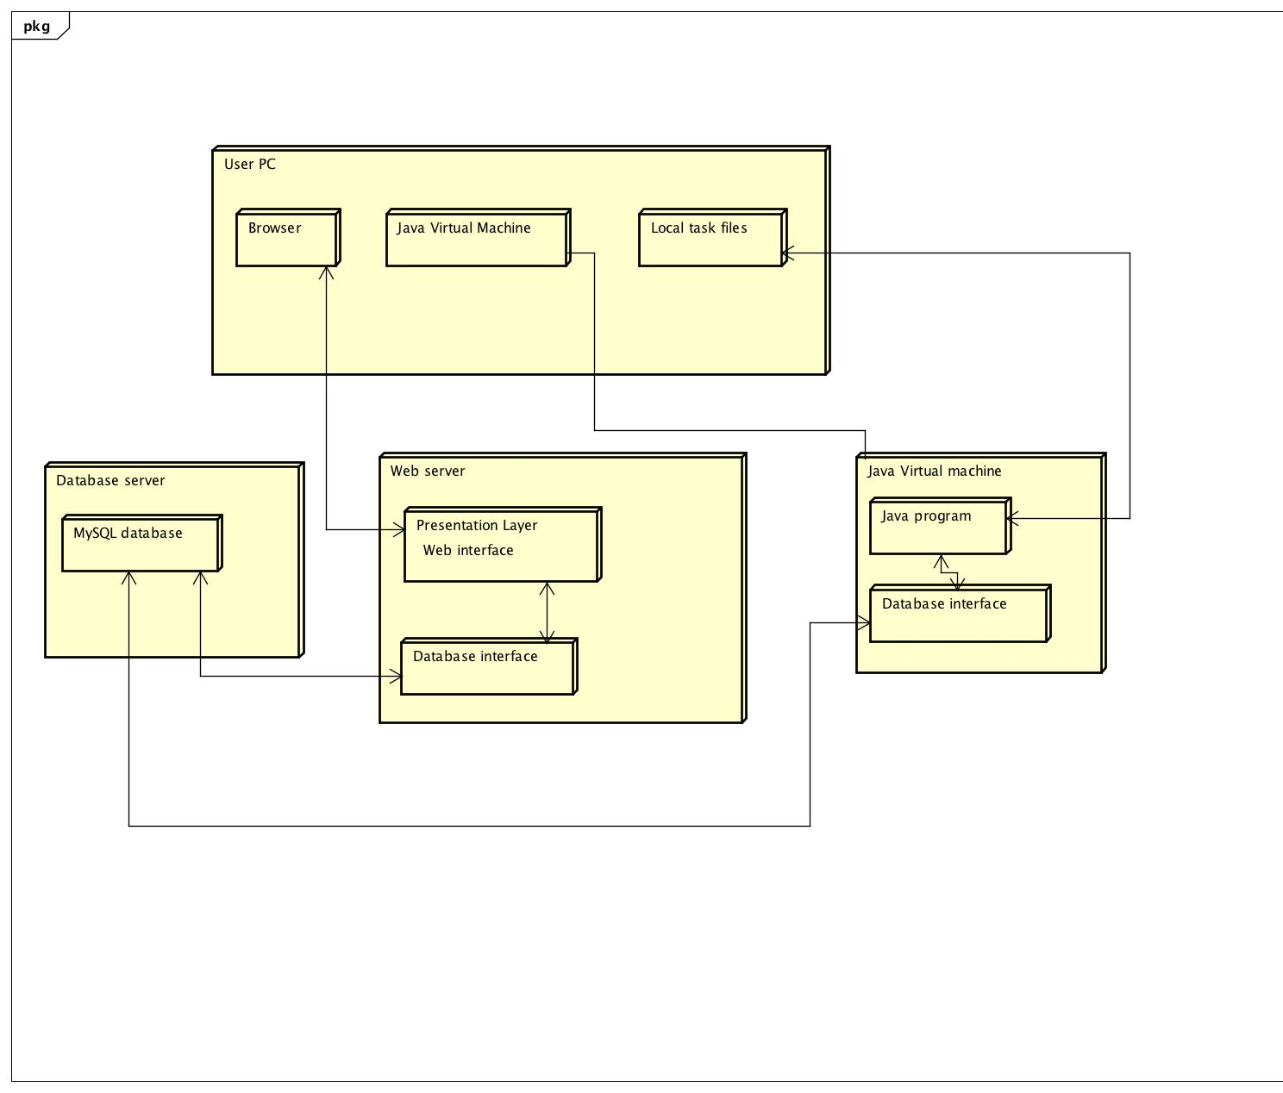

## 2.2 Applications Interactions

The Web service will use PHP on the server to connect to the database, firstly we must establish a connection within the PHP script. To connect to the database using MySQL we must first use the function mysql_connect, along with the username, password and hostname of the database. Then once connected we may begin to run queries, the function used to perform these queries is named mysql_query(). Lastly, we will need to close the connection, although this isn’t necessary as PHP automatically closes the connection when the script ends. By using the mysql_close() function we will close the connection.

JDBC is a driver which allows the Java Application connect to a data source, in our case it’s a MySQL database. It will allow the Java Application to send and update query statements and process the results. JDBC will access our remote server using the Internet’s file addressing scheme and a file name our on server, which in our case will be our database name.

The communication protocol we will be using within both JDBC and PHP is HTTP. HTTP meaning Hyper Text Transfer Protocol will enable the PHP script and the JDBC to communicate with the database by firstly declaring a port on which our database will be accessible. In this project will we have a connecting PHP page which will include the database address, username and password. This PHP page will be called many times.

Below is a component diagram illustrating everything that is mentioned above.

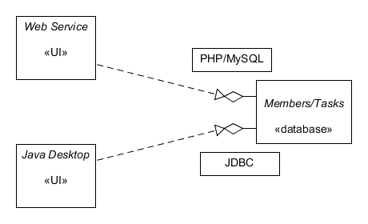

# 

## 

# 3.0 Interaction Design

## 3.1 Use Case Diagrams

Below is the Use Case Diagram for the Web Application Tasker Man.

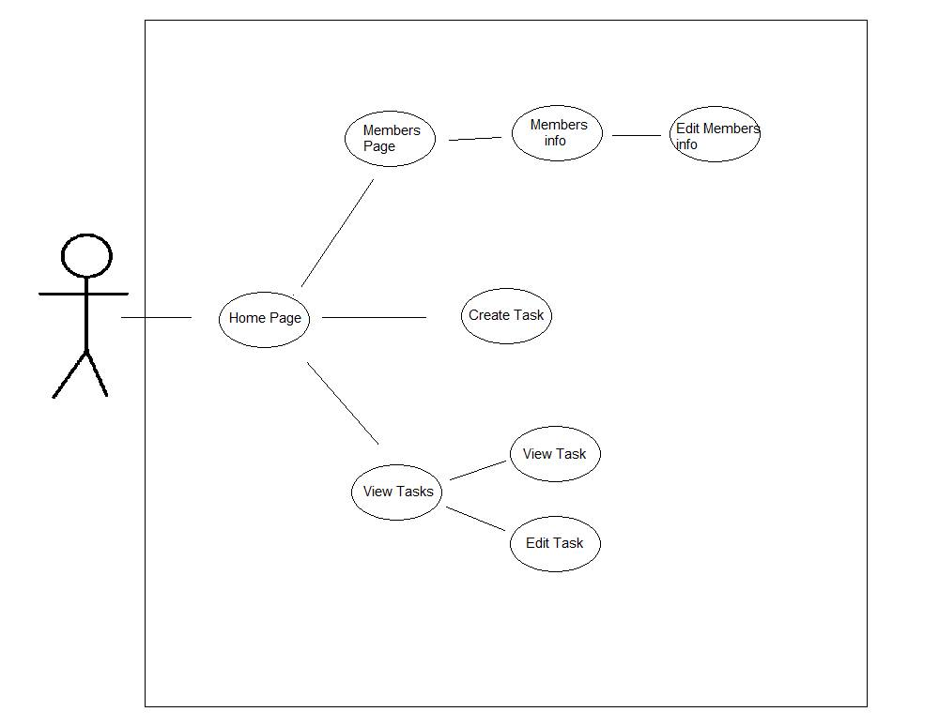

The name of the system (TaskerMAN), is displayed on the top left within the System boundary.The Actor in this case is the Manager of the project, which can be seen to the left of the use case, just outside the system boundary.

The system boundary contains all of the functionality or services provided by the system.

Associations within the use case diagram are used to display the connections between the pages of the website. From this we can see that the user starts at the home page, from there can visit any one of three separate pages (Members, Create task and View Task). From these sections, the user can travel further into the website.

* Through Members, the user can reach ‘Members Info’, and from there, ‘Edit Members Info’.
* From the View Tasks page, the user can then visit one of two options. ‘View Task’ and ‘Edit Task’.

Below is the use case diagram for the user application Tasker CLI.

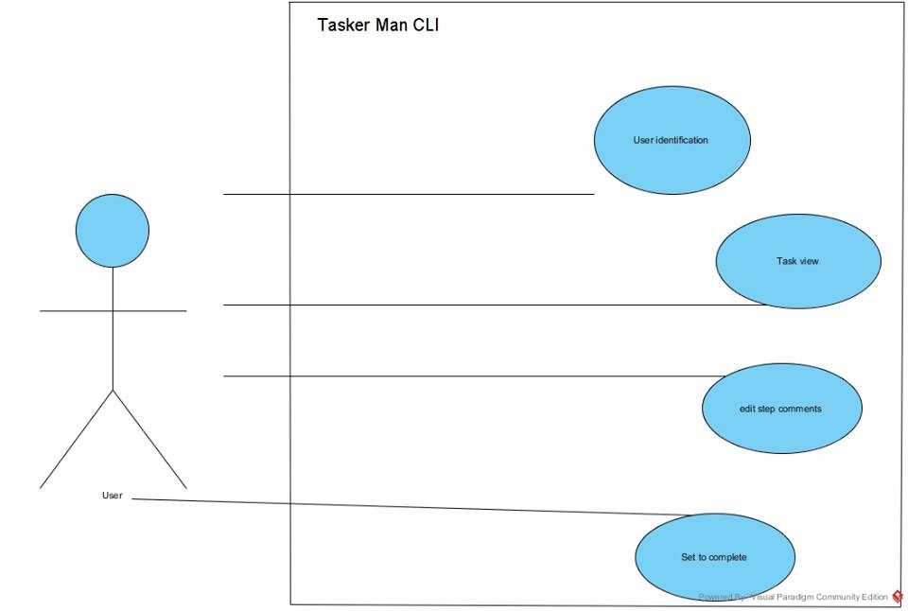

The associations are used in the use case diagram are used to display how the use interacts with the application. You can view all the functionality of the program. So we can see that the application will provides: user identification, the ability to view tasks, to edit the comment about the tasks and finally to able to set the user’s assigned task to completed.

## 

## 3.2 User Interface Design

Below are the rough designs drawn up before the final design for the web application Tasker Man.

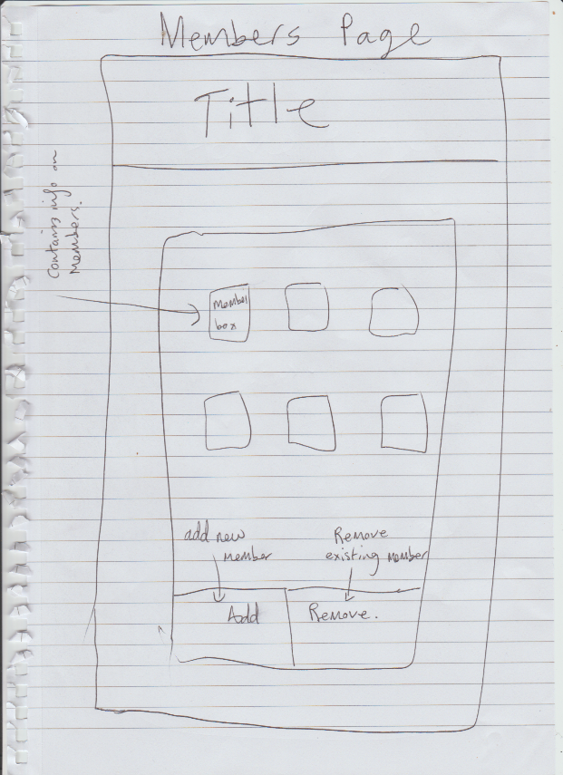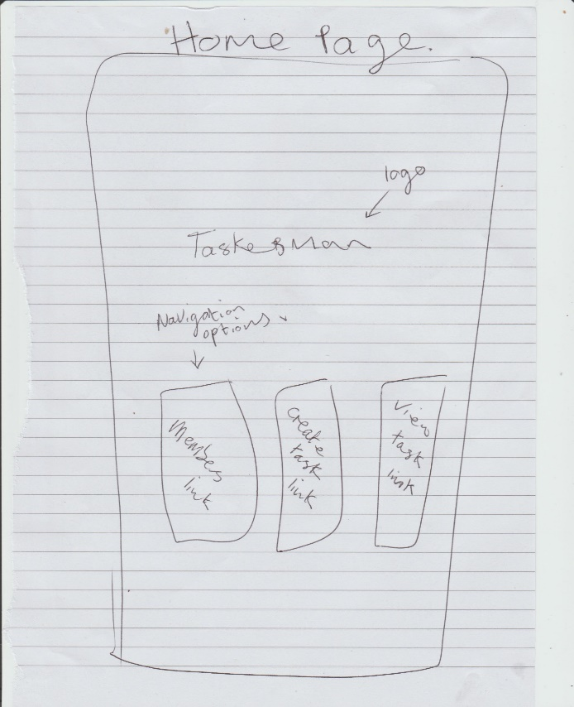

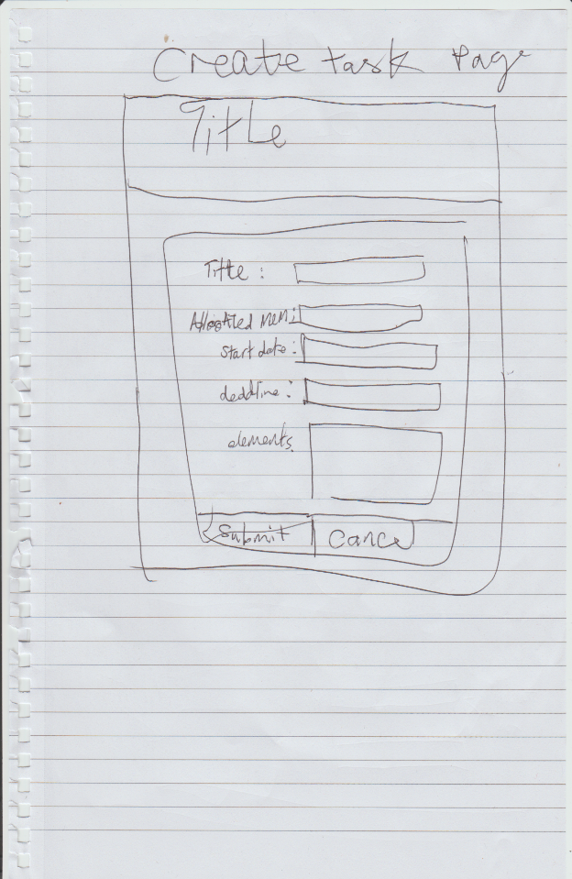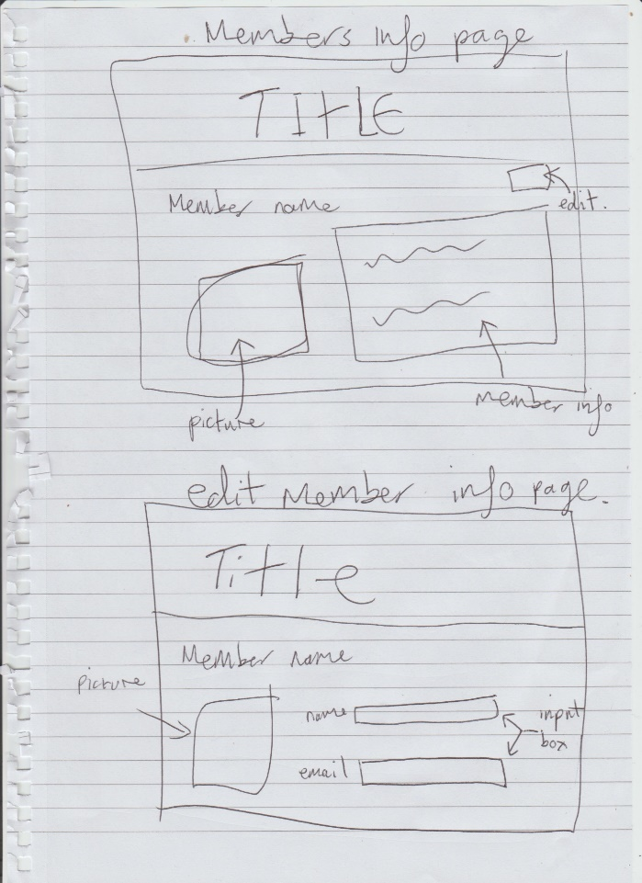

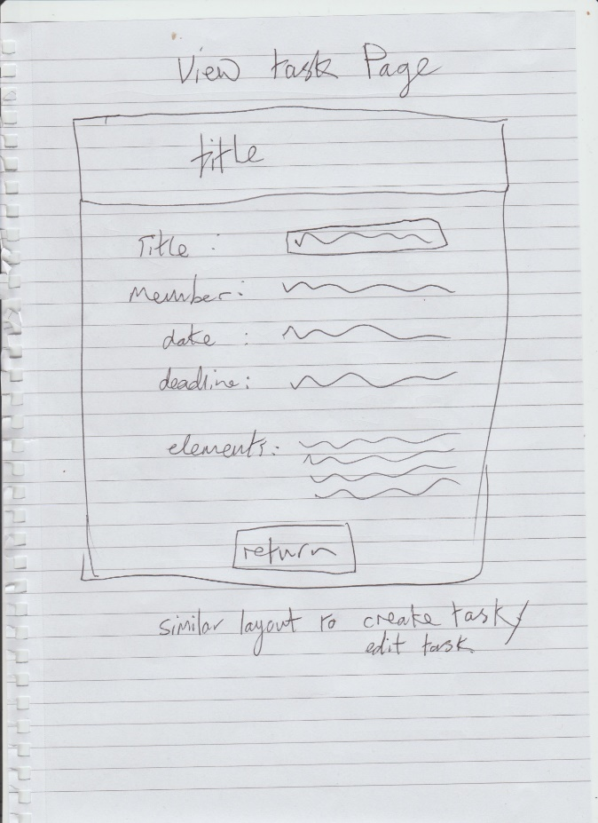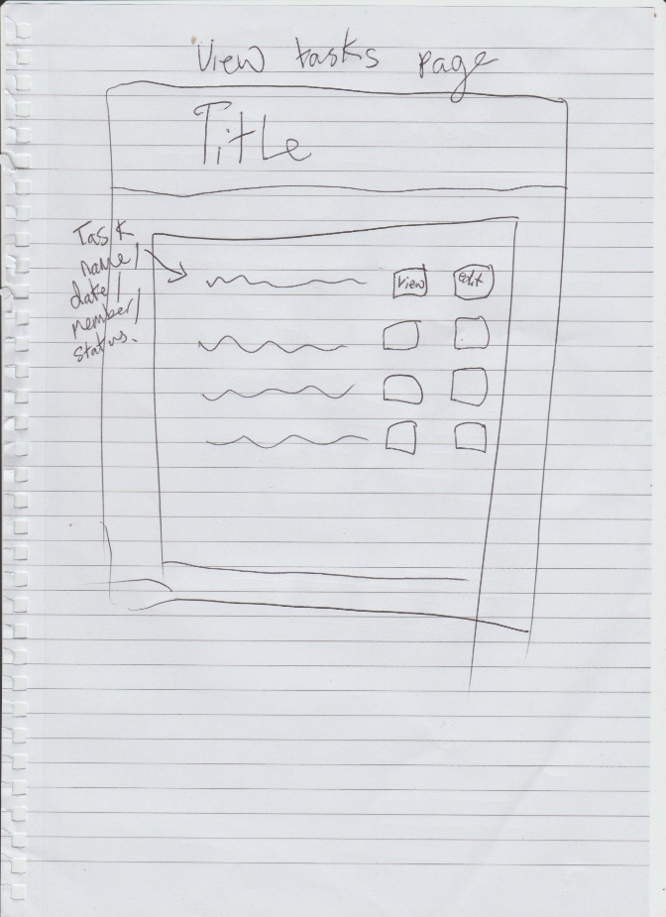

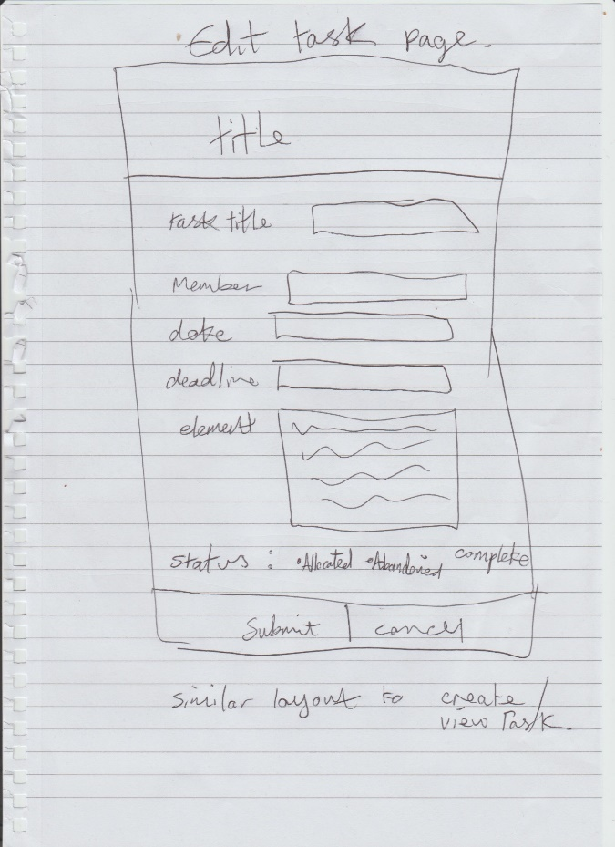

Below are the final designs for the user interface with descriptions.

### 3.2.1 Template

The header of the website will not change throughout the site, and can be found on every page, with the exception of the home page where is does not exist. This header will give easy access to all of the main sub sections of the site, and also the home page. The navigation is clearly defined, while clicking on the website logo will redirect the user back to the home page.

### 3.2.2 Home Page

For the home page I've designed a simple page that gives the user the choice to navigate to any of the three main sub sections of the website. Clicking on any of the three boxes will redirect the user to the selected page.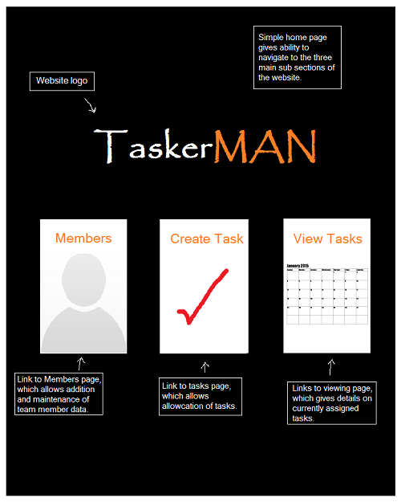

### 3.2.3 Members Page

The member’s page contains all of the existing members. By clicking on any of the members portraits, the user will be redirected to the member’s information page, which holds information on the selected user.

On this page there is the option to add of remove members. Clicking the ‘Add’ button will redirect to the ‘Add Members Page’, which gives the user the ability to create a new user with personalised information, while clicking on the ‘Remove’ button will give the user the ability to then click on the desired profile for deletion, without the hassle of moving to another page.

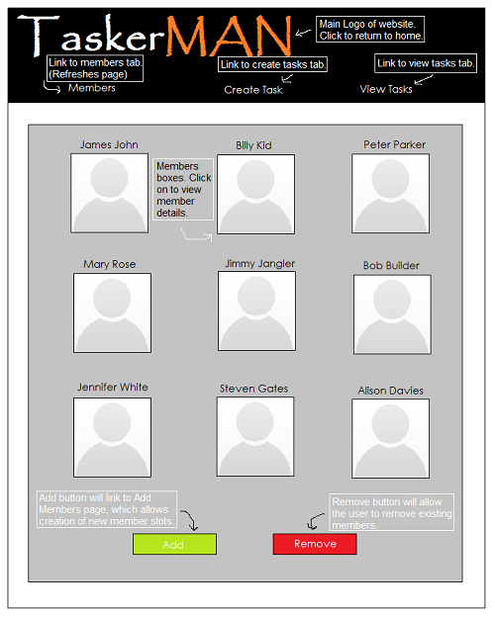

### 3.2.4 Members Information Page

The information page contains the required details of the member. The edit button on the top right of the users information is a link to the ‘Edit Members Information Page’, which gives the user the ability to the existing information on the member.

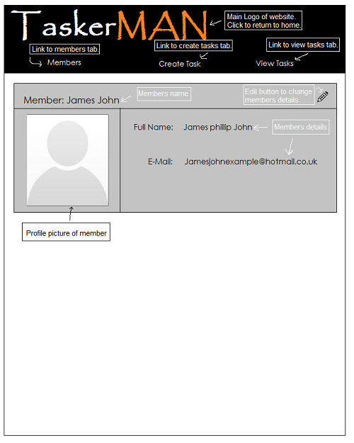

### 3.2.5 Edit Members Information Page

The edit information page is used to change the member’s current details, which can be saved by submitting, or restored to its original state prior to editing by pressing the Cancel button.

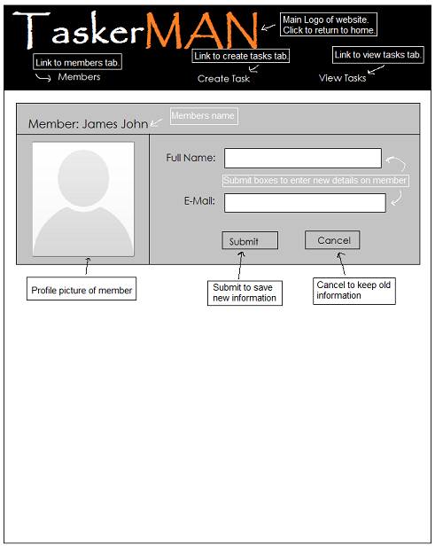

### 3.2.6 Create Task Page

The create task page allows the user to create tasks.

To create a task the site requires information to be submitted by the user: The member to which it is being assigned and various task details (Title of the task, Starting date, Deadline, Task elements). On clicking the drop down list, all available members will be displayed ready for the user to choose the desired member. On submission the task will automatically be set as "Active". Any mistakes made whilst creating the task can be altered through the ‘Edit Task Page’.

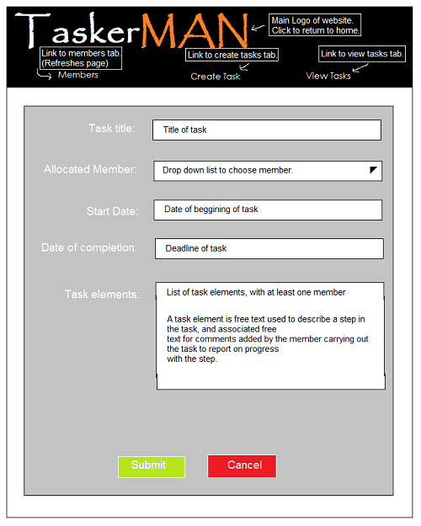

### 3.2.7 View Tasks Page

The view tasks page displays all the tasks that have been assigned, whether they be active, abandoned or complete. To view these tasks in greater detail simply click the view button adjacent to the description. The Edit button will redirect the user to the Edit Task page.

This list should be sorted by expected completion date. It should be possible to filter this list by task status and/or allocated team member.

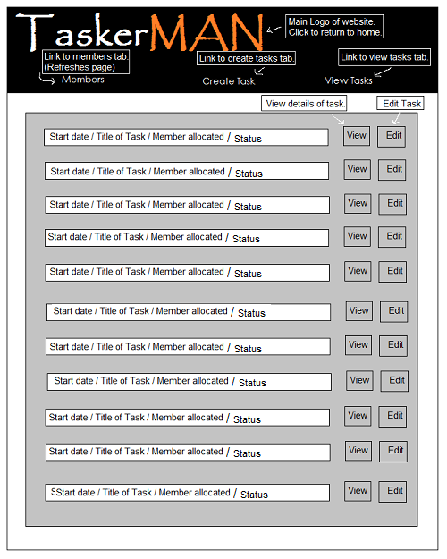

### 3.2.8 View Task Page

The view task page simply allows the user to view a task in greater detail. Once the user is ready to leave the page, click the "Return to Tasks" button to return to the ‘View Tasks’ page.

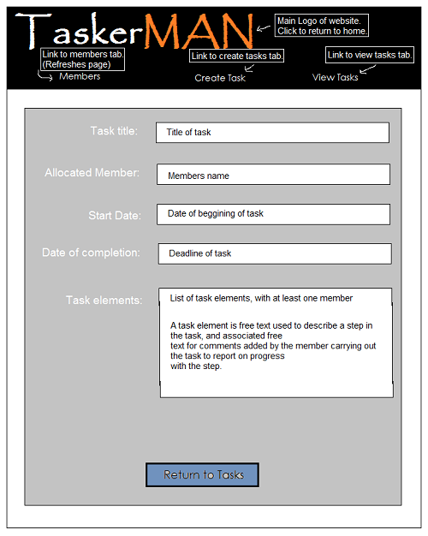

### 3.2.9 Edit Task Page

The edit task page will give all the same options as was had when creating the task originally, with the addition allowing the user to edit the tasks current status. From here the user will also be able to change the member to whom the task is allocated. The ‘Submit’ button will save any changes made to the task, while the ‘Cancel’ button will restore the original information prior to editing.

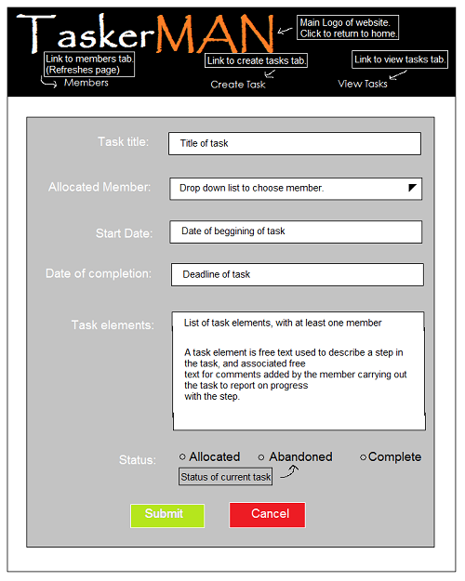

Below are the rough designs for the user application Tasker CLI.

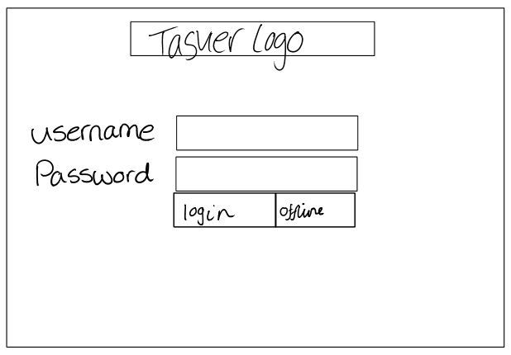

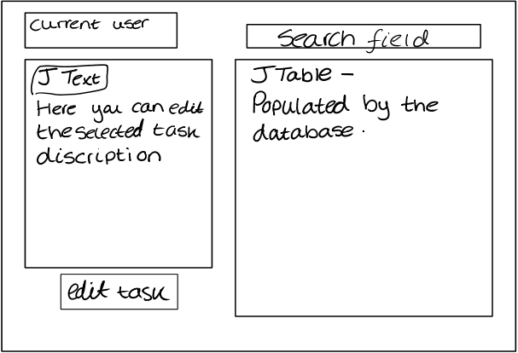

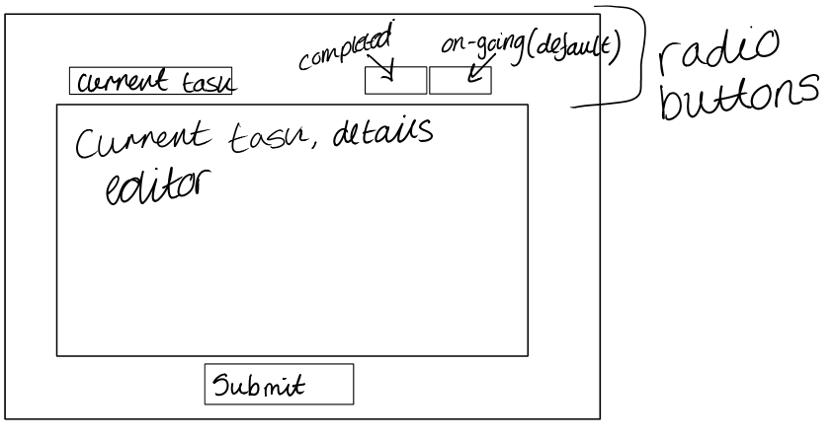

Below are the final designs for the user interface on the user application Tasker CLI

### 3.2.10 Login page

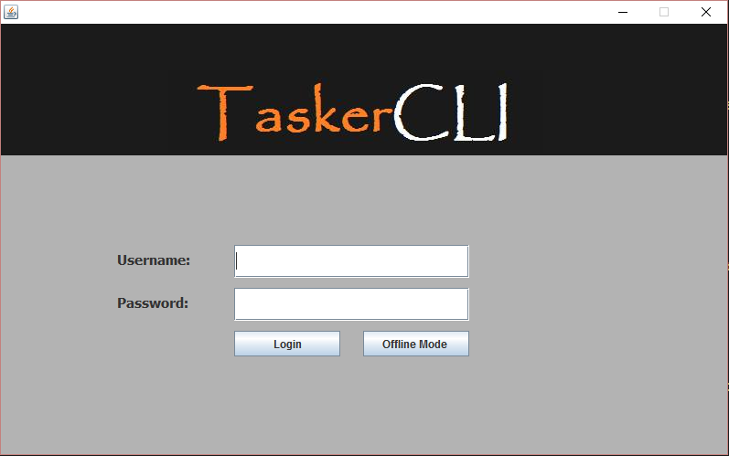When the desktop application is first executed, this login windows appears requiring a username and password, which are stored in the database. Alternatively you can login using the offline mode, which uses the files stored on the local machine. Both buttons will redirect you to the user application.

### 3.2.11 User Application

The user application, is where the main program runs. In this window the current user tasks are displayed, in the JList below, the user can then select their task, which then populates the right hand fields with the selected tasks details. The user can then edit the comment of the tasks or set the task to complete.

JList which holds all current tasks for the current user.

Displays information, when a task is selected

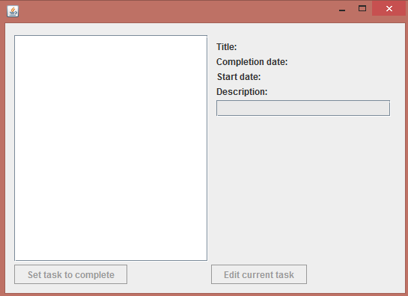

Edit the current task, if none is selected then, button become unusable.

Set a task to complete, and then calls the sync method.

### 3.2.12 Editor

The editor window allows users to edit task details which are populated with data from that ArrayList which stores all information about the tasks within the Java application. If the Java application is in offline mode then the information is saved to local storage via text file.

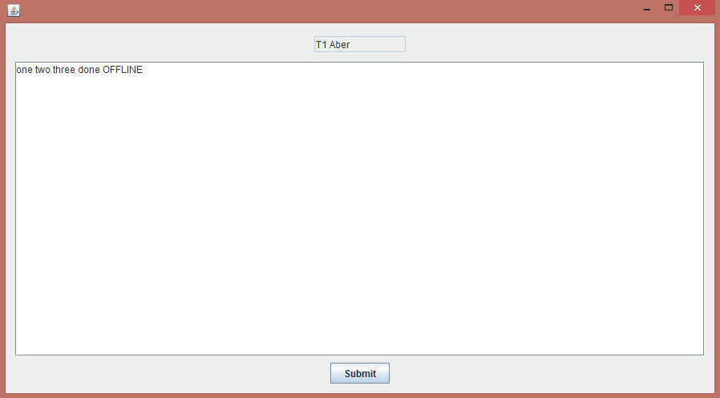

# 4.0 Significant Classes and Component Description

## 4.1 MainFrame.java

**File Name**: MainFrame.java

This class is the main controller of the program, it starts and initialises the program by calling **TaskerLogin.java.**

## 4.2 Load.java

**File Name**: Load.java

When the **TaskerLogin.java** starts, it loads all the tasks currently stored in local storage into the java application and are stored as Task Objects in an ArrayList. This is used to save the tasks from the database into local storage, on the user's computer. Tasks are saved before editing, after the task has been edited and every five minutes, to ensure that the tasker system is always updated.

**Functional requirements ref: FR8a FR9**

**Dependency: DatabaseConnect**

## 4.3 Task.java

**File Name:** Task.java

Creates an object that is defined by the task properties.

## 4.4 DatabaseConnect.java

**File Name:** DatabaseConnect.java

This class is used to connect to our database. The Java application synchronises with the database every five minutes, or if changes have been made to a task. If there is a connection established, it will check if any new tasks have been added or deleted on the server, then update local storage accordly. It will then upload any changes that are done locally, and then update the matching tasks on the server with that information.

**Functional requirements ref: FR9, FR11**

**Functional requirements ref: Task.java**

## 4.5 TaskerLogin.java

**File Name:** TaskerLogin.java

This class creates the graphical user interface for the login part of the application. It requires a username and password, which is compared with values in the database. If authentication is successful the user is directed to **TaskerPage.java.** However if the user is unsuccessful then they will given the option to use offline mode which uses the local storage while checking for database connection.

**Functional requirements ref: FR8**

**Dependency: MainFrame.java**

## 4.6 TaskerPage.java

**File Name:** TaskerPage.java

This class displays all the information of all tasks. The information is displayed in a table and when a task is selected its full description will be displayed next to it in a panel. The user also has the ability to search the table, to help find a specific task. Once a task has been selected the user can press a button below the full task description to edit the task.

**Dependency: TaskerLogin.java**

## 4.7 TaskerEditor.java

**File Name:** TaskerEditor.java

Creates the editor window for tasks. It creates a large edit panel, which is populated with the full task description and comments and allows the user to edit whatever is in there. Once finished the user must then press the submit button, which saves it to local storage.

**Functional requirements ref: FR10**

**Dependency: TaskerPage.java**

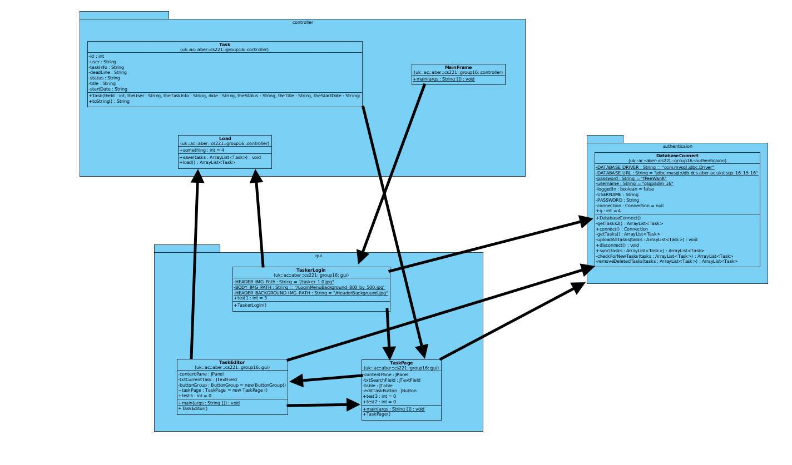

# 5.0 Detailed Design

## 5.1 Schema Design

tasks { TaskID, StartDate, DateOfCompletion, TitleOfTask, MemberAllocated, Status, Comments }

members { id, name, email, password }

Within our Group Project we decided we needed to have two database tables, one for the members and one for the tasks. We chose to have two, one for the login which will be our members table, we will use the email address field as the username and the password field as the password to login. The other fields will be used to hold basic information and the Primary Key for a unique identifier. We decided to have all of the data types set to text apart from the ‘id’ which is set to int(11) for simplicity.

Our second and final database table is Tasks, this table will be used to store data about the set tasks which will be allocated to members from the members table. Again, all data types are set to varchar with various sizes for simplicity apart from the Task ID which is used to uniquely identify the Task given. We were going to have some data types set to Date, but decided not to and are going to use JavaScript and various methods within java to validate the input so there is no room for error.

## 5.2 Format of Data Transmitted

An SQL server set up on “db.dcs” receives and sends data to and from the applications. Data is being passed from one system/application, this includes data being sent from the website through PHP and the java application. Both of these are passing information to and from the SQL server. The website and Java application are sending SQL queries to the server, this is how the system requests or adds new data to and from the server an example of this is seen below:

SELECT   
 *   
FROM   
 members   
WHERE   
 id='5'

Data is also being sent back from the SQL server to the applications of the system. This is being sent as a string and the system interprets this.

# References

# Change History

|  |  |  |  |  |
| --- | --- | --- | --- | --- |
| Version | CCF  No. | Date | Changes Made To Document | Changed By |
| 1.1 | N/A | 2015-10-29 | Format changed to suit design specification. Changed release version. | Robert Mouncer – rdm10 |
| 1.2 | N/A | 2015-10-29 | Changed to release. | Robert Mouncer – rdm10 |
| 1.3 | N/A | 2015-11-25 | Changed to draft after Nigel Hardy’s feedback | Robert Mouncer –rdm10 |
| 1.4 | N/A | 2015-11-25 | Ready For Review | Robert Mouncer –rdm10 |
| 1.5 | N/A | 2015-11-25 | Ready For Release after changes made. | Robert Mouncer –rdm10 |