Department of Computer Science Aberystwyth University Aberystwyth Ceredigion SY23 3DB Copyright © Aberystwyth 2015

Config Ref: SE_16_PM_01

Date: 20/10/2015

Version: 1.1

Status: Release

|  |
| --- |
| Group 16 |
| Project Plan |
| Author: Rhodri Pearce |

|  |
| --- |
|  |

**Contents**

1. Introduction
   1. Purpose of this document
   2. Scope
   3. Objective
2. Gantt Chart
   1. Deliverables Deadlines
   2. Key Dates/Timetable
   3. The Gantt Chart
3. Risk Analysis

**1. Introduction**

This document specifies the project plan set out for the CS22100 group project.

* 1. **Purpose Of This Document**

The purpose of this document is to set out a plan and a timescale for the group project. It will list and describe the time scale and what objectives should be achieved by when.

* 1. **Scope**

This document specifies the time scale for the project that should be kept to at all times by all members of the group. It provides a list of all key dates and deadlines in list form as well as in a Gantt chart. Tasks in the lists have been given reference numbers. A description of the task can be found on the task list. It also provides a risk analysis section listing any potential problems and how they will be overcome.

* 1. **Objectives**

The main objective of this document is to aid group members in time keeping when completing tasks. The start and finish dates provided by the Gantt chart should help members plan their time accordingly and will give a rough indication of how much time they should spend on a task.

**2. Gantt Chart**

This section outlines the key dates of the project in list form and in a Gantt chart.

**2.1. Deliverables Deadlines**

This section outlines the deadlines of the project deliverables. The deliverables have been set out by the department and the correct parts of the project must be submitted by these deadlines.

Deliverables Deadlines

* Week commencing 26th of October (30th) Interaction and high level design for the system
* Week commencing 9th of November (13th) Test specification for the final system
* Week commencing 23rd of November (27th) Design Specification for the final system
* Week commencing 7th of December (11th) Prototype 1 demos to manager
* January 25th – 29th Integration and testing week
* January 29th 16:00 Delivery of Software
* Week commencing 1st February (5th) Acceptance Testing
* February 15th 16:00 Hand over of all documentation

**2.2. Key Dates**

This is the time scale for task completion and all key dates (dates and times may change slightly as the project progresses). Each deliverable and task have been set a time scale and the appropriate documents should be completed in the allocated time in order to keep the project on track and to allow enough time for changes and reviews. Extra tasks and dates may be added as the project progresses.

Each task been assigned a reference and a list of each task will be kept on a separate document [1] (SE_16_PM_02) along with a description of the task.

Below is a list of all the current tasks and deliverables with their completion dates.

* SE_16_SW_01 – 21st of October
* SE_16_DS_01 – 27th of October
* SE_16_DS_02 – 27th of October
* Review meeting for deliverable 27th of October (to be confirmed)
* Deliverable - Interaction and high level design for the system – 30th Of October
* SE_16_TS_01 – 9th of November
* Review meeting for deliverable 9th of November
* Deliverable - Test specification for the final system – 13th of November
* SE_16_DS_03 – 23rd of November
* Review meeting for deliverable 23rd of November
* Deliverable - Design Specification for the final system – 27th of November
* SE_16_WC_01 – 7th of December
* SE_16_WC_02 – 7th of December
* Review meeting for deliverable 7th of December
* Deliverable – Prototype 1 demos to manager – 11th of December
* Integration and testing week - January 25th – 29th
* SE_16_MI_01 – 29th Of January
* SE_16_WC_03 – 29th of January
* Review meeting for deliverable – 25th of January
* Deliverable - Delivery of Software 29th of January
* SE_16_TS_02 – 1st of February
* Review meeting for deliverable – 1st of February
* Deliverable – Acceptance testing – 5th of February
* SE_16_EPR_01 – 10th of February
* Deliverable - Hand over of all documentation – 15th of February

**2.3. The Gantt Chart**

This section presents the key dates above in the form of a Gantt chart.

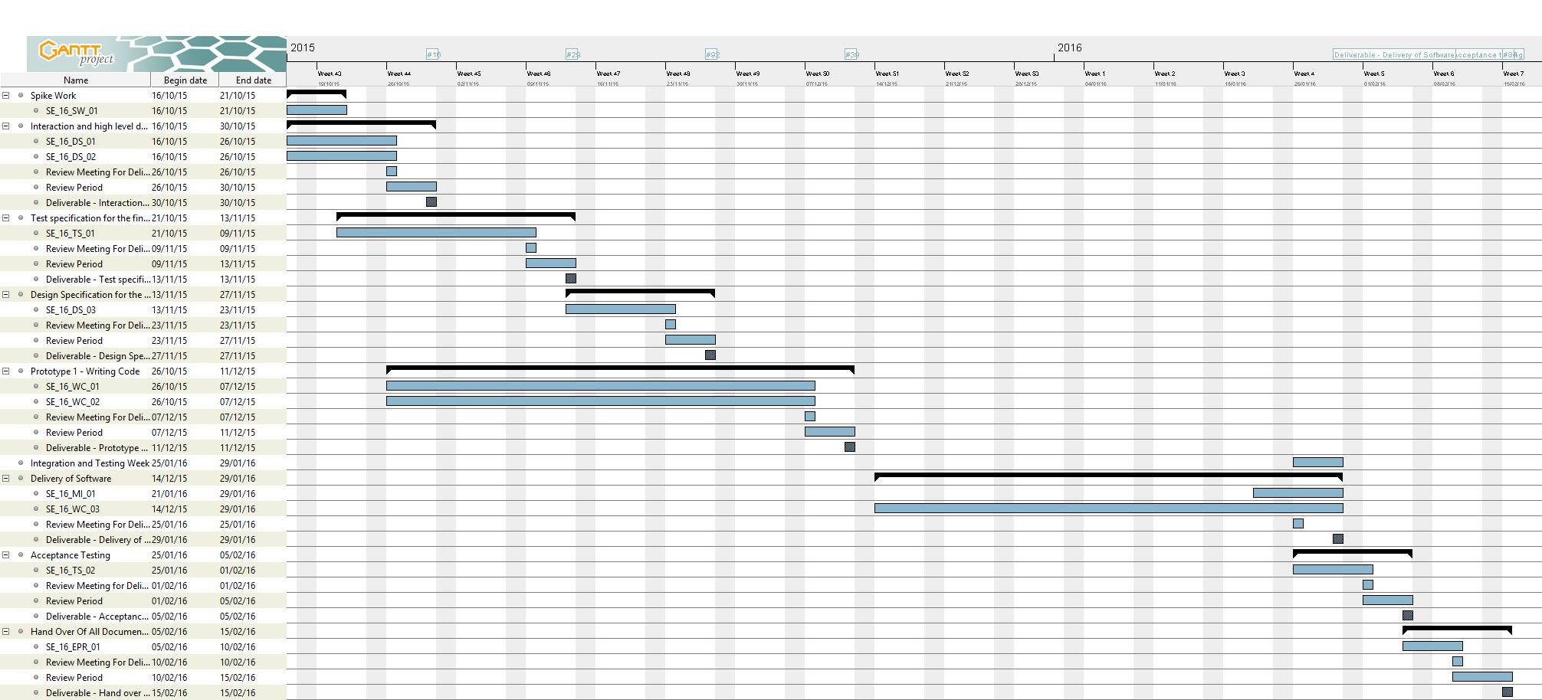

1. **Risk Analysis**

This section aims to outline the potential problems we may encounter as the project progresses. The first potential issue is certain elements of the project taking too long to complete. This risk will be minimised by ensuring that all tasks are started in good time and that all issues that are encountered are reported during any group meeting so that the issue can be resolved.

The second potential risk is that a crucial group member may be ill. To minimise the effect this could have on the project at least two group members will be assigned to major tasks to ensure that at least one member will be able to continue with the task.

The next potential risk will be problems uploading deliverables/documents to GitHub or Blackboard. To reduce this risk all documents and deliverables will be uploaded several hours before any deadline.

Another risk is critical errors or flaws in the developed software. This will be overcome by thoroughly testing the software as we progress through the project. Errors and flaws will also be brought up and discussed in review meetings and hopefully corrected in the review period between then and the deadline.

The final risk is the loss of files due to a software or hardware malfunction. This risk will be removed by every group member backing up their work on external memory and by uploading the work to the GitHub repository.

**References**

[1] Project Task List, R. M. Pearce, SE_16_PM_02, 1.0 Release

**Document Change History**

|  |  |  |  |  |
| --- | --- | --- | --- | --- |
| Version | CCF  No. | Date | Changes Made To Document | Changed By |
| 1.1 | N/A | 22/10/2015 | Minor changes made to the document. Section 1.3 was slightly changed due to misspelling. Section 3 was changed to improve format. | Robert Mouncer |