# TESTING

Software testing is a process to evaluate the functionality of a software application with an intent to find whether the developed software met the specified requirements or not and to identify the defects to ensure that the product is defect free in order to produce the quality product. In simple words, testing is executing a system in order to identify any gaps, errors or missing requirements in contrary to the actual requirements. The purpose of the testing is to evaluate the system’s compliance with the specified requirements. The process of testing an integrated system to verify that it meets specified requirements.

In the software development life cycle (SDLC), the testing plays an important role. Usually software testing is considered as one phase of the software development life cycle. It is the process of finding bugs in the software and make the software bug free.

Importance of testing: -

1. To find out the defects and errors those were made during the development phase.
2. To make sure of the customer’s reliability and their satisfaction in the application.
3. To lower the amount of time it takes to test software and report bugs.
4. To improve consistency and performance.
5. To improve the quality, reliability and performance of the system with all check what all functions software supposed to do and check that software is not doing what he not supposed to do.
6. As it is not possible to make the software application defect free but testing will be necessary.
7. To produce the good quality product, the testing of the application is key factor in SDLC.
8. Testing should be introduced in the early stage of the SDLC. The cost of fixing the bug is larger if testing is not done in early stage and bugs found in later stage.

Importance of testing: -

After the development of the application, different test is run to ensure if the application runs properly or not. There are lots of testing done to check the application such as White Box Testing, Black Box Testing, Regression Testing, Unit Testing etc. Different testing is done in different way to obtain results. Some are done to check the functions, some are to check the design, and some are to check the performance. Among these all the testing here I have run two types of testing. They are Unit Testing and Black Box Testing.

### Unit Testing

In this testing, different components present in the application is tested. It is done to ensure that every unit of system performs as it is designed to. Various inputs are given, and single output is generated. It can test a single function, individual program or processes within it. It can be manual or automatic. More reliable code changes can be done with this testing. There are various frameworks, drivers, stubs etc. to assist in performing unit test. This test is done by the develop themselves. By this testing the code will be reliable, reusable which helps in easy debugging.

### Black Box Testing

It is considered as high-level testing method. Also known as behavioural test method. Only input and output are noticed by the tester. The codes, inner design, implementation, structure is not visible or is not known to the tester. As it is named so, the user test only outside the box, the tester is not familiar with the inner structure. The interface error, behaviour error, termination error functions etc. are tested. No skill to the code is needed to perform such test. This is applicable for the acceptance testing and system testing.

**Test Name**: - Registration test

**Pre-Condition**: - User must get registered into the system

|  |  |  |  |  |  |
| --- | --- | --- | --- | --- | --- |
| **Test No** | **Test Scenario** | **Test Input Data** | **Expected Result** | **Actual Result** | **Result(pass/fail)** |
| 1 | To check if the value inserted is working properly or not | First Name: Reeza  Last name: kc  DOB:1997-07-10  Age:20  Email:rija@gmail.com  Address: ktm  Phone number:214768867  Passport No:987654p  Username: reeza  Password:reeza23 | The data should be inserted into the database and user should be directed to the login page | Successfully new user is created and user is accessed with the login page. | Pass |

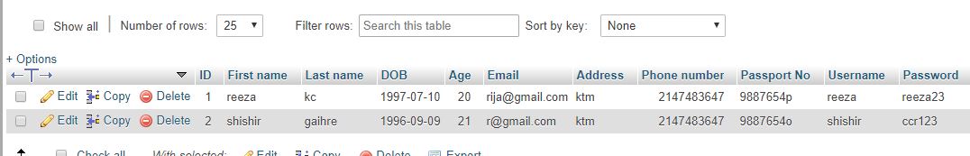

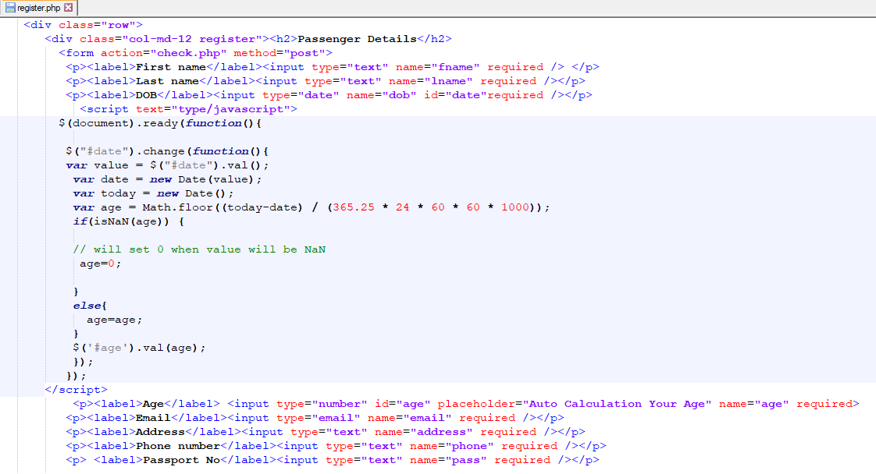

**Test Name**: - Login test

**Pre-Condition**: - User must get logged in into the system

|  |  |  |  |  |  |
| --- | --- | --- | --- | --- | --- |
| **Test No** | **Test Scenario** | **Test Input Data** | **Expected Result** | **Actual Result** | **Result(pass/fail)** |
| 2 | To check if the value is inserted properly or not | Username: reeza  Password: reeza23 | The data should be inserted to the database and user should be redirected to the dashboard | User is logged in successfully. | pass |

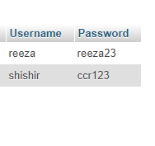

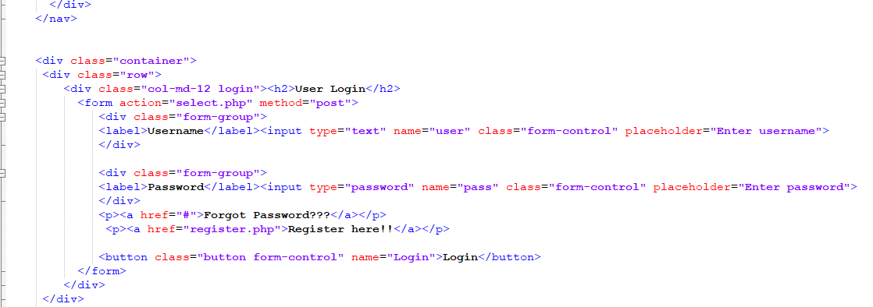

**Test Name**: - booking test

**Pre-Condition**: - User must book ticket into the system

|  |  |  |  |  |  |
| --- | --- | --- | --- | --- | --- |
| **Test No** | **Test Scenario** | **Test Input Data** | **Expected Result** | **Actual Result** | **Result(pass/fail)** |
| 3 | To check if the ticket is booked or not | Title : Mr.  Full name: shishir kc  Email :ccr@gmail.com  Phone: 254567556  Trip: one way  Booking date: 2019-09-08  Class:first class  Adult:1  Children:1  Leaving from: ktm  Going to: butwal | The data should be inserted to the database and user should book the ticket. | Ticket booked successfully. | Pass |

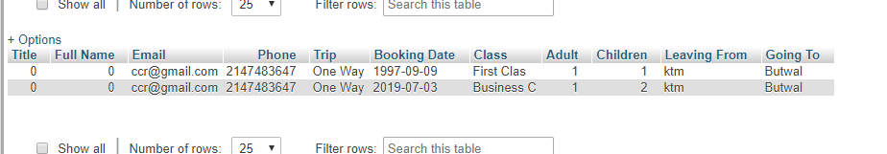

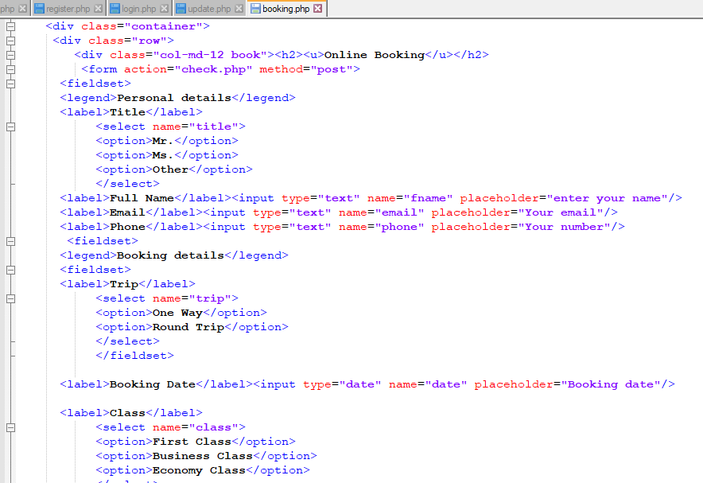

**Test Name**: - passenger update test

**Pre-Condition**: - passenger detail must be update into the system

|  |  |  |  |  |  |
| --- | --- | --- | --- | --- | --- |
| **Test No** | **Test Scenario** | **Test Input Data** | **Expected Result** | **Actual Result** | **Result(pass/fail)** |
| 4 | To check if the passenger detail is updated or not | First Name: Roja  Last name: kc  DOB:1997-07-10  Age:20  Email:roja@gmail.com  Address: ktm  Phone number:9888875  Passport No:987654p  Username: reeza  Password:reeza23 | The data should be updated into the database. | Successfully passenger detail is updated. | fail |



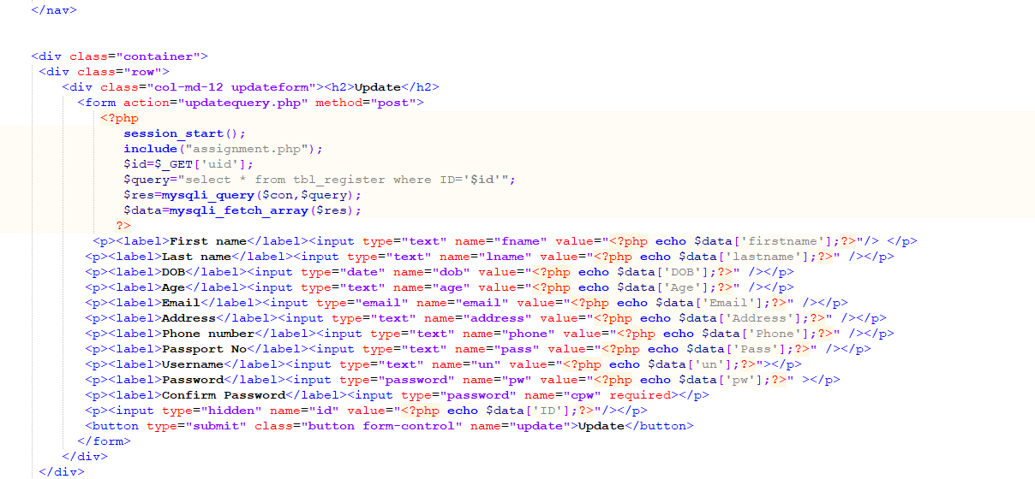

**Test Name**: - passenger delete test

**Pre-Condition**: - passenger detail must be deleted in the system

|  |  |  |  |  |  |
| --- | --- | --- | --- | --- | --- |
| **Test No** | **Test Scenario** | **Test Input Data** | **Expected Result** | **Actual Result** | **Result(pass/fail)** |
| 4 | To check if the passenger detail is updated or not | First Name: Roja  Last name: kc  DOB:1997-07-10  Age:20  Email:roja@gmail.com  Address: ktm  Phone number:9888875  Passport No:987654p  Username: reeza  Password:reeza23 | The data should be deleted from the database. | Successfully passenger detail is deleted. | pass |

