COMP482 – Assignment 3

Richard Jacklin

August 30, 2025

Final Report - Heuristic Evaluation

Results of Evaluation – Interface Problems
1. Simple and natural dialogue
- In the list of project tasks, there is no separators between the user assigned the task and the task description. Severity: 3
- “Add task” button is sandwiched between “Task Management” and “Tasks” labels, adding unnecessary extra information. “Task Management” label could be removed. Severity: 2
- On the Analytics page, the word “Select” is repeated in each label dropdown. This could be redesigned so that “Select” only displays once, Severity: 2
- “Add Task Card” button has the same unnecessary extra information problem as the “Add Task” button. “Sprint Management” label could be removed. Severity: 2
- On the Task Card view screen, text is bunched up in the top left corner. Percentage contribution to total sprint may also overwhelm user. Severity: 2
- “Add Wiki Page” button has the same unnecessary extra information problem as the “Add Task” and “Add Task Card” buttons. “Sprint Management” label could be removed. Severity: 2

2. Speak the user’s language
- “Create” button may be confusing to users on the “Set New Password” screen. Maybe “Set new password” or “Update password” would be better for the user to understand. Severity: 2

3. Minimize user memory load
- Lack of indicators for where exactly users currently are in the interface. They need to use a combination of screen title cues and their memory. For example, user sees “Add Task Card” but then has to remember where they were previously in the interface to know where the “Back” button at the top will send them. Severity: 5

4. Be consistent
- Confusing use of the words “Sprint” and “Task Card” in the same portions of the interface without clear distinction may confuse users (although the product is aimed at software developers and so this level of jargon is appropriate). Same with “Document” and “Wiki”. Severity: 1
- The button “Back to Menu” on the left side of the Projects screen is unclear. User may not know what “Menu” is referring to. Severity: 4
- Back button language is inconsistent. On the Projects screen it says “Back to Menu” (meaning back to main menu on Welcome screen), when adding Tasks/TaskCards/Wiki Pages it only says “Back”, and on the Analytics screen it says “Back to Projects”. Severity: 4

5. Provide feedback
- On the task view page, clicking “Post Comment” without entering anything into the “Add Comment” box doesn’t provide any feedback to the user. This field should have the same error message feedback as the create forms have. Severity: 3
- Buttons that have stub functionality (e.g., “Delete Task”) don’t provide any feedback to the user. However, this is intentional as these are implementation stubs and would show proper feedback in a real-world implementation of BLOOM. Severity: 1

6. Provide clearly marked exits
- When a user clicks a notification and is directed to the associated task, there is no visual indication of how to get back to their notifications. In this case, the user has to click “Back to Tasks” and then “Back to Menu” to see the “Notifications” button again. Severity 5

7. Provide shortcuts
- There is no batch feature for analytics and report generation. Users can only perform one set of analytics at a time and receive back only one report at a time. Severity: 4
- There are currently no keyboard shortcuts for advanced users. They have to follow the same slow input process as beginner users. Severity: 2

8. Good error messages
- When users enter a new “Task Card” with story points set to 0, the error message says “Story points must be greater than 0” but does not explain how to increase them. It is just assumed that the user will know that they can either use the + button to increase the value or select the current value and enter a different number. Severity: 3

9. Prevent errors
- No warning to users that selecting “Back” will not save their current form inputs. Severity: 5
- No confirmation when users set their new password after first login. Severity: 5

From this heuristic evaluation, the main heuristic evaluation problems I identified in BLOOM were to do with simple/natural dialog, minimizing the user’s memory load, consistency, and clearly marked exits. There is far too much text in a small space on most of the screens, which would result in a poor experience for many users. Although the level of jargon is adequate, the BLOOM interface may be confusing for users specifically on the “Set New Password” screen as the button to set the user’s new password just says “Create”. This issue is a misapplication of the consistency heuristic as “Create” is used throughout the interface when users are adding new elements (Tasks, Pages, etc.). Although the user is technically adding a new password, the consistent “Create” button text is not appropriate for the context of setting a new password.
The interface relies heavily on the user’s memory for navigation as there is no visual indication as to where a user is, relative to other screens in the interface. Nothing happening when the user clicks “Post Comment” without entering any text into the comment box may also confuse users and is a clear example of a lack of feedback in the interface. Users may also be confused with the lack of clearly marked exits in the BLOOM interface. Although there are back buttons throughout, their text is inconsistent and may even be confusing to the user in some instances (e.g., “Back to Menu” is the text for the button to direct the user to the Welcome screen where the main application menu is). The lack of shortcuts in the interface, specifically for analytics and report generation, could be frustrating for the software engineers the BLOOM application is developed specifically for. The lack of direction in the error message when setting story point values may also cause users frustration. This piece of the interface is confusing overall as the input defaults to a value of 1 to guide the user but still allows the value to go down to 0 during input (causing the error message). Finally, the largest potential issue in the current BLOOM implementation is that there is no way of preventing users from accidentally clearing their form inputs by navigation back in the interface.

Results of Evaluation – Discussion
In evaluating my implementation of the BLOOM application interface, I would consider the quality of the system design to be quite good for a small demo application. Although there are several major design issues in the implementation, they are all related to the application being a small demo with stub functionality. I am assuming that a real-world implementation of BLOOM would address the most severe issues.
The best design aspects of BLOOM are its largely consistent visual design, frequent exit paths, appropriate use of software engineering jargon, and the robustness it provides through feedback and error handling. In designing BLOOM, I made a conscious effort to provide the same visual layout throughout. Every screen, except those for logging in or adding new elements, are displayed with a content-relevant menu on the left side and the content in a window on the right. Additionally, every left side menu provides a Back and Exit button section at the bottom. This design remains consistent even on screens where there are no navigation buttons in the left side menu (e.g., when viewing an element, such as a Task). However, the design and usability of BLOOM could be greatly improved if this consistent layout was also applied to the login screen and the add elements screens. As described, the consistent back and exit buttons on the left side of the screen also factors into BLOOM providing frequent exit paths for users. I designed the application so that the user can also exit what they are currently doing in the interface. This design decision was partly inspired by my discovery that the DearImGui application framework I used has a known issue where the built-in MacOS window exit button (in the top left corner of all MacOS applications) doesn’t work by default. This encouraged me to add exit buttons throughout the interface.
I would consider the best aspect of Bloom’s current design is its robustness. Throughout my testing I ensured there is no aspect of the system (barring any expected edge cases) where the user will do something and either get stuck in the interface or have the application crash. The application handles incorrect inputs by giving the user feedback and, in almost all cases, directing the user towards the solution. Additionally, there is visual feedback in the interface to guide the user (e.g., the title input field becomes red when the user tries to create a Task without a title). One issue with this implementation is that if the input field becomes red due to an error, it remains red until the user clicks “Create” or navigates away from the screen. This is a relatively minor issue though and would be unlikely to cause much frustration for users. I would also consider the use of correct jargon and appropriate technical terminology to be a great part of BLOOM. I designed the application with software developers in mind and chose terminology in the interface that is appropriate for their level of knowledge. This could be further improved by ensuring that technical terms are not used interchangeably in the interface.
The worst design aspects of BLOOM are its cluttered use of text, lack of consistent terms, lack of shortcuts for the target audience, and reliance on the user’s memory. The cluttered use of text is a relatively minor problem and has to do with visual spacing. In a proper implementation, I would choose a design that has more “room to breathe”. Adding the visual design principles of layout and spacing would help the information that needs to be presented not be overwhelming to users. In terms of consistent terms, I’m specifically referring to the use of the terms Sprint/Task Cards and Documentation/Wiki. “Task Card” and “Wiki” are often the chosen terms, but in some instances of the interface, they are used interchangeably with their counterpart term in a way that could be confusing for users.
Although BLOOM implements a shortcut for notifications where the user is sent directly to the associated task, there are other important shortcuts that are missing. As the target audience for BLOOM is software engineers, I would expect added functionality to support their advanced use cases. Software engineers are very proficient with computers and would likely want batch processing, customization, and keyboard shortcut features. In a full, real-world implementation of BLOOM, these features would need to be on the list of features to add for its intended audience. A final critical problem that would need to be addressed in BLOOM is its lack of visual indication to users for where there are in the application at any given time. BLOOM offers various ways for users to move back and forth through the interface, but it largely relies on the user’s memory for them to be able to predict where they will be sent when they click a button. To resolve this, I would add breadcrumb navigation that is visible at all times. This would provide users with a constant visual cue to orient where they are, as well as where they can expect to be sent if they click a “Back” button. This added functionality would especially complement BLOOM’s current issue with a lack of consistency in back button text.
In conclusion, I do believe that BLOOM would work well for its target audience of software engineers, despite its currently limited implementation. Many buttons for editing, deleting, and so on are simply not implemented due to the scope of the application for this course and the assignment. BLOOM features a largely consistent interface design throughout and ways to exit the application through. It also uses an appropriate level technical terminology for its intended users and provides feedback and error handling throughout. Best of all, the system currently has no observed ways for the user to get stuck in the interface. Despite what works well currently, there are a few aspects of BLOOM’s design that could be improved in its current implementation. The text on the pages is currently quite cluttered, despite it almost entirely being relevant to the user. The appropriate use of jargon could also be greatly improved by correcting the inconsistent use of some similar terms in the interface (e.g., interchanging “Sprint” and “Task Card”). As described above, adding breadcrumb navigation would also help fix BLOOM’s currently reliance on the user’s memory for orienting them within the app. Finally, adding improved shortcuts would be essential for an app that is aimed at software developers. These users are proficient with computers and would likely be frustrated that there are no keyboard shortcuts and no way to customize the interface to suit their specific needs. With more time, the scope of BLOOM would be expanded and address the interface issues discovered in this heuristic evaluation.
Screenshots
Login Screen
1. Initial login screen
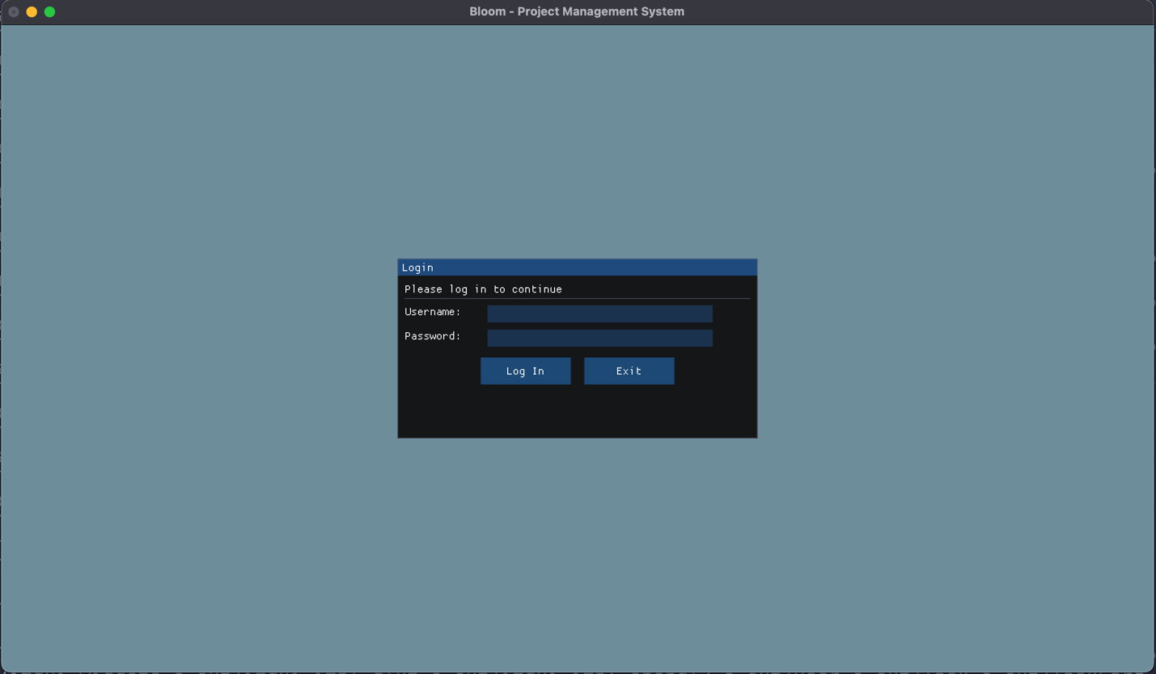
2. Login error
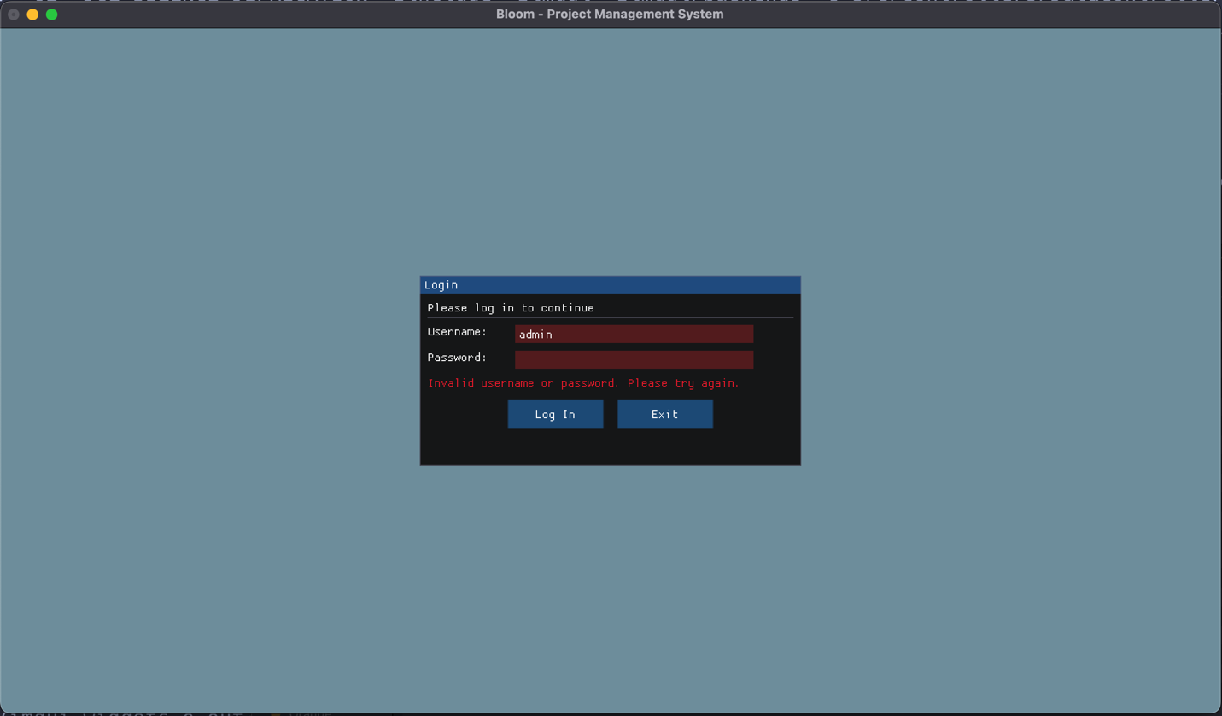
3. First-time user login, needs to set new password (change temp password they were given)
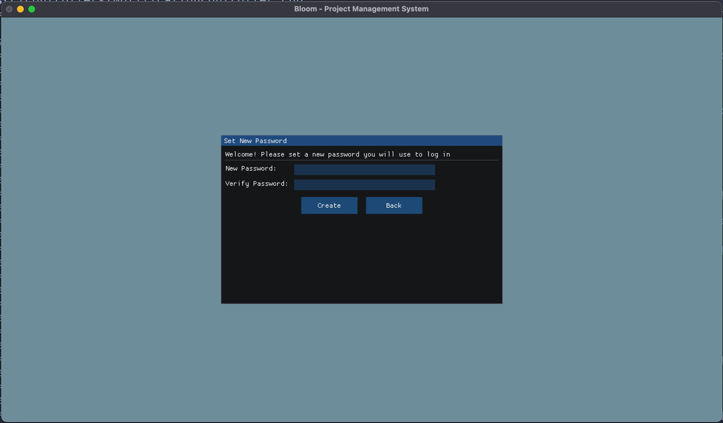
4. New password validation (simply ensures both input fields match)
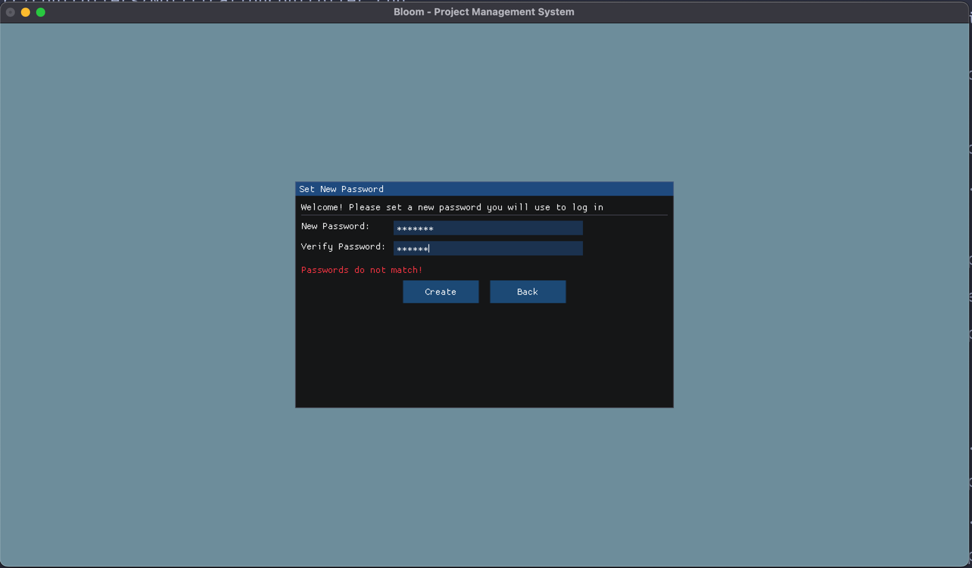
Welcome Screen
1. Initial welcome screen after login
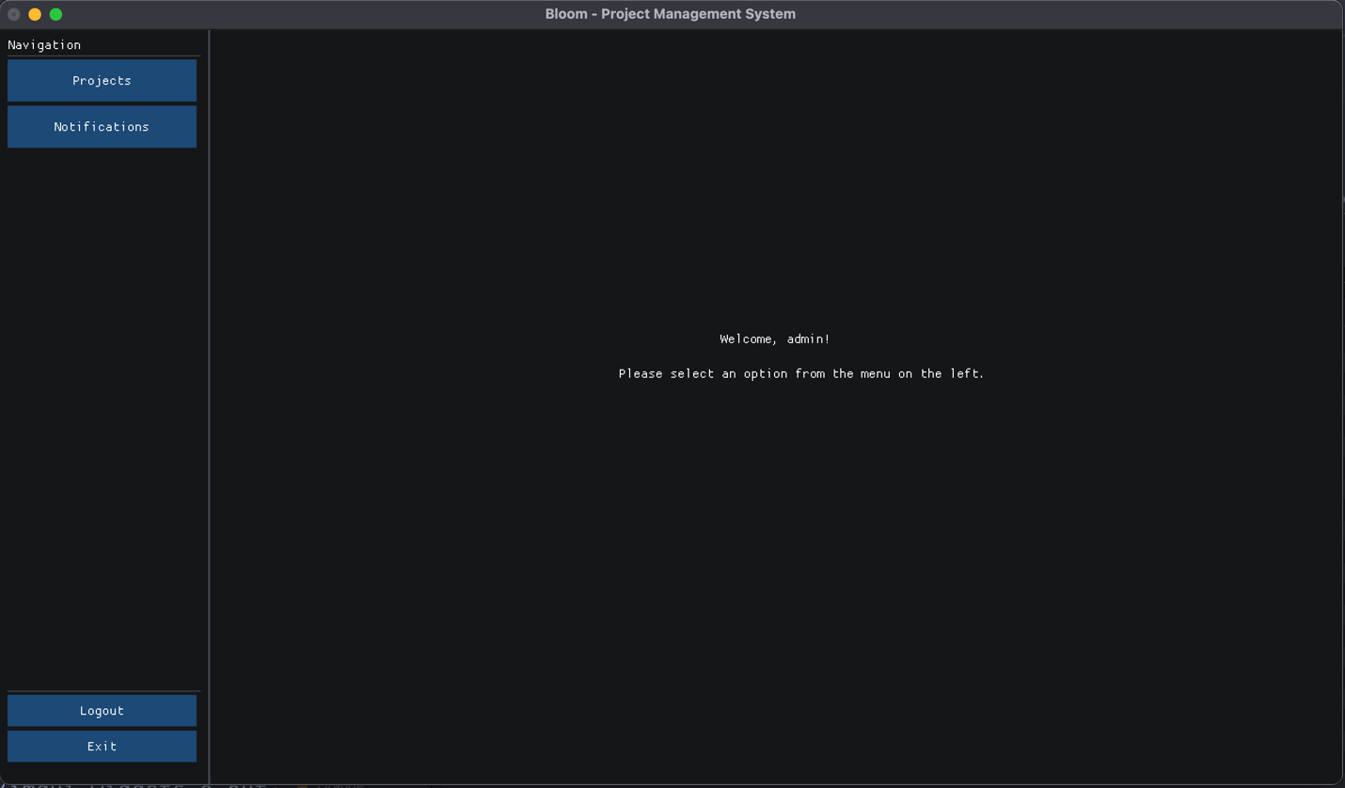
Projects Screen
1. Initial projects screen
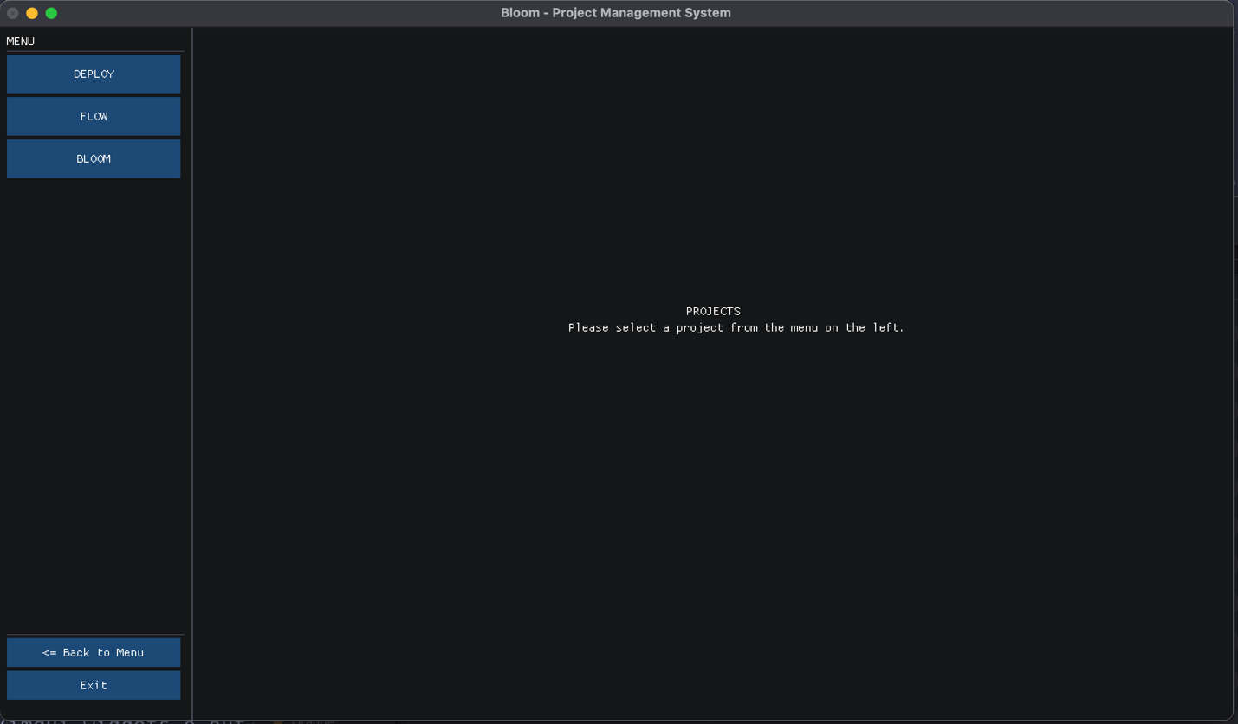
2. Screen after selecting a project, initially shows list of tasks
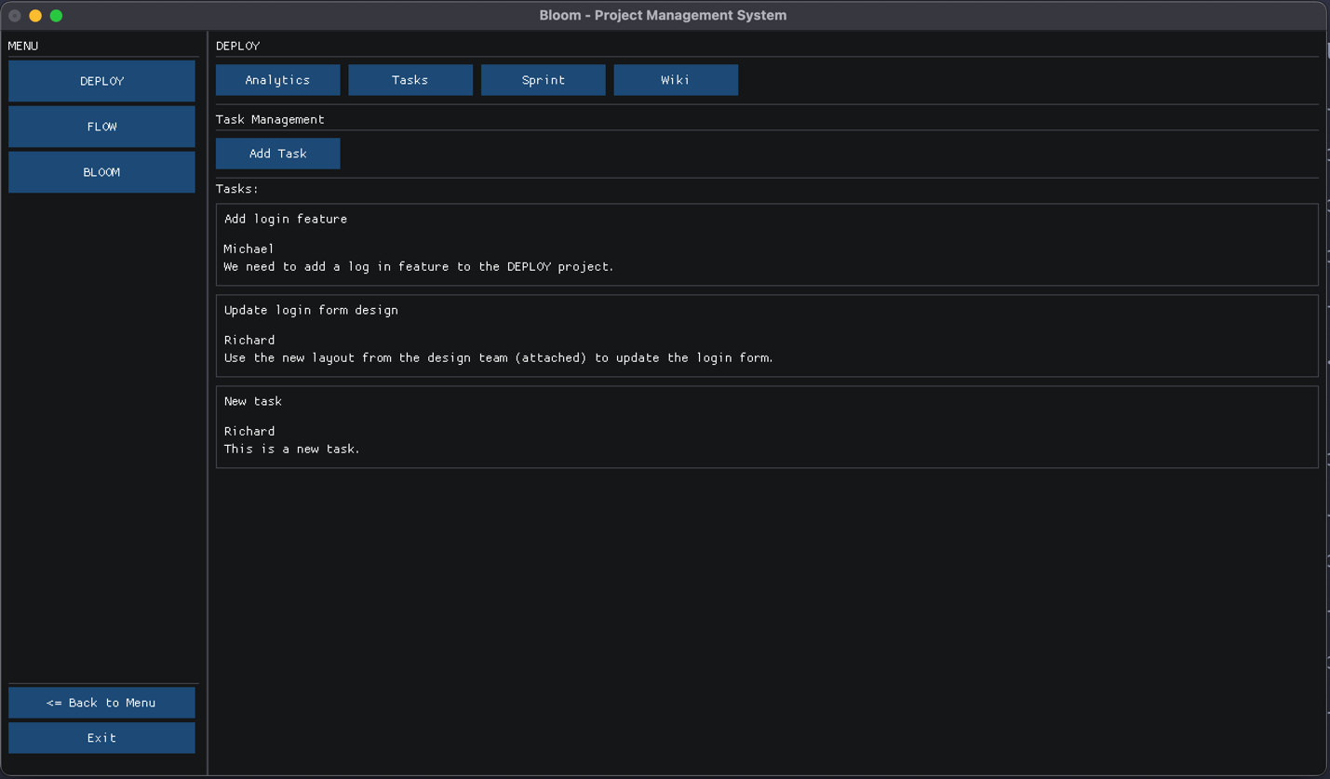
Task Screens
1. Viewing a task
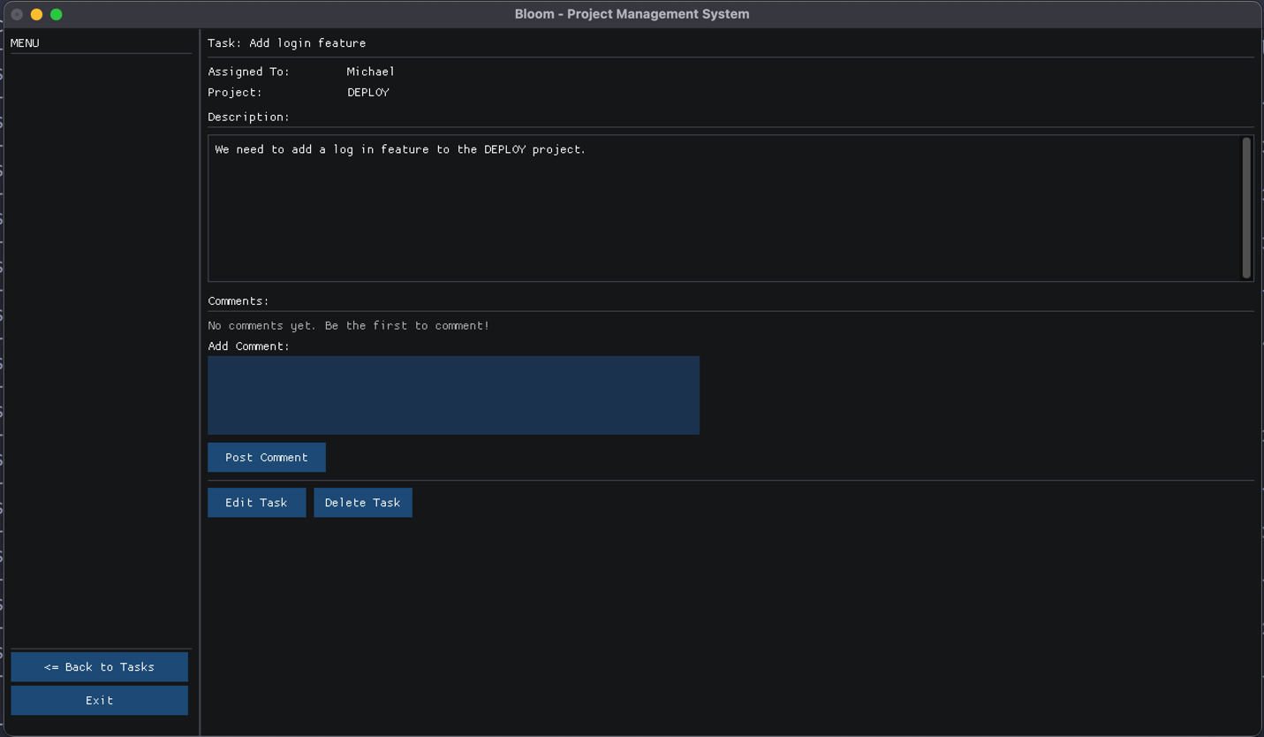
2. Adding comment to task (method of informal communication from Assignment 1)
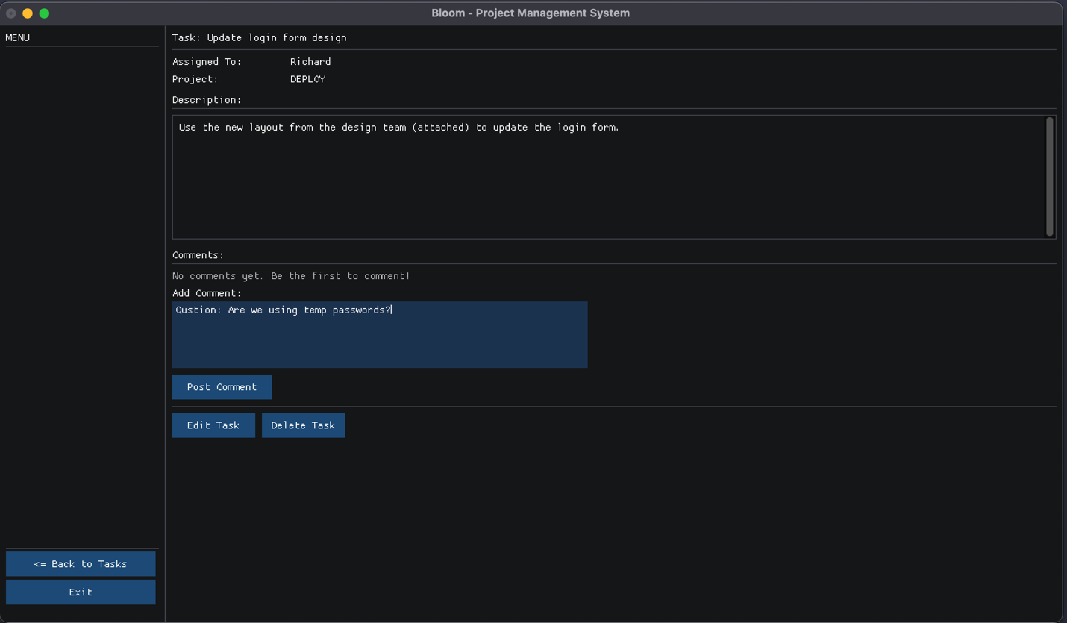
3. Comment shows below task description after it is added
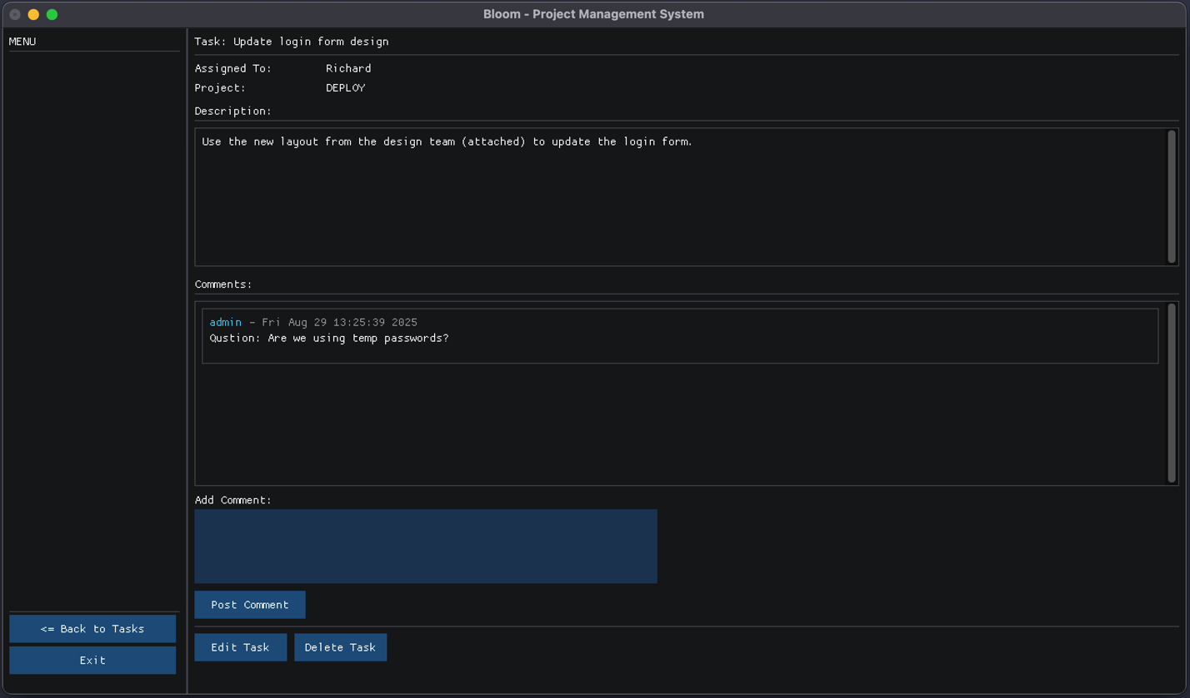
4. Error message when adding a new task without a title
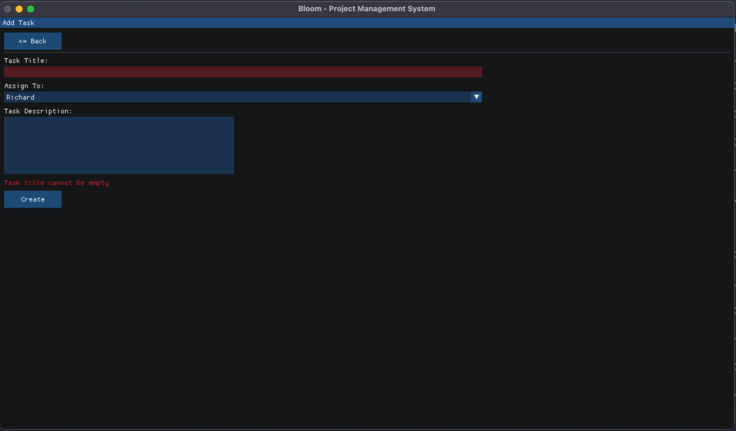
5. Adding new task (no previous input errors)
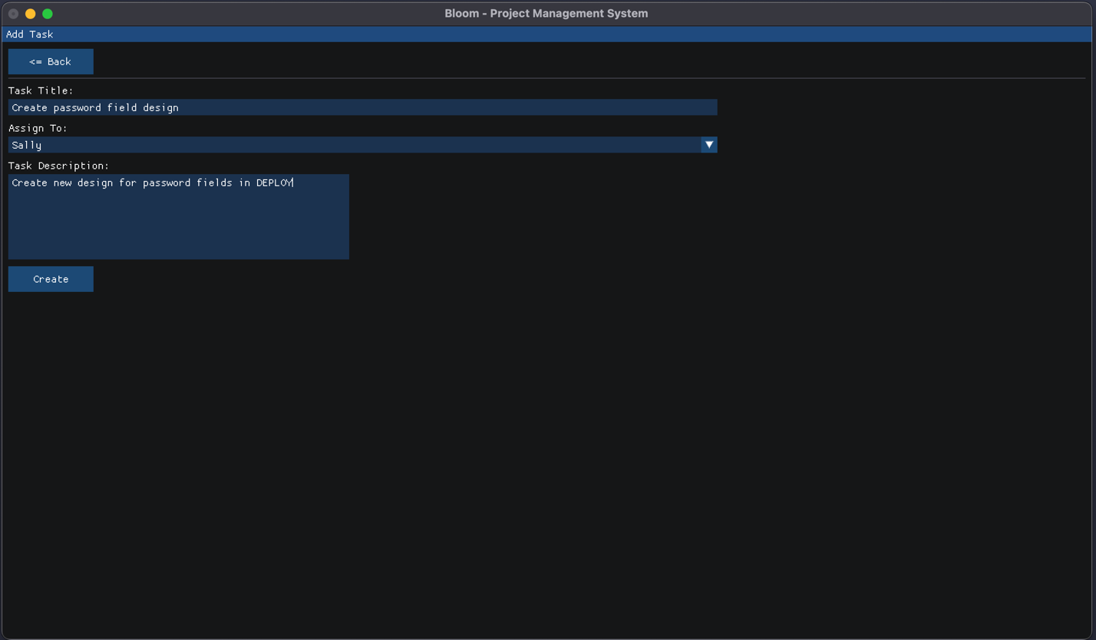
6. Newly added task displays in updated project task list
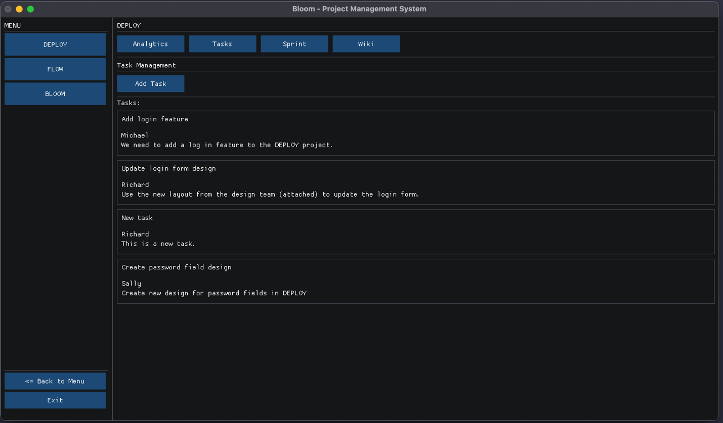
Sprint Screens
1. List of project sprint’s task cards (after clicking “Sprint” button in top menu)
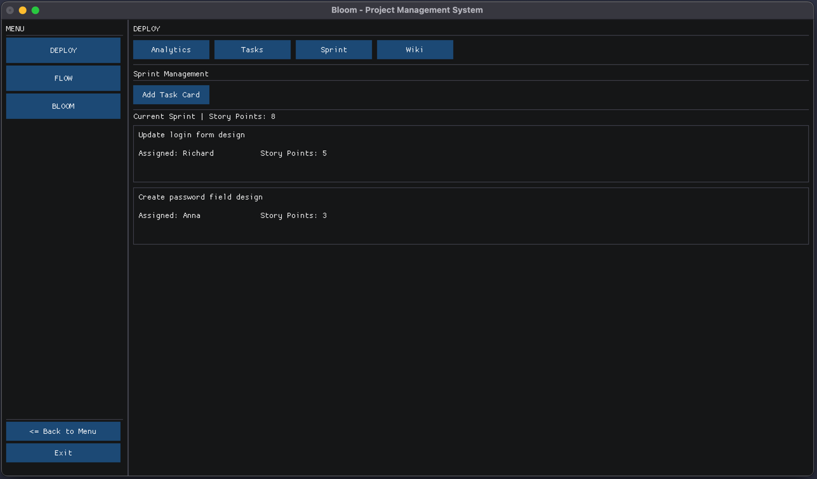
2. Viewing a task card
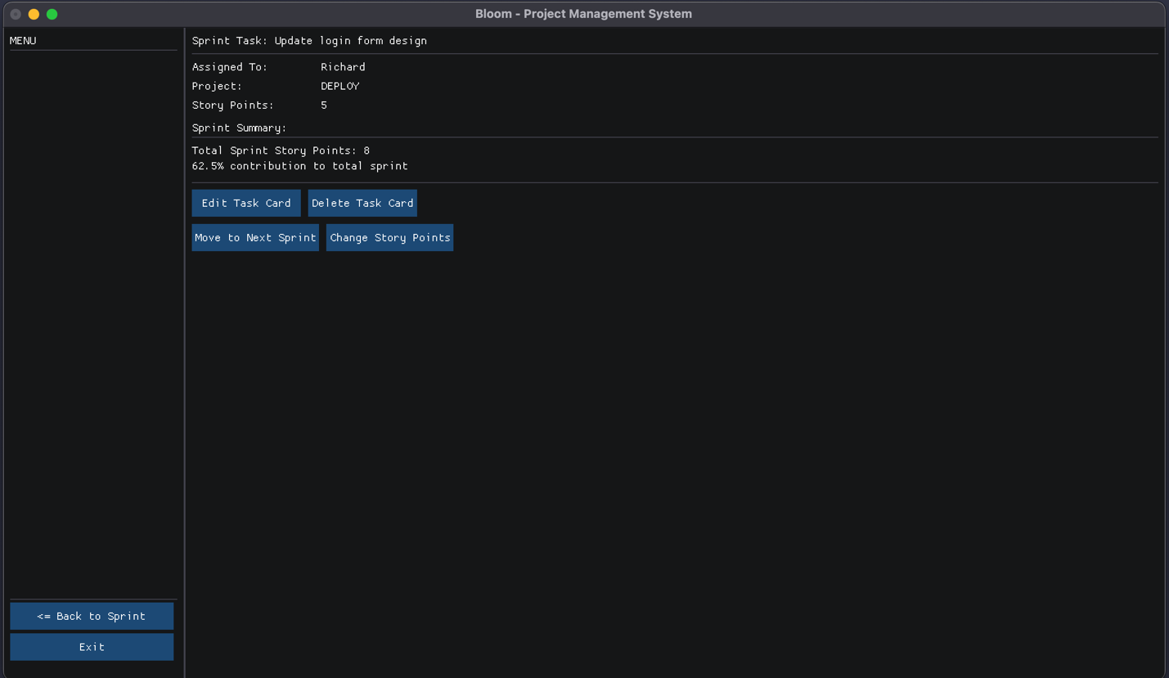
3. Error message when adding a new task card without a title
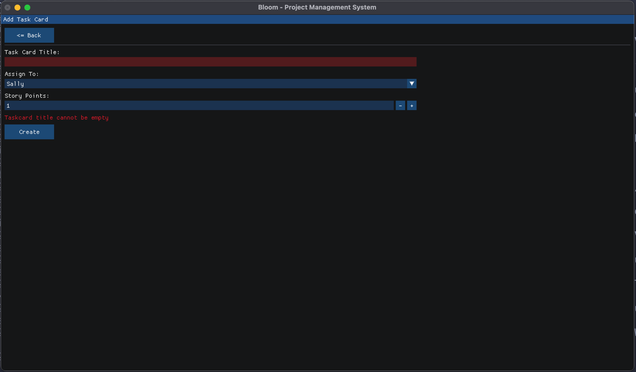
4. Error messages when adding a new task card with 0 story points (handling unexpected inputs/robustness as default is 1)
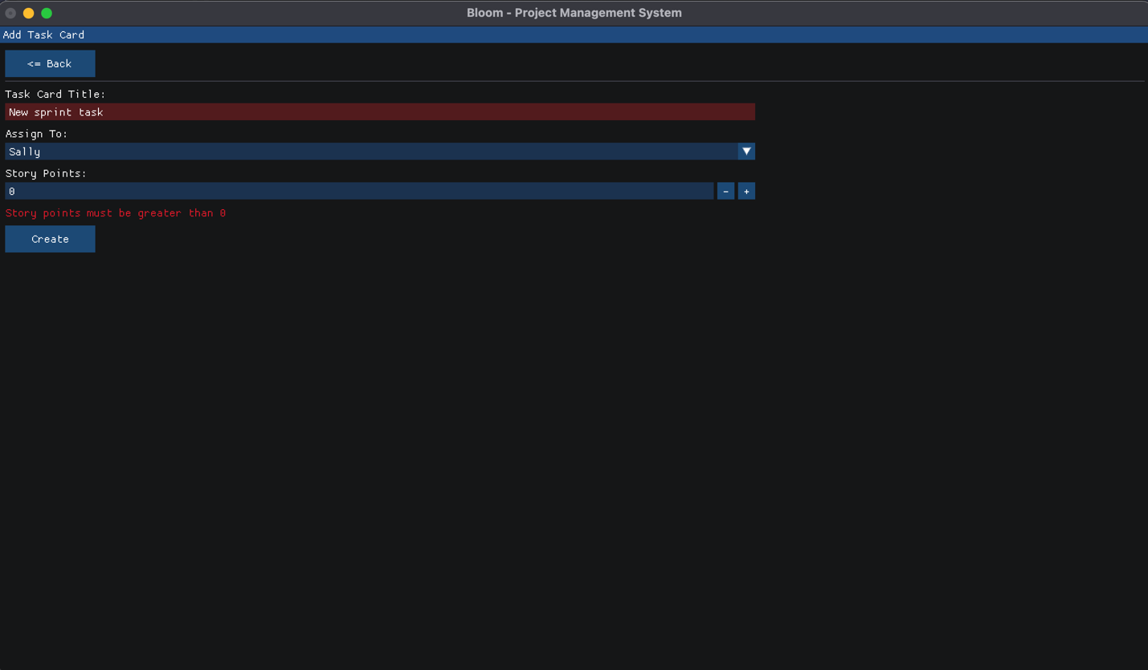
5. Adding new task card after input error
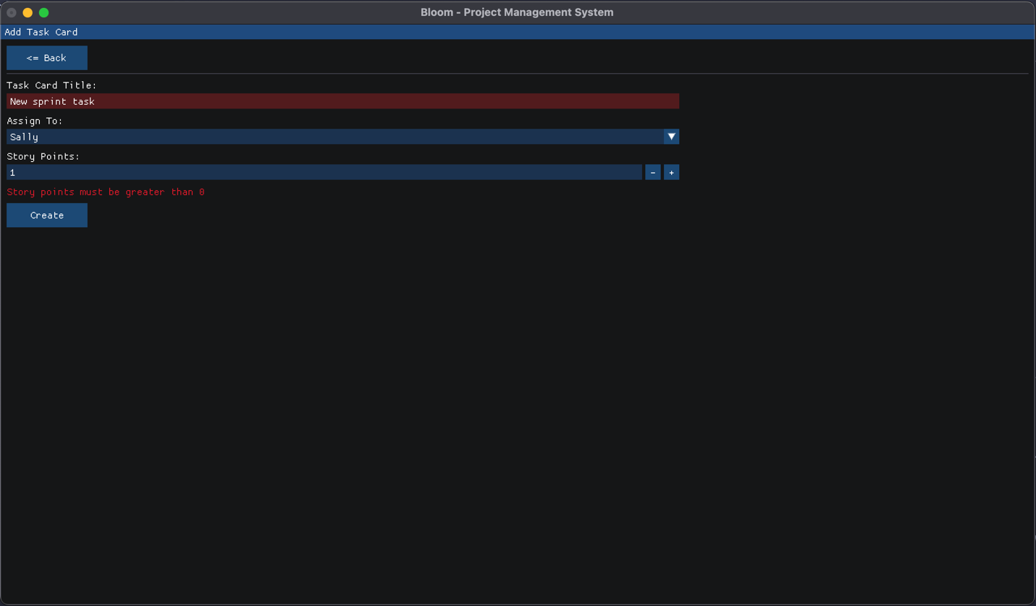
6. Newly added task card displays in updated project sprint’s task card list
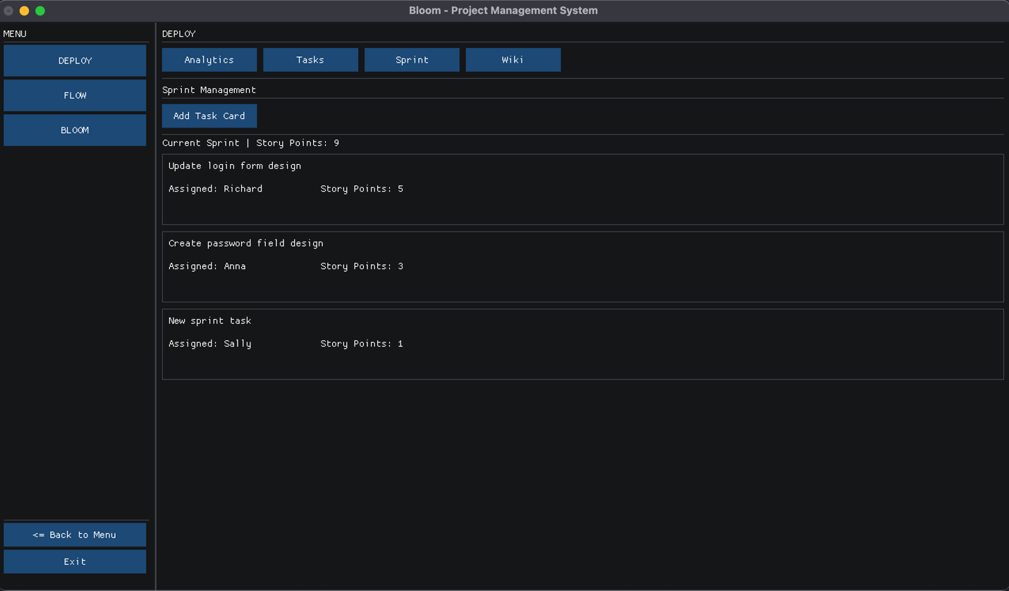
Wiki Screens
1. List of project document wiki’s pages (after clicking “Wiki” button in top menu)
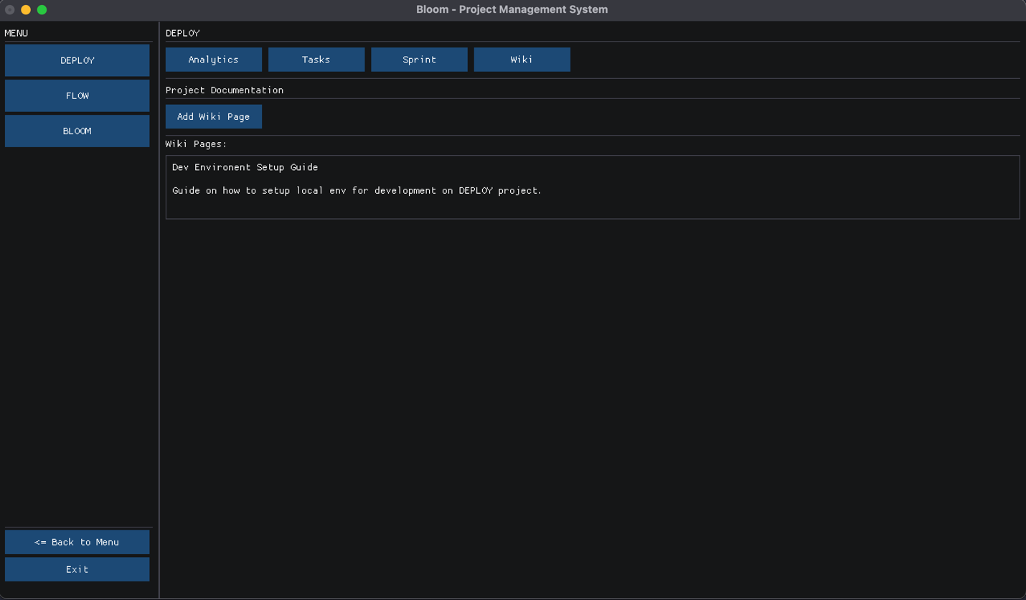
2. Viewing a wiki page
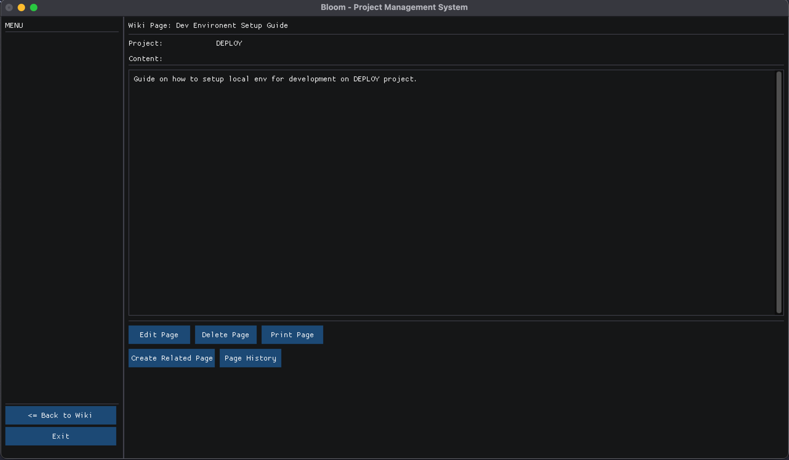
3. Error message when adding a wiki page without a title
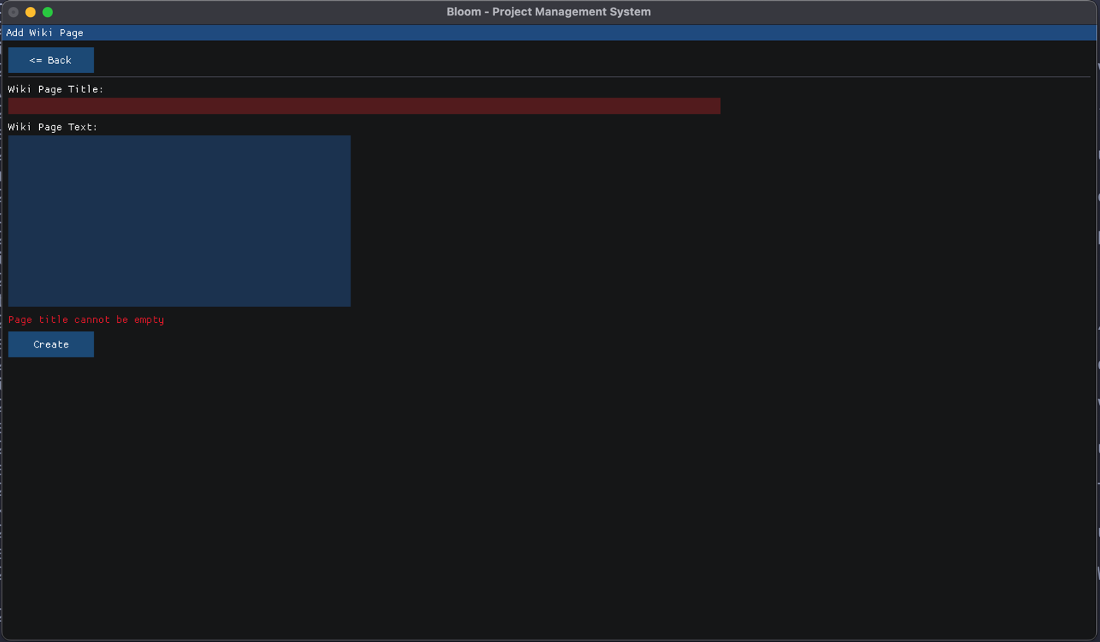
4. Adding new wiki page (no previous input errors)
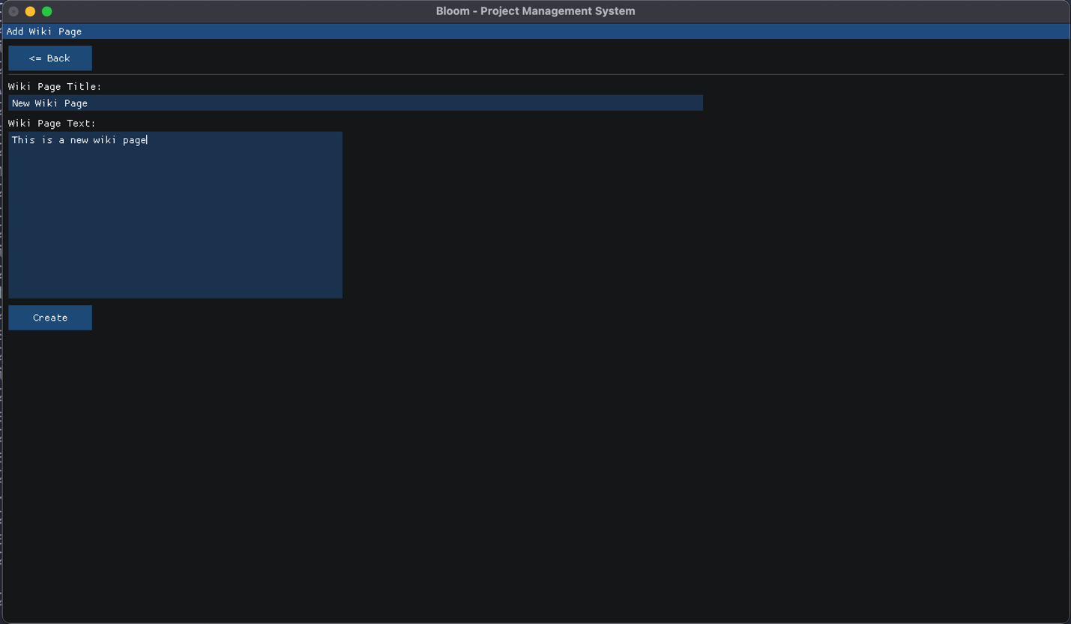
5. Newly added wiki page displays in updated project wiki list
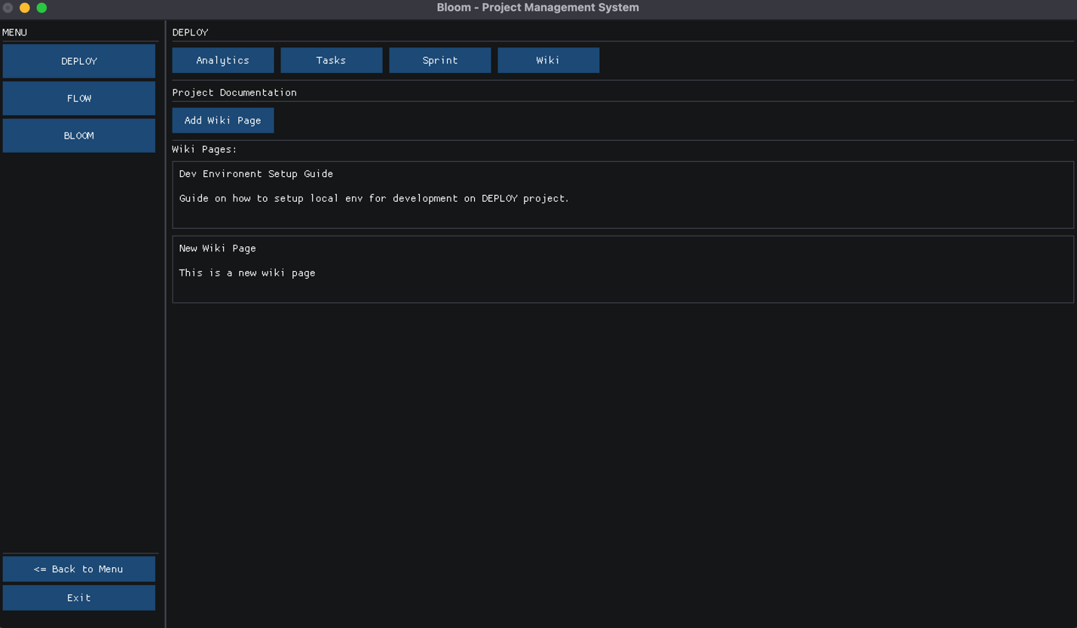
Analytics and Report Generation Screens
1. Initial analytics screen
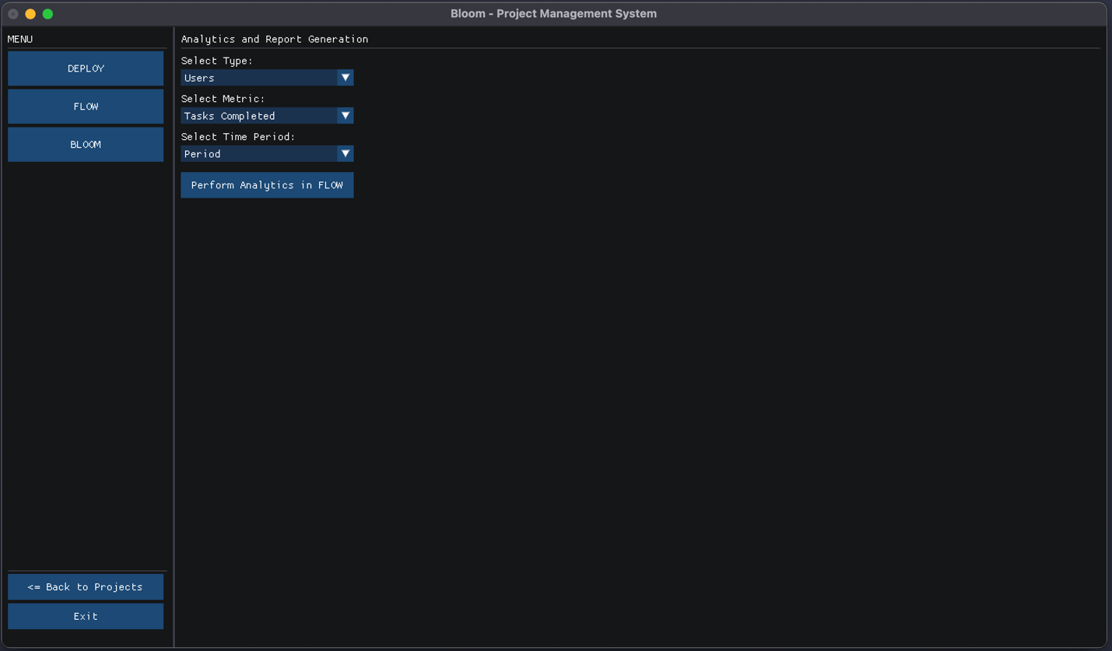
2. User can select attributes from drop-down inputs to run analytics on
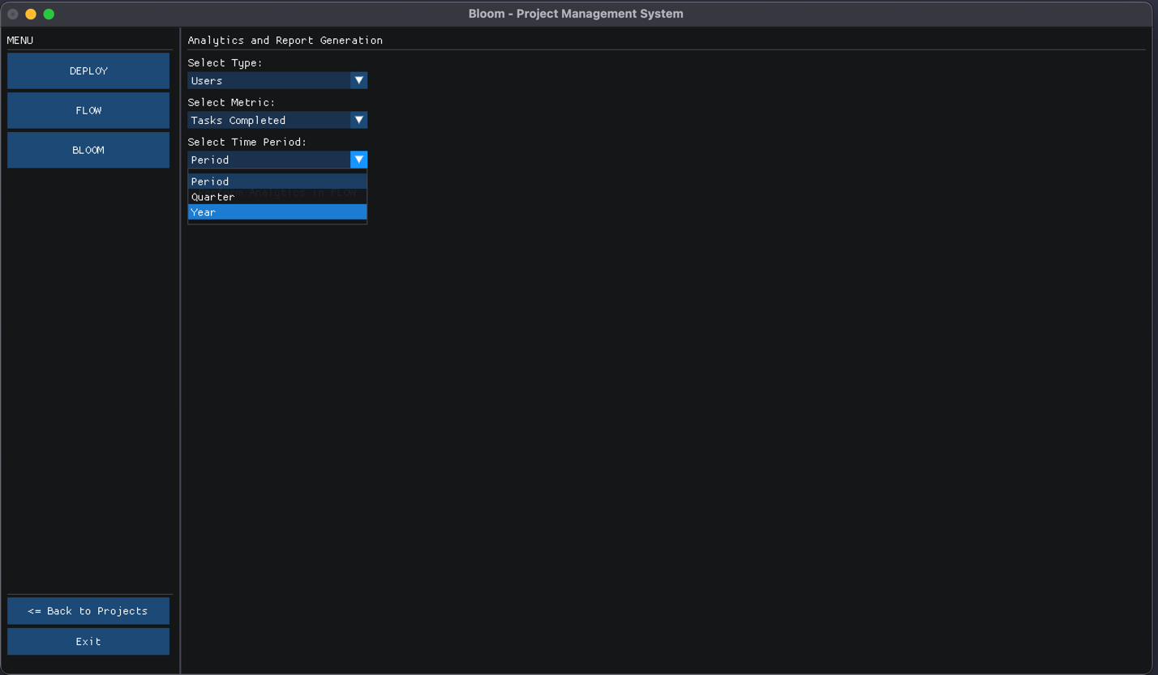
3. Mock analytics processing when user clicks button
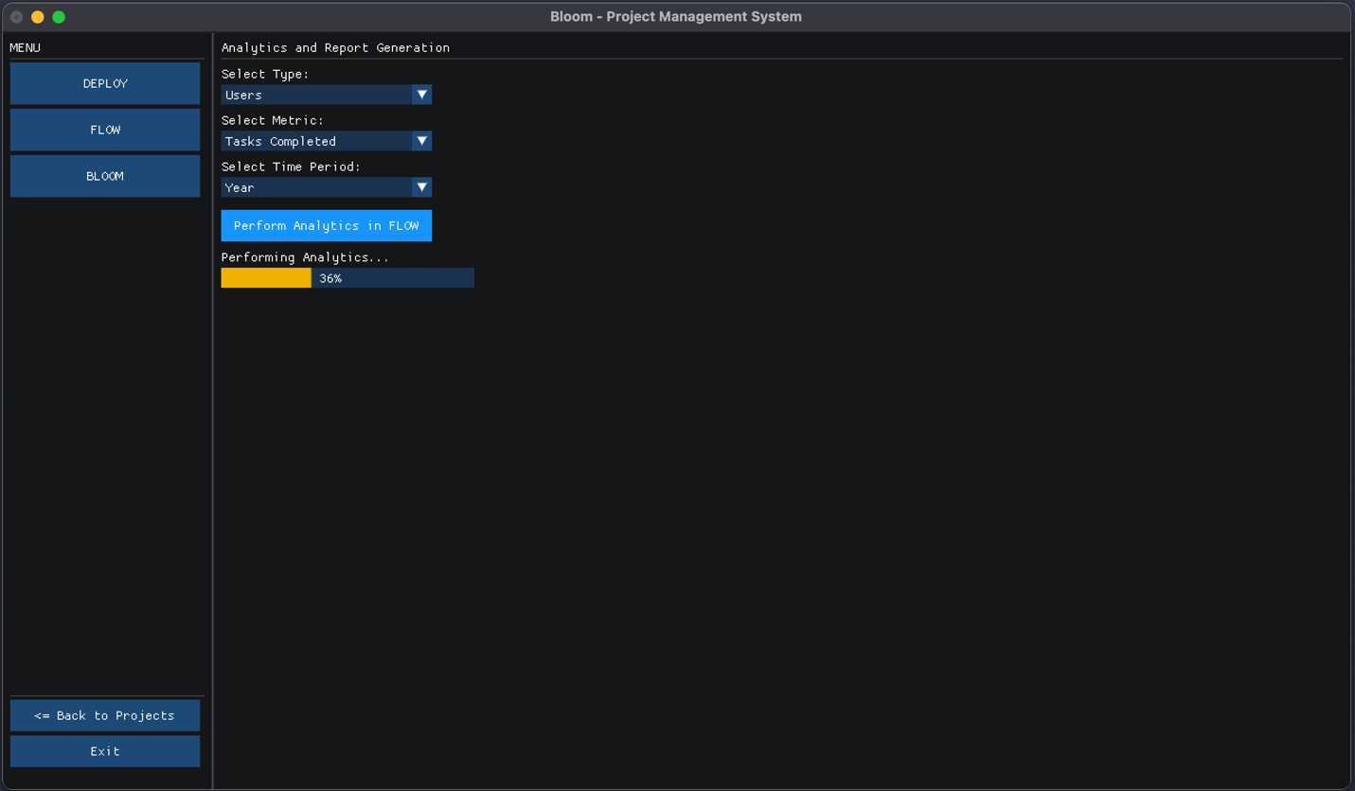
4. Mock report generated screen after performing analytics
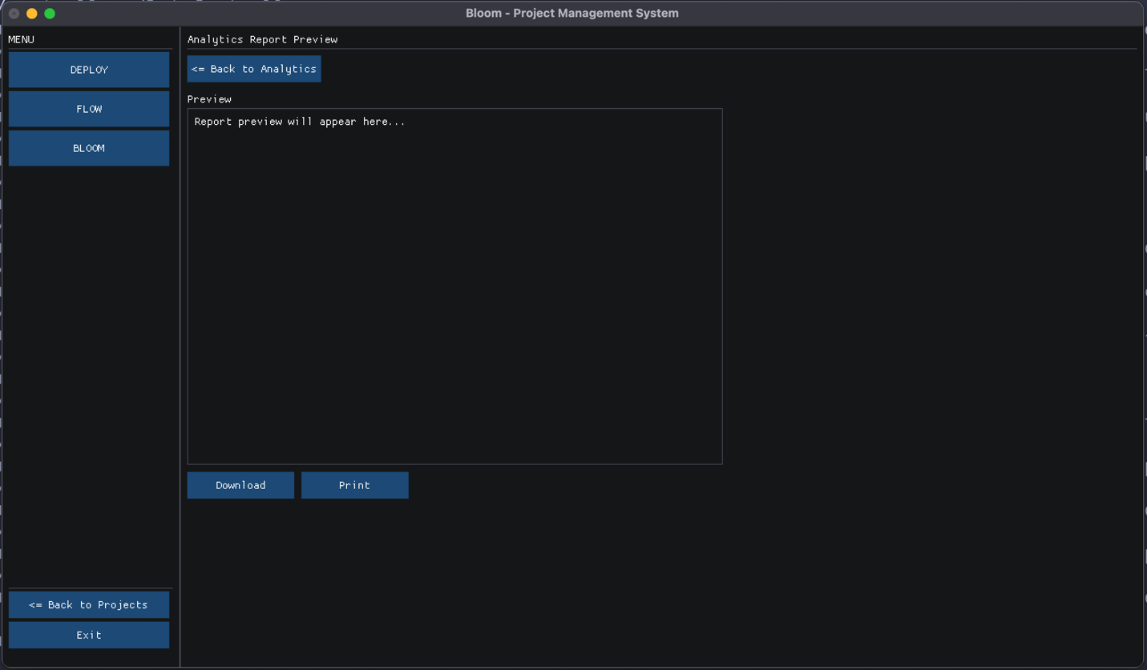
Notifications Screen
1. Initial notifications screen (unread notifications have an orange circle indicator in UI)
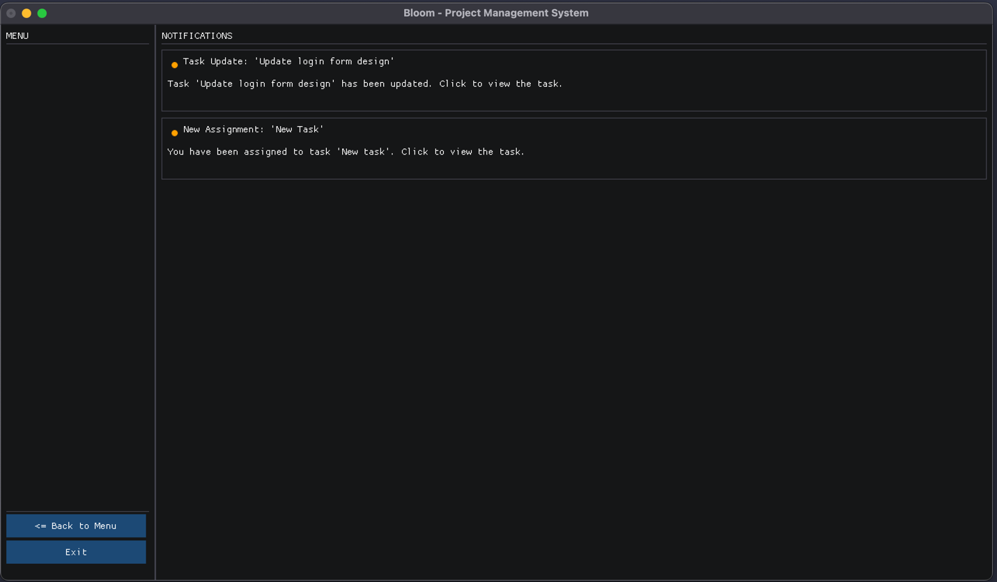
2. When a user clicks a notification, they are directed to the associated task (shortcut for user)
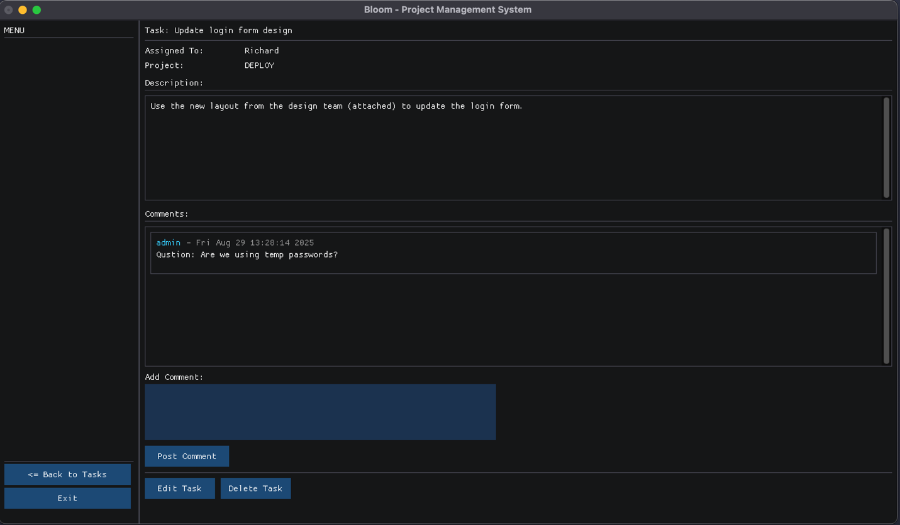
3. After a notification has been clicked, it is marked “read” and so orange circle UI is gone
