Name: Rija Munawar Ali
ID: 68452
Program: BSSE
Course: Information Security
Semester: Fall - 2025

(Open-Ended Lab 1)

TOPIC: AN ADVANCED HYBRID ENCRYPTION SYSTEM ENSURING DATA PRIVACY, INTEGRITY, AND HIGH-PERFORMANCE COMMUNICATION

1. INTRODUCTION & REQUIREMENTS
• Purpose of Hybrid Cryptography:
Hybrid cryptography combines the speed of AES with the secure key transfer of RSA. AES encrypts data quickly, while RSA protects and transfers the AES key safely. Together, they provide efficient and strong data security.
• Need for confidentiality, integrity, and secure key exchange:
Confidentiality keeps data private, integrity ensures the data hasn’t been changed, and secure key exchange protects the AES key during transfer. RSA secures the key, and SHA hashing confirms that the data is still accurate after decryption.
• System requirements (AES, RSA, SHA, file handling, user menu):
The system needs AES for fast encryption, RSA for safe key encryption, and SHA for integrity verification. File handling is required to save and load encrypted data. A user-friendly menu lets users choose operations like encryption, decryption, and key generation easily.
• Security requirements (confidentiality, integrity, safe key storage):
Confidentiality restricts unauthorized access, integrity protects data from modification, and safe key storage prevents leakage of private keys. Keeping RSA private keys and AES keys secure is critical for maintaining system trust.

2. Basic Implementation
• Implement AES encryption/decryption:
AES encrypts data using a symmetric key, IV, padding, and CBC mode. The same key and IV are used during decryption to restore the original plaintext.
• Implement RSA key generation and key encryption:
RSA generates a public–private key pair. The AES key is encrypted using the RSA public key and can only be unlocked with the matching private key, keeping it protected.
• Implement SHA hashing of plaintext:
A SHA hash is created from the plaintext to ensure integrity. After decryption, the program recomputes the hash and compares it with the original to confirm the data is unchanged.
• File I/O to store encrypted data and keys:
The encrypted AES key, IV, ciphertext, and hash are stored using Base64 encoding so binary data can be saved safely and read easily from files.
• Menu-driven console interface:
A simple menu guides the user through encryption, decryption, key generation, and viewing logs, making the system easy to operate.

3. Performance Testing & Analysis
• Time taken to encrypt/decrypt:
AES performs encryption very quickly, while RSA operations take longer. The program measures these times to analyse performance.
• Key generation performance:
RSA key generation is computationally heavy. Larger key sizes, like 2048 or 4096 bits, take more time but offer stronger security.
• File size comparison (before & after encryption):
Encrypted files are larger due to padding, the IV, the RSA-encrypted AES key, and Base64 encoding, which slightly increases file size.
• Hash comparison validity:
If the hash after decryption matches the stored hash, the data is verified as original. A mismatch indicates corruption or tampering.

4. Optimization & Advanced Features
• Efficient memory usage:
The program processes data in smaller chunks to reduce memory load and improve performance, especially for large files.
• Using dynamic arrays or buffers:
Dynamic buffers adjust to the data size, preventing overflow and allowing flexible handling of files of any length.
• Improved RSA modulus size:
Larger RSA modulus sizes, such as 2048 or 4096 bits, increase the security of key exchange by making it harder to break RSA encryption.
• Adding key verification:
Key verification ensures the correct private key is being used by testing a small decryptable value before processing the full file.
• Handling large files:
The system encrypts and decrypts large files in chunks instead of loading everything at once, preventing memory issues.

5. Extensions & Creativity
• Adding password-based access:
A password layer can be implemented to restrict use of the system. A KDF can convert the password into a secure key to protect the program.
• Exporting encrypted data in a custom file format:
Encrypted data can be stored in a custom structure containing the IV, encrypted AES key, ciphertext, and hash, making it easier to parse.
• Integrating timestamp using <time.h>:
A timestamp can be added during encryption or decryption to maintain logs and track when data was processed.
• Using ASCII bar-graph for encryption speed display:
An ASCII bar graph can visually show encryption speed, giving users a quick and simple way to see performance.

Core Concepts Covered
- AES symmetric encryption
- RSA public/private key cryptography
- SHA-1/SHA-256 hashing
- Structs for cryptographic metadata
- File handling for secure storage
- Menu-based user interface
- Control structures (if, switch, loops)
- Modular programming using functions


CCP Deliverables
a. Background / Theory
• Overview of symmetric encryption (AES):
AES is a symmetric cipher where one shared key performs both encryption and decryption. It processes data in fixed-size blocks and is optimized for speed, making it suitable for large volumes of data. With key sizes such as 128-bit or 256-bit, AES offers strong protection against brute-force attacks.
• Asymmetric key exchange (RSA):
RSA uses a pair of keys — a public key for encrypting data and a private key for decrypting it. Since it involves heavy mathematical operations, RSA is slower but is excellent for securing small, critical pieces of information like session keys.
• Data integrity hashing (SHA):
SHA algorithms generate a unique, fixed-length hash from any input. Even a tiny change in the data produces a completely different hash, allowing systems to verify integrity. SHA-256 and SHA-512 provide strong resistance against collisions and tampering.
• Why hybrid encryption is used in SSL, TLS, VPNs:
Hybrid encryption takes advantage of RSA’s secure key transfer and AES’s fast data encryption. This combination delivers strong, efficient protection, which is why modern communication protocols like SSL, TLS, and VPNs use hybrid systems for secure data exchange.
• Importance of secure key exchange:
The security of encrypted data depends entirely on keeping the key safe. Secure key exchange methods ensure that the encryption key reaches the intended receiver without being intercepted or altered. Techniques like RSA, Diffie-Hellman, and ECDH protect the key during transmission.

Procedure / Methodology
- Generate RSA keys
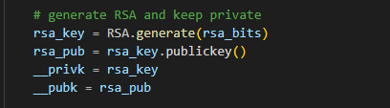
- Generate random AES key
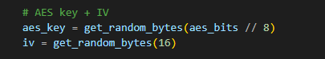
- User enters plaintext
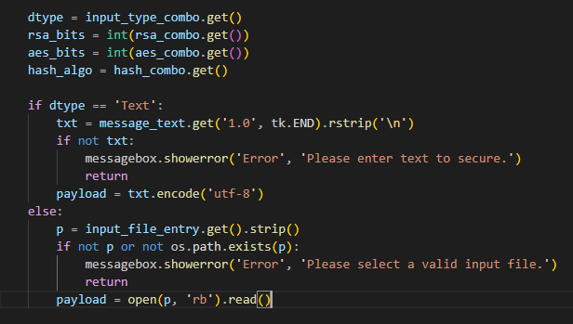
- Compute SHA hash
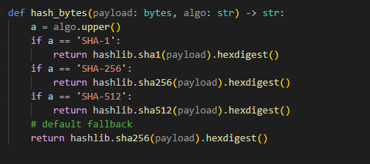
- Encrypt plaintext using AES
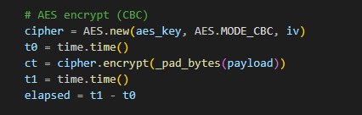
- Encrypt AES key using RSA public key
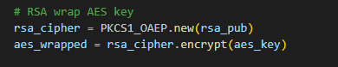
- Store encrypted key + ciphertext + hash in a file
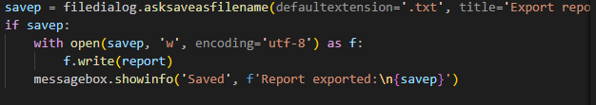

- For decryption:
- Decrypt AES key with RSA private key
- Decrypt data with AES
- Recompute SHA hash and compare
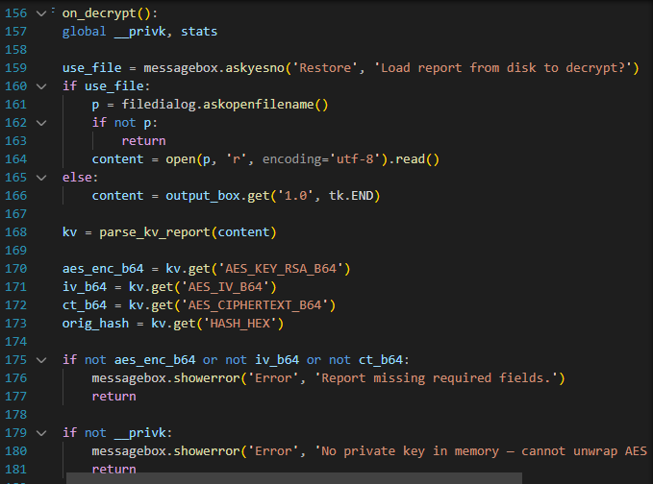

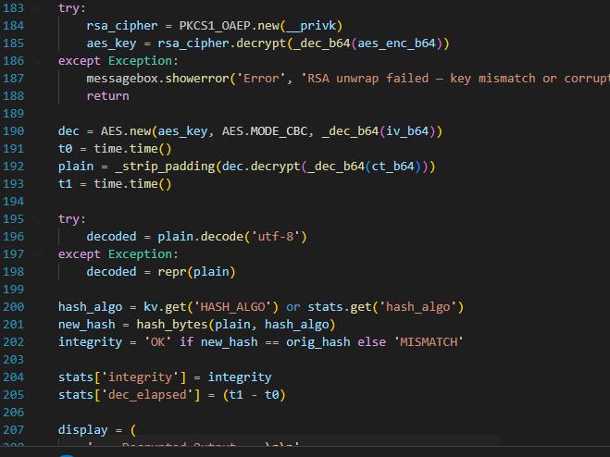
SOURCE CODE:
import tkinter as tk
from tkinter import ttk, filedialog, messagebox
from Crypto.Cipher import AES, PKCS1_OAEP
from Crypto.PublicKey import RSA
from Crypto.Random import get_random_bytes
import base64
import hashlib
import time
import os

def _pad_bytes(data: bytes) -> bytes:
return data + b"\0" * (AES.block_size - len(data) % AES.block_size)

def _strip_padding(data: bytes) -> bytes:
return data.rstrip(b"\0")

def _enc_b64(data: bytes) -> str:
return base64.b64encode(data).decode('utf-8')

def _dec_b64(s: str) -> bytes:
return base64.b64decode(s.encode('utf-8'))

def hash_bytes(payload: bytes, algo: str) -> str:
a = algo.upper()
if a == 'SHA-1':
return hashlib.sha1(payload).hexdigest()
if a == 'SHA-256':
return hashlib.sha256(payload).hexdigest()
if a == 'SHA-512':
return hashlib.sha512(payload).hexdigest()
# default fallback
return hashlib.sha256(payload).hexdigest()

# Session keys
__privk = None
__pubk = None

# stats kept for UI security summary
stats = {
'aes_size': None,
'rsa_size': None,
'hash_algo': None,
'enc_elapsed': 0.0,
'dec_elapsed': 0.0,
'integrity': 'Unknown'
}

def build_kv_report(aes_b64, aes_enc_b64, iv_b64, ct_b64, hash_hex, elapsed, aes_sz, rsa_sz, hash_algo):
parts = []
parts.append(f'AES_KEY_BITS={aes_sz}')
parts.append(f'RSA_KEY_BITS={rsa_sz}')
parts.append(f'HASH_ALGO={hash_algo}')
parts.append('')
parts.append(f'AES_KEY_RSA_B64={aes_enc_b64}')
parts.append(f'AES_IV_B64={iv_b64}')
parts.append(f'AES_CIPHERTEXT_B64={ct_b64}')
parts.append(f'HASH_HEX={hash_hex}')
parts.append(f'TIME_SECS={elapsed:.6f}')
return '\n'.join(parts)

def parse_kv_report(text: str):
out = {}
for line in text.splitlines():
if '=' in line:
k, v = line.split('=', 1)
out[k.strip().upper()] = v.strip()
return out

# ---------------- File / UI actions ----------------

def pick_input_file():
path = filedialog.askopenfilename()
if path:
input_file_entry.delete(0, tk.END)
input_file_entry.insert(0, path)
input_type_combo.set('File')

def on_encrypt():
global __privk, __pubk, stats

dtype = input_type_combo.get()
rsa_bits = int(rsa_combo.get())
aes_bits = int(aes_combo.get())
hash_algo = hash_combo.get()

if dtype == 'Text':
txt = message_text.get('1.0', tk.END).rstrip('\n')
if not txt:
messagebox.showerror('Error', 'Please enter text to secure.')
return
payload = txt.encode('utf-8')
else:
p = input_file_entry.get().strip()
if not p or not os.path.exists(p):
messagebox.showerror('Error', 'Please select a valid input file.')
return
payload = open(p, 'rb').read()

# generate RSA and keep private
rsa_key = RSA.generate(rsa_bits)
rsa_pub = rsa_key.publickey()
__privk = rsa_key
__pubk = rsa_pub

# AES key + IV
aes_key = get_random_bytes(aes_bits // 8)
iv = get_random_bytes(16)

# AES encrypt (CBC)
cipher = AES.new(aes_key, AES.MODE_CBC, iv)
t0 = time.time()
ct = cipher.encrypt(_pad_bytes(payload))
t1 = time.time()
elapsed = t1 - t0

# RSA wrap AES key
rsa_cipher = PKCS1_OAEP.new(rsa_pub)
aes_wrapped = rsa_cipher.encrypt(aes_key)

# compute hash of original
h = hash_bytes(payload, hash_algo)

report = build_kv_report(
_enc_b64(aes_key),
_enc_b64(aes_wrapped),
_enc_b64(iv),
_enc_b64(ct),
h,
elapsed,
aes_bits,
rsa_bits,
hash_algo
)

# show in output area and optionally save
output_box.config(state='normal')
output_box.delete('1.0', tk.END)
output_box.insert(tk.END, report)
output_box.config(state='disabled')

savep = filedialog.asksaveasfilename(defaultextension='.txt', title='Export report as...')
if savep:
with open(savep, 'w', encoding='utf-8') as f:
f.write(report)
messagebox.showinfo('Saved', f'Report exported:\n{savep}')

# update stats for later checks
stats['aes_size'] = aes_bits
stats['rsa_size'] = rsa_bits
stats['hash_algo'] = hash_algo
stats['enc_elapsed'] = elapsed

def on_decrypt():
global __privk, stats

use_file = messagebox.askyesno('Restore', 'Load report from disk to decrypt?')
if use_file:
p = filedialog.askopenfilename()
if not p:
return
content = open(p, 'r', encoding='utf-8').read()
else:
content = output_box.get('1.0', tk.END)

kv = parse_kv_report(content)

aes_enc_b64 = kv.get('AES_KEY_RSA_B64')
iv_b64 = kv.get('AES_IV_B64')
ct_b64 = kv.get('AES_CIPHERTEXT_B64')
orig_hash = kv.get('HASH_HEX')

if not aes_enc_b64 or not iv_b64 or not ct_b64:
messagebox.showerror('Error', 'Report missing required fields.')
return

if not __privk:
messagebox.showerror('Error', 'No private key in memory — cannot unwrap AES key.')
return

try:
rsa_cipher = PKCS1_OAEP.new(__privk)
aes_key = rsa_cipher.decrypt(_dec_b64(aes_enc_b64))
except Exception:
messagebox.showerror('Error', 'RSA unwrap failed — key mismatch or corrupted data.')
return

dec = AES.new(aes_key, AES.MODE_CBC, _dec_b64(iv_b64))
t0 = time.time()
plain = _strip_padding(dec.decrypt(_dec_b64(ct_b64)))
t1 = time.time()

try:
decoded = plain.decode('utf-8')
except Exception:
decoded = repr(plain)

hash_algo = kv.get('HASH_ALGO') or stats.get('hash_algo')
new_hash = hash_bytes(plain, hash_algo)
integrity = 'OK' if new_hash == orig_hash else 'MISMATCH'

stats['integrity'] = integrity
stats['dec_elapsed'] = (t1 - t0)

display = (
'--- Decrypted Output ---\n\n'
+ decoded
+ '\n\nIntegrity: ' + integrity
+ f'\nDecryption Time: {t1 - t0:.6f} sec'
)

output_box.config(state='normal')
output_box.delete('1.0', tk.END)
output_box.insert(tk.END, display)
output_box.config(state='disabled')

def run_security_audit():
s = (
'*** Security Summary ***\n\n'
f'AES (bits): {stats["aes_size"]}\n'
f'RSA (bits): {stats["rsa_size"]}\n'
f'Hash: {stats["hash_algo"]}\n'
f'Encrypt elapsed: {stats["enc_elapsed"]:.6f} sec\n'
f'Decrypt elapsed: {stats["dec_elapsed"]:.6f} sec\n'
f'Integrity: {stats["integrity"]}\n'
)
messagebox.showinfo('Security Audit', s)

# ---------------- GUI ----------------
app = tk.Tk()
app.title('HYBRID ENCRYPTION SYSTEM')
app.geometry('1100x650')

# Main container split: left controls, right output
container = ttk.Frame(app)
container.pack(fill='both', expand=True, padx=10, pady=10)

left = ttk.Frame(container)
left.pack(side='left', fill='y', padx=10)

right = ttk.Frame(container)
right.pack(side='right', fill='both', expand=True)

header = ttk.Label(left, text='HYBRID ENCRYPTION SYSTEM', font=('Segoe UI', 15, 'bold'))
header.pack(pady=6)

# Input Mode
sec1 = ttk.LabelFrame(left, text='Input Settings')
sec1.pack(fill='x', pady=6)

ttk.Label(sec1, text='Input Mode:').pack(anchor='w', pady=2)
input_type_combo = ttk.Combobox(sec1, values=['Text', 'File'], width=18, state='readonly')
input_type_combo.pack(pady=2)
input_type_combo.set('Text')

ttk.Label(sec1, text='Message / Data:').pack(anchor='w', pady=2)
message_text = tk.Text(sec1, width=45, height=6)
message_text.pack()

ttk.Label(sec1, text='File Path:').pack(anchor='w', pady=2)
input_file_entry = ttk.Entry(sec1, width=40)
input_file_entry.pack(side='left')
ttk.Button(sec1, text='Select...', command=pick_input_file).pack(side='left', padx=4)

# Crypto Settings
sec2 = ttk.LabelFrame(left, text='Crypto Settings')
sec2.pack(fill='x', pady=10)

ttk.Label(sec2, text='RSA Keysize:').pack(anchor='w')
rsa_combo = ttk.Combobox(sec2, values=['1024', '2048'], width=18, state='readonly')
rsa_combo.pack()
rsa_combo.set('2048')

ttk.Label(sec2, text='AES Keysize:').pack(anchor='w', pady=4)
aes_combo = ttk.Combobox(sec2, values=['128', '256'], width=18, state='readonly')
aes_combo.pack()
aes_combo.set('256')

ttk.Label(sec2, text='Hashing:').pack(anchor='w', pady=4)
hash_combo = ttk.Combobox(sec2, values=['SHA-1', 'SHA-256', 'SHA-512'], width=18, state='readonly')
hash_combo.pack()
hash_combo.set('SHA-256')

# Vertical Buttons
sec3 = ttk.LabelFrame(left, text='Actions')
sec3.pack(fill='x', pady=12)

ttk.Button(sec3, text='Encrypt Data', command=on_encrypt).pack(fill='x', pady=4)
ttk.Button(sec3, text='Decrypt Data', command=on_decrypt).pack(fill='x', pady=4)
ttk.Button(sec3, text='Security Review', command=run_security_audit).pack(fill='x', pady=4)
ttk.Button(sec3, text='Close', command=app.quit).pack(fill='x', pady=4)

# Output on right side
output_box = tk.Text(right, width=70, height=32)
output_box.pack(fill='both', expand=True)
output_box.insert(tk.END, 'Output panel — results will be displayed here.')
output_box.config(state='disabled')

app.mainloop()()

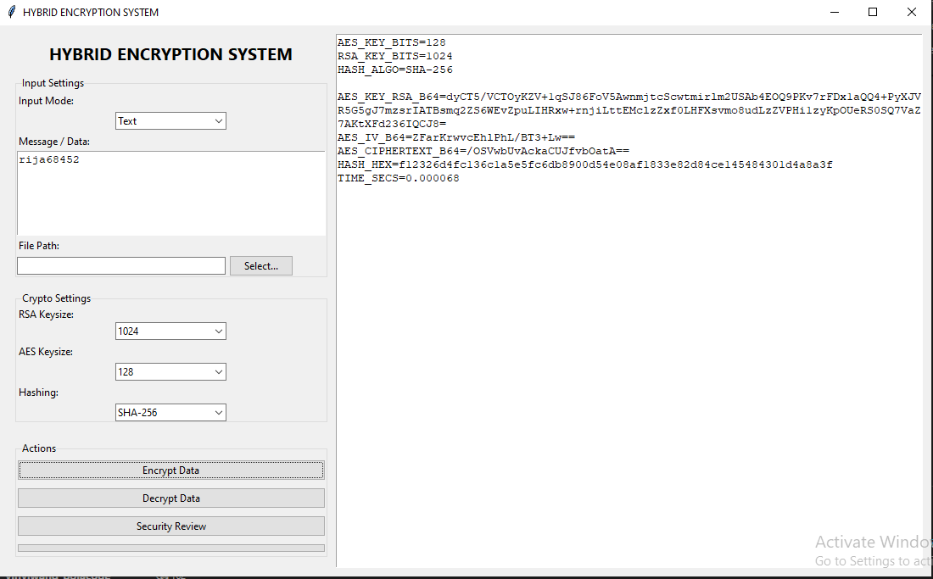
OUTPUT:

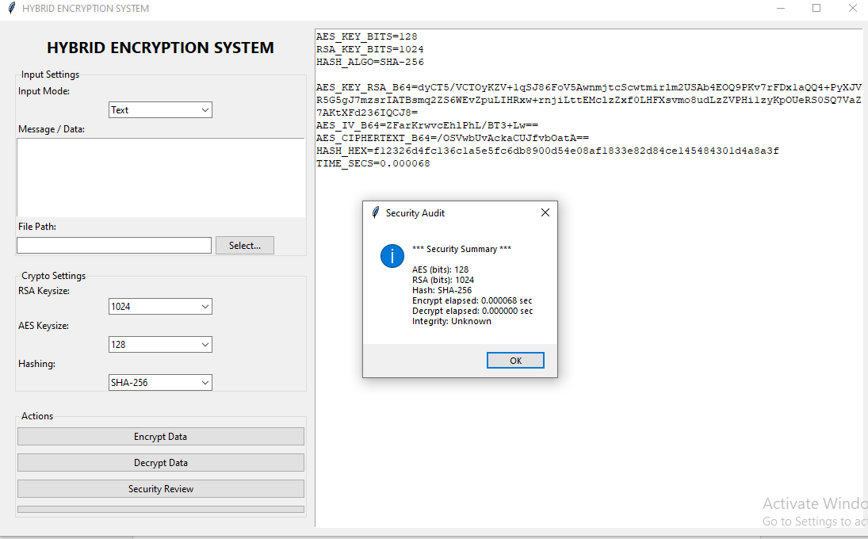

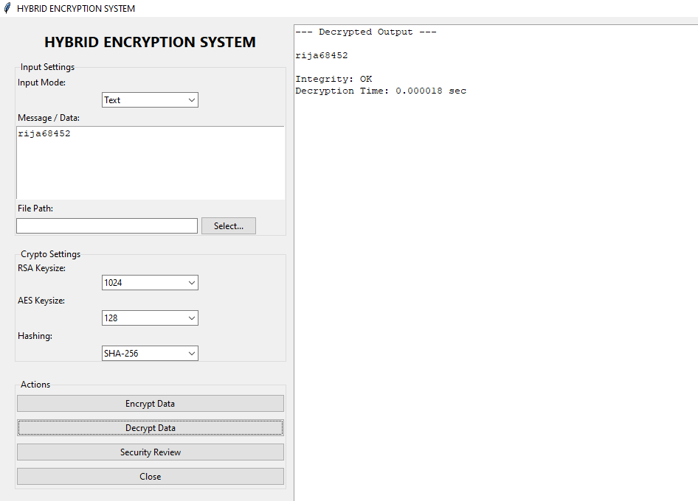

Data Collection
  - Sample text messages:
“Hybrid cryptography is used to provide confidentiality and secure key exchange.”
- File content:

