# ICT171 Assignment 2 – Cloud Server Project Documentation

Student Name: Rijan   
Student ID: 35318341  
Unit: ICT171 – Introduction to Server Environments and Architectures  
Project Title: Rijan’s Digital Art Gallery  
Global IP Address: 54.152.239.47  
Domain Name: [https://rijansht.com](https://rijansht.com/)  
GitHub Repository: <https://github.com/rijan777-af>  
Video Explainer:

**Project Overview**

**Rijan’s Digital Art Gallery is a cloud-hosted portfolio website deployed on an Amazon EC2 instance running Ubuntu and Apache2. This project demonstrates my technical proficiency in cloud deployment, Linux-based web server setup, secure domain configuration, SSL implementation, and automation using Bash scripting and cron.**

**The website features a clean, responsive layout using HTML and CSS, and showcases a selection of curated digital artworks sourced from Pinterest. These images are clearly marked as being used for academic demonstration only, in accordance with licensing best practices.**

**Key technologies used include:**

* **☁️ AWS EC2 for infrastructure**
* **🌐 Domain pointing via Amazon Route 53**
* **🔐 SSL security via Let’s Encrypt Certbot**
* **🖥️ Apache2 for hosting**
* **📜 Bash script with cron for automated Apache health checks**
* **🗂️ GitHub for version control and open-source transparency**

**This project fulfills the requirements of ICT171 by:**

* **Successfully deploying a secure, public-facing website**
* **Managing files and permissions in a virtualized Linux environment**
* **Demonstrating infrastructure automation and monitoring**
* **Using version control and a professional GitHub repository**
* **Including full documentation and licensing compliance**

**In addition to meeting all technical goals, the website reflects my personal interest in digital media and visual presentation. The footer and license sections clearly link to my public GitHub repository and provide transparency regarding image sources and open-source code.**

**Server Setup (Ubuntu + Apache2)**

**Step 1: Launch EC2 Instance**

* Platform: AWS EC2
* Image: Ubuntu Server 22.04 LTS
* Instance Type: t2.micro
* Security Group: Allow ports 22 (SSH), 80 (HTTP), 443 (HTTPS)

Screenshot: AWS EC2 dashboard showing instance IP and security rules

**Step 2: Connect to Server**

ssh -i keymate.pem [ubuntu@54.152.239.47](mailto:ubuntu@54.152.239.47)

**Step 3: Install Apache2**

sudo apt update && sudo apt upgrade -y

sudo apt install apache2 -y

Screenshot: Apache2 installation

**Step 4: Enable Firewall Rules**

sudo ufw allow 'Apache Full'

sudo systemctl enable apache2

sudo systemctl start apache2

Screenshot: Apache2 status and firewall enabled

**Domain & DNS Configuration**

* Domain Registrar: Amazon Registrar
* A Record set to: 54.152.239.47

Screenshot: AWS DNS settings

**SSL/TLS Setup**

sudo apt install certbot python3-certbot-apache -y

sudo certbot --apache -d rijansht.com

Screenshot: Certbot output and HTTPS lock icon on browser

**Website Deployment**

**Step 1: Uploading Files via SCP**

scp -i keymate.pem index.html ubuntu@54.152.239.47:/var/www/html/

scp -i keymate.pem -r images/ ubuntu@54.152.239.47:/var/www/html/images/

**Step 2: Set Permissions**

sudo chown -R www-data:www-data /var/www/html

Screenshot: SCP upload and permissions

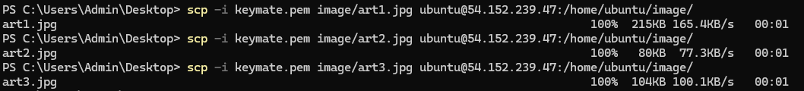

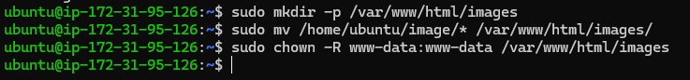

**Bash Script – Apache Status Logger**

**File: check_apache.sh**

#!/bin/bash

echo "Check on $(date)" >> /var/log/apache_check.log

systemctl status apache2 | head -n 10 >> /var/log/apache_check.log

**Cron Job**

crontab -e

*/30 * * * * /home/ubuntu/check_apache.sh

Screenshot: cron job configuration and output in log file

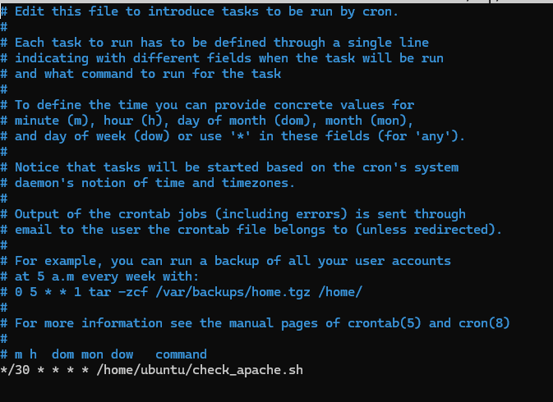

**GitHub & Version Control**

**Key Steps:**

git init

git add .

git commit -m "Initial commit"

git branch -M main

git remote add origin https://github.com/rijan777-af/rijansht-art-gallery

git push -u origin main

Screenshot: GitHub repository, commit log, and project files

REPO URL: https://github.com/rijan777-af/rijan-digital-art-gallery



**License & Attribution**

* Website Code: Licensed under [CC BY 4.0](https://creativecommons.org/licenses/by/4.0/)
* Images:
  + art1.jpg, art2.jpg, and art3.jpg are from Pinterest and used only for academic demonstration.

Badge:

<a href="https://creativecommons.org/licenses/by/4.0/" target="_blank">

<img src="https://licensebuttons.net/l/by/4.0/88x31.png" alt="Creative Commons License" />

</a>

**GitHub Version Control**

To manage version control for this project, I used Git and GitHub. I created a GitHub repository named rijan-digital-art-gallery which contains all website files including HTML, CSS, images, license, and project documentation.

**Repository Details:**

* 🔗 GitHub URL: <https://github.com/rijan777-af/rijan-digital-art-gallery>
* 📁 Contains:
  + index.html – website source code
  + images/ – gallery images (sourced from Pinterest)
  + README.md – project overview and student details
  + LICENSE – Creative Commons license

GIT COMMAND USED

git init

git add .

git commit -m "Initial commit – ICT171 Assignment 2"

git branch -M main

git remote add origin https://github.com/rijan777-af/rijan-digital-art-gallery.git

git push -u origin main

These commands were used to initialize the local repository, track project files, create the initial commit, and push everything to the main branch of the remote repository on GitHub.

**License & Attribution**

**This project uses open-source code under the CC BY 4.0 License.  
All images are sourced from Pinterest and are used for academic demonstration only — they are not licensed for reuse or distribution.**

**Attribution and license details are included on the website and in the GitHub repository.**

**Website Source Code**

The HTML and CSS code used in this project is licensed under:

**Creative Commons Attribution 4.0 International (CC BY 4.0)**  
🔗 https://creativecommons.org/licenses/by/4.0/

This license allows others to:

* Copy, modify, and share the code
* Use it for personal, academic, or commercial purposes
* As long as attribution is given to the original author

**Images Used in the Gallery**

All three images (art1.jpg, art2.jpg, art3.jpg) are sourced from **Pinterest** and are:

* Not original creations
* Not owned by me
* Not licensed under Creative Commons

They are used solely for **academic demonstration purposes** as part of this ICT171 assignment. These images are not intended for redistribution, reuse, or public release beyond this educational context.

A notice is clearly displayed on the website under each artwork stating:

“Source: Pinterest – Used for academic demonstration only.”

**Website Disclosure**

* A license badge for CC BY 4.0 is displayed on the website
* The GitHub repository also contains a LICENSE file
* The footer includes a link to the public GitHub source code

**Video Explainer**

Content:

* EC2 setup walkthrough
* Apache status
* File upload via SCP
* Domain access & SSL
* Script functionality
* GitHub code and commit history

**Final Submission Checklist – ICT171 Assignment 2**

This checklist verifies that all project requirements have been completed for ICT171 Assignment 2. The project was developed, tested, and deployed following the specified unit guidelines.

| **Task Description** | **Completed?** |
| --- | --- |
| EC2 instance created and running on AWS | ✅ Yes |
| Apache2 installed and serving index.html | ✅ Yes |
| HTML file uploaded and displays on <https://rijansht.com> | ✅ Yes |
| Custom domain name (rijansht.com) correctly points to EC2 IP (via Route 53) | ✅ Yes |
| Let’s Encrypt SSL installed and site accessible over HTTPS | ✅ Yes |
| Bash script (check_apache.sh) created and logs Apache status | ✅ Yes |
| Cron job set to run the script every 30 minutes | ✅ Yes |
| GitHub repository created: [github.com/rijan777-af/rijan-digital-art-gallery](https://github.com/rijan777-af/rijan-digital-art-gallery) | ✅ Yes |
| GitHub repo contains index.html, images/, LICENSE, and README.md | ✅ Yes |
| License section clearly describes CC BY 4.0 and Pinterest image use | ✅ Yes |
| Git used for version control with correct commit history | ✅ Yes |
| Screenshots taken: EC2 setup, SCP uploads, cron, browser, GitHub repo | ✅ Yes |
| README.md created and uploaded to GitHub | ✅ Yes |
| GitHub URL included on website footer | ✅ Yes |
| Final documentation written and exported as a single PDF | ✅ Yes |
| PDF file named correctly: ICT171_Assignment2_35318341.pdf | ✅ Yes |