Contents Page No.

1. Introduction:

For the first semester, this report is done for the Web Development (CSY-1018) subject. This subject is kept in the module to teach the students about the web designing by the use of some programming languages such as HTML, CSS. As we have only learned HTML5 and CSS3, only HTML5 and CSS3 has been used to make those webpages. Most of the instructions were given protocols and we had to validate our HTML and CSS files as per given. The other major requirement was to use GitHub for the completion of the project. We had to use some basic Git commands and also have a live URL in GitHub.

1. Development:

Development of the webpages was a multi-step process. When I was provided with the details of this project, I started brain storming ideas. I also took some ideas from a few other personal websites. Then I made a proper wire framing for the webpages. Then finally those wireframes were made into webpages.

1. Brain Stormed ideas:

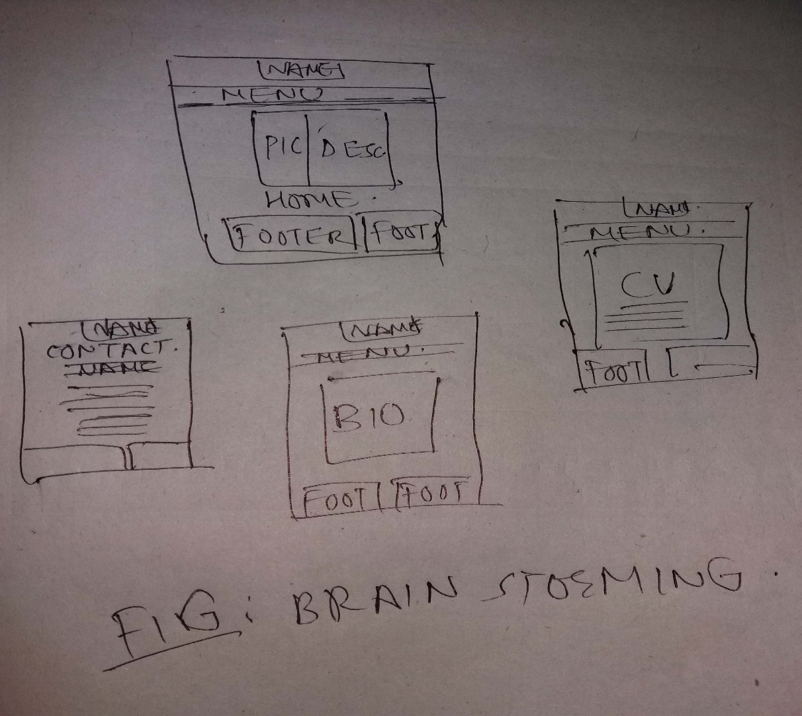

Fig.: Brainstorming Ideas

I simply made a couple of small figures before making actual wireframes. They were the first hard copy representation of the webpage ideas. I have taken some ideas in gist from webpages in internet.

1. Wire-Framing

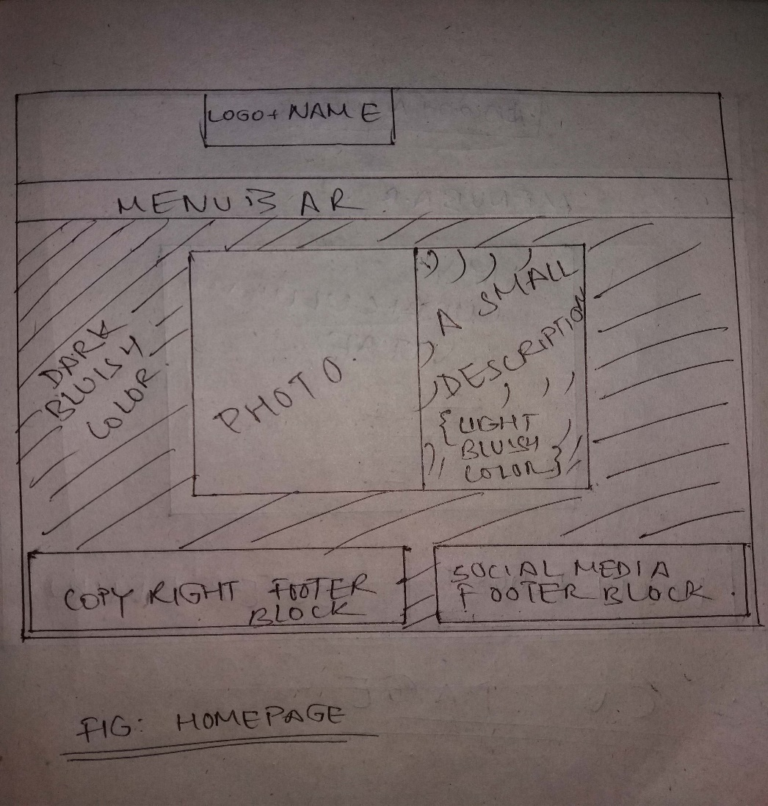

Fig.: Home-Page

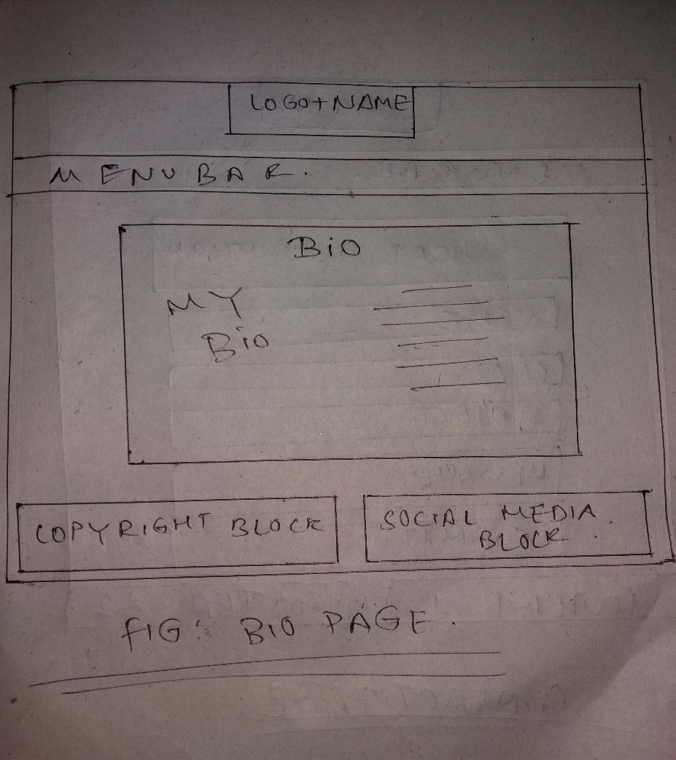

Fig.: Bio Page

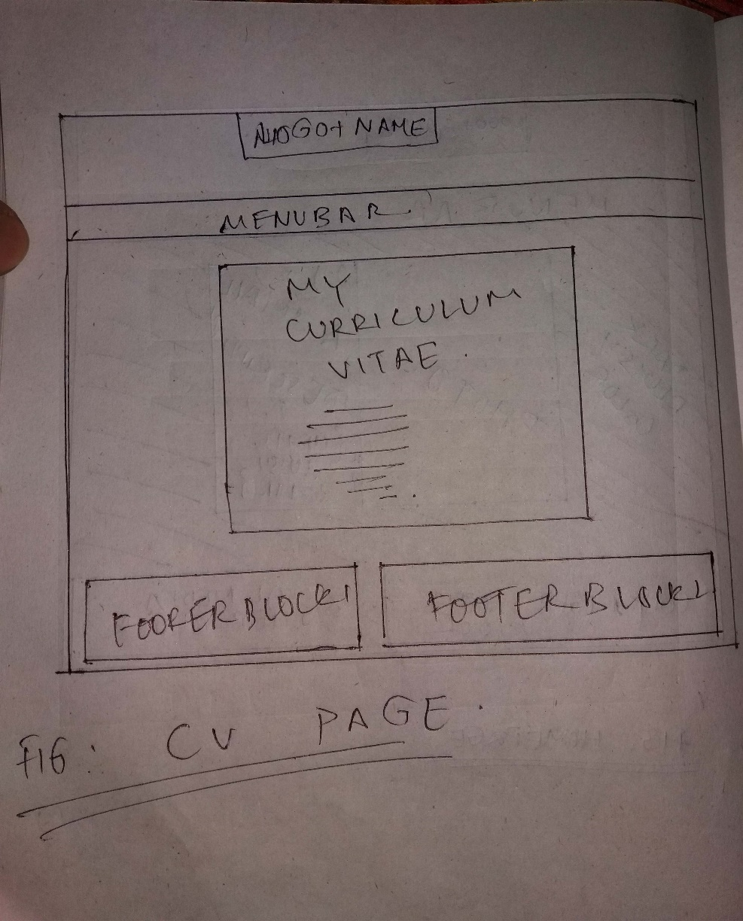

Fig.: CV Page

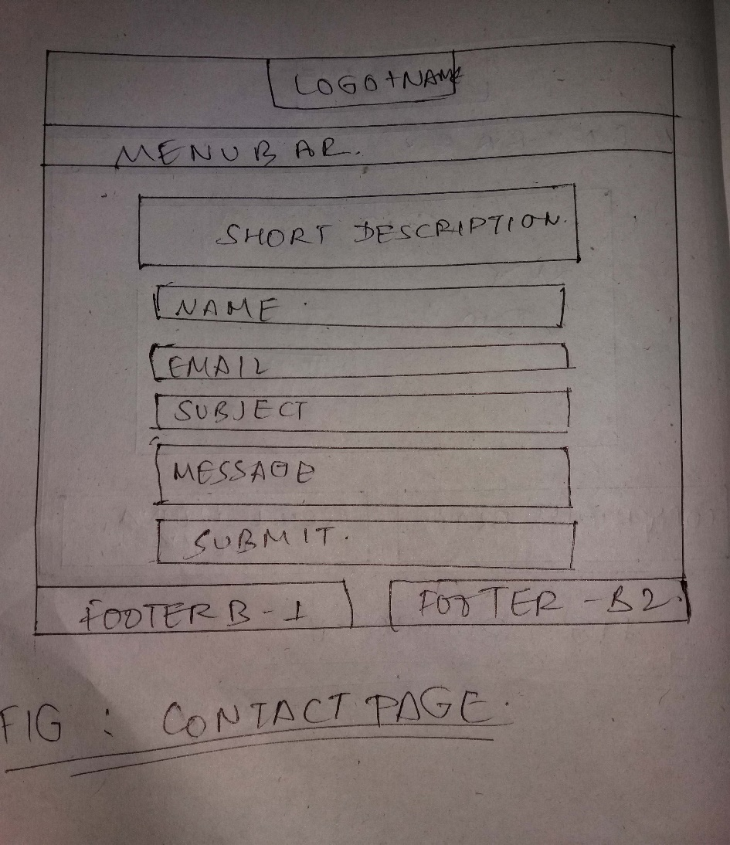

Fig.: Contact Page