**Hand Gesture Recognition using open CV**

Rijesh Shrestha, Parangat Narsingh Pradhan

Department of Computer Science And Engineering

School of Engineering & Technology

Sharda University,Greater Noida-201310

Email:2018011897.rijesh@ug.sharda.ac.in

2018009122.parangat@ug.sharda.ac.in

**Abstract:**

Hand Gesture Recognition is interpreting human hand gestures via mathematical algorithms.Image identification is becoming a crucial step in most of the modern world problem-solving systems. Approaches for image detection, analysis and classification are available in numbers, but the difference between such approaches is still arcane.It essential that proper distinctions between such techniques should be interpreted and they should be analyzed.  The main aim is to recognize and classify such hand gestures to their correct meaning with the maximum accuracy possible.

In this research we have used different approach where it tells the recognition of sign language and tells the corresponding English alphabet using Contour Analysis and Feature Extraction Technique. This study aims for hand detection The principal goal of this project was the design of a software for tracking and

extraction of features of object, specifically human using Open CV.

**Keywords**-contours,convexity defects,convex hull,open CV

1. **Introduction**

Understanding sign language is a tedious task and it is a skill that has to be learned with practice. But with this paper, we aim to provide several schemes of identifying and understanding such letters without learning the sign language. We focus primarily on the development of new procedures to understand sign language, and to find differences between the approaches and best method of recognition of the sign language. There are several difficulties developing a better method for sign recognition such as in real life images captured are so excessively noisy that high level of pre - processing is required.American sign language is a widely used language for physically impaired (as shown in Fig 1). The main model is constructed to recognize sign gesture images of the hand, Creation of image threshold-Finding Contours-find Convex hull and convexity defects lastly calculate it.

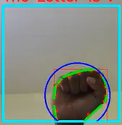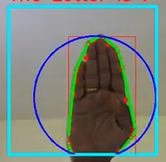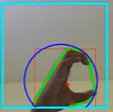

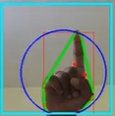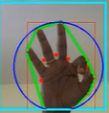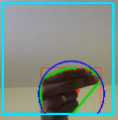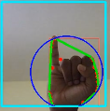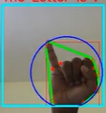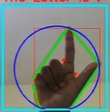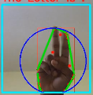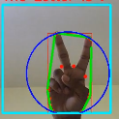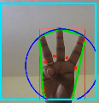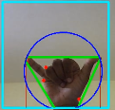

**Fig:1**

1. **Literature Review**

Almost only in India, 19% of people are affected from hearing impairment and 7% are affected from speech impairment. The normal means of communication between other non-disabled people is difficult for them as most of the people find sign language hard to understand. Here the problem is the vast interaction difficulties that an impaired person faces while trying to communicate with most of the people who don’t know sign language. In this proposed work, an effort has been placed to

recognize ASL Alphabets and Numbers, which mainly depends only on hand and fingers. The process of identifying ASL Alphabets and Numbers is distributed as

preprocessing the input image, computation of the region properties of the preprocessed image, and transliteration from treated image to text.

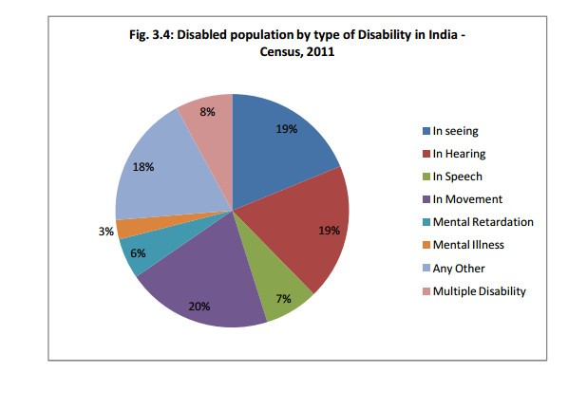

1. **Process**

Most of the researchers classified gesture recognition system into mainly three steps after acquiring the input image from camera(s), videos or even data glove instrumented device. These steps are: Extraction Method, features estimation and extraction, and classification or recognition.

**Step1:**

Creation of image threshold. Isolating the foreground from the

Background is essential as we want the hand to be the region of Interest.

**Step2:**

Finding Contours. The Hand is identified using an inbuilt function that finds Contours which OpenCV provides . The function is later then returns an array of co-ordinates of the formation of the Contour

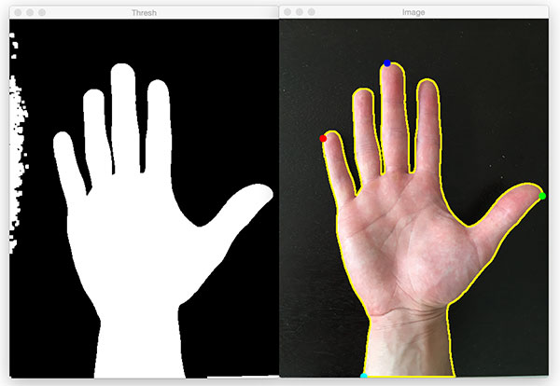

**Step3:**

Convex hull and convexity defects.The data obtained from the contour’s is later used to obtain entity known as “Convexity defects”.They are the

irregularities in contours. Based on the value of this , we can Identify how many fingers are present . This is valuable information as it provides information as to which Letter is corresponding. 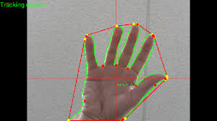

**Calculation:**

We compute a triangle . Let the sides be “a” ,”b” and “c” . This

triangle is formed by the starting point of the contour , the ending point of the contour and the farthest point of the contour . (a , b , c respectively ) . “a” is computed as follows

a = math.sqrt((end[0] - start[0])**2 + (end[1] - start[1])**2) [7]

Similarly , b and c are also calculated .Now using the cosine rule to calculate the angles.

**Step4: Identification.**

**Letter A:** For identifying A , we computed the difference between the area of a

circle and the area of the contour . The circle is obtained by bounding the contour . The reason this method is adopted for A is that there is very little difference between the two areas (mentioned above ) which makes the Letter A stand out from the other letters . Hence this algorithm was found to be very efficient .

**Letter B:** For the letter B , we computed the contour area . This method is adopted because the Letter B has the largest area among the other letters .

**Letters V, C, L, Y:** This part gets executed when the Letter A fails . If the number of convexity defects are equal to 1 , the following algorithm is employed . The “angle” is calculated . This entity is obtained by an OpenCV inbuilt function that calculates the overall figure’s orientation , giving us an angle . Based on the values of the angle , Letters V , C, L and Y are identified .

**Letters F and W:** Letters F and W are the only alphabets in the American Sign Language to have 2 convexity defects . Once 2 convexity defects are identified , the angle is compared . Hence the Letters F and W are identified in this manner.

**Letters D, J, H, I, U:** A combination of parameters are computed to identify these letters , Solidity , Aspect ratio and Angles are computed .

On intensive testing of Contour Parameters , we found the above parameters to be reliable and efficient .

**4.Conclusions & challenges faced**

The principal goal of this project was the design of a software for tracking and

extraction of features of object, specifically human using Open CV. 13 Letters are

currently being able to be recognised . Further research into this project can be

done. The advantage of this solution is that it does not require any special inputs.

Ordinary digital image of human hand is sufficient and algorithm can process

stream of such images in real time.

The main challenge is the lightning condition of the environment, there should be a proper lighting else there would be difficulties while detecting the hand and the other problem faced is the background removal as it would detect the other objects while facing the webcam.

1. **References**

1.B M Chethana Kumara, H S Nagendraswamy and R

Lekha Chinmayi, “Spatial Relationship Based Features

for Indian Sign Language Recognition”, International

Journal of Computing, Communications &

Instrumentation Engineering, Vol. 3, Issue 2, ISSN 2349-

1469, 2016.

2.Srinath S, Ganesh Krishna Sharma, “Classification

approach for Sign Language Recognition”, International

Conference on Signal, Image Processing, Communication

& Automation, 2017.

3.Shivashankara S, Srinath S, “A comparative Study of

Various Techniques and Outcomes of Recognizing

American Sign Language: A Review”, International

Journal of Scientific Research Engineering & Technology

(IJSRET), Vol. 6, Issue 9, pp.1013-1023, 2017.

4.Shivashankara S, Srinath S, “A Review on Vision Based

American Sign Language Recognition, its Techniques,

and Outcomes”, 7th IEEE International Conference on

Communication Systems and Network Technologies

(CSNT-2017), pp.293-299, 2017.

5.Helen Cooper, Brian Holt, Richard Bowden, “Sign Language Recognition”,