**User Manual**

**Having Trouble here?**

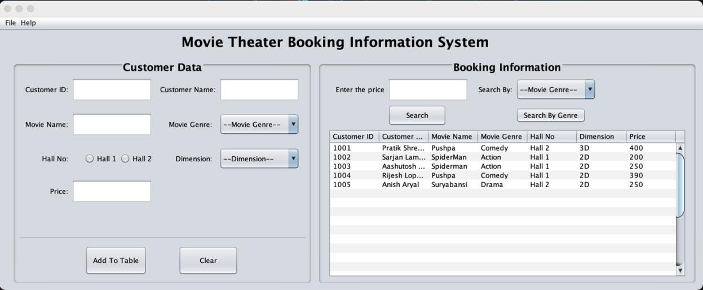

**This might help you:**

1. The GUI doesn’t accept letters for:

* Movie ID
* Price

The value must be entered as a number, ranging from 0 to 9.

1. The field in the GUI should be filled else a warning message is displayed.
2. The data of the customer can be added by clicking ‘Add to Table’ button by filling up all the field. After adding data to the table, a pop up will appear as below:

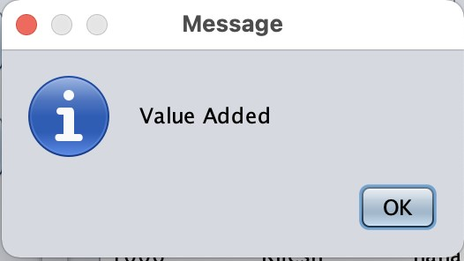

1. The ‘clear’ button clears all the text fields, radio button and combo box of the GUI. 5. For exiting program user can use CTRL + x or click in file of the menu bar and click on ‘Exit’.

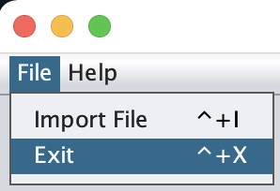

**Having Trouble here?**

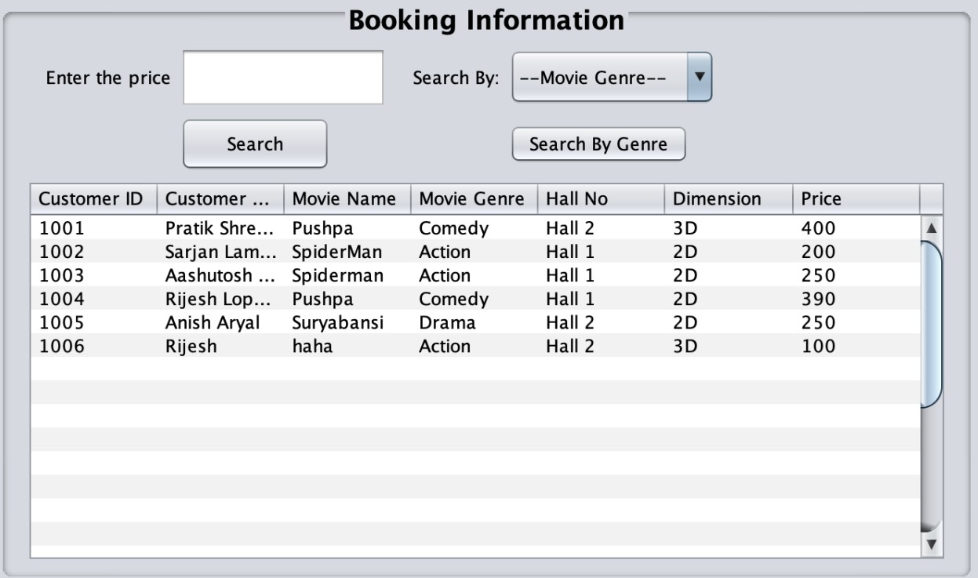

**This might help you:**

1. The ‘Search by price” text field only accept integer if user tries to input string value it will not be entered in the text field.
2. The ‘Search’ button helps user to search for data of customer of entered price in the ‘Search by price’ text field.
3. If the entered price is repeated then the first data of that price is displayed.
4. The ‘Search by Genre’ button helps user to search the number of data present in the respective genre which user can choose from the combo box.
5. The user can import existing data into the table from the file option of the menu bar, where user can see import option or user can use a shortcut key i.e., CTRL + I **Shortcut keys:**

* For importing data: CTRL + I
* For opening user manual: CTRL + M
* For exiting the program: CTRL + X