- Depth-First Search (DFS) Algorithm:
  - Explain how the DFS algorithm works, and describe it using pseudocode or an algorithm.
Depth-First Search (DFS) is an algorithm for traversing or searching tree or graph data structures. The algorithm starts at the root (or an arbitrary node) and explores as far as possible along each branch before backtracking. It uses a stack (often implicitly through recursion) to remember the nodes to visit next.
  - Implement the 8-puzzle problem using the DFS algorithm in Python.
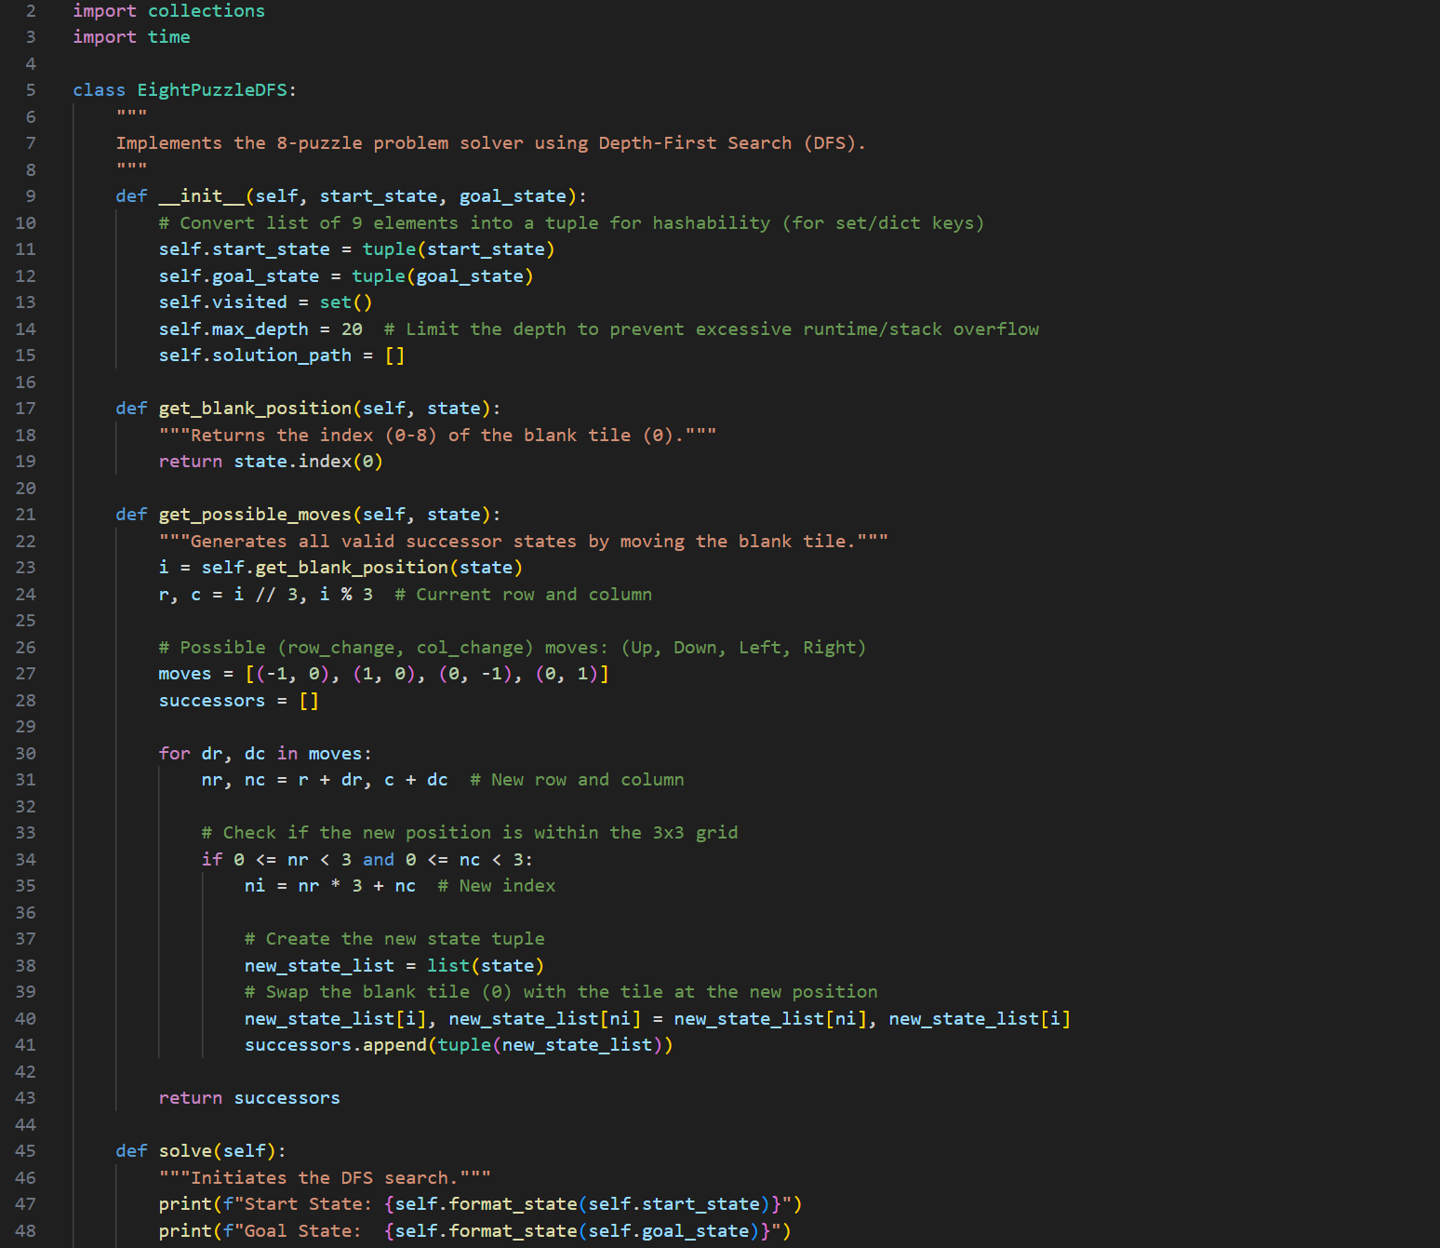
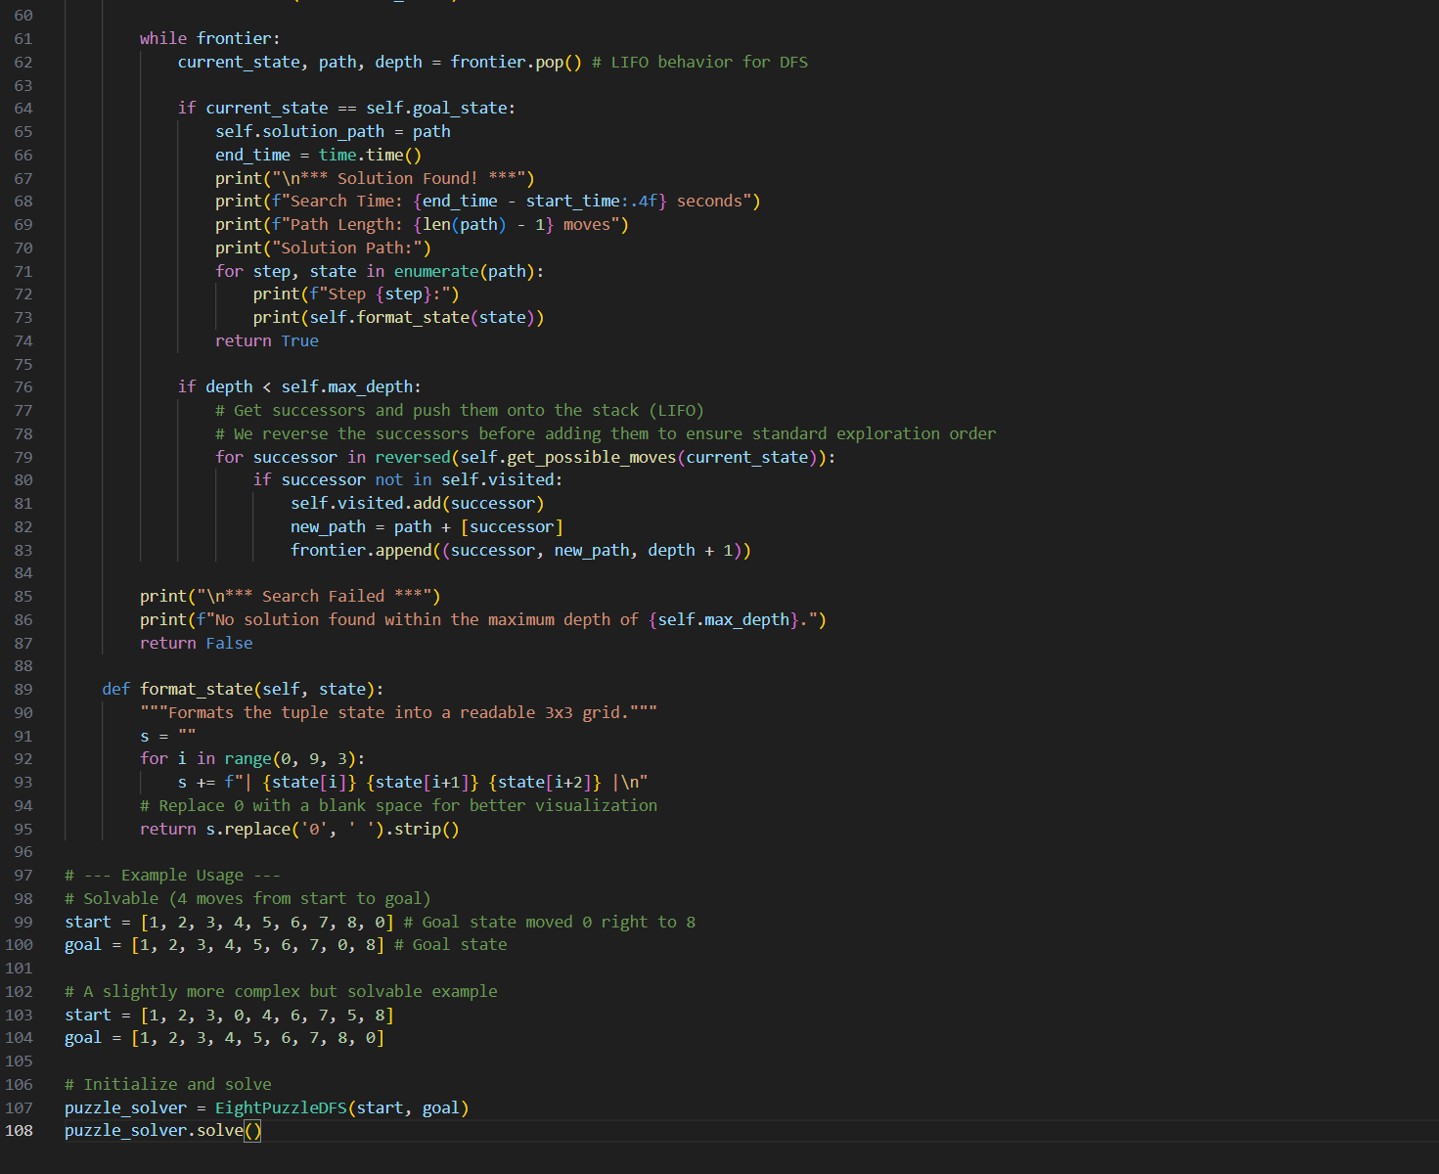
  - Include screenshots of your code and its output. Please write your name as a comment in the code.
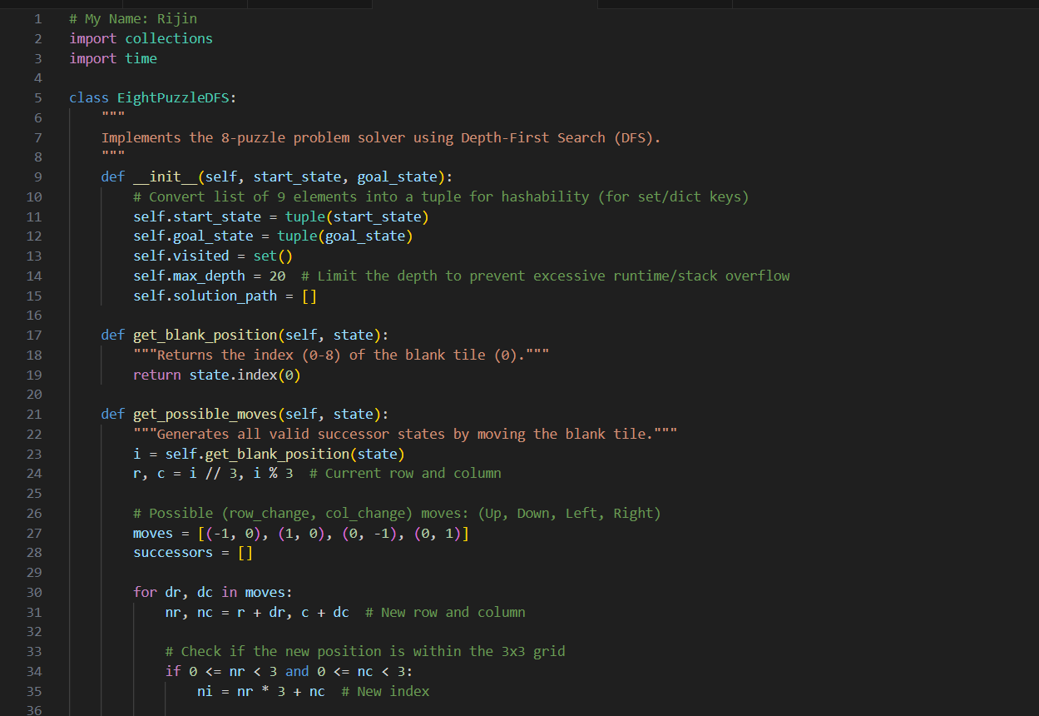
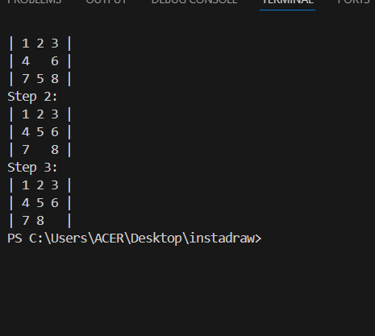
  - Discuss why, in some cases, DFS may fail to find a solution for this problem.
For the 8-puzzle problem, DFS may fail to find an optimal solution, or even any solution within a reasonable time, due to two main reasons:
a. Non-Optimality (Finding the Long Path): DFS is not guaranteed to find the shortest path. It dives deep into one branch first. If the shortest path is at a shallow depth, but the algorithm chose a very long, irrelevant path first, it will find the long solution and stop, ignoring the optimal one.
- Infinite Loop/Path Exploration (Failure to Terminate): The state space of the 8-puzzle is finite ($9!/2 = 181,440$ reachable states). However, without a mechanism to track visited states (as implemented in the code above), DFS can get trapped in a loop, repeatedly moving between the same few states on a branch, especially in a graph structure. Even with cycle detection, DFS is not complete in a graph with infinite depth paths or an infinite state space. Although the 8-puzzle is finite, DFS's tendency to explore one path to its maximum depth means that if the goal is at a shallow depth, but the algorithm is stuck exploring an extremely long or redundant path, it will effectively fail to find the solution within a practical time limit or the maximum recursive depth/memory limit. The depth limit in the provided code is a common, non-guaranteed way to prevent this practical failure.
- Breadth-First Search (BFS) State Space Design:
  - While implementing BFS in Python, did you first construct the entire state space (tree or graph) before starting the search, or did you build it dynamically during the search?
When implementing BFS in Python, I would build the state space dynamically during the search, rather than constructing the entire graph/tree beforehand.
Approach and Justification
- Approach: The BFS algorithm uses a queue (First-In, First-Out, FIFO) to manage the frontier of states to be explored.
  - Start by adding the initial state to the queue.
  - Maintain a visited set to store all states encountered.
  - In each step, dequeue the next state.
  - If it's the goal, stop.
  - Otherwise, generate its successors (neighbors).
  - For each new, unvisited successor, add it to the visited set and enqueue it.

  - Explain the approach you took, and justify why you chose that method.
• State Space Size: The 8-puzzle has a relatively small state space (181,440 reachable states). However, for larger problems, such as the 15-puzzle ($10^{13}$ reachable states) or problems with a theoretically infinite state space (like an agent moving in an unbounded grid), constructing the entire state space in memory is impossible or impractical.
• Memory Efficiency: Building the state space dynamically means we only store the nodes in the frontier (queue) and the nodes already visited, which is generally a small fraction of the total space at any given time, saving significant memory.
• Completeness/Relevance: Since BFS guarantees finding the shortest path (it explores layer-by-layer), we are guaranteed to find the goal state the first time we encounter it. Generating irrelevant parts of the search space beforehand would be a waste of computation. We only generate the states necessary to connect the start state to the goal state.
- Informed Search vs. BFS:
  - What do you understand by the term informed search?
Informed search, also known as heuristic search, is a type of search strategy that uses problem-specific knowledge beyond the definition of the state space. This knowledge, called a heuristic function , estimates the cost from the current state to the goal state. This allows the search algorithm to explore the most promising states first, significantly improving efficiency compared to uninformed methods.

  - How does informed search differ from Breadth-First Search (BFS)?
BFS blindly explores neighbors in a level-by-level manner, whereas Informed Search strategically guides the search towards the goal using an educated guess (the heuristic value).
- Heuristic Values in Informed Search:
  - Define heuristic values in the context of informed search algorithms.
A heuristic value, denoted AS, in the context of informed (or heuristic) search algorithms is an educated estimate of the cost of the cheapest path from the current state to the goal state.

  - List a few common heuristic functions and mention their application areas.
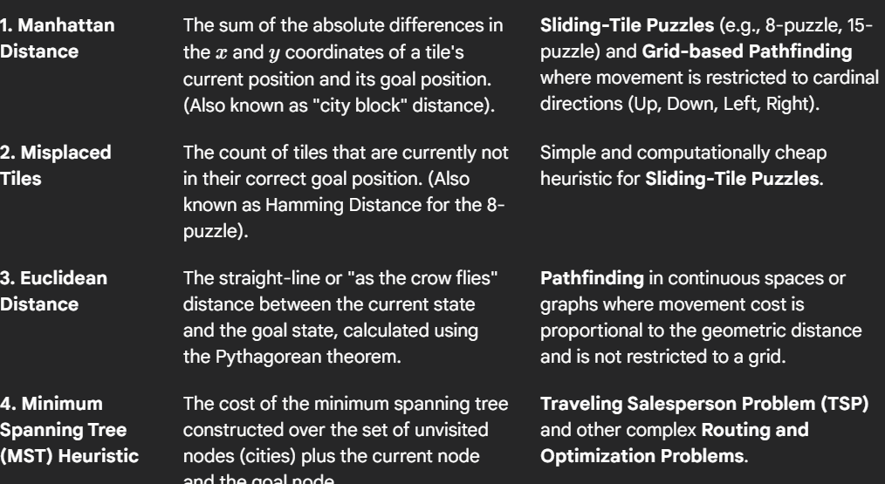
- A* Algorithm for Binary String Matching:
  - How can the A* algorithm be applied to solve the problem of binary string matching?
Example: From the start state 10110101 to the goal state 01100011.
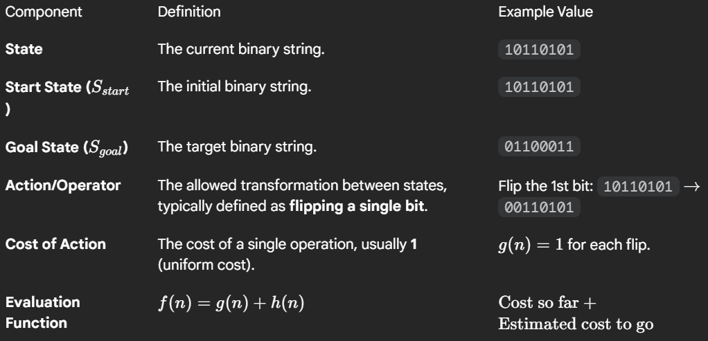
  - Implement the A* algorithm in Python to solve this problem.
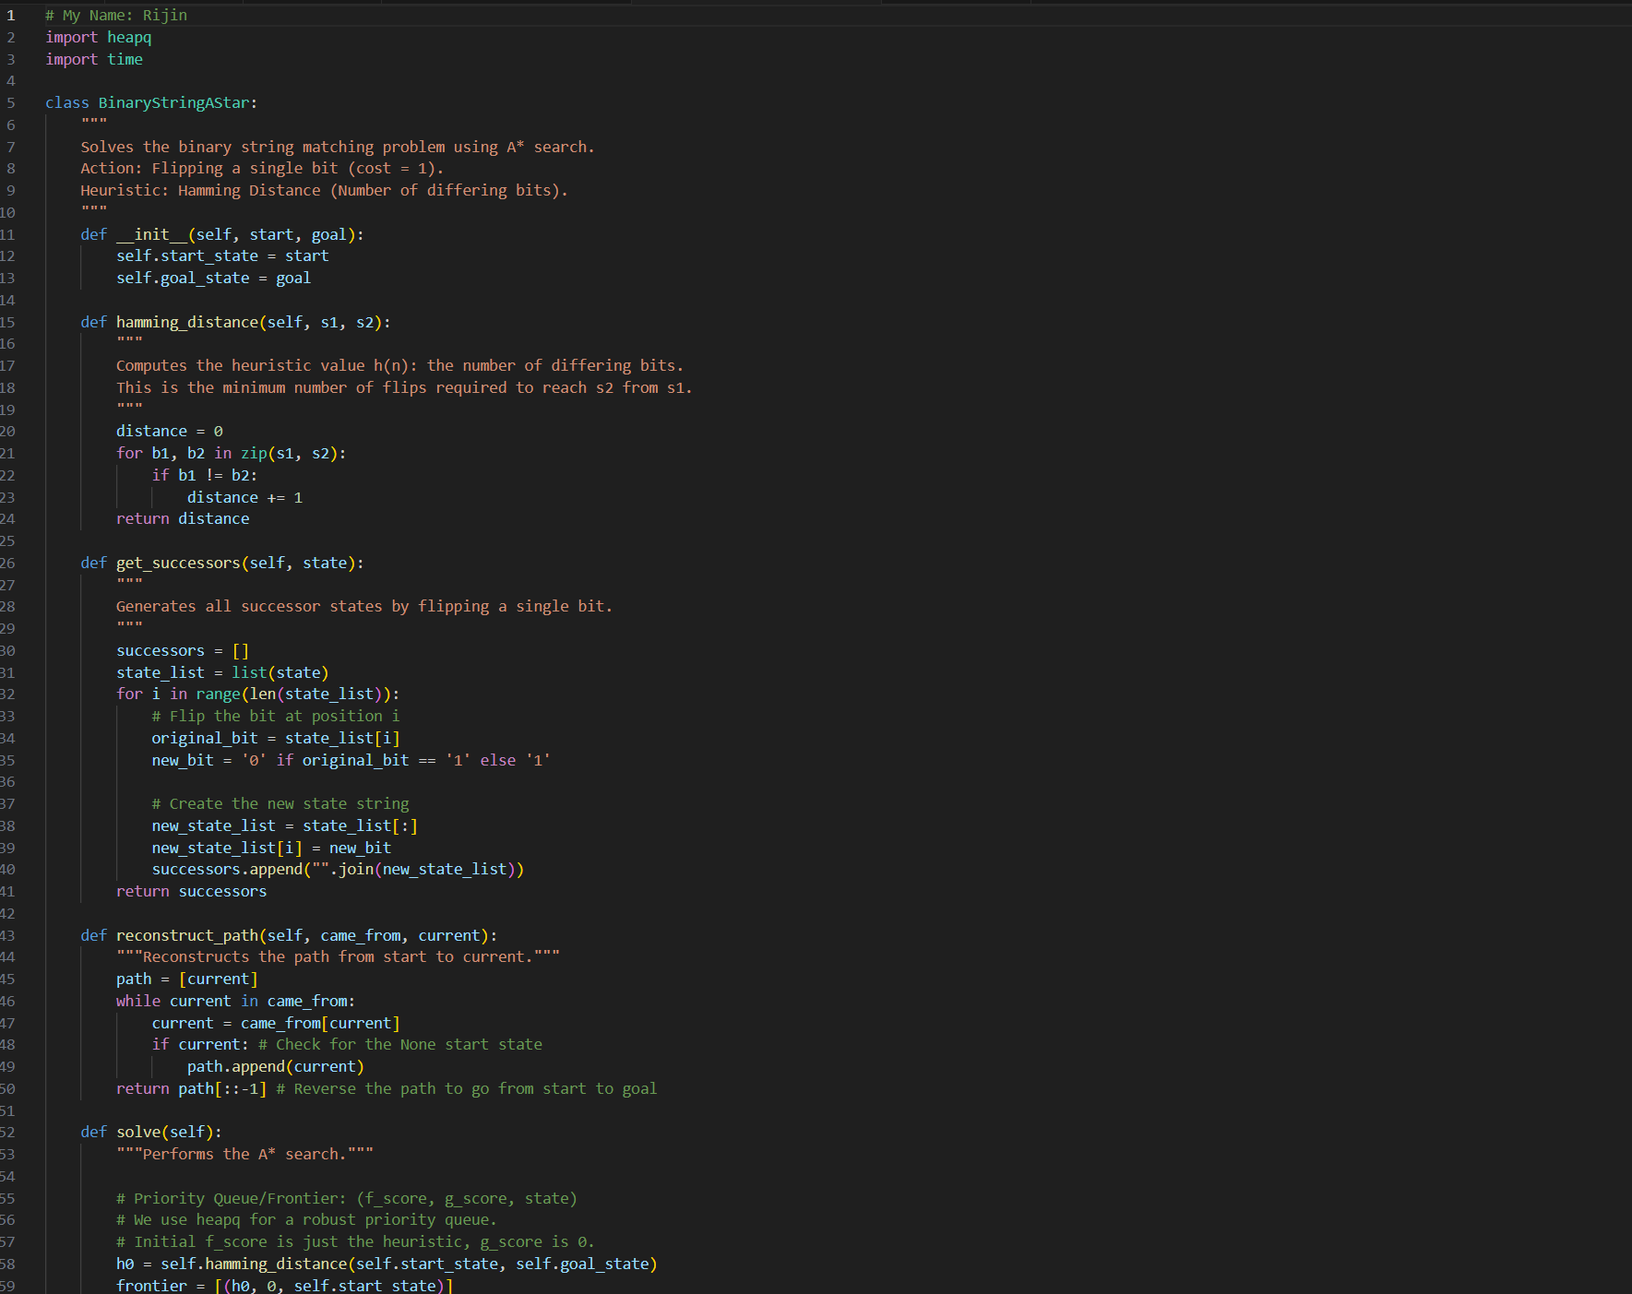

  - Include screenshots of your code and output, and write your name as a comment in the code.

   