Rijish Ganguly

CEE 690: MBDS

Mark Borsuk and Christopher Krapu

Bitcoin – as a Financial Asset

A comparison of optimal portfolios with and without Bitcoin

Introduction

This paper seeks to estimate the Beta of Bitcoin with respect to two different portfolios and

answer the question whether we should include bitcoin as part of our investment portfolio using Markowitz Portfolio Optimization. It begins with a brief introduction to Bitcoin and challenges of investing in Bitcoin followed by a concise description of Beta calculation using the CAPM (Capital Asset Pricing Model) theory, results from calculation of Betas with respect to two different portfolios and lastly, the efficient frontier obtained from including Bitcoin to an existing portfolio of thirteen randomly selected stocks.

Bitcoin is a decentralized digital currency without a central bank or single administrator that can be sent from user to user on the peer-to-peer bitcoin network without the need for intermediaries.1 The average non-technical person who invests in the financial markets/cryptocurrencies is acquainted with Beta and Alpha as they are fundamental measurements to determine a portfolio's performance. Hence, learning about the Beta of Bitcoin is of utmost importance to an investor.

Currently, there is not a sufficient amount of research to conclude whether bitcoin responds positively to a bearish stock market. The world’s biggest cryptocurrency Bitcoin has enjoyed a very loose relationship with other assets during its brief history, but that could be changing. A recent report from Digital Asset Data showed that from May-July 2019, Bitcoin has moved in tandem with gold and has swung inversely to moves in the stock market. The findings tend to signal that Bitcoin for that particular period behaved more like a store of value and is potentially being used as a safe-haven asset during global uncertainty in traditional markets.

The historical method used to estimate Beta is to regress asset returns against market returns. The slope of the regression corresponds to the Beta of the asset and measures the riskiness of the asset. We decide on an estimating period, decide on a return interval and choose a particular market index.

Any insights gleaned from my study can be applied to any part of the world. However, my study is focused on the US financial markets and I'll be using two indices S&P 500 and the Dow Jones and to determine the volatility of Bitcoin. The study can be expanded, and the Beta of any cryptocurrency can be estimated with respect to a local benchmark index. A potential correlation that would be interesting from a practical point of view would be correlation between Bitcoin with S&P 500. If bitcoin is not correlated to the stock market, it may make it an excellent addition to a traditional portfolio for diversification. And, as an uncorrelated asset, it would serve a different function than gold, which tends to be negatively correlated with the performance of the stock market.

Although the initial excitement about cryptocurrencies and Bitcoin among investors has dwindled over the past year, optimists still believe that Bitcoin would fundamentally alter payments, economics and politics in the near future. Since the value of Bitcoin can be denominated in dollar value and it fluctuates with market conditions, we can consider bitcoin not only as a form of currency but also as an investment vehicle.

One of the objectives of this paper is to discuss whether it is optimal to include Bitcoin to a well-diversified portfolio in spite of the several challenges posed by the volatility of cryptocurrencies. A major reason why the price of Bitcoin fluctuates severely over the course of a time period is due to the small market of cryptocurrency. The total market capitalization of digital crypto currencies exceeded US $800 billion in early 2018, with Bitcoin comprising of 40% of the total market capitalization. For comparison’s sake, the global equity market crossed a total value of US $76.3 trillion.2 The reason why market capitalization plays a significant factor in increased volatility is because small markets are susceptible to manipulation compared to large markets.

According to Kerim Derhalli, CEO and founder of Invstr Ltd., small changes to the key variables of supply and demand can have a significant influence on Bitcoin prices.3 A major investor or a small group of investors working collaboratively can create a sharp gain or loss in the value of Bitcoin. Another significant factor that contributes to the volatility of Bitcoin is the low liquidity of Bitcoin. Low liquidity exacerbates the price fluctuations resulting in high volatility.

Regulation is another contributing factor to the volatility of Bitcoin. Since the inception of Bitcoin in 2009, several governments have tried to regulate Bitcoin along with other digital crypto currencies. The U.S. Commodity Futures Trading Commission (CFTC) announced in 2015 that bitcoin and other digital currencies were commodities, and as a result the government agency could regulate them.4 In India, the Reserve Bank implemented a ban on dealings with crypto businesses in 2018. The Chinese Government has banned initial coin offerings (ICO) and has cracked down on domestic exchanges of cryptocurrencies. As a result of regulations and anti-cryptocurrency laws imposed by the governments around the world, the price of Bitcoin has become increasingly volatile over the years.5

The price of a Bitcoin as an asset is not immune to news events and speculation. Coinbase added 100,000 users in a single day after exchange operator CME Group Inc. announced in November 2017 that it planned to add bitcoin futures that year. Positive news can increase investor interest and increase demand resulting in higher prices, while negative news might cause the prices to plummet.6 In August 2016, nearly 120,000 units of bitcoin went missing from Bitfinex. Soon after the news broke, the price of Bitcoin fell by more than 20%.7 Lastly, another major factor behind Bitcoin’s volatility is the uneven distribution of Bitcoin among investors. Aaron Brown from AQR Capital Management, estimated that 1,000 individuals owned approximately 40% of all bitcoin.8 If a single individual possesses a significant amount of Bitcoin, the individual can cause substantial price fluctuations by selling a fraction.9

Fig I. Picture depicting standard deviation of daily returns for Bitcoin

Source: <https://www.buybitcoinworldwide.com/volatility-index/>

As we can observe from Figure I, the Bitcoin volatility hit a 17-month low in the early October of 2018. While some pundits believed that this might be a sign of the cryptocurrency maturing and becoming more stable, some believed otherwise. This period of low volatility came to an abrupt end in mid-November as Bitcoin prices crashed. The volatility of gold averages around 1.2%, while other major currencies average between 0.5% and 1.0%. In contrast, the volatility of Bitcoin averages around 3.36%.

Beta

A Beta coefficient is a measure of the volatility, or systematic risk, of an individual asset in

comparison to the unsystematic risk of the entire market. Beta is used in the capital asset pricing

model (CAPM), which calculates the expected return of an asset using Beta and expected market

returns. In statistical terms, Beta represents the slope of the line through a regression of data

points from an individual asset's returns against those of the market. Beta measures the tendency

of an asset to respond to changes in the price of a benchmark, like the S&P 500. The S&P 500 is

a commonly used benchmark because it usually reflects the performance of the overall U.S.

stock market. A positive Beta indicates that an asset is correlated with a benchmark. If the

benchmark increases in value, then the asset also tends to increase in value. A negative Beta

indicates the reverse.

The formula for Beta is:

Beta = Covariance (Re, Rm)

Variance (Rm)

Where Re is the return of an individual asset, Rm is return on overall market and Variance (Rm) is the variance of the entire market. When viewed in the light of the CAPM, Beta is a regression of asset returns against portfolio returns. We collect historical returns on the asset *i*, the market proxy *m,* and the risk free rate; that is, ri,t, rm,t, rf,t  for t = 1 to T. The most common way to estimate the Betas is to use the single index model, or characteristic line regression:

*ri*,*t* − *rf*,*t* = α*i* + β*i* ( *rm*,*t* − *rf*,*t*) + ε*i*,*t*

Where,

ε*i,t* - is the idiosyncratic risk of asset

α*i -* is the alpha or excess return of asset i

βi - is the Beta of the asset i

In estimating Betas, we typically rely on a relatively short rolling window of 5 year of historical data because Betas vary significantly over time which might be attributed to changes in a firm’s leverage and operations, acquisitions or expansion of the firm into other industries or changes in the composition of the aggregate market. GARCH (generalized autoregressive conditional heteroskedasticity) and related statistical procedures explicitly allow for time-variation of the Betas. In the process of estimating Betas, we typically use monthly data. We can potentially get better estimates using higher frequency data. However, some significant drawbacks of higher frequency data are non-synchronous prices and bid-ask bounce effects. For CAPM (Capital Asset Pricing Model), the benchmark portfolio is the market portfolio. However, we can calculate Beta against other portfolios. The Beta value calculated with respect to a particular portfolio would describe the activity of the asset’s return with changes in the benchmark portfolio.

In this paper, I have tried to estimate the Beta of Bitcoin. I have attempted to calculate the Beta of Bitcoin against S&P 500 and the Dow Jones Industrial Average (DJIA) using CAPM (Capital Asset Pricing Model) theory. All analyses were performed using monthly data for four years from January 2015 to December 2018.

A Beta of greater than one would signify that bitcoin prices contain systematic risk related to benchmark portfolio. A Beta close to zero would imply that bitcoin prices are uncorrelated with the benchmark portfolio. A Beta of less than zero would imply that bitcoin prices are negatively correlated and could act as a hedge against systematic risk from the benchmark portfolio.

Data

All data for analysis was retrieved from Yahoo Finance. I will be using the Python packages pandas_datareader and yfinanceto import the data. Each monthly return column for BTC (Bitcoin), DJIA (Dow-Jones Industrial Average) and SPY500 (S&P 500) has 47 entries. There were no missing columns or NULL data. The nature of data is mostly float values as we are importing daily returns from 2015-01-01 to 2018-12-01 for each individual asset. Using groupby and pct_changefunctions, I was able to obtain the monthly returns for each asset from daily returns. This data will be used for both calculating the Beta of Bitcoin with respect to two different portfolios and Markowitz Optimization to get the optimal portfolio. The columns in the daily return data-frame are highest stock value for a particular day and asset, lowest stock value for a particular day and asset, the opening stock value for a particular day and asset, the closing stock value for a particular day and asset and adjusted closing stock value for a particular day and asset.

S&P 500 (SPY)

The S&P 500 measures the value of the stocks of the 500 largest corporations by market capitalization listed on the New York Stock Exchange. The intention of Standard & Poor's is to have a price that provides a quick look at the stock market and economy. It’s calculated by taking the sum of the adjusted market capitalization of all S&P 500 stocks and then dividing it with an index divisor, which is a proprietary figure developed by Standard & Poor's. The S&P 500 is considered an effective representation for the economy due to its inclusion of around 500 companies, which covers all areas of the United States and across all industries.

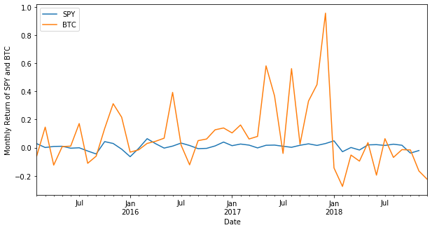

Fig II. Picture depicting monthly return of SPY and BTC, BTC is much volatile than SPY

Using statsmodels and statsmodels.api, I ran a linear regression between the monthly returns of SPY (S&P 500) and BTC (Bitcoin). The resulting Beta from running the regression was found to be 2.467 with the standard error being 1.36. This suggests that the price of bitcoin is significantly more volatile compared to the market. R-squared is the proportion of variance explained. It is the proportion of variance in the observed data that is explained by the model, or the reduction in error over the null model. The R2 value of the regression was found to be 0.0676 thus indicating that the regression is a poor descriptor of the data. The coefficients - Beta and Alpha were calculated using least squares criterion. Fitting the model took 312 milliseconds using two cores on a personal computer.

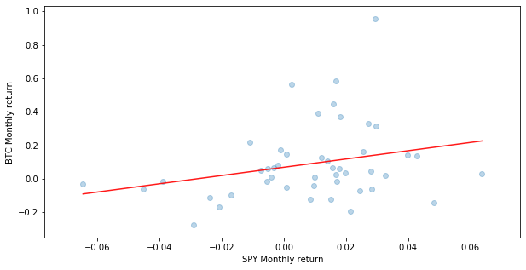

Fig III. BTC monthly return vs SPY monthly return for four years

In a Bayesian framework, linear regression is stated in a probabilistic manner. That is, we reformulate the linear regression model to use probability distributions. I used PyMC3 to construct a Bayesian Linear Regression Model with three random variables – intercept (normal variable with standard deviation of 20), Beta (normal variable with standard deviation of 20) and Sigma (Half-Cauchy with Beta equals to 10). The likelihood was specified using the linear regression formula and the SPY (S&P 500) monthly return values as observed data. Once the model was defined, we could start using Markov chain Monte Carlo to draw samples from the posterior. PyMC3 has multiple algorithms built in, its default is a more advanced method called the No-U-Turn sampler which is itself a variety of Hamiltonian Monte Carlo.

The summary of the trace was found to be as following:

|  |  |  |  |  |  |  |  |
| --- | --- | --- | --- | --- | --- | --- | --- |
| Variable | Mean | Standard Deviation | MC Error | HPD 2.5 | HPD 97.5 | N Eff | Rhat |
| Intercept | 0.068795 | 0.036827 | 0.000438 | -0.00002 | 0.141733 | 5889.898 | 1.000477 |
| Beta | 2.450225 | 1.412896 | 0.020068 | -0.24700 | 5.292267 | 4955.707 | 1.000203 |
| Sigma | 0.229804 | 0.025210 | 0.000308 | 0.186181 | 0.281960 | 6327.349 | 0.999966 |

Fig IV. Data and posterior predictive regression lines

We can observe that the mean values of the random variables are very similar to the values we obtained from using **statsmodel**. We can also conclude that the chains were well mixed as the R-hat value of each variable is found to be close to 1 indicating that each individual chain is representative of the whole population of samples. The total time taken for sampling was 17.2 seconds using two cores on a personal computer.

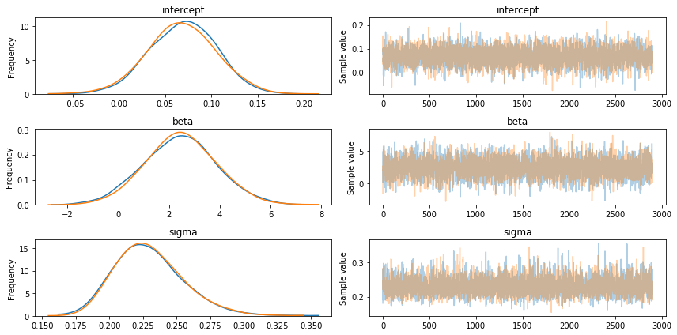

Fig V. Traceplot for the Bayesian Linear Model

 Bayesian models provide a full posterior probability distribution for each of the model parameters, as opposed to a frequentist point estimate. In figure V, on the left side of the panel we can see marginal distributions for each parameter of interest. For the intercept, 95% of the posterior samples reside within 0.0 and 0.142, for the Beta, 95% of the posterior samples reside within -0.247 and 5.292 and for the sigma, 95% of the posterior samples reside within 0.186 and 0.282. The WAIC (Watanabe-Akaike information criterion) for the model was calculated to be -1.78.

Dow-Jones Industrial Average (DJIA)

The Dow Jones Industrial Average (DJIA) is an index that tracks 30 large, publicly-owned companies trading on the New York Stock Exchange (NYSE). The Dow Jones Industrial Average was designed to serve as a proxy for the broader U.S. economy. When the index launched, it included just 12 companies that were almost purely industrial in nature. The first components operated in railroads, cotton, gas, sugar, tobacco and oil. The S&P 500 is often the institutional investor's preferred index given its depth and breadth, while the Dow Jones Industrial Average has historically been associated with the retail investor's gauge of the U.S. stock market.

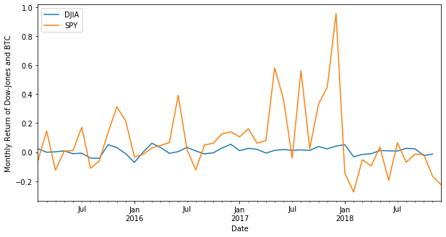

Fig VI. Picture depicting monthly return of DJIA and BTC, BTC is much volatile than DJIA

Using statsmodels and statsmodels.api, I ran a linear regression between the monthly returns of DJIA (Dow Jones Industrial Average) and BTC (Bitcoin). The resulting Beta from running the regression was found to be 2.97 with the standard error being 1.21. This suggests that the price of bitcoin is much more volatile compared to the DJIA, the volatility is comparatively higher than what was observed when we ran the regression against S&P 500. R-squared is the proportion of variance explained. It is the proportion of variance in the observed data that is explained by the model, or the reduction in error over the null model. The R2 value of the regression was found to be 0.1156 thus indicating that the regression is a poor descriptor of the data. The fit of the data is slightly bettered compared to the regression against S&P 500. The coefficients - Beta and Alpha were calculated using least squares criterion. The time taken to fit the model was 485 milliseconds using two cores on a personal computer.

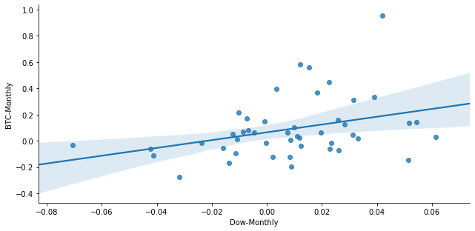

Fig VII. BTC monthly return vs DJIA monthly return for four years

In a Bayesian framework, linear regression is stated in a probabilistic manner. That is, we reformulate the linear regression model to use probability distributions. I used PyMC3 to construct a Bayesian Linear Regression Model with three random variables – Intercept (normal variable with standard deviation of 20), Beta (normal variable with standard deviation of 20) and Sigma (Half-Cauchy with Beta equals to 10). The likelihood was specified using the linear regression formula and the SPY monthly return values as observed data. Once the model was defined, we could start using Markov chain Monte Carlo to draw samples from the posterior. PyMC3 has multiple algorithms built in; its default is a more advanced method called the No-U-Turn sampler which is itself a variety of Hamiltonian Monte Carlo.

The summary of the trace was found to be as following:

|  |  |  |  |  |  |  |  |
| --- | --- | --- | --- | --- | --- | --- | --- |
| Variable | Mean | Standard  Deviation | MC Error | HPD 2.5 | HPD 97.5 | N Eff | Rhat |
| Intercept | 0.065065 | 0.034529 | 0.000474 | -0.00207 | 0.132043 | 5526.211 | 0.999907 |
| Beta | 2.934768 | 1.231204 | 0.015160 | 0.555084 | 5.460796 | 5822.594 | 0.999897 |
| Sigma | 0.223225 | 0.024847 | 0.000281 | 0.177437 | 0.271687 | 7076.63 | 0.999863 |

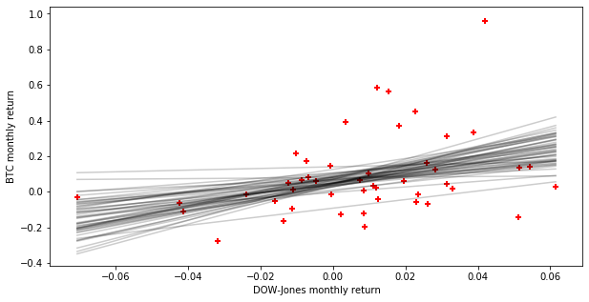

Fig VIII. Data and posterior predictive regression lines

We can observe that the mean values of the random variables are very similar to the values we obtained from using statsmodel. We can also conclude that the chains were well mixed as the R-hat value of each variable is found to be close to 1 indicating that each individual chain is representative of the whole population of samples. The time taken for sampling was 14.9 seconds using two cores on a personal computer.

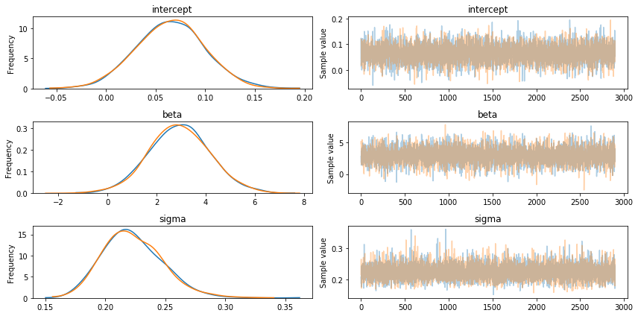

Fig IX. Traceplot for the Bayesian Linear Model

Bayesian models provide a full posterior probability distribution for each of the model parameters, as opposed to a frequentist point estimate. In figure IX, on the left side of the panel we can see marginal distributions for each parameter of interest. For the intercept, 95% of the posterior samples reside within -0.02 and 0.132, for the Beta, 95% of the posterior samples reside within 0.555 and 5.461 and for the sigma, 95% of the posterior samples reside within 0.177 and 0.272. The WAIC (Watanabe-Akaike information criterion) for the model was calculated to be -4.41. By the Watanabe-Akaike information criterion, this model is better compared to the linear regression with S&P 500. Overall, DJIA (Dow-Jones Industrial Average) is a better predictor of price of Bitcoin as we get better fit of data and more negative value of WAIC.

One drawback of our regressions is that we can’t determine the reason behind the correlation or uncorrelation of Bitcoin with the market indices. Moreover, the relationships determined by the regressions might become redundant with time owing to the high volatility of Bitcoin as a financial asset. Hence, we need to constantly run the regressions over a short span of time to gain insight for the near future.

Markowitz Portfolio Theory and Bitcoin

Markowitz Portfolio Theory is a theory on how risk-averse investors can construct portfolios to optimize or maximize expected return based on a given level of market risk, emphasizing that risk is an inherent part of higher reward. According to the theory, it's possible to construct an "efficient frontier" of optimal portfolios offering the maximum possible expected return for a given level of risk. In this experiment, I tried to generate an efficient frontier with two risky assets – the market portfolio (SPY500) and Bitcoin. I imported the daily returns for SPY500 and Bitcoin for the period 2016-01-01 to 2017-01-01 and calculated the annual returns from the imported data for this experiment. I generated 50000 random portfolios with the two risky assets being the constituents in different proportions. In the optimal portfolio, the standard deviation was found to be 13.8%, whereas the return was calculated to be 16.7%. The proportion of Bitcoin in the optimal portfolio was calculated to be 6.12%, whereas, the proportion of the market portfolio was calculated to be around 93.88%. However, when I imported the daily returns for SPY500 and Bitcoin for the period 2018-01-01 to 2019-01-01, calculated the annual returns and ran the same experiment the standard deviation of the optimal portfolio was found to be 16%, whereas the return was calculated to be – 7.8%. The proportion of Bitcoin in the optimal portfolio was calculated to be 3.69%, whereas, the proportion of the market portfolio was calculated to be around 96.3%. This shows that the optimal portfolio for Bitcoin and SPY500 changes with respect to time because of the high volatility in the price of Bitcoin.

Next, I repeated the experiment with 14 different risky assets which comprised of 13 randomly selected stocks and Bitcoin. The stocks randomly selected were as following - 'GOOGL' (Google), 'AAPL' (Apple), 'INTC' (Intel Corporation), 'CAT' (Caterpillar Inc.), 'JNJ' (Johnson and Johnson), 'FB' (Facebook), 'TWLO' (Twilio Inc.), 'KL' (Kirkland Lake Gold Ltd.), 'QCOM' (Qualcomm Inc.), 'GS' (Goldman Sachs), 'AMD' (Advanced Micro Devices Inc), 'PFE' (Pfizer Inc.) and 'BAC’ (Bank of America Corp.). I imported the daily returns for the 13 stocks and Bitcoin for the period 2016-01-01 to 2017-01-01 and calculated the annual returns from the imported data for this experiment. The standard deviation of the optimal portfolio was calculated to be 14.06 % whereas the return was found to be 31.58 %. The proportion of Bitcoin by weight in the optimal portfolio was calculated to be 15.28%. However, when I imported the daily returns for the 13 stocks and Bitcoin for the period 2018-01-01 to 2019-01-01, calculated the annual returns and ran the same experiment the standard deviation of the optimal portfolio was calculated to be 15.3%, whereas the return was found to be -2.5%. The proportion of Bitcoin by weight in the optimal portfolio was calculated to be 0.15%. Thus, in both experiments, we observe a huge change in the composition of the optimal portfolio from one year to another which can be attributed to the high volatility of Bitcoin. Hence, we can conclude that constructing an optimal portfolio with Bitcoin as a constituent should be done over a short period of time taking short-time historical data into consideration.

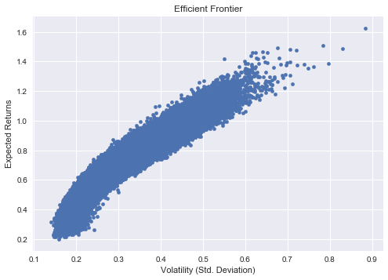

Figure IX. Fourteen risky assets including BTC for the period of 2016-01-01 to 2017-01-01

According to a study by Yale economist Aleh Tsyvinski, BTC-USD should occupy about 6% of every portfolio in order to achieve optimal construction. Even those who are strong bitcoin skeptics should maintain at least 4% BTC allocation, according the study. The study indicates that even the staunchest opponents of the cryptocurrency world are best off investing 1% of their assets in this space, if only for diversification purposes.10 From our experiments, we observed that high volatility of Bitcoin might be a deterrent to risk-averse investors from investing in Bitcoin. However, we saw that we could get high returns from an optimal portfolio containing Bitcoin which excelled the average market returns. Hence, we can conclude that Bitcoin does add value to a portfolio, but only when held in small amounts.

.

Bibliography

1. *Cyber Patrol Management System*, cpms.cidwb.in/portal/cybercrime/bitcoin.html.
2. “Coinbase Hits 12 Million Users, Adds 100k Members in Just 24 Hours | Finance Magnates.” *Finance Magnates | Financial and Business News*, Finance Magnates, 2 Nov. 2017,www.financemagnates.com/cryptocurrency/news/coinbase-hits-12-million-users-adds-100k-memebers-just-24-hours/.
3. “40% Of the World's Bitcoins Are Held by Just 1,000 People.” *Money*, money.com/money/ 5056346/bitcoin-ownership/.
4. Baldwin, Clare. “Bitcoin Worth $72 Million Stolen from Bitfinex Exchange in Hong Kong.” *Reuters*, Thomson Reuters, 3 Aug. 2016, www.reuters.com/article/us-bitfinex-hacked-hongkong-idUSKCN10E0KP.
5. “Bitcoin.” U.S. COMMODITY FUTURES TRADING COMMISSION, www.cftc.gov/Bitcoin/ index.htm.
6. “Data Indicates Bitcoin Price Is Uncorrelated with Stock Market.” *CryptoSlate*, 3 Apr. 2019, cryptoslate.com/data-indicates-bitcoin-price-uncorrelated-stock-market/.
7. Editor. “Coin News Telegraph.” *Coin News Telegraph*, 24 Sept. 2018, coinnewstelegraph.com/ bitcoin-price-today-usd-live-how-much-is-bitcoin-worth-latest-price-chart-analysis-and-bitcoin-price-prediction-2018-mon-sept-24/.
8. Editor, Vantage Asia. “Cryptocurrency Laws and Regulations in China 2018 | Asia Business Law Journal.” *Vantage Asia*, 26 July 2018, www.vantageasia.com/cryptocurrency-law-china/.
9. “FTSE Global All Cap Index.” *Bogleheads*, www.bogleheads.org/wiki/

FTSE_Global_All_Cap_Index.

1. Investopedia. “What Does the S&P 500 Index Measure and How Is It Calculated?” *Investopedia*, Investopedia, 16 Apr. 2019, www.investopedia.com/ask/answers/040215/what-does-sp-500-index-measure-and-how-it-calculated.asp.
2. Kenton, Will. “Understanding Beta and How to Calculate It.” *Investopedia*, Investopedia, 19 Apr. 2019, www.investopedia.com/terms/b/Beta.asp.
3. Liu, et al. “Risks and Returns of Cryptocurrency.” *NBER*, 2 Aug. 2018, www.nber.org/ papers/w24877.
4. “Market Cap Of Cryptocurrencies.” *A Window into Crypto World*, coinhodl.site/market-cap-of-cryptocurrencies/.
5. “The Bitcoin Volatility Index.” *(3.51%) Bitcoin Volatility Index - Charts vs Dollar & More*, [www.buybitcoinworldwide.com/volatility-index/](http://www.buybitcoinworldwide.com/volatility-index/).

15. Salvatier J, Wiecki TV, Fonnesbeck C. 2016. “*Probabilistic programming in Python using PyMC3”*. PeerJ Computer Science 2:e55 https://doi.org/10.7717/peerj-cs.55

16.“What Causes Volatility in Bitcoin?” *FXCM UK*, www.fxcm.com/uk/insights/what-causes-volatility-in-bitcoin/

Works Cited

1. *Cyber Patrol Management System*, cpms.cidwb.in/portal/cybercrime/bitcoin.html.
2. “Market Cap of Cryptocurrencies.” *A Window into Crypto World*, coinhodl.site/market-cap-of-cryptocurrencies/
3. *“Coin News Telegraph.” Coin News Telegraph, 24 Sept. 2018, coinnewstelegraph.com/ bitcoin-price-today-usd-live-how-much-is-bitcoin-worth-latest-price-chart-analysis-and-bitcoin-price-prediction-2018-mon-sept-24/.*
4. “Bitcoin.” U.S. COMMODITY FUTURES TRADING COMMISSION, www.cftc.gov/Bitcoin/ index.htm
5. Editor, Vantage Asia. “Cryptocurrency Laws and Regulations in China 2018 | Asia Business Law Journal.” *Vantage Asia*, 26 July 2018, www.vantageasia.com/cryptocurrency-law-china/
6. “Coinbase Hits 12 Million Users, Adds 100k Members in Just 24 Hours | Finance Magnates.” *Finance Magnates | Financial and Business News*, Finance Magnates, 2 Nov. 2017,www.financemagnates.com/cryptocurrency/news/coinbase-hits-12-million-users-adds-100k-memebers-just-24-hours/
7. Baldwin, Clare. “Bitcoin Worth $72 Million Stolen from Bitfinex Exchange in Hong Kong.” *Reuters*, Thomson Reuters, 3 Aug. 2016, www.reuters.com/article/us-bitfinex-hacked-hongkong-idUSKCN10E0KP.
8. “40% Of the World's Bitcoins Are Held by Just 1,000 People.” *Money*, money.com/money/ 5056346/bitcoin-ownership/
9. “What Causes Volatility in Bitcoin?” *FXCM UK*, www.fxcm.com/uk/insights/what-causes-volatility-in-bitcoin/
10. Liu, et al. “Risks and Returns of Cryptocurrency.” *NBER*, 2 Aug. 2018, www.nber.org/papers/ w24877.