Beta of Bitcoins and Three Different Portfolio

This project seeks to estimate the Beta of Bitcoin with respect to three different portfolios and answer the question whether we should include bitcoin as part of our investment portfolio using Markowitz Portfolio Optimization. A major part of this project is trying to estimate the Beta of Bitcoin. I have attempted to calculate the beta of Bitcoin against S&P 500, the Dow Jones and the FTSE Global All Cap Index using CAPM theory.

A beta coefficient is a measure of the volatility, or systematic risk, of an individual asset in comparison to the unsystematic risk of the entire market. Beta is used in the capital asset pricing model (CAPM), which calculates the expected return of an asset using beta and expected market returns. In statistical terms, beta represents the slope of the line through a regression of data points from an individual asset's returns against those of the market. Beta measures the tendency of an asset to respond to changes in the price of a benchmark, like the S&P 500. The S&P 500 is a commonly used benchmark because it usually reflects the performance of the overall U.S. stock market. A positive beta indicates that an asset is correlated with a benchmark. If the benchmark increases in value, then the asset also tends to increase in value. A negative beta indicates the reverse.

In estimating betas, we typically rely on a relatively short rolling window of 5 year of historical data because betas vary significantly over time which might be attributed to changes in a firm’s leverage and operations, acquisitions or expansion of the firm into other industries or changes in the composition of the aggregate market. GARCH and related statistical procedures explicitly allow for time-variation of the Betas. In the process of estimating betas, we typically use monthly data. We can potentially get better estimates using higher frequency data. However, some significant drawbacks of higher frequency data are non-synchronous prices and bid-ask bounce effects. For CAPM, the benchmark portfolio is the market portfolio. However, we can calculate beta against other portfolios. The beta value calculated with respect to a particular portfolio would describe the activity of the asset’s return with changes in the benchmark portfolio.

**In this HW, I am displaying the process only for Dow-Jones.** The Dow Jones Industrial Average (DJIA) is an index that tracks 30 large and publicly owned companies trading on the New York Stock Exchange (NYSE). The Dow Jones Industrial Average was designed to serve as a proxy for the broader U.S. economy. When the index launched, it included just 12 companies that were almost purely industrial in nature. The first components operated in railroads, cotton, gas, sugar, tobacco and oil. The S&P 500 is often the institutional investor's preferred index given its depth and breadth, while the Dow Jones Industrial Average has historically been associated with the retail investor's gauge of the U.S. stock market.

1. Using **statsmodel**

My linear regression function is as following:



Alpha = 0.0648440326969843

R value = 0.3464282675018629

Slope = 2.971995182551312

Standard Error = 1.2132398915475122

R2 value = 0.12001254452

1. Using **pyMC3**



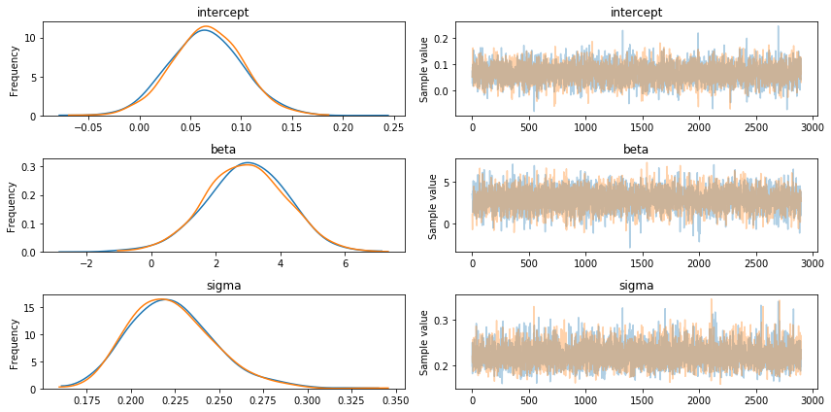

WAIC = -4.410386971734574

WAIC_se = 15.802276509328316

p_WAIC = 3.9768789769698594

Execution Time: 14.9 seconds