Dynamic structure in streamflow generation
Sample Final Project Report for CEE 690-07, Fall 2019
Chris Krapu

1. Introduction
One of the most important research areas in water resources engineering and management is the accurate description of the transformation of rainfall into runoff and consequently streamflow. While runoff generation mechanisms must be a combination of linear and nonlinear processes (Jakeman and Hornberger, 1993; Kirchner, 2009) it is typically assumed that urbanization reduces the amount of rainfall which infiltrates into the soil matrix with the effect of increasing streamflow (DeWalle et al., 2000), reducing groundwater recharge (Rose and Peters, 2001) and linearizing the streamflow response to precipitation inputs. However, there are multiple factors theorized to control the partition of streamflow generation between linear and nonlinear runoff mechanisms including the ecology and biology of basin vegetation (Ukkola et al., 2015) and a shifting climate (Nash and Gleick, 1991) among others. There is no clear consensus regarding the settings and time periods in which one set of factors is most important. We therefore pose the following research questions:
- How has the partitioning of runoff between linear and nonlinear mechanisms changed over the past 50 years?
- Do urbanized and undeveloped catchments exhibit different modes of variation in this partition?

To answer these questions, we constructed a dynamic linear model of monthly streamflow values across over 200 basins in which stream discharge is assumed to be a function of precipitation, potential evapotranspiration and past discharge observations as well as dynamic random and seasonal effects.

2. Data
Daily observations of stream discharge (Q) and basin-wide averages of potential evapotranspiration (PET) and precipitation (P) in units of area-averaged equivalent water depth (mm.) were taken from the Model Parameter Estimation Experiment (MOPEX) dataset (Duan et al., 2006) which was originally collected for the purpose of inter-comparison and improvement of hydrology and atmospheric models across a wide range of climatic conditions. Daily records of Q, P and PET over the period 1948/01/12 - 1999/12/31 were aggregated to a monthly mean for a total of 624 monthly timesteps per basin. While 438 basins across the USA are included in the MOPEX database, many of these have significant stretches of missing records in one or several variables and we applied an imputation scheme at both the daily and monthly timescale. Gaps of up to 14 days in length were forward-fill imputed before monthly aggregation. At a monthly timescale, gaps up to 4 months long were filled by forward-fill imputation up to 2 months from the observation immediately preceding the gap and by backward-fill imputation up to 2 months from the observation immediately following the gap. Any basins which had any remaining gaps after this step were not used in further analysis. Of the 438 original basins considered, 264 were used in the remainder of this study. The distribution of these catchments over catchment size and aridity index defined as the ratio of annual precipitation to annual PET can be seen in and covers a wide range of hydroclimatic conditions across basins up to 4000 km² in size. The geographical distribution of these basins is shown in Figure 5 with most sites falling within the eastern half of the conterminous US. In addition to these time series observations, static data regarding catchment land cover classifications were also included with in the MOPEX dataset. These per-basin summaries of the 1 km. land cover products from the International Geosphere-Biosphere Program (IGBP) covered 16 land use types including multiple types of deciduous and evergreen forests in addition to grassland, urbanized areas and cropland. The MOPEX catchments span a range of urbanization levels () ranging from approximately zero development to nearly complete urbanization.
In order to include contributions to stream discharge which are a nonlinear function of precipitation, we included an additional column for the elementwise square of the precipitation observations P which we designate as P². While P² is not a linear function of P, a high degree of correlation between these two variables could lead to unstable coefficient estimates. To prevent this from occurring, we applied an orthogonal polynomial transformation to P and P² using the Gram-Schmidt process (Arfken and Weber, 2012; Holder, 1985; Jackson and Aron, 1971) and obtained transformed values of P and P² which are both linear and increasing functions of the original variables yet have a dot product of zero. This requires a QR decomposition of the Vandermonde matrix composed of columns containing elementwise powers of P. Conceptually, this procedure removes the portions of the -th elementwise power of the vector P which lie on the subspace spanned by the 1st through ()th elementwise powers of the vector P. The monthly per-basin observations of discharge (Q), precipitation (P), squared precipitation (P²) and potential evapotranspiration (PET) were centered and standardized to have a sample mean of zero and a sample standard deviation of 1.

3. Modeling

3.1 Dynamic linear models
We applied a dynamic linear model (DLM) (West, 2013) to the task of estimating the monthly streamflow discharge at time t conditional on contemporaneous observations of precipitation and PET as well as recent observations of past precipitation and streamflow values. DLMs subsume standard time series models such as autoregressive models (AR) and moving average models (MA) along with their extensions to periodic and exogenous data within a Bayesian statistical framework. Specifically, dynamic linear models are a class of state-space models specified by enumerating four time-varying quantities: a regression design vector or matrix , a state evolution matrix , a state evolution variance matrix and an observational variance matrix . In practice, computationally efficient estimation of DLM parameters requires an iterative filtering scheme; the Kalman filter is a special case of this procedure under additional assumptions and is frequently used in hydrologic time series analysis (Bergman and Delleur, 1985; Lee and Singh, 1998). In the case where only the observed data at each time point is scalar as in this study, then is a vector and is a scalar quantity. For a more complete exposition on the statistical properties and inference methodology for the DLM, see Pole et al. (2011) or Prado and West (2010). Dynamic linear models have been applied in other hydrology-related contexts such as estimation of stream temperature (Wagner et al., 2017), analysis of sediment loads (Ahn et al., 2017), and streamflow forecasting (Ciupak et al., 2015). We note that a major distinction between Ciupak et al. (2015) and this work is that the former was purely focused on forecast predictive accuracy for a single river basin rather than retrospective analysis and hypothesis testing over multiple river basins as in this study. A key advantage of the DLM framework is that multiple time series modeling components can easily be incorporated by constructing the state-space vector and evolution matrix to simultaneously account for autoregressive, moving average, exogenous regressions and periodic effects among other possible modeling components. The probabilistic model of the observed scalar data specified by these components is illustrated in equations 1-3 after West and Harrison (1997). In this equation and all others that follow, we denote multi- and matrix-variate quantities in boldface and scalar quantities in standard type. The notation indicates that is a random variable with distribution parameterized by a mean a and a variance or covariance matrix B.
- Observation equation: with
- System equation: with
- Initial information:
The observation equation (1) expresses the observed data as the dot product of the linear function of the regression vector and the state space vector . could include exogenous variables and is known ahead of time while includes time-varying model parameters which are unobserved. The variation in model parameters over time in the system equation (2) is governed by the form of which is chosen by the modeler in advance and the evolution covariance matrix . The entries in control the rate at which the system’s underlying dynamics are theorized to change but are difficult to specify a priori. To remedy this, we adopt a discounting approach (West and Harrison, 1997) in which we assume is a proportional to our uncertainty regarding our estimate of , i.e. 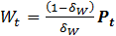 where is the covariance matrix encoding our uncertainty in the value of at time t and . We refer to as a discounting factor because its specification controls the relative importance of past observations in determining the state covariance; higher values of the discount factor imply that past estimates of state covariance are appropriate to model future behavior while a low value leads to inflation of state covariance and a less precise estimate of the state vector in future time steps. Using such an approach has the dual advantage of allowing for gradual changes in model parameters over time and eliminating the need to specify a priori. Furthermore, we similarly avoid having to specify the scalar observation variance by modeling its inverse, the observational precision as a dynamic gamma-distributed quantity subjected to repeated beta-distributed multiplicative rescalings in a Markovian beta-gamma evolution model (Shephard, 1994; West and Harrison, 1997). This evolution model depends upon a parameter which serves a similar function as for the observational variance. From a classical time series perspective, this is akin to specification of conditional heteroscedasticity in ARCH or GARCH models which have found occasional use in streamflow forecasting (Modarres and Ouarda, 2013; Wang et al., 2005). We note that these treatments of the system evolution variance and the observation variance are standard steps in a Bayesian time series analysis if a specific form or value of and is not known from prior information (Prado and West, 2010). In order to estimate the DLM parameters given observations and a prior distribution over the state vector , efficient inference can be achieved by applying forward filtering and backward smoothing (FFBS) without recourse to more complicated sequential Monte Carlo methods (Weerts and El Serafy, 2006) . In the context of a dynamic linear model with unknown observational and evolution variance, FFBS constitutes a Bayesian generalization of the Kalman filter and the Viterbi algorithm frequently used for computing point estimates of parameters in hidden Markov models (Rabiner and Juang, 1986). A major advantage of this approach over non-Bayesian schemes is that we can efficiently generate Monte Carlo samples from the posterior distribution over the state vector across all time points. Quantification of uncertainties regarding our parameter estimates can then be easily calculated from these samples. Unlike many other studies applying Bayesian methodologies to water resource issues (de A. Barreto and de Andrade, 2000; Kuczera and Parent, 1998; Vrugt and Ter Braak, 2011), Markov chain Monte Carlo (MCMC) techniques such as Gibbs sampling and the Metropolis-Hastings algorithm are not required for inference in this modeling framework. We also note that this is a probabilistically coherent parameter estimation scheme that does not require heuristics with uncertain statistical foundations as is the case with many simple rainfall-runoff models (Piotrowski et al., 2017). We implemented the FFBS algorithm in Python and this code is available at https://github.com/ckrapu/bayesian_forecasting/.

3.2 Model structure
In this study, we specified the structure of the DLM as follows: at each time t, the vector is a 7-dimensional vector with elements specified as (1) the orthogonal polynomial representation of the precipitation at time t, (2) potential evapotranspiration, (3) orthogonalized precipitation from the preceding timestep, (4) the orthogonalized squared precipitation for the current timestep (5) a sinusoidal term with a period of 12 months and a phase maximizing the effect’s value in January, (6) stream discharge from the preceding timestep, and (7) a constant term of 1. Elements 1-5 constitute a dynamic regression (including a seasonal effect) while 6 designates an AR(1) component and 7 designates a constant component. The corresponding entries in the vector are then directly interpretable as the regression coefficients for the variables in . While the exact form of the nonlinear relation between precipitation and runoff generation likely varies across catchments and is unknown, we follow the recommendation of Jakeman and Hornberger (1993) to approximate this nonlinearity with a limited number of polynomial terms; polynomial regression of streamflow at a monthly timescale was also explored in (Muftuoglu, 1990). Autoregressions (Adamowski et al., 2012; Carlson, et al., 1970; Ghanbarpour et al., 2009; Vecchia, 1985) and autoregression-like approaches (Sivakumar, 2003) have similarly found some degree of acceptance by practitioners of data-driven hydrological modeling. Previous studies in a similar modeling framework have incorporated predictors such as the El Nino Oscillation (ENSO) index for modeling rainfall (Krishnaswamy et al., 2015) or streamflow (Risko and Martinez, 2014) but we did not include these variables as the effect of these atmospheric pressure indices on basin hydrology is understood to be mediated through precipitation (Diaz and Markgraf, 1992) and PET which are already included as covariates in this model. It is possible that there exists some influence of ENSO on snowpack accumulations (Twine et al., 2005) which would not be well-captured in this model, but snow-dominated basins comprise a small subset of the selected catchments. An additional polynomial component of order 2 was also considered but did not improve predictive performance in a preliminary analysis and lacked a clear mechanistic interpretation beyond what was already provided by inclusion of a constant term, i.e. a polynomial of order 1. With this construction of , we fixed as a 7-dimensional identity matrix which then simplifies equation (2) to a vector-valued random walk process of This specification allows for evolution of the model parameters without assuming a linear or higher-order polynomial growth trend. This model structure was shared across all 264 river basins and is described visually as a conceptual diagram in .

3.3 Limitations
The relative simplicity of this model is accompanied by several limitations that should be made clear. First, it is mostly linear and incorporates nonlinear effects only through polynomial transformations of its input variables. Some of the most effective simple hydrological modeling schemes operating at a daily timescale use a combination of linear and nonlinear modules that may also include discontinuous threshold effects (Jakeman and Hornberger, 1993) or non-polynomial relations (Kirchner, 2009). Additionally, no notion of the distribution of rainfall across events within a single month is encoded in this model structure and it is possible that an increase in rainfall intensity accompanied by a decrease in event frequency could lead to dramatically higher runoff generation (Slater and Villarini, 2017); this phenomenon would not be well-captured by the variables included. We include no covariates which directly measure the effect of vegetation or ecohydrological flow networks which are known to play a critical role in runoff generation (Band et al., 2014). The specification of a prior distribution on the model state vector at the beginning of inference is difficult and we resorted to an empirical Bayes approximation by performing partial inference with a naïve prior in order to obtain a more accurate prior on in a full inference run. Issues of equifinality—also referred to as identifiability in the statistics literature—can result from an overly flexible model structure in which multiple model components are equally capable of explaining the data. Finally, snowpack accumulations over timescales greater than 2 months are not included in the model structure, reducing the suitability of this approach for snow-dominated catchments with substantial early-winter snowfall.

3.4 Inference and model fitting
The model we have described in previous sections was fit independently for each river basin with no probabilistic dependencies between multiple catchments. Before conducting inference strictly within the context of the dynamic linear model, 4 different quantities were required to be specified in advance. These include the variance evolution parameters , the prior mean of the distribution over the DLM state vector at the first timestep and the accompanying covariance of that prior distribution, . We identified by performing a grid search over all combinations of the options and for a total of 16 possible combinations. These discount factors are typically chosen to be close to 1 as values closer to zero imply that the system variance is rapidly increasing over time and we did not wish to encode this into our choice of model parameters. The optimal choice of was selected by maximizing the model marginal likelihood conditional on this value of the discount factors. In this preliminary fitting stage, we assumed a prior mean of 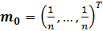 for the state vector with dimension n and a diffuse prior covariance of where is the n-dimensional identity matrix. Forward-filtering was applied to the entire length of the data record and the model marginal likelihood was calculated after this single pass. No retrospective backward smoothing was applied at this stage. For the details of the filtering update equations and the calculation of the model marginal likelihood see Prado and West (2010).
Usage of a naïve prior distribution over the DLM state elements at the first timestep poses an issue with regard to interpretations of trends in the parameters; if this prior is specified incorrectly then the model has sufficient flexibility to adjust its parameter values to more closely match reality and later forecasts and estimations will not be unduly biased. However, this realignment to correct an inappropriate initial specification will lead to shifts in model parameters in the early portion of the record which do not reflect actual changes in the data generating process. To remedy this, we considered a prior state vector mean calculated as the empirical mean of the state vector estimates from time steps 62 to 124 out of 624 total timesteps, i.e. the second 10% of the data in the temporal dimension. This was done to constrain the prior mean over the state vector to be sufficiently close to the beginning of the data but to remove any influence from an ill-specified and naïve prior. An identical approach was taken with the prior covariance . With this specification of the discount factors and the prior distribution over for each river basin, we then performed a full FFBS pass over the data to calculate point estimates of the posterior mean of at each point in time. We also calculated the coefficient of determination ) for 1-step ahead predictions and the mean absolute 1-step ahead forecast error (MAE). The distribution of values across space (Figure 5) and aridity index () show increasing predictive accuracy in watersheds with a high precipitation/PET ratio and generally shows increased performance in the SE USA relative to western or northern states. We view this as support for our earlier statement that this modeling approach does not capture multi-month dependencies between snowpack accumulation and spring snowmelt runoff. Six watersheds in the American West and the northern Great Plains exhibited negative values, indicating that this specific set of modeling assumptions is wholly unsuited to modeling runoff generation in these systems. In order to check the DLM assumption that the distribution of monthly streamflow is normal after conditioning on the included covariates, we generated histograms of the model forecast errors/residuals which appeared to be symmetric and normally distributed (Figure 8). We also examined the relation between the forecasted streamflow and the forecast error (); there appears to be a positive correlation between error and forecast suggesting that the model performance degrades at higher and higher levels of streamflow with underestimation of large flows in general (). For an example of the estimated posterior mean and sampled parameter estimates including the dynamic observational variance, see Figure 7. Figure 6 shows the distribution of catchments over discount factors.

3.5 Residual analysis
We conducted an analysis of the residual errors in order to determine whether there exists additional time series structure which our modeling scheme was unable to capture. We calculated the partial autocorrelation function (PACF) with a maximum lag of 48 months for each of the residual time series using a Python implementation of the PACF with a bias-corrected Yule-Walker algorithm available in the StatsModels library (Seabold and Perktold, 2010). The PACF captures autoregressive correlations for each possible lag time while controlling for effects due to all other lag times and consequently is a useful tool for identifying lagged dependencies in time series data. Assuming a relatively stringent standard of , only 2 out of PACF entries had a value significantly different from zero and this test provided no evidence for the existence of additional autoregressive structure in the residuals. We also examined the spectral density of the per-timestep sum of residuals across all watersheds as depicted in. We observed a peak at a biannual frequency with a period of 6 months (Figure 12) and a flat spectral density for harmonics with larger periods.

4. Results
To pool estimates of regression parameter across catchments, we computed a cross-catchment mean and median for each parameter. These aggregations were done separately for two subsets of catchments: basins with less than 20% of their surface area classified as urban were classified as undeveloped (N_{u} = 173 basins) while basins with more than 40% of their surface area were classified as developed (N_{d} = 73 basins). Figure 7 illustrates these summaries of parameter values across time along with the variation across the middle two quartiles. The mean and median were found to be in close agreement for all combinations of catchment subset and parameter save for the PET coefficient for undeveloped basins. For both subsets, the estimated parameter values exhibited a low degree of cross-catchment deviation; the precipitation parameter was universally positive and usually within the range while the PET coefficient was typically negative. This conforms to our understanding of the physical processes governing runoff generation as enhanced atmospheric demand for moisture generally reduces runoff and added rainfall increases it. The lagged precipitation and discharge coefficients also assumed support mostly in the range . Visual comparison of the variation in parameter values across time reveals that in several cases (PET, seasonal, P², constant term) the developed catchments exhibited more substantial variation over time than the counterpart estimates in the undeveloped catchments.
In order to test the hypothesis that nonlinear runoff generation processes are replaced with linear generation processes in developed catchments, we calculated the difference between the posterior summary mean for the PET, linear precipitation and squared precipitation coefficients in both developed and undeveloped catchments. Figure 13 illustrates these differences and their evolution through time. The difference between developed and undeveloped catchments (Figure 14) in the linear coupling between precipitation and runoff generation appears to be a steadily increasing function of time. This is consistent with our expectation that catchments which are converted to either impervious surfaces or other less permeable cover types should experience increased runoff generation which is linear in the hydrologic inputs. However, we do not observe a monotonic decrease in the nonlinear precipitation coefficient though its value does appear to vary less over time for undeveloped watersheds. Finally, the difference of the cross-catchment means of the PET coefficient suggests that runoff generation in developed watersheds is more strongly linked to potential evapotranspiration than in undeveloped watersheds and that this disparity has only grown with time. One potential explanation for this is that earlier spring melt and could lead to additional precipitation bypassing catchment storage (Hodgkins et al., 2003) in snowpack to generate runoff immediately. In that case, PET would correlate with increasing streamflow and much of the snowmelt runoff which could not previously be well-captured in this modeling framework would then be transferred to a linear precipitation contribution to runoff generation.

5. Discussion
Multiple studies have looked at changes in streamflow over the second half of the twentieth century (Lettenmaier et al., 1994; McCabe and Wolock, 2002) and concluded that some positive trend or increase in streamflow volumes has taken place, with a special emphasis on the eastern United States. While the main statistical tool applied in these studies has been a nonparametric trend test (Burn and Elnur, 2002; Helsel and Hirsch, 2002) as pointed out by McCabe and Wolock, (2002), direct attribution of these increases has been given at least in part to rising precipitation (Lins and Slack, 1990) throughout the year or in specific seasons (Small et al., 2006) though interactions between climate and water management have also been theorized to play an important role (Lettenmaier et al., 1994). Nonparametric trend tests suffer from technical issues when applied to environmental time series (Serinaldi et al., 2018; von Storch, 1999) and we view this study as a methodological improvement that allows estimation of trends due to mechanistic processes via dynamic regression. We cannot declare that all predictions consistent with our initial hypothesis have been realized; while the linear dependence of streamflow on precipitation has been seen to grow steadily for urbanized catchments, we did not see a decrease in the nonlinear contribution of precipitation to runoff generation. This leads us to consider conceptual models in which the two trends are compatible. As nonlinear runoff generating or mitigating mechanisms include soil infiltration, interception loss and evapotranspiration (Rumynin, 2015), a lack of systematic change in the strength of nonlinear coupling between streamflow and precipitation suggests that these aspects of catchment hydrology have not been substantially altered. Consequently, the increase in the linear precipitation coefficient may be due to an increase in the intensity of extreme events which may both lead to higher effective rainfall (Beven, 2012) without perturbation of nonlinear runoff generation processes. In addition to an increasing trend in the difference of the precipitation coefficient, we also observe an increasing trend in the coefficients themselves in both developed and undeveloped catchments. The increase in precipitation coefficient values for developed catchments () and undeveloped catchments () is quite large and suggests that there are other factors in runoff generation which are uniformly increasing the strength of coupling between precipitation in most American catchments. An important consideration in this analysis is that we have assumed highly simplistic mechanisms of runoff generation and changing estimates of parameter values in the DLM framework could reflect variations in the strength of these mechanisms or, alternately, variation due to unmodeled processes that are not adequately represented elsewhere in the model. For slowly varying processes, these unmodeled factors should be assimilated into the dynamic level, i.e. the constant term, but dynamics with shorter characteristic timescales may not be captured by variations in the local level.

6. Figures
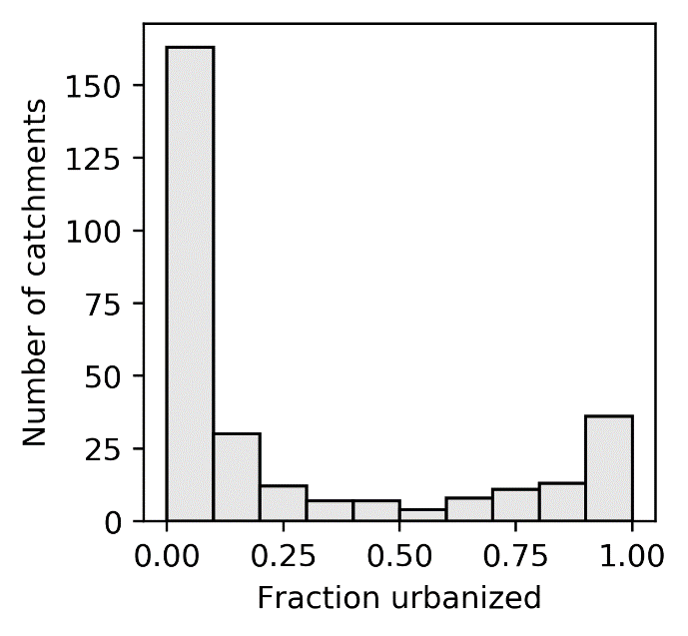  Figure 1: Distribution of catchments across urban fraction |  | 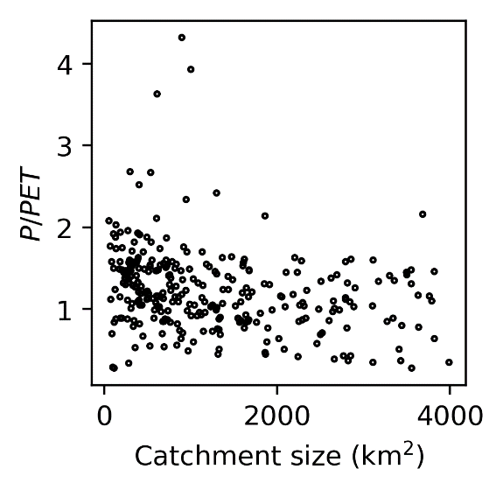  Figure 2: Distribution of catchments across size and aridity index
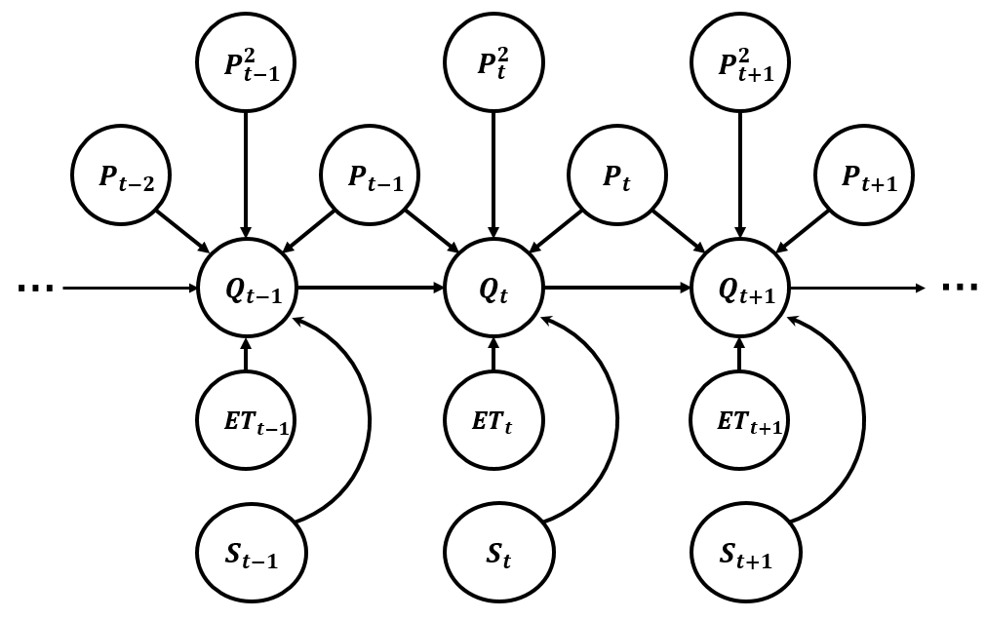  Figure 3: Graphical model of runoff generation. The constant DLM component has been omitted from this diagram. | 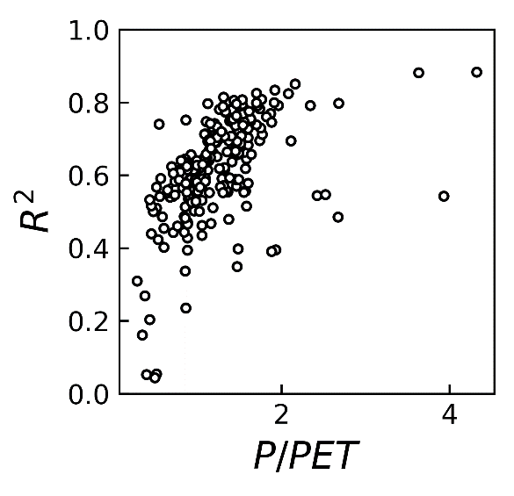  Figure 4: Model forecast accuracy versus aridity index

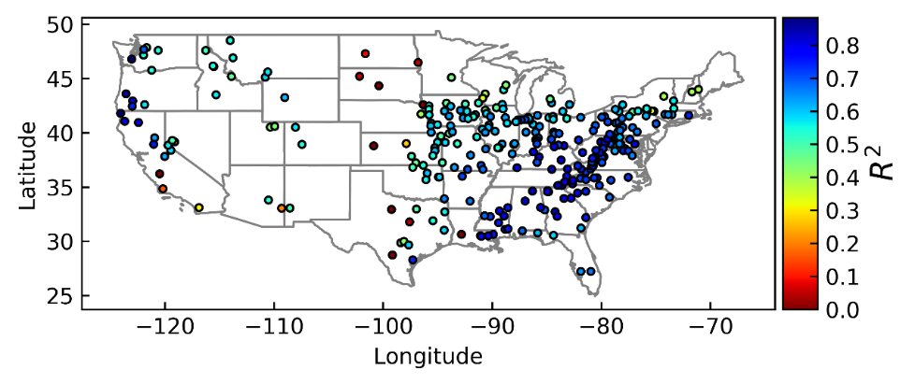
Figure 5: Geographical distribution of forecast accuracy
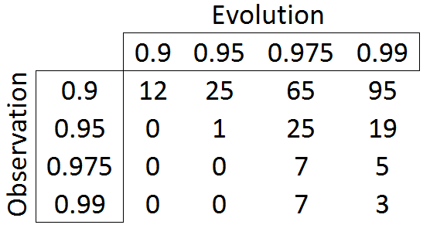
Figure 6: Breakdown of discount factors across all basins
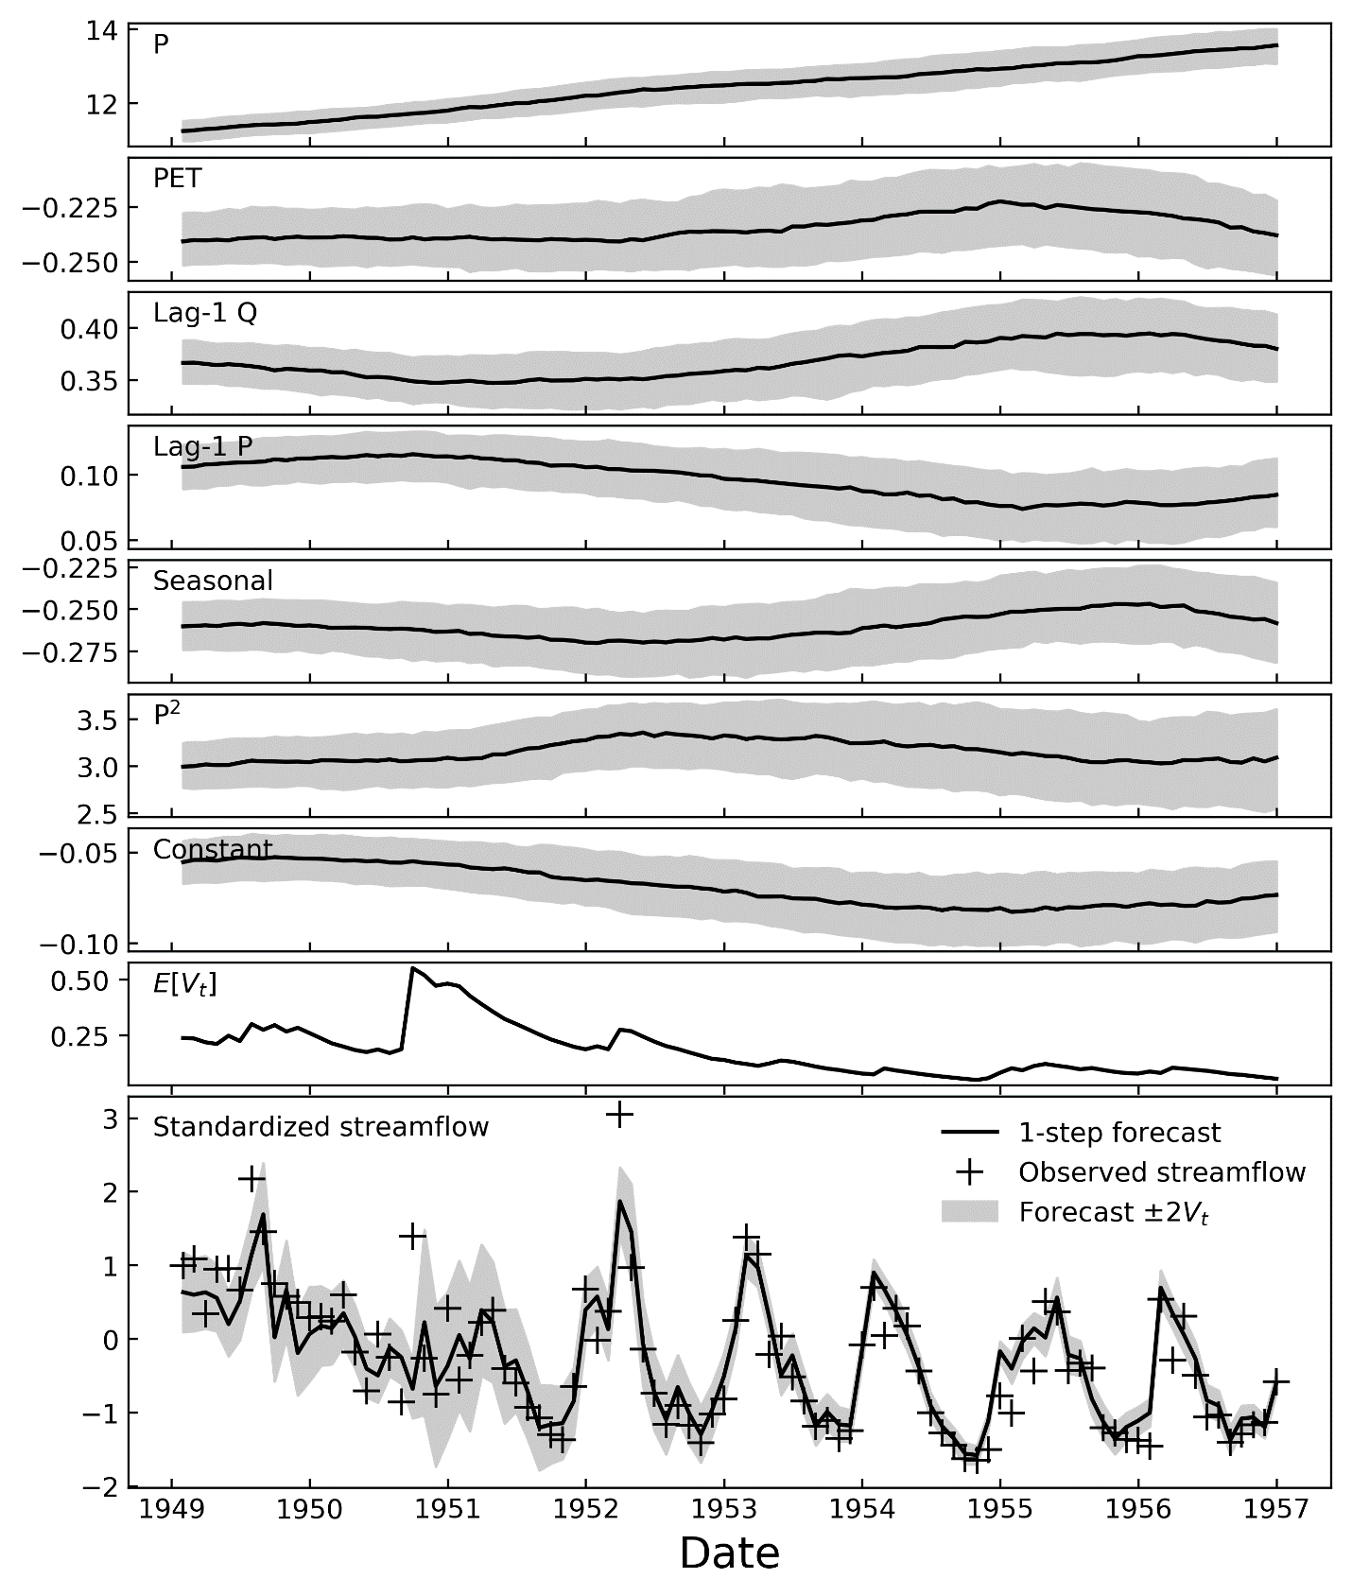
Figure 7: DLM parameter estimates and forecasts for the French Broad River at Blantyre, North Carolina from 1949 – 1957. Gray regions in the upper 7 subplots indicate 25-75% range of Monte Carlo samples.
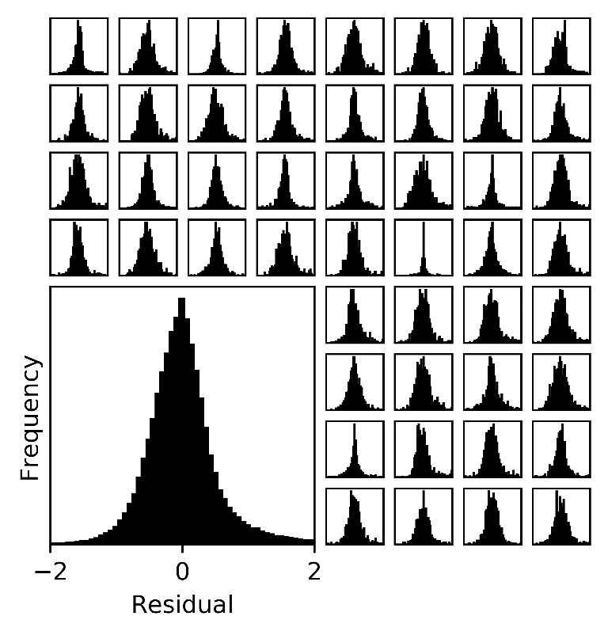  Figure 8: Distribution of all model residuals and per-basin residuals for 48 randomly selected catchments | 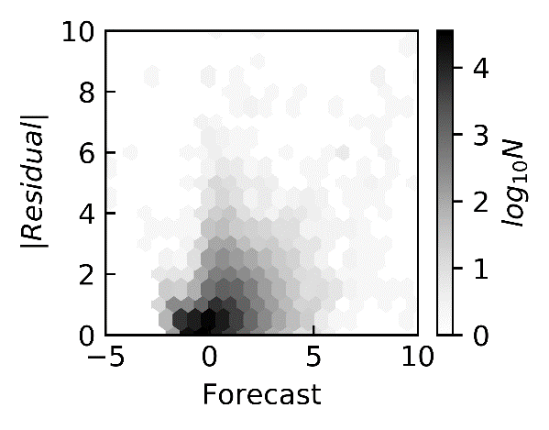  Figure 9: Relation between forecasted streamflow and forecast error. Cell shading indicates the number of residual and forecast pairs falling within that bin.
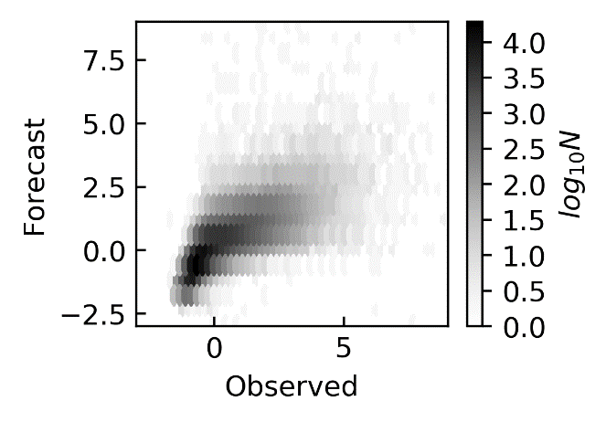  Figure 10: Relation between observed and forecasted streamflow across all catchments | 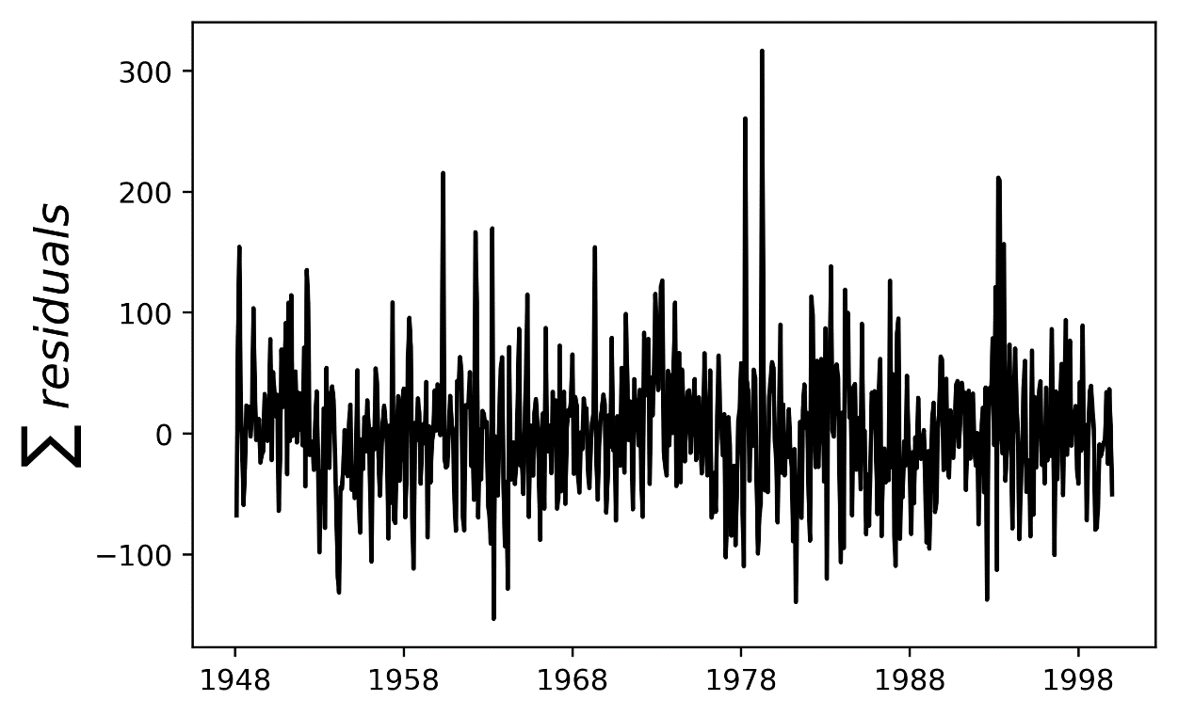  Figure 11: Sum of all DLM residuals

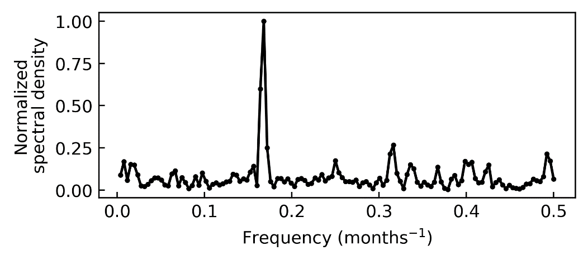
Figure 12: Power spectral density estimate of residuals
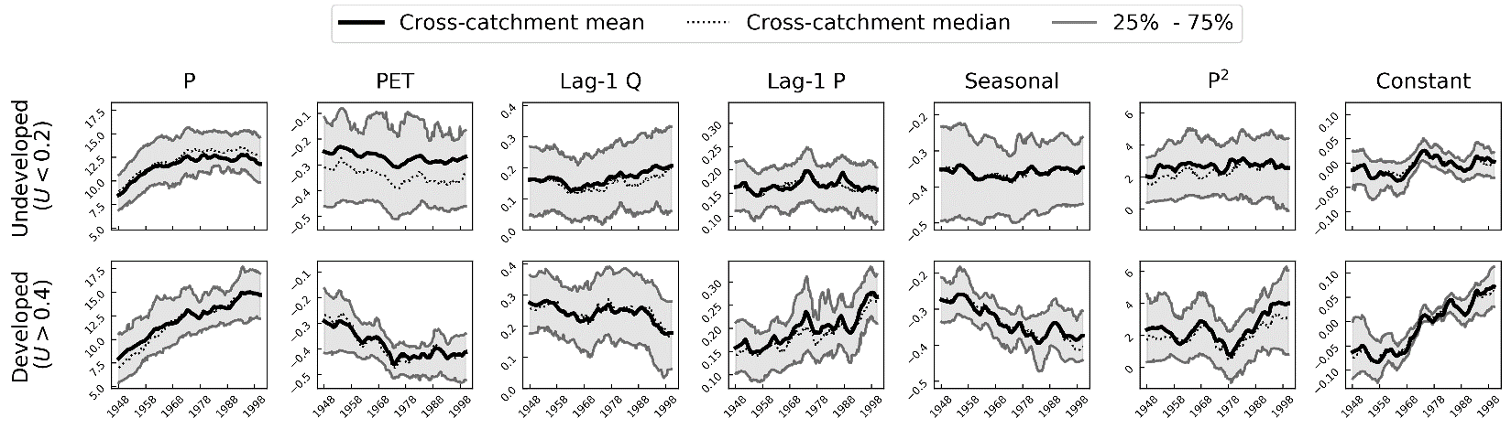
Figure 13:Trends in cross-catchment summaries of DLM parameters
Precipitation
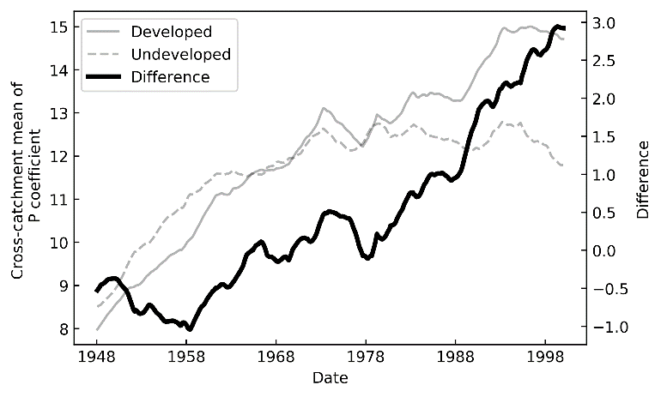
Precipitation²
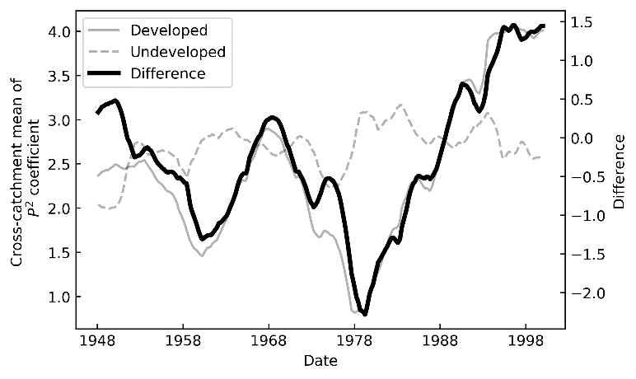
Potential evapotranspiration
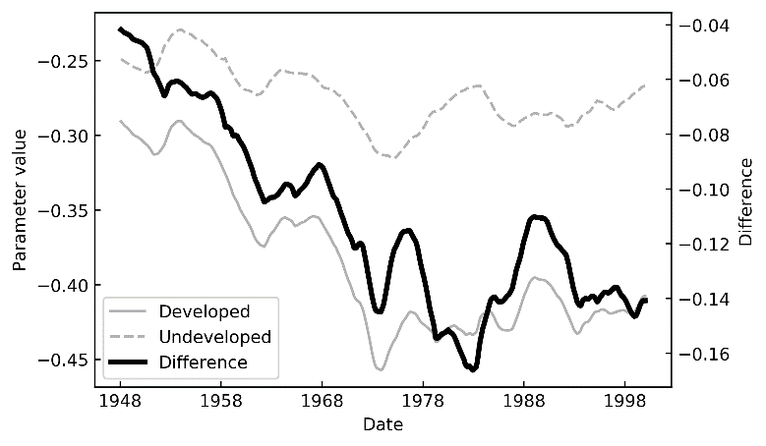
Figure 14: Trends in differences in DLM parameters between developed and undeveloped catchments

7. References
Adamowski, J., Fung Chan, H., Prasher, S.O., Ozga-Zielinski, B., Sliusarieva, A., 2012. Comparison of multiple linear and nonlinear regression, autoregressive integrated moving average, artificial neural network, and wavelet artificial neural network methods for urban water demand forecasting in Montreal, Canada: WATER DEMAND FORECASTING USING WAVELET-NEURAL NETWORKS. Water Resour. Res. 48. https://doi.org/10.1029/2010WR009945
Ahn, K.-H., Yellen, B., Steinschneider, S., 2017. Dynamic linear models to explore time-varying suspended sediment-discharge rating curves: TIME-VARYING SEDIMENT RATING CURVES. Water Resour. Res. 53, 4802–4820. https://doi.org/10.1002/2017WR020381
Arfken, G.B., Weber, H.J., 2012. Mathematical Methods for Physicists, 7th ed.
Band, L.E., McDonnell, J.J., Duncan, J.M., Barros, A., Bejan, A., Burt, T., Dietrich, W.E., Emanuel, R., Hwang, T., Katul, G., Kim, Y., McGlynn, B., Miles, B., Porporato, A., Scaife, C., Troch, P.A., 2014. Ecohydrological flow networks in the subsurface: ECOHYDROLOGICAL FLOW NETWORKS IN THE SUBSURFACE. Ecohydrology n/a-n/a. https://doi.org/10.1002/eco.1525
Bergman, M.J., Delleur, J.W., 1985. Kalman filter estimation and prediction of daily stream flows: I. Review, algorithm, and simulation experiments. JAWRA J. Am. Water Resour. Assoc. 21, 815–825.
Beven, K., 2012. Rainfall-Runoff Modelling: The Primer, 2nd ed. Wiley-Blackwell.
Burn, D.H., Elnur, M.A.H., 2002. Detection of hydrologic trends and variability. J. Hydrol. 255, 107–122.
Carlson, R., MacCormick, A.J.A., Watts, D., 1970. Application of Linear Random Models to Four Annual Streamflow Series. Water Resour. Res. 6, 1070–1078.
Ciupak, M., Ozga-Zielinski, B., Adamowski, J., Quilty, J., Khalil, B., 2015. The application of Dynamic Linear Bayesian Models in hydrological forecasting: Varying Coefficient Regression and Discount Weighted Regression. J. Hydrol. 530, 762–784.
de A. Barreto, G., de Andrade, M., 2000. Bayesian Inference and Markov Chain Monte Carlo Methods Applied to Streamflow Forecasting, in: Proc. 6th Intl. Conf on Probabilistic Methods Applied to Power Systems. Funchal.
DeWalle, D.R., Swistock, B.R., Johnson, T.E., McGuire, K.J., 2000. Potential effects of climate change and urbanization on mean annual streamflow in the United States. Water Resour. Res. 36, 2655–2664.
Diaz, H.F., Markgraf, V., 1992. El Niño: historical and paleoclimatic aspects of the Southern Oscillation. Cambridge University Press.
Duan, Q., Schaake, J., Andréassian, V., Franks, S., Goteti, G., Gupta, H.V., Gusev, Y.M., Habets, F., Hall, A., Hay, L., Hogue, T., Huang, M., Leavesley, G., Liang, X., Nasonova, O.N., Noilhan, J., Oudin, L., Sorooshian, S., Wagener, T., Wood, E.F., 2006. Model Parameter Estimation Experiment (MOPEX): An overview of science strategy and major results from the second and third workshops. J. Hydrol. 320, 3–17. https://doi.org/10.1016/j.jhydrol.2005.07.031
Ghanbarpour, M.R., Abbaspour, K.C., Hipel, K.W., 2009. A comparative study in long-term river flow forecasting models. Int. J. River Basin Manag. 7.
Helsel, D.R., Hirsch, R.M., 2002. Statistical Methods in Water Resources Techniques of Water Resources Investigations. U.S. Geological Survey.
Hodgkins, G.., Dudley, R.., Huntington, T.., 2003. Changes in the timing of high river flows in New England over the 20th Century. J. Hydrol. 278, 244–252. https://doi.org/10.1016/S0022-1694(03)00155-0
Holder, R.L., 1985. Multiple regression in hydrology. Institute of Hydrology, Wallingford, Oxfordshire.
Jackson, D.R., Aron, G., 1971. Parameter estimation in hydrology: The state of the art. JAWRA J. Am. Water Resour. Assoc. 7, 457–472.
Jakeman, A.J., Hornberger, G.M., 1993. How much complexity is warranted in a rainfall-runoff model? Water Resour. Res. 29, 2637–2649.
Kirchner, J.W., 2009. Catchments as simple dynamical systems: Catchment characterization, rainfall-runoff modeling, and doing hydrology backward. Water Resour. Res. 45, n/a-n/a. https://doi.org/10.1029/2008WR006912
Krishnaswamy, J., Vaidyanathan, S., Rajagopalan, B., Bonell, M., Sankaran, M., Bhalla, R.S., Badiger, S., 2015. Non-stationary and non-linear influence of ENSO and Indian Ocean Dipole on the variability of Indian monsoon rainfall and extreme rain events. Clim. Dyn. 45, 175–184. https://doi.org/10.1007/s00382-014-2288-0
Kuczera, G., Parent, E., 1998. Monte Carlo assessment of parameter uncertainty in conceptual catchment models: the Metropolis algorithm. J. Hydrol. 69–85.
Lee, Y.H., Singh, V.P., 1998. Application of the Kalman filter to the Nash Model. Hydrol. Process. 12, 755–767.
Lettenmaier, D.P., Wood, E.F., Wallis, J.R., 1994. Hydroclimatological trends in the continental United States, 1948-88. J. Clim. 7.
Lins, H.F., Slack, J.R., 1990. Streamflow trends in the United States. Geophys. Res. Lett. 26, 227–230.
McCabe, G.J., Wolock, D.M., 2002. A step increase in streamflow in the conterminous United States: A STEP INCREASE IN STREAMFLOW. Geophys. Res. Lett. 29, 38-1-38–4. https://doi.org/10.1029/2002GL015999
Modarres, R., Ouarda, T.B.M.J., 2013. Modelling heteroscedasticity of streamflow times series. Hydrol. Sci. J. 58, 54–64. https://doi.org/10.1080/02626667.2012.743662
Muftuoglu, R.F., 1990. Monthly runoff gneration by nonlinear models. J. Hydrol. 277–291.
Nash, L.L., Gleick, P.H., 1991. Sensitivity of streamflow in the Colorado basin to climatic changes. J. Hydrol. 125, 221–241.
Piotrowski, A.P., Napiorkowski, M.J., Napiorkowski, J.J., Osuch, M., Kundzewicz, Z.W., 2017. Are modern metaheuristics successful in calibrating simple conceptual rainfall–runoff models? Hydrol. Sci. J. 62, 606–625. https://doi.org/10.1080/02626667.2016.1234712
Pole, A., West, M., Harrison, J., 2011. Applied Bayesian Forecasting and Time Series Analysis, 2nd ed, CRC Texts in Statistical Science. Chapman and Hall.
Prado, R., West, M., 2010. Time Series: Modeling, Computation and Inference, 1st ed, CRC Texts in Statistical Science. Chapman and Hall.
Rabiner, L.R., Juang, B.H., 1986. An Introduction to Hidden Markov Models. IEEE ASSP Mag.
Risko, S.L., Martinez, C.J., 2014. Forecasts of seasonal streamflow in West-Central Florida using multiple climate predictors. J. Hydrol. 519, 1130–1140. https://doi.org/10.1016/j.jhydrol.2014.08.043
Rose, S., Peters, N.E., 2001. Effects of urbanization on streamflow in the Atlanta area (Georgia, USA): a comparative hydrological approach. Hydrol. Process. 15, 1441–1457. https://doi.org/10.1002/hyp.218
Rumynin, V.G., 2015. Overland Flow Dynamics and Solute Transport, Theory and Applications of Transport in Porous Media. Springer International Publishing, Cham. https://doi.org/10.1007/978-3-319-21801-4
Seabold, S., Perktold, J., 2010. Statsmodels: Econometric and statistical modeling with python, in: Proceedings of the 9th Python in Science Conference. p. 61.
Serinaldi, F., Kilsby, C.G., Lombardo, F., 2018. Untenable nonstationarity: An assessment of the fitness for purpose of trend tests in hydrology. Adv. Water Resour. 111, 132–155. https://doi.org/10.1016/j.advwatres.2017.10.015
Shephard, N., 1994. Local scale models: State space alternative to integrated GARCH processes. J. Econom. 60, 181–202.
Sivakumar, B., 2003. Forecasting monthly streamflow dynamics in the western United States: a nonlinear dynamical approach. Environ. Model. Softw. 18, 721–728. https://doi.org/10.1016/S1364-8152(03)00074-4
Slater, L., Villarini, G., 2017. Evaluating the Drivers of Seasonal Streamflow in the U.S. Midwest. Water 9, 695. https://doi.org/10.3390/w9090695
Small, D., Islam, S., Vogel, R.M., 2006. Trends in precipitation and streamflow in the eastern U.S.: Paradox or perception? Geophys. Res. Lett. 33. https://doi.org/10.1029/2005GL024995
Twine, T.E., Kucharik, C.J., Foley, J.A., 2005. Effects of El Niño–Southern Oscillation on the climate, water balance, and streamflow of the Mississippi River basin. J. Clim. 18, 4840–4861.
Ukkola, A.M., Prentice, I.C., Keenan, T.F., van Dijk, A.I.J.M., Viney, N.R., Myneni, R.B., Bi, J., 2015. Reduced streamflow in water-stressed climates consistent with CO2 effects on vegetation. Nat. Clim. Change 6, 75–78. https://doi.org/10.1038/nclimate2831
Vecchia, A.V., 1985. PERIODIC AUTOREGRESSIVE-MOVING AVERAGE (PARMA) MODELING WITH APPLICATIONS TO WATER RESOURCES. JAWRA J. Am. Water Resour. Assoc. 21, 721–730.
von Storch, H., 1999. Misuses of Statistical Analysis in Climate Research, in: Analysis of Climate Variability. Springer-Verlag Berlin Heidelberg, pp. 11–26.
Vrugt, J.A., Ter Braak, C.J.F., 2011. DREAM: an adaptive Markov Chain Monte Carlo simulation algorithm to solve discrete, noncontinuous, and combinatorial posterior parameter estimation problems. Hydrol. Earth Syst. Sci. 15, 3701–3713. https://doi.org/10.5194/hess-15-3701-2011
Wagner, T., Midway, S., Whittier, J., DeWeber, J., Paukert, C., 2017. Annual Changes in Seasonal River Water Temperatures in the Eastern and Western United States. Water 9, 90. https://doi.org/10.3390/w9020090
Wang, W., Van Gelder, P., Vrijling, J.K., Ma, J., 2005. Testing and modelling autoregressive conditional heteroskedasticity of streamflow processes. Nonlinear Process. Geophys. 12, 55–66.
Weerts, A.H., El Serafy, G.Y.H., 2006. Particle filtering and ensemble Kalman filtering for state updating with hydrological conceptual rainfall-runoff models: PARTICLE AND ENSEMBLE KALMAN FILTERING. Water Resour. Res. 42. https://doi.org/10.1029/2005WR004093
West, M., 2013. Bayesian dynamic modelling. Bayesian Inference Markov Chain Monte Carlo Honour Adrian FM Smith 145–166.
West, M., Harrison, J., 1997. Bayesian forecasting and dynamic models, 2nd ed. ed, Springer series in statistics. Springer, New York.

