Rijish Ganguly

RG239

1. **Bit Stuffing.**
   1. A bit string, 10011111100101111100011, needs to be transmitted at the data link layer. What is the string transmitted across the Link after bit stuffing by the sender, assuming the bit stuffing scheme shown in the lecture slides?

After bit stuffing following the scheme, the string that would be transmitted across the Link Layer is 1001111101001011111000011.

* 1. A frame is received by the data link layer, which was transmitted using bit stuffing: 0111111000111110110011111001101111110. What is the bit string that the link layer passes up the stack to the network layer after bit de-stuffing, assuming the bit stuffing scheme shown in the lecture slides?

After bit de-stuffing, the bit string that the link layer passes up the stack to network layer is

011111100111111100111110110111111. The bit de-stuffing is done following the scheme shown in class.

1. **Link Layer Protocols.** A channel has a bit rate of 4 kilobits per second and a propagationdelay of 20 milliseconds. For what range of frame sizes does stop-and-wait give a link utilization efficiency of at least 50%?

1 data frame = x Kbytes = 1024x bytes = 1024*8 = 8192x bits

Transmission speed = 4000 bits /second

Tdata = 8192x/4000 = 2.048x seconds

Tack ~ 0

Tprop = 20 ms

For utilization of 50%, we calculate x to be approximately = 0.0195

Data frame size for 50% utilization = 160 bits

1. **Distance Vector Routing.** Consider the subnet shown below. Distance vector routing isused, and the following vectors (showing the cost from each node) have just come in to router C: from **B**: (5, 0, 9, 12, 6, 2); from **D**: (16, 12, 6, 0, 9, 10); and from **E**: (7, 6, 3, 9, 0, 4). The measured delays from C to **B**, **D**, and **E** are 6, 6, and 3, respectively. What will C’s new routing table be after this update? Show both the outgoing line to use and the expected delay.

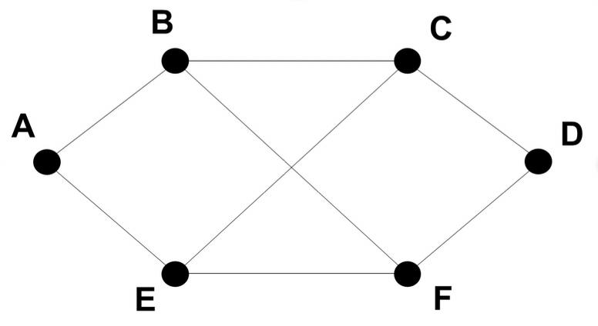

Routing Table Format:

|  |  |  |
| --- | --- | --- |
| Destination | Cost | Next Hop |
| A |  |  |
| B |  |  |
| C |  |  |
| D |  |  |
| E |  |  |
| F |  |  |

1. **TCP Sequence Numbers.** To get around the problem of sequence numbers wrappingaround while old TCP packets still exist, TCP could use 64-bit sequence numbers instead of 32 bits. However, theoretically an optical fiber can run at 75 Terabits per second. What maximum packet lifetime would be required to prevent sequence number wrap-around even with 64-bit sequence numbers? Assume that each byte of a packet has its own sequence number (as TCP does).
2. **DNS.** Using an online whois lookup service likewhois.net, look up duke.edu. On what datewas the domain registered? When does it expire? What are the DNS servers for this domain? Include a screenshot of your source.

Date of Registry: 02-Jun-1986

Date of Expiration: 31-Jul-2021

DNA name servers: DNS-AUTH-01.OIT.DUKE.EDU

DNS-AUTH-02.OIT.DUKE.EDU

DNS-NC1-01.OIT.DUKE.EDU

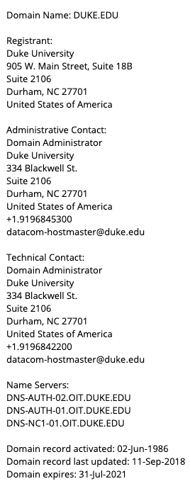

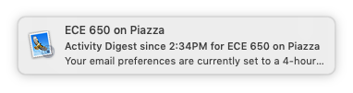

1. **Internet Services.** Using netcat (the ‘nc’ command) in a terminal, manually display thefollowing URL to the console. <http://rabihyounes.com/awesome.txt>

My request in request.txt

GET /awesome.txt HTTP/1.1

Host: rabihyounes.com

Connection: close

[empty line]

[empty line]

