Analysis of Flavour and Texture Changes in Sweet Potato
Qingyuan Zhang [a]*, Jiawen Xu [a], Ziqing Zhao [a], Jun Li [b], Yuxiao Chang [b]
[a] Department of Food Science, Shenyang Agricultural University, Shenyang, Liaoning, 110866, China
[b] Shenyang Key Laboratory for Nutritional Resource & Quality Control of Grain and Oil, Shenyang, Liaoning, 110866, China
* Author for correspondence; e-mail: ZQY19990227@outlook.com
ORCiD: https://orcid.org/0009-0006-7106-6965
Received: 17 March 2026 Revised: 1 June 2026 Accepted: 13 July 2026 Published: August 2026
Citation: Zhang Q., Xu J., Zhao Z., Li J. and Chang Y., Analysis of flavour and texture changes in sweet potato. Chiang Mai Journal of Science, 2026; 53(5): e2026081. DOI 10.12982/CMJS.2026.081.
Copyright: ©2026 Author (s). This is an Open Access article distributed under the term of the Creative Commons Attribution 4.0 International License CC BY 4.0 (https://creativecommons.org/licenses/by/4.0).
GRAPHICAL ABSTRACT

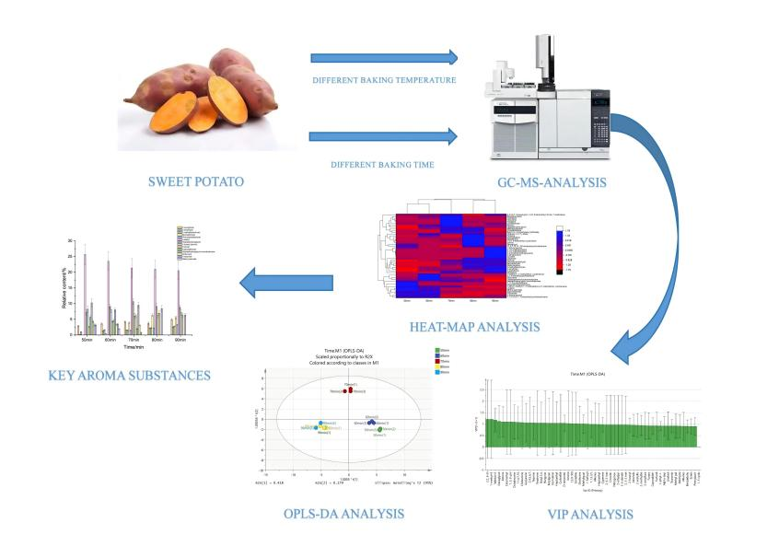

ABSTRACT
Baking is among the most favoured methods for preparing sweet potatoes. The Maillard reaction that occurs during the baking process enhances the flavour, rendering the sweet potatoes both delicious and appealing in colour. By investigating and optimizing the baking temperature and time, one can significantly improve both the flavour and quality of sweet potatoes while also understanding how various baking conditions affect their nutritional composition. Experimental results indicate that the ideal conditions for maximizing the edible quality of sweet potatoes are a baking time of 70 min at a temperature of 140 °C. The sweetness value is highest at 140 °C and 70 min respectively, the value is 18.02 and 18.96, while bitterness and astringency values are at their lowest. The bitterness and astringency values are -11.77 and -6.26 at 140 °C, and -2.51 and -4.99 at 70 min. Additionally, the levels of aromatic components, such as linalool and benzaldehyde, which contribute to the sweet aroma, are also highest under these conditions. Sensory scores of sweet potatoes treated under these conditions were significantly higher than other groups, reaching 86 ± 3 out of a total score of 100.

Keywords: sweet potato, baking treatment, Maillard reaction, flavour quality
1. INTRODUCTION
Sweet potato is rich in a variety of nutrients and contains a great quantity of starch, which is the main source of energy for the human body. It can be used as a substitute for rice, wheat and other food crops. Sweet potato protein has a complete variety of amino acids, abundant content, and an ideal composition of amino acids, which has high protein biological value [1]. Sweet potatoes can be a good source of essential dietary nutrients for the prevention of malnutrition caused by vitamin A and other micronutrient deficiencies [2]. The active components of sweet potatoes, such as polyphenols, flavonoids and anthocyanins, have strong biological activities. Various biological functions of sweet potatoes are related to antioxidant activities, including antioxidant, anti-cancer, anti-diabetes, liver protection, anti-tumour, antibacterial and anti-inflammatory activities [3]. Studies have shown that different types of sweet potatoes help regulate blood sugar levels and lower insulin, and can be used as a potential drug to treat type-II diabetes [4].
Baking is a time-honoured method of food heat treatment, widely used in the processing of cereals, meat and other food products. The specific process conditions in the baking process, including baking temperature, treatment time and other parameters, have a significant impact on the sensory evaluation, odour, texture characteristics and taste value of the product. Studies have shown that different baking conditions can significantly affect the texture characteristics and the aroma of sweet potatoes [5]. Therefore, experiments and optimization of baking conditions are helpful in improving the edible quality of baked sweet potatoes.
The effect of baking on the quality of sweet potato food is mainly reflected in the following two aspects. First of all, under the condition of high-temperature heating, the starch in sweet potatoes undergoes a gelatinization reaction, decomposing into maltose, glucose, and other small-molecule sugars under the action of heat-activated amylase, glucose and other small molecular sugars, thus significantly improving the sweetness of sweet potato [6]. At the same time, the cell wall of the sweet potato tissue cells softened, which reduced the hardness of the sweet potato and made the texture of the sweet potato soft and waxy [7]. Secondly, high temperature will also cause the Maillard reaction to occur inside the sweet potato. Different baking temperatures and times will significantly affect the reaction process and degree of the Maillard reaction, resulting in different volatile substances, changing the aroma components of the sweet potato and the relative content of each component, thus affecting the aroma of the baked sweet potato [8].
At present, few studies have fully explored the effects of different baking conditions on the food quality of baked sweet potato, and the specific mechanism of action of Maillard reaction on the aroma components of sweet potato is still unclear. Therefore, this experiment aims to study the effects of baking conditions on sensory evaluation, texture characteristics and aroma components of sweet potatoes. The effects of different stages of Maillard reaction on the content of volatile substances in sweet potato aroma were also discussed.

2. MATERIALS AND METHODS
2.1 Materials and Pretreatment
Fresh sweet potato (Hami variety) picked from Liaoning, China, the picking period was June, medium-sized sweet potatoes were selected, a single sweet potato weighs from 320 g to 350 g, the length was 15-20 cm and the diameter was 5-7 cm. Sweet potatoes were washed and then baked in a baking oven (Panasonic oven, model H3801KSP). All sweet potatoes remained structurally intact with their peels completely covering the flesh during the baking treatment, no segmentation processing has been performed. The oven uses infrared lamp as the heat source, and the heating method was direct radiant heating.
To explore the effects of different baking conditions on the quality of sweet potatoes, different baking times and baking temperatures were selected as two independent variables in this study. According to the research of Caro-Hernández, the ideal temperature for sweet potato baking was about 140 °C [9], and the baking time of sweet potatoes should be controlled from 30 min to 90 min to obtain the best edible quality [10], which was similar to the results of pre-experiment. For the pre-experiments, the baking times were set from 30 min to 100 min, and the baking temperature were set from 100 °C to 220 °C, and the pre-experiment was an 8×7 orthogonal experiment. The final experimental parameters were determined by sensory evaluation of sweet potatoes.
The experiment was designed based on the above two pieces of research and results from pre-experiment. According to the results of pre-experiment, when the baking time was shorter than 50 min and the temperature was lower than 120 °C, the inner part of sweet potato was not fully baked and still remain raw; when the baking time was longer than 90 min and the temperature was higher than 200 °C, the sweet potato was over baked, with a large hard shell covering its surface, and the sweet potato had a strong bitter smell. For the baking time, the parameters of baking time were set as 50 min, 60 min, 70 min, 80 min and 90 min in 140 °C condition. For the baking temperature, the parameters of baking temperature were set as 120 °C, 140 °C, 160 °C, 180 °C and 200 °C in 70 min condition, in total 10 samples under different baking condition were taken to study the effects of different baking temperatures and baking time on the quality of sweet potato respectively. After baking, the sweet potatoes were cooled to room temperature for sensory evaluation, aroma composition measurement, taste value and texture detection. All sweet potatoes maintained morphological integrity.

2.2 Raw Sweet Potato’s Content of Reducing Sugar and Starch
According to the method of Islam [11], the content of reducing sugar and starch of the raw sweet potato which was not baked were measured. The sweet potato was peeled, washed and cut into small pieces as samples for measuring starch and reducing sugars. All the measurement were repeated 3 times and take the average value.
Took 1-2 g sample peeled and properly smash, then 5 mL of 80% Ethanol (EtOH) was added and heated in a dry block heat bath for 30 min at 80 °C and the extracts were then centrifuged for 10 min at 5000 r/min. The supernatant was then decanted, and the process was repeated four to five times in total. All of the supernatants were combined and thoroughly mixed together, and 80% ethanol was used to make the final volume 25 mL, and sugar was extracted from this solution. The residues from this extraction process were collected for analysis of starch content.

2.3 Volatile Aroma Components
The method of Zhang was improved [12]. Took 5 g of baked sweet potato after peeling as a sample, quickly smashed the sample into a paste and then put it in a 20 mL extraction bottle, and placed the bottle in 60 °C water. Inserted the composite extraction head into the headspace extraction bottle, made the extraction fibre head exposed to the upper headspace of the sample in the bottle, and proceeded with the extraction for 50 min. After the extraction was completed, performed the qualitative and quantitative analysis of aroma components was by a GC-MS instrument (Agilent, model 7880A-5975A).
Injection: Drove the extraction needle into the forward sample port, desorbed at 250 °C for 5 min, and use helium as the carrier gas. Switched the GC-MS instrument to non-shunt injection mode, and the temperature rise process was as follows: the initial temperature was 40 °C and maintained for 12 min. Raised the temperature to 108 °C at the rate of 3 °C/min, and maintained for 2 min. Then rose the temperature to 250 °C at the rate of 5 °C/min. Mass spectrum conditions: The ionization mode was EI; The ion source temperature was 230 °C. The scanning mass number ranged from 45 to 550 m/z.
The Gas Chromatography-Mass Spectrometry (GC-MS) spectrogram was compared with the standard spectrogram of the NIST11 mass spectrometry library, and the components with matching degrees greater than or equal to 80 were selected. Calculate the relative content of each component using the peak area normalization method, every measurement was repeated three times to calculate the average value and the standard deviation, the final measurement results were set as the sum of the average value and the standard deviation. Orthogonal Partial Least Squares-Discriminant Analysis (OPLS-DA) and Variable Importance in Projection (VIP) analysis were performed on all three groups of experimental data to screen out the volatile substances that had a great impact on sweet potato aroma.
The GC-MS analysis was repeated under the same experimental conditions using the certified reference materials of those substances instead of the sweet potato sample, to confirm that sweet potato aroma contains these key volatile substances certainly.

2.4 Taste Value
The sweet potato’s taste value was determined by Ilic's method [13]. Weighed 50 g of baked sweet potatoes, peeled and smashed the sample into a paste. Put the smashed sample in a beaker, and add 250 mL pure water, the mixed solution was then centrifuged in a centrifuge at 3500 r/min for 15 min and filtered after being centrifuged. Took the supernatant liquid, diluted it to 1:40, and used an electronic tongue (Japanese INSENT, model SA402B) to measure the value of the sweetness, bitterness, astringent, umami, saltiness, sour and spicy taste of the sweet potato.

2.5 Sensory Evaluation
The sensory evaluation was carried out according to the method of Tsai with some modifications [14]. Unpeeled sweet potatoes were subjected to sensory evaluation by 10 professional evaluators in a comfortable environment. The 10 evaluators who participated in the sensory evaluation were trained for 3 hours. In the sensory evaluation, hunger can affect the ability of evaluators, therefore, the mid-morning and mid-afternoon of each day were chosen as the period for evaluation. The evaluation will be conducted again in 30 min after the evaluation was completed. The evaluator will gargle to remove the residual food residue after the evaluation and avoid affecting the next evaluation. Under inspection, evaluators were required not to smoke or eat snacks within one hour before the test. The evaluator should not bring any foreign odour to the evaluation activity, such as tobacco smell or cosmetics smell, so as not to affect the evaluation of the results. If the evaluator was upset or had a cold or other illness, the evaluator should not participate in the sensory evaluation. Every measurement was repeated three times. The appearance, texture, flavour and taste of sweet potato were evaluated. The maximum score was 100 score, and the final result was the average score of 10 reviewers. The scoring criteria of sensory evaluation are shown in Table 1.

Table 1. Baked sweet potato sensory evaluation criteria.

Item | Score | Evaluation criterion
Appearance | 30 | Bright and uniform colour, flat surface, no browning and impurities. (21-30)
Appearance | 30 | The colour is relatively bright and uniform, and the surface is slightly brown, with slightly protruding and collapsing. (11-20)
Appearance | 30 | The colour is not uniform, with obvious protrusions and collapses. (1-10)
Texture | 30 | Moderate hardness, fine texture, and a suitable degree of chew. (21-30)
Texture | 30 | Hardness is slightly low, texture is slightly loose. (11-20)
Texture | 30 | Hardness is obviously low, the texture is obviously loose. (5-10)
Texture | 30 | Hardness is extremely high, too hard to chew. (0-5)
Flavour | 40 | The flavour is pure, no odour, with obvious sweetness. (26-40)
Flavour | 40 | The aroma is mild, slightly astringent, with medium sweetness. (11-25)
Flavour | 40 | The sweetness is not obvious, with an obvious bitter and astringent taste. (1-10)

2.6 Texture Analysis
The method of Banerjee and Kumar was adopted and improved [15]. The baked sweet potato was peeled and cut into 3 cm × 5 cm × 5 cm squares, and its hardness, viscosity and chewiness were measured by a texture analyzer (Brookfield, USA, model CT3-10K). Use the P-Cy35S cylindrical probe to conduct the Texture Profile Analysis (TPA). The hardness, elasticity, viscosity and chewiness of sweet potato blocks were obtained from the texture characteristic curves. The parameter conditions were as follows: the probe descending speed was 2 mm/s, the probe testing distance was 15 mm, the trigger force was 25 g, the number of test cycles was two, and the experiment was repeated three times for each sweet potato sample.

2.7 Statistical Analysis
Experimental data were analyzed using Origin 2021 and Design Expert 12. The three samples were measured and represented by mean ± standard deviation. When the significance level was 0.05, and the P < 0.05, the difference was significant.

3. RESULTS AND DISCUSSION
3.1 Content of Reducing Sugar and Starch
The result shows that the content of reducing sugar of the sweet potato reaches 10.27 ± 0.62 g/100 g, and the content of starch is around 27.51 ± 1.20 g/100 g. Both of the results above are in fresh weight. According to the research data from Luo [16], the contents of both reducing sugar and starch of the sweet potato which is used in this research are ranking in top line of 20 different varieties of sweet potato.

3.2 Volatile Aroma Components
Volatile substances and their relative peak areas are measured by GC-MS. A total of 48 volatile substances are detected in the aroma of baked sweet potatoes, including 7 alkanes, 3 esters, 3 furans, 4 alcohols, 4 ketones, and 18 olefin substances, 5 aldehydes and 5 nitrogen-containing heterocycles. Figure 1 is the heat map of the clustering analysis of aroma component content. The horizontal coordinate represents the grouping of different baking times and baking temperatures, the vertical coordinate stands for each aroma component, and different colour blocks represent the relative content of corresponding aroma components, the red block represents low content and the blue block represents high content. It can be seen from the figure that the contents of alcohols, esters and alkanes are high in the initial stage of the heating process, and then the contents decrease significantly with the extension of the heating process. The contents of furan and nitrogenous heterocyclic substances increased significantly at the late stage of the heating process.

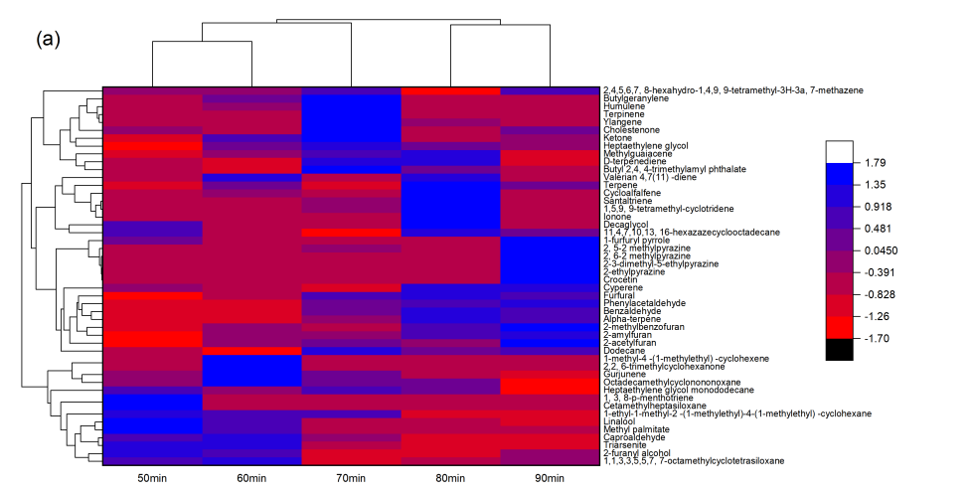
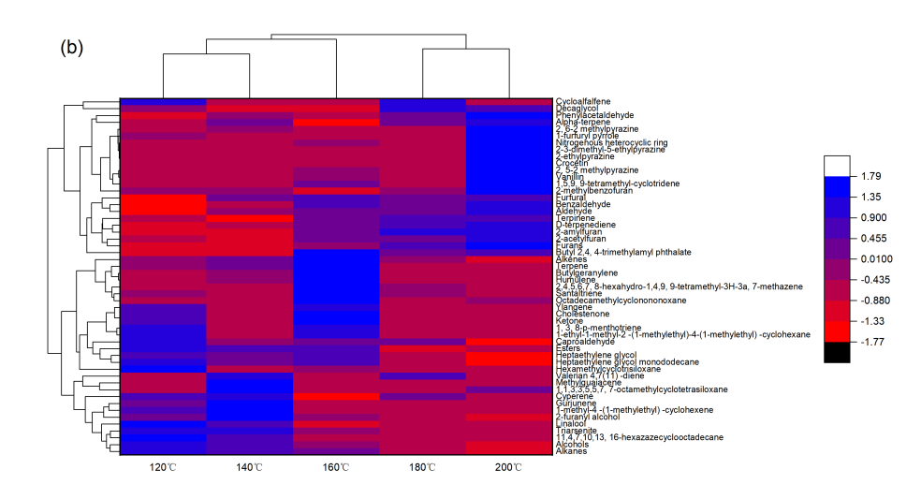

Figure 1. Heat map of sweet potato aroma components with different baking times (a) and baking temperatures (b).

As shown in Figure 2, OPLS-DA principal component analysis results of sweet potato aroma component content at different baking temperatures showed that PC1 contribution is 43.9% and PC2 contribution is 22.3%, and all samples are within a 95% confidence interval. The three coordinates of the samples baked at 120 °C and 140 °C are located in the fourth quadrant, the coordinates of the samples baked at 160 °C are located in the second quadrant, and the result coordinates of the samples baked at 180 °C and 200 °C are located in the third section. The analysis results of sweet potato aroma component content under different baking times showed that the PC1 contribution degree is 41.8% and the PC2 contribution degree is 17.9%, all samples are within a 95% confidence interval. The coordinates of the sweet potato samples with a baking duration of 50 min and 60 min are located in the fourth quadrant, and the coordinates of the 70 min sweet potato samples are located in the second and first quadrants, all coordinates are distributed around the Y axis. The coordinates of the 80 min and 90 min sweet potato samples are located in the third quadrant. The above analysis results show that when the baking conditions are relatively close, there is a gap in the aroma components of sweet potato, but the difference is not significant. When the difference in baking conditions is large, the difference in sweet potato aroma components becomes more significant.

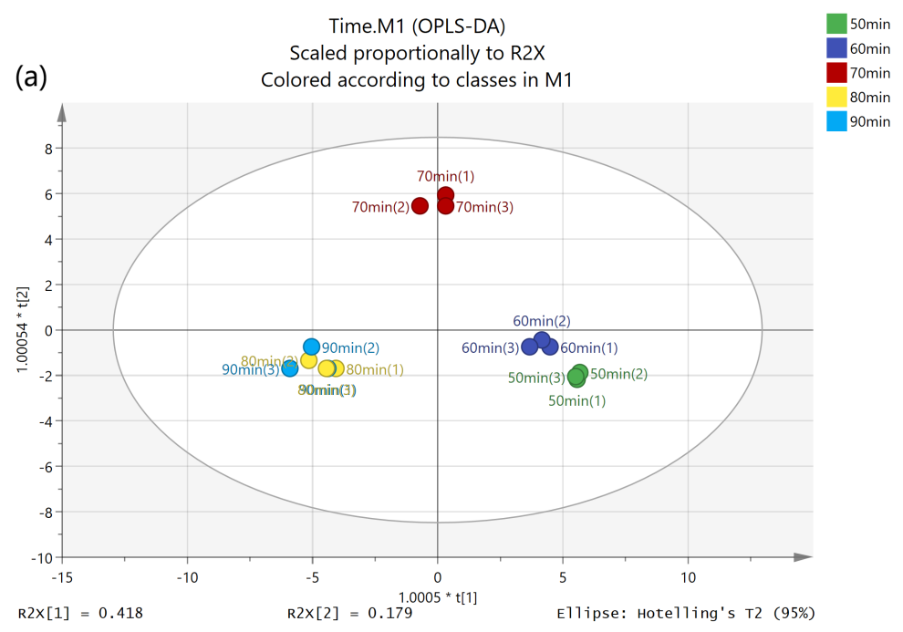

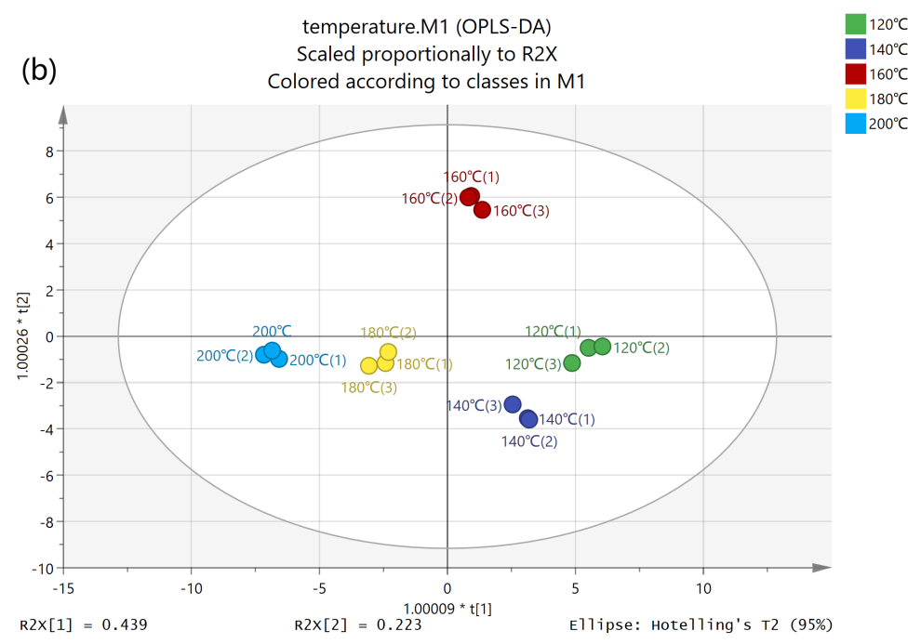

Figure 2. OPLS-DA analysis of aroma components of sweet potato with different baking times (a) and baking temperatures (b).

In order to distinguish the variation trend of the contents of different aroma substances under different baking conditions, VIP analysis of the contents of each aroma substance is carried out to further determine the substances which influence the aroma of sweet potato signally under different baking conditions [17]. Substances with great contribution to the aroma of sweet potato content are selected according to the result of VIP, P and FC (Fold Change) value in OPLS-DA analysis, VIP > 1.1, P < 0.05 and FC > 2 or FC < 0.5 as the criteria for screening substances [18]. The higher the VIP value, the more significant the contribution that the volatile substance makes to the aroma of the sample. As shown in Figure 2, the results of the OPLS-DA score chart showed that the coordinates of sweet potato samples under different baking conditions are distributed in multiple quadrants, which is consistent with the results of PCA principal component analysis, proving that there are significant differences in sweet potato aroma under different baking conditions. As can be seen from Figure 3, the VIP score chart showed that there are 14 substances that met the screening criteria, VIP > 1.1, P < 0.05 and FC > 2 or FC < 0.5. These substances included linalool, Heptaethylene glycol, 2-furanol, benzaldehyde, phenylacetaldehyde, furfural, Caproaldehyde, 2-acetylfuran,
2-amylfuran, 2-methylbenzofuran, Heptaethylene glycol monododecane, triarsenite, methyl palmitate. Therefore, the following analysis should concentrate on the changing trend of these substances. Key aroma components and corresponding certified reference materials are presented in Table 2. All the 14 kinds of key substances have been validated by standards-controlled tests.

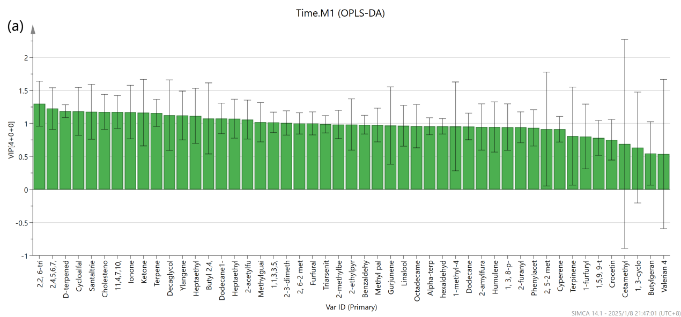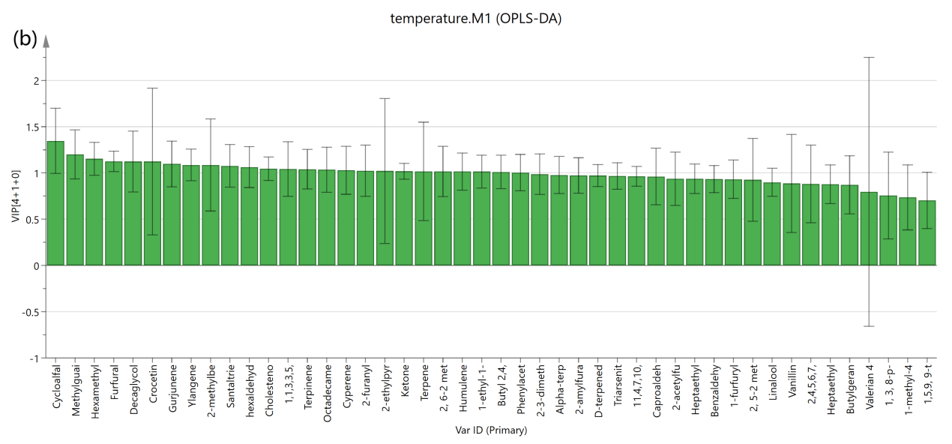

Figure 3. VIP score chart of key differences in volatile flavour substances for different baking times (a) and baking temperatures (b).

Table 2. Key aroma components and corresponding certified reference materials.

Compound name | Certified reference materials | Supplier
Linalool | Linalool | Merck KGaA
Heptaethylene glycol | Polyethylene glycol | Merck KGaA
2-furanyl alcohol | 2-furanyl alcohol | Merck KGaA
Benzaldehyde | Benzaldehyde | Merck KGaA
Phenylacetaldehyde | Phenylacetaldehyde | Merck KGaA
Furfural | Furfural | Merck KGaA
Caproaldehyde | Caproaldehyde | Merck KGaA
2-acetylfuran | 2-acetylfuran | Merck KGaA
2-amylfuran | 2-amylfuran | Merck KGaA
2-methylbenzofuran | 2-methylbenzofuran | Merck KGaA
Heptaethylene glycol monododecane | Heptaethylene glycol monododecane | Merck KGaA
Dodecane | Dodecane | Merck KGaA
Triarsenite | C₉H₂₇AsO₃Si₃ | Achemica
Methyl palmitate | C₁₇H₃₄O₂ | MedChemExpress

The component with the highest content among the aroma of sweet potato is alcohol, which fluctuates around 40% under different baking conditions and decreases with the increase of baking temperature, from 46.75% at 120 °C to 40.23% at 140 °C, and 36.72% at 200 °C. The main reason for this change is that in the primary stage of the Maillard reaction, alcohol macromolecular substances are cracked under high temperatures, and fewer molecular substances such as furans and aldehydes are produced [19]. The highest content of alcohol is linalool, its content is 25.32% at the baking temperature of 120 °C and 24.13% at 140 °C. When the temperature finally rose to 200 °C, its content further decreased to 21.67%. As for the baking time, its content is 25.67% at 50 min and 21.34% at 70 min, when the baking time is extended to 90 min, the content decreases to 20.51%. Linalool has a soft aroma similar to lilac, which makes a significant contribution to sweet potato aroma and can obviously improve the edible quality of sweet potato [20]. Heptaethylene glycol in alcohol has a fresh fruit flavour, and its relative content decreases from 9.74% to 8.64% when the baking temperature increases from 120 °C to 140 °C, and finally drops to 4.22% when the temperature rises to 200 °C. As for the baking time, its content is 7.19% at 50 min and 10.62% at 70 min when the baking time is extended to 90 min, the content decreases to 6.84%. It can be seen that when the temperature is higher than 140 °C and the baking time is longer than 70 min, the content of Heptaethylene glycol starts decreasing with the rising of temperature and the length of baking time. 2-furanyl alcohol has a floral-like aroma, the content is 10.10% at 120 °C, 12.15% at 140 °C and 7.64% at 200 °C, also displayed an obvious decreasing trend with the rising of temperature when the temperature is higher than 140 °C. Therefore, after the baking temperature reaches 140 °C and the baking time reaches 70 min, it is not recommended to raise the temperature and lengthen the time, because if the baking temperature is too high and the baking time is too long, the content of aromatic alcohols such as linalool, Heptaethylene glycol and 2-furanol alcohol will decrease significantly, thus weakening the aroma of sweet potato.
The content of aldehydes in sweet potato aroma also fluctuated with the change in baking conditions. The main changes are that with the increase in baking temperature and baking time, the content of hexaldehyde decreased, and the content of benzaldehyde and phenylacetaldehyde increased. Benzaldehyde and phenylacetaldehyde have a similar aroma to almonds and flowers, which can enhance the sweet smell [21]. When the baking temperature is 120 °C, the relative content of hexaldehyde is 3.26%, but benzaldehyde and phenylacetaldehyde are not detected. When the baking temperature is 140 °C, the relative of hexaldehyde drops to 1.32%, and the content of Benzaldehyde and phenylacetaldehyde rises to 3.88% and 1.44%. When the baking temperature finally rises to 200 °C, no hexaldehyde is detected, the relative content of benzaldehyde is 5.57%, and the relative content of phenylacetaldehyde is 3.23%. As for the baking time, the content of hexaldehyde kept dropping with the extension of baking time, while the content of benzaldehyde and phenylacetaldehyde increased obviously, which is similar to the trend of temperature. The main reason for this change is that hexaldehydes are decomposed under high temperatures and aldehydes of small molecules are produced. At the same time, heating will lead to the volatilization of alcohols and the thermal decomposition of esters. The original monosaccharides in sweet potato also undergo caramelization and decomposition into small molecule substances and then rearrange to produce aldose due to the Maillard reaction. Aldose can also enhance sweet potato’s aroma [22]. The results showed that the content of benzaldehyde and phenylacetaldehyde increased with the extension of baking time, which is consistent with the results obtained in the research literature [23]. In conclusion, increasing the baking temperature and extending baking time properly can improve the content of benzaldehyde and phenylacetaldehyde, but when the sweet potato is overbaked, the content of nitrogen-containing heterocyclic substances will increase sharply, and the content of alcohol will decrease, reducing the edible quality of sweet potato. It will be more ideal to control the baking temperature and baking time in a proper range, instead of raising the baking temperature and extending the baking time to chase for the higher content of benzaldehyde and phenylacetaldehyde.
Furan substances in sweet potato aroma also showed an increasing trend. With the increase of baking temperature and the extension of baking time, the content of furan substances decreased from 3.59% at 120 °C to 3.18% at 140 °C, and 10.56% at 200 °C. As for baking time, the content of furan substances increased from 4.04% at 50 min to 7.29% at 70 min, and 10.27% at 90 min. The detected furan substances mainly included 2-acetyl furan,
2-amyl furan and 2-methylbenzofuran. 2-acetyl furan has a nutty aroma, 2-amyl furan has a bean aroma,
2-methylbenzofuran has a fruit aroma. These three furan substances can improve the aroma of sweet potatoes. The main reason for the increase of furan components is that the Maillard reaction is further carried out under the action of high temperature, in the intermediate stage of the Maillard reaction, the aldehydes produced by the decomposition of alcohols, such as 5-methylfurfural, continue to decompose under with temperature, produce substances with lower molecular weight, thus increasing the content of furan substances [24].
The main categories of aroma components that decrease significantly are alkanes and esters. When the baking temperature is 120 °C, the relative contents of alkanes and esters are 27.32% and 6.97%. When the baking temperature is 200 °C, the contents of alkanes and esters decrease to 15.59% and 0.54%. Heptaethylene glycol monododecane, 1-ethyl-1-methyl-2-(1-methylethyl)-4-(1-methylethyl)-cyclohexane, triarsenite and methyl palmitate decreased significantly. The main reason for this change is that the alkanes and esters of large molecules are cracked under high temperatures, thus reducing their content [25]. Alkanes and esters have high flavour thresholds, and their influence on sweet potato aroma is not obvious [26]. The significant decrease in the relative content of alkane and ester in sweet potato aroma will lead to an obvious increase in the relative content of other substances such as alcohol, which indirectly enhances the sweet potato aroma.
When the baking temperature rises to 200 °C and the baking time is extended to 90 min, nitrogen-containing heterocyclic substances with a significantly increased content are detected in the aroma, with a relative content of 7.59% at 200 °C and 9.73% at 90 min. This is because at high temperatures, the Maillard reaction enters the final stage, and the aroma substances such as alcohols are significantly consumed at high temperatures due to the cracking reaction, and various nitrogenous heterocyclic substances are produced [27]. When the baking temperature rises to 200 °C and the baking time is extended to 90 min, the special aroma of baked sweet potato does not exist, and its smell is mainly the pungent smell of burnt.
At this stage, the caramelization reaction proceeds fully, causing large sugar molecules to break down into small molecular compounds such as aldehydes, which have a bitter and astringent taste, thereby intensifying the perception of bitterness and astringency. Lee [28] found that when increasing the baking temperature of the cake from 60 °C to 80 °C significantly increased the content of 5-hydroxymethylfurfural among the volatile compounds, which is consistent with the phenomenon observed in this experiment. When the baking time was extended from
50 minutes to 90 minutes, the relative content of furfural increased from 2.59% to 6.29%. When the baking temperature increased from 120 °C to 200 °C, the relative content of furfural rose from 1.01% to 7.01%, which leads to a marked increase of bitter smell.
Therefore, excessive baking will seriously affect the edible quality of sweet potatoes. The change trend of the relative content of key aroma substances is shown in Figure 4. The molecular formula and characteristic description of these aroma components are recorded in Table 3.

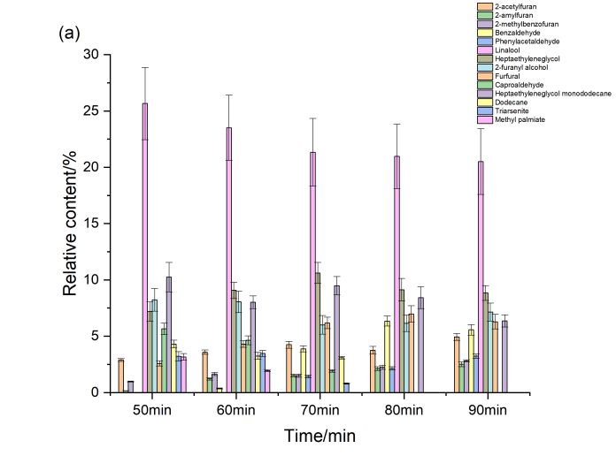

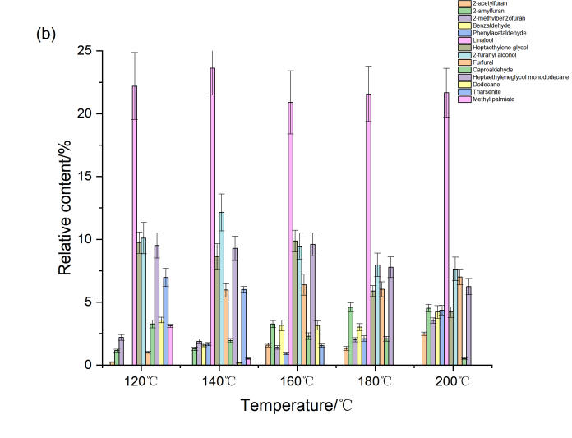

Figure 4. Effect of different baking times (a) and baking temperatures (b) on the content of key aroma substances.

Table 3. Characterization of key aroma components.

Compound name | Molecular formula | Aroma characterization
Linalool | C₁₀H₁₈O | Aroma of flower and fruit
Heptaethylene glycol | C₁₄H₃₀O₈ | Fresh, fruity aroma
2-furanyl alcohol | C₅H₆O₂ | Floral aroma
Benzaldehyde | C₇H₆O | Almond, flower fruity aroma
Phenylacetaldehyde | C₈H₈O | Sweet aroma of fruit
Furfural | C₅H₄O₂ | Almond, flower fruit aroma
Caproaldehyde | C₆H₁₂O | Herbaceous taste
2-acetylfuran | C₆H₆O₂ | Almond, nut aroma
2-amylfuran | C₉H₁₄O | Aroma of beans, vegetables
2-methylbenzofuran | C₉H₈O | Fruity aroma
Heptaethylene glycol monododecane | C₂₆H₅₄O₈ | -
Dodecane | C₁₂H₂₆ | -
Triarsenite | C₉H₂₇AsO₃Si₃ | -
Methyl palmitate | C₁₇H₃₄O₂ | Smell of iris

3.3 Taste Value
Taste is the sensory characteristic of taste production, and is one of the important criteria for food quality [29]. Figure 5 reflects the changes in each taste value of sweet potato under different baking temperatures and baking times. As can be seen from the figure, the saltiness, umami and sour values of sweet potato remained stable, and the taste values with great changes mainly included sweetness, bitterness and astringent.

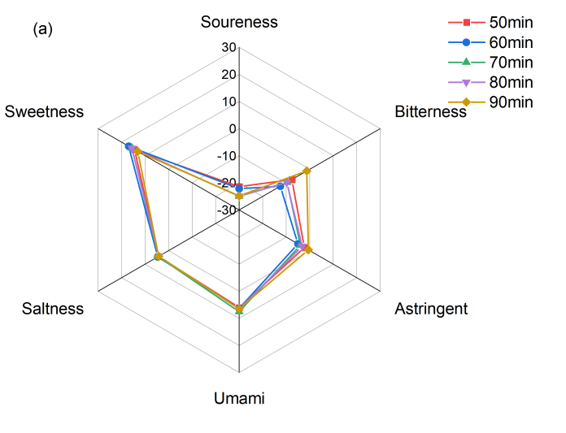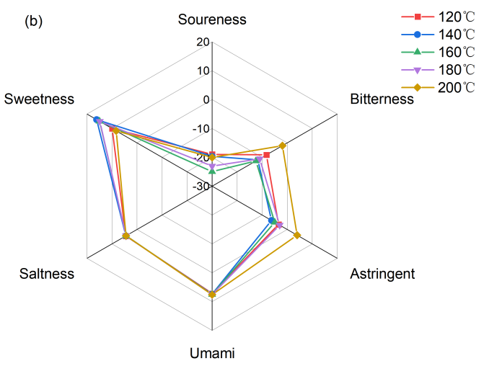

Figure 5. Effect of different baking times (a) and baking temperatures (b) on the taste of sweet potato.

According to Figure 5, the sweetness value is highest at 140 °C and 70 min respectively, the value is 18.02 and 18.96, because in the initial heating stage, the macromolecular sugars such as starch in sweet potato are decomposed by heat and generated glucose, maltose, fructose and other sweet-smelling small molecular sugars. At the same time, the bitterness and astringency of sweet potato are also lowest at 140 °C and 70 min. The bitterness and astringency values are -11.77 and -6.26 at 140 °C, and -2.51 and -4.99 at 70 min, indicating that the sweetness value is much higher than the bitterness and astringency value. The reason is that there are some astringent substances such as oxalic acid, tannin and anthocyanin in unbaked sweet potatoes, and glucoside alkaloids will make fresh sweet potatoes have a certain bitter taste [30]. In the initial stage of baking, these bitter and astringent substances will be cracked, thereby reducing the bitterness and astringency of the sweet potato. At the same time, the enzymatic reaction and scorching are not fully carried out, and not too many bitter and astringent substances are produced.
When the baking temperature is further increased and the baking time is prolonged, the value of bitterness and astringency of the sweet potato gradually increases, while the sweetness decreases. When the baking temperature is 200 °C, the sweet, bitter and astringent values of sweet potato are 8.34, -1.93 and 3.9, and when the baking time is 90 min, the sweet, bitter and astringent values are 13.12, -1.24 and -0.5. It can be seen that the sweet value is still higher than the bitter and astringent values, but the gap is significantly narrowed. This is because, with the continuous progress of the Maillard reaction in baking, the final products such as nitrogen-containing heterocycles produced by the pyrolysis reaction are largely generated, producing a strong bitter taste, which affects the flavour of sweet potato [31]. At the same time, excessive baking will also cause the sugar in the sweet potato to char, produce a large number of coke-like hard shells on the surface of the sweet potato flesh, and produce a very obvious bitter taste, seriously affecting the flavour of the sweet potato.

3.4 Sensory Evaluation
The results of the sensory evaluation are shown in Table 4. For the baking time, the sensory evaluation scores reach the highest value at 70 min, and the score is 86. For the baking temperature, the sensory evaluation scores reach the highest value at 140 °C, and the score is 86. Under these situations, the sweet potato has a rich aroma, no burnt odour, moderate hardness, and pure white colour, and the results of the sensory evaluation are ideal.
With the increase in baking temperature and the extension of baking time, the sensory score showed a trend of increasing at first and then decreasing. When the baking temperature was lower than 140 °C and the baking time was less than 70 min, the sweet potato was not fully cooked inside, and the fragrance was not obvious. This is because the Maillard reaction has not been fully carried out, and the production of volatile substances with aromatic smells such as furfural and benzaldehyde is insufficient. At the same time, the content of remaining starch is still too high, and the reducing sugar content generated by the decomposition of sweet potato is insufficient, which reduces the sweetness of the sweet potato, so the sensory evaluation of sweet potato processed under this condition is not very ideal.
When the baking temperature is higher than 140 °C and the baking time is longer than 70 min, the sensory score begins to decline. The starch and monosaccharide of sweet potato are overcooked under high temperatures, and the colour changes to yellow and black. At the same time, a hard coke-like shell is formed on the surface of the sweet potato flesh, which seriously affects the taste and colour of the sweet potato. At this stage, the caramelization reaction continues proceeding, causing the sugars in sweet potatoes to undergo browning reactions, which deepen the color of the sweet potatoes and lead to a decrease in sensory scores. Mundt [32] found that the browning reaction continued as the temperature increased. When the baking temperature of cookies increases from 105 °C to 135 °C, their color becomes noticeably darker, consistent with the results obtained in this study. The aroma of sweet potato is weakened, and there is an obviously burnt smell and a burnt bitter taste when chewing sweet potato pulp. Therefore, the sensory score of sweet potatoes prepared at higher temperatures and longer baking time is not very ideal.

Table 4. Effect of baking time and temperature on sensory evaluation of sweet potato.

Baking time (min) | 50 | 60 | 70 | 80 | 90
Sensory evaluation score | 73 ± 3^{c} | 79 ± 2^{b} | 86 ± 3ª | 62 ± 2^{d} | 55 ± 4e

Baking temperature (°C) | 120 | 140 | 160 | 180 | 200
Sensory evaluation score | 56 ± 3e | 86 ± 3ª | 73 ± 2^{b} | 62 ± 3^{c} | 53 ± 2^{d}
Note: Different letters in the same row indicate significant differences at P < 0.05.

3.5 Texture Analysis
The texture of sweet potatoes with different baking temperatures and duration was determined, and the results are shown in Table 5. With the increase of baking temperature and the extension of baking time, the hardness of the sweet potato decreases at first and reaches the lowest value at 160 °C (427 N) and 80 min (432 N), the chewiness of sweet potato also decreases. At the initial stage of heating, due to the damage to the crystallinity of sweet potato and the dissociation of the double helix structure caused by heat treatment [33], the formation of granule hollow zone reduces the hardness of sweet potato. Chen [34] also reported that after being treated by high temperature, starch molecules will become more unstable under the effect of gelatinization, which also lead to the decrease of the hardness of starch. In addition, the cell walls of sweet potato flesh tissue are damaged after heating, the cells of starchy sweet potato are fused after cooking [35], and the tissue structure of the potato block is destroyed at high temperatures, so the hardness of sweet potato decreases. Supapvanich [36] found that the decomposition of the cell wall structure could significantly reduce the flesh hardness of Hami melons, the conclusion supports the phenomenon we observed in the experiment. As the heating continues, the reducing sugar in the sweet potato flesh caramelizes, forming a burnt paste shell, resulting in a slight increase in the hardness and chewiness of the sweet potato after heating.
Elasticity represents the ability of an object to change under the influence of external factors and then return to its original form [37]. Adhesiveness is the resistance that is first felt when cutting food [38]. The adhesiveness of sweet potato shows an increasing trend with the increase of baking temperature and the extension of baking time and reaches the maximum value at 200 °C (141 N) and 90 min (136 N) because starch is decomposed into glucose and fructose after dehydration with the increase of temperature, which increased the stickiness of sweet potato [39]. Martin [40] found that with the increase of temperature, pectin molecules become more densely packed, forming compact rod-like helical structures, thereby increasing the adhesiveness of pectin. The above two factors also lead to an increase in the adhesiveness of sweet potatoes under high-temperature treatment. On the other hand, the degree of the Maillard reaction and the degradation of starch increase, thus leading to the formation of maltose, which also increases adhesiveness. The chewiness of sweet potatoes increases slightly, but the overall amplitude is not significant.

Table 5. Effect of different amounts of baking time and temperature on the texture of sweet potato.

Baking time (min) | Hardness (N) | Elasticity (m) | Adhesiveness (N) | Chewiness (N)
50 | 482.73 ± 5.27ª | 0.44 ± 0.01e | 112.09 ± 2.11e | 109.53 ± 3.49ª
60 | 453.25 ± 6.01^{b} | 0.50 ± 0.02^{c} | 124.56 ± 1.37^{d} | 90.17 ± 2.17e
70 | 432.27 ± 5.31e | 0.53 ± 0.02ª | 131.82 ± 1.26^{c} | 92.89 ± 2.31^{d}
80 | 447.60 ± 4.97^{d} | 0.51 ± 0.01^{b} | 136.54 ± 2.79ª | 97.84 ± 1.97^{b}
90 | 449.39 ± 3.61^{c} | 0.49 ± 0.01^{d} | 135.60 ± 2.47^{b} | 95.03 ± 1.51^{c}

Baking temperature (°C) | Hardness (N) | Elasticity (m) | Adhesiveness (N) | Chewiness (N)
120 | 482.47 ± 4.01ª | 0.42 ± 0.02e | 103.27 ± 1.31e | 112.03 ± 2.17ª
140 | 433.53 ± 5.17^{d} | 0.53 ± 0.01^{b} | 129.17 ± 0.98^{d} | 93.37 ± 1.99^{d}
160 | 427.10 ± 2.19e | 0.55 ± 0.02ª | 133.59 ± 1.44^{c} | 87.20 ± 2.01e
180 | 441.59 ± 3.37^{c} | 0.52 ± 0.01^{c} | 139.98 ± 1.40^{b} | 95.62 ± 1.41^{b}
200 | 451.97 ± 4.34^{b} | 0.48 ± 0.01^{d} | 141.84 ± 1.51ª | 94.32 ± 1.74^{c}
Note: Different letters in the same column indicate significant differences at P < 0.05.

4. CONCLUSIONS
The effects of different baking times and temperatures on the quality of sweet potatoes are studied in this paper. GC-MS identified 48 volatile compounds in baked sweet potato, among which linalool and other alcohols are the main sources of sweet potato aroma. With the increase of baking temperature and the extension of baking time, the alkanes, alcohols and esters in sweet potato are pyrolyzed to small molecule aldehydes due to the Maillard reaction, reducing the sweet potato's aroma. Excessive baking will lead to the formation of nitrogen-containing heterocyclic substances, which have a kind of pungent smell, seriously affecting the edible quality of sweet potatoes.
The electronic tongue analysis shows that moderate baking temperature and baking time can significantly improve the sweetness of the sweet potato and reduce the bitterness and astringency of the sweet potato. The sensory evaluation shows that when the baking temperature is below 140 °C and the baking time is shorter than
60 min, the sweet potato flavour cannot be fully reflected. When the baking temperature rose to 200 °C, and the baking time extended to 90 min, the sweet potato would be burnt and affect the result of sensory evaluation. The influence of baking time and baking temperature on the texture of sweet potato is mainly reflected in hardness and adhesiveness. When the baking temperature is below 140 °C and the baking time is shorter than 60 min, the hardness of the sweet potato would remain at a high level. Excessive baking will lead to the formation of a scorched paste shell on the surface of the sweet potato, making the sweet potato too hard and sticky.
It is suggested that in order to achieve optimal edible quality of sweet potatoes, the baking temperature should be appropriately reduced and the baking duration should be shortened. When the baking temperature is excessively high, the combined effects of the Maillard reaction and caramelization reaction will induce the generation of a large amount of bitter-tasting volatile compounds, result in significant darkening of the sweet potato pulp color, and promote the formation of a distinct hard crust, which ultimately leads to a severe deterioration in the edible quality of sweet potatoes. Based on our findings regarding the sharp increase in furfural and nitrogen-containing heterocycles under intensive thermal treatment, future research should transition from single-factor empirical testing to Response Surface Methodology (RSM) combined with multi-objective kinetic modeling. This will aim to mathematically balance the maximizing of sweet aroma compounds (such as linalool) against the rigorous suppression of bitter-tasting pyrolytic artifacts. Furthermore, further investigations should map the precise correlation between macromolecular starch-pectin degradation and the microstructural changes responsible for sweet potato texturometric transitions during advanced baking phases.
Although a potential interaction may exist between baking temperature and time, the effects of each factor were determined independently in this study. This separate determination was strategically selected because evaluating multi-factor simultaneous variations within the complex volatile matrices would exponentially increase the collinearity and complexity of the OPLS-DA and VIP analyses, potentially obscuring the specific chemical trajectories of individual drivers.

ACKNOWLEDGEMENTS
This research is supported by Shenyang Agricultural University. We want to express our appreciation to Liaoning Share Green Co., Ltd. and Shandong Laiyang Longda Food Co., Ltd., due to the material and testing service. Dr. Zheng’s guidance and Ms. Liu’s assistance are also very appreciated.

AUTHOR CONTRIBUTIONS
Qingyuan Zhang: Conceptualization, Methodology, Validation, Formal analysis, Investigation, Data curation, Writing-Original draft, Project administration, Writing - Review & Editing, Funding acquisition. Jiawen Xu: Validation. Ziqing Zhao: Validation. Jun Li: Resources. Yuxiao Chang: Resources.

CONFLICT OF INTEREST STATEMENT
The authors declare no conflict of interest.

DECLARATION OF USE OF GENERATIVE AI
If Generative AI was used during the preparation of the manuscript, this should be declared in the form of the following statement: "During the preparation of this manuscript, the authors used [name and version of AI] in order to [reason for using it].”
It is also understood that, after using AI, the authors have reviewed and edited the manuscript accordingly and take full responsibility for its content.
Where Generative AI was used in the preparation of the manuscript, authors are required to include a declaration briefly stating the purpose for which it was used. It is also understood that, after using AI, the authors will have carefully reviewed and edited the manuscript before submitting it.

ETHICAL GUIDELINES
The sensory evaluation in this paper was approved by Shenyang Agricultural University Institutional Animal Care and Use Committee, according to “Guideline of Shenyang Agricultural University Application for Laboratory Animal/Human Welfare and Ethical”, after we confirmed that no one was hurt or caught food poisoning, the trial registration number is 24050801, and the date of registration is May 8, 2024. We provide a registration file named as Shenyang Agricultural University Application for Laboratory Animal Welfare and Ethics review, which is attached as related file.

FUNDING
This work was financed by Project of Liaoning Provincial Department of Education: LJ232510157002, Comprehensive Utilization and Quality Control of Characteristic Grain and Oil Resources in Liaoning Province and Shenyang Key Laboratory for Nutritional Resource & Quality Control of Grain and Oil, Shenyang Agricultural University, Shenyang.

REFERENCES
[1] Tedesco D., Moreira B.R.A., Barbosa Júnior M.R., Maeda M. and Silva R.P., Sustainable management of sweet potatoes: A review on practices, strategies, and opportunities in nutrition-sensitive agriculture, energy security, and quality of life. Agricultural Systems, 2023; 210: 103693. DOI 10.1016/j.agsy.2023.103693.
[2] Ju D., Mu T. and Sun H., Sweet potato and potato residual flours as potential nutritional and healthy food material. Journal of Integrative Agriculture, 2017; 16(11): 2632–2645. DOI 10.1016/S2095-3119(16)61601-5.
[3] Alam M.K., A comprehensive review of sweet potato (Ipomoea batatas [L.] Lam): Revisiting the associated health benefits. Trends in Food Science & Technology, 2021; 115: 512–529. DOI 10.1016/j.tifs.2021.07.001.
[4] Qin Y., Naumovski N., Ranadheera C.S. and D’Cunha N.M., Nutrition-related health outcomes of sweet potato (Ipomoea batatas) consumption: A systematic review. Food Bioscience, 2022; 50: 102208. DOI 10.1016/j.fbio.2022.102208.
[5] Hou F., Mu T., Ma M. and Blecker C., Optimization of processing technology using response surface methodology and physicochemical properties of baked sweet potato. Food Chemistry, 2019; 278: 136–143. DOI 10.1016/j.foodchem.2018.11.034. There was a discrepancy in the title compared to the original.
[6] Xie Y., Liu Q., Mao C., Pang H., Ye P., Cui B., et al., Radio frequency puffing of purple sweet potato nutritious snacks. Journal of Food Engineering, 2024; 367: 111894. DOI 10.1016/j.jfoodeng.2023.111894.
[7] Zou H., Xu L., Xu Z., Xie W., Wang Y., Liao X., et al., Effects of ultra-high temperature treatment and packages on baked purple sweet potato nectar. LWT-Food Science and Technology, 2018; 94: 129–135. DOI 10.1016/j.lwt.2018.04.037.
[8] Habinshuti I., Mu T.H. and Zhang M., Structural, antioxidant, aroma, and sensory characteristics of Maillard reaction products from sweet potato protein hydrolysates as influenced by different ultrasound-assisted enzymatic treatments. Food Chemistry, 2021; 361: 130090. DOI 10.1016/j.foodchem.2021.130090.
[9] Caro-Hernández O., Aguilar-Palazuelos E., Gutiérrez-Dorado R., Caro-Corrales J., Jacobo-Valenzuela N., Carrazco-Escalante M., et al., Analysis of physicochemical variables and bioactive compounds in baked sweet potato snacks. Journal of Food Science, 2024; 89(9): 8569–8580. DOI 10.1111/1750-3841.17509. Issue number was incorrect.
[10] Tsai Y.J., Lin L.Y., Yang K.M., Chiang Y.C., Chen M.H. and Chiang P.Y., Effects of baking sweet potato (Ipomoea batatas L. Lam.): Quality, volatile compound composition, and sensory evaluation. Foods, 2021; 10(11): 2602. DOI 10.3390/foods10112602. There was a discrepancy in the title compared to the original.
[11] Islam M.M., Naznin S., Naznin A., Uddin M.N., Amin M.N., Rahman M.M., et al., Dry matter, starch content, reducing sugar, color and crispiness are key parameters of potatoes required for chip processing. Horticulturae, 2022; 8(5): 362. DOI 10.3390/horticulturae8050362.
[12] Zhang R., Tang C., Jiang B., Mo X. and Wang Z., Optimization of HS-SPME for GC-MS analysis and its application in characterization of volatile compounds in sweet potato. Molecules, 2021; 26(19): 5808. DOI 10.3390/molecules26195808.
[13] Ilic J., Tomasevic I. and Djekic I., Influence of water-based and contact heating preparation methods on potato mechanical properties, mastication, and sensory perception. International Journal of Gastronomy and Food Science, 2021; 25: 100401. DOI 10.1016/j.ijgfs.2021.100401.
[14] Tsai Y.J., Lin L.Y., Yang K.M., Chiang Y.C., Chen M.H., Chiang P.Y., et al., Effects of baking sweet potato (Ipomoea batatas L. Lam.): Quality, volatile compound composition, and sensory evaluation. Foods, 2021; 10(11): 2602. DOI 10.3390/foods10112602. Duplicate with [10]
[15] Banerjee R. and Kumar K.J., Evaluating the effects of time-dependent drying and pressure heat treatments on the variation of physicochemical and rheological properties of suran starch. International Journal of Biological Macromolecules, 2024; 263(Pt 1): 130071. DOI 10.1016/j.ijbiomac.2024.130071.
[16] Luo K., Zhang J., Li X., 4th author’s name, 5th author’s name and 6th author’s name, Comparison of quality characteristics among 20 sweet potato varieties. Scientific Reports, 2025; 15: 28154. DOI 10.1038/s41598-025-13564-5. The 4th-6th author’s names were missing.
[17] Dong L., Piao Y., Zhang X., Zhao C., Hou Y. and Shi Z., Analysis of volatile compounds from a malting process using headspace solid-phase micro-extraction and GC–MS. Food Research International, 2013; 51(2): 783–789. DOI 10.1016/j.foodres.2013.01.052.
[18] Mo X., Xu Y. and Fan W., Characterization of aroma compounds in Chinese rice wine Qu by solvent-assisted flavour evaluation and headspace solid-phase microextraction. Journal of Agricultural and Food Chemistry, 2010; 58(4): 2462–2469. DOI 10.1021/jf903631w. There was a discrepancy in the title compared to the original.
[19] Api A.M., Belsito D., Bhatia S., Bruze M., Calow P., Dagli M.L., et al., RIFM fragrance ingredient safety assessment, l-linalool, CAS Registry Number 126-91-0. Food and Chemical Toxicology, 2016; 97S: S11–S24. DOI 10.1016/j.fct.2015.12.014.
[20] Xiao L., Lee J., Zhang G., Ebeler S.E., Wickramasinghe N., Seiber J., et al., HS-SPME GC/MS characterization of volatiles in raw and dry-baked almonds (Prunus dulcis). Food Chemistry, 2014; 151: 31–39. DOI 10.1016/j.foodchem.2013.11.052. There was a discrepancy in the title compared to the original.
[21] Guclu G., Dagli M.M., Aksay O.K., Keskin M., Kelebek H. and Selli S., Comparative elucidation on the phenolic fingerprint, sugars and antioxidant activity of white, orange and purple-fleshed sweet potatoes (Ipomoea batatas L.) as affected by different cooking methods. Heliyon, 2023; 9(6): e18684. DOI 10.1016/j.heliyon.2023.e18684. Issue number was incorrect.
[22] Shen X., Wang H., Zhuang H., Yao L., Sun M., Yu C., et al., Comparative analysis of the aromatic profile of single malt whiskies from different regions of Scotland using GC-MS, GC-O-MS and sensory evaluation. Journal of Food Composition and Analysis, 2024; 133: 106465. DOI 10.1016/j.jfca.2024.106465.
[23] Nakamura A., Ono T., Yagi N. and Miyazawa M., Volatile compounds with characteristic aroma of boiled sweet potato (Ipomoea batatas L. cv Ayamurasaki, I. batatas L. cv Beniazuma and I. batatas L. cv Simon 1). Journal of Essential Oil Research, 2013; 25(6): 497–505. DOI 10.1080/10412905.2013.809320.
[24] Chen L.L., Wang P., Chen H.Q., Guo Z.K., Wang H., Dai H.F., et al., New furan derivatives from a mangrove-derived endophytic fungus Coriolopsis sp. J5. Molecules, 2017; 22(2): 261. DOI 10.3390/molecules22020261.
[25] Cho Y., Kang J., Huh M. and Yun S.I., Styrene-free synthesis and curing behaviour of vinyl ester resin films for hot-melt prep process. Materials Today Communications, 2022; 30: 103143. DOI 10.1016/j.mtcomm.2022.103143. There was a discrepancy in the title compared to the original.
[26] Shi X., Dean L.O., Davis J.P., Sandeep K.P. and Sanders T.H., The effects of different dry bake parameters on peanut quality using an industrial belt-type baker simulator. Food Chemistry, 2018; 240: 974–979. DOI 10.1016/j.foodchem.2017.07.130. There was a discrepancy in the title compared to the original.
[27] Sayon D.R.S., Fakih A., Mercier F., Kondjoyan N., Meurillon M., Ratel J., et al., Targeted quantification and untargeted exploration of furan and derivatives in infant food by headspace extraction-gas chromatography-Q Exactive Orbitrap mass spectrometry. Food Research International, 2024; 191: 114614. DOI 10.1016/j.foodres.2024.114614.
[28] Lee J., Roux S., Descharles D., Rega B. and Bonazzi C., Unravelling caramelization and Maillard reactions in glucose and glucose + leucine model cakes: Formation and degradation kinetics of volatile markers extracted during baking. Food Research International, 2024; 183: 114183. DOI 10.1016/j.foodres.2024.114183.
[29] Ki S.Y. and Jeong Y.T., Neural circuits for taste sensation. Molecules and Cells, 2024; 47(7): 100078. DOI 10.1016/j.mocell.2024.100078.
[30] Zhu L., Mu T., Ma M., Sun H. and Zhao G., Nutritional composition, antioxidant activity, volatile compounds, and stability properties of sweet potato residues fermented with selected lactic acid bacteria and bifidobacteria. Food Chemistry, 2022; 374: 131500. DOI 10.1016/j.foodchem.2021.131500.
[31] Yang H., Li W., Lu B., Zi L., Xu N. and Guo L., Effect of different hot air drying process on flavour compounds and Maillard reaction products of Boletus edulis by HS-SPME/GC-MS coupled with multivariate analysis. LWT-Food Science and Technology, 2024; 198: 116055. DOI 10.1016/j.lwt.2024.116055. There was a discrepancy in the title compared to the original.
[32] Sandra M. and Bronislaw L.W., A kinetic model for browning in the baking of biscuits: Effects of water activity and temperature. LWT-Food Science and Technology, 2007; 40(6): 1078–1091. DOI 10.1016/j.lwt.2006.07.011. - - The authors' names should be written in the following format: full surname followed by the abbreviated first name and a period (e.g., Chaiklangmuang S. and Meesuk S.).
- The end page number was incorrect.
[33] Singh S., Raina C.S., Bawa A.S. and Saxena D.C., Effect of heat-moisture treatment and acid modification on rheological, textural, and differential scanning calorimetry characteristics of sweetpotato starch. Journal of Food Science, 2005; 70(6): e373–e378. DOI 10.1111/j.1365-2621.2005.tb11441.x.
[34] C. Zhiguang, H. Junrong, P. Huayin, W. Keipper. The effects of temperature on starch molecular conformation and hydrogen bonding. Starch-Stärke, 2022; 74(1–2): 2100288. DOI 10.1002/star.202100288.
- The authors' names should be written in the following format: full surname followed by the abbreviated first name and a period (e.g., Chaiklangmuang S. and Meesuk S.).
- In the list of authors, please use conjunction "and" before the last author's name.
- Issue number was incorrect.
[35] Chen X., Zhu L., Zhang H., Zhang Y., Cheng L. and Wu G., Influence of cell-wall permeability on starch digestion in sweet potato cells. Food Hydrocolloids, 2025; 159: 110718. DOI 10.1016/j.foodhyd.2024.110718.
[36] Supapvanich S. and Tucker G.A., Cell wall hydrolysis in netted melon fruit (Cucumis melo var. reticulatus L. Naud) during storage. Chiang Mai Journal of Science, 2013; 40(3): 447–458.

[37] Adal S., Delikanlı Kıyak B., Çalışkan Koç G., Süfer Ö., Özkan Karabacak A., İnan Çınkır N., et al., Applications of electrolyzed water in the food industry: A comprehensive review of its effects on food texture. Future Foods, 2024; 9: 100369. DOI 10.1016/j.fufo.2024.100369.
[38] Bhuiyan M.H.R. and Ngadi M., Application of batter coating for modulating oil, texture and structure of fried foods: A review. Food Chemistry, 2024; 453: 139655. DOI 10.1016/j.foodchem.2024.139655.
[39] Wang X., Wang Y., Zhao H., Tao H., Gao W., Wu Z., et al., Influence of hot-air drying on the starch structure and physicochemical properties of two corn cultivars cultivated in East China. Journal of Cereal Science, 2023; 114: 103796. DOI 10.1016/j.jcs.2023.103796.
[40] Martin A.M., Viscometric study of pectin. Effect of temperature on the hydrodynamic properties. International Journal of Biological Macromolecules, 2011; 48(issue): 286–291. DOI 10.1016/j.ijbiomac.2010.11.014.
- The authors' names should be written in the following format: full surname followed by the abbreviated first name and a period (e.g., Chaiklangmuang S. and Meesuk S.).
- Issue number was missing.

