3D-Printed Polymeric Resin Composites with g-C₃N₄ Nanosheets for Efficient Dye Removal in Wastewater Treatment
Htet Yadanar Soe [a], Thanate Na Wichean [b], Gasidit Panomsuwan [a], Oratai Jongprateep [a] and Ratchatee Techapiesancharoenkij [a]*
[a] Department of Materials Engineering, Faculty of Engineering, Kasetsart University, Bangkok 10900, Thailand
[b] Materials Innovation Center, Department of Materials Engineering, Faculty of Engineering, Kasetsart University, Bangkok 10900, Thailand
* Author for correspondence; e-mail: fengrct@ku.ac.th
ORCiD: https://orcid.org/0000-0002-6026-7685
Received: 27 June 2025 Revised: 9 December 2025 Accepted: 26 February 2026 Published: 19 March 2026
Citation: Soe H.Y., Na Wichean T., Panomsuwan G., Jongprateep O. and Techapiesancharoenkij R., 3D-printed polymeric resin composites with g-C₃N₄ nanosheets for efficient dye removal in wastewater treatment. Chiang Mai Journal of Science, 2026; 53(2): e2026032. DOI 10.12982/CMJS.2026.032.
Copyright: ©2026 Author (s). This is an Open Access article distributed under the term of the Creative Commons Attribution 4.0 International License CC BY 4.0 (https://creativecommons.org/licenses/by/4.0).

GRAPHICAL ABSTRACT

ABSTRACT
The widespread contamination of industrial wastewater with synthetic dyes presents a serious environmental challenge, impacting ecosystems, water quality, and public health. Developing 3D-printed polymeric resin composites embedded with g-C₃N₄ nanosheet scaffolds that were fabricated by stereolithography (SLA) technique for wastewater treatment applications. In this research, we enhanced the physicochemical characteristics of bulk g-C₃N₄ via direct thermal delamination. Structural analysis using X-ray diffraction (XRD) confirmed the crystalline phase of g-C₃N₄, and Scanning Electron Microscopy (SEM) revealed the nanosheets' morphology, with an average thickness conducive to high surface activity. The adsorption behavior of both bulk g-C₃N₄ and exfoliated g-C₃N₄ scaffolds was evaluated in the dark for 16 hours to ensure the attainment of adsorption equilibrium. Photocatalytic testing was performed under UV light (λ = 365 nm). After 8 hours of UV exposure, the dye removal efficiency of the 3D-printed composites against MB dyes reached 78%, 83%, 84%, and 86%, respectively, demonstrating their potential for effective dye removal. The results highlight the effectiveness of 3D-printed g-C₃N₄/polymeric resin composites as a viable solution for dye-contaminated wastewater, advancing sustainable treatment methods and contributing to environmental conservation and cleaner industrial processes.

Keywords: stereolithography (SLA), g-C₃N₄, resin, thermal oxidation method, photocatalytic activity
HIGHLIGHTS
- Thermal exfoliation produced high-surface-area g-C₃N₄ nanosheets.
- SLA 3D printing enabled g-C₃N₄/polymer composite fabrication.
- Composites showed efficient adsorption-photocatalytic dye removal.
- Photocatalytic MB removal efficiency reached 86% under UV light.
- 3D scaffolds demonstrated good stability and recyclability.

1. INTRODUCTION
Industrial wastewater frequently contains synthetic dyes and aromatic pollutants that are resistant to biodegradation, making effective treatment challenging [1]. Methylene blue aqueous dye solutions are widely utilized within the material, paper, leather, pharmaceutical, and cosmetic industries, and when discharged into water sources, they can cause serious risks [2]. More than 10,000 dyes and pigments have been used in production factories, with approximately 7 x 105 tons of synthetic dyes generated annually [3]. Dye wastewater includes a variety of contaminants, including dangerous adhesives, bases, or salts acidic substances, and auxiliaries that are teratogenic for cancer-causing, and exotic foods [4]. These characteristics may cause symptoms related to asthma, skin irritations, eye burns, and allergic conjunctivitis in humans. Consequently, the removal of organic dyes from wastewater has become increasingly important. A variety of methods for treating dye waste have been produced including membrane filtering, chemical deposition, and adsorption. Unfortunately, the treatments mainly remove the molecule of dye from water bodies to other materials such as adsorption compounds sediments, or membranes, rather than removing current dyes. Hybrid approaches such as combining electrocoagulation with photocatalysis have also shown improved dye removal efficiency in textile effluents [5]. Recently, the graphite-layered double hydroxides (LDH/GP) composites can effectively adsorb malachite green dye from wastewater, achieving high removal efficiency and reusability [6]. Combining electrocoagulation with supported photocatalysis can achieve up to 90% dye removal from batik textile wastewater with high COD levels [5]. However, these techniques are complex and require substantial financial investments, making them less suitable for small-scale applications. In contrast, photodegradation treatment provides a promising method for entirely removing the color from wastewater. When dangerous dye molecules are exposed to photodegradation, they break down into less toxic particles or molecules, and they completely disintegrate into water (H₂O) and carbon dioxide (CO₂). As a result, photodegradation has become an efficient method for wastewater treatment [7].
Recently, there has been significant attention on a metal-free polymer semiconductor (g-C₃N₄), for its potential applications as a photocatalyst. Its introduction into the field of heterogeneous catalysts in 2006 [8]. Graphitic carbon nitride (g-C₃N₄) has gained recognition because of its favorable band gap, earth abundance, conventional electrical structure, metal-free composition, and outstanding chemical and thermal stability. With a band gap near 2.7 eV, it is a promising material for photocatalytic applications under visible light [9]. However, pristine bulk g-C₃N₄ exhibits limited photocatalytic activity [10]. Thus, it is highly desirable to find an efficient method to enhance g-C₃N₄'s photocatalytic performance. Researchers have focused on g-C₃N₄ for its superior thermal and chemical robustness, capacity for visible light activation, distinct electronic features, and straightforward synthesis. The remarkable stability of g-C₃N₄ stems from its π-conjugated stacked arrangement, characterized by repeating tri-s-triazine units and the van der Waals forces binding the stacked sheets [11].
To overcome these challenges and enhance g-C₃N₄'s efficiency as a photocatalyst, different techniques have been investigated. These approaches incorporate morphology optimization, elemental substitution, structural hybridization, and defect engineering. Among these approaches, the transformation of g-C₃N₄ into two-dimensional (2D) nanosheets has emerged as a particularly effective method. This method not only increases the specific surface area, resulting in a significant increase in adsorption and photoactive sites, but also enhances the dispersibility of g-C₃N₄ for composite material fabrication. Presently, there are three developed and widely used methods to produce g-C₃N₄ nanosheets. For thermal exfoliation, bulk g-C₃N₄ disintegrates layer by layer through thermal oxidation processes [12]. Chemical exfoliation involves redox mechanisms and intercalation techniques facilitated by oxidizing agents such as sulfuric acid (H₂SO₄) and nitric acid (HNO₃) [13]. Ultrasonic vibration disrupts the layered structure of g-C₃N₄ by adjusting the interfacial energy between the solvent and the material [14]. In this top-down approach including exfoliation of the parent layered material is one of the especially effective techniques for their mass production, which is fundamental for their widespread practical utilization.
In addition to conventional methods, there's an increasing requirement for one-step exfoliation methods, offering example is the direct calcination of a blend of dicyandiamide and ammonium chloride (NH₄Cl) to yield g-C₃N₄ nanosheets, where NH₄Cl acts as a gas template [15]. Furthermore, the single-step thermal decomposition of melamine at 700°C has been successful in producing crystalline g-C₃N₄ nanosheets with improved hydrogen generation potential. These advancements demonstrate the potential for optimized strategies to efficiently fabricate nanosheets on a larger scale [16]. The incorporation of citric acid in forming a structure resembling sheets and introducing pores within g-C₃N₄ particles [17]. The choice of exfoliation method significantly affects the physical and optical characteristics of g-C₃N₄ nanosheets, although a comprehensive comparison of these techniques regarding photocatalytic performance remains incomplete [14]. Comparisons of various exfoliation methods to modify the photocatalytic activity of g-C₃N₄ nanosheets are still insufficient.
A larger surface area is essential for improving the efficiency of photocatalysis and adsorption. 3D printing technology provides an effective solution, allowing a straightforward fabrication of complex structures with expanded surface areas [18]. Using 3D-printed frameworks created from polymer resin, biowaste-derived adsorbents, and photocatalytic materials can optimize waste management, reduce water treatment expenses, and conserve resources [19]. Ecofriendly 3D-printed TiO₂/SiO₂/polymeric scaffolds have been developed for efficient dye removal, utilizing TiO₂ as a photocatalyst and SiO₂ as an adsorbent. The techniques have been applied with graphite-layered double hydroxide composites, offering effective surface interaction for removing dyes such as Malachite Green [6].These scaffolds, fabricated via stereolithography (SLA), exhibit high adsorption capacity, photocatalytic activity, and reusability, making them a promising solution for organic pollutant mitigation [20]. Furthermore, the buoyancy of these 3D-printed structures allows them to effectively adsorb and break down organic contaminants, while also making it easier to recover and reuse.
This research focuses on creating composite materials tailored for efficient dye removal, utilizing 3D printing to fabricate wastewater treatment composites composed of polymer resins, adsorbents, and catalysts. In this study, we synthesized g-C₃N₄ nanosheets through a thermal oxidation technique. The influence of thermal exfoliation conditions on the structural characteristics and photocatalytic properties of g-C₃N₄ was thoroughly evaluated. This method enhanced the photocatalytic efficiency of porous g-C₃N₄ via the thermal polymerization of melamine. The process required two distinct heating phases, leading to improved functionality. It was observed that raising the exfoliation temperature to 560 °C significantly improved the specific surface area, reaching 62 m²/g. Higher temperatures resulted in smaller particle sizes and thinner nanosheet structures. The transformation from bulk g-C₃N₄ to nanosheets was identified as a sequential oxidation process accompanied by the separation of layers, contributing to the reduced particle dimensions and an increased energy band gap. This research introduces an innovative method for developing nanostructures and optimizing the electronic properties of g-C₃N₄ to enhance its photocatalytic activity in degrading methylene blue (MB). Furthermore, the nanosheets demonstrated excellent stability under repeated irradiation, retaining high photocatalytic efficiency across multiple reaction cycles. This technology facilitates wastewater treatment through both adsorption and photocatalytic approaches.

2. MATERIALS AND METHODS
2.1 Materials
Melamine (99%) was obtained from SIGMA Co., Ltd. (Germany). HD resin was obtained from Sync Innovation Co., Ltd. (Thailand). Methylene blue (MB) was purchased from KOSDAQ Co., Ltd. (Korea). The research used analytical-grade materials and reagents. Deionized water was consistently employed for all experiments.

2.2 Methods
The synthesis of g-C₃N₄ nanosheets involved the thermal treatment of melamine. 10 grams of melamine was placed in a lidded ceramic container and gradually heated at a rate of 5 °C per minute until reaching 550 °C, where it was maintained for 2 hours under ambient air. According to the chemical equation (1), the decomposition of melamine into graphitic carbon nitride is accompanied by the release of ammonia gas [21]. The structural transformation from melamine to bulk g-C₃N₄, by the thermal treatment, is shown in Figure 1.

3C₃H₆N₆(s)⟶3g-C₃N₄(s)+6NH₃(g) (1)

Figure 1. Schematic of the structure of g-C₃N₄ Nanosheets.

Following the process, the mixture was permitted to gradually return to room temperature. The resultant substance was ground to powdered g-C₃N₄. Subsequently, the powdered g-C₃N₄ underwent a separation process through thermal oxidation.

2.2.1 Exfoliation of g-C₃N₄ by thermal oxidation method
To produce exfoliated g-C₃N₄ samples, layer splitting of bulk g-C₃N₄ powders was applied through a layer-by-layer thermal oxidation method, as illustrated in Figure 2. Bulk g-C₃N₄ powders of 3 grams were placed in a crucible and heated at a rate of 5 °C/min to varying temperatures, including CN (520°C) NSs, CN (540°C) NSs, and CN (560°C) NSs nanosheets, for 3 hours under normal atmosphere.

Figure 2. Schematic of preparation of few-layer g-C₃N₄ by Layer-by-layer thermal exfoliation.

2.3 Fabrication of the Polymeric Scaffolds
Stereolithography (SLA) was utilized to fabricate polymeric scaffolds incorporating the g-C₃N₄ photocatalyst. The resin and exfoliated g-C₃N₄ powders were mixed in a 90:10 weight ratio and stirred overnight for uniform dispersion. Using a Phrozen Shuffle XL Lite printer, scaffolds were 3D-printed under UV light (385–405 nm) to solidify the material, producing both pure polymer and composite g-C₃N₄ /polymer scaffolds. The fabricated scaffold exhibited a cylindrical architecture measuring 3 cm in diameter and 1 cm in height, with an average weight of 7 g.

Figure 3. Schematic of preparation of fabrication of polymeric scaffolds.

2.4 Characterization
The crystalline structures of the materials were analyzed using a Philips X'Pert X-ray diffractometer equipped with Cu Kα radiation (λ = 0.154 nm), operating at 40 kV and 30 mA over the 2θ range of 10° to 70°. The Scherrer equation was utilized to determine the crystallite size [22].

D = 0.89λ/(βcos θ) (2)

where θ is the Bragg's angle, λ represents the wavelength, and β is the peak width at half maximum (FWHM). The Fourier transform infrared (FTIR) analysis of the materials was conducted at room temperature through the KBr pellet method, covering a wavenumber range from 600 to 4000 cm⁻¹, utilizing a Bruker Alpha-E spectrometer. The morphological and compositional properties of the samples were thoroughly examined using a scanning electron microscope (SEM) on a Hitachi SU3500 and Energy dispersive spectroscopy (EDS) (Oxford instruments, AztecOne). The morphological shapes and thicknesses of the samples were examined by an atomic force microscope (AFM, Horiba AiST-NT). UV-Vis absorption spectroscopy was carried out with a SHIMADZU UV-1700 spectrophotometer. Bandgap values were determined from the (αhν)^{1/2} vs. hν plot, applying Tauc's method for indirect bandgap analysis, as described [23].

αhν = ${( h - E_{g} ) }^{2}$ (3)

where α, h, ν, E_{g} represent the absorption coefficient, Plank's constant, the photon frequency, and the energy band gap, respectively. Photoluminescence (PL) spectra were analyzed with a HORIBA fluorescence spectrophotometer operating with an excitation wavelength of 350 nm.

2.5 Photocatalytic Degradation of Methylene Blue
The photocatalytic performance of 3D-printed bulk g-C₃N₄ and exfoliated g-C₃N₄ nanosheet scaffolds was assessed by examining the degradation of methylene blue (MB) in water-based solutions under exposure to UV light. During the experiment, 3D-printed catalyst samples were immersed in 100 mL of a 0.01 mg L⁻¹ aqueous MB solution in a glass container. The adsorption experiment was carried out in the dark for 24 hours, followed by UV irradiation for 8 hours. Throughout the reaction, 3 mL of the solution was extracted at hourly intervals using a syringe to monitor the MB concentration. The removal efficiency of MB dyes was evaluated after the 24 hours adsorption period by exposing the dye containing solution to UV light (λ = 365 nm) for 8 hours. The dye removal or degradation efficiency was computed using the formula:

%R = (C₀-C_{t})/ C₀ × 100 (4)

where %R indicates the percentage of dye degradation, C₀ represents the initial MB concentration, and C_{t} is the MB concentration at a particular time t.

To evaluate the degradation kinetics, the values of ln(C/C₀) were plotted as a function of irradiation time (t), where C₀ is the initial dye concentration and C is the concentration at a specific reaction time. The resulting linear trend indicates that the degradation process fits a pseudo–first-order kinetic model,

ln(C/C₀) = k t (5)

where k represents the apparent rate constant (min⁻¹). The pseudo first order nature of the reaction implies that the degradation rate is predominantly governed by the dye concentration, rather than by the simultaneous interaction of multiple reactants as seen in second-order systems. The kinetic behavior is observed in photocatalytic degradation processes, where the reaction is primarily driven by the generation and activity of reactive species such as hydroxyl radicals (OH) and superoxide radicals (O₂⁻) at the catalyst surface, which facilitate the breakdown of organic dye molecules.

3. RESULTS AND DISCUSSION
The bulk g-C₃N₄ and exfoliated g-C₃N₄ nanosheets were produced through a thermal oxidation approach. These materials were subsequently subjected to oxidation-assisted exfoliation to create two variants of g-C₃N₄ nanosheets, as described in the experimental procedure. The resulting nanosheets, designated as CN (520°C) NSs, CN (540°C) NSs, and CN (560°C) NSs nanosheets, were prepared at various temperatures.

3.1 Structure Characterization
The X-ray diffraction (XRD) analysis of the synthesized g-C₃N₄ samples provides essential details on the structural changes resulting from different thermal treatment conditions. Previous studies have identified two characteristic diffraction peaks at 2θ = 27.1 ° and 13.1 ° in the g-C₃N₄ samples as they were initially prepared [24]. The peak observed at approximately 12.5 ° is associated with the (100) crystal structure of g-C₃N₄, corresponding to the in-plane repeating unit of tri-s-triazine. The layered arrangement of conjugated aromatic rings is responsible for the dominant peak around 27.5 °, which relates to the (002) crystal plane [25]. The Full Width at Half Maximum (FWHM) measurement of the (002) diffraction peak indicates variations in the crystallite sizes of the samples. The CN (520°C) NSs, CN (540°C) NSs, and CN (560°C) NSs nanosheets have smaller crystallite sizes than the bulk g-C₃N₄, as listed in Table 1. The crystallite sizes of the exfoliated g-C₃N₄ nanosheets (CN (520°C) NSs, CN (540°C) NSs, CN (560°C) NSs) are smaller than that of the bulk g-C₃N₄, signifying the production of g-C₃N₄ nanosheets through exfoliation of bulk g-C₃N₄ in different oxidation temperatures. Moreover, applying varied oxidation temperatures can lower the crystallinity level and disrupt the long-range order in the atomic structures of CN (520°C) NSs, CN (540°C) NSs, and CN (560°C) NSs nanosheets, as indicated by the weaker diffraction intensities of both (002) and (100) peaks in these nanosheets.

Figure 4. XRD patterns of bulk g-C₃N_{4,} CN (520°C) NSs, CN (540°C) NSs, and CN (560°C) NSs nanosheets.

Table 1. Crystallite dimensions of g-C₃N₄-based photocatalysts calculated using the Scherrer equation.
Sample | Crystallize Size(nm)
Bulk g-C₃N₄ | 4.4
CN (520°C) NSs | 3.6
CN (540°C) NSs | 3.4
CN (560°C) NSs | 3.1

3.2 Phase Structure
FTIR evaluation was performed within the wavenumber range of 400–4000 cm⁻¹ to explore the chemical composition of the synthesized bulk g-C₃N₄, CN (520°C) NSs, CN (540°C) NSs, and CN (560°C) NSs nanosheets, as depicted in Figure 5. The prominent absorption band observed at 3000–3600 cm⁻¹ corresponds to the stretching vibrations of the N–H functional group [26],[27]. The unique stretching modes of CN heterocycles are observed within the 1200–1700 cm⁻¹ range. The characteristic breathing mode of triazine units is evident from the peak at 810 cm⁻¹, verifying their consistent chemical framework [28]. Significantly, the peaks corresponding to triazine motifs in CN (520°C) NSs, CN (540°C) NSs, and CN (560°C) NSs nanosheets are less intense relative to the peak observed in bulk g-C₃N₄. This suggests a reduced degree of structural order in the arrangement of triazine motifs within the nanosheets, influenced by solvent treatment. Furthermore, the samples subjected to temperature variations displayed broader absorption bands around 3200 cm⁻¹ and 3600 cm⁻¹, which is attributed to the stretching vibrations of the –N–H and –O–H bonds. The thermal oxidation method increased the rate of oxidation and produced more -NH₂ and -OH. The synthesis of nanosheets with the use of only temperature treatment did not result in element doping nor heterojunction in the product [29],[30].

Figure 5. FTIR spectra of bulk g-C₃N_{4,} CN (520°C) NSs, CN (540°C) NSs, and CN (560°C) NSs nanosheets.

3.3 BET Surface Areas
To evaluate the surface area and porosity of the g-C₃N₄ samples, nitrogen absorption and desorption patterns were analyzed. The patterns in Figure 6 reveal that all thermally exfoliated g-C₃N₄ samples display type IV isotherm characteristics (according to the BDDT model) with H₃-type hysteresis loops, as defined by IUPAC criteria. This indicates the presence of slit-like mesoporous structures. The bulk g-C₃N₄ sample displayed a low N₂ adsorption volume, suggesting a poorly developed porous structure.

Figure 6. N₂ adsorption–desorption isotherms for the bulk g-C₃N_{4,} CN (520°C) NSs, CN (540°C) NSs, and CN (560°C) NSs nanosheets.

Table 2. Surface area for bulk g-C₃N_{4,} CN (520°C) NSs, CN (540°C) NSs, and CN (560°C) NSs nanosheets.

Sample | Surface Area (m²/g)
Bulk g-C₃N₄ | 5
CN (520°C) NSs | 32
CN (540°C) NSs | 49
CN (560°C) NSs | 62

In contrast, the g-C₃N₄ nanosheet samples showed significantly higher N₂ gas adsorption compared to the bulk sample, indicating the formation of enlarged mesopores. This enhancement in porosity led to a substantial improvement in surface area, increasing from 5 m²/g for bulk g-C₃N₄ to 62 m²/g for CN (560°C) NSs (Table 2). These results demonstrated that thermal exfoliation of g-C₃N₄ at elevated temperatures effectively produced materials with larger surface areas.

3.4 Morphology
SEM images of CN (520°C) NSs, CN (540°C) NSs, and CN (560°C) NSs are shown in Figure 7 (b), (c), and (d). They show aggregates of g-C₃N₄ nanosheets, displaying more defined nanosheets and curled edges as compared to bulk g-C₃N₄ samples. The sizes of the nanoclusters are also smaller for the thermal-treated NS samples as compared to the bulk g-C₃N₄. These SEM observations serve as evidence to produce g-C₃N₄ nanosheets through a thermal oxidation exfoliation process.
The morphological structures and thicknesses of the CN samples were investigated by AFM, and the corresponding height profiles are presented in Figure 8. The bulk g-C₃N₄ exhibited a substantial thickness of approximately 107 nm, confirming the sheet-like structures characteristic of pristine g-C₃N₄. The CN (520°C) NSs sample showed a decreased thickness of 59 nm, indicating partial delamination of the layered framework. Further exfoliation at CN (540°C) NSs resulted in a thickness of 47 nm, demonstrating the formation of thinner few-layer nanosheets. Remarkably, the CN (560°C) NSs showed a significantly reduced thickness of 23 nm, confirming the formation of highly exfoliated ultrathin nanosheets. Consistently, AFM analysis revealed that bulk g-C₃N₄ flakes (40 μm in size) exhibited thicknesses of 100-300 nm due to stacked layers, whereas exfoliated nanosheets (5-10 μm in size) showed reduced thicknesses of 15-30 nm and an increased porous structure [31]. These exfoliation processes effectively weakened the interlayer van der Waals interactions, transforming bulk g-C₃N₄ into thinner nanosheet architectures. These nanosheet morphology enhanced surface exposure, shortened charge migration pathways, and improved charge separation efficiency for photocatalytic reactions.

Figure 7. SEM images of bulk g-C₃N₄ (a), CN (520°C) NSs (b), CN (540°C) NSs (c), and CN (560°C) NSs nanosheets (d).

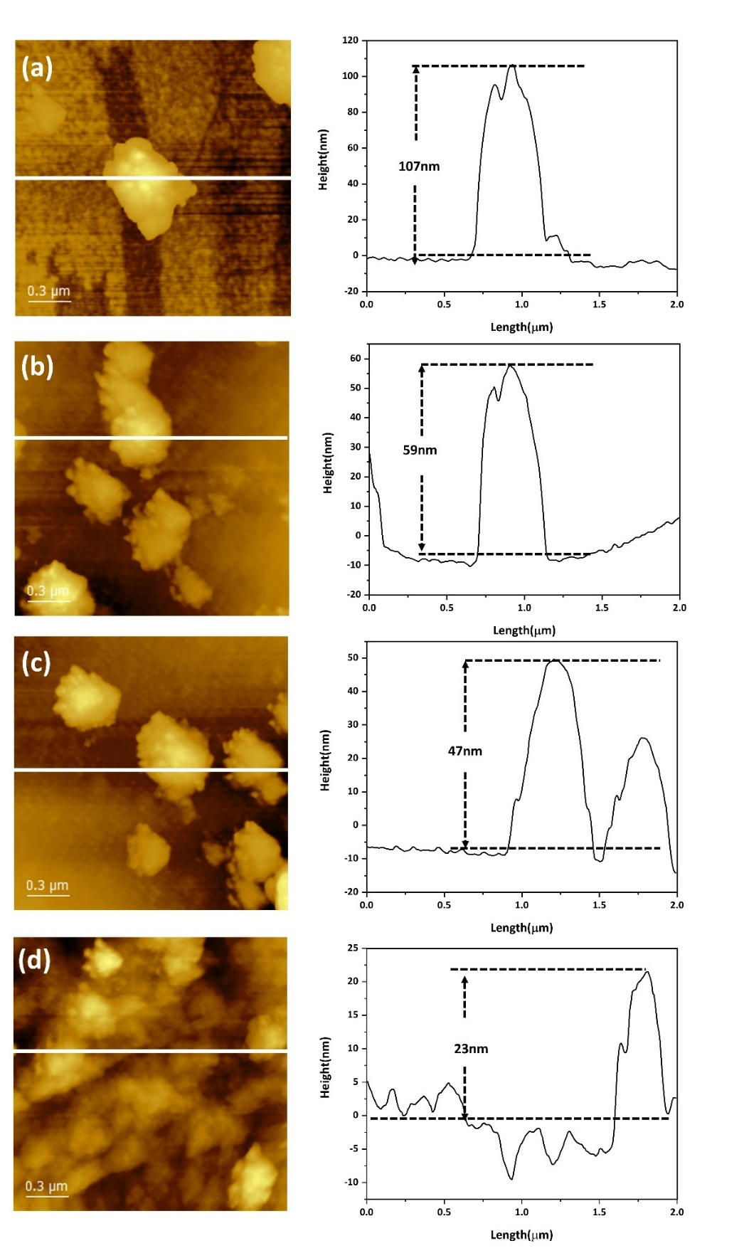

Figure 8. AFM images of bulk g-C₃N₄ (a), CN (520°C) NSs (b), CN (540°C) NSs (c), and CN (560°C) NSs (d) nanosheets.

3.5 Characterization of the 3D-Printed Scaffold
SEM results (Figure 9(i)) showed that the pure resin exhibited a smooth and uniform surface, consistent with its homogeneous polymeric composition. When comparing the monolithic polymer scaffold to the one incorporating g-C₃N₄, distinct structural differences were observed. The monolithic polymer scaffold exhibited a smooth surface with a layer-by-layer deposition, whereas the scaffold containing g-C₃N₄ displayed a non-uniform microstructure with particles adhered to its surface. The 3D interconnected morphology facilitated surface exposure and charge transport, while simultaneously promoting efficient mass transfer of reactant molecules to the active sites. Elemental analysis using EDS and elemental mapping further confirmed the presence and distribution of g-C₃N₄ within the printed structure. As shown in Figure 9(ii), carbon (C) and nitrogen (N) signals were clearly detected and uniformly distributed throughout the composite surface and confirming its successful embedding within the polymeric composition. These results show that the 3D printing process effectively immobilized g-C₃N₄ nanosheets in the resin matrix without significant agglomeration or phase separation. The uniform dispersion of nanosheets ensured intimate interfacial contact between the polymer scaffold and the photocatalytic material, which was essential for maintaining photocatalytic activity while providing structural integrity and convenient easy recyclability over multiple cycles.

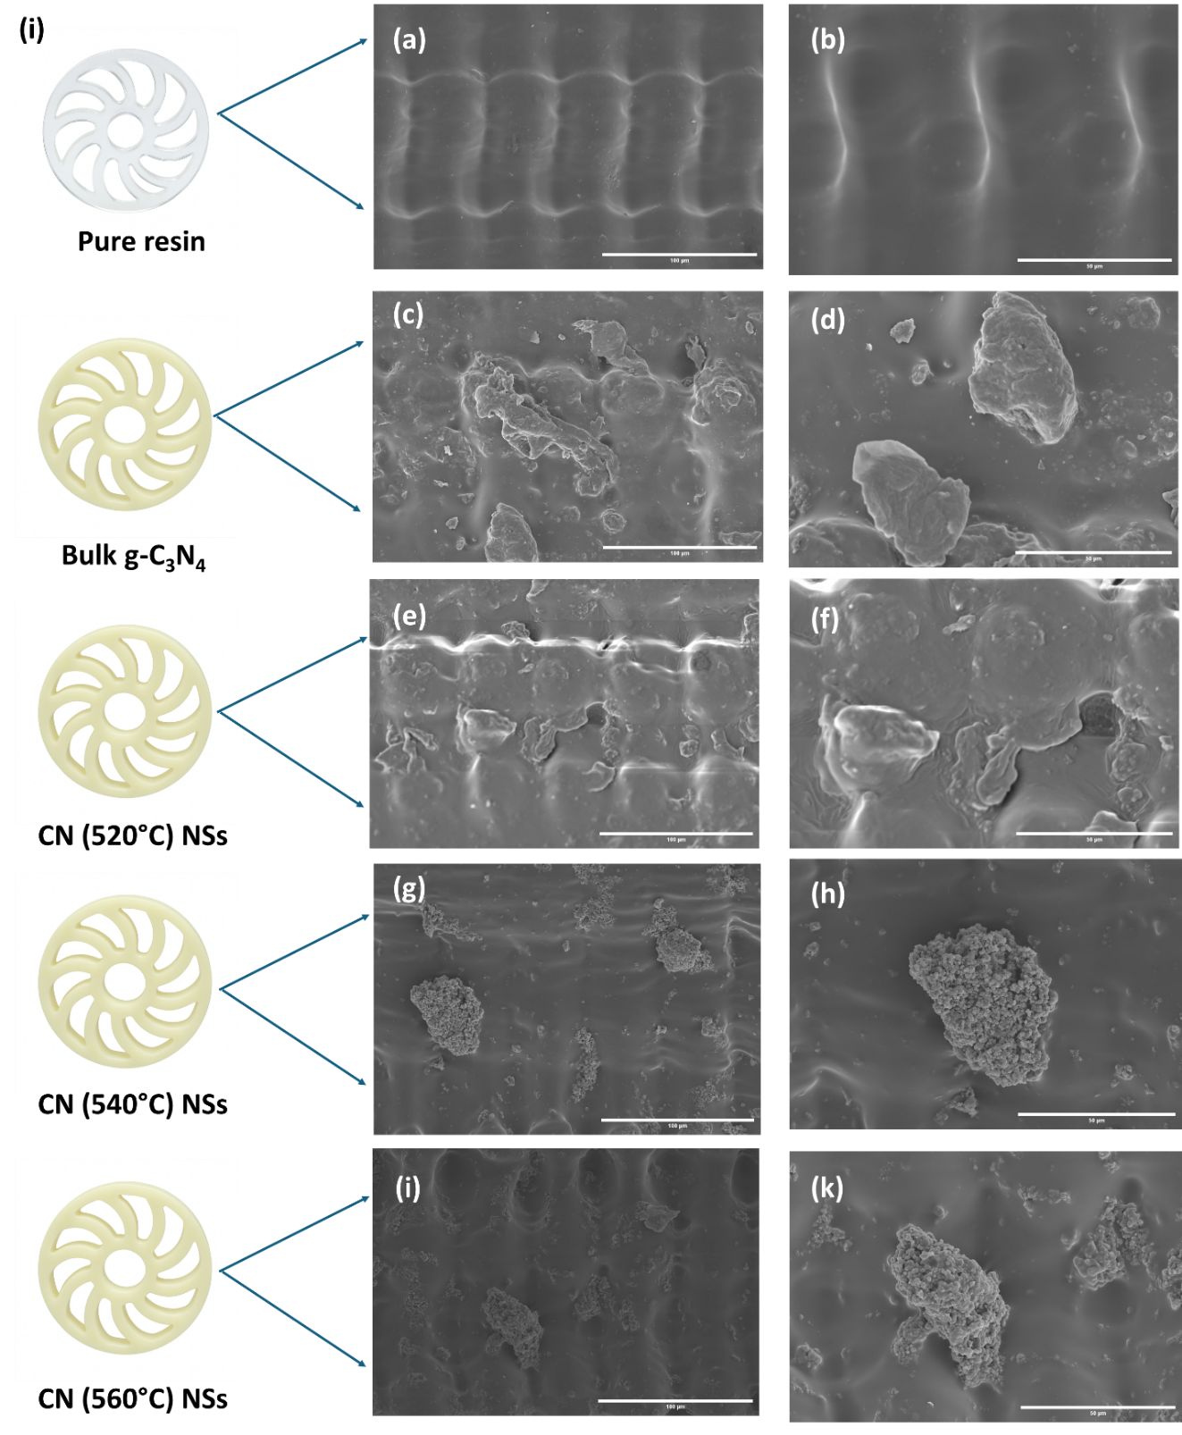
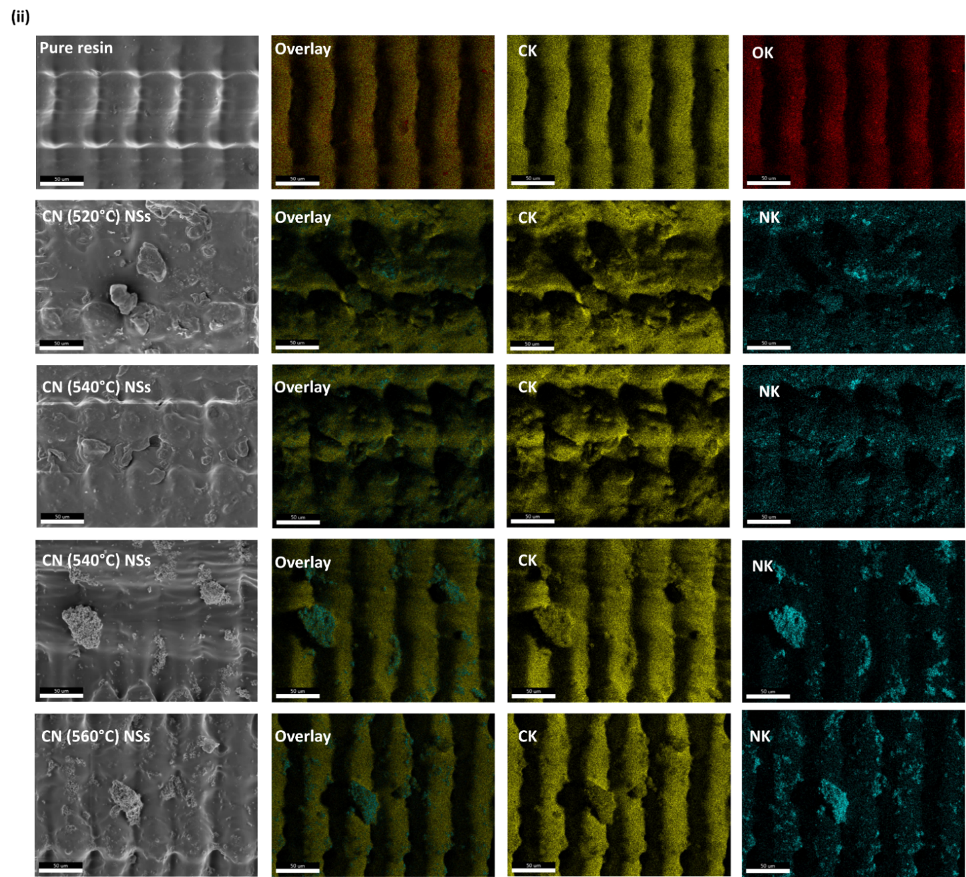

Figure 9. SEM (i) and EDS images (ii) of 3D-printed pure resin and resin mixed with bulk g-C₃N_{4,} CN (520°C) NSs, CN (540°C) NSs, and CN (560°C) NSs nanosheets.

3.6 Optical Properties
UV-vis spectroscopy and photoluminescence (PL) measurements were conducted to determine the optical characteristics of bulk g-C₃N_{4,} CN (520°C) NSs, CN (540°C) NSs, and CN (560°C) NSs nanosheets, as indicated in Figure 10(a) and 11, respectively. The nanosheet samples in Figure 10(a) had a greater absorption peak in the blue-green (450-550nm) region. Specifically, the nanosheets exhibited a notable enhancement in light absorbance within the visible light spectrum, leading to increased photocatalytic activity. Compared to bulk g-C₃N₄, the absorption edges of CN (520°C) NSs, CN (540°C) NSs, and CN (560°C) NSs nanosheets shifted noticeably toward the low-energy region, indicating enhanced visible-light absorption. The Tauc plots (Figure 10(b)) illustrate how the tailing edges of the nanosheets were pushed to the lower energy (visible region). The calculated bandgaps for bulk g-C₃N_{4,} CN (520°C) NSs, CN (540°C) NSs, and CN (560°C) NSs nanosheets are 2.73, 2.67, 2.65, and 2.61 eV, respectively, consistent with previous research [32].

Figure 10. UV spectra (a) and Tauc plots (b) for bulk g-C₃N_{4,} CN (520°C) NSs, CN (540°C) NSs, and CN (560°C) NSs nanosheets.

The effectiveness of charge separation and the recombination of photo-excited electrons and holes in photocatalysts is related to the photoluminescence (PL) intensity. Figure 11 displays the PL spectra of bulk g-C₃N₄, CN (520°C) NSs, CN (540°C) NSs, and CN (560°C) NSs nanosheets, under excitation at 350 nm. The PL intensity of the bulk g-C₃N₄ is larger than those of the exfoliated CN samples, indicating reduced radiative recombination. The efficiency of separating and recombining photogenerated electrons and holes in photocatalysts is correlated with the intensity of photoluminescence (PL). The layered architecture of g-C₃N₄ promoted rapid charge recombination due to extended interlayer migration pathways. Exfoliation into few-layer nanosheets mitigated this limitation by confining the material in two dimensions, which shortened the diffusion length for charges to reach the surface [33]. This morphological change, coupled with an enlarged surface area and a greater abundance of accessible nitrogen sites, synergistically improved charge separation efficiency.
Overall, UV and PL spectra demonstrate that CN (520°C) NSs, CN (540°C) NSs, and CN (560°C) NSs nanosheets display improved photocatalytic characteristics compared to bulk g-C₃N₄. This enhancement can be ascribed to various factors, including the wider spectrum of visible light absorption by the nanosheets, the greater presence of active surface areas, and the inclusion of structural imperfections within the nanosheets. These characteristics enhance the production efficiency of electron-hole pairs when exposed to light and reduce their recombination during the charge transfer mechanism.

Figure 11. PL spectra of bulk g-C₃N₄ and CN (520°C) NSs, CN (540°C) NSs, and CN (560°C) NSs nanosheets.

3.7 Photocatalytic Activity
The photocatalytic performances of bulk g-C₃N₄, CN (520°C) NSs, CN (540°C) NSs, and CN (560°C) NSs nanosheets were evaluated through the degradation of methylene blue (MB) under UV light. The photocatalytic experiments were conducted only under UV irradiation using a UVP UVGL-58 UV lamp operating at 365 nm (long-wave) with a lamp power of 8 W. As illustrated in Figure 12, all samples exhibited MB degradation upon UV irradiation. Notably, CN (520°C) NSs, CN (540°C) NSs, and CN (560°C) NSs nanosheets demonstrated a higher rate of MB degradation than bulk g-C₃N₄. As shown in Figure 13, after 8 hours of UV light exposure, bulk g-C₃N₄ exhibited significantly lower MB degradation than CN (520°C) NSs, CN (540°C) NSs, and CN (560°C) NSs nanosheets, even lower than previously reported g-C₃N₄ nanosheets generated using thermal exfoliation [34],[35]. CN (520°C) NSs, CN (540°C) NSs, and CN (560°C) NSs nanosheets exhibited a superior rate of MB decomposition compared to bulk g-C₃N₄. The results are consistent with previous studies that the porous structure of g-C₃N₄ nanosheets could adsorb more molecules because of their larger surface area and more active sites [31],[36]. The CN (560ºC) NSs exhibited the highest MB removal efficiency at 86%, followed by CN (540ºC) NSs and CN (520ºC) NSs with efficiencies of 84% and 83%, respectively. Bulk g-C₃N₄ showed the lowest performance at 78%. When compared to the TiO₂/SiO₂ scaffold [20], which achieved a total MB removal efficiency of 85.5%, only the CN (560ºC) NSs slightly exceeded the efficiency. This improvement can be attributed to the expanded surface area, which facilitates more efficient charge movement and decreases charge recombination. The increased surface area enhances the contact between reactant molecules and catalytic active sites, leading to improved molecular adsorption. Additionally, the porous nanosheets improve charge carrier mobility, minimizing charge recombination and facilitating the migration of electrons from bulk materials to the nanosheet surface, encouraging greater interaction with adsorbed molecules [37].

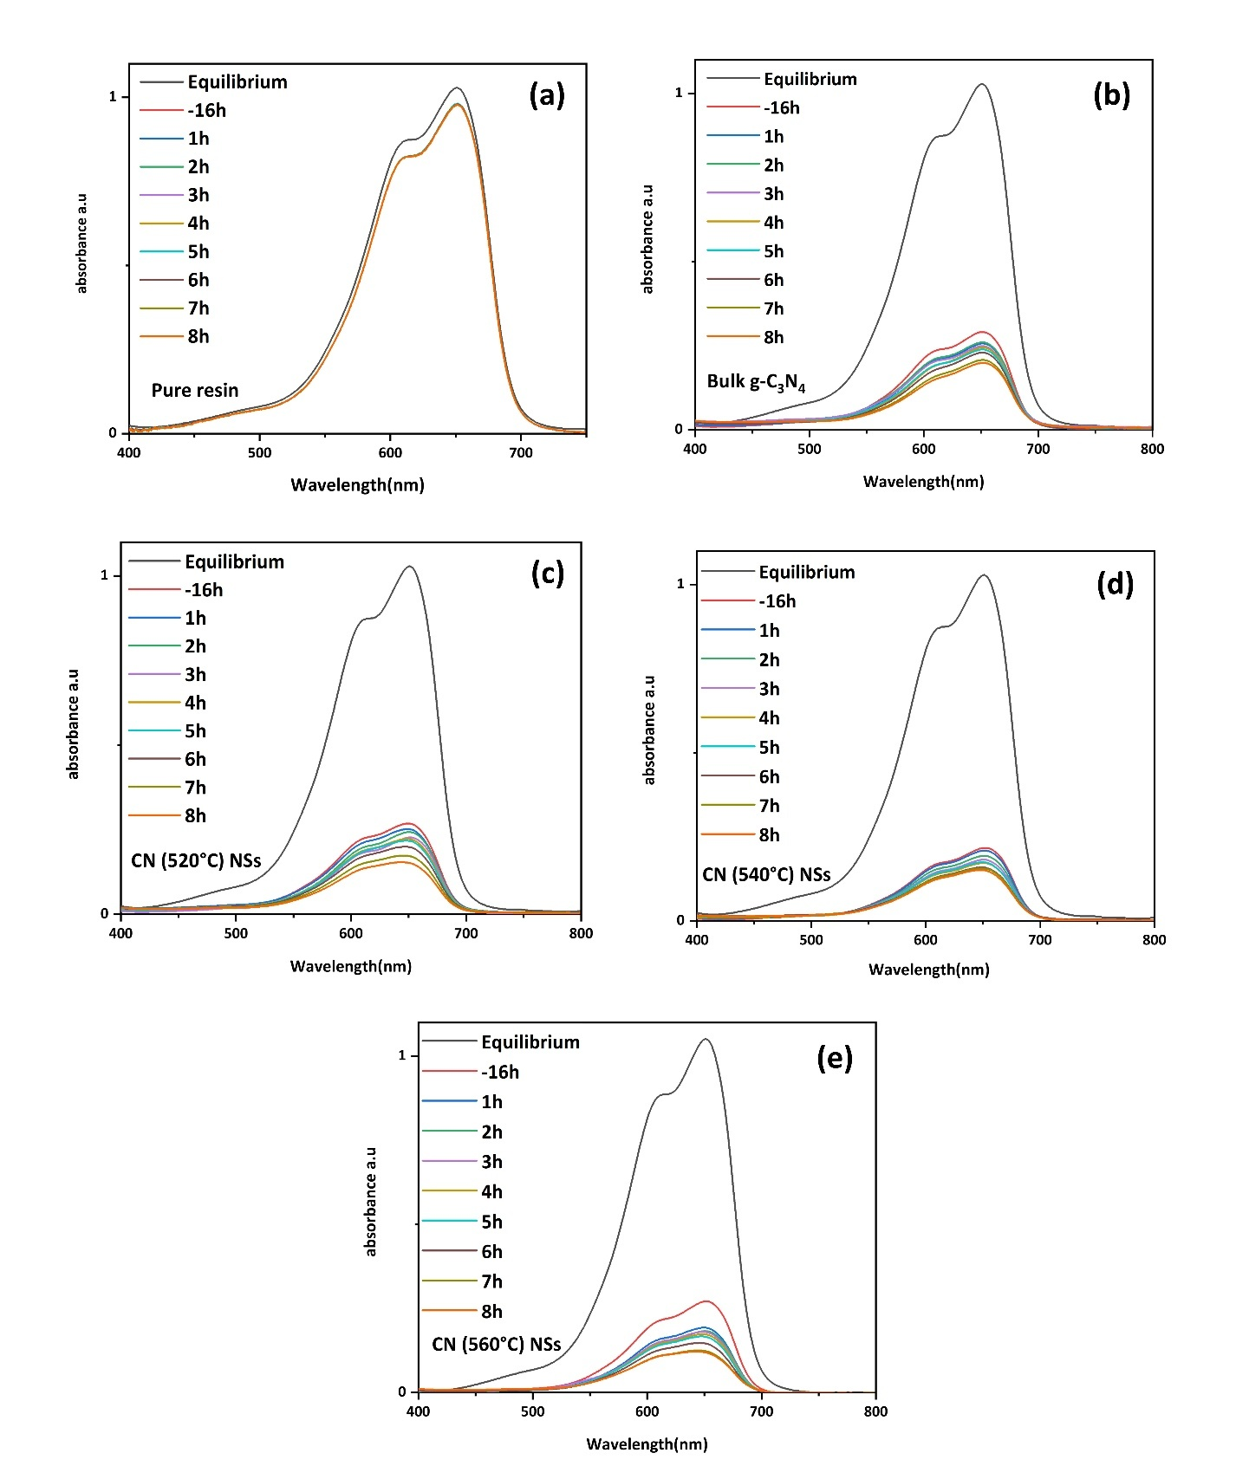

Figure 12. Time-dependent absorption spectra of MB aqueous solution degraded by 3D-printed pure resin (a), bulk g-C₃N₄ (b), CN (520 °C) NSs (c), CN (540 °C) NSs (d), and CN (560 °C) NSs (e) nanosheets under UV radiation.

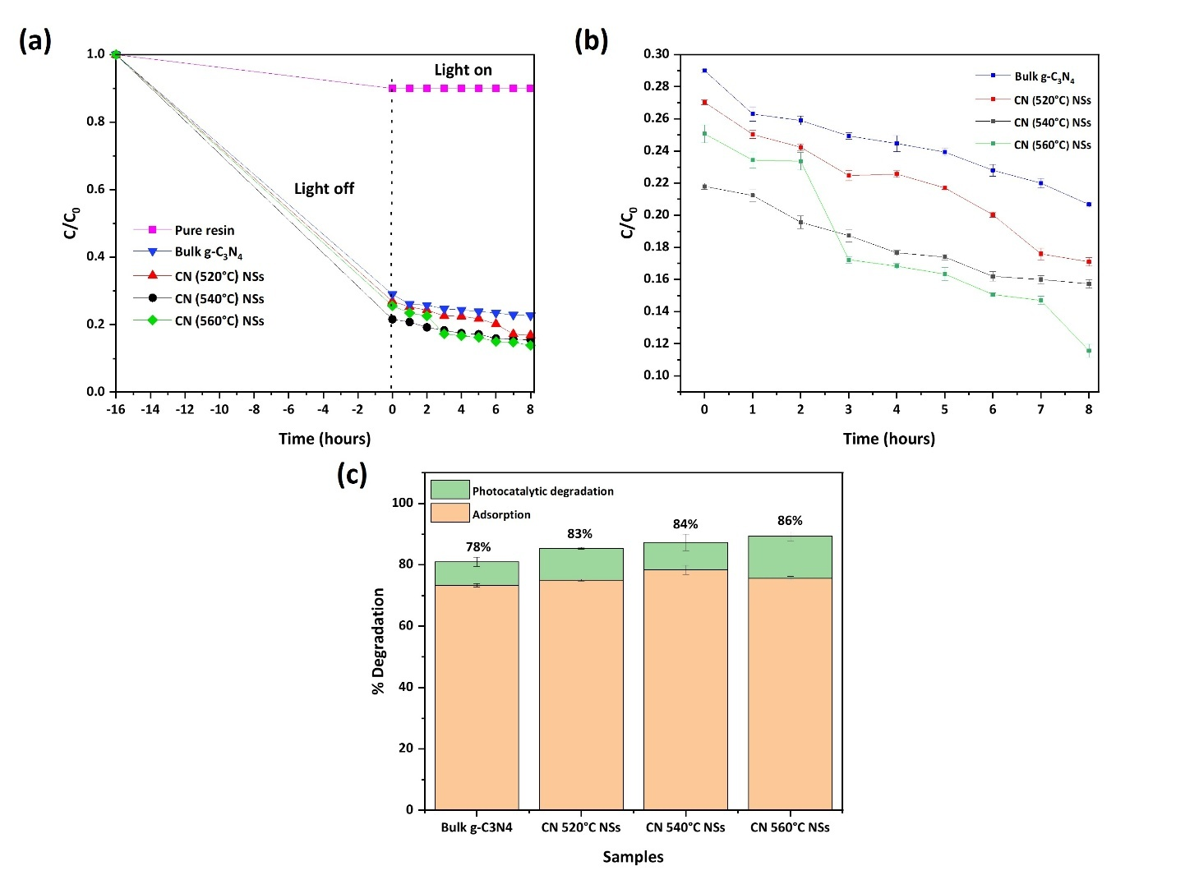

Figure 13. MB dye removal performance 3D printed pure resin, bulk g-C₃N₄, CN (520 °C) NSs, CN (540 °C) NSs, and CN (560 °C) NSs nanosheets under UV radiation: the adsorption and photocatalytic degradation profiles before and during UV irradiation (a); the time-dependent photocatalytic profiles during the UV irradiation (b) and the overall dye removal (c) (adsorption and photocatalysis).

As illustrated in Figure 14, the k values of all samples were calculated according to a pseudo-first-order kinetic model (Equation 5). The bulk g-C₃N₄ exhibited a relatively low-rate constant of 0.0026 min⁻¹, indicating limited photocatalytic activity, likely due to inefficient charge separation and the presence of thick, stacked layers. In contrast, the exfoliated samples demonstrated progressively higher rate constants, with values of 0.004 min⁻¹, 0.005 min⁻¹, and 0.0078 min⁻¹ for CN (520 °C) NSs, CN (540 °C) NSs, and CN (560 °C) NSs nanosheets, respectively. The rate constant for the CN-560 nanosheet under UV light is an order of magnitude higher than reported values for standard TiO₂ thin films [38], [39]. In contrast, doped g-C₃N₄ and TiO₂/g-C₃N₄ composites often exceed 0.01 min⁻¹ by enhancing light absorption and charge transfer [40].
These results show that greater exfoliation enhanced photocatalytic reaction kinetics, attributed to thinner nanosheet structures providing shorter charge transport pathways, larger surface exposure, and more accessible active sites. The improved rate constant for the CN (560°C) NSs nanosheet indicates superior charge separation efficiency and accelerated formation of reactive oxygen species (OH and O₂⁻), which collectively promote faster dye degradation.

Figure 14. Pseudo-first-order kinetic plots (ln(C/C₀) vs. time) for 3D-printed pure resin, bulk g-C₃N₄, CN (520 °C) NSs, CN (540 °C) NSs, and CN (560 °C) NSs nanosheets under UV radiation.

3.8 Reusability and Stability of the Photocatalyst Scaffold
To investigate the practical applicability of the scaffolds, their reusability for dye removal was examined. After each use, the g-C₃N₄/polymer scaffold was washed with ethanol followed by deionized water, and its dye removal efficiency was subsequently measured. As shown in Figure 15, the catalyst retained a high degradation efficiency during repeated use, although a slight decrease in performance was observed with successive cycles. The removal efficiency decreased from approximately 86% in the first cycle to 81% in the second cycle, and further to 73% in the third cycle. This gradual reduction in activity can be attributed to the partial accumulation of residual dye molecules on the catalyst surface, which may occupy active sites and hinder light absorption, thereby reducing the generation and migration of photoinduced charge carriers.

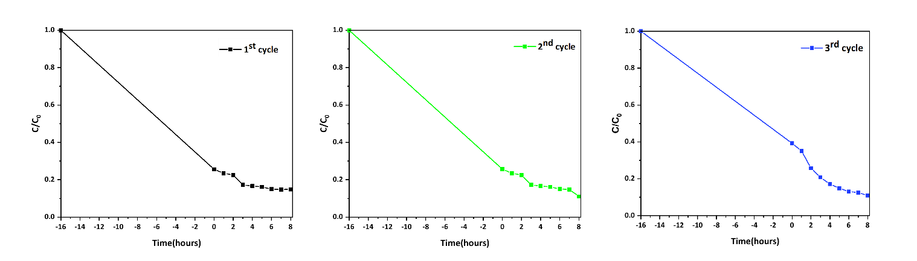

Figure 15. Photocatalytic reusability performance of the 3D-printed CN (560°C) NSs sample over three consecutive degradation cycles.

4. CONCLUSIONS
We effectively produced 2D g-C₃N₄ nanosheets using the thermal oxidation exfoliation approach. The g-C₃N₄ /polymer scaffolds for dye removal were successfully fabricated by the stereolithography technique. Dye removal examination revealed that MB dye molecules were effectively adsorbed by the scaffolds and its total removal efficiency was 78%, 83%, 84%, and 86%, for bulk g-C₃N₄, CN (520°C) NSs, CN (540°C) NSs, and CN (560°C) NSs, respectively. The photocatalytic performance was greatly enhanced by the efficiency in separating photo-excited charge carriers and the augmented light absorption attributed to the expanded specific surface area. The reusability evaluation revealed that the scaffold maintains good photocatalytic activity over repeated cycles, with a slight reduced performance due to residual dye remaining on the surface. These results indicate that the scaffold possesses stability for repeated use. Additional optimization, through varying exfoliation techniques and contents of photocatalytic g-C₃N₄ in 3D-printed resin composite, may be further investigated to improve performance. Thus, the excellent photocatalytic activity shows that these materials have a promising future as high-performance photocatalysts for addressing global environmental and energy challenges.

ACKNOWLEDGEMENTS
This research was supported by the Faculty of Engineering, Kasetsart University for the international Ph.D. scholarship. Kasetsart University Research and Development Institute is acknowledged for the support of the Special Research Unit for Biomass Conversion Technology for Energy and Environment, KURDI Grant No. FF(KU) 51.67.

AUTHOR CONTRIBUTIONS
Htet Yadanar Soe: Conceptualization, Methodology, Investigation, Data curation, Formal analysis, Writing Original draft preparation, Reviewing and Editing. Thanate Na Wichean: Methodology, Formal analysis. Gasidit Panomsuwan: Funding acquisition, Supervision, Methodology. Oratai Jongprateep: Conceptualization, Funding acquisition, Supervision, Methodology. Ratchatee Techapiesancharoenkij: Conceptualization, Funding acquisition, Supervision, Resources, Methodology, Formal analysis, Reviewing and Editing, Correspondence.

CONFLICT OF INTEREST STATEMENT
The authors declare no conflict of interests.

DECLARATION OF USE OF GENERATIVE AI
The authors declare that Large Language Models (LLMs) were used solely to improve language clarity and correct grammar errors. The manuscript was reviewed and edited by the authors. The authors take full responsibility for the content of this publication. No generative AI tools were used for purposes other than those stated above.

FUNDING
- Faculty of Engineering, Kasetsart University for the international Ph.D. scholarship.
- Kasetsart University Research and Development Institute is acknowledged for the support of the Special Research Unit for Biomass Conversion Technology for Energy and Environment, KURDI Grant No. FF(KU) 51.67.

REFERENCES
[1] Wang H., Zhao W., Chen Y., Yang X., Li Y. and Meng X., A novel magnetic TiO₂-graphene oxide composite material with enhanced photocatalytic performance for acridine orange. Chiang Mai Journal of Science, 2021; 48(2): 506–519.
[2] Buthiyappan A., Abdul Aziz A.R. and Wan Daud W.M.A., Recent advances and prospects of catalytic advanced oxidation process in treating textile effluents. Reviews in Chemical Engineering, 2015; 32(1): 1–47. DOI 10.1515/revce-2015-0034.
[3] Robinson T., McMullan G., Marchant R. and Nigam P., Remediation of dyes in textile effluent: A critical review on current treatment technologies with a proposed alternative. Bioresource Technology, 2001; 77(3): 247–255. DOI 10.1016/S0960-8524(00)00080-8.
[4] Moyo S., Makhanya B.P. and Zwane P.E., Use of bacterial isolates in the treatment of textile dye wastewater: A review. Heliyon, 2022; 8(6): e09765. DOI 10.1016/j.heliyon.2022.e09632.
[5] Danwittayakul S. and Chantes P., Combination of electrocoagulation and photocatalysis process for dye removal from textile effluent. Chiang Mai Journal of Science, 2021; 48(2): 533–544.
[6] Palapa N.R., Taher T., Fajri S. and Lesbani A., Adsorptive removal of malachite green from aqueous solution over graphite-layered double hydroxides composite. Chiang Mai Journal of Science, 2021; 48(5): 1351–1362.
[7] Ayodhya D. and Veerabhadram G., Recent advances in photodegradation of dyes using doped and heterojunction semiconductor metal sulfide nanostructures. Materials Today Energy, 2018; 9: 83–113. DOI 10.1016/j.mtener.2018.05.007.
[8] Goettmann F., Fischer A., Antonietti M. and Thomas A., Chemical synthesis of mesoporous carbon nitrides using hard templates and their use as a metal-free catalyst for Friedel-Crafts reaction of benzene. Angewandte Chemie International Edition, 2006; 45(27): 4467–4471. DOI 10.1002/anie.200600412.
[9] Wang X., Maeda K., Thomas A., Takanabe K., Xin G., Carlsson J.M., et al., A metal-free polymeric photocatalyst for hydrogen production from water under visible light. Nature Materials, 2009; 8: 76–80. DOI 10.1038/nmat2317.
[10] Kong L., Wang J., Mu X., Li R., Xiaoxue L., Fan X., et al., Pore-size-dependent g-C₃N₄ for efficient photocatalysts: Regulation synthesizes and physical mechanism. Materials Today Energy, 2019; 13: 11–21. DOI 10.1016/j.mtener.2019.04.011.
[11] Kang Y., Yang Y., Yin L.-C., Kang X., Wang L., Liu G., et al., Selective breaking of hydrogen bonds of layered carbon nitride for visible-light photocatalysis. Advanced Materials, 2016; 28: 6471–6477. DOI 10.1002/adma.201601567.
[12] Niu P., Zhang L., Liu G. and Cheng H.M., Graphene-like carbon nitride nanosheets for improved photocatalytic activities. Advanced Functional Materials, 2012; 22: 4763–4770. DOI 10.1002/adfm.201200922.
[13] Afanasov I.M., Shornikova O.N., Kirilenko D.A., Vlasov I.I., Zhang L., Verbeeck J., et al., Graphite structural transformations during intercalation by HNO₃ and exfoliation. Carbon, 2010; 48: 1862–1865. DOI 10.1016/j.carbon.2010.01.055.
[14] Dong X. and Cheng F., Recent development in exfoliated two-dimensional g-C₃N₄ nanosheets for photocatalytic applications. Journal of Materials Chemistry A, 2015; 3: 23642–23652. DOI 10.1039/C5TA07374J.
[15] Lu X., Xu K., Chen P., Jia K., Liu S. and Wu C., Facile one step method realizing scalable production of g-C₃N₄ nanosheets and study of their photocatalytic H₂ evolution activity. Journal of Materials Chemistry A, 2014; 2: 18924–18928. DOI 10.1039/C4TA04487H.
[16] Iqbal W., Qiu B., Lei J., Wang L., Zhang J. and Anpo M., One-step large-scale synthesis of highly active g-C₃N₄ nanosheets for efficient sunlight-driven photocatalytic hydrogen production. Dalton Transactions, 2017; 46: 10678–10684. DOI 10.1039/c7dt00849j.
[17] Yuhaneka G., Rozafia A., Utomo W., Iryani A. and Hartanto D., Synthesis of porous g-C₃N₄ and its application as photocatalyst for methylene blue degradation. Malaysian Journal of Fundamental and Applied Sciences, 2022; 18: 463–472. DOI 10.11113/mjfas.v18n4.2496.
[18] Mallakpour S., Azadi E. and Hussain C.M., MOF/COF-based materials using 3D printing technology: applications in water treatment, gas removal, biomedical, and electronic industries. New Journal of Chemistry, 2021; 45: 13247–13257. DOI 10.1039/d1nj02152d.
[19] Kolya H. and Kang C.-W., Bio-based polymeric flocculants and adsorbents for wastewater treatment. Sustainability, 2023; 15: 9844. DOI 10.3390/su15129844.
[20] Bansiddhi A., Panomsuwan G., Hussakan C., Lin Htet T., Kandasamy B., Janbooranapinij K., et al., Eco-friendly 3D-printed TiO₂/SiO₂/polymer scaffolds for dye removal. Topics in Catalysis, 2023; 66: 1662–1673. DOI 10.1007/s11244-023-01864-x.
[21] Li C., Yang X., Yang B., Yan Y. and Qian Y., Synthesis and characterization of nitrogen-rich graphitic carbon nitride. Materials Chemistry and Physics, 2007; 103: 427–432. DOI 10.1016/j.matchemphys.2007.02.057.
[22] Zhang Y., Mori T., Ye J. and Antonietti M., Phosphorus-doped carbon nitride solid: Enhanced electrical conductivity and photocurrent generation. Journal of the American Chemical Society, 2010; 132: 6294–6295. DOI 10.1021/ja101749y.
[23] Makuła P., Pacia M. and Macyk W., How to correctly determine the band gap energy of modified semiconductor photocatalysts based on UV-Vis spectra. The Journal of Physical Chemistry Letters, 2018; 9: 6814–6817. DOI 10.1021/acs.jpclett.8b02892.
[24] Thomas A., Fischer A., Goettmann F., Antonietti M., Müller J.-O., Schlogl R., et al., Graphitic carbon nitride materials: Variation of structure and morphology and their use as metal-free catalysts. Journal of Materials Chemistry, 2008; 18: 4893–4908. DOI 10.1039/b800274f.
[25] Li J., Wang Y., Li X., Gao Q. and Zhang S., A facile synthesis of high-crystalline g-C₃N₄ nanosheets with closed self-assembly strategy for enhanced photocatalytic H₂ evolution. Journal of Alloys and Compounds, 2021; 881: 160551. DOI 10.1016/j.jallcom.2021.160551.
[26] Schwinghammer K., Mesch M.B., Duppel V., Ziegler C., Senker J. and Lotsch B.V., Crystalline carbon nitride nanosheets for improved visible-light hydrogen evolution. Journal of the American Chemical Society, 2014; 136: 1730–1733. DOI 10.1021/ja411321s.
[27] Duan J., Chen S., Jaroniec M. and Qiao S., Porous C₃N₄ nanolayers@N-graphene films as catalyst electrodes for highly efficient hydrogen evolution. ACS Nano, 2015; 9: 931–940. DOI 10.1021/nn506701x.
[28] Han Q., Wang B., Gao J., Cheng Z., Zhao Y., Zhang Z., et al., Atomically thin mesoporous nanomesh of graphitic C₃N₄ for high-efficiency photocatalytic hydrogen evolution. ACS Nano, 2016; 10: 2745–2751. DOI 10.1021/acsnano.5b07831.
[29] Dong F., Zhao Z., Xiong T., Ni Z., Zhang W., Sun Y., et al., In situ construction of g-C₃N₄/g-C₃N₄ metal-free heterojunction for enhanced visible-light photocatalysis. ACS Applied Materials & Interfaces, 2013; 5: 11392–11401. DOI 10.1021/am403653a.
[30] Dong G., Ai Z. and Zhang L., Efficient anoxic pollutant removal with oxygen functionalized graphitic carbon nitride under visible light. RSC Advances, 2014; 4: 5553–5560. DOI 10.1039/C3RA46068A.
[31] Stefa S., Griniezaki M., Dimitropoulos M., Paterakis G., Galiotis C., Kiriakidis G., et al., Highly porous thin-layer g-C₃N₄ nanosheets with enhanced adsorption capacity. ACS Applied Nano Materials, 2023; 6: 1732–1743. DOI 10.1021/acsanm.2c04632.
[32] Yan H., Chen Y. and Xu S., Synthesis of graphitic carbon nitride by directly heating sulfuric acid treated melamine for enhanced photocatalytic H₂ production from water under visible light. International Journal of Hydrogen Energy, 2012; 37: 125–133. DOI 10.1016/j.ijhydene.2011.09.072.
[33] Wen J., Xie J., Chen X. and Li X., A review on g-C₃N₄-based photocatalysts. Applied Surface Science, 2017; 391: 72–123. DOI 10.1016/j.apsusc.2016.07.030.
[34] Zhao H., Yu H., Quan X., Chen S., Zhao H. and Wang H., Atomic single layer graphitic-C₃N₄: Fabrication and its high photocatalytic performance under visible light irradiation. RSC Advances, 2014; 4: 624–628. DOI 10.1039/C3RA45776A.
[35] Tong J., Zhang L., Li F., Li M. and Cao S., An efficient top-down approach for the fabrication of large-aspect-ratio g-C₃N₄ nanosheets with enhanced photocatalytic activities. Physical Chemistry Chemical Physics, 2015; 17: 23532–23537. DOI 10.1039/c5cp04057d.
[36] Bharathi K., Sudha M., Bakiyaraj G., Nakamura A., Archana J. and Navaneethan M., Protonated g-C₃N₄-assisted enhanced adsorption and photocatalytic degradation mechanism of zinc chromite/bismuth oxide nanocomposites for organic contaminants and inactivation of Gram-negative bacteria. Diamond and Related Materials, 2025; 159: 112828. DOI 10.1016/j.diamond.2025.112828.
[37] Mohtar S.S., Aziz F., Ismail A.F., Sambudi N.S., Abdullah H., Rosli A.N., et al., Impact of doping and additive applications on photocatalyst textural properties in removing organic pollutants: A review. Catalysts, 2021; 11: 1160. DOI 10.3390/catal11101160.
[38] Duran F., Diaz-Uribe C., Vallejo W., Muñoz-Acevedo A., Schott E. and Zarate X., Adsorption and photocatalytic degradation of methylene blue on TiO₂ thin films impregnated with Anderson–Evans Al-Polyoxometalates: Experimental and DFT study. ACS Omega, 2023; 8: 27284–27292. DOI 10.1021/acsomega.3c02657.
[39] Abdellah M.H., Nosier S.A., El-Shazly A.H. and Mubarak A.A., Photocatalytic decolorization of methylene blue using TiO₂/UV system enhanced by air sparging. Alexandria Engineering Journal, 2018; 57: 3727–3735. DOI 10.1016/j.aej.2018.07.018.
[40] Shen L., Xing Z., Li Z., Wu X., Zhang Y., Zhu Q., et al., Black TiO₂ nanobelts/g-C₃N₄ nanosheet laminated heterojunctions for visible-light photocatalysis. Scientific Reports, 2017; 7: 41978. DOI 10.1038/srep41978.

