Mechanistic Insights into Prochloraz and Pyraclostrobin Suppression of Fusarium-Induced Leaf Spot in Hosta ventricosa
Zengrui Zhu [a], Yunfei Li [b], Chunxia Wang [a], Chixing Wu [c] and Shengfeng Mao [a, d]*
[a] Co-Innovation Center for Sustainable Forestry in Southern China, College of Forestry and Grassland, Nanjing Forestry University, Nanjing, Jiangsu 210037, China
[b] College of International Education, Jinling Institute of Technology, Nanjing, Jiangsu 211199, China
[c] Ciwu Town Government forestry station, Zhuji, Zhejiang 311817, China
[d] Bamboo of Industry Institute, Zhejiang Agriculture and Forestry University, Hangzhou, Zhejiang 311300, China
* Author for correspondence; e-mail: maosf@126.com
ORCiD: https://orcid.org/0009-0001-9710-5858
Received: 22 September 2025 Revised: 15 January 2026 Accepted: 22 January 2026 Published: 17 March 2026
Citation: Zhu Z.r., Li Y.f., Wang C.x., Wu C.x. and Mao S.f., Mechanistic insights into prochloraz and pyraclostrobin suppression of fusarium-induced leaf spot in Hosta ventricosa. Chiang Mai Journal of Science, 2026; 53(2): e2026029. DOI 10.12982/CMJS.2026.029.
Copyright: ©2026 Author (s). This is an Open Access article distributed under the term of the Creative Commons Attribution 4.0 International License CC BY 4.0 (https://creativecommons.org/licenses/by/4.0).

GRAPHICAL ABSTRACT
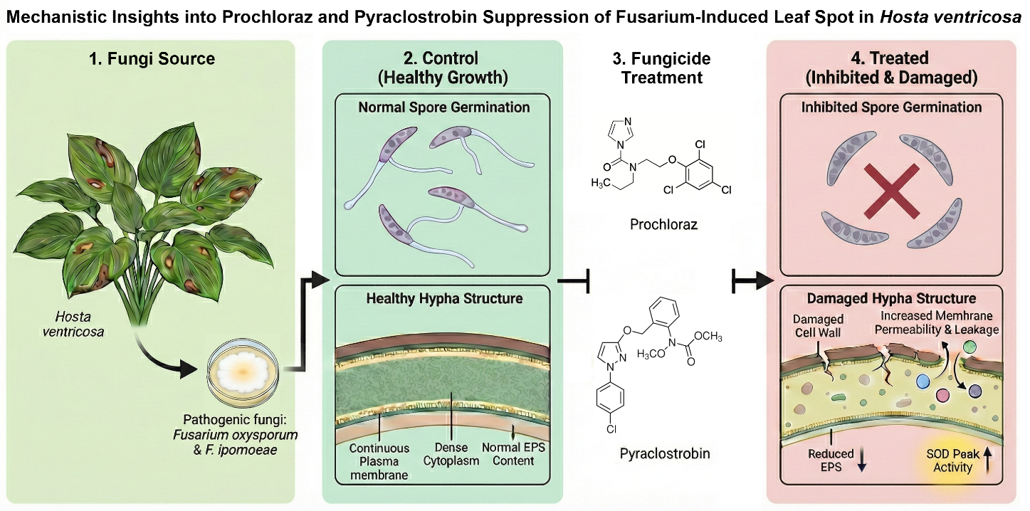

ABSTRACT
The present study aims to identify effective fungicides and their inhibitory activities against the pathogenic fungi responsible for leaf spot disease in Hosta ventricosa: Fusarium oxysporum and F. ipomoeae. The inhibitory effects of five widely used fungicides were evaluated using the mycelial growth rate method. Furthermore, by focusing on factors such as spore germination, extracellular polysaccharide (EPS) content, superoxide dismutase (SOD) and peroxidase (POD) activities, and the morphology and structure of the mycelium, the study examined the inhibitory activity of the fungicides exhibiting superior control efficacy. The EC₅₀ values, which denote the concentrations required for 50% inhibition, were determined to be 0.03 and 0.21 μg/mL for F. oxysporum treated with prochloraz and 0.43 and 0.18 μg/mL for F. ipomoeae treated with pyraclostrobin. These findings indicate that both prochloraz and pyraclostrobin exhibited significant inhibitory effects. When prochloraz and pyraclostrobin were administered at a dose of 10×EC₅₀, significant increases in mycelial cell membrane permeability were observed, whilst spore germination rates decreased relative to the control and EPS generation was reduced. Both fungicides significantly modulated SOD and POD activities in a concentration-dependent and strain-specific manner. The results of the transmission electron microscopy and scanning electron microscopy observations demonstrated that the cell walls of the mycelium treated with pesticides exhibited signs of damage, characterised by a reduction and unevenness of the cytoplasmic content. In addition to these observations, notable changes in the morphology and structure of the intracellular cavity were identified. These findings imply that pyraclostrobin and prochloraz have potent antifungal properties, mainly affecting the mycelial cell membrane and increasing its permeability. This study contributes to the existing body of knowledge on the antifungal properties of pyraclostrobin and prochloraz, thereby providing a scientific foundation for the management of leaf spot disease in Hosta ventricosa.

Keywords: Hosta ventricosa, Fusarium oxysporum, Fusarium ipomoeae, agent screening, efficacy evaluation

1. INTRODUCTION
Hosta ventricosa is a perennial herb in the Hosta family, Asparagaceae. It is employed as an ornamental flower in substantial quantities due to its prolonged flowering period and aesthetically pleasing floral pigmentation. Moreover, it possesses medicinal properties, with its extracts exhibiting notable insecticidal activity against certain agricultural pests, substantial antifungal effects on fungi [1], and considerable inhibitory effects on cellular inflammation [2]. H. ventricosa does not have strict soil requirements and generally grows well in a variety of soils, commonly found in the understory or along roadsides. Following the process of planting, the plant exhibits rapid reproduction through the formation of root tillers and demonstrates exceptional hardiness, characteristics that facilitate its accessibility as a source of plant material. H. ventricosa shows a strong heterostylous restraining effect, with almost no weeds growing around it and no insect pests [3]. H. ventricosa is susceptible to diseases, and studies have shown that phytopathogenic fungi have shown that various pathogens have been isolated from the leafy parts of H. ventricosa: F. oxysporum [4], Alternaria alternata [5], Colletotrichum spaethianum [6], Pseudomonas butyrica, and P. syringae [7]. The control of diseases associated with them is rarely reported. The commonly used chemicals for the control of foliar diseases in actual control include zinc diclofenac, chlorothalonil, and diclofenac ammonium, which are susceptible to resistance with long-term application, leading to increasingly poor control results.
A severe disease that affected the leaves of H. ventricosa in Nanjing in 2020–2025 caused the leaves to dry up and wilt, and in extreme cases, the entire plant died. This affected the garden plant landscape and resulted in a significant financial loss. The pathogens responsible for H. ventricosa leaf spot disease were identified by Wang CX et al. [4] from the leaves of the plant. The disease initially manifests as small pale brown to yellowish-brown lesions on leaves, which expand along veins. The lesion centre becomes dark brown and necrotic with a pale yellow margin. As the disease progresses, lesions coalesce, causing leaves to scorch and shrivel. Infection typically begins at leaf margins and tips, often accompanied by yellow-green mottling. See Supplementary Figure S1 for field symptoms and morphological characteristics of the two fungal pathogens. The isolates ZE-1b and ZE-2b were found to be Fusarium oxysporum, and the isolates ZE-1E and ZE-2E were found to be Fusarium ipomoeae. While the pathogens have been identified, the pathogenic mechanisms of the F. oxysporum and F. ipomoeae complexes on H. ventricosa, as well as the multi-faceted inhibitory actions of fungicides against them, remain unexplored. This study provides the first comprehensive insight by investigating fungicide actions not only on mycelial growth but also through spore germination, cell membrane integrity, enzyme activity, and ultrastructural alterations, thereby elucidating the antifungal mechanisms at multiple levels. The effectiveness of five chemical fungicides—prochloraz, pyraclostrobin, pyrazoxystrobin, iprodione, and azoxystrobin—against the two H. ventricosa pathogens will be further screened and evaluated in this paper based on their studies. Additionally, the antifungal activity of the more effective fungicides—prochloraz and pyraclostrobin—on the pathogens will be investigated. These data will help to select more effective chemical control methods against H. ventricosa leaf spot, provide a theoretical basis for field control of H. ventricosa leaf spot, and provide a reference basis for the development of broad-spectrum fungicides for the control of Fusarium diseases.

2. Materials and methods
2.1 Fungal Pathogen and Agents
The tested strains were F. oxysporum ZE-1b and F. ipomoeae ZE-1E, both provided by Wang CX [4] and preserved in the laboratory. Test agents: 96.2% iprodione, 97% prochloraz, 96.3% myclobutanil, 98.4% azoxystrobin, and 98% pyraclostrobin were purchased from Aladdin Biochemical Technology Co., Ltd. (Shanghai, China). All five fungicides were dissolved in dimethyl sulfoxide (DMSO) and formulated into a master batch of 1×10⁴ mg/L for use. Test media: Potato Dextrose Agar (PDA) [8], Alternaria Ethanol Agar (AEA) [8], and Yeast Extract Peptone Dextrose (YEPD) [9] media were used.
2.2 Methods
2.2.1 In vitro assay of fungicidal activity on mycelial growth
The inhibitory activity of five fungicides on the mycelial growth of two pathogenic fungi, F. oxysporum and F. ipomoeae, was determined by employing the mycelial growth rate method [10]. The five fungicides (azoxystrobin, pyraclostrobin, prochloraz, iprodione and myclobutanil) were formulated into concentration gradients with final concentrations of 100, 10, 1, 0.1, and 0.01 μg/mL when the PDA medium was cooled down to 55°C. The blank control group consisted of PDA medium alone, while the solvent control group comprised PDA medium supplemented with a volume of DMSO equivalent to that used in the experimental groups. A sterile 6 mm punch was used to take mycelial plugs from the periphery of colonies cultured for 3-5 d. The mycelial surface was inoculated on the PDA medium, and each treatment was repeated three times and placed in an incubator at 25°C for 5 d. The fungal colony diameter was measured in two perpendicular directions, and the average was used as the primary data for subsequent probit analysis and toxicity regression plotting as detailed in 2.2.8.

2.2.2 Determination of cell membrane permeability
A 6-mm sterile cork borer was used to obtain mycelial plugs from the periphery of colonies cultured for 3 d. Five plugs were inoculated into each 100 mL of YEPD medium and cultured for 36 h at 175 rpm and 25°C with oscillation. Fungicides with final concentrations of EC₅₀, 10×EC₅₀, and EC₉₀ were then added, and the cultures were conducted without fungicides as a control and under the same conditions for 36 h. The culture broth was filtered through sterile double-layer gauze to remove the liquid. The mycelial discs were then removed using sterile forceps, and the remaining mycelia were retained. The mycelia were rinsed twice with sterile water and subjected to vacuum filtration for 20 min. Subsequently, 0.5 g of the mycelia was dissolved in 20 mL of distilled water and stirred evenly, thus forming a suspension. The membrane permeability of fungal mycelia was assessed by monitoring the conductivity of a suspension over time [11]. Conductivity (C₁) was measured at 0, 5, 10, 20, 40, 60, 80, 100, 120, 140, 160, and 180 min using a DDS-307A conductivity meter (INESA Scientific Instrument Co., Ltd., Shanghai, China). Following the final measurement, the same sample was boiled for 5 min and cooled to room temperature to obtain the final conductivity (C₂). The relative conductivity at each time point was then calculated using the formula: (C₁ / C₂) × 100%.

2.2.3 Inhibition of spore germination
5 μL of 0.1% glucose aqueous solution, 10 μL of 10⁴ spores/mL spore suspension, and 5 μL of 20 mg/L ampicillin were added to 2 mL sterile centrifuge tubes. The fungicides were added so that the final concentrations were EC₅₀, 10×EC₅₀, and EC₉₀, respectively, and no pesticide was used as a control. Under the dark environment of a 25°C incubator, following a 12 h incubation period [12], the process of germination was observed under the Zeiss microscope. The germination of a spore was defined as the moment at which the length of the germ tube equalled or exceeded half the length of the spore itself. For each replicate, a total of 200 spores were examined, and the numbers of both germinated and non-germinated spores were recorded [13]. Spore germination rate = Number of germinated spores / Total number of spores examined × 100%. Each treatment was performed in triplicate.

2.2.4 Detection of extracellular polysaccharide (EPS) content
The phenol-sulfuric acid method was employed [12, 14]; anhydrous glucose was prepared into a standard solution of 0-180 μg/mL with a gradient of 20 μg/mL in sterile water. In a 50 mL centrifuge tube, 2 mL of different concentrations of standard solution and 1 mL of 5% phenol solution were added, respectively, and then 5 mL of concentrated sulfuric acid was added uniformly. The tube was then placed in a water bath at 25°C for 30 min to allow the sulfuric acid to concentrate. Sterile water was used as a control, and the absorbance at 490 nm was determined using a LAMBDA 365 UV/Vis spectrophotometer (PerkinElmer, USA) to plot the standard curve.
Under the same conditions as described in section 2.2.2, fungal cultures containing fungicides at final concentrations of EC₅₀, 10×EC₅₀, and EC₉₀ were prepared by shake-flask cultivation. A pesticide-free control culture was also incubated under identical conditions for 36 h. The fungal biomass was harvested by centrifugation at 10,000 rpm for 20 min. The resulting product was then discarded, and the pellet was washed by resuspending in three volumes of anhydrous ethanol, followed by repetition of the alcohol precipitation step three times. The final precipitate was then subjected to drying in an oven at a temperature of 50°C. The crude polysaccharide sample was dried for 10 min. The last precipitate was placed in a 50°C drying oven and dried for 10 min to obtain the crude polysaccharide sample. Take 8 mL of sterile water to resuspend the sample as the solution to be tested. The sterile water was used as the reference sample. The absorbances of each tube at 490 nm were determined. The EPS content was calculated based on the standard curve. Each test was repeated three times.

2.2.5 Detection of oxalic acid content
According to the ferric-salicylate complexation colorimetric method [15], a series of standard solutions were prepared in 50 mL centrifuge tubes. Each tube received 2 mL of 0.5 mg/mL FeCl₃ solution, 20 mL of HCl–KCl buffer (pH = 2), and 0.5% sulfosalicylic acid solution. Then, 0, 0.1, 0.2, 0.4, and 0.8 mL of 2 mg/mL sodium oxalate solution were added to the respective tubes. The volume in each tube was brought to 25 mL with sterile water, followed by thorough mixing. After homogenisation, the solution was placed in a water bath at 25°C for 30 min, and the absorbance of the solution at 510 nm was recorded using a UV spectrophotometer with sterile water as the control to draw the standard curve.
Fungal cultures were prepared under the same shake-flask conditions described in section 2.2.2 and were amended with fungicides to final concentrations of EC₅₀, 10×EC₅₀, and EC₉₀, without pesticide as a control, and continued to cultivate under the same conditions for 36 h. Subsequently, the cultures were centrifuged at 1500 rpm for 10 min, and the supernatant was collected for analysis. Using sterile water as a reference, the absorbance value of each tube solution at 510 nm was determined using a UV spectrophotometer, and the oxalic acid content of each sample was calculated based on the standard curve, and each test was repeated three times.

2.2.6 Determination of antioxidant enzymes SOD and POD activity
2.2.6.1 Determination of mycelial SOD enzyme activity
(1) Preparation of enzyme solution
The final concentrations of pesticide EC₅₀, 10×EC₅₀ and EC₉₀ were prepared by shaking cultivation under the same conditions as in section 2.2.2, without pesticide as a control, and continued to cultivate under the same conditions for 36 h. Filter the fungal liquid with a three-layer filter membrane, take 0.4 g of mycelium in a pre-cooled mortar and pestle, add SiO₂ to grind it, and then add 1 mL of phosphate-buffered saline (PBS) to grind it into a slurry, two times in an ice bath, and then finally, the volume was set to 4 mL. Into the tube, centrifuge at 12000 rpm, at 4°C for 5 min; the supernatant is the SOD crude enzyme solution [16].
(2) Determination of enzyme activity
In a 10 mL centrifuge tube, add 1.5 mL of PBS buffer solution, 0.3 mL of Met solution, 0.3 mL of EDTA disodium salt solution, 0.3 mL of nitro blue tetrazolium (NBT) solution, 0.3 mL of riboflavin, 0.3 mL of enzyme solution and 0.5 mL of PBS for the experimental group, and 0.8 mL of PBS for the control group, and mix thoroughly, then place the control tube in the dark, and place the experimental group under a 5770 Lx light lamp for 20 minutes. At the end of the reaction, the tubes were covered with black cloth to terminate the reaction. The amount of enzyme that inhibited the photochemical reduction of NBT by 50% was taken as 1 unit of enzyme activity. The absorbance of each tube was measured at 560 nm, and SOD activity was calculated.

2.2.6.2 Determination of mycelial POD enzyme activity
(1) Preparation of enzyme solution
Prepare the POD crude enzyme solution under the same conditions as in 2.2.6.1 [16].
(2) Measurement of enzyme activity
The reaction system was 300 µL: 100 µL of enzyme solution, 50 µL of 0.6% H₂O₂, 150 µL of 0.3% guaiacol, and 300 µL of PBS buffer as the control group, and each treatment was repeated three times. The absorbance value at 470 nm was recorded, and enzyme activity was calculated.

2.2.6.3 Calculation formula for the activities of antioxidant enzymes SOD and POD
(1) SOD activity: (U·g ⁻¹h ⁻¹FW⁻¹) = (A₀-A_{S}) ×V×60/(A₀×W×a×t×0.5)
(2) POD activity: (U·g ⁻¹h ⁻¹FW⁻¹) = OD₄₇₀×V×60/(V_{S}×W×t×0.1)
Where A₀ and A_{S} are the optical density of the enzyme reaction system at wavelength 560 nm for the control and the sample, respectively; V is the volume of enzyme reaction volume (mL); W is the fresh weight of the sample (g); a is the dilution factor; t is the reaction time (h); OD₄₇₀ is the optical density of the sample at 470 nm; 60 is the value of the time conversion; V_{S} is the volume of the sample for measuring OD value (mL); 0.5 and 0.1 are the correction factors for each formula.

2.2.7 Scanning electron microscopy and transmission electron microscopy
After inoculating the cakes into the PDA medium containing drug for 5 d, the mycelium was scraped with a sterile needle into a 2 mL centrifuge tube, and 2.5% glutaraldehyde fixative was added according to 5 times the mycelium volume and washed three times with 0.1 M PBS for 10 min each time. The samples were dehydrated and dried with anhydrous ethanol of 30%, 50%, 70%, 80%, 90%, and 100% step by step for 30 min each time. The samples were put into isoamyl acetate for replacement in a water bath. The samples were then exchanged in isoamyl acetate for 30 min each time, dried in a freeze dryer, coated with gold on a sticky copper stage, observed under a QUANTA 200 scanning electron microscope and photographed. The samples for transmission electron microscopy were processed in the same way, but the fixative was treated with 1% osmium acid, 5 times the volume of the mycelium for 2 h. After dehydration and drying, the samples were embedded by penetration with Epon812 embedding agent and then cut by an LKB-IV ultrathin slicer (LKB, Sweden) and stained with lead uranyl acetate and lead citrate, and then the ultrastructural changes of the wall of the body were observed by using the Hitachi h-7500 radio electron microscope [17].

2.2.8 Data analysis
The mycelial growth inhibition rate was primarily calculated using Microsoft Excel. To evaluate the intrinsic toxicity of the fungicides, the concentration-inhibition response data were subjected to probit analysis using the DPS software package. In this analysis, inhibition rates were converted to probit, and fungicide concentrations were transformed to logarithms. A linear regression of probit values against log₁₀(concentration) was performed to generate the equation (y = a + bx), from which the half-maximal effective concentration (EC₅₀), slope, Pearson's correlation coefficient (r), and associated statistics (χ², p-value) were derived. The goodness-of-fit of the probit model was assessed by the Chi-Square test, with a significance probability (p) > 0.05 indicating a valid fit.
For comparisons of the mean mycelial growth inhibition across different treatment groups, a one-way analysis of variance (ANOVA) was performed at a significance level of α = 0.05 using IBM SPSS Statistics 26. Where the ANOVA indicated a significant effect, Duncan's new multiple range test was applied for post-hoc comparisons. In the figures, data are presented as the mean ± standard deviation, and bars topped with different lowercase letters indicate statistically significant differences (P < 0.05). It should be noted that all figures were generated to visualise the data using GraphPad Prism 7.

3. Results and analysis
3.1 Fungicide Toxicity to Mycelial Growth
The dose-dependent inhibitory effects of five fungicides on the mycelial growth of F. oxysporum (ZE-1b) and F. ipomoeae (ZE-1E) are shown in Figure 1-3. The half-maximal effective concentration (EC₅₀), slope and chi-squared value (χ²) of the toxicity regression lines were calculated (Table 1). Prochloraz and pyraclostrobin exhibited the strongest inhibition against both pathogens and were therefore selected for further study. In stark contrast, azoxystrobin showed the weakest inhibitory effect.

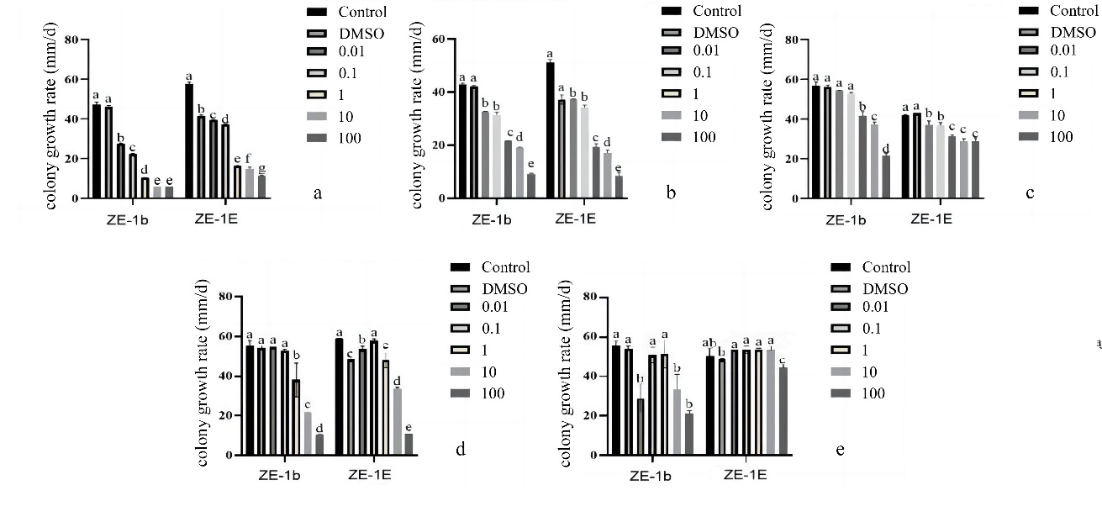

Figure 1. Mycelium growth of ZE-1b/ZE-1E treated by different chemical fungicide. The blank control (Control) and solvent control (DMSO) are included for comparison in all panels; prochloraz-treated (a); pyraclostrobin-treated (b); azoxystrobin-treated (c); myclobutanil-treated (d); iprodione-treated (e).

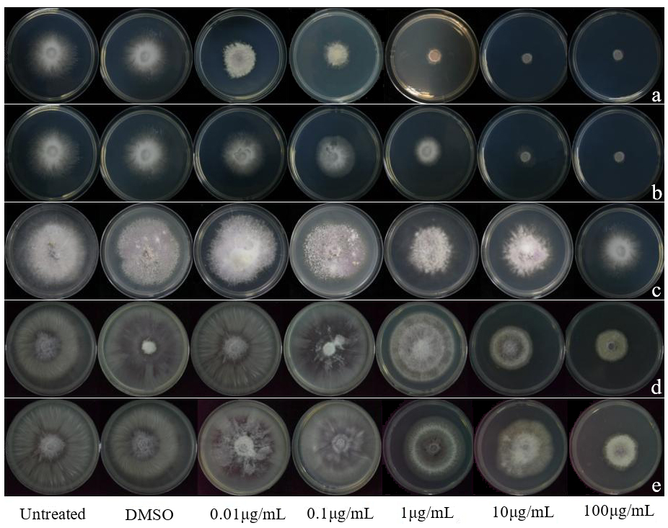

Figure 2. Inhibitory effect of five chemical fungicides on mycelial of isolate ZE-1. The blank control (Control) and solvent control (DMSO) are included for comparison in all panels; prochloraz-treated (a); pyraclostrobin-treated (b); azoxystrobin-treated (c); myclobutanil-treated (d); iprodione-treated (e).

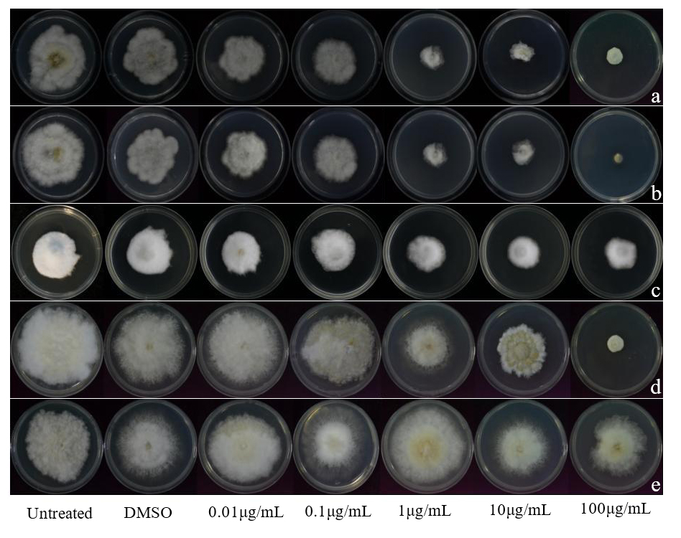

Figure 3. Inhibitory effect of five chemical fungicides on mycelial of isolate ZE-1. The blank control (Control) and solvent control (DMSO) are included for comparison in all panels; prochloraz-treated (a); pyraclostrobin-treated (b); azoxystrobin-treated (c); myclobutanil-treated (d); iprodione-treated (e).

Table 1. Inhibitory effect of different chemical fungicides on mycelial growth of ZE-1b and ZE-1E. Data were derived from probit analysis of mycelial growth inhibition rates (y = a + bx). “Slope ± SE” denotes the slope of the regression line with its standard error; EC₅₀ is the concentration for 50% growth inhibition; χ², d f, and P-value indicate the goodness-of-fit of the probit model.
Strains | Fungicide | Slope ± SE | EC₅₀/ (μg/mL) | χ²  (d f=3) | P
ZE-1b | azoxystrobin | 0.4971±0.239 | 94 | 3.460 | 0.326
ZE-1b | pyraclostrobin | 0.5090±0.281 | 0.43 | 2.236 | 0.525
ZE-1b | prochloraz | 0.6129±0.315 | 0.03 | 1.970 | 0.579
ZE-1b | iprodione | 0.5471±0.593 | 30 | 1.145 | 0.766
ZE-1b | myclobutanil | 0.7239±0.296 | 1.65 | 4.239 | 0.237
ZE-1E | azoxystrobin | 0.2166±0.286 | 1386 | 2.013 | 0.571
ZE-1E | pyraclostrobin | 0.4988±0.248 | 0.18 | 1.643 | 0.650
ZE-1E | prochloraz | 0.6070±0.472 | 0.21 | 1.346 | 0.718
ZE-1E | iprodione | 0.2424±0.361 | 204 | 5.549 | 0.136
ZE-1E | myclobutanil | 0.5226±0.264 | 79 | 1.721 | 0.632

3.2 Effect of Test Agents on Cell Membrane Permeability
The effects of prochloraz and pyraclostrobin on the membrane permeability of ZE-1b and ZE-1E cells (Figure 4) revealed that, while the EC₅₀ and EC₉₀ of prochloraz and pyraclostrobin varied for various fungi, the electrical conductivity of ZE-1b and ZE-1E treated with the two concentrations increased over time but did not differ substantially from the control. Conversely, fungi treated with a 10×EC₅₀ concentration exhibited a significantly higher relative conductance compared to the control group (P < 0.05). The findings demonstrated that the membrane permeability of ZE-1b and ZE-1E cell membranes was significantly enhanced by treatment with both prochloraz and pyraclostrobin at 10×EC₅₀ concentrations.

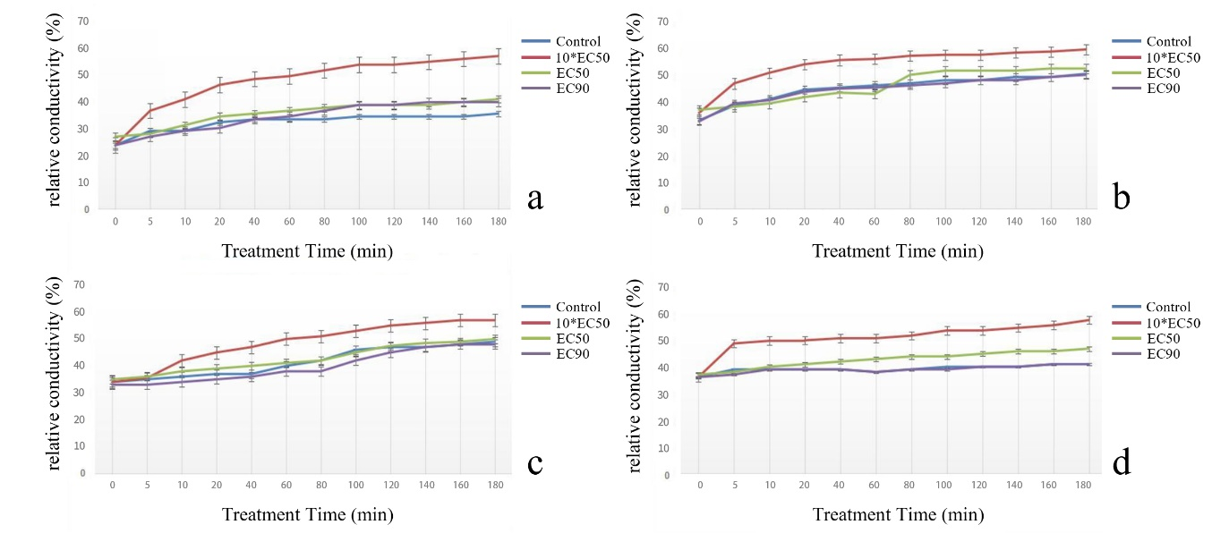

Figure 4. Effects of different concentrations of prochloraz and pyraclostrobin on the membrane permeability of ZE-1b/ZE-1E mycelium cells; relative conductivity of prochloraz-treated ZE-1b at different treatment times (a); relative conductivity of prochloraz-treated ZE-1E at different treatment times (b); relative conductivity of pyraclostrobin-treated ZE-1b at different treatment times (c); relative conductivity of pyraclostrobin-treated ZE-1E at different treatment times (d).

3.3 Inhibition of Spore Germination by Test Agents
The results of the study demonstrated that both prochloraz and pyraclostrobin significantly inhibited the spore germination of ZE-1b and ZE-1E within 48 hours, compared to the control (Figure 5).
For ZE-1b, the spore germination rate decreased from 32% in the control to 14% and 11% under prochloraz treatment at EC₉₀ and 10×EC₅₀, respectively. With pyraclostrobin at 10×EC₅₀, the germination rate decreased from 19% to 12%. For ZE-1E, prochloraz at EC₉₀ and 10×EC₅₀ reduced the germination rate from 54% in the control to 11% and 14%, respectively. Pyraclostrobin at 10×EC₅₀ reduced it from 52% to 18%.
Morphological observations further revealed the concentration-dependent inhibitory effects of both fungicides (Figure 6). Prochloraz and pyraclostrobin both exhibited consistent concentration-dependent inhibition of spore germination in the two Fusarium strains. At EC₅₀ and 10×EC₅₀ concentrations, germinating spores exhibited significantly shortened and deformed germ tubes (prochloraz treatment resulted in incomplete mycelial development, while pyraclostrobin treatment produced short, shrunken germ tubes). At EC₉₀ concentrations, all spores remained in their original oval state without germination. The reduced germination rates and aberrant spore morphology demonstrate a significant, concentration-dependent inhibition by both fungicides.

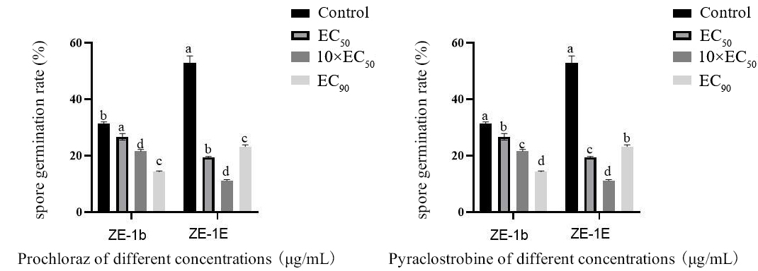

Figure 5. Effect of different concentrations of prochloraz and pyraclostrobin on the spore germination of ZE-1b/ZE-1E.

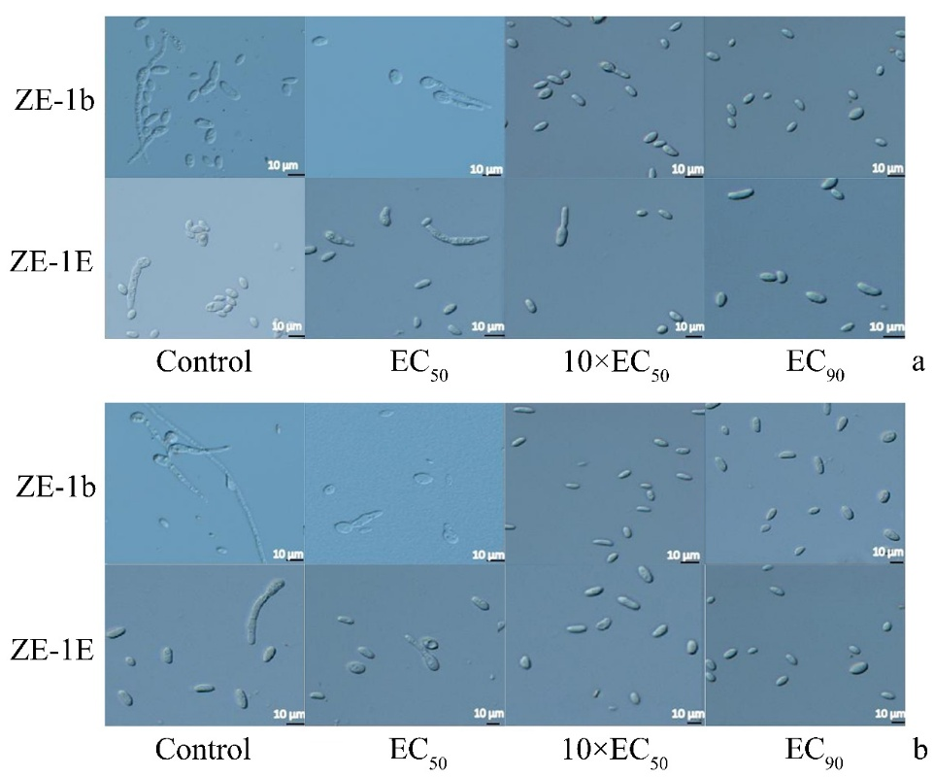

Figure 6. Effect of different concentrations of prochloraz and pyraclostrobin on the spore germination of ZE-1b/ZE-1E; Spore germination of ZE-1b/ZE-1E after treatment with different concentrations of prochloraz (a); Spore germination of ZE-1b/ZE-1E after treatment with different concentrations of pyraclostrobin (b).

3.4 Effects on Extracellular Polysaccharide (EPS) Content of Mycelium
Fusarium pathogens treated with prochloraz and pyraclostrobin had a significantly lower EPS content than the control group. Additionally, ZE-1b treated with 10×EC₅₀ concentration had a greater reduction in extracellular polysaccharide content than the other three treatments, and ZE-1E treated with EC₉₀ concentration of prochloraz demonstrated a greater reduction in extracellular polysaccharide content than the other three treatments (Figure 7). Compared to the other three treatments, the pyraclostrobin 10×EC₅₀ concentration resulted in a greater reduction in the amount of extracellular polysaccharides (Figure 7). The findings demonstrated that both pyraclostrobin and prochloraz reduced the synthesis of EPS in Fusarium pathogens and that the inhibitory impact increased as both doses were increased.

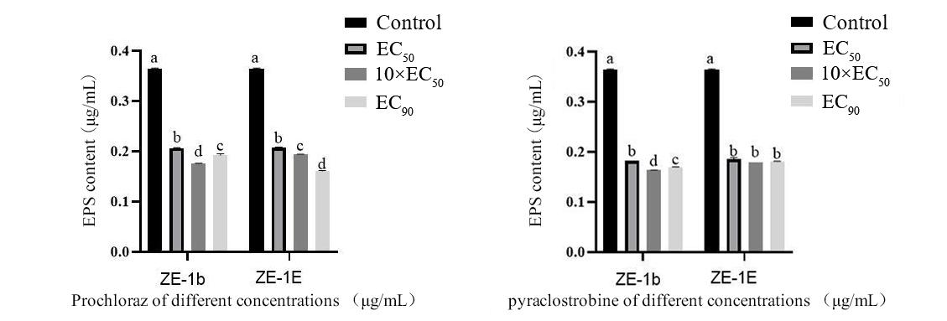

Figure 7. Effects of different concentrations of prochloraz and pyraclostrobin on the extracellular polysaccharide content of ZE-1b/ZE-1E.

3.5 Effects on Mycelial Oxalic Acid Content
The results demonstrated that both prochloraz and pyraclostrobin significantly inhibited oxalic acid synthesis in both ZE-1b and ZE-1E, with the inhibitory effect exhibiting a dose-dependent enhancement (Figure 8).
In ZE-1b, prochloraz at EC₉₀ resulted in the most significant reduction, with oxalic acid content reduced to 0.24 U/g FW. This was lower than the levels at EC₅₀ (0.34 U/g FW) and 10xEC₅₀ (0.25 U/g FW). Pyraclostrobin demonstrated the most significant effect at 10×EC₅₀, reducing the content to 0.13 U/g FW, which represented a 12% decrease compared to the control and was lower than the values observed at EC₅₀ and EC₉₀ (both 0.14 U/g FW).
A comparable dose-response pattern was observed in ZE-1E. Treatment with prochloraz resulted in a reduction of oxalic acid to 0.34, 0.26, and 0.25 U/g FW at EC₅₀, 10xEC₅₀, and EC₉₀, respectively, with a consistent reduction of approximately 9% compared to the control across concentrations. For pyraclostrobin, the most potent inhibition occurred at 10×EC₅₀, where the content dropped to 0.11 U/g FW, marking a 25% reduction relative to the control. The values at EC₅₀ and EC₉₀ were determined to be 0.15 and 0.14 U/g FW, respectively.

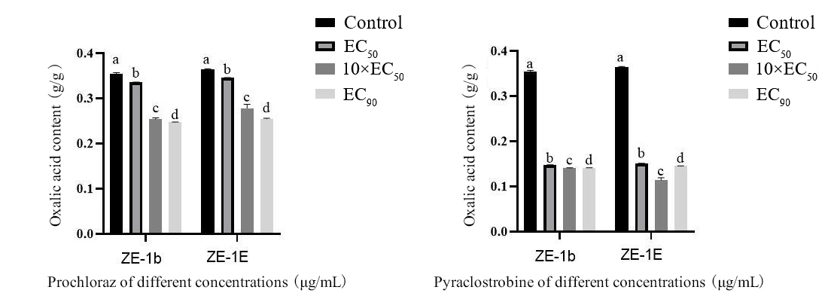

Figure 8. Effect of different concentrations of prochloraz and pyraclostrobin on oxalic acid content of ZE-1b/ZE-1E.

3.6 Effects on Antioxidant Enzyme Activities of Mycelium
Treatment with prochloraz and pyraclostrobin significantly altered the SOD and POD activities in both ZE-1b and ZE-1E mycelia, with responses varying by fungicide, strain, and concentration (Figure 9).
The administration of prochloraz resulted in the manifestation of distinct patterns. In ZE-1b, SOD activity peaked at 566 U/g FW under EC₅₀ treatment, decreasing to 261 and 257 U/g FW at 10xEC₅₀ and EC₉₀, respectively. In contrast, the activity of ZE-1E SOD was found to be most effective at an 10×EC₅₀ of 415 U/g FW, with lower activity observed at EC₅₀ (209 U/g FW) and EC₉₀ (175 U/g FW). In the context of POD activity, ZE-1b exhibited an upward trend, reaching its peak at 10×EC₅₀ (50 U/g FW). Conversely, ZE-1E demonstrated a significant increase at EC₉₀, achieving a level of 102 U/g FW.
Pyraclostrobin treatment resulted in differential modulation of enzyme activities. In ZE-1b, SOD activity peaked at 10×EC₅₀ (695 U/g FW), whereas in ZE-1E, it increased continuously with concentration, reaching a maximum of 608 U/g FW at EC₉₀. POD activity in ZE-1b exhibited a maximum at EC₉₀ (646 U/g FW), following an initial decline. In ZE-1E, the POD activity exhibited a complex trend, with the peak observed at EC₅₀ (917 U/g FW).

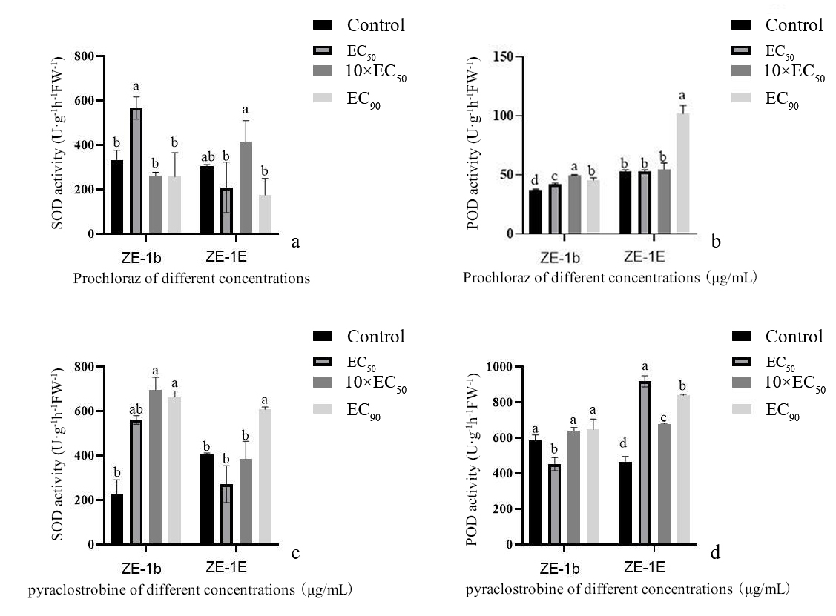

Figure 9. Effects of different concentrations of prochloraz and pyraclostrobin on SOD and POD activity of ZE-1b/ZE-1E; effect of different concentrations of prochloraz on ZE-1b/ZE-1E SOD activity (a); effect of different concentrations of prochloraz on ZE-1b/ZE-1E POD activity (b); effect of different concentrations of pyraclostrobin on ZE-1b/ZE-1E SOD activity (c); effect of different concentrations of pyraclostrobin on ZE-1b/ZE-1E POD activity (d).

3.7 Effect on Mycelial Growth of Pathogenic Fungi under Scanning Electron Microscopy and Transmission Electron Microscopy
Scanning and transmission electron microscopy were employed to examine the morphological and ultrastructural changes in ZE-1b and ZE-1E mycelia following treatment with prochloraz and pyraclostrobin at 10×EC₅₀.
Scanning electron microscopy observations revealed that untreated mycelia of both strains exhibited smooth and intact surfaces (Figure 10). Conversely, prochloraz treatment induced severe surface alterations, including roughness, wrinkling, deformation, and the adherence of particulate matter. Treatment with pyraclostrobin resulted in a range of deleterious effects, with ZE-1b mycelia exhibiting signs of shrivelling and wrinkling and ZE-1E mycelia displaying a significant number of adherent particles (Figure 10). These morphological distortions suggest accelerated cellular senescence triggered by both fungicides.
Further detailed observations were made using transmission electron microscopy, which revealed further information on the intracellular damage (Figure 11). Untreated control cells of both pathogens displayed a regular round or oval shape with intact cell walls and uniformly distributed cytoplasm. Treatment with prochloraz resulted in significant ultrastructural disruption: ZE-1b cells exhibited thinned cell walls, unevenly reduced cytoplasm, and the formation of hollow intracellular cavities; ZE-1E cells showed compromised cell walls and disorganised cytoplasmic content aggregated into dark clusters. Treatment with pyraclostrobin resulted in comparable severe damage, including broken cell walls, reduced and uneven cytoplasm with enlarged cavities in ZE-1b, and fragmented cell walls with aggregated cytoplasmic material in ZE-1E.

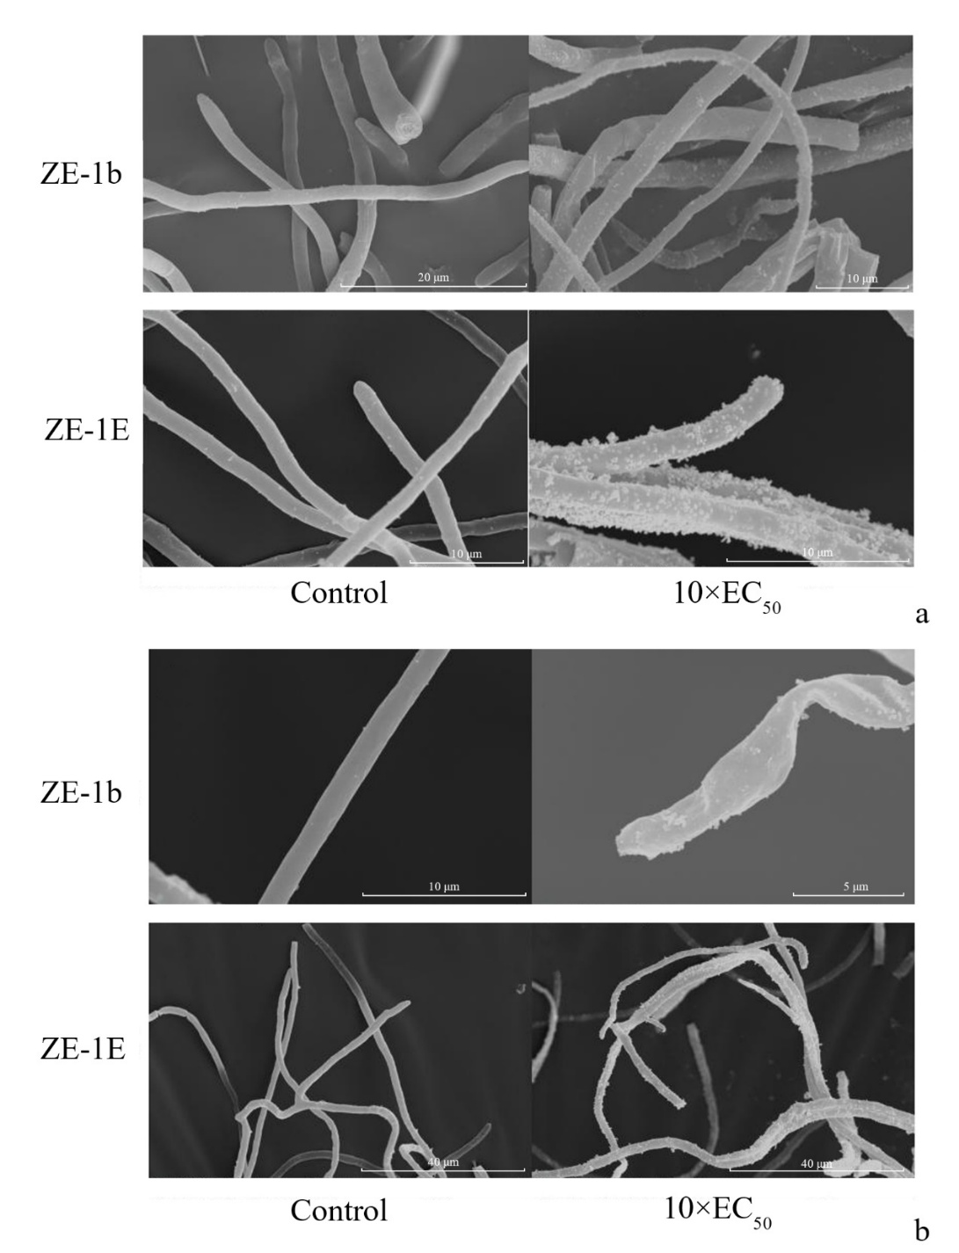

Figure 10. Effect of prochloraz and pyraclostrobin on the surface of mycelium under scanning electron microscope of ZE-1b/ZE-1E; Changes in mycelial morphology of ZE-1b/ZE-1E mycelium after treatment with prochloraz (a); Changes in mycelial morphology of ZE-1b/ZE-1E mycelium after treatment with pyraclostrobin (b).

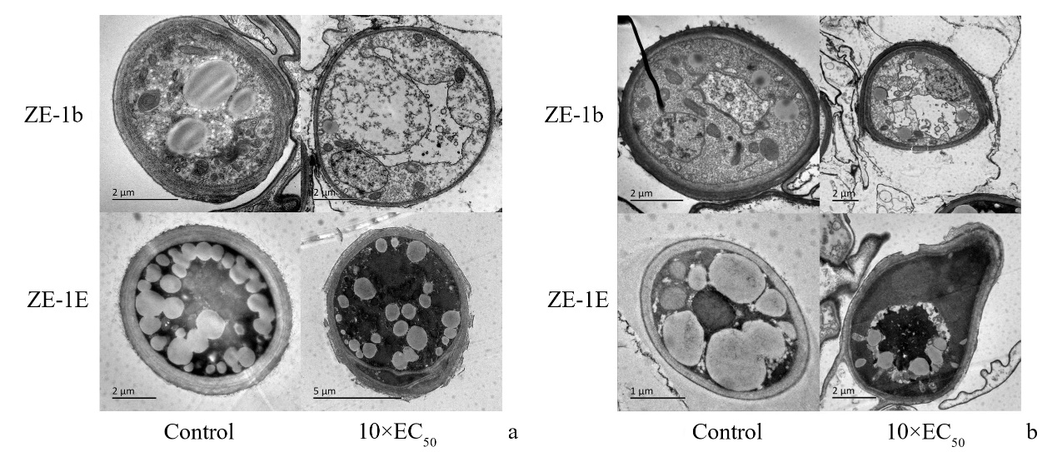

Figure 11. Effect of prochloraz and pyraclostrobin on the cell of mycelium under transmission electron microscope of ZE-1b/ZE-1E; Changes in mycelial cell morphology of ZE-1b/ZE-1E mycelium after prochloraz treatment (a); Changes in mycelial cell morphology of ZE-1b/ZE-1E mycelium after pyraclostrobin treatment (b).

4. Discussion
The present study constitutes the first comprehensive evaluation of five common fungicides against F. oxysporum ZE-1b and F. ipomoeae ZE-1E, the causative agents of leaf spot in H. ventricosa. The low EC₅₀ values for prochloraz (0.03 and 0.21 mg/L) and pyraclostrobin (0.43 and 0.18 mg/L), respectively, confirm their high intrinsic efficacy, consistent with reports against other Fusarium species [18-20]. While this reaffirms their broad-spectrum utility, the novelty of our work lies in elucidating their distinct, multifaceted mechanisms of action within this specific pathosystem, which directly informs targeted application strategies.
The results obtained for prochloraz provide substantial support for its known primary mode of action, which is the disruption of ergosterol biosynthesis, leading to membrane integrity loss [21,22]. It is imperative to underscore that the present study demonstrates that this membrane damage acts as a pivotal event, triggering a cascade of secondary pathologies, including a significant reduction in key virulence factors, such as extracellular polysaccharides (EPS) and oxalic acid. Recent findings regarding F. oxysporum pathogenesis have emphasised the critical role of EPS in fungal biofilm formation and virulence [23]. The present study demonstrates that prochloraz effectively disrupts this key component of pathogenicity. This phenomenon exemplifies the notion that a primary cytostatic effect can result in a pronounced reduction in pathogenicity. In light of this mechanism, prochloraz is especially well-suited for deployment during the nascent stages of infection, or in the context of preventative measures, where the destabilisation of the pathogen's structural integrity and the obstruction of its initial establishment (e.g., the formation of biofilms via EPS) can prove most decisive.
The most intriguing finding pertains to pyraclostrobin. While the inhibition of mitochondrial respiration and energy depletion undoubtedly contribute to fungal death [25], the present data demonstrate that the action of the substance extends beyond the depletion of energy. At the 10×EC₅₀ concentration, significant membrane damage was observed, accompanied by a decline in EPS and oxalic acid. This finding suggests the presence of a secondary, target-specific mechanism that directly compromises membrane function and virulence. This multifaceted activity—which simultaneously induces an energy crisis, membrane damage, and suppression of virulence factors—constitutes a potent, multi-front attack. This mechanism not only elucidates its remarkable efficacy in practical applications but also provides a novel perspective on its mode of action against phytopathogenic fungi. The notion of a synergistic, multi-targeted attack is further substantiated by recent research on combinational formulations [26] and biocontrol-fungicide blends [21], although our study demonstrates that pyraclostrobin alone can manifest such polyvalent activity, which is consistent with its documented broad-spectrum efficacy and plant health-promoting effects [27].
In conclusion, the mechanistic analysis conducted in this study provides substantial evidence that prochloraz and pyraclostrobin are effective chemical compounds for managing H. ventricosa leaf spot. The multi-targeted action of pyraclostrobin and the virulence-suppressing effect of prochloraz provide a rationale for their use and establish them as excellent candidates for integration into sustainable Integrated Pest Management (IPM) programs. This mechanistic insight is crucial for designing effective resistance management strategies, such as using these multi-site-acting compounds in rotation or mixture with site-specific inhibitors [28, 29], to preserve their efficacy for this emerging disease. In order to mitigate the risk of resistance and reduce the environmental impact, we recommend the following integrated strategies: 1) Formulation of prochloraz or pyraclostrobin in conjunction with compatible biocontrol agents (e.g., Trichoderma spp.), as evidenced by integrated disease management programs [30]; 2) Utilisation of their synergistic potential in combination with each other [31] or with fungicides of different modes of action (e.g., prochloraz with hymexazol [32]), thereby enabling reduction of dosage and management of resistance; 3) Incorporation into rotations with protectant fungicides like Bordeaux mixture, a strategy proven effective in reducing application frequency while maintaining control efficacy [33].
Notwithstanding the valuable insights that this in vitro study has yielded, a caveat must be issued: the necessity for field validation. Future research should also employ transcriptomic/proteomic approaches to fully elucidate the signalling networks connecting pyraclostrobin-induced energy shutdown to the observed secondary effects. Such omics techniques have proven to be effective in elucidating host-pathogen interactions, as evidenced by genomic and proteomic analyses of banana's response to F. oxysporum f. sp. cubense infection, which decoded the mechanisms of host resistance [34, 35]. Finally, the monitoring of field populations for sensitivity shifts using novel diagnostic technologies [36, 37] will be crucial for the long-term management of resistance.

ACKNOWLEDGEMENTS
This work was supported by the Natural Science Foundation of the Jiangsu Higher Education Institutions of China (22KJA220001), Zhejiang A&F University Higher Education Research Project (GJZD202503).

AUTHOR CONTRIBUTIONS
Zengrui Zhu: Writing - original draft, Methodology, Investigation, Formal analysis, Data curation.
Yunfei Li: Investigation, Validation, Formal analysis.
Chunxia Wang: Formal analysis, Data curation, Investigation.
Chixing Wu: Conceptualization, Funding acquisition, Project administration.
Shengfeng Mao: Writing - review & editing, Supervision, Resources, Funding acquisition.

CONFLICT OF INTEREST STATEMENT
The authors declare that there are no competing interests.

DECLARATION OF USE OF GENERATIVE AI
During the preparation of this manuscript, the authors used ChatGPT (OpenAI) to assist with language polishing and to improve the clarity of English expression. After employing this tool, the authors thoroughly reviewed, edited, and validated the content, and take full responsibility for the final version of the work.

REFERENCES
[1] Wu J., Huang R., Jiao D., Liu S., Liu H. and Liu H., Protection by Hosta ventricosa polysaccharides against oxidative damage induced by t-BHP in HepG2 cells via the JNK/Nrf2 pathway. International Journal of Biological Macromolecules, 2022; 208: 453-462. DOI 10.1016/j.ijbiomac.2022.03.134.
[2] Wang X., Bao X., Hai H., Mei L., Li Q. and Liang X., Effects of Hosta plantaginea extract on RAW264.7 cell inflammation and airway inflammation in mice with asthma. West China Journal of Pharmaceutical Sciences, 2023; 38(05): 488-492. DOI 10.13375/j.cnki.wcjps.2023.05.003.
[3] Wang Y., Zeng Y., Chen S., Han D., Huang Y. and Yuan H., Determination of insecticidal activity of Hosta ventricosa flowers extracts against Plutella xylostella and analysis of their chemical components. Journal of Jilin Agricultural University, 2024; 46(01): 28-33. DOI 10.13327/j.jjlau.2022.5636.
[4] Wang C.X., Zhang H.L., Wang S.H. and Mao S.F., Leaf spot of Hosta ventricosa caused by Fusarium oxysporum in China. PeerJ, 2021; 9: e12581. DOI 10.7717/peerj.12581.
[5] Tan X., Zhao J., Yu Z., Qiao G. and Qin W., Isolation and identification of the pathogen causing leaf spot on Hosta ventricosa. Acta Phytopathologica Sinica, 2023; 53(05): 970-973. DOI 10.13926/j.cnki.apps.000843.
[6] Sun H.Y., Sun L., Hong Y.Z. and Liang Y., First report of anthracnose on Hosta ventricosa caused by Colletotrichum spaethianum in China. Crop Protection, 2020; 131: 105104. DOI 10.1016/j.cropro.2020.105104.
[7] Liu Z.X., Dong A.R., Jia H.Q., Zhou Y., Liu X.F. and Zhang X.Y., First report of Pseudomonas syringae pv. syringae causing leaf blight on Hosta ventricosa in China. Plant Disease, 2019; 103(8): 2123-2124. DOI 10.1094/PDIS-03-19-0566-PDN.
[8] Karim M.M., Usman H.M., TAN Q., HU J.J., Fan F., Hussain R., et al., Fungicide resistance in Colletotrichum fructicola and Colletotrichum siamense causing peach anthracnose in China. Pesticide Biochemistry and Physiology, 2024; 203: 106006. DOI 10.1016/j.pestbp.2024.106006.
[9] Li Q.S., Guo R.R., Li A.N. and Wang Y.l., Roles of NADPH oxidases in regulating redoxhomeostasis and pathogenesis of the poplar canker fungus. Cytospora chrysosperma. Stress Biology, 2025; 5(1): 33. DOI 10.1007/s44154-025-00223-y.
[10] Mu L.Y., Research Methods of Chemical Plant Protection, China Agriculture Press, Beijing, 1994.
[11] Shen Y.T., Chen C.Y., Cai N., Yang R.P., Chen J.Y., Kahramanoglu I., et al. The antifungal activity of loquat (Eriobotrya japonica Lindl.) leaves extract against Penicillium digitatum. Frontiers in Nutrition, 2021, 8: 663584. DOI 10.3389/FNUT.2021.663584.
[12] Zuo Y.X., Qin H.Q., Nie F.J., Huang L.L., Gao X.N., Kang Z.S., et al., Investigation of Sclerotinia stem rot in Shaanxi Province. Plant Protection, 2011; 37(02): 116-119. DOI 10.3969/j.issn.0529-1542.2011.02.025.
[13] Tang X.L., Yang J.M., Meng Z.L. and Shi Y., Sensitivity of Coryneum populinum Bres. to five fungicides. Forest Research, 2023, 36(5): 160-168. DOI 10.12403/j.1001-1498.20230126
[14] Dai Y., Wu X.Q., Wang Y.H. and Zhu M.L., Biocontrol potential of Bacillus pumilus HR10 against Sphaeropsis shoot blight disease of pine. Biological Control, 2021; 152: 104458. DOI 10.1016/j.biocontrol.2020.104458.
[15] Duan L.Z., Wang J.F. and Zhao J.R., Study on the determining conditions of oxalate content in spinach with coloration method. Journal of Anhui Agricultural Sciences, 2007; (03): 632-633+643. DOI 10.13989/j.cnki.0517-6611.2007.03.003.
[16] Guo H.P. and She W.Q., The transcriptional regulation and mechanism research progress of chloroplast superoxide dismutases in plant. Journal of Anhui Agricultural Sciences, 2015; 43(08): 381-384. DOI 10.13989/j.cnki.0517-6611.2015.08.149.
[17] Bozzola J.J. and Russell L.D., Electron microscopy: Principles and techniques for biologists. Quarterly Review of Biology, 1992; 67(2): 247-249 DOI 10.1086/417649.
[18] Liu S.C., Liu R.B., Chu B., Li Z., Meng Q.Q., Gou Y.F., et al., Identification and screening of fungicides against Piper nigrum basal Fusarium wilt disease in Hainan, China. Journal of Basic Microbiology, 2023; 63(11): 1254-1264. DOI 10.1002/jobm.202300183.
[19] Mao X.W., Cao T.B., Chen L.T., Li M., Zhao X.C., Liu H., et al., Resistance risk and mechanism of prochloraz in Fusarium solani. Pesticide Biochemistry and Physiology, 2025; 213: 106548. DOI 10.1016/j.pestbp.2025.106548.
[20] Mao Y.S., Qiu H., Gao X.L., Li Y.G., Zheng X.M., Cai Y.Q., et al., Resistance risk and molecular mechanism of tomato wilt pathogen Fusarium oxysporum f. sp. lycopersici to pyraclostrobin. Journal of Agricultural and Food Chemistry, 2024; 72(8): 3998-4007. DOI 10.1021/acs.jafc.3c09907.
[21] Zhang Y.L., Chen J., Bai X.M., Sun W.J., Wang N. and Feng W.X., The combined activity of Pseudomonas fluorescens 5B12 blended with fungicide against Botrytis cinerea on cucumber. Chinese Journal of Pesticide Science, 2025; 27(4): 741-746. DOI 10.16801/j.issn.1008-7303.2025.0064.
[22] Vinggaard A.M., Hass U., Dalgaard M., Andersen H.R., Bonefeld-Jorgensen E., Christiansen S., et al., Prochloraz: An imidazole fungicide with multiple mechanisms of action. International Journal of Andrology, 2010; 29(1):186-192. DOI 10.1111/j.1365-2605.2005.00604.x.
[23] Zhang Z.Y., Li Y.G., Xu J.K., Zou H.H., Guo Y., Mao Y.S., et al., The G143S mutation in cytochrome b confers high resistance to pyraclostrobin in Fusarium pseudograminearum. Pest Management Science, 2024; 80(10): 4941-4949. DOI 10.1002/ps.8220.
[24] Ferreira D.G. and Negri M., In vivo and in vitro pathogenicity of Fusarium oxysporum and its biofilm components. Brazilian Journal of Microbiology, 2025; 56: 1061–1067. DOI 10.1007/s42770-025-01632-x.
[25] Yang L.J. and Bai Y.L., Strobilurin fungicide—Pyraclostrobin. Modern Agrochemicals, 2012; 11(04): 46-50+56. DOI 10.3969/j.issn.1671-5284.2012.04.013.
[26] de Souza P.H.N., Bacchi L.M.A., Gavassoni W.L. and Andrade W.D., Association of hydrogen peroxide with commercial fungicide formulations in the control of Asian soybean rust. Ciência Rural, 2022; 52(3): e202001196. DOI 10.1590/0103-8478cr20200196.
[27] Cao H.C., Zhang D.X., Liu S.G., Luo J., Jing T.F., Pan S.H., et al., Achieving win–win ecotoxicological safety and fungicidal activity of pyraclostrobin-loaded polyurea microcapsules by selecting proper polyamines. Journal of Agricultural and Food Chemistry, 2021; 69(7): 2099-2107. DOI 10.1021/acs.jafc.0c07482.
[28] Duraisamy K., Ha A., Kim J., Park A.R., Kim B., Song C.W., et al., Enhancement of disease control efficacy of chemical fungicides combined with plant resistance inducer 2,3-butanediol against turfgrass fungal diseases. The Plant Pathology Journal, 2022; 38(3): 182-193. DOI 10.5423/PPJ.OA.02.2022.0022.
[29] Karakotov A., Zheltova E., Talanova O., Saraev V., Slavashevich M. and Golubeva N., Insect-fungicidal composition with synergistic efficacy. RU Pat. No. 2773310C1 (2022).
[30] Acosta-González U., Leyva-Mir S.G., Silva-Rojas H.V. and Rebollar-Alviter A., Preventive and curative effects of treatments to manage strawberry root and crown rot caused by Neopestalotiopsis rosae. Plant Disease, 2024; 108(5): 1278-1288. DOI 10.1094/PDIS-05-23-0958-RE.
[31] Rajput L.S., Shaikh M.S., Borah M., Kumar S., Nataraj V., Shivakumar M., et al., Evaluation of combination fungicides for charcoal rot and collar rot management in soybean. Agronomy, 2025; 15(3): 528. DOI 10.3390/agronomy15030528.
[32] Geng Z.Y., Zhao J.L., Ren Y.P., Zhou G. and Sun G.B., Studies on the effects of prochloraz and hymexazol to Fusarium moniliforme and Rhizoctonia solani. Journal of Agriculture, 2011; 1(4): 32-36. DOI 10.11924/j.issn.2095-4050.2011-xb0335.
[33] Jiang H., Meng X.L., Ma J., Sun X.N., Wang Y.N., Hu T.L., et al. Control effect of fungicide pyraclostrobin alternately applied with Bordeaux mixture against apple Glomerella leaf spot and its residue after preharvest application in China. Crop Protection, 2021; 142(5): 105489. DOI: 10.1016/j.cropro.2020.105489.
[34] Panatda J., Duangdao C., Pakpoom S., Kawee S., Kumrop R. and Sittiruk R., Proteomic analysis of banana seedling (Musa ABB cv. 'Kluai Namwa Mali-ong) infected with Fusarium oxysporum f. sp. cubense (FOC). Chiang Mai Journal of Science, 2025; 52(5): e2025060. DOI 10.12982/CMJS.2025.060.
[35] Li X.Y., Luo M., Song H.D. and Dong Z.Y., Transcriptome analysis of early pathogenetic responsive genes in Cavendish bananas during Fusarium oxysporum f. sp. cubense Race 1 and Race 4 infection. Chiang Mai Journal of Science, 2023; 50(5): e2023052. DOI 10.12982/CMJS.2023.052.
[36] Zhang Y.Z., Li Z., Man J., Xu D., Wen L., Yang C., et al., Genetic diversity of field Fusarium asiaticum and Fusarium graminearum isolates increases the risk of fungicide resistance. Phytopathology Research, 2023; 5(1): 51. DOI 10.1186/s42483-023-00206-9.
[37] Zang J.H., Guo Y.F., Fu F.F., Wang F.Q., Dai T.T., Cao F.L., Detection and field visualization of male and female Ginkgo biloba using RPA-LFD, enhanced by EZ-D and PNADCK technology. Journal of Forestry Research, 2025; 36(1): 121. DOI 10.1007/S11676-025-01922-Y.

