Study of High-Performance MnO₂ Cathode Materials in Aqueous Zinc-Ion Batteries for Paraglider Power Applications
Chen Liang [a,b], Jiyao Zhou [c], Wei Huang [d], Xinbin Pei [e] and Ling Li [a]*
[a] Physical Education Teaching Department, Anyang Institute of Technology, Anyang, 455000, China
[b] Udon Thani Rajabhat University, Udon Thani Province, 41000, Thailand
[c] State Grid International Development Co., Ltd., Beijing, 100006, China
[d] BGP Inc., China National Petroleum Corporation, Zhuozhou, 072750, China
[e] FENGFAN Co., Ltd., Baoding, 071000, China
* Author for correspondence; e-mail: 537742870@qq.com
ORCiD: https://orcid.org/0000-0003-4285-8673
Received: 22 October 2025 Revised: 5 December 2025 Accepted: 5 January 2026 Published: 23 March 2026
Citation: Liang C., Zhou J.y., Huang W., Pei X.b. and Li L., Study of high-performance MnO₂ cathode materials in aqueous zinc-ion batteries for paraglider power applications. Chiang Mai Journal of Science, 2026; 53(2): e2026034. DOI 10.12982/CMJS.2026.034.
Copyright: ©2026 Author (s). This is an Open Access article distributed under the term of the Creative Commons Attribution 4.0 International License CC BY 4.0 (https://creativecommons.org/licenses/by/4.0).

GRAPHICAL ABSTRACT
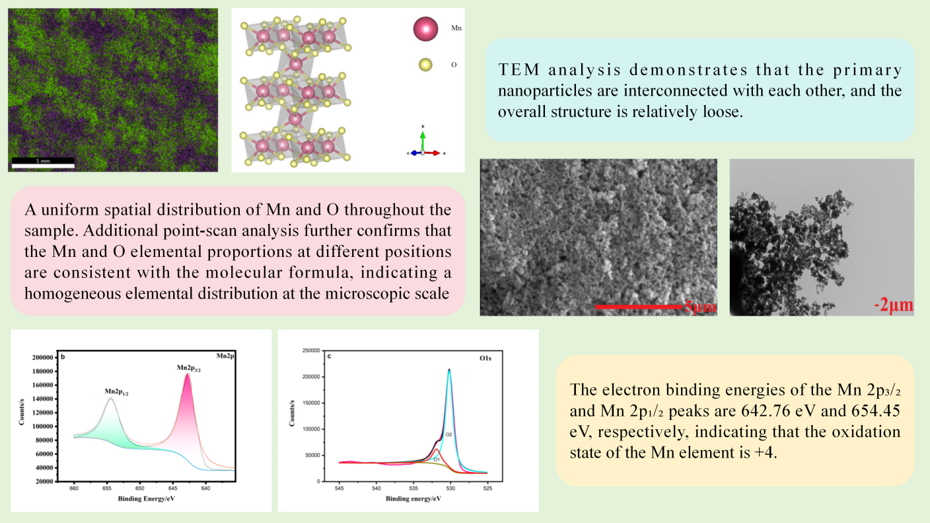

ABSTRACT
Currently, paragliders primarily rely on gasoline engines as their power source for flight. However, during high-altitude flights, the risks of fuel leakage and fire pose significant threats to flight safety. Using secondary batteries as an alternative power system is expected to significantly enhance the safety performance of paragliders. This study focuses on the preparation and performance optimization of MnO₂, the key electrode material for aqueous zinc-ion batteries. MnO₂ materials were synthesized via a hydrothermal method, and the effects of manganese source type, hydrothermal temperature, and reaction time on the electrochemical performance of the materials were systematically investigated to determine the optimal synthesis process. The influence of high-temperature calcination on the material's structure and properties was also compared. Electrochemical tests, such as galvanostatic charge-discharge, cyclic voltammetry, and electrochemical impedance spectroscopy, revealed that the synthesized MnO₂ material maintained a specific capacity as high as 256 mAh/g at a current density of 50 mA·g⁻¹ even after high-rate discharge, with symmetric redox peaks indicating excellent electrochemical reversibility. Further physical characterization showed that XRD analysis indicated the uncalcined sample had low crystallinity but no significant impurities. SEM images revealed that the material consists of nanometer-sized spherical particles, which effectively increases the specific surface area and contributes to enhanced electrochemical performance. EDS and elemental analysis confirmed uniform element distribution, while FT-IR testing further verified the stable structural characteristics of the synthesized MnO₂ material. This study provides an important theoretical basis and technical reference for high-performance MnO₂ cathode materials for the electrification transformation of paraglider power systems.

Keywords: MnO₂, zinc ion battery, electrochemical performance, hydrothermal method

1. INTRODUCTION
Paragliding, with its unique flying experience and thrill, attracts numerous enthusiasts to engage in the sport. At present, most paragliders rely on gasoline engines as their power source to achieve longer flight distances and higher altitudes, thereby meeting pilots' needs in various scenarios. However, gasoline engines pose multiple safety hazards during high-altitude flight. On the one hand, gasoline is highly volatile; under prolonged flight conditions and complex weather conditions, components such as fuel lines and tanks are prone to leakage due to aging, wear, or external impacts. Once gasoline leaks, in the low-temperature, low-pressure environment at high altitudes, gasoline vapor mixed with air can easily reach the explosion limit. Upon encountering ignition sources such as static electricity or mechanical sparks, it can lead to fire or even explosion, seriously threatening the pilot's life. On the other hand, gasoline engines generate extremely high temperatures during operation. If the cooling system fails or the engine operates under sustained high load, the internal temperature may rise sharply, potentially causing a fire. Additionally, mechanical failures of the engine, such as piston seizure or connecting rod fracture, may also trigger engine fires or sudden power loss, posing significant safety risks to paragliding.
The application of secondary (rechargeable) battery systems in aviation power is regarded as one of the effective solutions to address the aforementioned issues. As an energy conversion device that transforms chemical energy into electricity, batteries are integral to daily life. In the context of the global energy crisis, they have garnered increased attention and seen rapid technological advancement. Lithium-ion batteries, with their high energy density and extended cycle life, have emerged as the dominant research focus in the battery sector [1–6]. Nevertheless, the scarcity and rising costs of raw materials, along with issues such as inherent flammability during operation and the high toxicity of discarded batteries, significantly hinder the widespread adoption of lithium-ion batteries. Consequently, the secondary battery market, primarily composed of lithium-ion batteries, is unable to satisfy the rapidly increasing energy demands [7–9].
In contrast to lithium-ion batteries, water-based zinc-ion batteries boast notable economic and environmental benefits, along with a high power density, thereby garnering substantial attention. As a renewable and eco-friendly battery system, zinc-ion batteries are highly promising due to their superior safety and numerous attributes that enable them to serve as potential replacements for lithium-ion batteries [10–14]. The resistivity of zinc ions is relatively low, at 5.9 µΩ·cm, and they maintain stability in both air and water, in contrast to lithium ions. The moderate ionic radius of zinc ions enhances their ability to intercalate and deintercalate within the cathode material, thereby reducing volume variation in the material during this process [15–19]. Furthermore, the reversible dissolution and precipitation of zinc ions on the surface of zinc foil contribute to a high theoretical specific capacity of 820 mA·g⁻¹ [20].
Manganese oxide is recognized as one of the most extensively utilized cathode materials for zinc-ion batteries, owing to its variable oxidation states, high reactivity, abundant natural resources, affordability, and environmental compatibility [21–23]. The crystal structure of MnO₂ is characterized by its high degree of polymorphism, with materials synthesized via different approaches exhibiting distinct crystal structures, growth orientations, morphologies, and sizes. The intrinsic structure of manganese dioxide comprises MnO₆ octahedral units, which are formed by one manganese atom coordinated with six oxygen atoms, resulting in various tunnel, layered, and close-packed frameworks, including cubic and hexagonal close-packed structures. Although MnO₂ demonstrates superior zinc storage performance, the material's tunnel structure can undergo phase transformation into a layered or spinel structure after repeated charge and discharge cycles, with this conversion being only partially reversible, thereby leading to degradation in the electrochemical performance of the battery material [24–26]. In response to these challenges, a range of modification techniques have been developed, such as nanostructure control, defect engineering, composite formation, and pre-insertion chemistry. Among these strategies, defect engineering has emerged as a particularly prominent method for optimizing manganese-based cathode materials [27]. This approach is commonly divided into four types: cation doping, oxygen vacancies, cation vacancies, and anion doping. Specifically, cation doping entails the incorporation of foreign cations (e.g., Co [28], V [29], Ag [30], La [31], Ce [32], and Ca [33]). MnO₂ has consistently attracted scholarly attention in the field of electrode research [34]. Yuan et al. [35] developed a flexible electrode based on a boron‑nitrogen co‑doped carbon nanotube array with anchored MnO₂ nanosheets. Electrochemical tests demonstrated that this electrode delivers a specific capacity of 310.7 mAh·g⁻¹ at 0.1 A·g⁻¹ and exhibits excellent long‑term cycling stability, retaining 79.7% of its capacity after 8000 cycles at 3 A·g⁻¹. Liu et al. [36] synthesized a multi‑walled carbon nanotube/MnO₂ nanoflower composite with a hexagonal structure via a co‑precipitation method. Rate capability and cycling stability tests confirmed that the material maintains a capacity of 335.6 mAh·g⁻¹ after 150 cycles at 0.2 A·g⁻¹ and 115.7 mAh·g⁻¹ after 4000 cycles at 2.0 A·g⁻¹. Zhao et al. [37] reported that vanadium‑doped MnO₂ supported on carbon nanosheets effectively reduces crystallinity and introduces oxygen vacancies, enabling the material to achieve a specific capacity of 352.9 mAh·g⁻¹ at 0.5 A·g⁻¹ and retain 83.2% of its initial capacity after 1000 cycles at 1 A·g⁻¹. Liu [38] conducted a study on the reaction mechanism of δ-MnO₂ materials prepared through a hydrothermal method and discovered that the zinc-ion storage mechanism involves the simultaneous occurrence of diffusion-controlled Zn²⁺ intercalation and H⁺ conversion processes. Following the discharge process, the emergence of a new ZnMn₂O₄ product was observed, suggesting that the layered structure of δ-MnO₂ was transformed into a spinel structure, forming ZnMn₂O₄. At present, the primary strategies to enhance the cycling performance of MnO₂ materials include doping, surface coating, and morphological control. Zhou [39] employed continuous calcination and reduction techniques to prepare β-MnO₂ nanorods with abundant oxygen vacancies to address the issue of sluggish reaction kinetics, and achieved a specific capacity of up to 240 mA·g⁻¹ at a current density of 100 mA·g⁻¹. Wu et al. [40] developed graphene-coated MnO₂ nanowires that demonstrated an energy density of 406.6 Wh·kg⁻¹ at a current density of 0.3 A·g⁻¹.
With the increasing public awareness of environmental protection and continuous social development, the adoption of green and renewable energy sources is accelerating, thereby driving the rapid development of rechargeable secondary batteries. Aqueous zinc-ion batteries are emerging as a highly promising candidate for energy storage applications. Nevertheless, the further advancement of aqueous zinc-ion batteries is constrained by multiple factors, among which the cathode plays a pivotal role in determining battery performance. Therefore, the development of stable cathode materials is crucial for the practical application and large-scale implementation of zinc-ion batteries. Manganese dioxide is an attractive cathode material for zinc-ion batteries, offering high theoretical capacity, excellent cycling stability, and abundant natural resources. This paper reports the synthesis of MnO₂ via a hydrothermal method, with systematic optimization of the manganese source, hydrothermal reaction time, and reaction temperature. Furthermore, the electrochemical performance of the material after calcination is systematically compared with that of the material directly synthesized by the hydrothermal method. This paper systematically compares and reveals the prominent advantages of applying a non-high-temperature calcination process for synthesizing MnO₂ materials in industrial applications. By bypassing the energy-intensive calcination step required in conventional methods, this approach not only simplifies the production process but also significantly reduces equipment investment and energy consumption. As a result, it offers a viable route for large-scale manufacturing with markedly reduced costs, demonstrating substantial economic benefits.
The primary objective of this work is to develop a synthetic route for MnO₂ materials suitable for industrial applications. As the comparative data in Table 1 show, although the specific capacity of our synthesized MnO₂ material does not rank among the highest reported, our non-calcination method demonstrates clear advantages in overall competitiveness. This approach directly avoids the most energy-intensive calcination step, thereby substantially reducing production energy consumption and carbon emissions at the source. Furthermore, the raw materials used are inexpensive and readily available, and the process flow is simplified, providing a reliable solution for the low-cost, large-scale production of high-performance electrode materials for paraglider power.

Table 1. Comparison of the electrochemical performance of MnO₂.
Sample | Current density | Specific capacity
graphene scroll‐coated α‐MnO₂ nanowires [26] | 3 A·g⁻¹ | 145.3 mAh·g⁻¹
MnO₂ composites supported on N-doped hollow porous carbon nanospheres [41] | 0.5mA·g⁻¹ | 103mAh·g⁻¹
oxygen‐deficient σ-MnO₂ [42] | 0.2 A·g⁻¹ | 345 mAh·g⁻¹
MnO₂ in this paper | 0.05mA·g⁻¹ | 256 mAh·g⁻¹

2. MATERIALS AND METHODS
2.1 Preparation of MnO₂ Material
In this study, MnO₂ materials were synthesized under varying hydrothermal conditions using reagents such as Mn(CH₃COO)₂·4H₂O, MnSO₄·H₂O, Mn(NO₃)₂, and potassium permanganate. First, 44 mmol of the manganese source and 44 mmol of potassium permanganate were dissolved in 60 mL of deionized water. The solution was stirred on a magnetic stirrer for approximately 30 min to ensure complete dissolution and homogeneous mixing of the components. The resulting homogeneous solution was then transferred to a 100 mL hydrothermal reactor, where the appropriate hydrothermal temperature and reaction duration were set. Upon completion of the hydrothermal process, the resulting precipitates were collected, thoroughly washed with deionized water, and dried to yield MnO₂ materials synthesized under distinct hydrothermal conditions. Subsequently, zinc-ion batteries were assembled using these materials for electrochemical performance evaluation. For the calcination process, the hydrothermal product was placed in a muffle furnace and calcined at 400 °C for 5 h to obtain the MnO₂ material synthesized via calcination.

2.2 Assembly of Zinc Ion Batteries
The MnO₂ material and acetylene black were mixed at a mass ratio of 8:1 and finely ground in an agate mortar for 30 min. PVDF, at a mass ratio of 1:1 with acetylene black, was dissolved in a minimal amount of N-methyl-2-pyrrolidone (NMP) and stirred for 5 min to form a uniform binder solution. This binder solution was then thoroughly blended with the ground MnO₂ and acetylene black to obtain a homogeneous slurry. The resulting slurry was uniformly coated onto stainless steel foil, which was subsequently dried at 80 °C until completely solvent-free. The dried foil, now bearing the active material, was cut into circular electrodes with a diameter of 10 mm to serve as the positive electrode. The MnO₂ mass loading of the active material was controlled at 1 mg·cm⁻². The coin cell assembly included a glass fiber separator, a metal zinc sheet as the negative electrode, and an electrolyte composed of a 2 mol·L⁻¹ ZnSO₄ solution and a 0.2 mol·L⁻¹ MnSO₄ solution. The components were assembled to form the battery, which was then left to stand for 24 hours before testing. Compared to carbon-coated current collectors or titanium materials, stainless steel offers low raw material costs and demonstrates excellent mechanical strength and toughness. Within the typical operating window of zinc-ion batteries, particularly at the zinc deposition potential on the anode side, a stable passivation film forms on the stainless steel surface, providing sufficient resistance to corrosion in weakly acidic zinc sulfate electrolyte. Moreover, its good electronic conductivity ensures efficient electron transfer between the current collector and active material during battery charging and discharging, thereby reducing the internal resistance of the battery.

2.3 Characterization and Test Methods
For the charge–discharge tests, the Lanbts BT2018A battery testing system was utilized. Cyclic voltammetry (CV) and electrochemical impedance spectroscopy (EIS) measurements were conducted on the CHI660E electrochemical workstation (Shanghai Chenhua, China). The CV tests were performed within a voltage range of 0.7–1.8 V with a scan rate of 0.1 mV·s⁻¹. The EIS measurements were carried out over a frequency range from 10 mHz to 100 kHz. X-ray diffraction (XRD) phase analysis was performed using a powder X-ray diffractometer manufactured in the Netherlands, with a scanning rate of 6°·min⁻¹. The morphology of the MnO₂ materials was examined using a scanning electron microscope (SEM) (FEI Nova NanoSEM 450, USA). Energy-dispersive X-ray spectroscopy (EDS) analysis was performed using an EDAX Hikari Plus detector (USA). Transmission electron microscopy (TEM) analysis was carried out on a microscope manufactured by Nippon High-Tech Co., Ltd. Fourier transform infrared (FTIR) spectroscopy was performed using a Shimadzu IRTracer-100 spectrometer (Japan) to analyze the infrared absorption characteristics of the materials.

3. RESULTS AND ANALYSIS
3.1 Electrochemical Properties of MnO₂ Materials Synthesized from Different Manganese Sources
Figure 1 exhibits the electrochemical characteristics of MnO₂ materials synthesized from various manganese precursors: Mn(CH₃COO)₂·4H₂O, MnSO₄·H₂O, and Mn(NO₃)₂. Figure 1(a) displays the initial charge-discharge curves, indicating that the MnO₂ material synthesized using Mn(CH₃COO)₂·4H₂O as the manganese source possesses the highest initial discharge capacity and a more extended initial discharge plateau. The difference in the initial charge and discharge capacities originates from the unique structural characteristics of the as-synthesized MnO₂ material. Owing to its specific synthesis route, the material possesses a high initial ion saturation, meaning that part of the sites available for Zn²⁺ accommodation are already occupied. Consequently, the initial charging process requires less charge to drive Zn²⁺ extraction, resulting in a lower charging capacity. During the subsequent discharge, Zn²⁺ can be inserted into all the available sites in the material, leading to a higher discharge capacity. This phenomenon directly demonstrates that the material can form a stable structure conducive to zinc ion storage without undergoing high-temperature phase transformation, highlighting its suitability for industrialization and excellent performance. Figure 1(b) shows the cyclic charge-discharge profiles, where materials were cycled 10 times at current densities of 50, 100, 200, 300, and 500 mA·g⁻¹g, and then cycled again for 10 times at 50 mA·g⁻¹. The MnO₂ material synthesized from Mn(NO₃)₂ demonstrated severe capacity fading with increasing cycle numbers. Although the MnO₂ material synthesized from MnSO₄·H₂O experienced less capacity fading during cycling, a significant capacity drop was observed when reverting to a current density of 50 mA·g⁻¹ after discharge at 500 mA·g⁻¹.
(b)
(a)
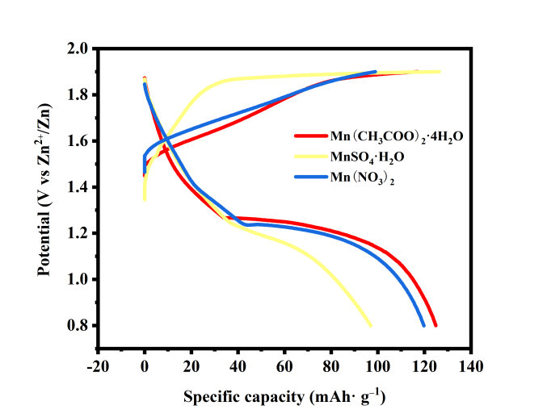 | 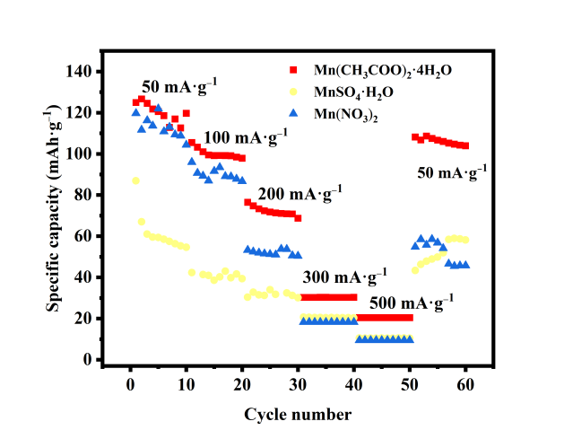
(c) | (d)
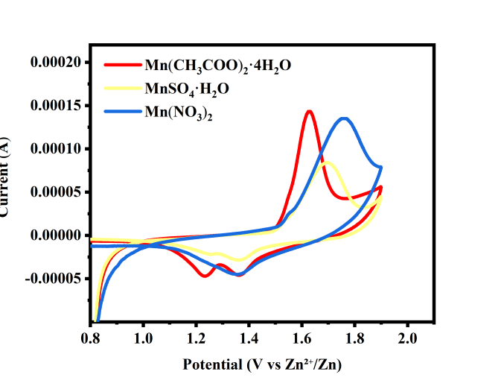 | 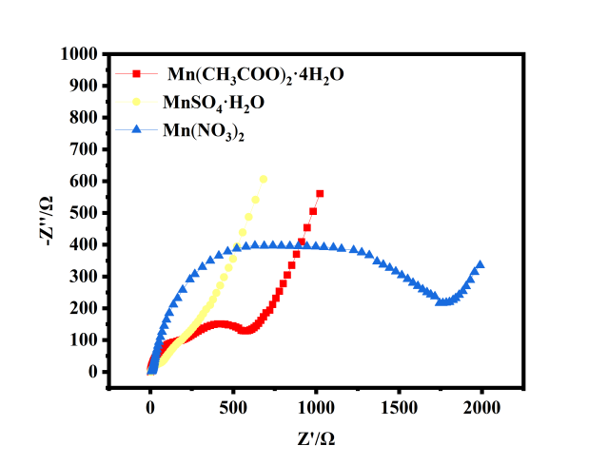
Figure 1. Electrochemical performance of MnO₂ materials synthesized from different manganese sources. Initial charge-discharge diagram of MnO₂ materials synthesized from different manganese sources (a), cyclic charge-discharge diagram of MnO₂ materials synthesized from different manganese sources (b), cyclic voltammetry of MnO₂ materials synthesized from different manganese sources (c) and electrochemical impedance spectroscopy of MnO₂ materials synthesized from different manganese sources (d).

Figure 1(c) presents the cyclic voltammetry (CV) curves of MnO₂ materials synthesized from different manganese sources. The material derived from Mn(CH₃COO)₂·4H₂O exhibits the largest oxidation and reduction peak areas, along with a smaller peak potential separation, suggesting high electrochemical reversibility. In combination with Figure 1(b), this material also demonstrates superior cycling stability. Figure 1(d) shows the electrochemical impedance spectroscopy (EIS) Nyquist plots of the MnO₂ materials. Table 2 provides the parameters obtained from fitting Figure 1(d) using the ZsimpWin program with the equivalent circuit R(QR)(Q(RW)). Rs denotes the electrolyte resistance, Rf the interface resistance, and Rct the charge-transfer resistance. The SEI film capacitance and double-layer capacitance are represented by Qf and Qdl, respectively. Table 2 reveals that the Rct of the material synthesized from MnSO₄·H₂O is relatively low, but its Rs is higher than that of the material prepared from Mn(CH₃COO)₂·4H₂O. The Rct of the material derived from Mn(NO₃)₂ increases significantly, indicating a large resistance to Zn²⁺ extraction from the crystal lattice, which severely hinders the improvement of electrochemical performance. The combined analysis of Figure 1 and Table 2 indicates that the material synthesized from Mn(CH₃COO)₂·4H₂O possesses the most stable electrochemical properties; therefore, it was selected as the manganese source for further optimization of the hydrothermal conditions to enhance the electrochemical performance of MnO₂ materials.

Table 2. Fitted kinetic parameters of MnO₂ materials synthesized from different manganese sources fitted by the equivalent circuit obtained from EIS.
Raw material | R_{s} (Ω) | Q (C_{f}) | R_{f} (Ω) | Q (C_{dl}) | R_{ct} (Ω) | W/Ω/s^{1/2}
Mn(CH₃COO)₂·4H₂O | 1.2 | 2.2×10⁻⁴ | 368.0 | 1.5×10⁻⁵ | 166.6 | 5.3×10⁻³
MnSO₄·H₂O | 3.7 | 2.3×10⁻³ | 110.2 | 1.2×10⁻⁴ | 60.3 | 5.0×10⁻³
Mn(NO₃)₂ | 6.2 | 2.3×10⁻⁵ | 871.0 | 7.4×10⁻⁴ | 640.0 | 6.2×10⁻⁴

3.2 Electrochemical Properties of MnO₂ Materials Synthesized at Different Hydrothermal Temperatures
Figure 2 illustrates the electrochemical properties of MnO₂ materials synthesized at different hydrothermal temperatures. The MnO₂ materials synthesized at 100 °C, 120 °C, 140 °C, 160 °C, and 180 °C, using Mn(CH₃COO)₂·4H₂O as the manganese source, exhibit distinct discharge plateaus. The material synthesized at 120 °C possesses the highest initial discharge capacity of 148.47 mAh·g⁻¹, which further increases to 160.06 mAh·g⁻¹ after 10 cycles at a current density of 50 mA·g⁻¹. As depicted in Figure 2(b), the discharge capacity of the material synthesized at 120 °C consistently surpasses that of the materials synthesized at the other temperatures during the charge–discharge tests at different current densities. After high-current cycling, when the current density is returned to 50 mA·g⁻¹, the capacities of the materials synthesized at 100 °C and 120 °C are higher than those in the initial cycles. Notably, the material synthesized at 120 °C achieves a maximum capacity of 190.61 mAh·g⁻¹, indicating a relatively stable crystal structure with strong tolerance to high-current cycling. Moreover, the material undergoes an electrochemical activation process during the charge–discharge cycles, leading to progressively enhanced and stabilized electrochemical performance.
Figure 2(c) shows the cyclic voltammetry (CV) curves of MnO₂ materials synthesized at different hydrothermal temperatures. The material produced at 140 °C exhibits the most prominent oxidation peak; however, it shows a relatively small reduction peak area with an asymmetric shape. In combination with Figure 2(b), this material displays a gradual capacity decay during cycling. By contrast, the material synthesized at 120 °C demonstrates larger oxidation and reduction peak areas along with a more symmetric peak shape, indicating superior electrochemical reversibility. Figure 2(d) presents the electrochemical impedance spectroscopy (EIS) Nyquist plots of the MnO₂ materials synthesized at different temperatures. The corresponding fitting results are summarized in Table 3. Table 3 reveals that although the charge-transfer resistance (Rct) of the material synthesized at 140 °C is relatively low, it is excessively small, indicating insufficient Zn²⁺ participation in the deintercalation process, which leads to inferior electrochemical performance. The combined analysis of Figure 2 and Table 3 suggests that 120 °C is the optimal hydrothermal temperature. Based on this result, further optimization of the hydrothermal reaction time is subsequently carried out.

(b)
(a)

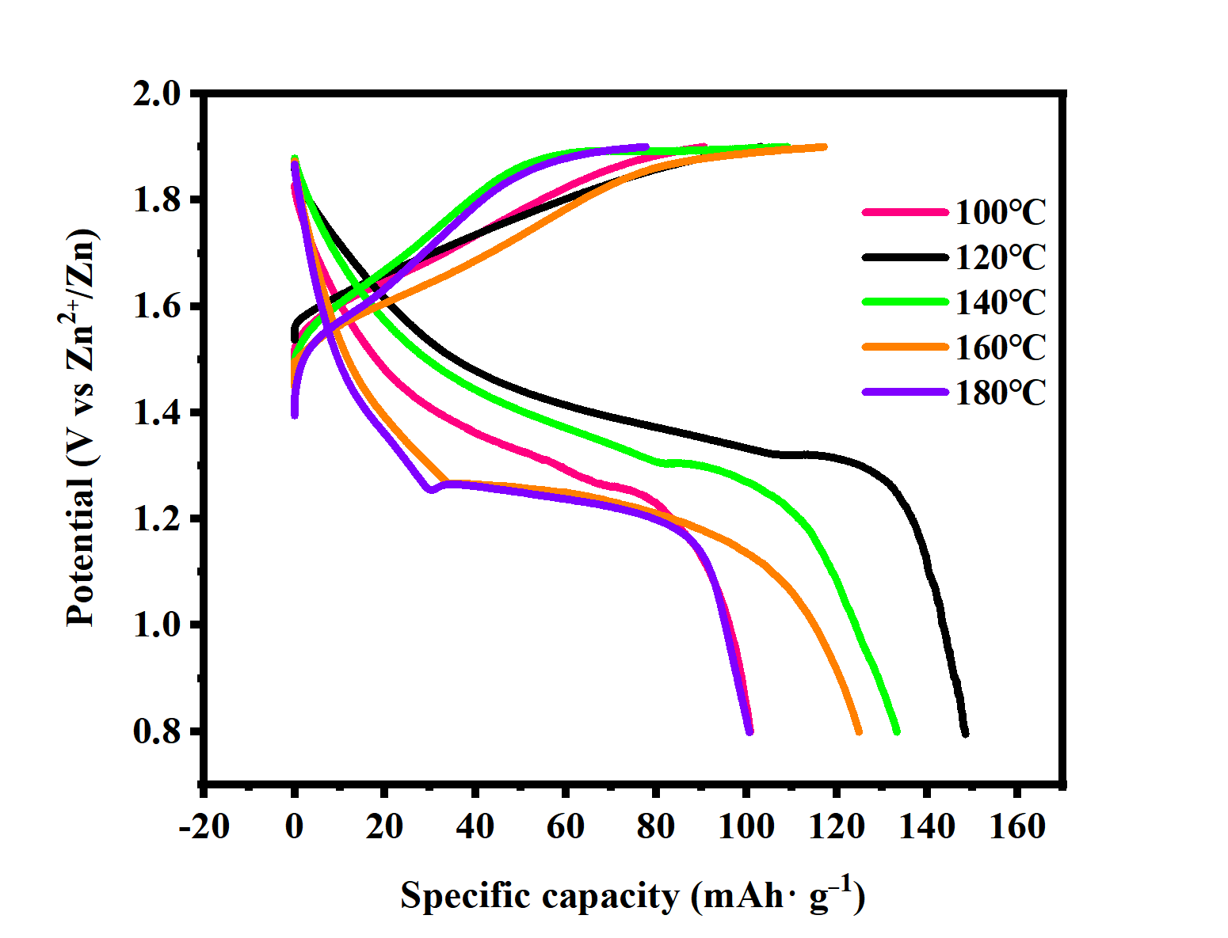 | 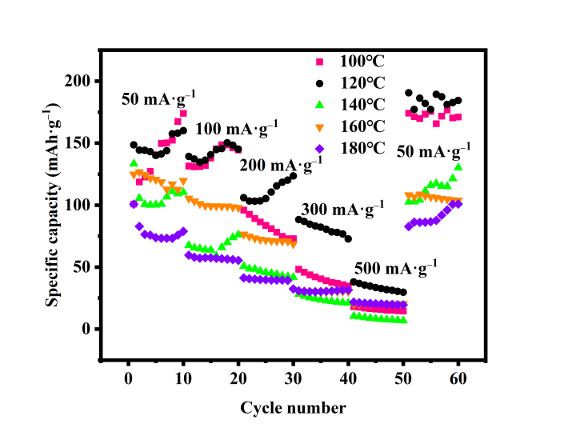
(c) | (d)
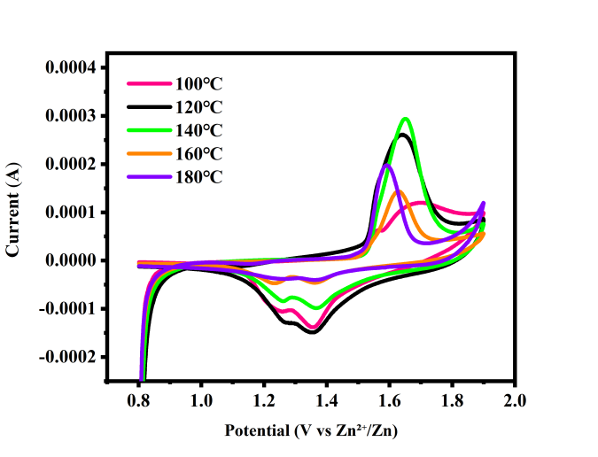 | 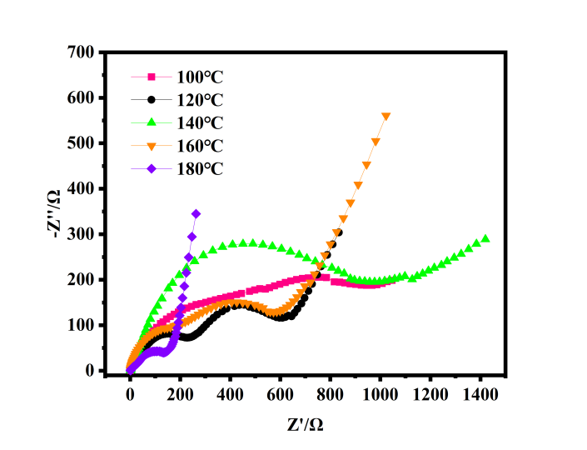
Figure 2. Electrochemical performance of MnO₂ materials synthesized at different hydrothermal temperatures. Initial charge-discharge diagram of MnO₂ materials synthesized at different hydrothermal temperatures (a), cyclic charge-discharge diagram of MnO₂ materials synthesized at different hydrothermal temperatures (b), cyclic voltammetry of MnO₂ materials synthesized at different hydrothermal temperatures (c) and electrochemical impedance spectroscopy of MnO₂ materials synthesized at different hydrothermal temperatures (d).

Table 3. The fitted kinetic parameters of MnO₂ materials synthesized at different hydrothermal temperatures obtained from EIS.
Hydrothermal temperatures | R_{s} (Ω) | Q (C_{f}) | R_{f} (Ω) | Q (C_{dl}) | R_{ct} (Ω) | W/Ω/s^{1/2}
100°C | 1.1 | 9.5×10⁻⁵ | 283.7 | 7.1×10⁻⁴ | 607 | 1.2×10⁻²
120°C | 1.8 | 7.3×10⁻⁵ | 309.4 | 4.8×10⁻⁴ | 147.7 | 9.8×10⁻³
140°C | 1.4 | 5.4×10⁻⁵ | 894.8 | 6.7×10⁻⁶ | 14.9 | 5.6×10⁻³
160°C | 1.2 | 2.2×10⁻⁴ | 368 | 1.5×10⁻⁵ | 166.6 | 5.3×10⁻³
180°C | 1.4 | 5.0×10⁻⁵ | 15.7 | 6.9×10⁻⁴ | 108.9 | 1.2×10⁻²

3.3 Electrochemical Properties of MnO₂ Materials Synthesized at Different Hydrothermal Time
Figure 3 illustrates the electrochemical performance of MnO₂ materials synthesized at a hydrothermal temperature of 120 °C under different hydrothermal durations. Figure 3(a) shows that the sample synthesized for 6 h exhibits the highest initial discharge capacity of 159.33 mAh·g⁻¹. Figure 3(b) presents the rate performance and cyclic charge–discharge behavior at different current densities, indicating that the materials synthesized for 6 h and 8 h maintain relatively stable electrochemical performance with negligible capacity decay. Notably, the MnO₂ material synthesized for 6 h, when the current density is restored to 50 mA·g⁻¹ after high-current discharge, achieves a capacity of up to 256 mAh·g⁻¹. This behavior suggests that the crystal structure undergoes gradual rearrangement and that the Zn²⁺ deintercalation channels are effectively broadened, resulting in a more stable lattice structure and enhanced electrochemical activation of the material after high-current cycling.
Figure 3(c) shows the cyclic voltammetry (CV) curves of MnO₂ materials synthesized at different hydrothermal durations. The enclosed areas of the oxidation and reduction peaks are larger for the materials synthesized for 6 h, 8 h, and 10 h, indicating that prolonged hydrothermal treatment enhances the peak symmetry and electrochemical reversibility. Figure 3(d) presents the electrochemical impedance spectroscopy (EIS) Nyquist plots of the materials synthesized at different hydrothermal times, with the corresponding fitting results summarized in Table 4. A combined analysis of Figure 3 and Table 4 reveals that the charge-transfer resistance (Rct) reaches its minimum at 6 h, indicating a facilitated Zn²⁺ deintercalation process, which results in a higher specific discharge capacity. The comprehensive analysis confirms that 6 h is the optimal hydrothermal duration, and the electrochemical stability of the MnO₂ materials synthesized under this condition surpasses that of samples prepared at other durations.
(b)
(a)
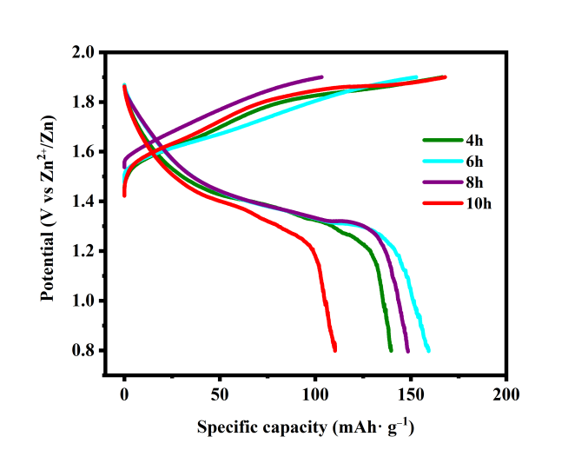 | 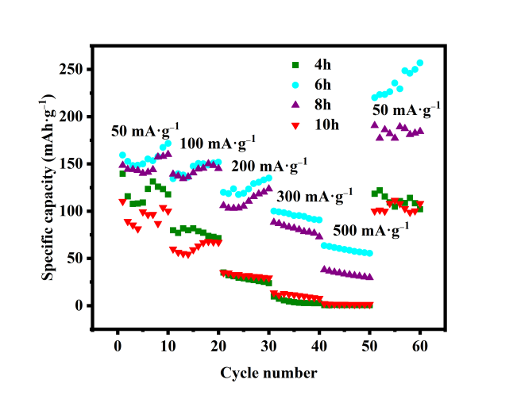
(c) | (d)
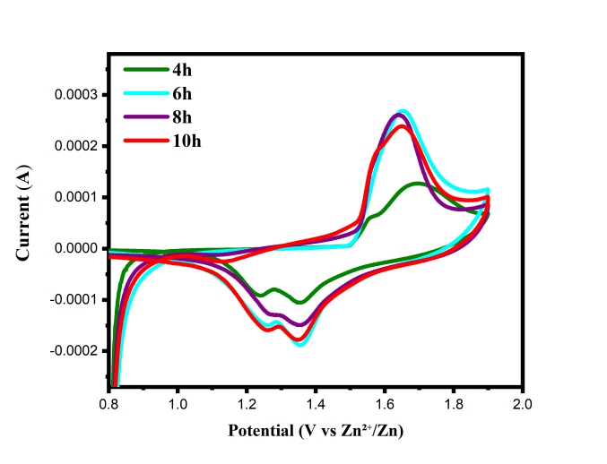 | 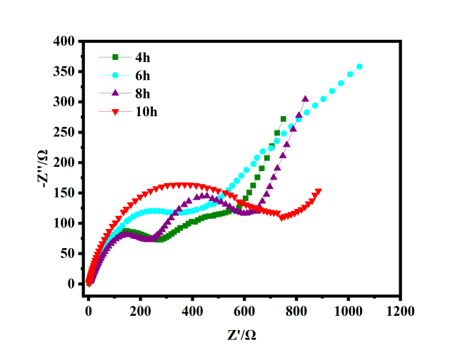

Figure 3. Electrochemical performance of MnO₂ materials synthesized at different hydrothermal times. Initial charge-discharge diagram of MnO₂ materials synthesized at different hydrothermal times (a), cyclic charge-discharge diagram of MnO₂ materials synthesized at different hydrothermal times (b), cyclic voltammetry of MnO₂ materials synthesized at different hydrothermal times (c) and electrochemical impedance spectroscopy of MnO₂ materials synthesized at different hydrothermal times (d).

Table 4. The fitted kinetic parameters of MnO₂ materials synthesized at different hydrothermal times obtained from EIS.
Hydrothermal times | R_{s}/(Ω) | Q(C_{f})(F) | R_{f}(Ω) | Q(C_{dl})(F) | R_{ct}(Ω) | W/Ω/s^{1/2}
4h | 2.4 | 3.2×10⁻⁵ | 242.7 | 9.9×10⁻⁴ | 310.8 | 1.1×10⁻²
6h | 1.0 | 1.2×10⁻⁴ | 229.4 | 2.1×10⁻³ | 82.1 | 2.4×10⁻⁴
8h | 1.8 | 7.3×10⁻⁵ | 309.4 | 4.8×10⁻⁴ | 147.7 | 9.8×10⁻³
10h | 2.0 | 7.5×10⁻⁵ | 232.4 | 3.5×10⁻⁴ | 491.5 | 1.6×10⁻²

3.4 Electrochemical Performance Test of MnO₂ Material Synthesized After High Temperature Calcination
Following the optimization of the manganese source and hydrothermal conditions, MnO₂ materials were synthesized at different hydrothermal temperatures and subsequently subjected to high-temperature calcination to evaluate the effect of calcination on their electrochemical properties. As shown in Figure 2, the MnO₂ materials exhibit relatively stable electrochemical performance at hydrothermal temperatures of 100 °C, 120 °C, 140 °C, and 160 °C, and these four temperatures were therefore selected for subsequent calcination treatment. After calcination at 400 °C for 5 h, the electrochemical performance of the MnO₂ materials was systematically evaluated. Figures 4(a) and 4(b) demonstrate that calcination leads to a noticeable decrease in discharge capacity and a more pronounced deterioration of cycling stability. Figure 4(c) shows that the potential separation between the oxidation and reduction peaks increases after calcination, indicating reduced electrochemical reversibility and inferior cycling stability. Furthermore, the analysis of Figure 4(d) and Table 5 indicates that calcination significantly increases both the interfacial resistance (Rf) and the charge-transfer resistance (Rct) of the MnO₂ materials, thereby severely impairing their electrochemical performance. Overall, high-temperature calcination fails to improve and instead degrades the electrochemical performance of the MnO₂ materials.

3.5 Physical Characterization of MnO₂ Material
Based on the analysis in the preceding sections, the optimal synthesis conditions for MnO₂ materials involve using Mn(CH₃COO)₂·4H₂O as the manganese source and conducting the hydrothermal reaction at 120 ℃ for 6 h. Subsequently, the MnO₂ material synthesized under these optimal conditions was subjected to detailed physical characterization. Figure 5 presents the XRD pattern of the MnO₂ material, which is in good agreement with the MnO₂ standard card (PDF#04-006-6397). Due to the absence of high-temperature calcination, the sample exhibits relatively low crystallinity. The diffraction peaks at 28.696°, 37.381°, 56.702°, and 67.299° correspond to the (110), (101), (211), and (310) crystal planes, respectively, and are consistent with the standard XRD pattern of MnO₂. No noticeable impurity peaks are detected, indicating the high phase purity of the synthesized MnO₂. The crystal structure schematic of MnO₂ is shown in Figure 6.

(b)
(a)

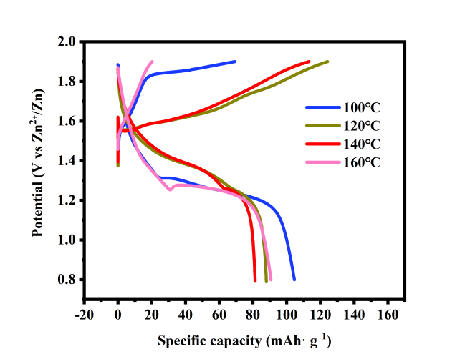 | 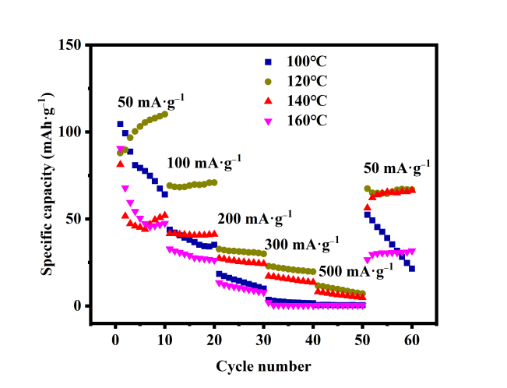
(c) | (d)
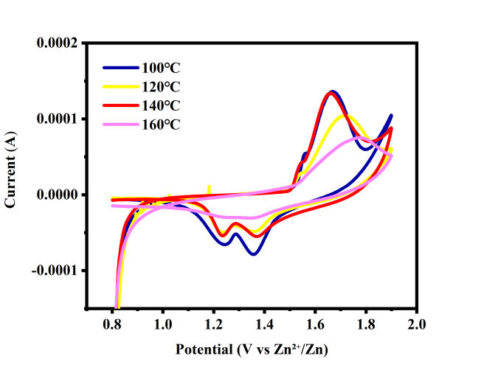 | 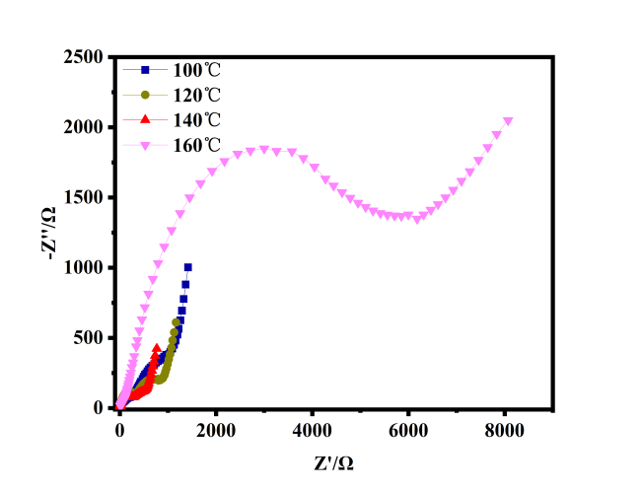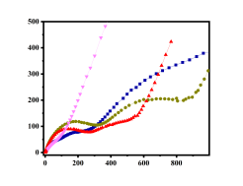
Figure 4. Electrochemical performance of MnO₂ materials synthesized by high temperature calcination at different hydrothermal temperatures. Initial charge-discharge diagram of MnO₂ materials synthesized by high temperature calcination at different hydrothermal temperatures (a), cyclic charge-discharge diagram of MnO₂ materials synthesized by high temperature calcination at different hydrothermal temperatures (b), cyclic voltammetry of MnO₂ materials synthesized by high temperature calcination at different hydrothermal temperatures (c) and electrochemical impedance spectroscopy of MnO2 materials synthesized by high temperature calcination at different hydrothermal temperatures (d).

Table 5. The fitted kinetic parameters of MnO₂ materials synthesized by high temperature calcination at different hydrothermal temperatures obtained from EIS.
Hydrothermal temperatures | R_{s}/(Ω) | Q(C_{f})(F) | R_{f}(Ω) | Q(C_{dl})(F) | R_{ct}(Ω) | W/Ω/s^{1/2}
100°C | 0.7 | 9.0×10⁻⁴ | 663.4 | 4.6×10⁻⁵ | 217.4 | 3.6×10⁻³
120°C | 2.0 | 5.0×10⁻⁴ | 423.6 | 1.5×10⁻⁵ | 306.5 | 5.5×10⁻³
140°C | 1.3 | 9.9×10⁻⁴ | 199 | 2.8×10⁻⁵ | 238.4 | 7.7×10⁻³
160°C | 1.7×10⁻⁹ | 2.0×10⁻⁵ | 3704 | 4.4×10⁻⁴ | 1.7×10³ | 3.1×10⁻⁵

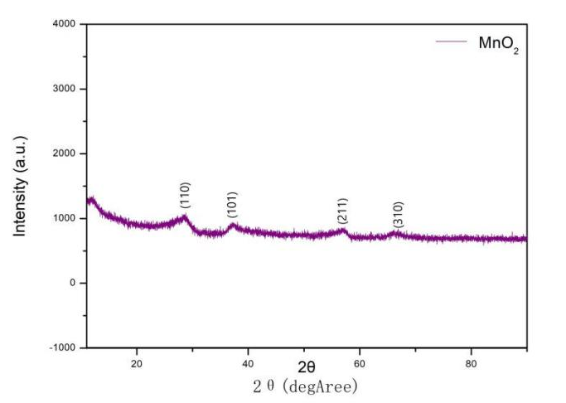
Figure 5. XRD pattern of MnO₂ material.

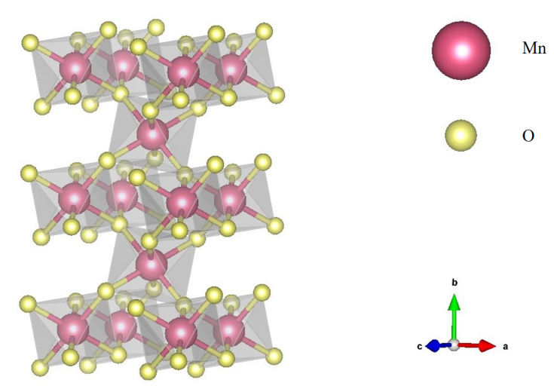

Figure 6. The crystal structure diagram of MnO₂.

Figure 7 shows the SEM image of the MnO₂ material synthesized by the hydrothermal method without high-temperature calcination. As can be seen from the figure, the MnO₂ material is composed of uniformly distributed spherical nanoparticles that are interconnected with each other. No severe agglomeration is observed, and the particles exhibit a cross-linked structure. The boundaries of the spherical particles are well defined, and the overall particle arrangement is relatively loose, with particles connecting and partially overlapping with one another. Smaller spherical particle sizes shorten the migration distance of Zn²⁺, because smaller primary particles effectively reduce the solid-phase diffusion length of ions. Moreover, enhanced contact between the particles and the electrolyte facilitates the migration and diffusion of Zn²⁺ in the material, thereby improving the capacity and rate performance. According to Figure 3, the MnO₂ material synthesized under this hydrothermal condition exhibits relatively stable discharge performance, and its capacity is higher than that of materials synthesized under other conditions, especially at high current densities. When the current density is returned to 50 mA·g⁻¹ after 50 charge–discharge cycles, the capacity is significantly increased. In addition, the spherical nanoparticle structure effectively increases the specific surface area of the material, and a higher surface area provides more active reaction sites for charge transfer. Meanwhile, the interparticle voids can accommodate a certain amount of electrolyte, providing additional ion transport channels for Zn²⁺ migration.
The variation of impedance is closely related to the microstructure and surface chemical state of the MnO₂ material in this paper. Specifically, the sample synthesized at 140°C for 6 hours exhibits the most desirable electrochemical interface characteristics, and its significantly lower R_{ct} value confirms superior charge transfer kinetics. This phenomenon can be primarily attributed to two distinct structural advantages. First, the ideal nanostructure formed under these conditions provides broad and accessible pathways for ion transport and charge distribution. Second, the in-situ generated defect-rich surface states serve as highly active sites, which not only effectively enhance the intrinsic conductivity of the material but also significantly reduce the energy barrier for Zn²⁺ insertion at the solid-phase interface, collectively promoting rapid and reversible electrochemical reactions.
In sharp contrast, the sample subjected to post-synthetic high-temperature calcination shows a significant increase in both R_{f} and R_{ct} values, directly revealing the negative impact of the calcination process on the material structure. First, the high-temperature treatment inevitably induces severe particle sintering and agglomeration, leading to a sharp decrease in specific surface area and the collapse of pore structures, which directly increases ion migration resistance within the electrode bulk and results in a notable rise in R_{f}. More critically, while calcination eliminates surface defects and functional groups, it is often accompanied by increased crystallinity and lattice "hardening". This structural change makes lattice relaxation more difficult, greatly hindering the kinetics of reversible Zn²⁺ insertion and extraction, thereby directly increasing the energy barrier of the charge transfer process, manifesting as a sharp rise in R_{ct}. In summary, this evidence clearly indicates that avoiding high-temperature calcination is crucial for preserving the intrinsic excellent kinetic performance of MnO₂ materials.
Figure 8 shows the EDS spectrum of the MnO₂ material. During the surface elemental scanning, the detected atomic ratio of Mn to O is approximately 1:2.34, which is close to the theoretical stoichiometric ratio of MnO₂. Furthermore, the elemental mapping results in Figure 9 demonstrate a uniform spatial distribution of Mn and O throughout the sample. Additional point-scan analysis further confirms that the Mn and O elemental proportions at different positions are consistent with the molecular formula, indicating a homogeneous elemental distribution at the microscopic scale.

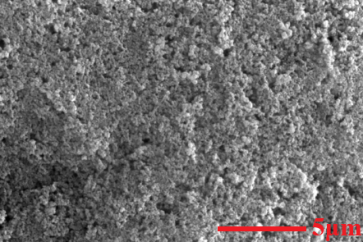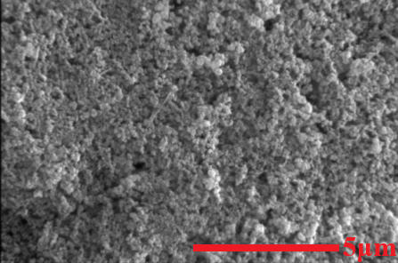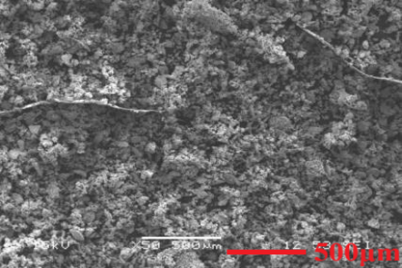
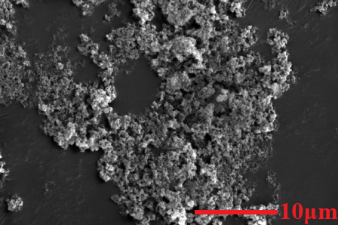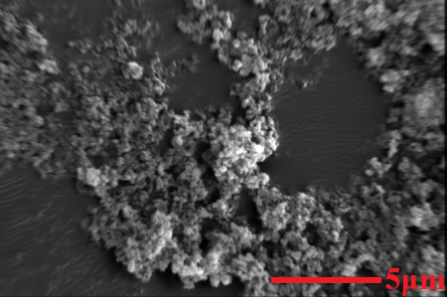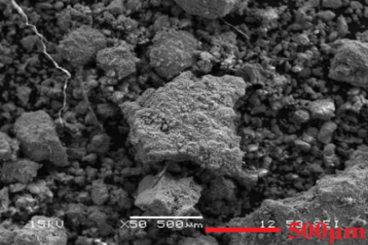

Figure 7. SEM image of MnO₂ material.

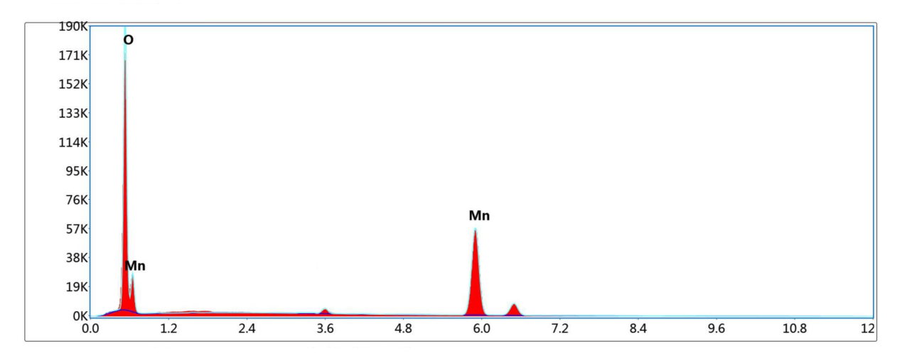

Figure 8. EDS diagram of MnO₂ material.

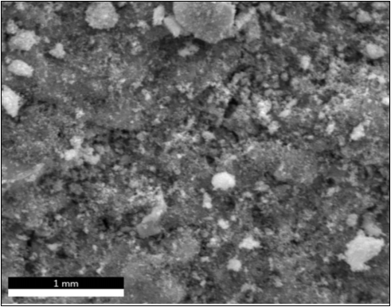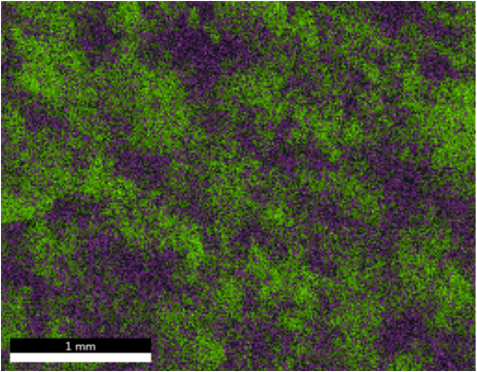
Mn，O

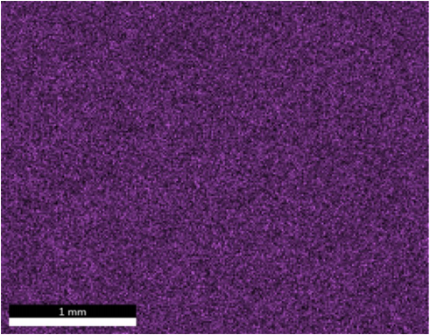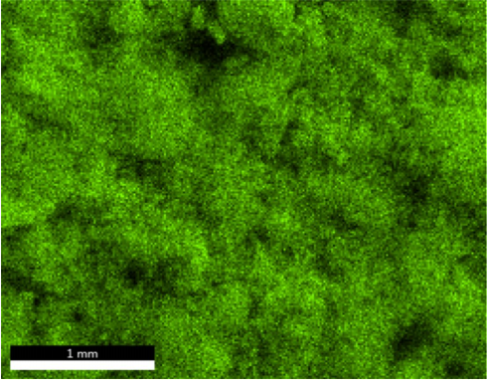
O
Mn

Figure 9. The element distribution diagram of MnO₂ material.

Figure 10 presents the transmission electron microscopy (TEM) image of the MnO₂ material, from which the microstructural features of the material can be clearly observed. TEM analysis demonstrates that the primary nanoparticles are interconnected with each other, and the overall structure is relatively loose. The individual particle size is in the nanoscale range. The interconnected nanoparticle network enables the particles to maintain continuous contact, while a certain amount of electrolyte can be retained within the interparticle spaces, which can facilitate charge transfer within the MnO₂ material and consequently enhance its electrochemical performance.
Figure 11 presents the X-ray photoelectron spectroscopy (XPS) spectrum of the MnO₂ material. Figures 11(a)–11(c) display the total XPS spectrum, the Mn 2p XPS spectrum, and the O 1s XPS spectrum, respectively. As shown in Figure 11(b), the electron binding energies of the Mn 2p₃/₂ and Mn 2p₁/₂ peaks are 642.76 eV and 654.45 eV, respectively, indicating that the oxidation state of the Mn element is +4. Figure 11(c) shows the XPS spectrum of O 1s, which is fitted with two peaks at 530.18 eV and 531.91 eV. The peak at 530.18 eV corresponds to the binding energy of Mn–O, indicating that the oxidation state of oxygen is -2. In conclusion, the valence states of the elements in the prepared material are consistent with those expected for MnO₂.

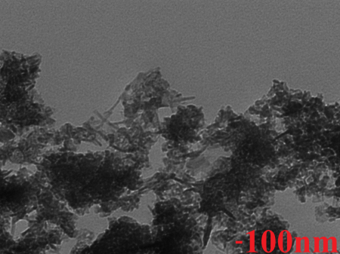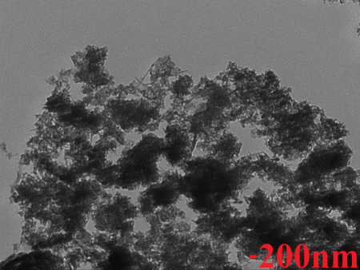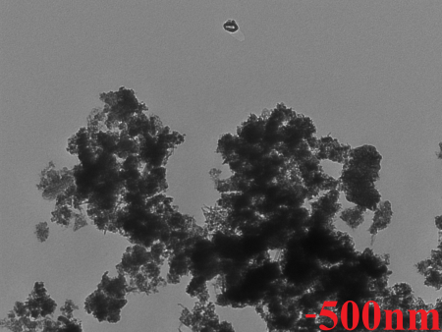
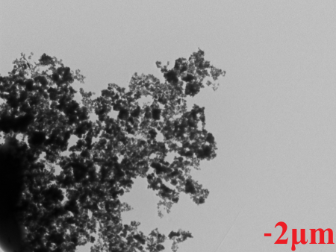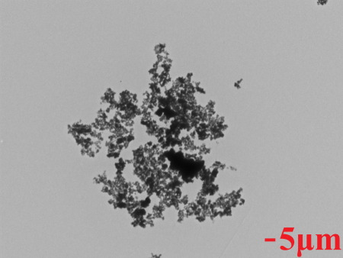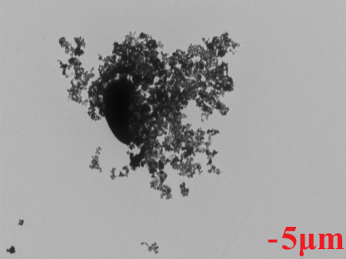

Figure 10. TEM diagram of MnO₂ material.

(c)
(b)
(a)
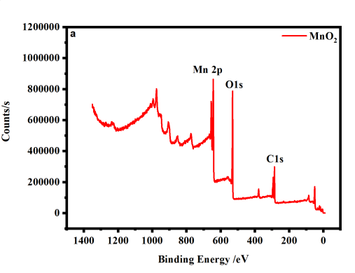 |  | 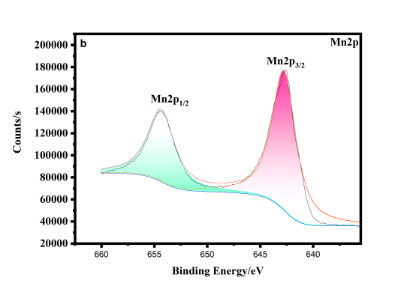 |  | 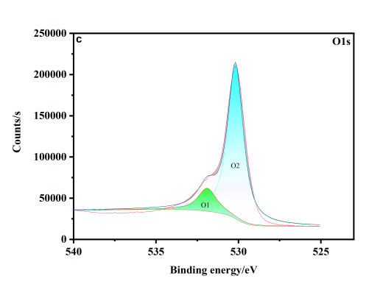
 | (a) X-ray photoelectron spectroscopy |  | (b) Mn 2p XPS diagram |  | (c) O 1s XPS diagram
Figure 11. XPS diagram of MnO₂ material. X-ray photoelectron spectroscopy (a), Mn 2p XPS diagram (b), O 1s XPS diagram (c)

Figure 12 presents the Fourier transform infrared (FTIR) spectrum of the MnO₂ material. Prior to the measurement, the sample was prepared by thoroughly mixing a small amount of MnO₂ powder with KBr and pressing the mixture into pellets. The FTIR test was conducted in the wavenumber range of 400–1000 cm⁻¹. The Mn–O bond stretching vibrations are the dominant features in MnO₂, corresponding to the observed absorption peaks at 500 cm⁻¹ and 732 cm⁻¹ [43]. Overall, the comprehensive analysis indicates that MnO₂ with relatively stable electrochemical performance has been successfully synthesized via the hydrothermal method.

Figure 12. Infrared spectrogram of MnO₂ material.

4. CONCLUSIONS
In this paper, the MnO₂ material was synthesized by the hydrothermal method. Through the optimization of the manganese source, hydrothermal temperature, and reaction time, combined with the analysis of electrochemical tests, it can be seen that the synthesized MnO₂ material exhibits stable electrochemical performance when Mn(CH₃COO)₂·4H₂O is used as the manganese source and the hydrothermal reaction is carried out for 6 hours at 120 °C. The material synthesized under this condition reaches a discharge capacity of up to 256 mA·g⁻¹ when the current density is returned to 50 mA·g⁻¹ after high-current discharge. In the CV diagram of MnO₂ materials synthesized under this condition, the oxidation and reduction peaks are more symmetric than those of materials synthesized under other conditions.
Subsequently, the MnO₂ materials synthesized at different hydrothermal temperatures were subjected to high-temperature calcination, and it was found that the electrochemical performance did not improve after calcination. XRD analysis shows that, although the material was not calcined at high temperature, its crystallinity remains relatively low, and no obvious impurities are observed. According to SEM analysis, the MnO₂ material is crosslinked by small spherical nanoparticles with uniform particle size, which can shorten the migration distance of Zn²⁺. At the same time, increased contact between the particles and the electrolyte facilitates the movement and diffusion of Zn²⁺ within the material, thereby improving the specific capacity and rate performance. EDS analysis shows that all elements are evenly distributed at the microscopic level. Overall, comprehensive analysis indicates that MnO₂ with stable electrochemical performance has been synthesized.

AUTHOR CONTRIBUTIONS
Chen Liang and Ling Li: Conceptualization, Methodology, Resources, Project administration. Jiyao Zhou: Data curation, Writing - Original draft preparation. Wei Huang: Visualization, Investigation. Xinbin Pei and Ling Li: Supervision, Funding acquisition. Ling Li and Jiyao Zhou: Software, Validation. Ling Li and Jiyao Zhou: Formal analysis, Writing- Reviewing and Editing.

CONFLICT OF INTEREST STATEMENT
The author(s) declared no potential conﬂicts of interest with respect to the research, author- ship, and/or publication of this article.

DECLARATION OF USE OF GENERATIVE AI
During the preparation of this manuscript, the authors used Deepseek in order to translate. All the authors reviewed and edited the manuscript accordingly and take full responsibility for its content.

FUNDING
This study is sponsored by Science and Technology Project of Henan Province (Foundation No. 252102240005).
This study is sponsored by Henan Provincial Higher Education Institutions' Key Research Project (Foundation No. 26A150001).

REFERENCES
[1] Suttison S., Thongrit P., Thammarong S., Pengpat K., Intatha U., Fan J., et al., Effect of NMC-doping concentration on the structural feature and electrical properties of lithium iron phosphate cathode for use in lithium-ion batteries. Chiang Mai Journal of Science, 2024; 51(4): e2024064. DOI 10.12982/CMJS.2024.064.
[2] Huang Z., Chen Y. and Zhou M., Soc estimation of Li-ion battery based on adaptive CKF algorithm. Chiang Mai Journal of Science, 2023; 50(6): e2023063. DOI 10.12982/CMJS.2023.063.
[3] Mao X., Sulfonated poly(ether sulfone)/ short-carboxylic multi-walled carbon nanotube composite membrane for vanadium redox flow battery. Chiang Mai Journal of Science, 2019; 46(1): 144-151.
[4] Thungprasert S., Sarakonsri T. and Tunkasiri T., Electron microscopy study of the formation of dendrite Cu₆Sn₅ powders synthesized by solution route method. Chiang Mai Journal of Science, 2007; 34(1): 29-33.
[5] Sarakonsri T., Aamchikad T. and Tunkasiri T., Processing parameters study on solution route synthesis of dendrite Cu. Chiang Mai Journal of Science, 2006; 33(3): 321-326.
[6] Sarakonsri T., Choksawatpinyo K., Seraphin S. and Tunkasiri T., Solution route preparation and characterization of dendrite InSb powders, anode material for lithium-ion batteries. Chiang Mai Journal of Science, 2006, 33(1): 79-83.
[7] Deiner L., Jenkins T., Powell A., Howell T. and Rottmayer M., High capacity rate capable aerosol jet printed Li‐ion battery cathode. Advanced Engineering Materials, 2019; 21(5): 1801281. DOI 10.1002/adem.201801281.
[8] Kang K., Meng Y., Breger J., Grey C. and Ceder G., Electrodes with high power and high capacity for rechargeable lithium batteries. Science, 2006; 311(5763): 977-980. DOI 10.1126/science.1122152.
[9] Goodenough J. and Kim Y., Challenges for rechargeable Li batteries. Chemistry of Materials, 2010; 22(3): 587-603. DOI 10.1021/cm901452z.
[10] Zhang X., Li J., Ao H., Liu D., Shi L., Wang C., et al., Appropriately hydrophilic/hydrophobic cathode enables high-performance aqueous zinc-ion batteries. Energy Storage Materials, 2020; 30: 337-345. DOI 10.1016/j.ensm.2020.05.021.
[11] Huang J., Zeng J., Zhu K., Zhang R. and Liu J., High-performance aqueous zinc–manganese battery with reversible Mn²⁺/Mn⁴⁺ double redox achieved by carbon coated MnO_{x} nanoparticles. Nano-Micro Letters, 2020; 12: 1-12. DOI 10.1007/s40820-020-00445-x.
[12] Zhang T., Tang Y., Guo S., Cao X., Pan A., Fang G., et al, Fundamentals and perspectives in developing zinc-ion battery electrolytes: A comprehensive review. Energy & Environmental Science, 2020; 13(12): 4625-4665. DOI 10.1039/D0EE02620D.
[13] Xu W. and Wang Y., Recent progress on zinc-ion rechargeable batteries. Nano-Micro Letters, 2019; 11(1): 1-30. DOI 10.1007/s40820-019-0322-9.
[14] Li C., Zhang X., He W., Xu G. and Sun R., Cathode materials for rechargeable zinc-ionbatteries: From synthesis to mechanism and applications. Journal of Power Sources, 2020; 449: 227596. DOI 10.1016/j.jpowsour.2019.227596.
[15] Li L., Zhou J., Pei X. and Zhang Y., Electrochemical properties and characterization of manganese doped ZnMn_{1-y}X_{y}O₄ material with conjoined spherical particle as cathode of zinc ion battery. Journal of Energy Storage, 2023; 71: 108238. DOI 10.1016/j.est.2023.108238.
[16] Li L., Zhou J. and Pei X., Preparation of magnesium carbonate and manganese carbonate composite materials doped at manganese site by hydrothermal method and study of Co doping effect. Ionics, 2024; 30(1): 247-260. DOI 10.1007/s11581-023-05249-8.
[17] Li L., Zhou J., Huang W., Pei X., Zheng Y. and Wei J., Effect of magnesium site doping on electrochemical properties of Mg-Mn composite materials and application of carpet-like sheets composite formed by Cr doping in aqueous zinc-ion batteries. Journal of The Electrochemical Society, 2024; 171(2): 020538. DOI 10.1149/1945-7111/ad28d8.
[18] Li L., Zhou J., Huang W., Pei X., Zheng Y. and Wei J., Hydrothermal synthesis of three-dimensional snowflake-like MgCO₃@ MnCO₃@ Mn₃N₂ composite materials and their application in aqueous zinc-ion battery cathodes. Journal of Alloys and Compounds, 2024; 1008: 176807. DOI 10.1016/j.jallcom.2024.176807.
[19] Li L., Zhang Y., Zhou J., Huang W., Liu C., Zhu H., et al., The performance study of nanosheet-like VO₂@ MnCO₃@ Mn₃N₂ composite material as the cathode material for aqueous zinc-ion batteries. Journal of Materials Science: Materials in Electronics, 2025; 36(2): 97. DOI 10.1007/s10854-024-14163-2.
[20] Blanc L., Kundu D. and Nazar L., Scientific challenges for the implementation of Zn-ion batteries. Joule, 2020; 4(4): 771-799. DOI 10.1016/j.joule.2020.03.002.
[21] Shi W., Lee W. and Xue J., Recent development of Mn-based oxides as zinc-ion battery cathode. Chemistry Sustainability Energy Material, 2021; 14: 1-26. DOI 10.1002/cssc.202002493.
[22] Chen K., Sun C. and Xue D., Morphology engineering of high performance binary oxide electrodes. Physical Chemistry Chemical Physics, 2015; 17(2):732-750. DOI 10.1039/C4CP03888F.
[23] Dhiman A. and Ivey D., Electrodeposited manganese oxide on carbon paper for zinc‐ion battery cathodes. Batteries & Supercaps, 2020; 3(3): 293-305. DOI 10.1002/batt.201900150.
[24] Zhang N., Cheng F., Liu J., Wang L., Long X., Li F., et al., Rechargeable aqueous zinc-manganese dioxide batteries with high energy and power densities. Nature Communications, 2017; 8(1): 405. DOI 10.1038/s41467-017-00467-x.
[25] Alfruqi M., Mathew V., Gim J., Kim S., Song J., Baboo J., et al., Electrochemically induced structural transformation in a γ-MnO₂ cathode of a high capacity zinc-ion battery system. Chemistry of Materials, 2015; 27(10): 3609-3620. DOI 10.1021/cm504717p.
[26] Wu B., Zhang G., Yan M., Xiong T., He P., Xu X., et al., Graphene scroll-coated α-MnO₂ nanowires as high-performance cathode materials for aqueous Zn-ion battery. Small, 2018; 14(13): 1703850. DOI 10.1002/smll.201703850.
[27] Xie C., Yan D., Chen W., Zou Y., Chen R., Zang S., et al., Insight into the design of defect electrocatalysts: From electronic structure to adsorption energy. Materials Today, 2019; 31: 47-68. DOI 10.1016/j.mattod.2019.05.021.
[28] Yang S., Zhang L., Luo M., Cui Y., Wang J., Zhao D., et al., Synergistic combination of a Co-doped σ-MnO₂ cathode with an electrolyte additive for a high-performance aqueous zinc-ion battery. ChemPhysMater, 2023; 2(1): 77-82. DOI 10.1016/j.chphma.2022.04.007.
[29] Huang L., Yi L., Chen Y., Wu Y., Hu Y., Luo X., et al., Enhanced electrochemical performance of MnO₂ by high oxidation state vanadium(V) doping. Journal of Alloys and Compounds, 2023, 946: 169386. DOI 10.1016/j.jallcom.2023.169386.
[30] Jiang J., Xu T., Lu J., Sun L. and Ni Z., Defect engineering in 2D materials: Precise manipulation an improved functionalities. Research, 2019; 2019: 4641739. DOI 10.34133/2019/4641739.
[31] Zhang M., Wu W., Luo J., Zhang H., Liu J., Liu X., et al., A high-energy-density aqueous zinc-manganese battery with a La-Ca co-doped ε-MnO₂ cathode, Journal of Materials Chemistry A, 2020; 8(23): 11642-11648. https://doi.org/10.1039/D0TA03706K.
[32] Song Y., Li J., Qiao R., Dai X., Jing W., Song J., et al., Binder-free flexible zinc-ion batteries: One-step potentiostatic electrodeposition strategy derived Ce doped-MnO₂ cathode. Chemical Engineering Journal, 2022; 431: 133387. DOI 10.1016/j.cej.2021.133387.
[33] Xie D., Wang Y., Tian L., Huang H., Sun J., Kim D., et al., Dual-functional Ca-ion-doped layered δ-MnO₂ cathode for high-performance aqueous zinc-ion batteries. Advanced Functional Materials, 2025; 35(4): 2413993. DOI 10.1002/adfm.202413993.
[34] Yang S. and Zhang L., Recent progress and perspectives on energy storage mechanisms for rechargeable Zn/MnO₂ batteries. Chemical Engineering Journal, 2025; 506(15): 160086. DOI 10.1016/j.cej.2025.160086.
[35] Yuan Y., Zhao Z., Bi H., Zhang R., Wang X., Qiu J., A B,N co-doped carbon nanotube array with anchored MnO₂ nanosheets as a flexible cathode for aqueous zinc-ion batteries. New Carbon Materials, 2025; 40(1): 200-210. DOI 10.1016/S1872-5805(25)60945-0.
[36] Liu H., Wang C., Kong F., Lu C., Tao S. and Qian B., Multiwalled carbon nanotubes decorated ɛ-MnO₂ nanoflowers cathode with oxygen defect for aqueous zinc-ion batteries. Journal of Electroanalytical Chemistry, 2024; 973(15): 118701. DOI 10.1016/j.jelechem.2024.118701.
[37] Zhao Y., Zhang Y., Ma X., Su A., Chen Z. and Zhang X., Vanadium dopant induced the small and low crystallinity layered MnO₂ supported on the carbon Nanosheets for high-performance aqueous zinc-ion batteries, Journal of Colloid and Interface Science, 2025; 703: 139152. DOI 10.1016/j.jcis.2025.139152.
[38] Xu C., Chiang S., Ma J. and Kang F., Investigation on zinc ion storage in alpha manganese dioxide for zinc ion battery by electrochemical impedance spectrum. Journal of The Electrochemical Society, 2012; 160(1): A93. DOI 10.1149/2.008302jes.
[39] Liu M., Zhao Q., Liu H., Yang J., Chen X., Yang L., et al., Tuning phase evolution of β-MnO₂ during microwave hydrothermal synthesis for high-performance aqueous Zn ion battery. Nano Energy, 2019; 64: 103942. DOI 10.1016/j.nanoen.2019.103942.
[40 Wu B., Zhang G., Yan M., Xiong T., He P., Xu X., et al., Graphene scroll-coated α-MnO₂ nanowires as high-performance cathode materials for aqueous Zn-ion battery. Small, 2018; 14(13): 1703850. DOI 10.1002/smll.201703850.
[41] Li D., Gao Q., Zhang H., Wang Y., Liu W., Ren M., et al., MnO₂ particles grown on the surface of N-doped hollow porous carbon nanospheres for aqueous rechargeable zinc ion batteries. Applied Surface Science, 2020; 510(30): 145458. DOI 10.1016/j.apsusc.2020.145458.
[42] Xiong T., Yu Z., Wu H., Du Y., Xie Q., Chen J., et al., Defect engineering of oxygen‐deficient manganese oxide to achieve high‐performing aqueous zinc ion battery. Advanced Energy Materials, 2019; 9(14): 1803815. DOI 10.1002/aenm.201803815.
[43] Kang L., Zhang M., Liu Z. and Ooi K., IR spectra of manganeseoxides with either layered or tunnel structures. Spectrochim Acta A, 2007; 67(3-4): 864. DOI 10.1016/j.saa.2006.09.001.

