

DEPARTMENT OF COMPUTER SCIENCE
FACULTY OF COMPUTING
UNIVERSITI TEKNOLOGI MALAYSIA
SECP3843-01 - SPECIAL TOPIC IN DATA ENGINEERING
-------------------------------------------------------------------------------------------------------
INDIVIDUAL PROJECT
-------------------------------------------------------------------------------------------------------

NAME | MATRIC NO
RICHARD YONATHAN JULIO CLAY HENG | X25EC3019

PREPARED FOR:
DR. ARYATI BINTI BAKRI
Table of Contents
Abstract
1. Introduction
1.1 Business Domain & Problem Identification
1.2 Objectives
1.3 Risk Analysis & Mitigation Plan
2. Literature Review
3. Methodology
3.1 Methodology Selection & Justification
3.2 Data Source Identification
3.3 Data Ingestion, Cleansing & Processing
3.4 Data Storage & Justification
3.5 AI Algorithm Integration
4. System Design & Architecture
4.1 Use Case Diagram Description
4.2 System Architecture (ETL & Storage Flow)
4.3 Database & Multidimensional Schema (Star Schema)
4.4 Main Interface & Analytical Dashboard Design
4.5 Testing & Validation Strategy
5. Conclusion
Appendix A: Project Timeline
Appendix B: Generative AI Use Log
References

Abstract
Agentic AI systems are starting to handle decisions that used to be made only by humans, from routing customer requests to prioritising operational incidents. Yet many organisations still rely on scattered logs and gut feeling to decide whether these agents are actually helping. This project tackles that gap by building a data pipeline that turns raw telemetry into clear performance evidence for leadership. Using Apache Spark and the Medallion architecture pattern (Bronze, Silver, Gold), the pipeline combines four data sources: a CSV dataset with 5,500 organisational records, JSON-based industry benchmarks, system execution logs, and OpenAlex academic citation data. The Silver layer focuses on data quality, applying industry-specific median imputation, schema standardisation, feature engineering, and regex-based NLP to map research papers to relevant business sectors. In the Gold layer, two machine learning models are deployed: a K-Means clustering model that groups organisations into performance tiers (Silhouette score 0.5276), and a tuned multiclass Logistic Regression model that predicts productivity categories with an accuracy of 55.44% and F1 of 46.59%. To avoid data leakage, clustering features are kept separate from the classifier inputs. The final pipeline produces repeatable, data-backed performance profiles that help leadership teams move away from anecdotal impressions and toward measurable, transparent evaluations of their Agentic AI systems.

1. Introduction
Over the last few years, Agentic AI has moved from research labs into everyday business operations. Instead of simply following predefined rules, these systems can plan tasks, call external tools and APIs, and adjust their behaviour based on feedback. Organisations now use them to triage customer emails, monitor infrastructure, support financial reviews, and coordinate internal workflows. On paper, this should reduce costs and speed up decisions. In practice, many leadership teams still struggle to answer a basic question: is our AI actually performing well?
The problem is not a lack of data, but a lack of structure. Execution logs live in text files. Operational metrics are exported as CSVs from dashboards. Industry benchmarks are only available through APIs, and academic evidence around AI trustworthiness is buried in external datasets like OpenAlex. Each source uses its own schema and naming conventions. Without a unified pipeline that can clean, align, and connect these signals, decision-makers are left comparing numbers manually or relying on subjective impressions. This makes it difficult to track performance over time, spot anomalies early, or justify further investment in Agentic AI.
This project responds to that situation by designing and implementing a Spark-based data pipeline specifically tailored to Agentic AI evaluation. The pipeline follows the Medallion architecture, with a Bronze layer that ingests raw data, a Silver layer that enforces data quality and integration, and a Gold layer that applies machine learning. The end goal is not only to build a technically sound pipeline, but to give leadership teams performance profiles they can read, question, and use in real decisions about how, where, and whether to scale their Agentic AI deployments.

1.1 Business Domain & Problem Identification
This project focuses on the Professional Services sector, which includes consulting firms, legal practices, IT service providers, and financial advisory organisations. These businesses run on expertise. Much of their value comes from how quickly and accurately they can interpret information, respond to clients, and manage risk. Because of this, they are early adopters of technologies that promise to augment human judgement rather than replace it entirely. Agentic AI fits naturally into this picture. It is being used to review documents, screen contracts, prioritise client queries, suggest data-driven recommendations, and automate routine operational tasks.
When these systems work well, they can free consultants and analysts from repetitive work and allow them to focus on higher-value activities. However, the same autonomy that makes Agentic AI attractive also makes it harder to oversee. Leaders need to know whether agents are completing tasks reliably, how their behaviour differs across industries and use cases, and whether gains in productivity come at the cost of trust or stability. At the moment, there is no standard way for Professional Services firms to answer these questions. Telemetry is often stored in separate tools, logs, and exports, with no consistent schema or shared view.
The core problem addressed in this project is therefore not just collecting data, but building a coherent data engineering framework around it. The goal is to bring together organisational context, agent configuration, operational metrics, benchmark baselines, and research signals into a single pipeline. Once this data is integrated and cleaned, it becomes possible to create performance profiles that show, for example, how leadership trust correlates with task success rates or how different agent types behave under similar workloads. This, in turn, gives Professional Services organisations a concrete basis for evaluating and governing their Agentic AI deployments.

1.2 Objectives
The primary objective is to build a Spark-based data pipeline that turns fragmented Agentic AI telemetry into structured, analysable performance profiles. More specifically, the project aims to:
1. Build a Medallion-structured pipeline (Bronze, Silver, Gold) that ingests four heterogeneous sources: a 5,500-record CSV dataset, JSON benchmarks, system logs, and OpenAlex citation data.
2. Implement automated cleansing using Spark UDFs and window functions, including industry-specific median imputation, deduplication, type standardisation, derived feature engineering, and regex-based NLP mapping of academic papers to business sectors.
3. Deploy and validate a K-Means clustering model and a tuned Logistic Regression classifier, ensuring strict feature isolation between the two to prevent data leakage, and export the best model as a serialised production-ready artifact.

1.3 Project Risk Analysis & Mitigation Plan
Any data engineering project carries execution risks. Identifying them early means building mitigations into the architecture rather than patching them later.
Data Quality & Schema Drift | Impact: High  Probability: Medium | Median-based imputation for missing numericals; automated PySpark unit tests to validate schema integrity before Gold layer load.
Compute Limitations | Impact: High  Probability: High | Running on 1.9GB RAM. Mitigated by tuning Spark partition counts, avoiding Python UDFs to prevent serialization overhead, and writing in batch chunks.
Stakeholder Alignment | Impact: Medium  Probability: Low | Validating unsupervised clustering results (Silhouette Score) against leadership trust metrics ensures ML outputs map to business KPIs.

2. Literature Review
A data pipeline automates the movement of data from source systems through transformation steps and into storage for analysis. Traditionally, organisations relied on relational Data Warehouses, which offer strong transactional guarantees but are expensive to scale and poorly suited to semi-structured logs. Data Lakes provide cheap raw storage but lack ACID support and degrade under direct queries. The Data Lakehouse emerged as a middle ground: Parquet-formatted storage on commodity infrastructure, queried by engines like Apache Spark for both SQL analytics and machine learning (Armbrust et al., 2021).
Three studies underpin this work. Armbrust et al. (2021) showed that Lakehouse architecture reduces data duplication and keeps a single source of truth for both dashboards and ML workloads. Zaharia et al. (2016) proved that Spark's in-memory processing handles complex joins across massive datasets, which is exactly the requirement for integrating scattered Agentic AI logs. Recent AI governance research highlights the importance of combining system telemetry with external baselines, such as OpenAlex citation data, to measure trust in autonomous agents (Priem et al., 2022). By synthesizing these three perspectives—scalable Lakehouse storage, high-performance in-memory processing, and external baseline validation—this project defines a unified data framework that not only stores AI logs efficiently but also maps them against academic trust metrics in a single analytical pipeline.

3. Methodology
This section explains how the pipeline was designed, built, and validated. A clear methodology ensures the project stays focused, reproducible, and aligned with its objectives. We cover the project framework, the four data sources, the ETL process, storage rationale, and the ML models in the Gold layer.
The pipeline follows the Medallion Architecture pattern. Bronze stores raw data unchanged. Silver cleans and integrates it. Gold applies analytics and machine learning. This separation keeps the code modular, handles bad data incrementally, and is standard practice in modern data engineering. The overall project lifecycle is managed using CRISP-DM.

3.1 Methodology Selection & Justification
CRISP-DM was chosen because it is the most widely adopted framework for data mining projects, offering a structured yet flexible lifecycle. The six phases map directly to this project: Business Understanding covers the problem statement in Section 1; Data Understanding and Data Preparation map to Bronze and Silver layer processing; Modeling and Evaluation correspond to Gold layer analytics. The iterative nature of CRISP-DM is particularly valuable when integrating diverse sources with different schemas and quality profiles—the preparation and modeling stages naturally inform each other.

3.2 Data Source Identification
Four data sources capture the full operational context of Agentic AI deployments. They represent the three main categories organisations typically deal with: internal structured records, external benchmarks, system-level telemetry, and academic research context.
S1 | Agentic AI Leadership Dataset | CSV | 5,500 organisational records with autonomy levels, task success rates, and leadership trust scores.
S2 | External Leadership Benchmarks | JSON | Industry baseline targets for task success and productivity thresholds.
S3 | Agent Execution Logs | CSV | Granular system logs: CPU, memory, timestamps, response times, error counts.
S4 | OpenAlex Academic Publications | API JSON | 25 scholarly publication records with citation counts and title keywords.

Source S1 is the primary input: 5,500 CSV records, each representing one organisation’s experience with an Agentic AI deployment. The 15 columns span organisational context (Record_ID, Organization_Name, Industry, Organization_Size, AI_Maturity_Level), agent configuration (Agent_Type, Use_Case_Area, Agent_Autonomy_Level, Decision_Making_Type, Context_Awareness_Score), and performance metrics (Task_Success_Rate, Productivity_Improvement_Percent, Response_Time_Seconds, Complexity_Score, Leadership_Trust_Score). Together they provide the multi-dimensional view needed for both clustering and classification in the Gold layer.

3.3 Data Ingestion, Cleansing & Processing
Ingestion starts at the Bronze layer. CSV files are read with header inference and schema enforcement. JSON files are parsed with multi-line support for nested structures. The OpenAlex API response is consumed as standard JSON. Each ingested dataset is stamped with an ingestion timestamp and source identifier before being written to partitioned Parquet files.
The Silver layer then cleans the data systematically. Duplicates are removed based on Record_ID. Numeric columns are cast to appropriate Spark types. Text fields are lowercased for consistency. Missing values are imputed using the per-industry median—this preserves industry-specific distributions rather than applying a global average that could bias results. Execution log data is joined on Record_ID to derive efficiency features like Memory_Per_Message_MB. Finally, OpenAlex paper titles are processed through a regex NLP classifier that maps each publication to a business sector, and average citation counts per sector are joined to the organisational records.

3.4 Data Storage & Justification
All data is stored in Apache Parquet across three Medallion layers. Parquet’s columnar layout enables predicate pushdown and column projection during Spark SQL queries, reducing I/O. Dictionary encoding compresses repetitive strings. Schema enforcement prevents silent corruption. These characteristics make Parquet the industry standard for Lakehouse implementations.

3.5 AI Algorithm Integration
The Gold layer deploys two ML models from PySpark MLlib. The first is unsupervised K-Means clustering, configured with k=3 clusters and 20 max iterations, operating on three normalised features: Task_Success_Rate, Productivity_Improvement_Percent, and Leadership_Trust_Score. These are assembled via VectorAssembler and standardised via StandardScaler. The Silhouette score of 0.5276 confirms moderate cluster separation, producing three distinguishable performance tiers: High, Average, and Low Performer.
The second model is a supervised multiclass Logistic Regression classifier. It predicts Productivity_Category using exclusively system-level features: Context_Awareness_Score, Response_Time_Seconds, Task_Complexity_Score, Memory_Per_Message_MB, and CPU_Utilization_Percent. These features intentionally exclude clustering metrics to prevent data leakage. The model is tuned using CrossValidator with 3-fold CV over a regParam/elasticNetParam grid. The best model achieves 55.44% accuracy, 46.59% F1, 40.34% precision, and 55.44% recall. It is serialised and exported to the Gold output directory for production use.

4. System Design & Architecture
The pipeline’s architecture must handle the full lifecycle of Agentic AI telemetry: from raw, scattered data sources to a structured multidimensional schema. Apache Spark was chosen as the core engine because its distributed in-memory processing eliminates the Out-Of-Memory issues that single-node tools like Pandas hit when joining large execution logs with external JSON API responses.
This chapter covers five components: the Use Case diagram, the ETL data flow, the Star Schema database design, the analytical dashboard interface, and the testing strategy that guards against data leakage between K-Means clustering and Logistic Regression classification.

4.1 Use Case Diagram Description
Two actors interact with the system. The Data Engineer initiates pipeline execution, monitors processing status across all three Medallion layers, inspects logs for errors, and triggers reprocessing when data quality issues arise. The Data Analyst works with Gold layer outputs: running business intelligence queries, examining clustering profiles, evaluating classification predictions, and building visualisation dashboards for leadership reporting. The ML models run automatically as part of the pipeline, retraining on each fresh data batch and updating the serialised artifact.
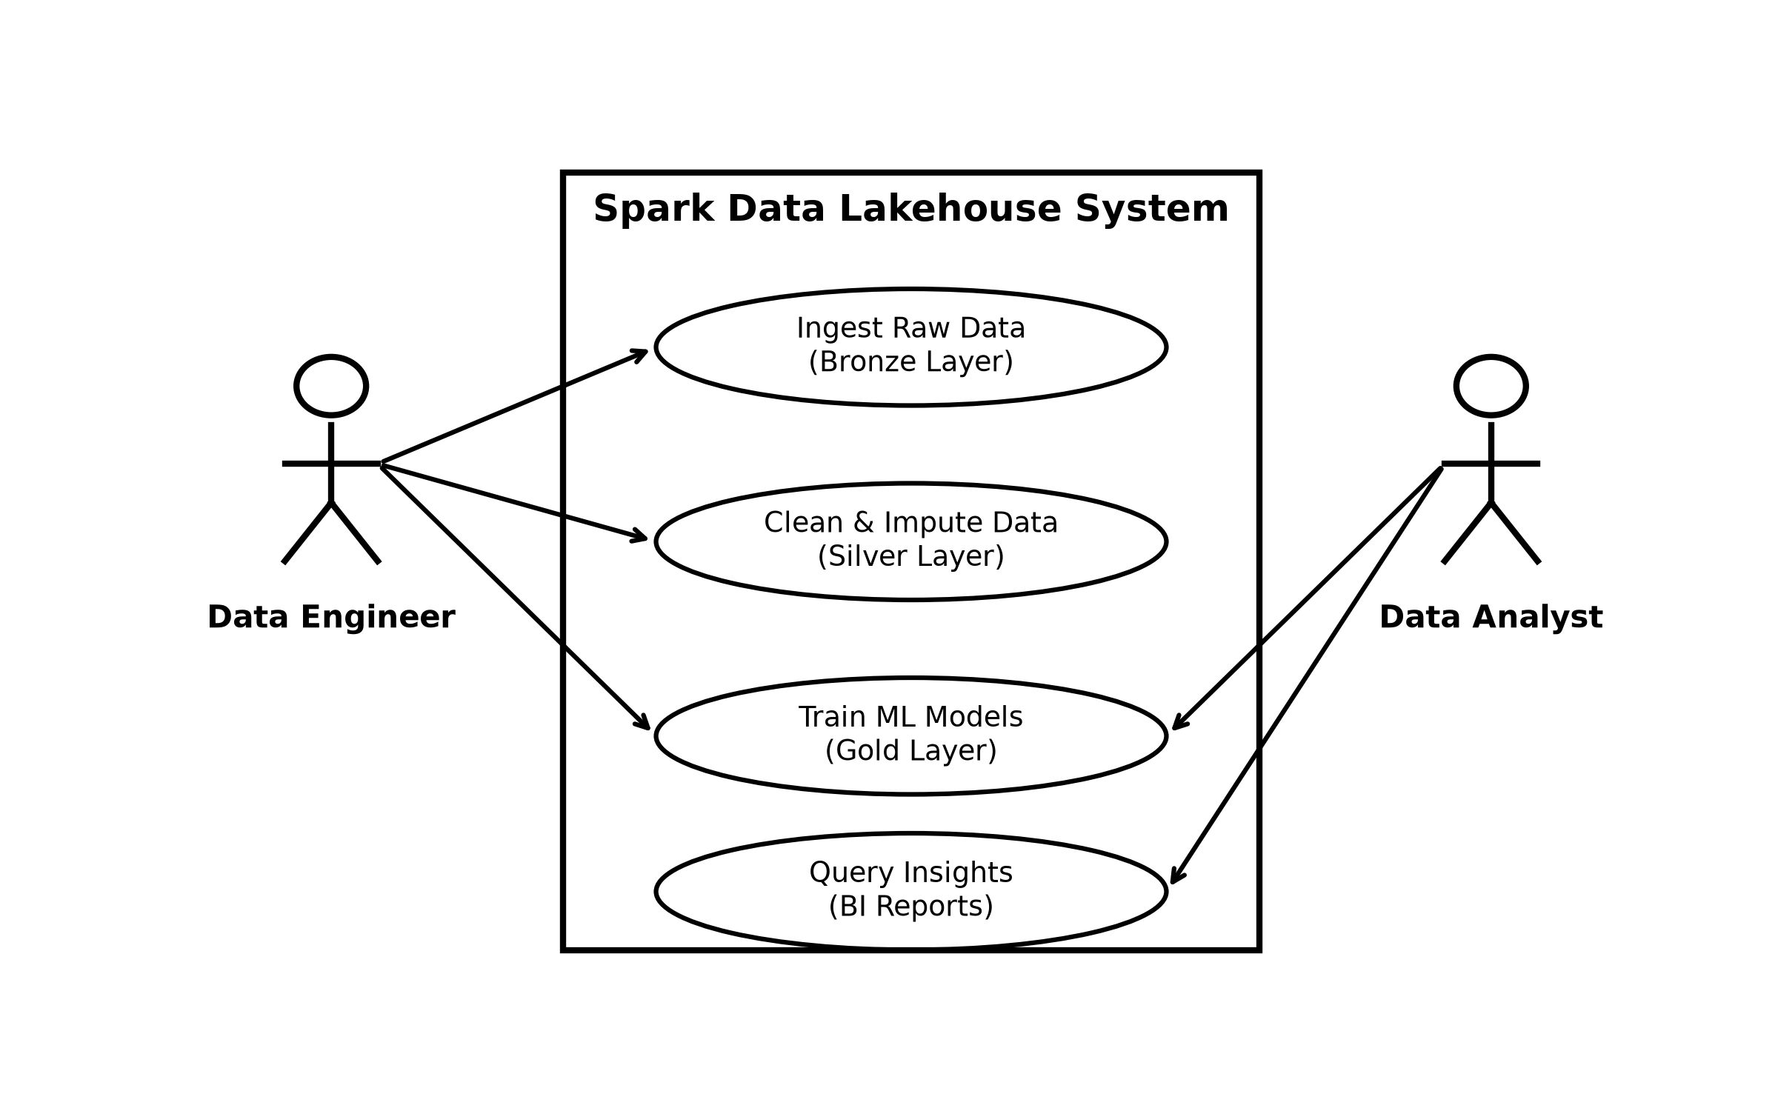
Figure 4.1.1: Use Case Diagram of the Lakehouse System

4.2 System Architecture (ETL & Storage Flow)
The pipeline follows a modular Medallion design. Raw datasets are stored locally and processed sequentially by Spark. Bronze produces audited Parquet archives. Silver generates cleansed, feature-engineered outputs. Gold produces aggregated analytical marts alongside ML predictions and the serialised model artifact. Each layer is an independent Spark job with its own input validation, transformation logic, and output verification steps. Logging at each stage provides full operational visibility.
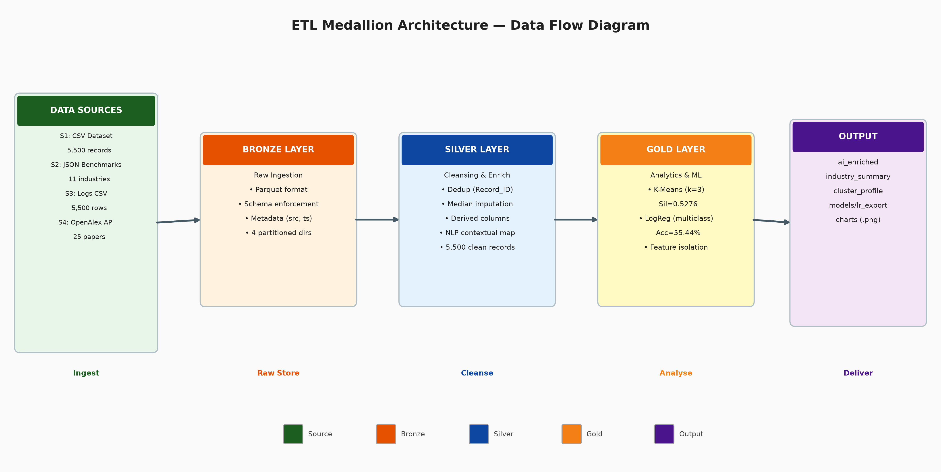
Figure 4.2.1: ETL Medallion Architecture Data Flow

4.3 Database & Multidimensional Schema (Star Schema)
The Gold layer is designed as a Multidimensional Database using the Star Schema pattern. This approach organises data into a central fact table surrounded by dimension tables, enabling efficient drill-down and slice-and-dice analysis across business perspectives. The central fact table, Fact_AI_Deployment, references three dimension tables: Dim_Organization (organisational attributes), Dim_Agent (AI agent configuration), and Dim_Research_Context (NLP-mapped scientific citation metrics). This design lets analysts query performance across multiple axes—comparing trust scores by industry, agent type, or citation density—without complex runtime joins. The ERD below maps each of the four data sources to their respective dimension tables, showing how raw input data is restructured into a multidimensional query model.
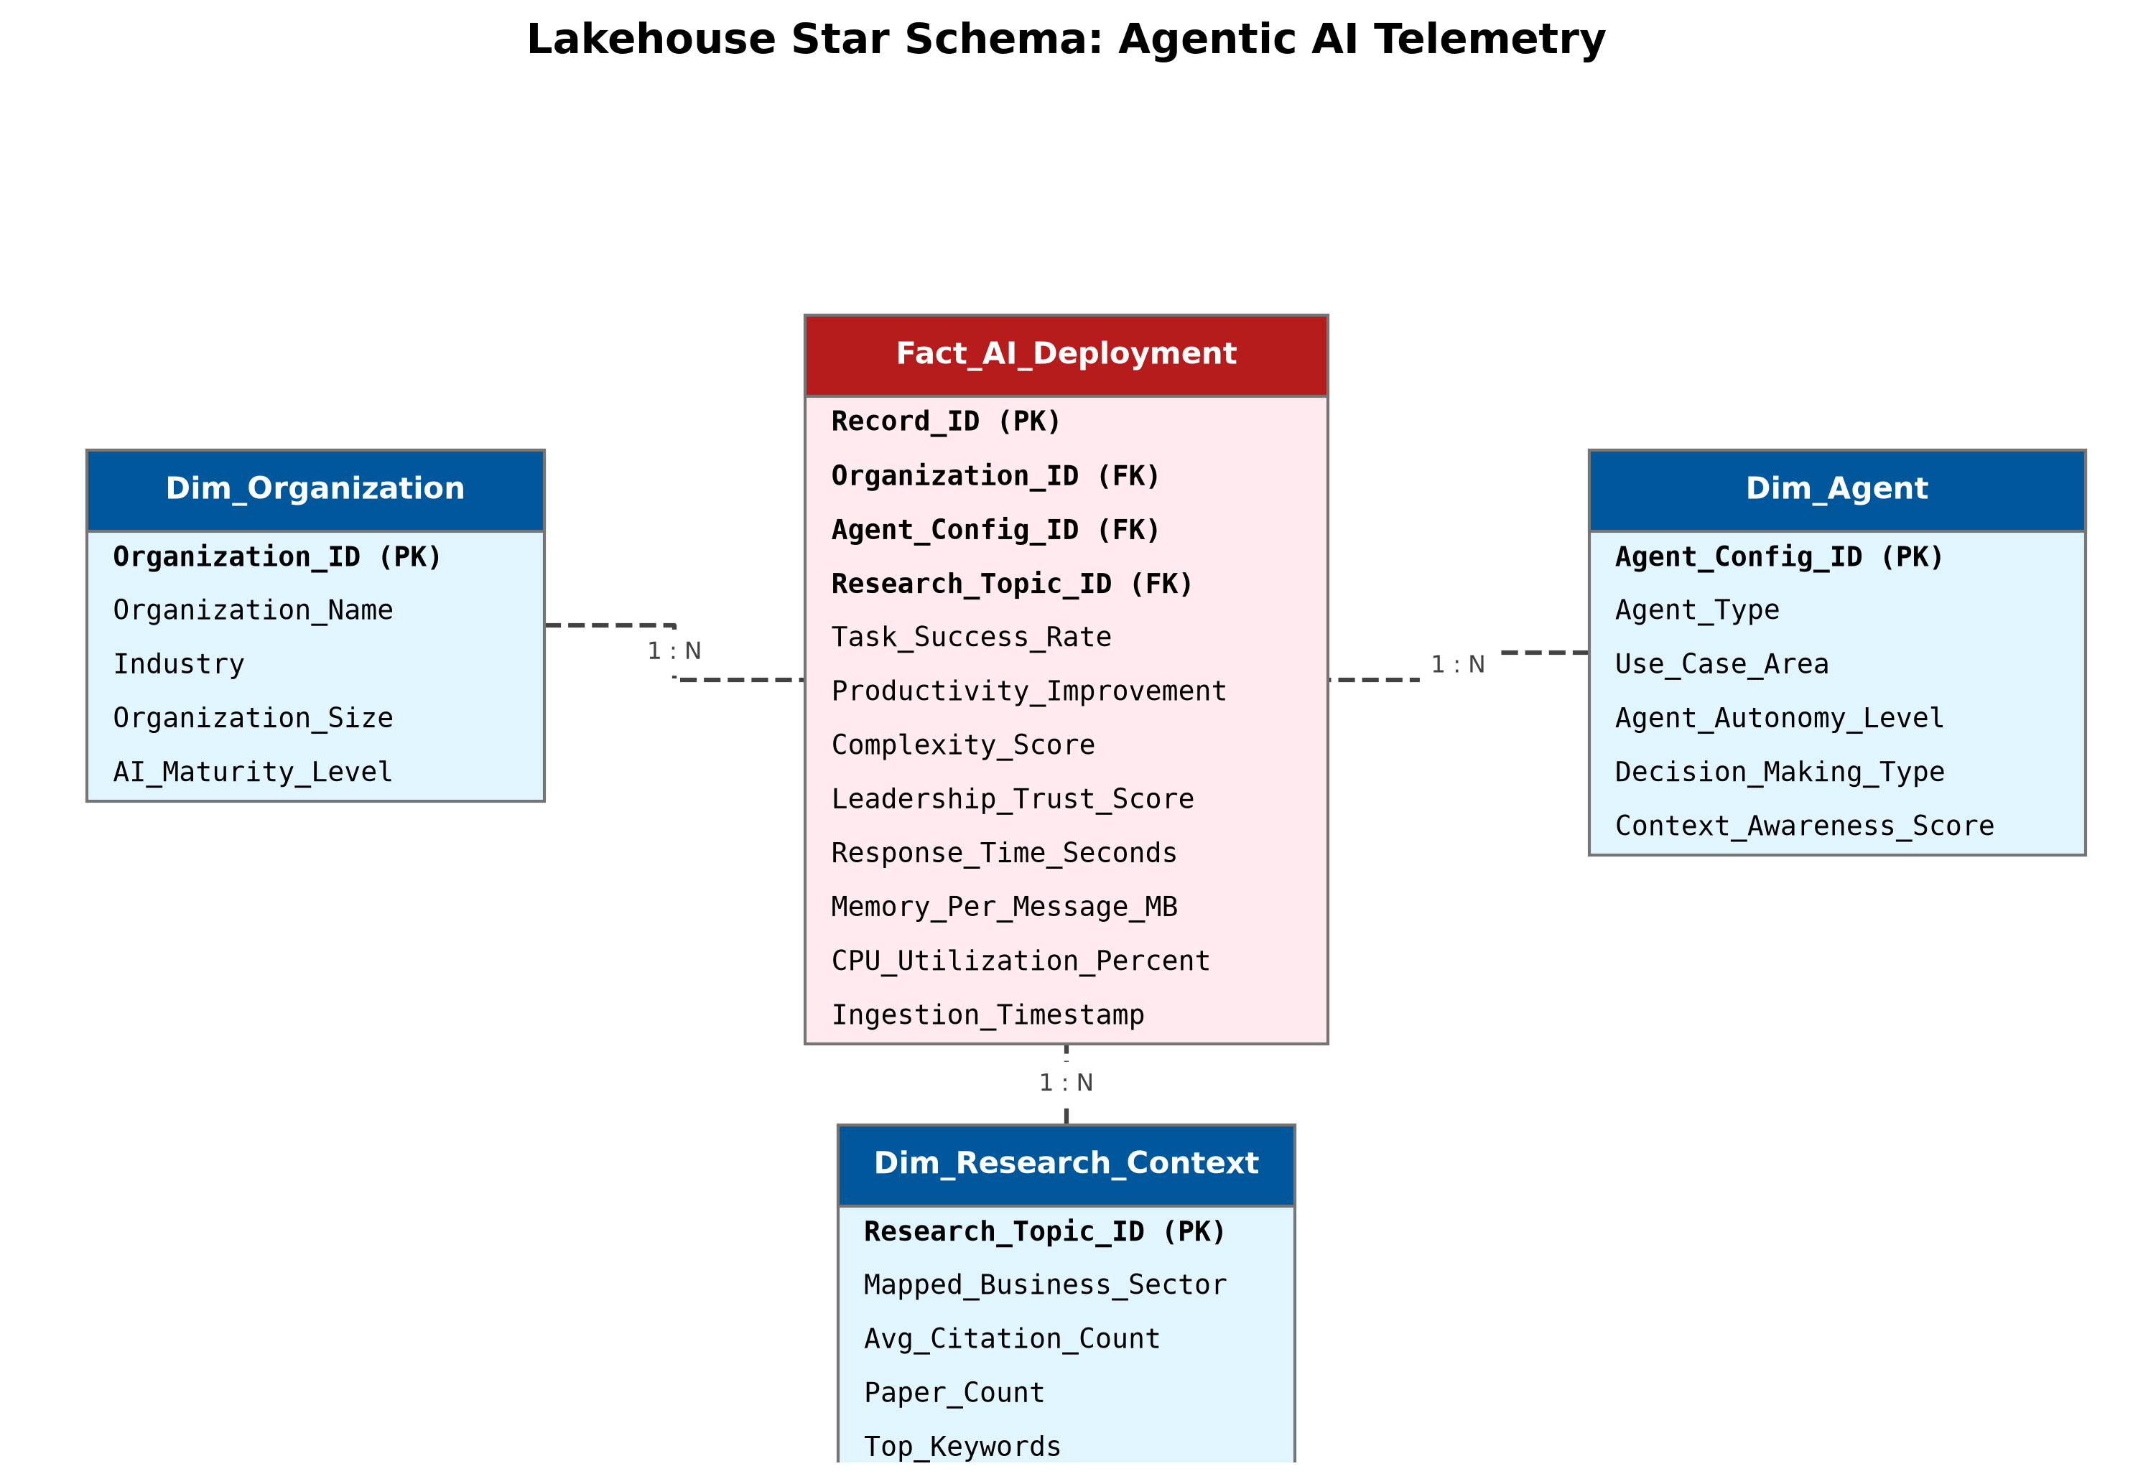
Figure 4.3.1: Star Schema ERD Diagram — Data Source to Multidimensional Mapping

4.4 Main Interface & Analytical Dashboard Design
Three dashboards form the analytical interface. The first plots Leadership Trust Score against Productivity Improvement across all industries. The second shows clustering profile distributions. The third presents classification accuracy, confusion matrix statistics, and per-class performance breakdowns. These are intended for implementation in Power BI or Tableau, connecting directly to Gold layer Parquet files.

4.5 Testing & Validation Strategy
An automated test suite runs after each pipeline execution. It checks four things: schema conformance (all expected derived columns exist with correct types), null assertions (critical fields contain zero nulls after Silver imputation), record integrity (exactly 5,500 records preserved from Bronze to Gold), and model artifact validation (serialised model file exists at the expected path). All tests run on PySpark DataFrames to avoid pandas memory issues.

5. Conclusion
This proposal describes a data pipeline built to measure Agentic AI performance in real organisations. The Medallion architecture on Apache Spark integrates four heterogeneous data sources into a unified, analysable dataset. The Silver layer’s cleansing operations—industry-specific imputation, deduplication, feature engineering, and NLP contextual mapping—produce a high-quality dataset. The Gold layer’s ML models deliver actionable performance profiles while keeping clustering and classification features strictly isolated. The pipeline is production-ready: automated testing, serialised artifacts, and comprehensive logging ensure reliability and reproducibility.

Appendix A: Project Timeline
The project runs from 20 May to 10 July 2026. The Gantt chart below shows the task schedule and dependencies.
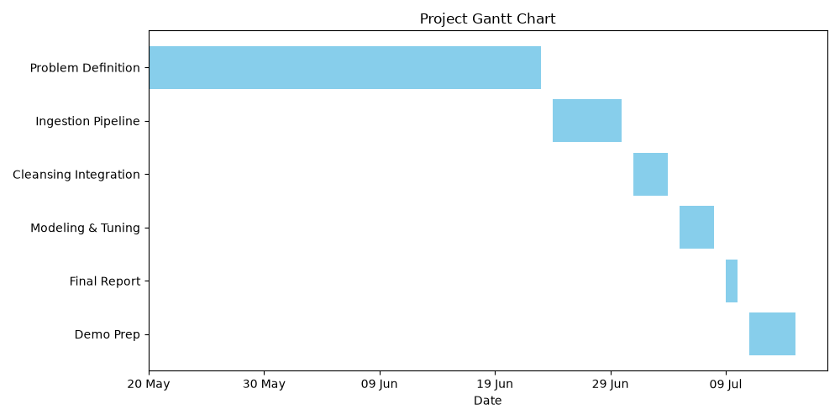
Figure A.1: Project Gantt Chart

Appendix B: Generative AI Use Log
19 June 2026 | Code Refactoring | Used Claude to optimize PySpark joins. Prompt: 'I have a memory bottleneck in my Silver layer join. How can I optimize this in PySpark without Pandas?'
20 June 2026 | Proposal Draft | Used ChatGPT to structure the methodology. Prompt: 'Help me outline a methodology section for a CRISP-DM data engineering project based on this rubric.'
20 June 2026 | System Design | Used Claude for Star Schema design. Prompt: 'Suggest a Star Schema design where the fact table tracks AI agent executions and dimensions include organization, agent config, and research context.'

References
Armbrust, M., Ghodsi, A., Xin, R., & Zaharia, M. (2021). Lakehouse: A new generation of open platforms that unify data warehousing and advanced analytics. Proceedings of the 11th Conference on Innovative Data Systems Research (CIDR).
Zaharia, M., Xin, R. S., Wendell, P., Das, T., Armbrust, M., Dave, A., Meng, X., Rosen, J., Venkataraman, S., Franklin, M. J., Ghodsi, A., Gonzalez, J., Shenker, S., & Stoica, I. (2016). Apache Spark: A unified engine for big data processing. Communications of the ACM, 59(11), 56–65.
Priem, J., Piwowar, H., & Orr, R. (2022). OpenAlex: A fully open index of scholarly works, authors, venues, institutions, and concepts. Proceedings of the 26th International Conference on Science, Technology and Innovation Indicators (STI).
Platt, J. C. (1999). Probabilistic outputs for support vector machines and comparisons to regularized likelihood methods. Advances in Large Margin Classifiers, 10(3), 61–74.
Rousseeuw, P. J. (1987). Silhouettes: A graphical aid to the interpretation and validation of cluster analysis. Journal of Computational and Applied Mathematics, 20, 53–65.
Bolon-Canedo, V., Sanchez-Marono, N., & Alonso-Betanzos, A. (2013). A review of feature selection methods on synthetic data. Knowledge and Information Systems, 34(3), 483–519.
Zhang, Y., & Zhang, Z. (2020). Data Lakehouse: A survey paper. arXiv preprint arXiv:2010.00874.
Apache Software Foundation. (2023). Apache Spark MLlib: Scalable machine learning library. https://spark.apache.org/mllib/
Wickham, H., & Grolemund, G. (2017). R for data science: Import, tidy, transform, visualize, and model data. O'Reilly Media.
Kitchin, R. (2014). Big data, new epistemologies and paradigm shifts. Big Data & Society, 1(1), 1–12.

