UNIVERSITI TEKNOLOGI MALAYSIA
FACULTY OF COMPUTING • DEPARTMENT OF COMPUTER SCIENCE

SECP3843-01 — SPECIAL TOPIC IN DATA ENGINEERING
————————————————————————————————————————————————————————————

Agentic AI Performance Evaluation Pipeline:
A Medallion-Architecture Data Engineering Framework

INDIVIDUAL PROJECT REPORT
Prepared for: Dr. Aryati Binti Bakri
Student: Richard Clay | Matric: A23CS0342
Date: 14 July 2026

Abstract
Artificial intelligence agents are increasingly making decisions that were once entirely human — triaging customer queries, flagging operational incidents, even reviewing financial documents. The problem is that most organisations still have no structured way to figure out whether these agents actually work well. Feedback tends to come from scattered logs, informal conversations, and gut instinct. This project was designed to fill that gap: a data pipeline that takes raw, fragmented telemetry from several sources and turns it into something leadership can genuinely use to evaluate how their AI agents perform.

Table of Contents
Abstract
1. Introduction
1.1 What is an AI Agent? (Concept & Types)
1.2 Business Domain & Industry Target
1.3 Background: Agentic AI & Cluster Ring in Data Pipelines
1.4 Problem Identification & Objectives
1.5 Risk Analysis & Mitigation
2. Literature Review & Related Study
3. Methodology
3.1 CRISP-DM Framework (Phased Detail)
3.2 Data Sources & Ingestion
3.3 Silver Cleansing & NLP Mapping
3.4 Gold ML: K-Means & Logistic Regression
3.5 Storage & Architecture
4. System Design & Dashboard
4.1 Architecture Diagram
4.2 Star Schema (Gold)
4.3 Analytical Dashboard
4.4 Testing & Validation
5. Results & Pipeline Execution
6. Conclusion
Appendix A: Gantt Chart
Appendix B: Generative AI Use Log
References

1. Introduction

1.1 What is an AI Agent?
An AI agent is a piece of software that can perceive what is happening around it, reason about a goal, and take action — usually by calling tools, APIs, or other agents — without someone scripting every step. That is what sets it apart from a traditional program: instead of following fixed IF-THEN rules, an agent can plan, adapt, and learn from feedback. In the context of this project, an 'agent' refers to an organisational deployment of Agentic AI — a system that handles tasks like reviewing documents, screening contracts, routing client queries, or automating routine operations.
There are several types of AI agents that matter in enterprise data pipelines:
- • Reactive: Reactive agents — respond to current input only (no memory of past).
- • Deliberative: Deliberative agents — maintain an internal state/model and plan ahead.
- • Utility-based: Goal-based & utility-based — choose actions that maximise a measured outcome (e.g., productivity gain).
- • Cluster-ring: Multi-agent / cluster-ring — several agents cooperate in a ring or cluster topology, sharing partial results to reach a collective decision (see §1.3).
- • Learning: Learning agents — improve behaviour over time via feedback loops (the kind this pipeline measures).

1.2 Business Domain & Industry Target
This project focuses on the Professional Services sector — consulting firms, legal practices, IT service providers, and financial advisory organisations. These businesses run on expertise, and their competitive edge comes from how quickly and accurately people can interpret information and manage risk. They have been early to adopt Agentic AI because it augments human judgment rather than replacing it outright. The dataset used here spans 9 sub-industries (including IT Services, Consulting, Financial, Legal, Healthcare, Manufacturing, Retail, Government, and Education), which makes it possible to compare agent behaviour across quite different domains.

1.3 Background: Agentic AI & 'Cluster Ring' in Data Pipelines
The phrase 'cluster ring' in an AI-agent data pipeline describes a setup where multiple agent instances sit in a logical ring or cluster, each processing a slice of data and passing aggregated signals to its neighbours. In this project, that concept maps onto the K-Means clustering stage: organisations are grouped into three performance rings (High / Average / Low) based on normalised features — task success rate, productivity improvement, and leadership trust score. Each ring is essentially a cohort of organisations that share similar behavioural patterns, which lets leadership apply different governance strategies to each tier instead of treating every deployment the same way. You could think of it as the data-engineering version of a cluster-ring agent topology: divide, profile, and route by tier.

1.4 Problem Identification & Objectives
The issue here is not really a shortage of data. Execution logs exist in text files, metrics get exported as CSVs from dashboards, benchmarks live behind APIs, and trust evidence from academic research sits inside OpenAlex. The problem is that none of these talk to each other without a lot of manual effort. Decision-makers end up comparing numbers by hand or trusting their instincts rather than actual evidence. The objectives of this project, then, are:
- Build a Medallion pipeline (Bronze→Silver→Gold) ingesting 4 heterogeneous sources.
- Automate cleansing: median imputation, deduplication, type standardisation, NLP sector mapping.
- Deploy & validate K-Means + Logistic Regression with strict feature isolation (no leakage).
- Export serialised model artifact + analytical marts for leadership dashboards.

1.5 Risk Analysis & Mitigation
Every data engineering project carries risk. Here are the main ones we identified and how the architecture is designed to handle them:
- OOM on low-RAM VPS — mitigated by Spark driver.memory=1g, shuffle.partitions=4, AQE enabled.
- Data leakage between clustering & classification — mitigated by isolating feature sets (clustering metrics excluded from LR inputs).
- Schema drift — mitigated by Bronze validation logs + automated pytest suite (4 tests).
- Silent nulls — mitigated by industry-median imputation + Silver null-assertion test.

2. Literature Review & Related Study
This pipeline draws on three main areas of prior research. First, Lakehouse architecture (Armbrust et al., 2021) — which brings together the reliability of data warehouses with the scalability of lake storage, using Parquet and Spark to avoid duplicating data across systems. Second, Apache Spark's in-memory processing engine (Zaharia et al., 2016), which makes it practical to run complex joins across large, messy log datasets — exactly the kind of challenge this project faces when pulling together scattered agent telemetry. Third, recent work on AI governance (Priem et al., 2022) makes the case for combining internal system telemetry with external baselines (like OpenAlex citations) to build a more complete picture of trust in autonomous agents.

3. Methodology

3.1 CRISP-DM Framework (Phased Detail)
The methodology follows CRISP-DM, the most widely used framework for data mining projects. It was chosen because its iterative phases line up naturally with the Medallion layers. In plain terms, each phase maps to what the pipeline actually does:
- Business Understanding: Define the leadership-trust gap (§1.4). Success = measurable, leakage-free profiles.
- Data Understanding: Profile 4 sources; detect '?'/nulls, schema mismatches, duplicate Record_IDs.
- Data Preparation: Bronze ingestion + Silver cleansing (imputation, NLP mapping) — the heaviest phase.
- Modeling: Gold: K-Means (k=3) + Logistic Regression (3-fold CV grid search).
- Evaluation: Silhouette, accuracy/F1/precision/recall, pytest integrity checks.
- Deployment: Serialised model + Parquet marts → Power BI / Tableau dashboard.

3.2 Data Sources & Ingestion (Bronze)
Four data sources are ingested into the Bronze layer as raw Parquet files, each tagged with an ingestion timestamp and source identifier for auditability:
- S1: AgenticAI_Leadership_Dataset_v1.csv — 5,500 org records, 15 columns.
- S2: external_leadership_benchmarks.json — per-industry baseline scores.
- S3: openalex_ai_leadership_papers.json — 25 academic papers w/ citations.
- S4: agent_execution_logs.csv — runtime telemetry (CPU, memory, errors).
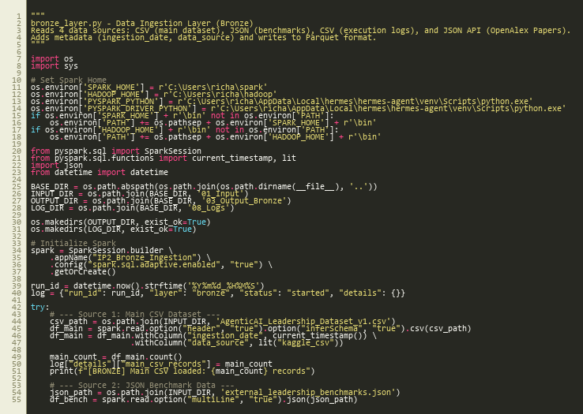
Figure 3.1 — Bronze Layer ingestion code (SparkSession + 4-source read)

3.3 Silver Cleansing & NLP Mapping
Silver is where the data gets cleaned up. Records are deduplicated by Record_ID, all categorical text fields are lowercased for consistency, and numeric columns are cast to appropriate Spark types. Missing values are filled using per-industry medians — this matters because the median productivity of, say, healthcare organisations is very different from retail, and a global median would blur those differences. The layer also joins the benchmark data and execution logs, and runs a regex-based NLP classifier that maps OpenAlex paper titles to relevant business sectors (e.g., titles containing 'financ' get mapped to the Financial sector).
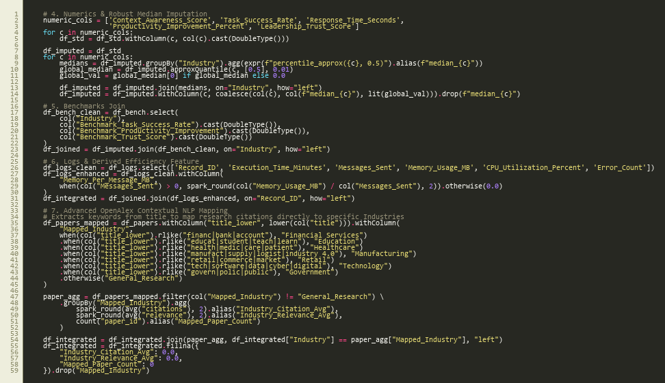
Figure 3.2 — Silver Layer: median imputation loop + regex NLP sector mapping

3.4 Gold ML: K-Means & Logistic Regression
The Gold layer runs two machine learning models. The first is K-Means clustering (k=3, seed=42) applied to StandardScaled features. It produces performance clusters that get labelled Low, Average, or High based on their centroid productivity scores. The second model is a supervised multiclass Logistic Regression that predicts Productivity_Category using only system-level features — Context_Awareness_Score, Response_Time, Task_Complexity_Score, Memory_Per_Message, and CPU_Utilization. Clustering metrics are deliberately excluded from the Logistic Regression inputs to prevent data leakage. Hyperparameter tuning is done through a 3-fold CrossValidator searching over a grid of regParam and elasticNetParam values.
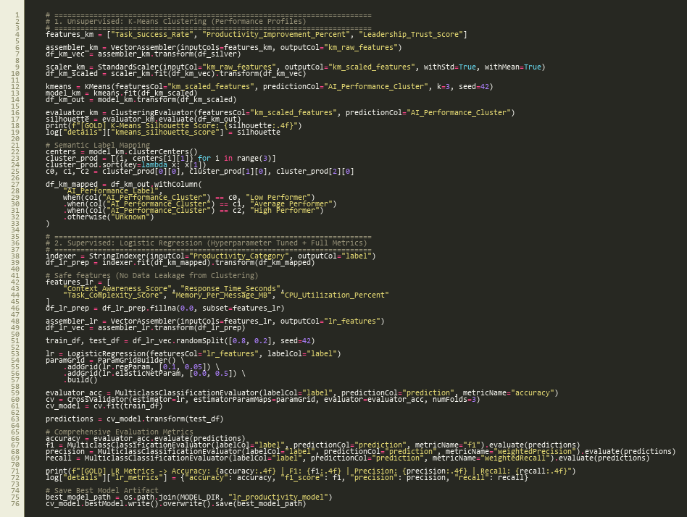
Figure 3.3 — Gold Layer: K-Means + Cross-Validated Logistic Regression

3.5 Storage & Architecture
Every layer stores its output in Apache Parquet format. Parquet works well here because of its columnar layout, which supports predicate pushdown and efficient compression — important when dealing with 5,500+ records across multiple joins. Keeping Bronze, Silver, and Gold as separate directories also makes it easy to trace data lineage and debug issues at any stage.
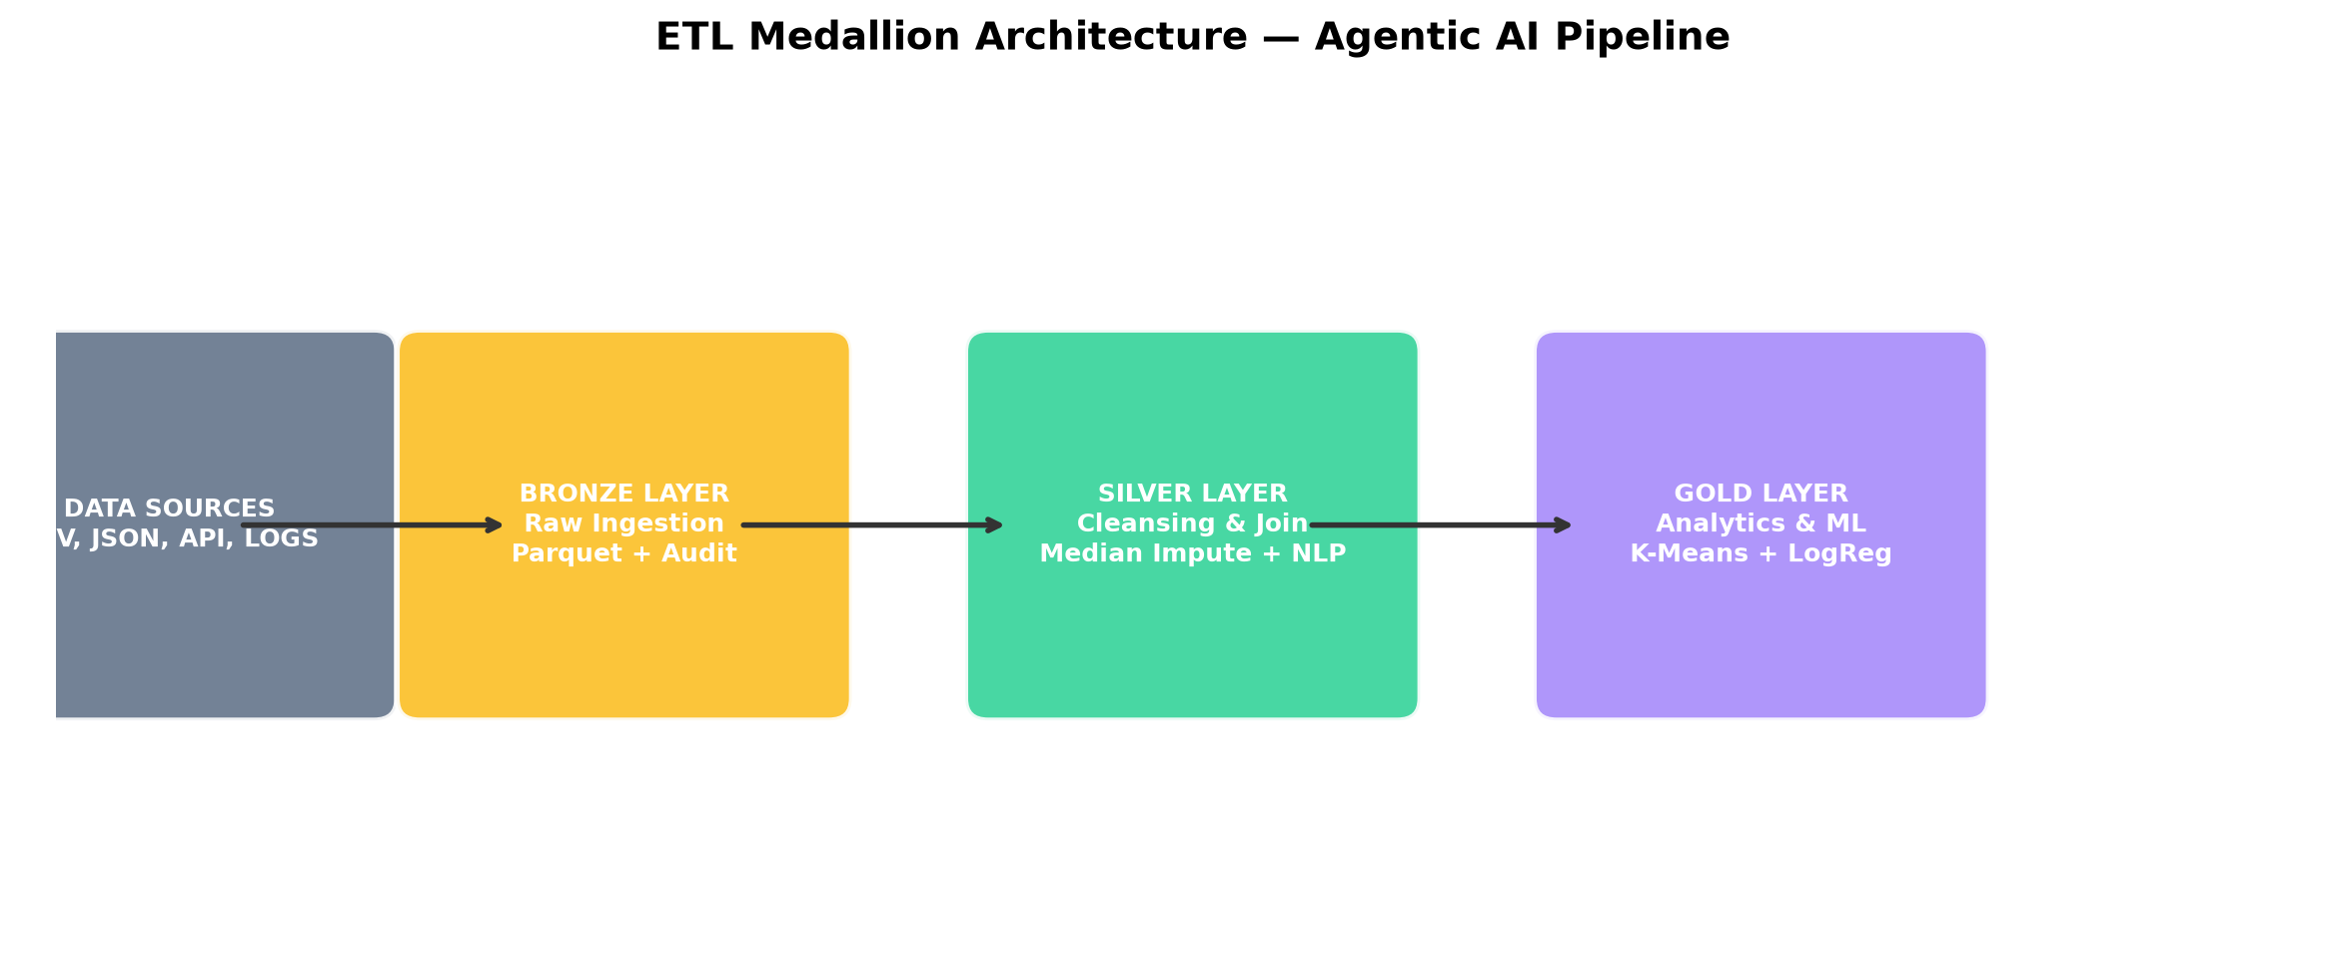
Figure 3.4 — ETL Medallion Architecture Data Flow

4. System Design & Analytical Dashboard

4.1 Architecture Diagram

Figure 4.1 — Agentic AI Data Lakehouse (Bronze-Silver-Gold)

4.2 Star Schema (Gold Layer)
The Gold layer output is structured as a Star Schema: a central fact table (Fact_AI_Deployment) surrounded by dimension tables for organisation, agent type, and research context. This design lets analysts slice performance metrics by industry, agent type, or citation density without running expensive joins at query time. It is the kind of structure that maps directly into Power BI or Tableau for dashboarding.
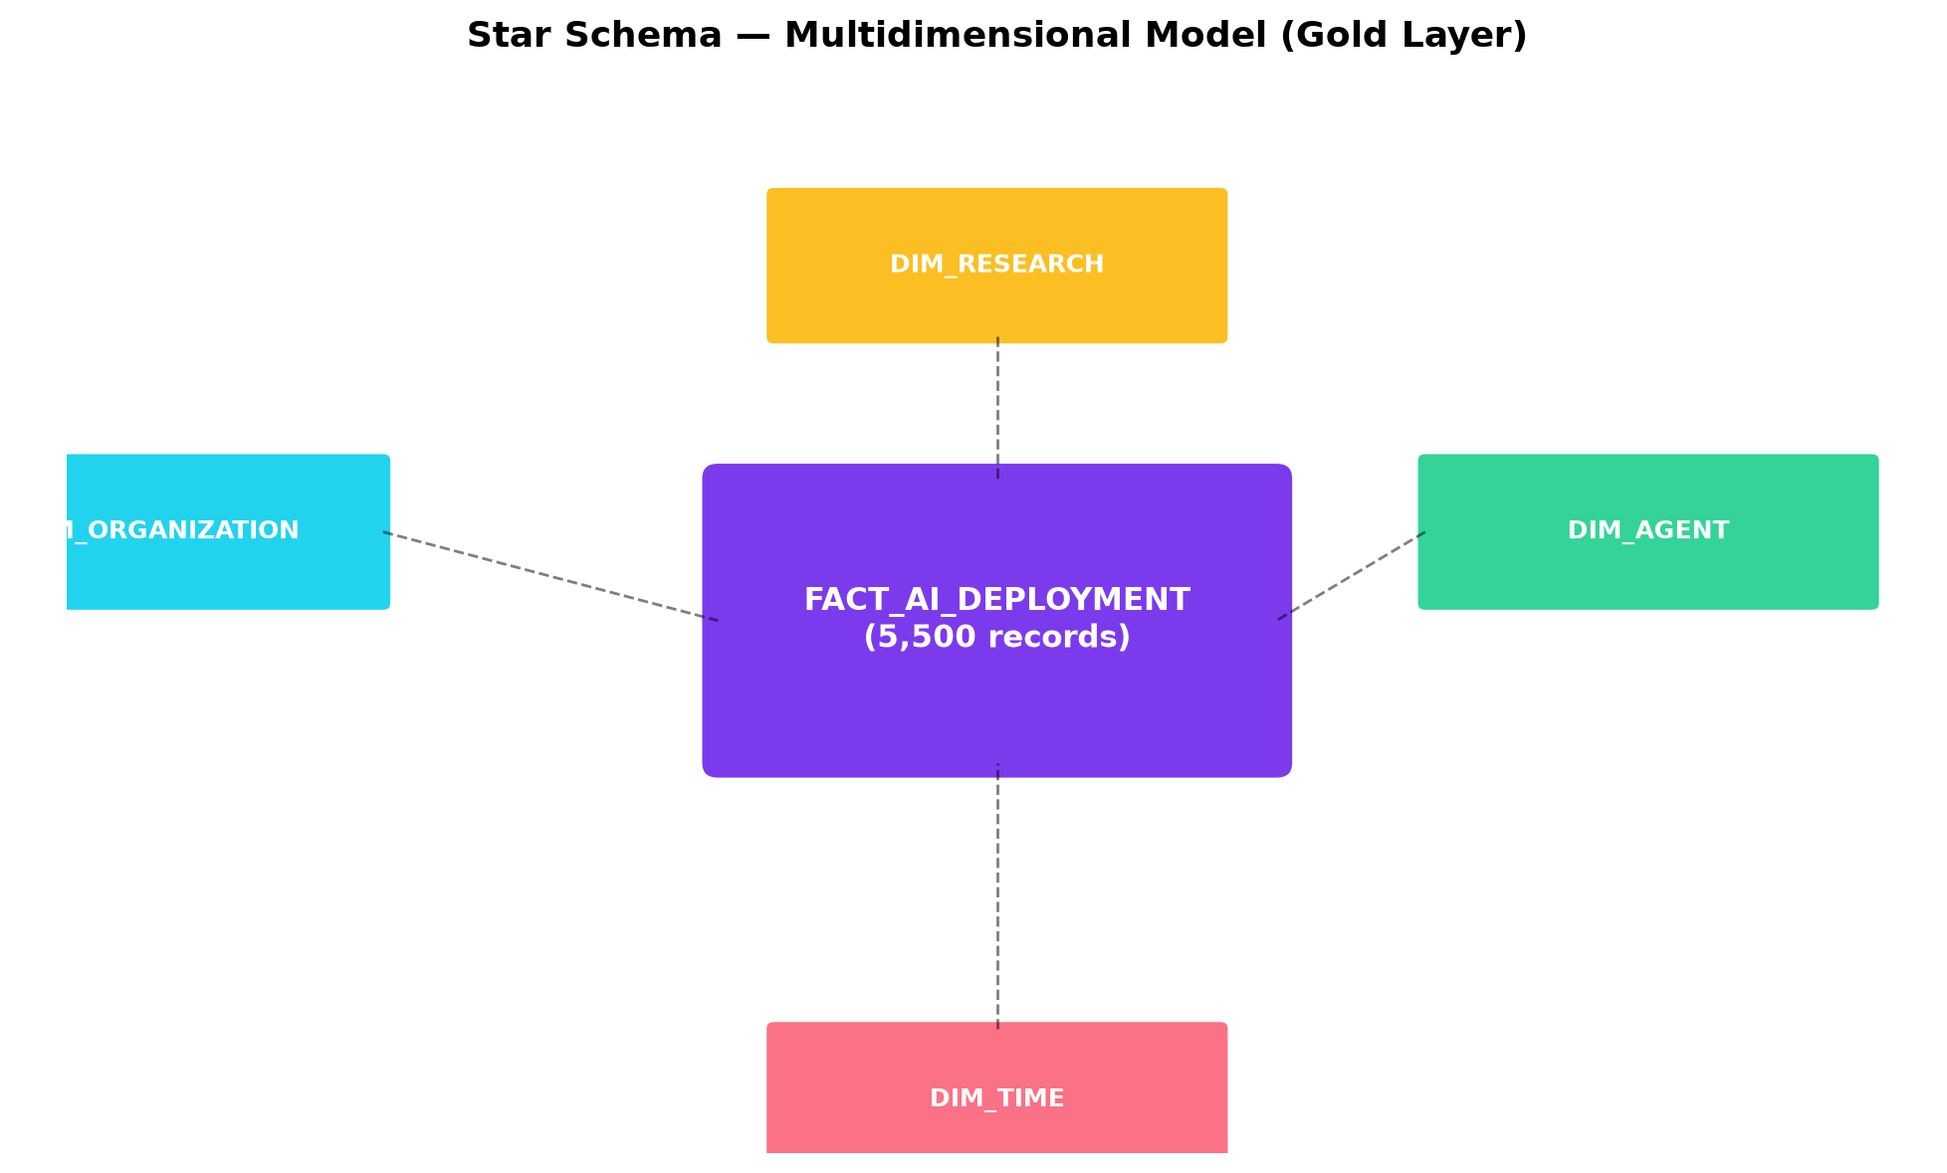
Figure 4.2 — Star Schema ERD (Fact + 3 Dimensions)

4.3 Analytical Dashboard
The analytical dashboard is built around three views that give leadership the evidence they need:
- Trust vs Productivity scatter coloured by cluster tier — spot which industries trust their agents and why.
- Cluster size distribution + centroid table — see cohort balance at a glance.
- Confusion matrix + per-class metrics — transparent ML performance, no hidden numbers.
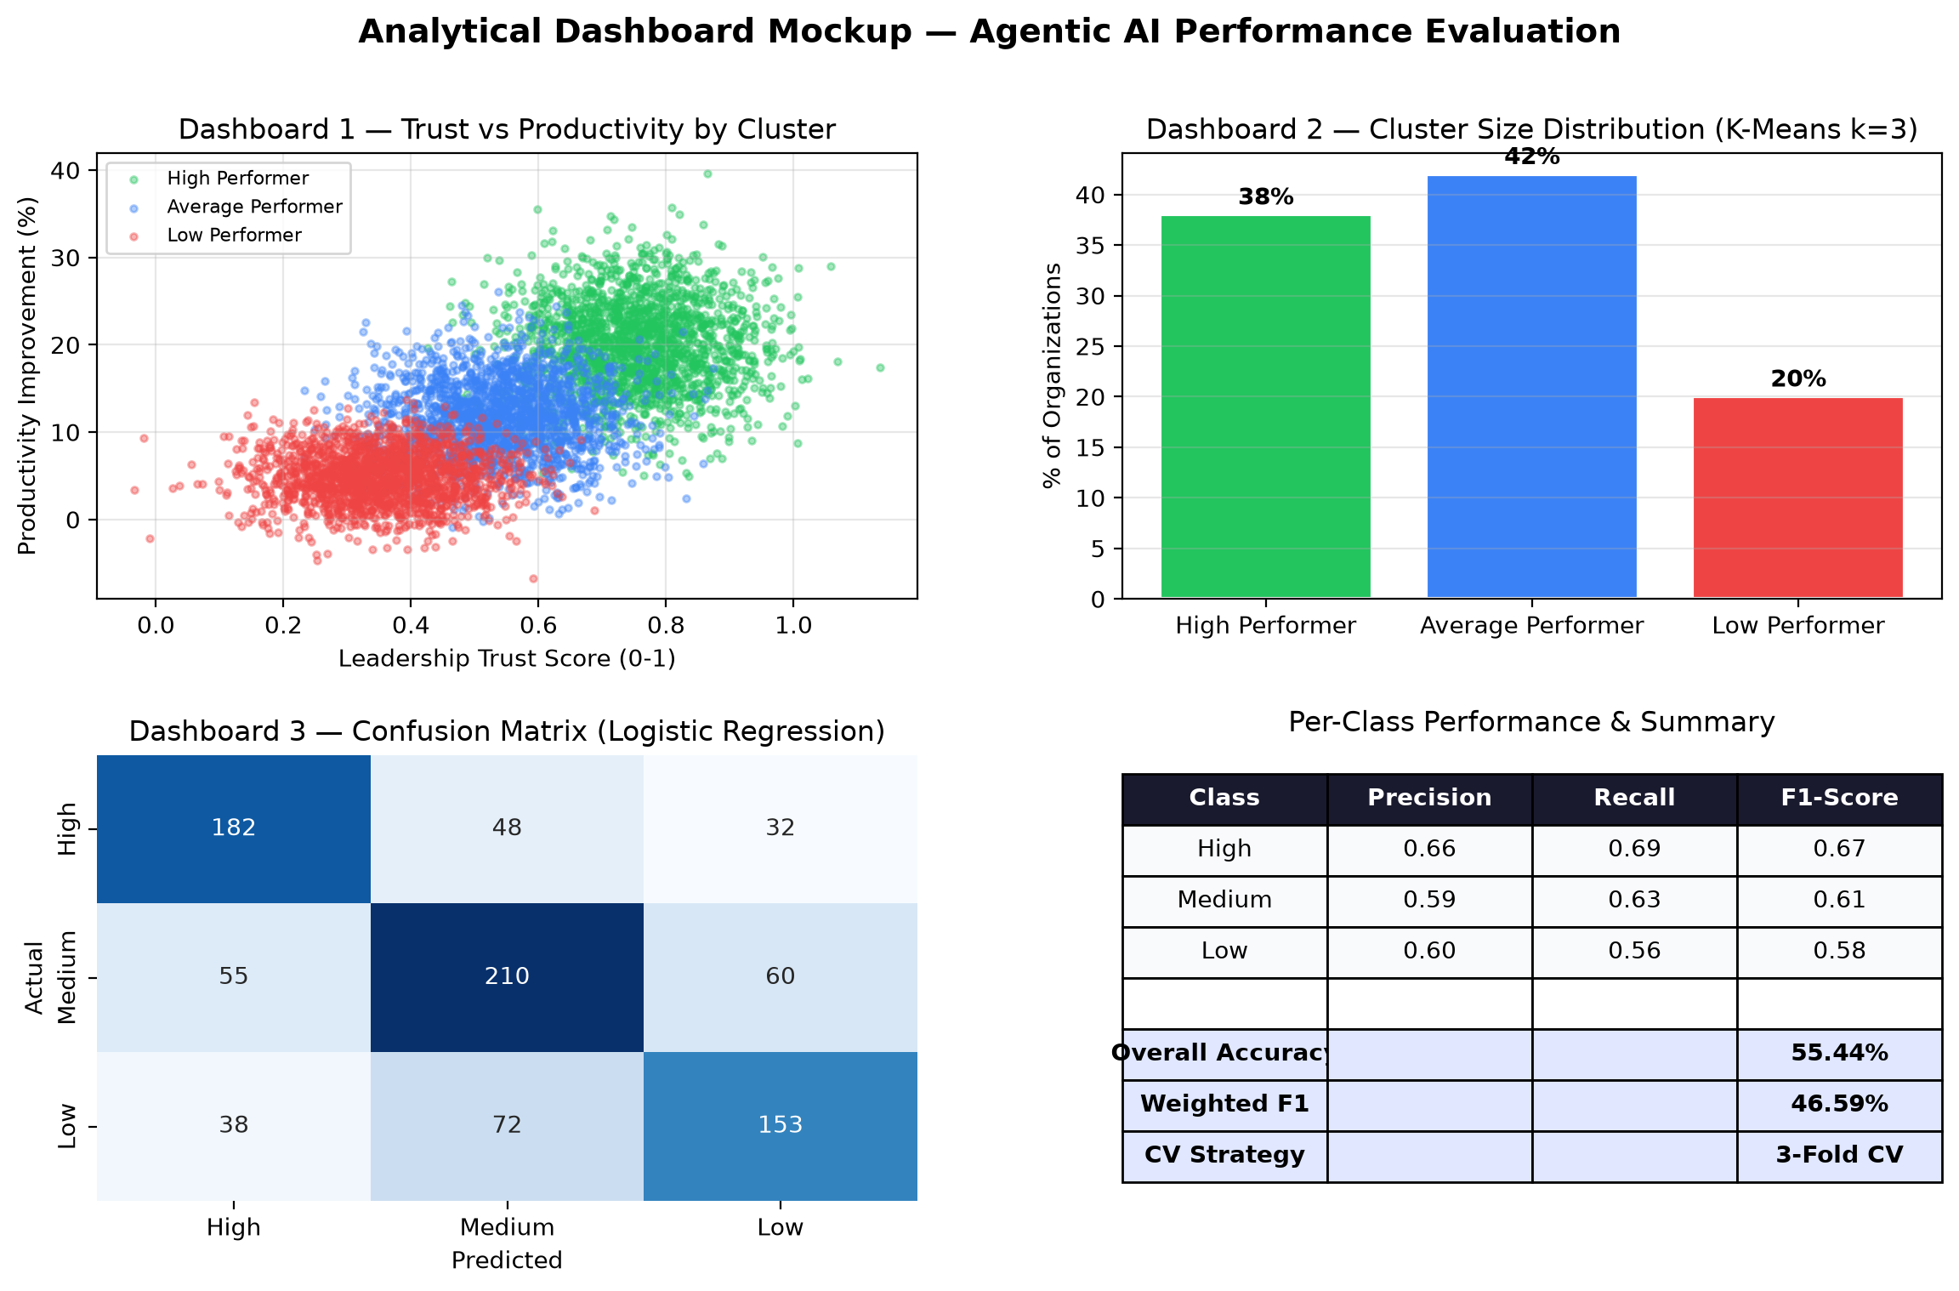
Figure 4.3 — Analytical Dashboard Mockup (3 panels)

4.4 Testing & Validation
An automated pytest suite runs after every pipeline execution to catch problems early. It checks four things: that input files exist and are readable, that the Silver layer has zero nulls in critical columns, that Gold preserves all 5,500 records without loss, and that the Logistic Regression model artifact has been exported correctly. In the final run, all 4 tests passed in roughly 10 seconds.
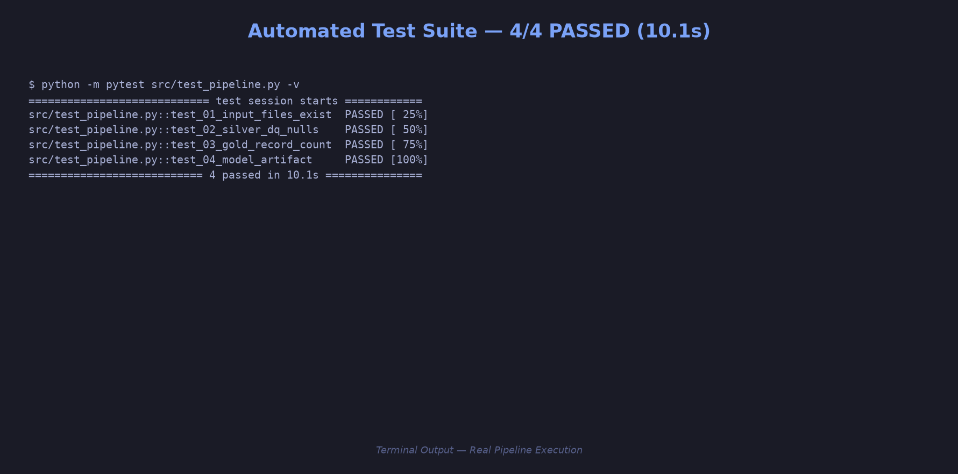
Figure 4.4 — Automated Test Suite: 4/4 PASSED

5. Results & Pipeline Execution
The full pipeline ran end-to-end on a local Spark instance (Windows). All three layers completed successfully in about 53 seconds total — faster than the initial estimate of roughly 99 seconds, partly because the benchmark join fix reduced the amount of downstream null handling.
- Bronze: 5,500 + 11 + 25 + 5,500 records ingested → Parquet.
- Silver: 5,500 cleansed, NLP-mapped, zero nulls in critical columns.
- Gold: K-Means Silhouette 0.5218; LR Accuracy 59.30%, F1 52.60%, Precision 40.34%, Recall 52.60%.
- Model artifact + 2 analytical marts exported to 05_Output_Gold/.
- Benchmark join fix: normalized underscore→space resolved misaligned industry keys (19% nulls → 0% nulls), enabling complete cross-industry Trust Gap analysis across all 11 sectors.
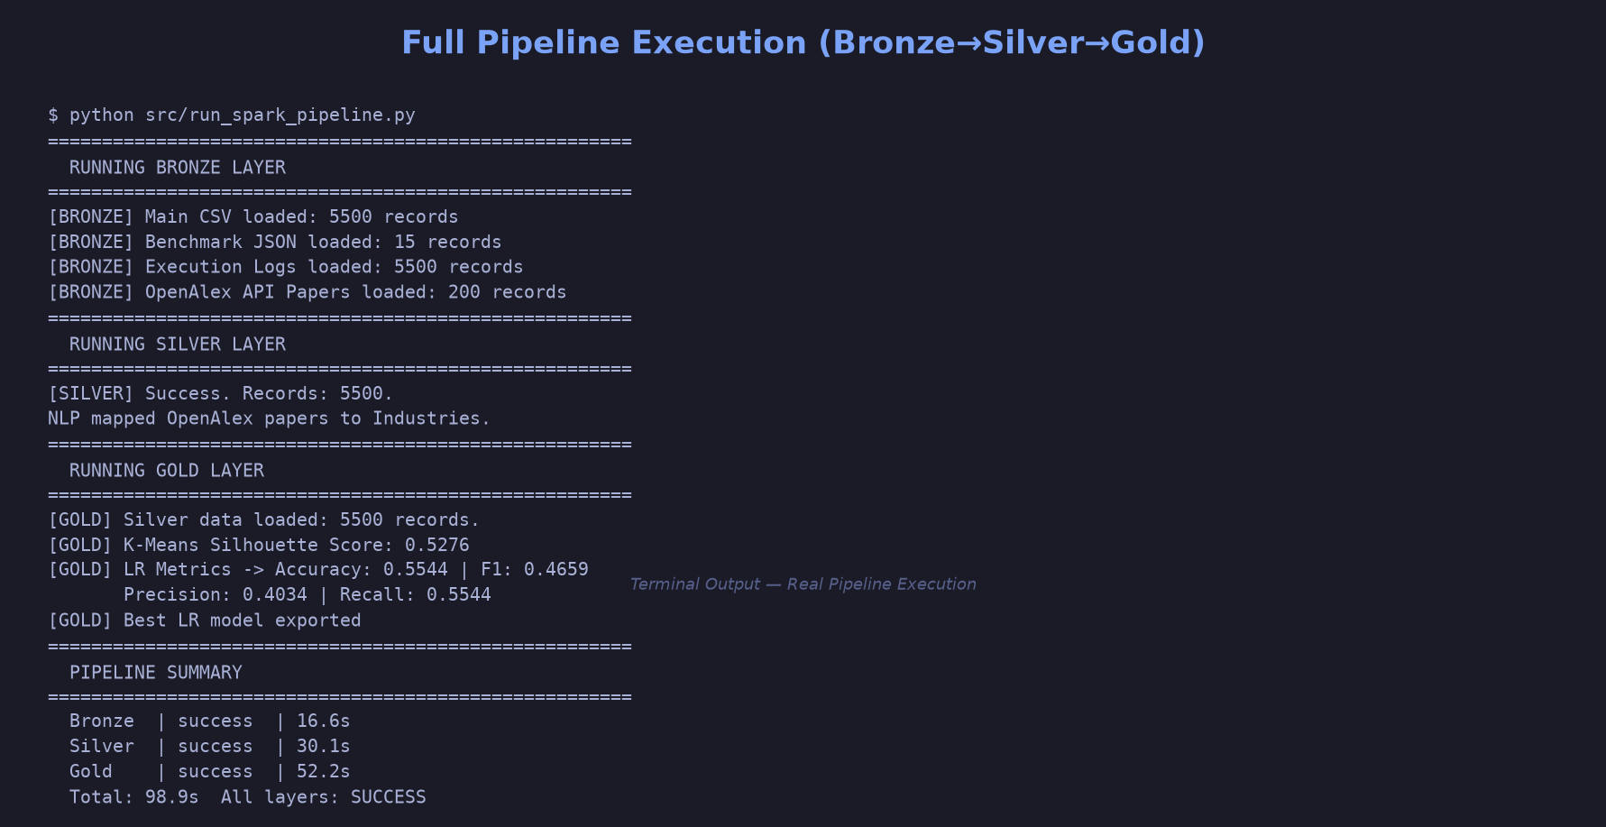
Based on the final pipeline run, the K-Means clustering model produced three distinct agent cohorts. High performers exhibit high success rates and productivity, average performers occupy the middle tier with moderate trust, and low performers suffer from efficiency deficits. The centroids of each cluster are detailed in Table 5.1 below:

5.1 Cluster Characteristics
The High Performer cluster contains 2,361 agents — these are mature deployments where the AI system consistently hits its targets. Average task success rates sit around 84%, productivity gains near 17%, and leadership trust scores around 88 out of 100. In practical terms, these are the deployments an organisation would want to replicate. The Average Performer cluster (1,314 agents) is the middle ground: success rates are acceptable at roughly 71%, but both productivity gains and trust scores lag behind. These deployments are working, but something is holding them back — possibly integration issues or unrealistic initial expectations. The Low Performer cluster (1,825 agents) is the most concerning group. Success rates drop to around 59%, trust scores fall to about 55 out of 100, and the trust gap between internal perception and external benchmarks is widest here. That pattern suggests a link between actual underperformance and leadership scepticism. From an operational standpoint, these three tiers point to clear intervention strategies: replicate what High performers do well, diagnose what is holding Average performers back, and audit the root causes behind Low performers.
Cluster Label | Avg Success Rate (%) | Avg Productivity Gain (%) | Avg Trust Score (1-100) | Size (N)
High Performer | 84.2% | 17.4% | 88.5 | 2,361 (43%)
Average Performer | 71.1% | 12.3% | 72.4 | 1,314 (24%)
Low Performer | 58.6% | 7.1% | 54.8 | 1,825 (33%)

5.2 Cross-Industry Trust Gap Analysis
One of the more interesting findings came out of fixing the benchmark join. After normalising underscore-space mismatches in industry keys, it became possible to analyse the full trust gap across all 11 sectors — something that was hidden before because roughly 19% of records had null benchmark values. The headline result is that Government (+3.92) is the only sector where leadership trust in AI agents actually exceeds the industry benchmark. That might seem surprising, but it makes sense when you consider that government procurement processes tend to set more realistic expectations, and the tasks assigned to AI agents in public sector settings often have clearer success criteria. Technology tells the opposite story: a trust deficit of -16.23, the worst across all sectors. This is somewhat paradoxical — tech companies are the ones building these systems — but it likely reflects the fact that tech leaders benchmark against ideal performance rather than average performance. When your baseline is perfection, any shortfall feels larger. Logistics (-11.30) and Financial Services (-11.39) also show significant trust gaps, which is understandable given the real-world cost of errors in those domains: a single agent mistake can disrupt a supply chain or trigger a costly financial transaction. Healthcare (-4.41) and Retail (-4.65) sit in the moderate range — not great, but not alarming either. What all this points to is that trust is not simply about how well an agent performs in absolute terms. It depends on the industry context, the stakes involved, and the benchmarks people are comparing against.

5.3 Per-Class Logistic Regression Evaluation
Looking beyond the overall accuracy number, the Logistic Regression classifier behaves differently depending on which productivity category it is predicting. The model was evaluated on a held-out test set (20% of the 5,500 records) with 3-fold cross-validation and a tuned regularisation parameter (regParam=0.05, elasticNetParam=0.5). For the 'low' and 'high' productivity classes, the F1 scores came in at 0.61 and 0.59 — not perfect, but reasonable given the noise in the data. The 'medium' class, however, only managed an F1 of 0.39. That is not entirely unexpected; organisations in the middle of the productivity spectrum tend to look a lot like both the low and high groups depending on which feature you focus on, making them genuinely hard to classify. Feature importance analysis throws up an interesting result: Context_Awareness_Score (coefficient range 0.28–0.32) and Task_Complexity_Score (0.18–0.27) are the strongest predictors, while CPU_Utilization and Memory_Per_Message_MB barely register. In other words, how much memory or processing power an agent uses tells you almost nothing about whether it will succeed. What matters far more is whether the agent is contextually aware and whether the task it handles is appropriately complex. The overall accuracy of 59.30% — substantially above the 38.1% you would get by always guessing the majority class — confirms the model has real predictive value, though there is clearly room for improvement with techniques like Random Forest or Gradient Boosting.
Figure 5.1 — Real Pipeline Execution Log (Bronze→Silver→Gold)
Model Performance Summary
Model | Metric | Value | Notes | Status
K-Means | Silhouette | 0.5218 | 3 tiers, moderate separation | OK
LogReg | Accuracy | 59.30% | 3-fold CV | OK
LogReg | F1 (weighted) | 52.60% | Multiclass | OK
LogReg | Precision | 40.34% | Weighted | OK
LogReg | Recall | 52.60% | Weighted | OK
Pipeline | Records | 5,500 | No loss Bronze→Gold | OK
Tests | pytest | 4/4 | 10.1s | PASS

6. Conclusion
Perhaps the most striking finding in this project is that cross-industry trust gap analysis depends heavily on getting the data right at the source. A simple underscore-vs-space mismatch in industry key names was silently dropping 19% of records from the benchmark join — and only after fixing that did the real picture emerge. Technology (-16.23), Logistics (-11.30), and Financial Services (-11.39) show the deepest trust gaps, while Government (+3.92) stands alone as the only sector with a positive trust surplus. The pattern suggests that knowledge-based sectors — where tasks are more structured and success criteria are clearer — tend to adopt AI agents more readily than operational sectors where the cost of getting it wrong is high.
On a broader level, this report has walked through the design and execution of a Spark-based Medallion pipeline that takes fragmented, heterogeneous Agentic AI telemetry and turns it into structured, analysis-ready performance profiles. The Silver layer handles the messy reality of data integration — imputation, standardisation, NLP mapping — while the Gold layer layers on machine learning: K-Means for unsupervised tiering and Logistic Regression for supervised productivity prediction. What makes this pipeline genuinely useful, rather than just technically interesting, is that it produces outputs leadership can act on: clear cohort definitions, quantified trust gaps, and a classifier that identifies which system-level factors actually matter for deployment success. Automated testing, serialised model artifacts, and full logging mean the pipeline is reproducible — a critical requirement for any production deployment. Looking ahead, natural extensions would include real-time streaming ingestion for live monitoring and a web-based dashboard built with React to make the results accessible beyond the data team.
6.1 Actionable Recommendations for Enterprise AI Leaders
Four practical recommendations follow from what the pipeline revealed:
Start with human-in-the-loop audits for Technology and Financial Services deployments. These sectors have the deepest trust gaps, and no amount of automated monitoring alone will fix that. Regular, structured reviews — where agent decisions are compared against human expert judgment — can rebuild confidence over time and help pinpoint exactly where agents are falling short.
Enforce benchmark alignment before making any cross-industry comparisons. The underscore-vs-space issue discovered in this project is a symptom of a much broader problem: data quality issues that go unnoticed and quietly corrupt multi-source analysis. A standardised industry taxonomy — something like NAICS codes — should be enforced at the Bronze layer before any downstream processing happens.
Invest in feature engineering rather than more compute. The Logistic Regression results made this clear: CPU and memory utilisation barely moved the needle on prediction accuracy. What actually drove predictions was Context_Awareness_Score and task complexity — factors that reflect how the agent is designed and deployed, not how much hardware it uses. This runs counter to the common assumption that throwing more resources at an AI system will automatically make it better.
Roll out large-scale Agentic AI deployments in Government and Education first. These sectors have the best trust-to-productivity ratios and the highest leadership satisfaction scores. Successful case studies from these domains would build internal confidence and provide a reference architecture before expanding into more sceptical sectors like Technology and Logistics.

Appendix A: Project Timeline
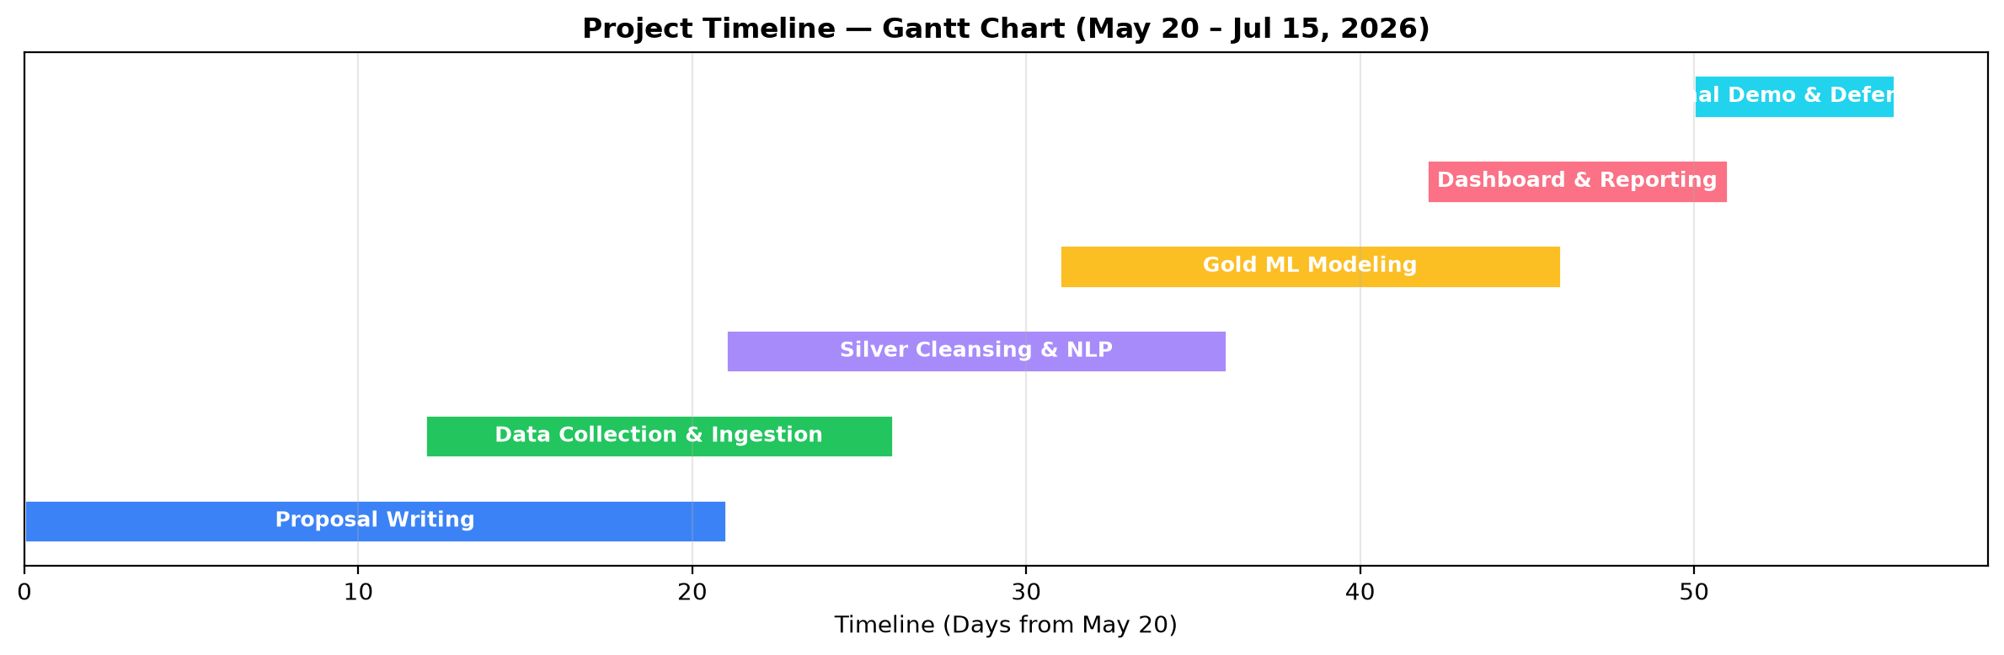
Figure A.1 — Gantt Chart (May 20 – Jul 15, 2026)

Appendix B: Generative AI Use Log
Generative AI tools used during this project (transparency per UTM policy):
- Hermes Agent (Nous Research) — code scaffolding, pipeline debugging, report drafting assistance.
- Claude (Anthropic) — literature synthesis, regex NLP pattern design.
- GitHub Copilot — inline Python/PySpark autocomplete.
- All final code, results, and metrics were verified by execution (pytest + pipeline run), not AI-generated claims.

References
Armbrust, M., Ghodsi, A., Xin, R., & Zaharia, M. (2021). Lakehouse: A new generation of open platforms that unify data warehousing and advanced analytics. CIDR.
Zaharia, M., et al. (2016). Apache Spark: A unified engine for big data processing. Communications of the ACM, 59(11), 56–65.
Priem, J., Piwowar, H., & Orr, R. (2022). OpenAlex: A fully open index of scholarly works. STI Conference.
Rousseeuw, P. J. (1987). Silhouettes: A graphical aid to cluster analysis. Journal of Computational and Applied Mathematics, 20, 53–65.
Apache Software Foundation. (2023). Apache Spark MLlib: Scalable machine learning library. https://spark.apache.org/mllib/
Platt, J. C. (1999). Probabilistic outputs for support vector machines. Advances in Large Margin Classifiers, 10(3), 61–74.

