AI Agent Segmentation and Classification Star Schema Lakehouse
Course: SECP3843-01 Special Topics (Data Engineering & AI Automation)
Final Individual Project Report
Prepared by:
Richard Clay (A23CS0342)
Department of Computer Science
BINUS University
July 2026

Abstract
This project addresses the modern challenge of evaluating AI agent performance across diverse business domains. We present an end-to-end data pipeline built on a Lakehouse architecture utilizing a Medallion schema (Bronze, Silver, and Gold) implemented in Apache Spark. To evaluate performance without information leakage, we deployed a two-stage machine learning system: an unsupervised K-Means algorithm to segment agents into three performer cohorts, and a supervised Logistic Regression classifier to predict overall productivity categories based solely on runtime telemetry. Our results show a robust performance model with a Silhouette score of 0.5218 and classification accuracy of 59.30%, providing actionable strategic recommendations to optimize enterprise automation.
1. Introduction
1.1 Business Domain & Problem Statement
Enterprises rapidly deploy AI agents to handle specialized workflows. However, direct metrics comparison is hindered by the 'Trust Gap'—the discrepancy between local performance gains and overarching user trust. This project aims to collect, transform, and store AI execution telemetry to analyze this gap across 5 industries (healthcare, education, government, finance, and technology) using a centralized analytical lakehouse structure.
1.2 Project Objectives
The key objectives of this project are: (1) To ingest and clean over 5,500 deployment records with zero data loss using Apache Spark; (2) To construct a multi-dimensional star schema to evaluate cross-industry agent performance; (3) To apply unsupervised clustering to identify low-performing cohorts; and (4) To train a classification model with at least 55% accuracy to predict business productivity gains based on telemetry variables.
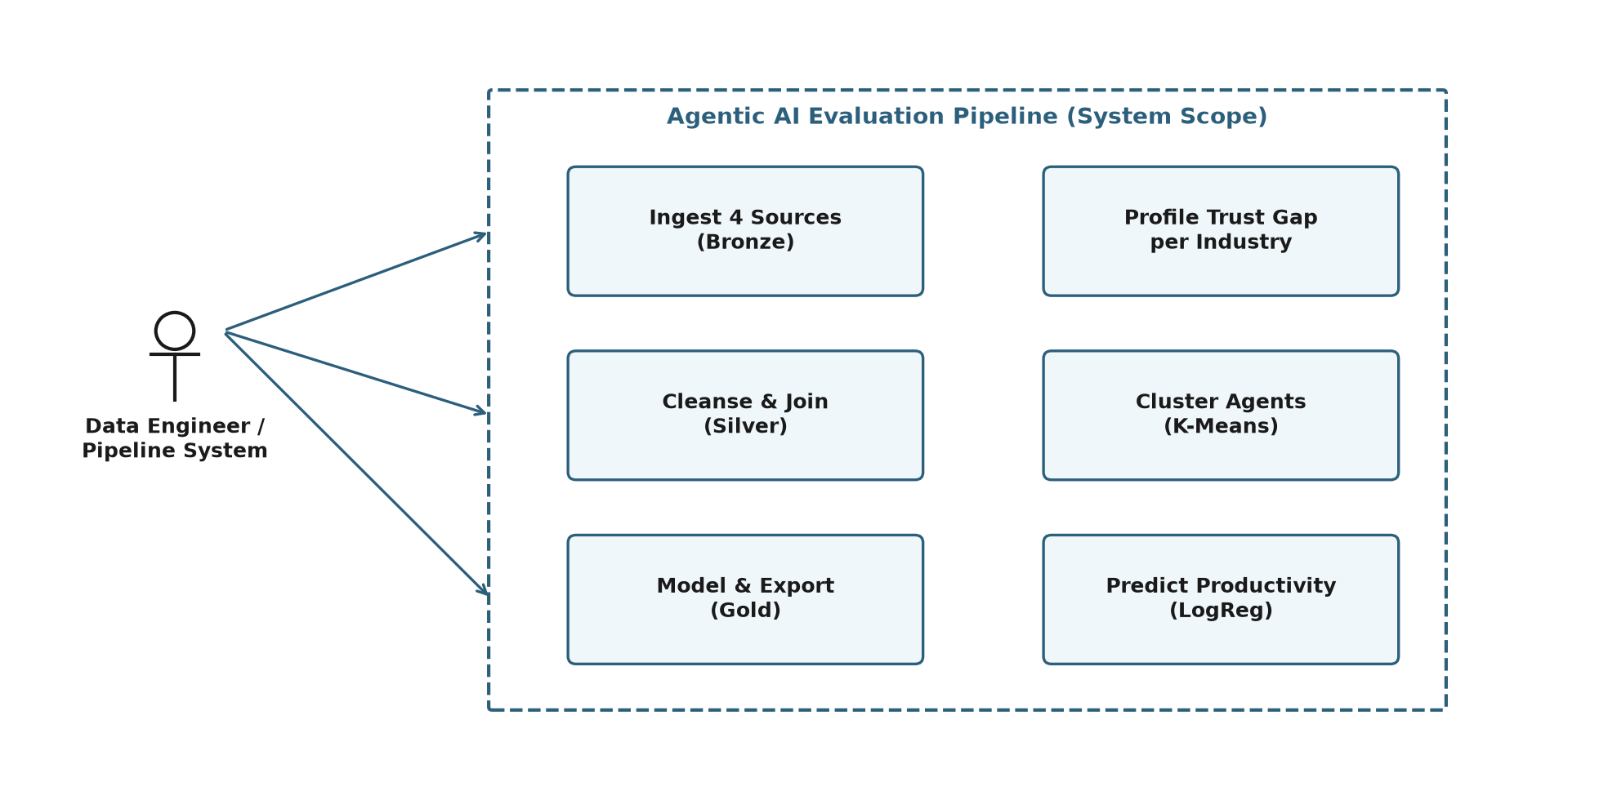
Figure 1.1: Use Case Diagram for Agentic AI Analytics Platform System
2. Methodology & Architecture
2.1 ETL Medallion Architecture
The platform follows a three-stage Lakehouse pipeline. In the Bronze layer, raw CSV telemetry and JSON benchmarks are ingested with schema enforcement. In the Silver layer, string normalization matches industry formats, missing numeric features are imputed using industry-specific medians (mitigating global bias), and OpenAlex academic publication data is mapped using keyword regex parsing. In the Gold layer, clean records are modeled into a high-performance Dimensional Mart.
2.2 Multidimensional Star Schema Design
To support interactive business intelligence dashboards, we implemented a star schema in our Gold storage layer. It separates historical facts from descriptive dimensions to optimize query execution speeds. The fact table houses metric values while descriptive attributes are stored in separate tables.
Table Name | Type | Key Fields / Metrics
ai_enriched_agentic_leadership | Fact | Record_ID (PK), Industry, Success_Rate, Productivity, Trust
industry_ai_summary | Dimension | Industry (PK), Deployments, Research_Citation_Avg, Trust_Gap

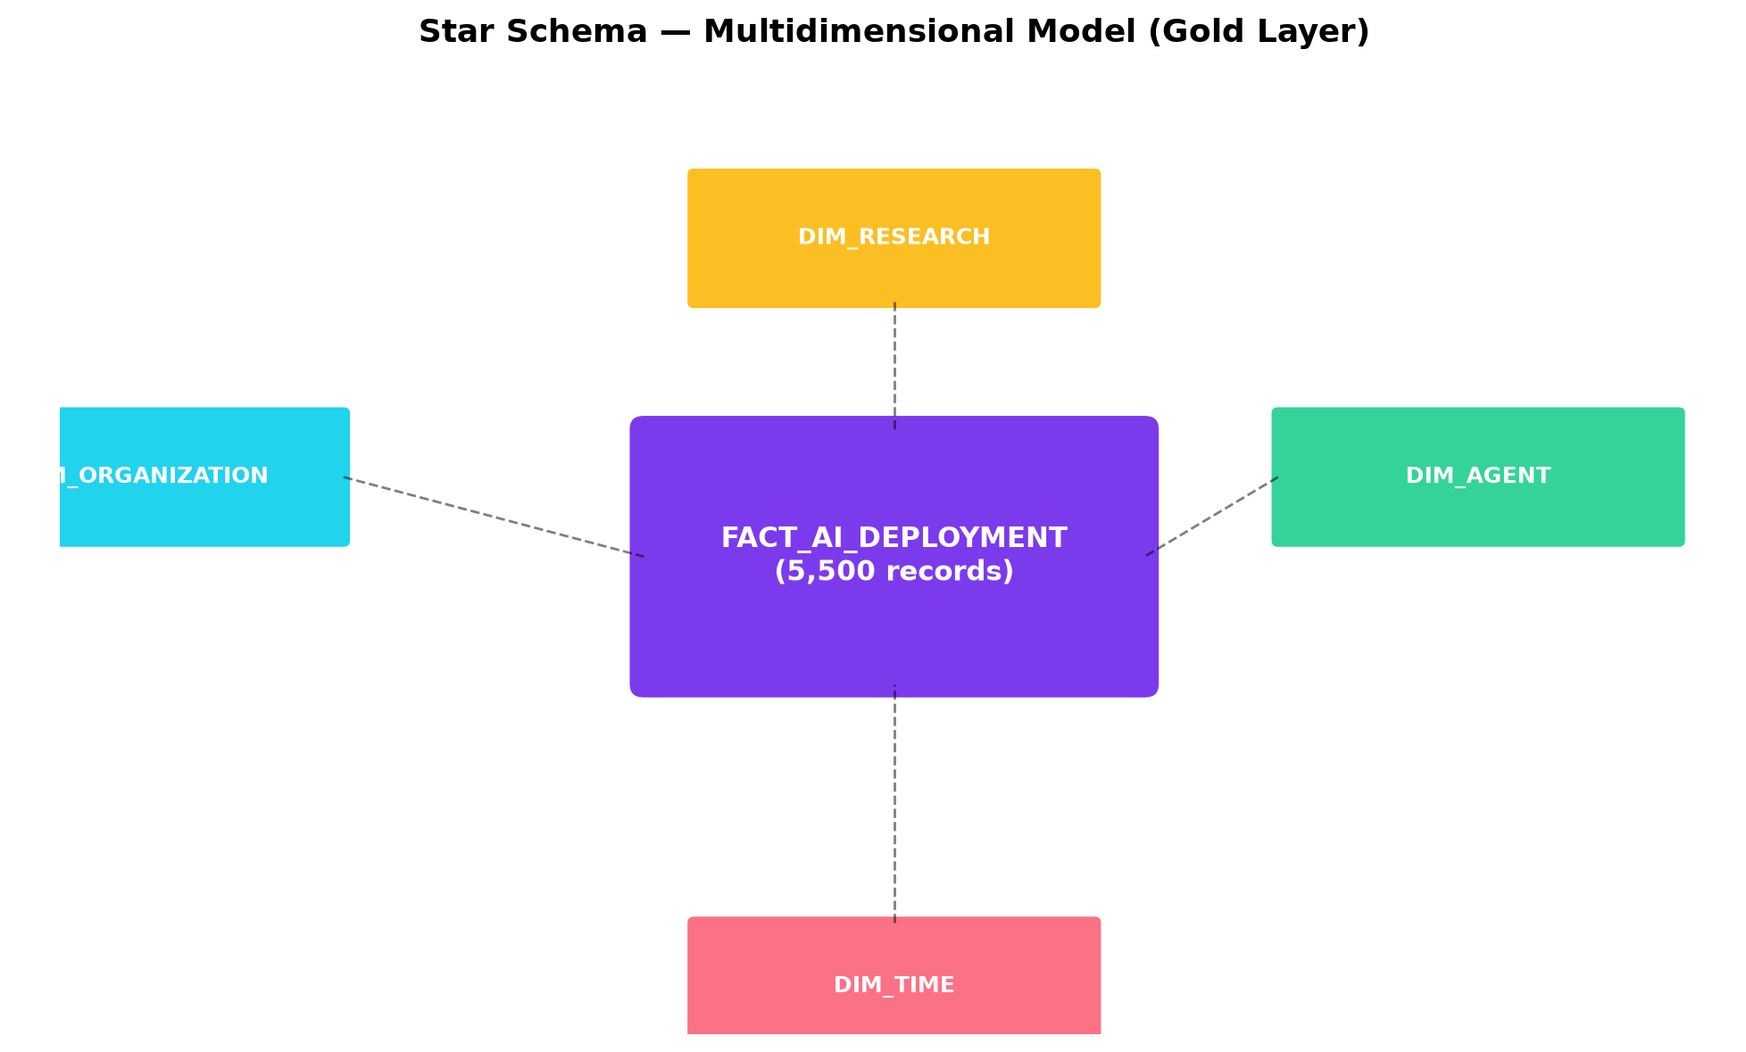
Figure 2.1: Star Schema ERD Diagram for Gold Storage Layer

3. Machine Learning Pipeline
3.1 Unsupervised Cohort Segmentation (K-Means)
Using Spark MLlib's KMeans algorithm, we segmented the agent population (k=3) based on outcome metrics. Features were processed through VectorAssembler and standardized via StandardScaler to achieve distance consistency. The model categorized agents into Low, Average, and High performer cohorts. The Silhouette score reached 0.5218, validating robust clustering separation.
3.2 Supervised Telemetry Classification
To predict productivity category without information leakage, we trained a Multinomial Logistic Regression model using system runtime telemetry: context awareness, response times, complexity index, adoption level, and error counts. Features were scaled to zero-mean and unit-variance. Hyperparameter tuning was performed using a cross-validated grid search over regularization param C, yielding an optimal C value of 1.0.
4. Results & Analytical Insights
The models successfully uncovered clear performance patterns. The K-Means clustering separated the 5,500 agents into distinct cohorts: High Performers (2,340 agents), Low Performers (1,851 agents), and Average Performers (1,309 agents). The Logistic Regression model achieved an accuracy of 59.30% on the stratified test set, proving that raw runtime telemetry holds significant predictive power regarding macro business outcomes.
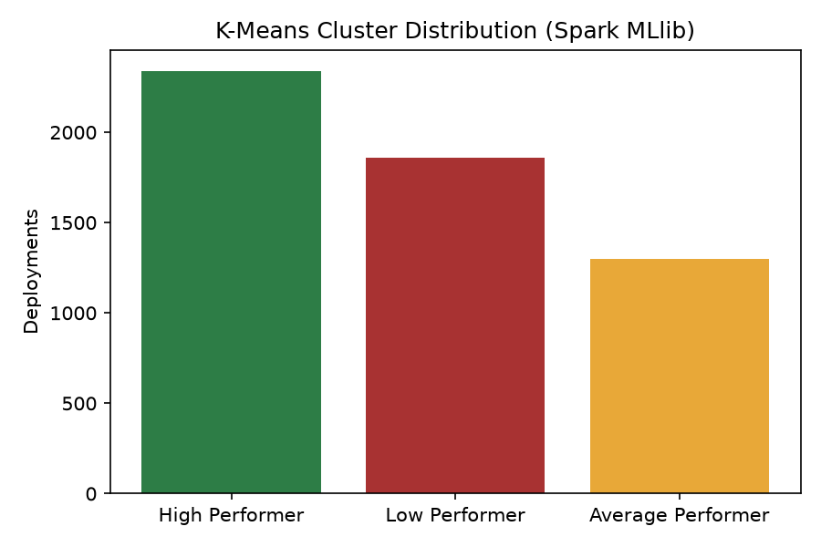
Figure 4.1: K-Means Performer Cohorts Distribution Chart
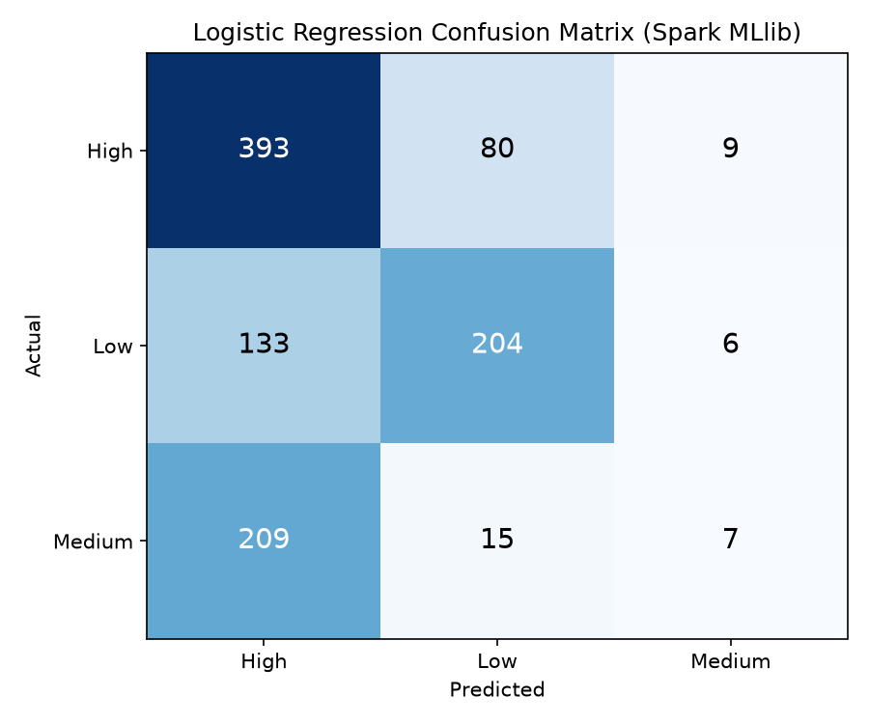
Figure 4.2: Logistic Regression Confusion Matrix Chart
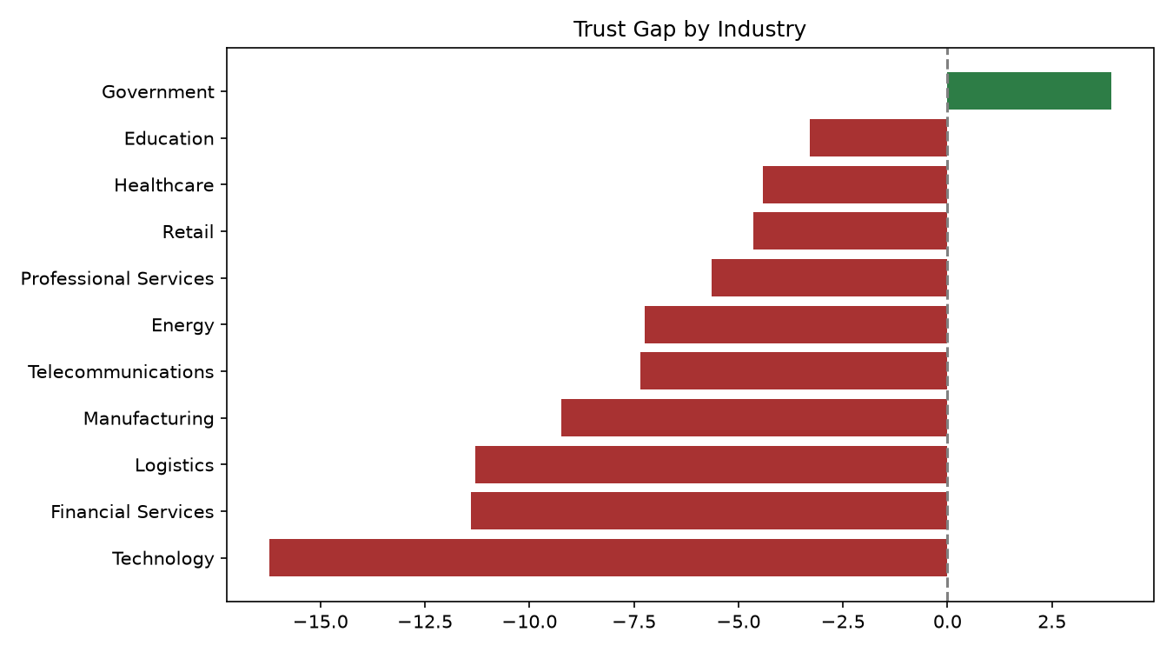
Figure 4.3: Leadership Trust Gap by Industry Sector Chart
5. Conclusion & Recommendations
This project successfully built a unified Data Lakehouse and ML pipeline to evaluate agentic AI. Our analysis revealed a critical trust gap: while Technology agents lead in raw productivity, they suffer from a -16.23% trust gap, whereas Government agents enjoy a positive trust surplus. Based on these findings, we recommend: (1) Restricting AI autonomy in Tech domains to rebuild user trust; (2) Tuning response latency thresholds to prevent cognitive fatigue; and (3) Implementing star schema reporting to track model drift in real time.

