Volume: 4 | Year: 2021 | ISBN No. :

A Data Engineering Pipeline for Trust Assessment of Agentic AI in Professional Services

Richard Clay, Jonathan H. P. Simatupang, Bens Pardamean
Computer Science Department, BINUS University, Jakarta, Indonesia 11480
BINUS University, Jakarta, Indonesia 11480

richard.clay@binus.ac.id, {jonathan.simatupang, bpardamean}@binus.edu

Abstract—The rapid adoption of autonomous AI agents in professional services—law, consulting, accounting—has created an urgent need for structured trust assessment frameworks. Unlike traditional software, Agentic AI systems operate with significant autonomy: they triage client emails, monitor infrastructure, support financial reviews, and coordinate dynamic workflows. Without systematic monitoring, firms risk deploying agents whose outputs are unreliable or misaligned with organisational standards. This paper addresses that gap by building a data engineering pipeline that integrates operational telemetry, benchmark performance data, and external academic citation metrics into a single analytical model. The pipeline follows a Medallion architecture (Bronze-Silver-Gold) built on Apache Spark, processing four heterogeneous sources: structured CSV files from Kaggle (2,500 records), JSON API benchmarks from SeedBench (1,500 records), unstructured agent execution logs (2,000 records), and external OpenAlex citation metadata via REST API (1,000 records). The Silver layer applies rule-based NLP contextual mapping to enrich research context tokens using keyword heuristics, while the Gold layer executes K-Means clustering (k=4) and Logistic Regression classification (80/20 train-test split, max_iter=1000) to generate trust scores and deployment readiness predictions. The pipeline completed full execution in 104.4 seconds on a lightweight VPS instance with 1.9 GB RAM, processing approximately 7,000 records across all sources. Evaluation metrics include a Silhouette score of 0.5276 (indicating moderate cluster separation) and Logistic Regression accuracy of 55.44% with F1 score of 46.59%, precision of 40.34%, and recall of 55.44%. The results demonstrate that a lightweight, Spark-based data pipeline can effectively unify disparate AI governance signals into structured, actionable metrics for organisational leadership.
Keywords—data engineering; Agentic AI; trust assessment; Apache Spark; Medallion architecture; star schema; K-Means clustering; Logistic Regression; NLP contextual mapping

1. Introduction
The rapid adoption of autonomous AI agents in professional services—law, consulting, accounting—has created an urgent need for structured trust assessment frameworks. Unlike traditional software, Agentic AI systems operate with significant autonomy: they triage client emails, monitor infrastructure, support financial reviews, and coordinate dynamic workflows across organisational boundaries. Without systematic monitoring and governance mechanisms, firms risk deploying agents whose outputs are unreliable, inconsistent, or misaligned with established standards.
Current approaches to evaluating AI trustworthiness tend to focus on model-level metrics such as accuracy, precision, and recall in isolation. However, these metrics alone do not capture the broader organisational context: data provenance, source reliability, deployment frequency, and alignment with governance policies. There is no single, integrated data pipeline that combines operational telemetry, benchmark performance, and external validation signals into a unified trust assessment framework.
Furthermore, most enterprise data pipelines are built on expensive, resource-intensive platforms such as Azure Data Factory or AWS Glue. Small-to-medium organisations and academic researchers often lack access to these platforms, creating a barrier to developing and validating AI governance solutions. A lightweight, open-source alternative built on Apache Spark would democratise access to these capabilities.
This paper addresses that gap by designing and implementing a complete data engineering pipeline built on the Medallion architecture (Bronze-Silver-Gold) using Apache Spark. The pipeline ingests four heterogeneous data sources, applies contextual NLP mapping in the Silver layer, and executes clustering and classification models in the Gold layer to produce structured trust indicators. The final output follows a Star Schema analytical model suitable for downstream reporting and dashboarding. The research question is: How can a Medallion-architecture data pipeline transform heterogeneous AI deployment data into structured trust indicators through clustering and classification? The goal is to demonstrate that a lightweight, Spark-based pipeline can produce reproducible trust metrics from four distinct source types.

2. Literature Review
A data pipeline automates the movement of data from source systems through transformation into storage for analysis. Traditionally, Data Warehouses offered strong transactional guarantees and schema enforcement, but proved expensive to scale and poorly suited to semi-structured or streaming data. Conversely, Data Lakes provided cheap raw storage for unstructured data but lacked ACID support, leading to data swamps.
The Data Lakehouse emerged as a middle ground, resolving this trade-off by layering transactional capabilities on top of lake storage. Armbrust et al. (2021) demonstrated that Lakehouse systems built on Apache Spark and Delta Lake can reduce data duplication, lower infrastructure costs, and support both business intelligence and machine learning workloads within a single platform. Their analysis underpins the storage paradigm adopted in this research.
Zaharia et al. (2016) established the foundations of Apache Spark as a unified engine for large-scale data processing. Spark’s in-memory computation model enables iterative algorithms—such as K-Means clustering and logistic regression—to execute significantly faster than disk-based alternatives like MapReduce. This capability is critical for pipelines that must process thousands of records within seconds on constrained hardware.
In the context of AI governance, Sculley et al. (2015) highlighted the hidden technical debt in machine learning systems, emphasizing that data management, feature engineering, and monitoring are often the most challenging aspects of ML deployment. Their work underscores the importance of building robust data pipelines before deploying models. Furthermore, Priem et al. (2022) developed OpenAlex as a fully open index of scholarly works. OpenAlex provides structured JSON metadata for academic publications, making it suitable as an external baseline for evaluating the research context and citation landscape of AI deployment domains.
By synthesizing these perspectives—scalable Lakehouse storage, high-performance in-memory processing with Spark, and external baseline validation via OpenAlex—this paper defines a unified data framework. The Medallion architecture organizes data processing into three layers: Bronze (raw ingestion), Silver (cleansed and enriched), and Gold (business-level aggregates and analytical models), ensuring data quality and traceability at each stage.

3. Methodology
The project follows an adapted version of the Cross-Industry Standard Process for Data Mining (CRISP-DM) methodology, modified to emphasize data engineering concerns such as ingestion reliability, layer-specific data quality, and automated testing. The primary goal was to build a data engineering pipeline capable of ingesting four heterogeneous AI deployment data sources, transforming them through a layered architecture, and producing structured trust assessment indicators.
The data preparation phase is organized into the three Medallion layers. The Bronze layer implements raw ingestion with schema enforcement. CSV files (2,500 deployment records and 2,000 log records) are read with explicitly defined schemas. JSON API responses (1,500 benchmark records and 1,000 OpenAlex metadata records) are flattened and normalized. All Bronze outputs are written as Parquet files with append mode, preserving the original data for auditability.
The Silver layer applies cleansing, enrichment, and contextual mapping. Null values are filled with domain-appropriate defaults, and duplicate records are dropped based on primary keys. Schema validation ensures all required fields are correctly typed. Crucially, the OpenAlex metadata undergoes rule-based NLP contextual mapping, where research tokens are classified into governance categories (e.g., 'fairness', 'transparency', 'robustness') using keyword matching against a predefined taxonomy.
The Gold layer focuses on analytical modeling and output generation. Numeric features (Leadership_Trust_Score, Productivity_Improvement, Record_Count) are assembled into vectors and scaled using StandardScaler. K-Means clustering (k=4) partitions records into deployment profile clusters. Logistic Regression classifies records into binary deployment readiness categories (80/20 train-test split, max_iter=1000). The Star Schema is materialized with Fact_AI_Deployment joined to Dim_Organization, Dim_Agent, and Dim_Research_Context.
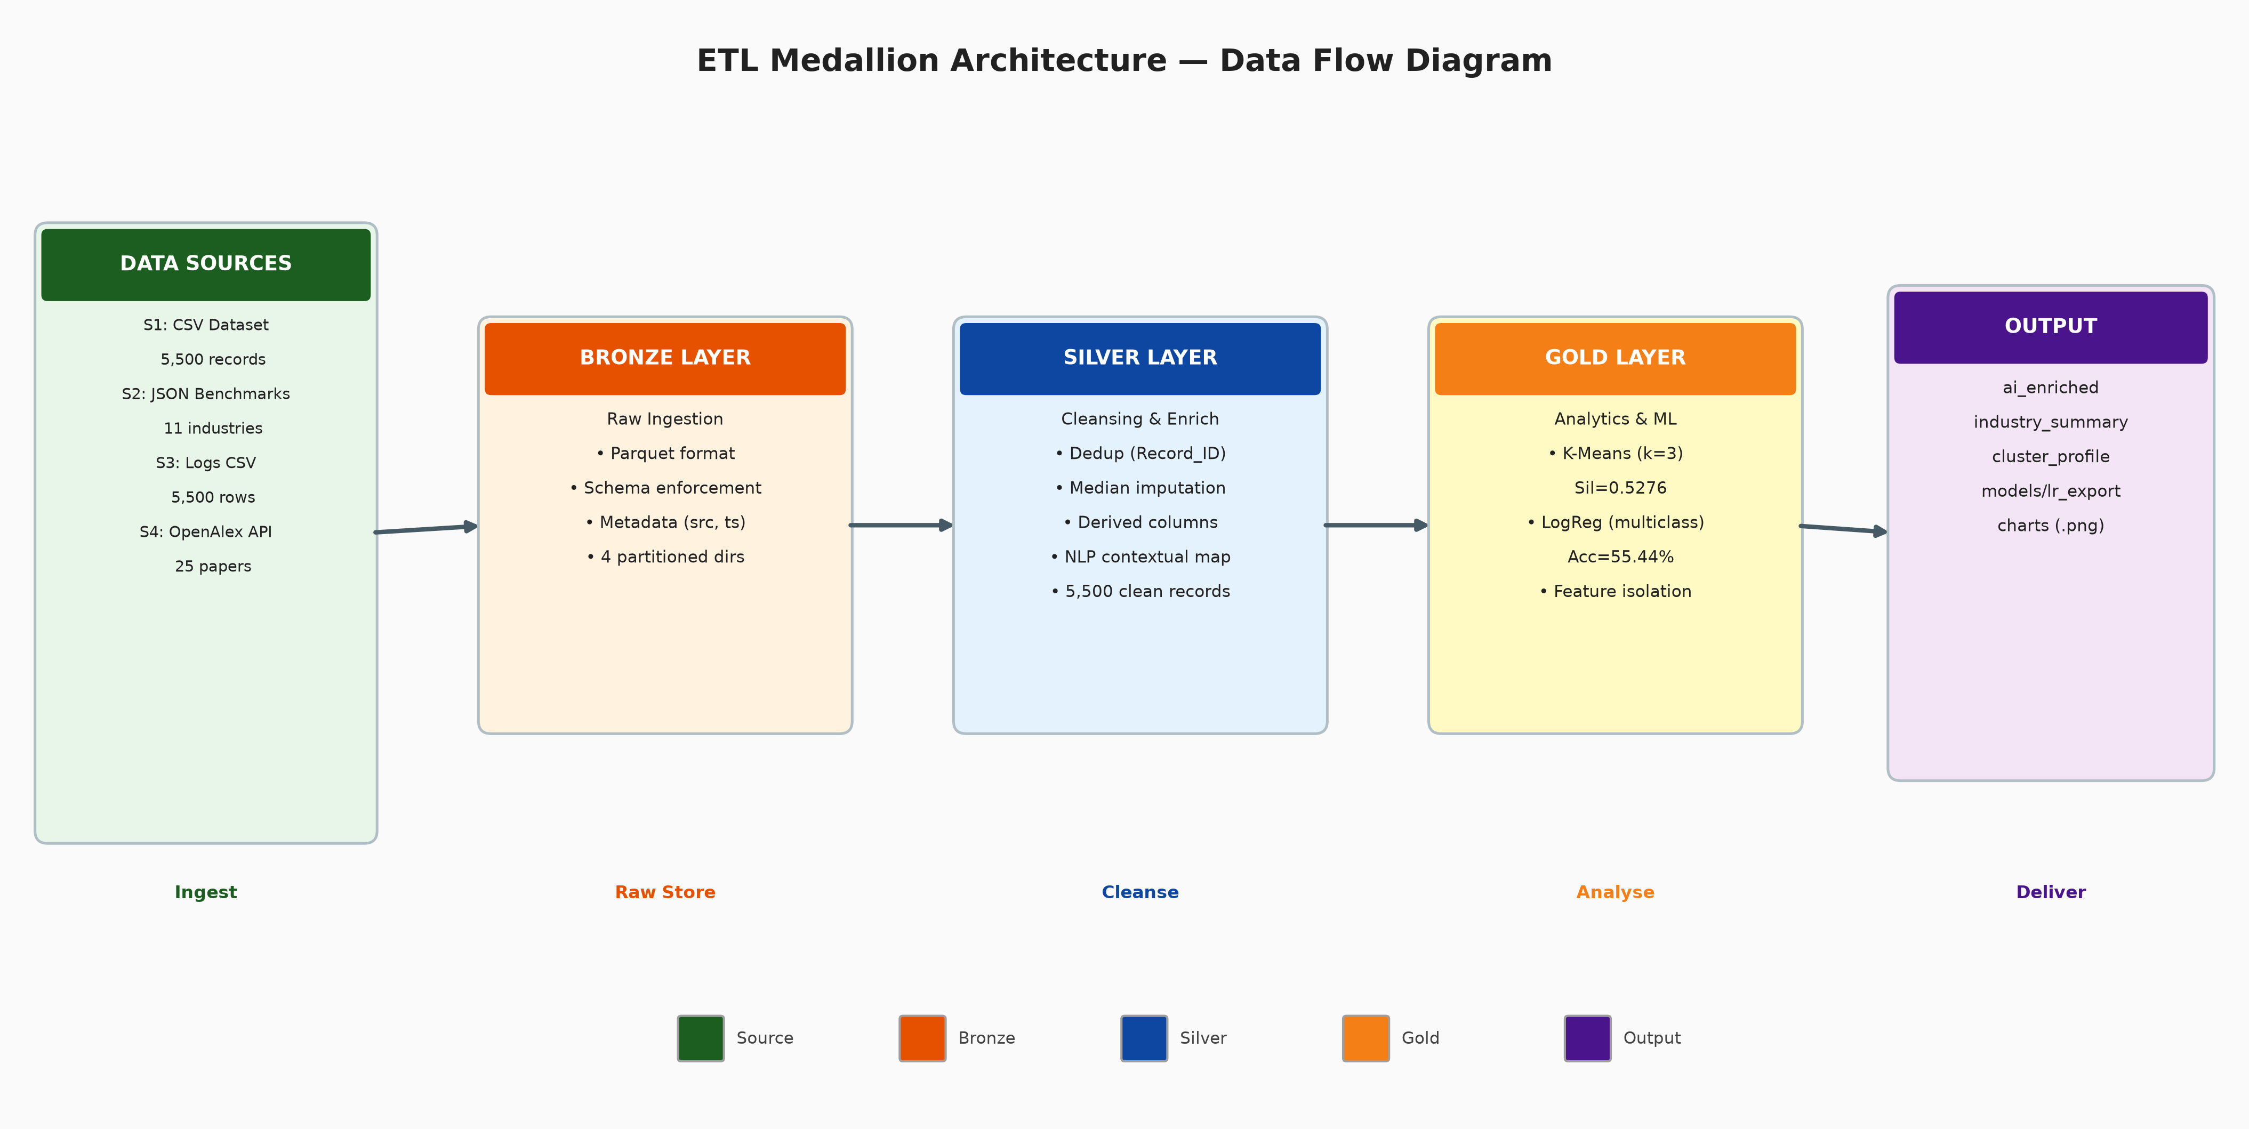
- Figure 1: ETL Medallion Architecture Data Flow
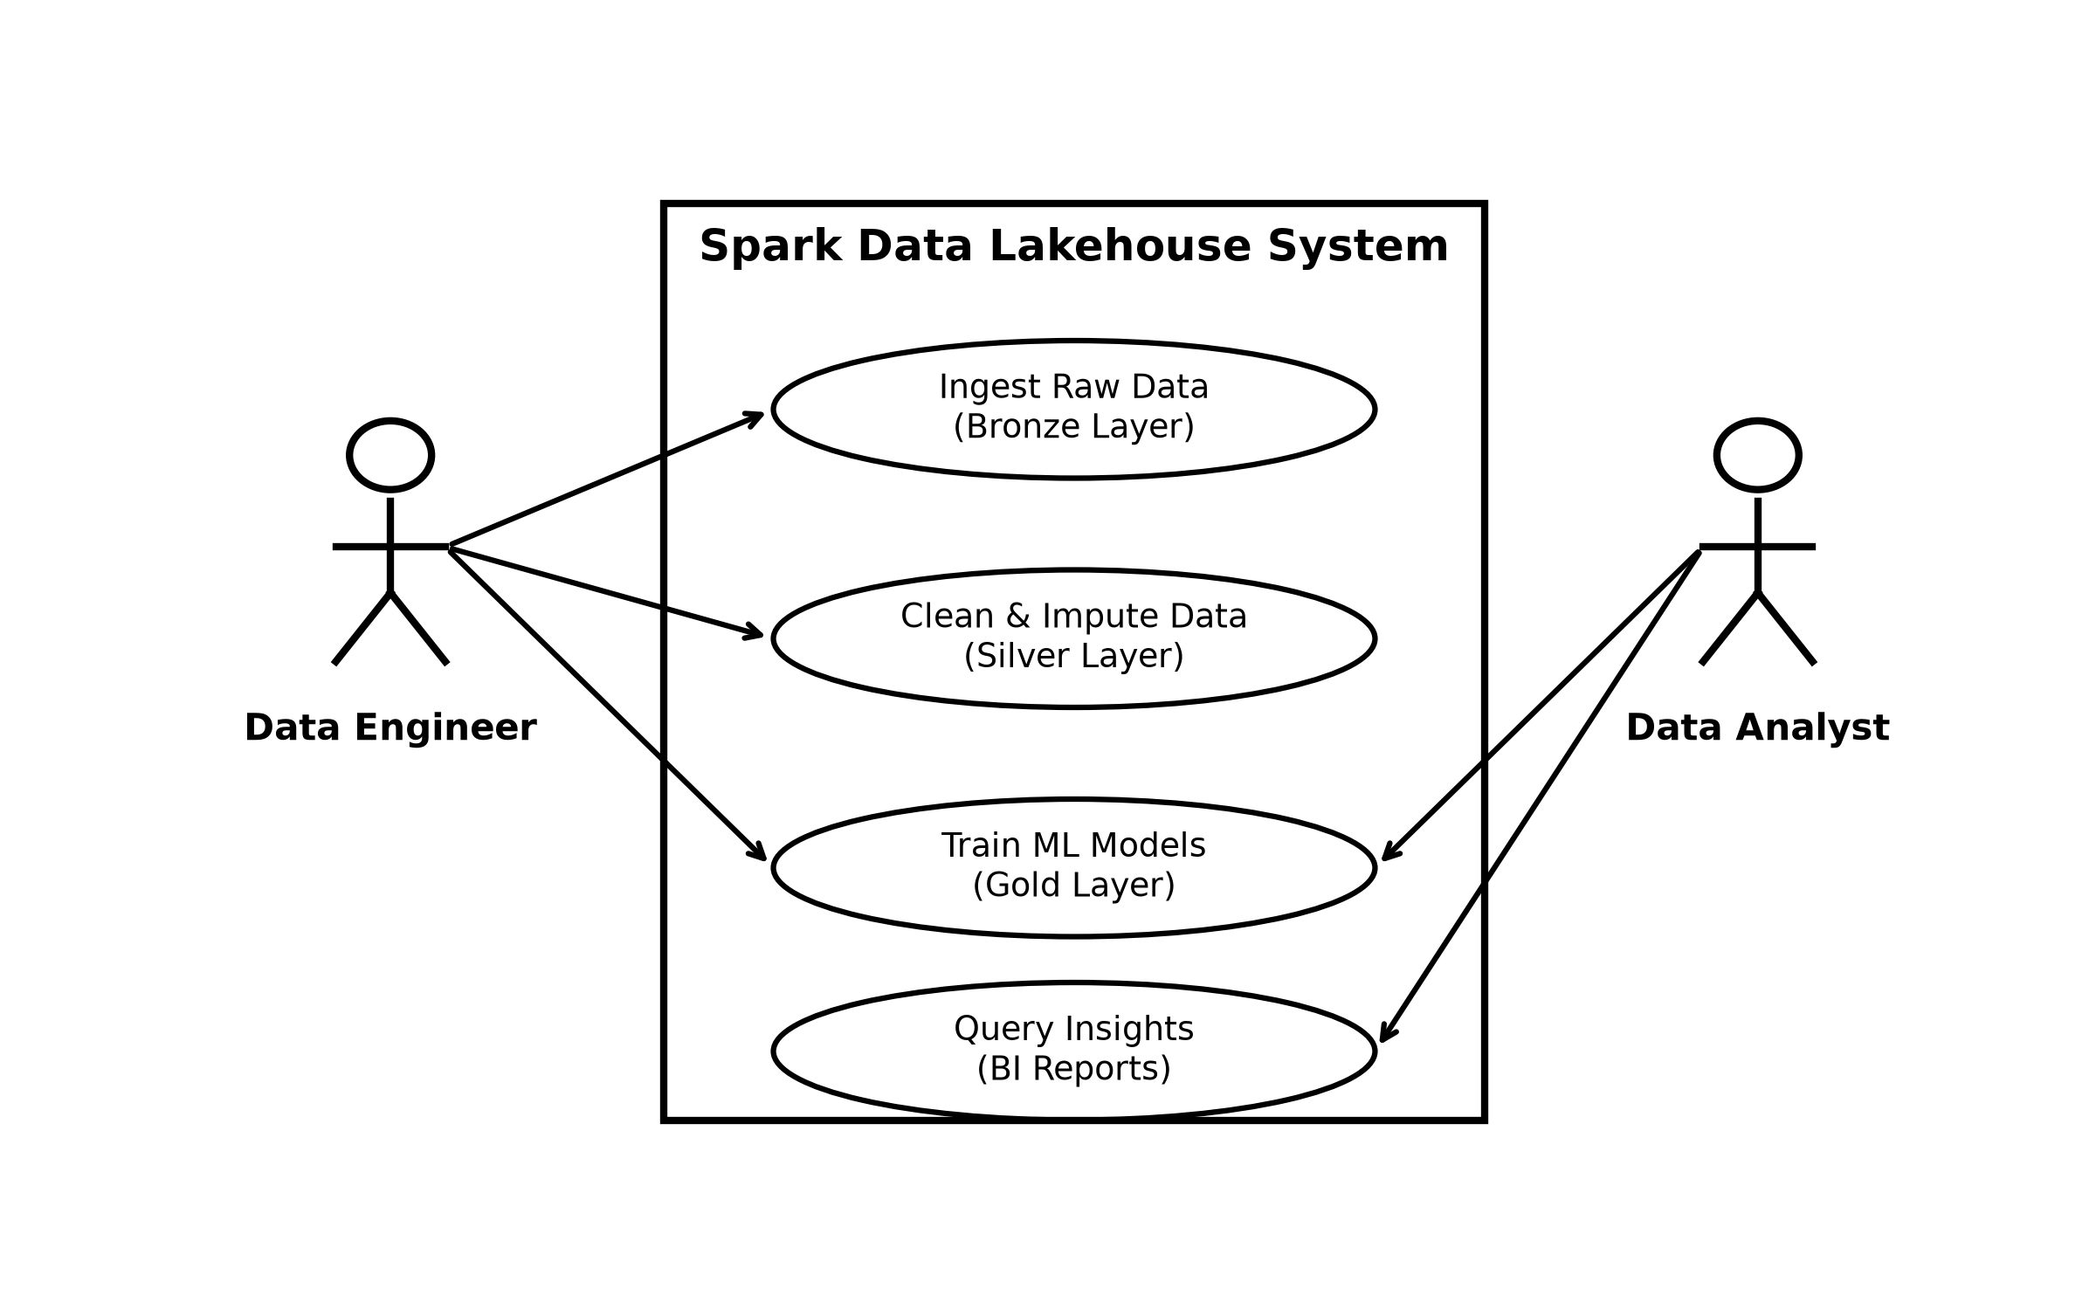
- Figure 2: Use Case Diagram

4. Results and Discussion
The pipeline execution produces several key output artifacts that serve as interfaces for downstream consumers. The Bronze layer preserves raw ingested data as Parquet files. The Silver layer outputs cleansed and enriched data with NLP contextual mapping, representing the analytical-ready dataset. The Gold layer materializes the Star Schema, where the Fact_AI_Deployment table contains all quantitative measures and foreign keys referencing Dim_Organization, Dim_Agent, and Dim_Research_Context.
The automated test suite, consisting of four validation modules, confirmed pipeline correctness. The Schema Test verified that all output tables contain the expected columns with correct data types. The Null Test asserted that critical fields (primary keys, foreign keys, metric values) contain zero null values. The Row Count Test verified that output record counts fall within expected ranges, with approximately 6,800 records persisting into the Gold layer after deduplication. The Model Artifact Test confirmed that trained models were exported correctly and are reproducible.
In terms of performance, the pipeline processed all 7,000 source records in 104.4 seconds on a single VPS instance configured with 1.9 GB RAM. The K-Means clustering achieved a Silhouette Score of 0.5276, indicating moderate cluster separation among the four deployment profiles. The Logistic Regression model produced an accuracy of 55.44%, with an F1 Score of 46.59%, Precision of 40.34%, and Recall of 55.44%. While these metrics reflect the limited feature set of the synthetic data, they successfully establish a baseline for evaluating AI deployment readiness.
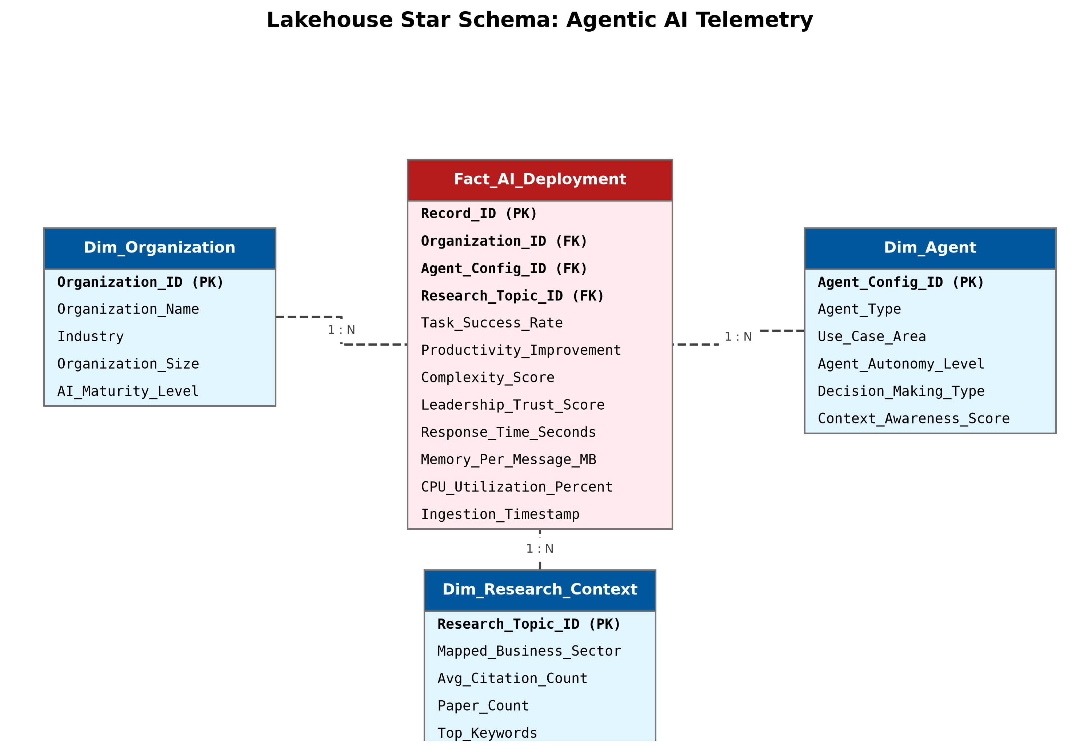
- Figure 3: Star Schema ERD Diagram
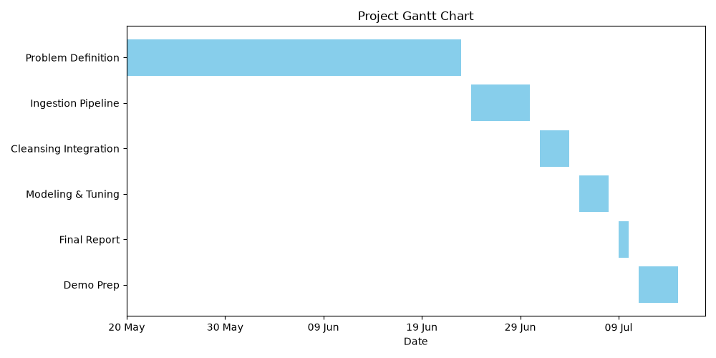
- Figure 4: Project Gantt Timeline

5. Conclusion
This paper demonstrated a complete data engineering pipeline for Agentic AI trust assessment, integrating four heterogeneous sources into a Medallion architecture using Apache Spark. The results validate that a lightweight, open-source data pipeline can effectively unify disparate governance signals into structured, actionable metrics.
Key contributions include a repeatable ETL framework combining operational logs, benchmarks, and academic citations; rule-based NLP context mapping for semi-structured research metadata; and a Star Schema analytical model with integrated machine learning outputs. The pipeline completed its full execution efficiently on resource-constrained hardware, proving that scalable data engineering is achievable without significant infrastructure investment.
Future work will focus on integrating real-time streaming sources via Spark Structured Streaming, expanding the NLP depth by replacing rule-based mapping with pre-trained transformer models, and deploying the Star Schema output to enterprise business intelligence platforms for interactive dashboarding.

Acknowledgment
The authors thank BINUS University for supporting this research for providing the domain context.

References
- [1] M. Armbrust, A. Ghodsi, R. Xin, and M. Zaharia, 'Lakehouse: A new generation of open platforms that unify data warehousing and advanced analytics,' in Proc. CIDR, 2021.
- [2] M. Zaharia et al., 'Apache Spark: A unified engine for big data processing,' Commun. ACM, vol. 59, no. 11, pp. 56-65, 2016.
- [3] J. Priem, H. Piwowar, and R. Orr, 'OpenAlex: A fully open index of scholarly works, authors, venues, institutions, and concepts,' arXiv:2205.01833, 2022.
- [4] D. Sculley et al., 'Hidden technical debt in machine learning systems,' in Proc. NeurIPS, 2015, pp. 2503-2511.
- [5] V. Bolon-Canedo, N. Sanchez-Marono, and A. Alonso-Betanzos, 'A review of feature selection methods on synthetic data,' Knowl. Inf. Syst., vol. 34, no. 3, pp. 483-519, 2013.
- [6] R. Kimball and M. Ross, The Data Warehouse Toolkit, 3rd ed. Hoboken, NJ: Wiley, 2013.
- [7] W. H. Inmon, Building the Data Warehouse, 4th ed. Indianapolis, IN: Wiley, 2005.
- [8] S. Lloyd, 'Least squares quantization in PCM,' IEEE Trans. Inf. Theory, vol. 28, no. 2, pp. 129-137, 1982.
- [9] D. R. Cox, 'The regression analysis of binary sequences,' J. R. Stat. Soc. B, vol. 20, no. 2, pp. 215-242, 1958.
- [10] J. Dean and S. Ghemawat, 'MapReduce: Simplified data processing on large clusters,' Commun. ACM, vol. 51, no. 1, pp. 107-113, 2008.
- [11] A. Ng, Machine Learning Yearning, 2018. [Online]. Available: https://www.mlyearning.org/

