# Association Rule:

1. Business Problem: To come up with different insights regarding the groceries dataset.
2. Data Collection: Groceries.csv
3. Data mining: We performed apriori algorithm on the Groceries dataset.

For support = 0.003, confidence = 0.6 and min. length = 2, we came up with 7 rules:

The top 6 rules are listed below:

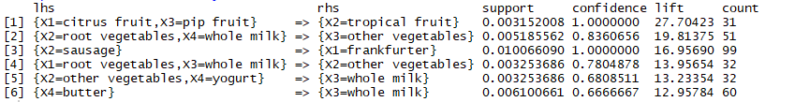

The Scatter plot for the is shown below:

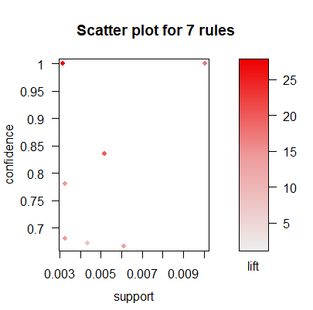

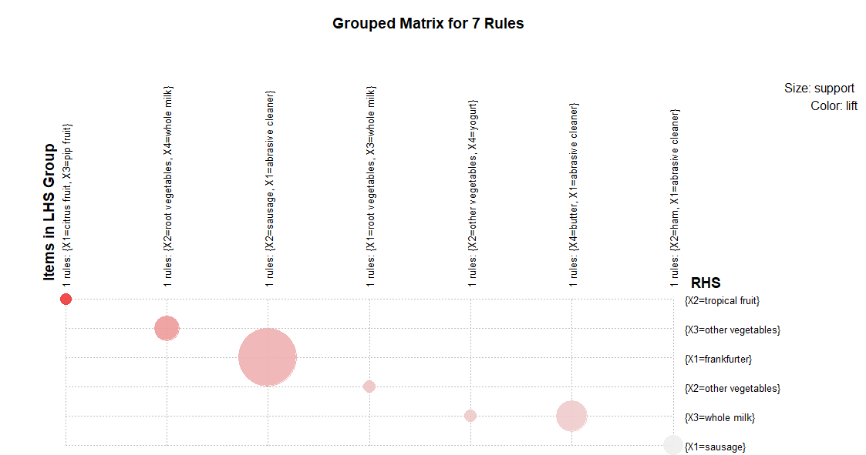

The insights drawn from the above plot are:

* Sausage, abrasive cleaner and frankfurter should be bundled together.
* Whole milk and butter should be kept close to abrasive cleaner