# Association-Rules :

1. Business Problem: To look for interesting insights using Association Rules in Book.csv Dataset
2. Data Collection: Book.csv
3. Data Mining: We performed the Association rule using apriori algorithm on the book dataset.

For support = 0.5 , confidence = 0.7 and min. length = 3, we came up with 1102 rules.

First 6 rules are shown below, sorted by the lift ratio:

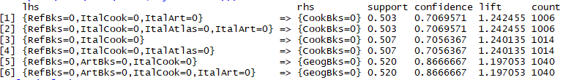

The Scatter Plot is also drawn Below:

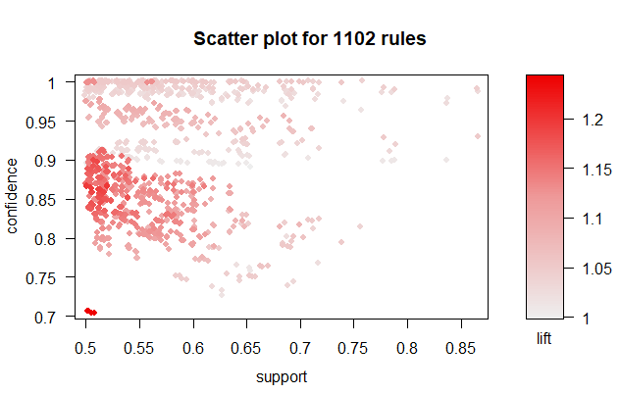

The Rules with highest confidence, support and lift are the best rules to consider.

Another plot is shown below:

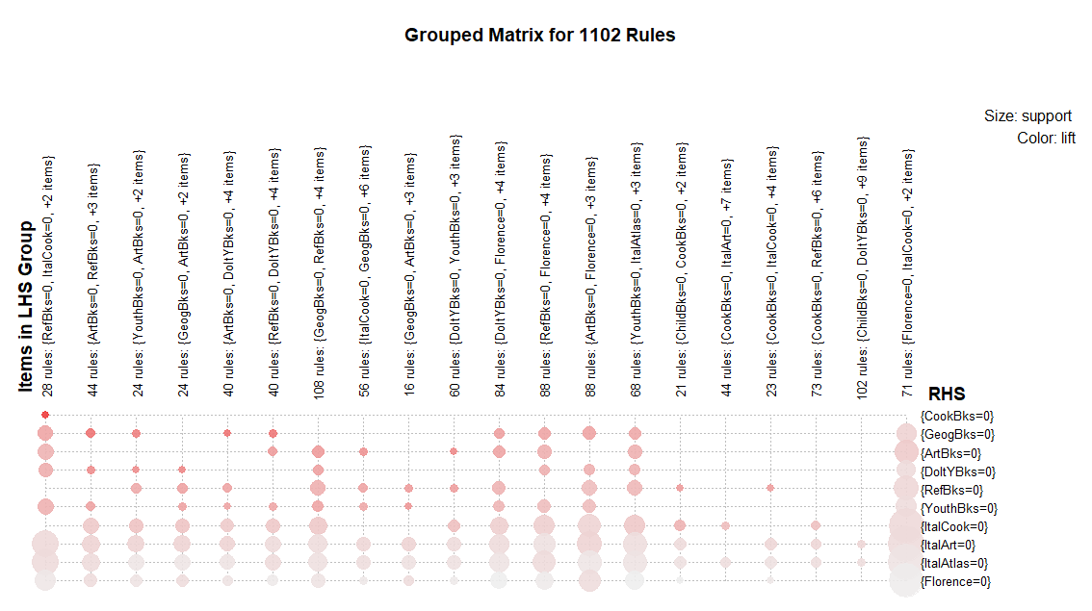

From the above plot, we came up with the below mentioned insights:

* Artbooks, ItalArt and Florence should be bundled together.
* ItalAtlas, RefBooks and ItalCook books should be bundled together.
* YouthBooks should be kept close to ItalCook Books.