# Association Rule:

1. Business Problem: To come up with different insights regarding the my_movies dataset.
2. Data Collection: my_movies.csv
3. Data mining: We performed apriori algorithm on the my_movies dataset.

For support = 0.2, confidence = 0.5 and min. length = 2, we came up with 11 rules:

The top 6 rules are listed below:

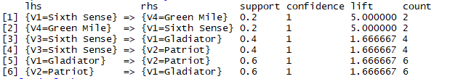

The Scatter plot for the is shown below:

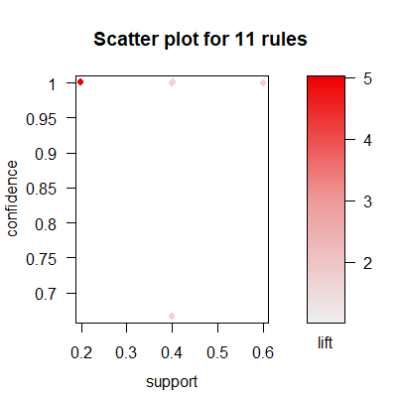

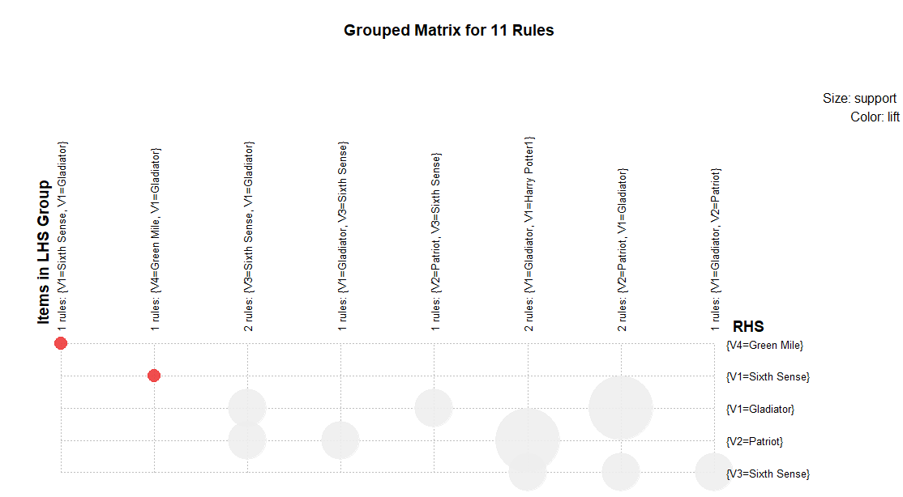

The following insights can be drawn from the above plot:

* Those who watched Green mile and gladiator, also watched Sixth Sense
* Those who watched gladiator and harry potter, also watched patriot