# Association Rule:

1. Business Problem: To come up with different insights regarding the Retail dataset.
2. Data Collection: transaction_retail.csv
3. Data mining: We performed apriori algorithm on the transaction_retail dataset.

For support = 0.1, confidence = 0.5 and min. length = 2, we came up with 11 rules:

The top 6 rules are listed below: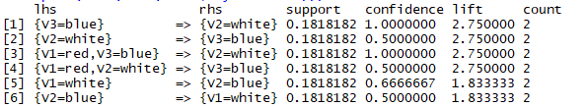

The Scatter plot for the is shown below:

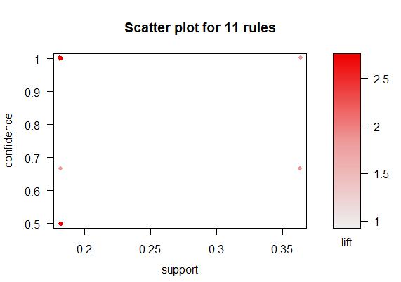

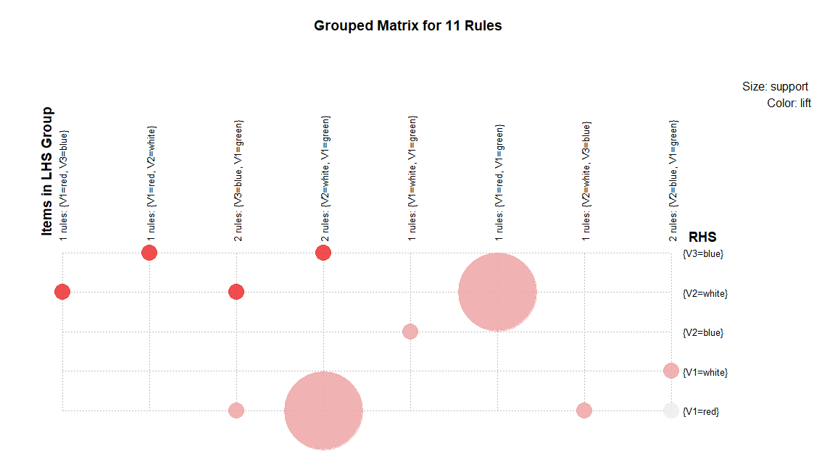

The major inferences we can draw are:

* Red , green and white occurs simultaneously
* White , green and blue occurs simultaneously
* Red , blue and white occurs simultaneously