# Association Rule:

1. Business Problem: To come up with different insights regarding the Retail dataset.
2. Data Collection: transaction_retail.csv
3. Data mining: We performed apriori algorithm on the transaction_retail dataset.

For support = 0.004, confidence = 0.5 and min. length = 3, we came up with 96 rules:

The top 6 rules are listed below:

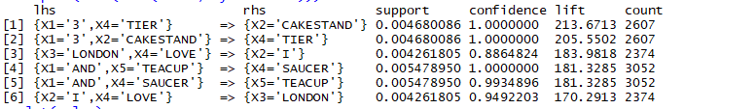

The Scatter plot for the is shown below:

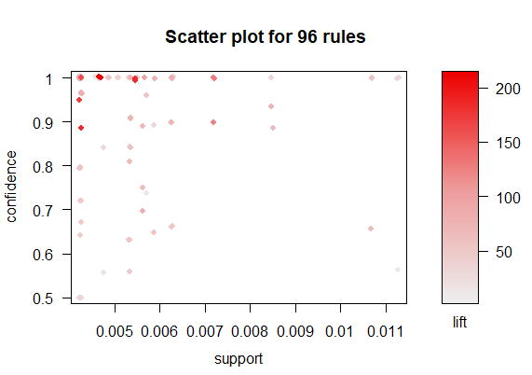

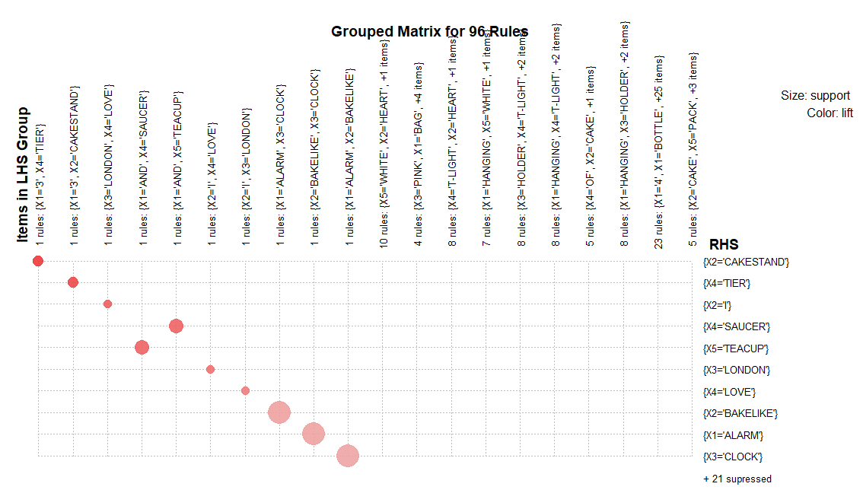

The insights drawn from the above plot are:

* Alarm, Clock and Bakelight should have some kind of relation. The dataset is actually not clear and different meaningless values are present. So I could not come up with proper insights.