# To Predict Weight Gain according to Calories Consumed

1. Data Collection: calc.csv
2. EDA:

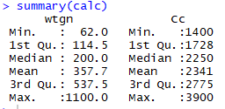

Standard Deviation(wtgn): 333.6925

Standard Deviation(Cc): 752.1095

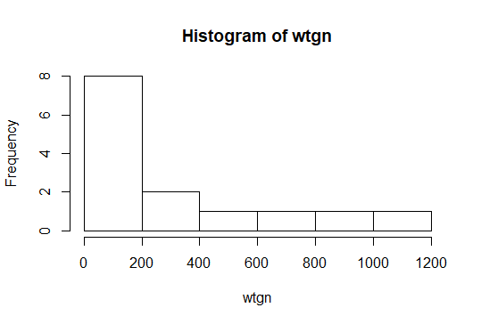

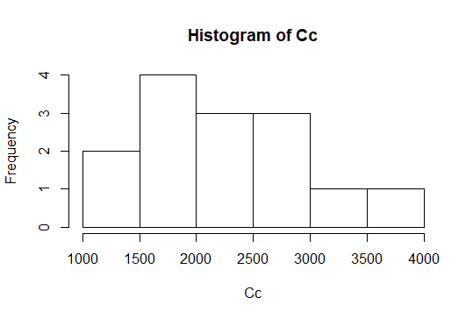

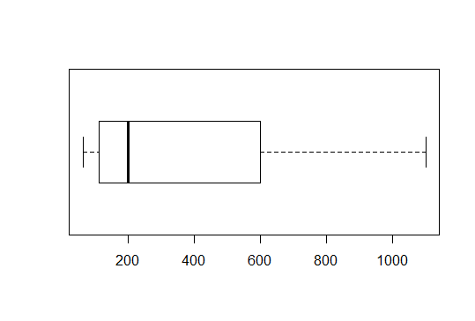

wt gain boxplot(no outliers)

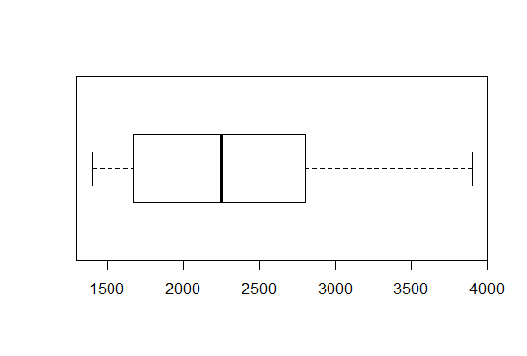

calorie consumed boxplot(no outliers)

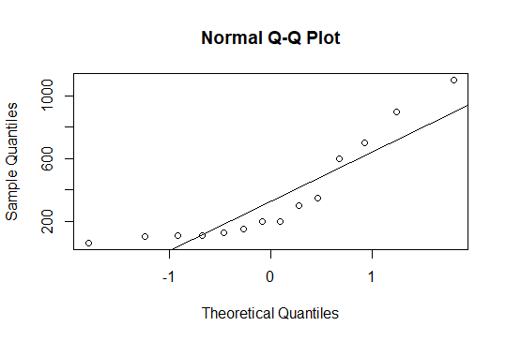

Q-Q plot for weight gain(non-normal)

Since, Weight Gain is not normally distributed, So we transform our model accordingly.

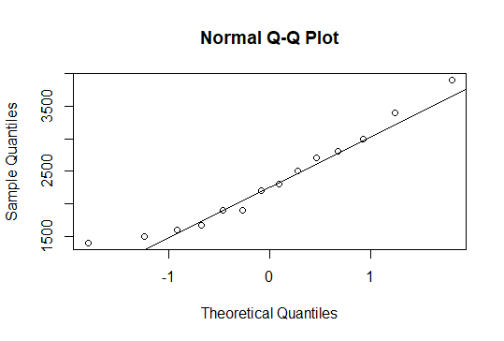

Q-Q plot for calorie consumed(Normal)

Scatter Plot:

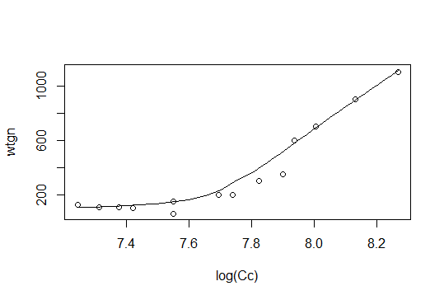

The Scatter plot suggests that:

* Not linear
* Positive collinearity
* Presence of clusters not visible

1. Data Mining:

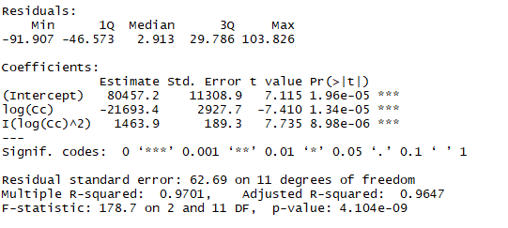

B0 = 80457.2 is significant

B1 = -21693.4 is significant

B2 = 1463.9 is significant

R2 value = 0.97

F-statistic and p- value suggests our model is good.

From our R Code, Our final Model is:

***Weight Gain = 80457.2 – 21693.4* log(Calorie consumed) + 1463.9*(log(Calorie consumed)^2)***

1. LINE Assumption:

Below plot satisfies that Residuals are independent

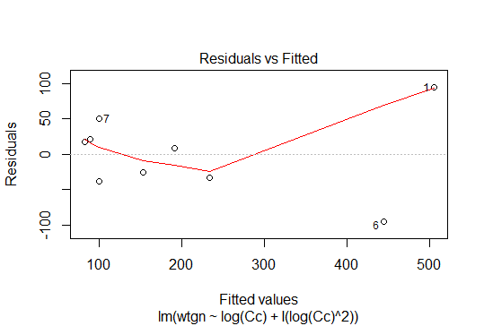

Below Plot Satisfies That residuals are normally distributed

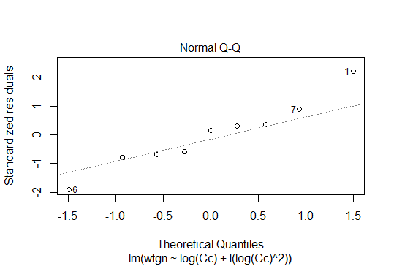

Below Plot Satisfies that there is no heteroscedasticity problem

