Exercise 1: Implementing the Singleton Pattern

public class Logger {

    private static Logger instance;

    private Logger() {

        System.out.println("Logger instance created");

    }

    public static Logger getInstance() {

        if (instance == null) {

            instance = new Logger();

        }

        return instance;

    }

    public void log(String message) {

        System.out.println("Log: " + message);

    }

    public static void main(String[] args) {

        Logger logger1 = Logger.getInstance();

        logger1.log("This is the first log message.");

        Logger logger2 = Logger.getInstance();

        logger2.log("This is the second log message.");

        System.out.println("Are both logger instances the same? " + (logger1 == logger2));

    }

}

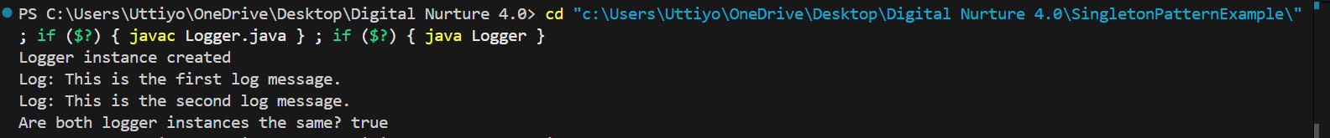Output

Exercise 2: Implementing the Factory Method Pattern

public class FactoryPatternTest

{

public interface Document {

    void open();

}

static class WordDocument implements Document {

    public void open() {

        System.out.println("Opening Word Document...");

    }

}

static class PdfDocument implements Document {

    public void open() {

        System.out.println("Opening PDF Document...");

    }

}

static class ExcelDocument implements Document {

    public void open() {

        System.out.println("Opening Excel Document...");

    }

}

static class DocumentFactory {

    public Document createDocument(String type)

    {

        if(type.equalsIgnoreCase("Word"))

        {

            return new WordDocument();

        }

        else if(type.equalsIgnoreCase("Pdf"))

        {

            return new PdfDocument();

        }

        else if(type.equalsIgnoreCase("Excel"))

        {

            return new ExcelDocument();

        }

        else

        {

            throw new IllegalArgumentException("Unknown document type: "+type);

        }

    }

}

    public static void main(String[] args) {

        DocumentFactory Factory = new DocumentFactory();

        Document wordDoc = Factory.createDocument("Word");

        wordDoc.open();

        Document pdfDoc = Factory.createDocument("Pdf");

        pdfDoc.open();

        Document excelDoc = Factory.createDocument("Excel");

        excelDoc.open();

    }

}

Output

