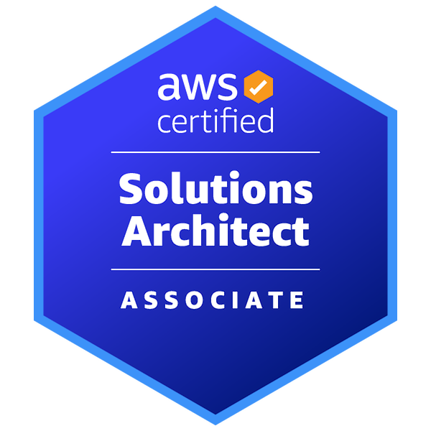
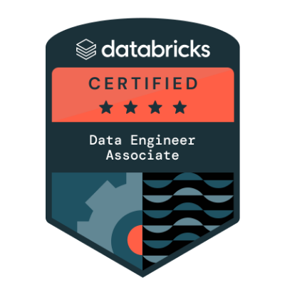
Lead Data Engineer | Cloud Solutions Architect
Rijul Sahu, Hyderabad, India | Professional Portfolio Website

SUMMARY
Lead Data Engineer with 15+ years experience driving complex data transformations, building scalable analytics platforms, and leading high-performing engineering teams. Proven ability to architect and implement cloud-based data ecosystems, automate CI/CD deployments, and translate business needs into robust technical solutions. Seeking to leverage holistic data expertise and cross-team collaboration skills to transition into a Solutions Architect position.

Professional experience
Lead Data Engineer | Mars Snacking (formerly Kellogg’s) | Hyderabad, IN | December 2020 – Present | 5 Years & 9 Months
- Authored a consolidated dbt transformation for the Retail Execution Data Mart, replacing multiple brand/category/store/UPC tables with a single high-performance mart delivering 14 precomputed KPIs across L4W/L13W/YTD for Kroger and Walmart, reducing redundancy, improving downstream BI/Agentic AI query performance, and enabling automated weekly refresh via scheduled dbt jobs.
- Designed and implemented a unified CI/CD DevOps framework for the organization using GitHub Enterprise and AWS CloudFormation, reducing production AWS resource deployment time by up to 80%.
- Led migration from Amazon Redshift stored procedures to dbt models, establishing automated data lineage for over 100 procedures across multiple regions.
- Architected an event-driven serverless ELT pipeline on AWS for Kellanova’s Retail Media Bid Optimization platform, integrating SKAI Marketing APIs with Snowflake/Databricks, automating bulk uploads and bid updates via Python Lambdas and Databricks ML models, and provisioning all components with CloudFormation and OIDC-based GitHub Actions CI/CD across environments.
- Designed and implemented a Snowflake Continuous Integration/Continuous Deployment framework leveraging the open-source tool Schemachange, streamlining the deployment of DDL, DML, and other Snowflake objects across the organization.
- Collaborated on a production AWS RDS Proxy implementation for a 60+ concurrency Lambda ELT pipeline, providing architecture guidance on IAM auth, connection pooling, and secure credential flow to eliminate connection-storm failures and reduce per-run connection latency at scale.
Senior Process Manager | eClerx Ltd | Mumbai, IN | August 2016 – December 2020 | 4 Years & 5 Months

“European multinational online food-delivery service based in Berlin, Germany” – AWS Setup & Architecture Infrastructure as Code Portfolio
- Designed the architecture and authored the Terraform IaaC template to facilitate deployment.
- Provided complete Infrastructure solution to client including end to end configuration and cost of Server & Storage components.
- Reduced deployment time by 70%, accelerating infrastructure provisioning from hours to minutes with Aurora Serverless and Infrastructure as Code automation.
Tech Stack: Aurora Serverless RDS, EC2, S3, VPC, Terraform, GitHub

“Largest sportswear manufacturer in Europe, and the 2nd largest in the world” – Platform Migration, Automation Data Integration Portfolio
- Led onsite team of 10 members in Zaragoza, Spain for client engagement and delivery.
- Developed in-house capability using existing tool sets for fast delivery & enabled DevOps model
- Automated solution with high data quality and scalable architecture, eliminating third-party vendor and license costs (saved $0.25 million).
- Designed data model for multiple business units enabling data analysis for stakeholders.
Tech Stack: Exasol, Python, AWS EMR cluster, CI/CD – GitHub Actions

“Global Leader in Architecture, Engineering & Entertainment Software, HQ in USA” – Consumer Analytics
- Designed and developed ETL data pipelines from enterprise Data Lake
- Performed ad-hoc analysis and data pulls for e-commerce, marketing, and customer insights.
- Authored business cases and project management support for strategic initiatives.
- Understand the nature and format of data to decide on the structure for the data warehouse & identify what operations to be performed in order to have consistency in data imported from heterogeneous sources/systems
Tech Stack: Shell Scripting, AWS EMR cluster, S3 & Redshift for storage, CI/CD – GitHub Actions, Hive, PySpark

“Trading leaders of Electro components in Europe & Asia Pacific” – Competitive intelligence, Retail pricing Big Data Portfolio
- Designed and deployed 6-node on-premise Hadoop cluster for data ingestion and processing (20 cores, 150GB RAM, 2TB storage).
- Created ETL Pipelines for 12 million+ inventory items of 43+ competitors and 30K product sku’s.
- Identified Price change patterns and monthly trends along with multiple KPIs like Stock status, Article matches, Percent difference.
- Saved cost of around $100K which was previously spent on yearly resourcing and ongoing support.
Tech Stack: Hortonworks data platform, Hive, Pig, Sqoop, Shell, UNIX, Oozie for scheduling, SQL server

“eClerx in house capability building” – Product development, Center of Excellence
- Led center-of-excellence team for end-to-end data integration expertise.
- Headed data engineering & governance related projects from end-to-end implementations.
- Strategizing data journey with customer’s IT stakeholders.
- Infiltrating technical understanding to developers and monitoring the deliverables.
Hadoop Developer | Saksoft Ltd | May 2015 – August 2016 | 1 Year & 4 Months

“third-largest private-sector banks in India” – Customer Segmentation, Fraud Analytics
- Authored Sqoop jobs for data loading from ODS to Hive tables.
- Wrote multiple data processing scripts for transaction and Text mining.
- Authored Shell scripts for automation and batch jobs.
- Managed housekeeping activities of Hadoop Production and Development Cluster
Software Engineer | Small tech Firms | August 2010 – February 2015 | 4 Years & 6 Months
- Began IT career as a Software Test Engineer, focusing on mobile application testing and quality assurance.
- Gained strong understanding of the software development life cycle (SDLC) and hands-on experience with Agile methodologies.

Solution Architect Transition Highlights
- Direct experience with cloud-based architecture strategy, policies, and standards.
- Led architectural design discussions with stakeholders, ensuring alignment with organizational goals.
- Good understanding of data governance, integration, scalability, and security frameworks.
- Enthusiastic about leveraging end-to-end data engineering expertise in large-scale solution & enterprise architecture.

KEY Skills
- Cloud Platforms: AWS (S3, Glue, IAM, Lambda, Cloud Formation, AWS amplify, Terraform – basics)
- Data Pipeline Tools: dbt
- Data warehouse: Snowflake
- Architecture & Modeling: Data Lake Design, Star/Snowflake Schema
- Programming: Python, SQL, Spark
- DevOps: CI/CD (GitHub Actions)
- Leadership: Team Mentoring, Cross-functional Collaboration, Technical Documentation

Certifications
- AWS Certified Solutions Architect Associate (Valid through August 2029)
- Databricks certified Data Engineer Associate (Valid through September 2027)

Education
- MBA in Marketing & General Management, ITM Business School, Mumbai, 2018 – 2010
- Bachelors of Engineering in Electronics & Telecommunications, CSVTU, Bhilai, 2006 – 2010

