
Table of Contents
Introduction 1
System Overview and Architecture 2
Crawler 3
Find Publication title and link 5
Crawl Author Name and Profile Link 6
Crawl Publication Date, Abstract, and other info 7
Search Functionality 9
1. Text Processing and Normalization 10
2. Multi-Field Search Indexing 11
3. TF-IDF Vectorization 12
4. Similarity Calculation and Ranking 13
5. Result Filtering and Display 15
Automatic Scheduler 18
Document Classification 19
1. Data Collection 20
1.1. Dataset Preparation 21
1.2. Fallback Mechanism 22
2. Data Preprocessing 24
3. Model Training and Text Classification 25
Challenges and Limitations 29
Conclusion 30
References 31
Appendix 32

List of Figures
Figure 1: Overall system architecture (crawler → index → API → UI) 2
Figure 2: Web crawler workflow 3
Figure 3: Crawler Process 4
Figure 4: Function for scraping publication links 5
Figure 5: Function to scan author name and available profile link 6
Figure 6: Function to extract publication date and abstract 7
Figure 7: Function to extract publication date and abstract 8
Figure 8: Function for pre-processing task and normalization 10
Figure 9: Inverted index construction 11
Figure 10: TF-IDF vectorization 12
Figure 11: Similarity calculation and ranking 14
Figure 12: Result filtering and display 16
Figure 13: Search Engine Flutter Web UI 17
Figure 14: Scheduler setup 18
Figure 15: Data collection 20
Figure 16: Dataset preparation (training pipeline text cleaning and feature creation) 21
Figure 17: Fallback mechanism 23
Figure 18: Data preprocessing (shared preprocessing used for training and inference) 24
Figure 19: Model training 26
Figure 20: Classification Text Function 27
Figure 21: Classify Text Flutter UI With Result 28

Introduction
This report presents the design and implementation of a vertical information retrieval (IR) system that indexes publications from Coventry University’s Pure Portal for the ICS Research Centre for Computational Science and Mathematical Modelling. The system focuses on academic records (title, authors, year, abstract and links) and provides ranked retrieval like Google Scholar but restricted to the target organization.
To meet the ST7071CEM coursework requirements, the solution implements the full IR pipeline: web crawling, text preprocessing, inverted index construction, TF–IDF based scoring, and an interactive query interface. A scheduled re-crawl mechanism is included so the index can be updated automatically when new publications appear.
In addition to searching, the project includes a text classification and clustering component using standard machine‑learning techniques. These components demonstrate how textual features can be used to categorize and group documents, and they are exposed through the same backend API for easy demonstration during the viva.
The report is structured to explain each major subsystem (crawler, search engine, scheduler, classification/clustering and UI) with supporting screenshots. The implementation choices are justified with reference to core IR concepts such as normalization, indexing, term weighting and ranking.

System Overview and Architecture
Dataset Summary: The crawler collected 357 publication records from the ICS Research Centre listing; 13 records do not include an abstract.
The classification dataset contains 4000 labeled samples across 3 categories (business, entertainment, health). The training code uses a stratified 80/20 split (about 3200 train, 800 test).
The system is organized into four layers: (1) a crawler that collects publication metadata from Pure Portal, (2) a storage and indexing layer that persists the crawled output and builds an inverted index, (3) a Fast API backend that exposes search, classification and clustering endpoints, and (4) a Flutter-based client interface that consumes these APIs and renders results with clickable links. This separation keeps responsibilities clear and makes the solution easier to maintain and extend.
During a typical workflow, the crawler downloads publication links from the organization listing, visits each publication detail page, extracts fields, and saves the structured data as JSON. The indexer then tokenizes the combined text fields (title, authors and abstract), computes term frequencies, and creates postings lists used by the query processor for fast retrieval.
Figure 1 illustrates this end‑to‑end data flow. It highlights how crawling and indexing are offline tasks, while querying and model inference are online tasks served through the backend API.
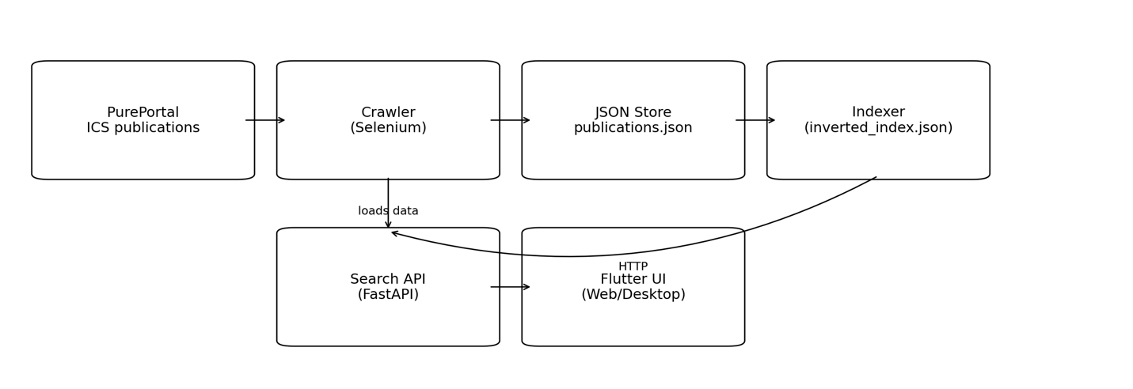
Figure 1: Overall system architecture (crawler → index → API → UI)

Crawler
A web crawler is an automated program that discovers web pages and extracts structured information for indexing and retrieval. Figure 2 and Figure 3 show the standard crawler workflow: the process begins from seed URLs, pages are fetched, content is parsed to extract links and data fields, duplicate URLs are filtered, and the extracted output is stored for later analysis and search.
In this project, the crawler targets the PurePortal organisation publications listing for the ICS Research Centre and is implemented in Python using Selenium to handle dynamic page rendering. The overall design follows the same pipeline illustrated in the figures but is implemented as a practical two-stage process to improve reliability. Stage 1 (Listing/Discovery) paginates through listing pages (?page={page_idx}), waits for result containers to load, and extracts publication title and link pairs from .result-container h3.title a. To keep crawling stable and polite, the crawler applies a short delay between page requests, checks robots.txt permissions, and respects crawl-delay rules before fetching pages. Collected URLs are then de-duplicated so each publication is processed only once. Stage 2 (Details/Extraction) visits each publication URL and extracts key metadata—title, authors, published date, and abstract—using fallback strategies to handle layout differences across pages. Finally, outputs are saved to JSON so partial results remain usable even if execution stops early, and the dataset can be reused for indexing and retrieval.
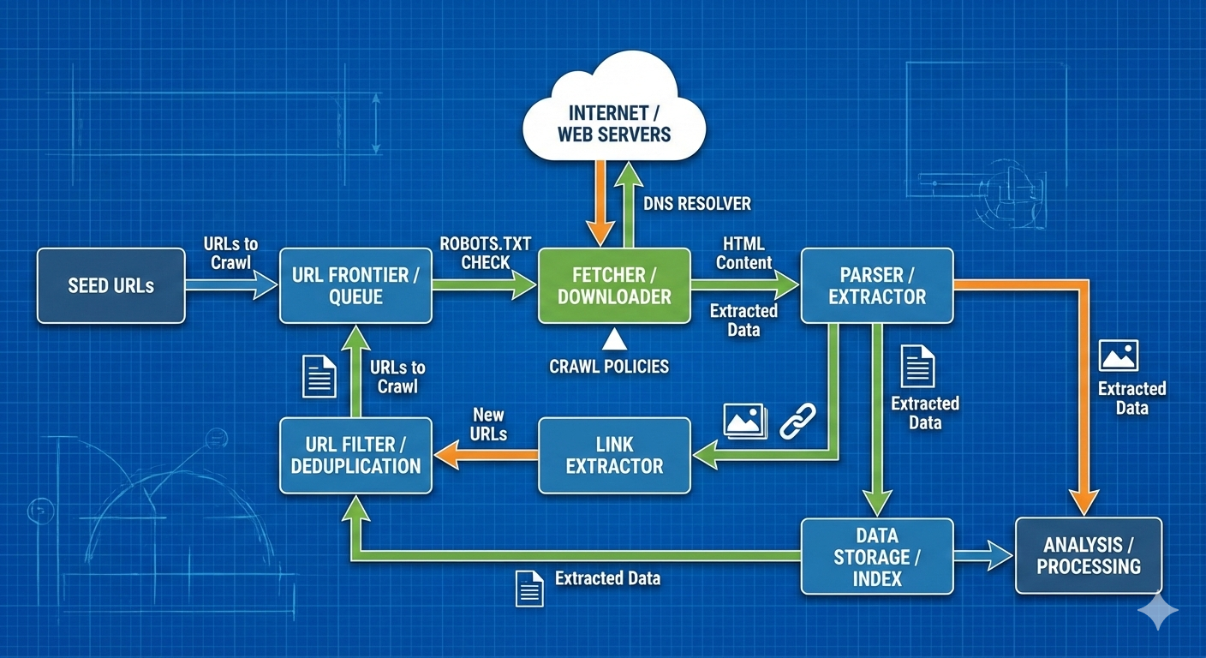
Figure 2: Web crawler workflow

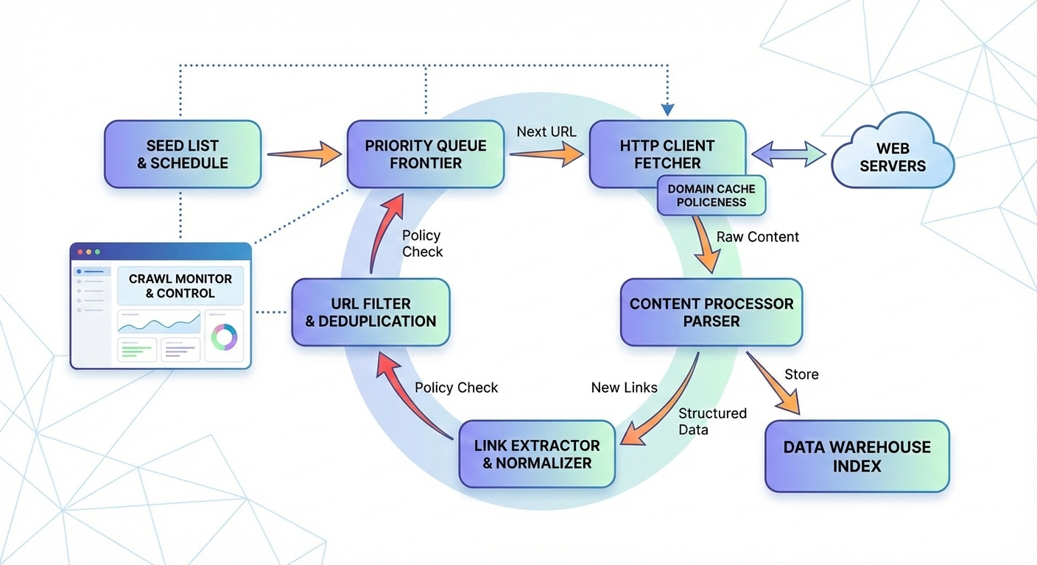
Figure 3: Crawler Process

Find Publication title and link
Stage 1 collects a reliable set of publication targets (title and URL) from the listing pages. The crawler navigates paginated results using the ?page={page_idx} parameter and waits until publication cards are loaded (or a “No results” state is detected) before extraction. For each .result-container, it reads the publication title and link from the h3.title a anchor and stores them as {title, link} pairs. To keep crawling efficient and polite, the implementation reuses a single Selenium browser session across pages (preserving cookies/session state) and applies a short throttle delay between page requests to reduce server load and improve crawl stability. After aggregation, URLs are de-duplicated using the link as a unique key so Stage 2 processes each publication only once, producing a stable and repeatable target list for downstream scraping and indexing.
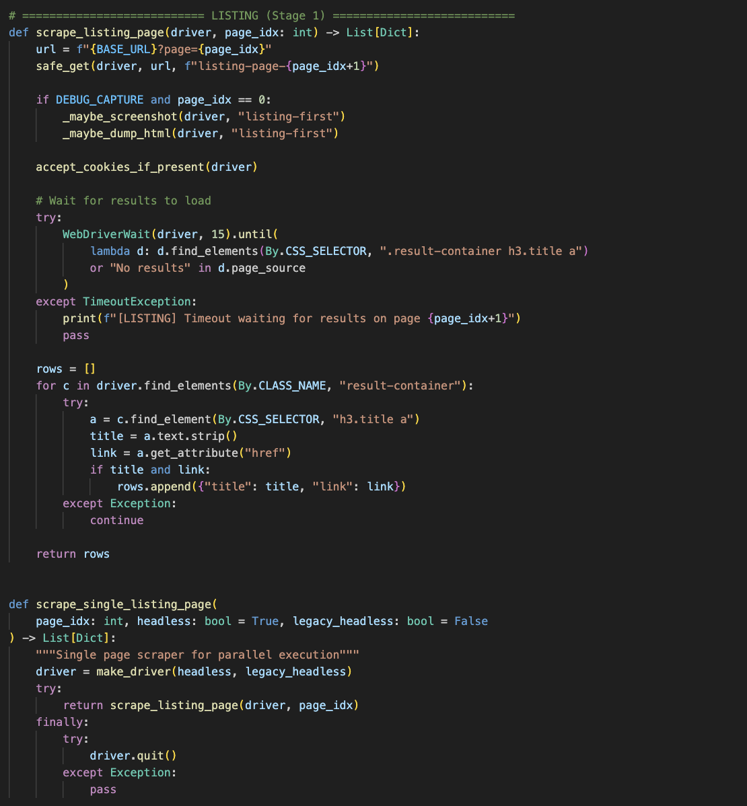
Figure 4: Function for scraping publication links

Crawl Author Name and Profile Link
Author extraction is implemented as a multi-strategy pipeline because PurePortal publication pages can present author information in different formats. The primary strategy scans person profile anchors (/en/persons/<slug>) that appear above the tab navigation (e.g., “Overview”), which helps avoid unrelated navigation links and reliably captures both the author name and a clickable profile URL. If this header-anchor method returns no authors, the crawler falls back to parsing the subtitle line that typically contains the author list together with the publication date, extracting author names from the text. If authors are still missing, it performs a quick metadata check using citation_author, and finally applies a BeautifulSoup fallback that searches for /en/persons/ links directly in the HTML. After extraction, authors are de-duplicated and stored as {name, profile} objects so the data remains both human-readable and usable for navigation/filtering in later stage.
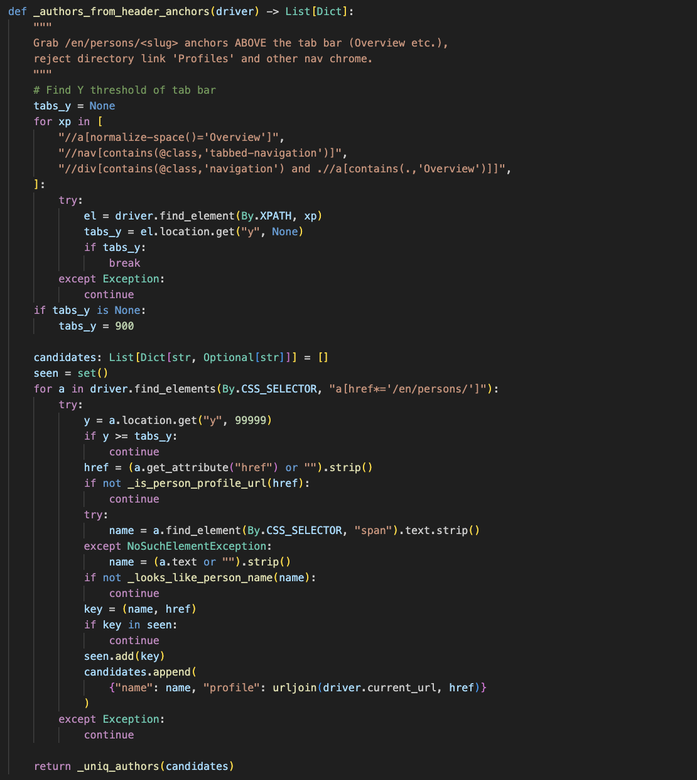
Figure 5: Function to scan author name and available profile link

Crawl Publication Date, Abstract, and other info
Publication date extraction is implemented with a simple fallback approach to handle minor layout differences across PurePortal pages. The crawler attempts common date locations such as span.date, time[datetime], and .time, and stores either the datetime attribute (when available) or the visible text. This produces a consistent published_date field that can later support sorting and year-based filtering in the search interface.
Abstract extraction uses a multi-stage strategy to maximise recall without breaking the crawl when elements are missing. First, the crawler tries a list of reliable “standard” abstract selectors (e.g., abstract sections and textblock patterns) and accepts the first sufficiently long text. If no abstract is found, it performs heading-based discovery by locating a heading containing “Abstract” and reading the most likely adjacent content blocks. As an additional fallback, it checks metadata fields (e.g., meta[name="description"], meta[property="og:description"], and meta[name="citation_abstract"]). If all strategies fail, the crawler stores an empty string rather than failing the record, ensuring indexing remains robust even with partial metadata.
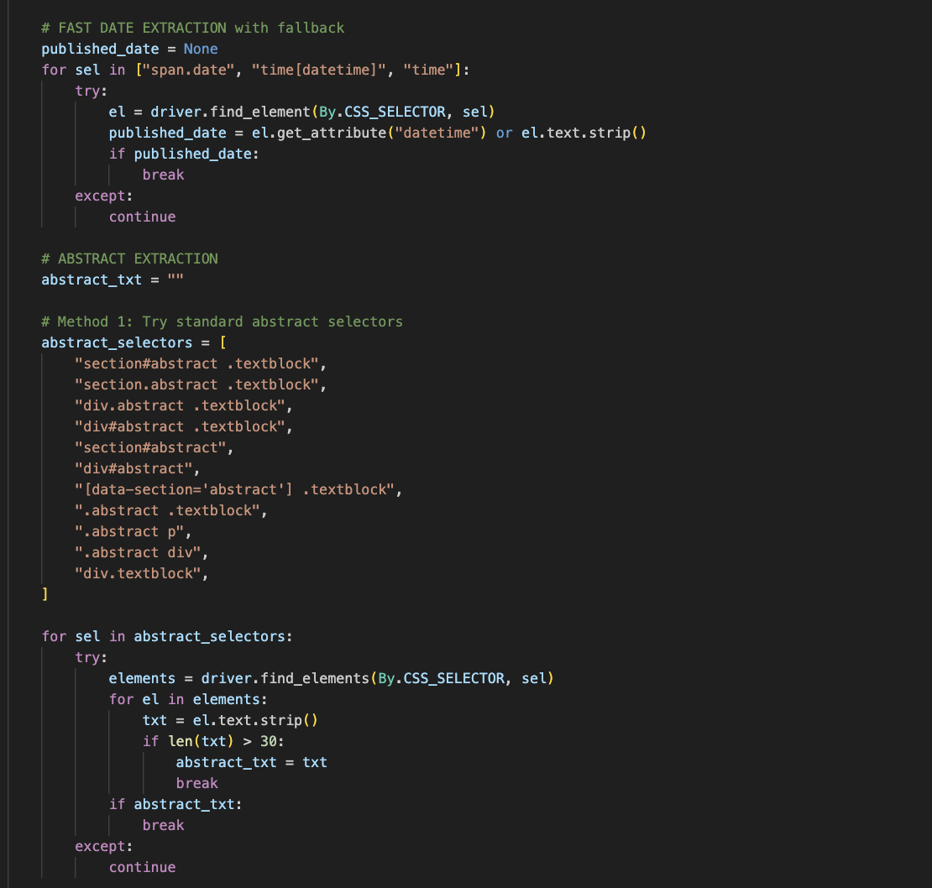
Figure 6: Function to extract publication date and abstract
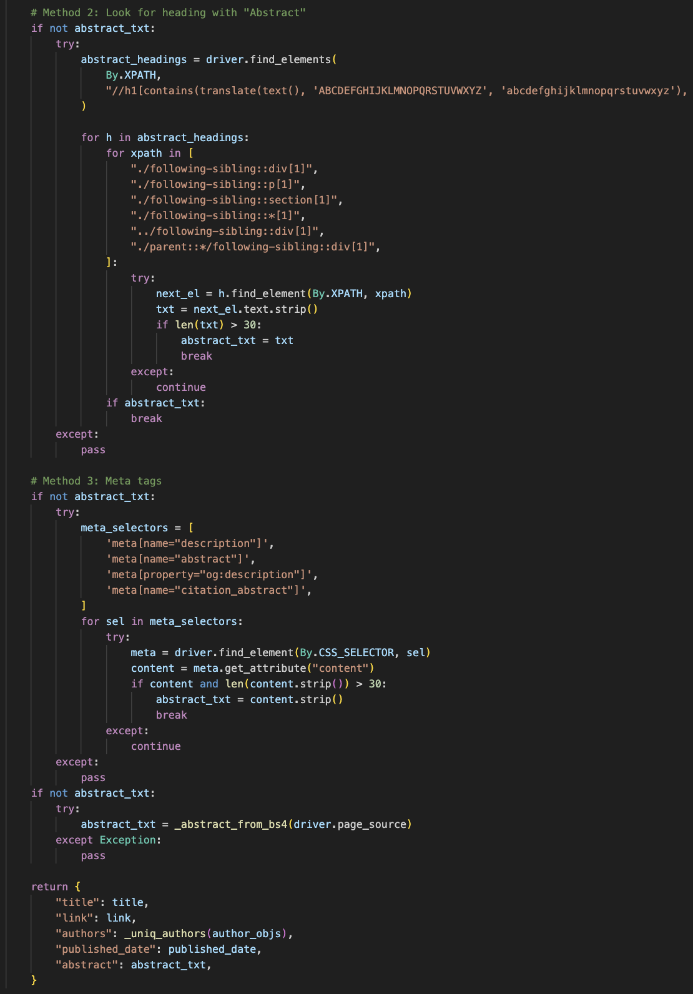
Figure 7: Function to extract publication date and abstract

Search Functionality
Search evidence: Add 2-3 example queries and show the ranked results (title, authors, year, score).
Include at least one query that you also test in Google Scholar for comparison, with a screenshot.
The search component supports two retrieval modes to ensure robust ranking in different runtime conditions. When a persistent inverted index is available, the system performs fast, index-based retrieval by using postings lists and document statistics (e.g., term frequency, document frequency, and document length) to compute a lightweight TF-IDF–style relevance score with length normalization. This mode follows core Information Retrieval principles and scales efficiently because only documents containing the query terms are scored.
If the inverted index is not available, the system falls back to a vector-space approach: it builds a TF-IDF document matrix and ranks results using cosine similarity. This ensures the system can still return meaningful ranked results even without a pre-built index, at the cost of higher computation. In both modes, queries and documents are normalized (e.g., case folding and basic token processing) to improve term matching. To improve responsiveness, a lightweight query cache is used at the API layer so repeated identical queries can return quickly without recomputing scores for a short time window.

Text Processing and Normalization
To ensure consistent matching between user queries and stored documents, the system applies the same preprocessing pipeline to both. Text is converted to lowercase, non-alphanumeric characters are removed, and the remaining content is tokenized. Common stop words are filtered out to reduce noise, and Porter stemming is applied so that different word forms map to a shared root (e.g., compute, computing, computational). This improves recall in an academic search setting by allowing partial and variant term matches while keeping the vocabulary smaller for indexing and scoring.
In addition to query/document preprocessing, the data is normalized at ingestion time so key fields are stored in a consistent structure (e.g., ensuring authors are always a list of objects and that missing abstract/date fields are handled safely). This prevents formatting differences in the raw crawl output from affecting indexing or retrieval.
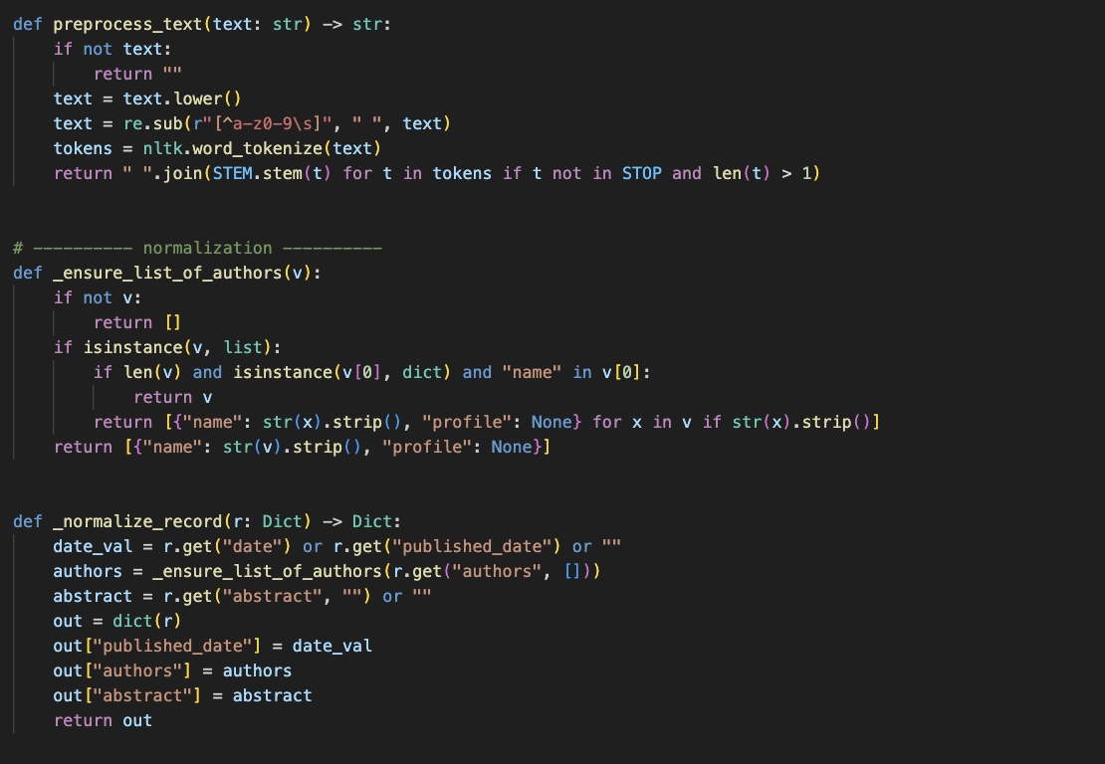
Figure 8: Function for pre-processing task and normalization

Multi-Field Search Indexing
To support richer retrieval, the indexing stage builds each document representation by combining multiple fields—publication title, author names, and abstract—into a single text stream before preprocessing. This allows queries to match important terms that may appear in any of these fields (e.g., an author name or a key phrase in the title), instead of relying only on the abstract.
After preprocessing, an inverted index is constructed where each term stores: (1) a postings list mapping document IDs to term frequency (tf), and (2) the document frequency (df) derived from the number of postings. The system also stores document length for each record, which enables efficient TF-IDF–style scoring with length normalization during retrieval. This design avoids scanning all documents at query time and makes ranking fast because only documents that contain query terms are considered.
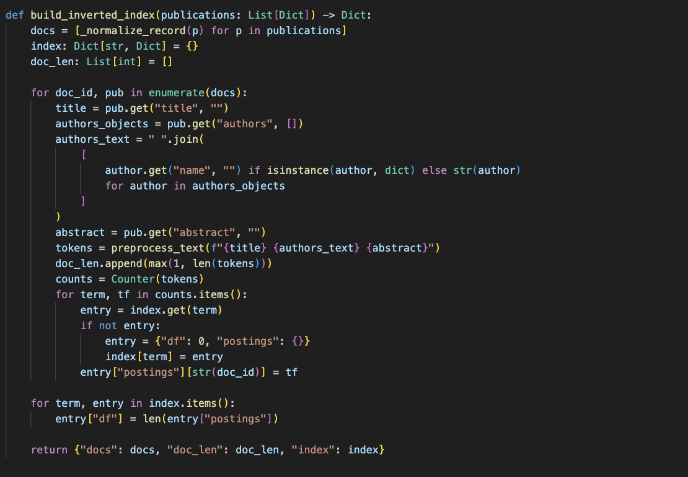
Figure 9: Inverted index construction

TF-IDF Vectorization
The retrieval component uses TF-IDF weighting to rank publications by relevance. In the index-based mode, term frequency is computed from the postings list and normalized by document length, then weighted by an inverse document frequency (IDF) factor (e.g., log((N+1)/(df+1)) + 1). This reduces the impact of very common terms while giving higher weight to distinctive terms, producing stable scores that work well for short academic queries.
When a pre-built index is not available, the system falls back to a vector-space model. In this mode, a TfidfVectorizer is used to build a sparse TF-IDF matrix over the combined searchable text for each publication (title + authors + abstract). User queries are transformed using the same vectorizer, and documents are ranked using cosine similarity. This fallback ensures the system can still return meaningful ranked results even without loading an inverted index, although it requires more computation because it relies on matrix operations over the full collection.
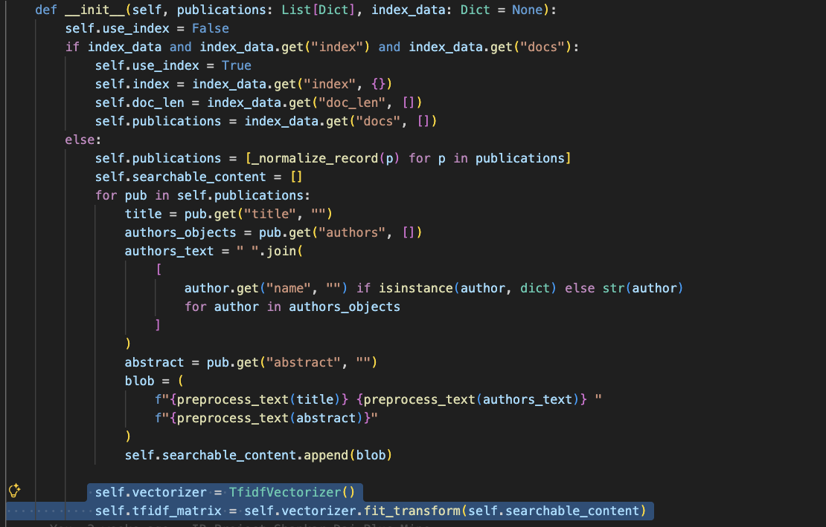
Figure 10: TF-IDF vectorization

Similarity Calculation and Ranking
After preprocessing the user query, the retrieval module calculates a relevance score for each candidate document and returns results ranked from highest to lowest score. In index-based mode, only documents that appear in the query terms’ postings lists are scored, so ranking is efficient and avoids scanning the full collection. Each document’s score is accumulated across query terms using a TF-IDF–style weighting with document-length normalization, so longer documents do not gain an unfair advantage.
In the vector-space fallback mode, the query is converted into a TF-IDF vector using the same model as the document matrix, and cosine similarity is computed against all documents. In both modes, a small score threshold is applied (e.g., ignoring scores below 0.01) to remove negligible matches and reduce noisy results. Finally, the ranked output is formatted into a consistent structure—title, link, authors, published date, abstract, and score—so the API and the Flutter interface can display results reliably using the same fields.
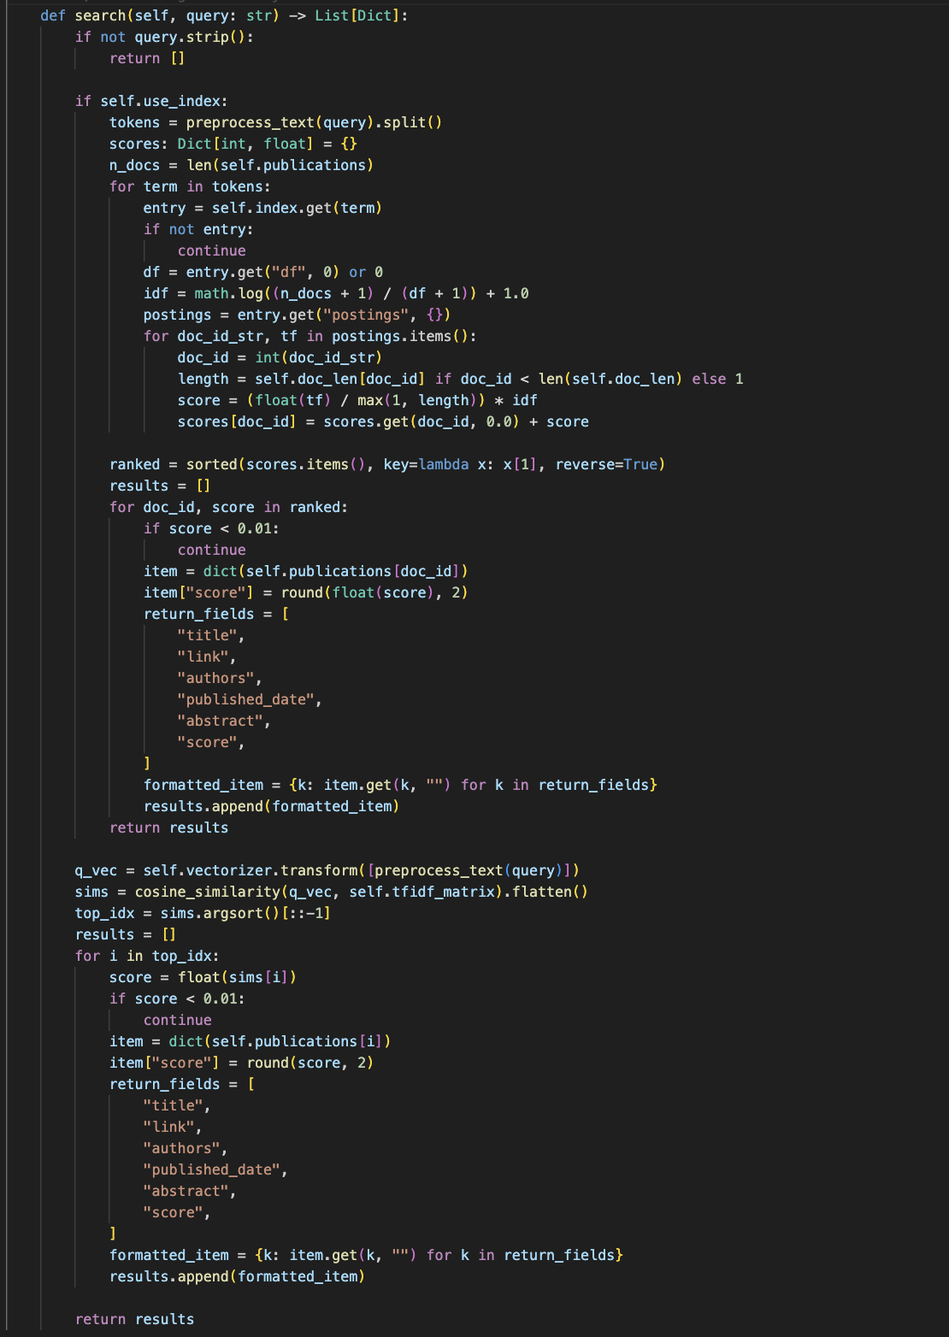
Figure 11: Similarity calculation and ranking

Result Filtering and Display
To support practical exploration of the ranked results, the search API provides optional post-retrieval filters and a consistent response format for the UI. After a query is processed and documents are ranked by relevance score, the API can apply an author filter (substring match against the author field) and a year-range filter (using year_from and year_to). Applying these filters after ranking keeps the retrieval logic simple while preserving the relevance-based ordering for results that remain.
The API also supports sorting and pagination for user-friendly navigation. Results can be sorted by relevance score (default), by publication date, or alphabetically by title. Pagination is controlled through page and size parameters, and the response includes the current page, total number of results, and total_pages, which the interface uses to render page controls and display result counts. This design ensures the front-end can display concise result cards (title, author, date, abstract snippet, and score) while still allowing users to refine and browse large result sets efficiently.
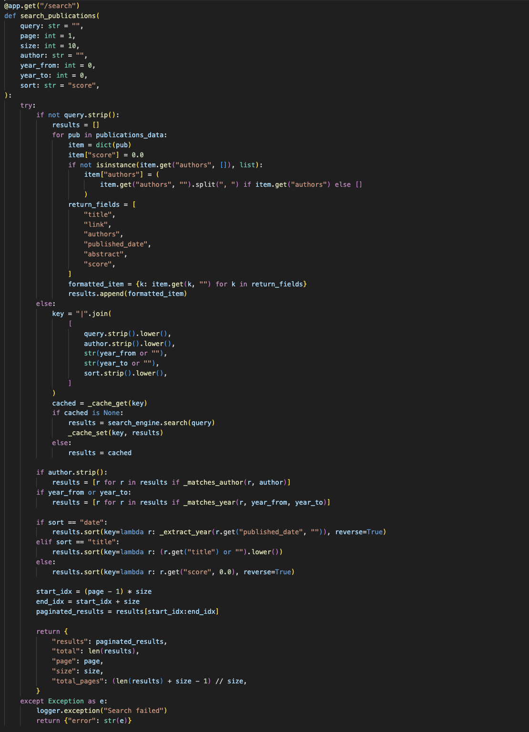
Figure 12: Result filtering and display

Figure 13: Search Engine Flutter Web UI

Automatic Scheduler
To keep the publication dataset and index up to date without manual runs, the system includes a weekly scheduler that automatically triggers the crawler. The scheduler is implemented using APScheduler and is configured as a cron-style job that runs every Sunday at midnight. When it starts a crawl, it attempts to use the project’s virtual-environment Python interpreter (if available); otherwise, it falls back to the system Python. The crawler is executed as a subprocess, and the scheduler keeps running in the background until it is stopped, allowing regular refreshes of newly added or updated publications. This automation reduces maintenance effort and supports the assignment requirement of maintaining a fresh, updateable collection.
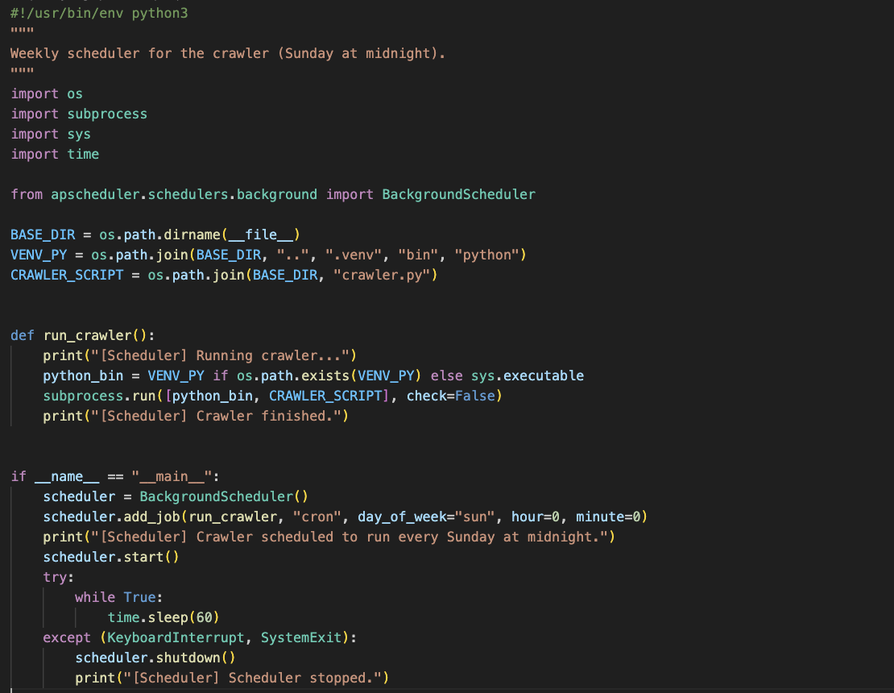
Figure 14: Scheduler setup

Document Classification
Classification evaluation: The model is trained from the 4000-sample dataset (balanced across 3 classes).
Record the accuracy and classification report returned by the training endpoint in the Appendix, and include at least 3 classification examples with their probability distributions.
Clustering Results (Evidence): Provide clustered outputs for varied inputs (short with stop words, short without stop words, longer abstract, and a mixed-topic input).
Include screenshots of the /cluster responses in the Appendix to demonstrate robustness.
The system includes a supervised text classification component to assign a category label to input text (typically an abstract or short research summary). Training data is loaded from two CSV sources: a category list (`categories.csv`) and labeled training samples (`training_documents.csv`). If the CSV files are not present, the system falls back to a small built-in dataset so the classifier remains functional during minimal setups . Categories are converted into numeric labels using a simple label encoder/decoder mapping, which allows the model to train and then convert predictions back into human-readable class names .
Two supervised models are supported: **Multinomial Naive Bayes** and **Logistic Regression** . During training, text is preprocessed and vectorized with TF-IDF (including n-grams) before fitting the chosen model; when a valid test split is possible, the system reports accuracy and a full classification report . At inference time, the classifier returns the **predicted category**, **confidence**, the **probability distribution** across classes, and a short explanation message to improve transparency of decisions . For robustness, if the input contains too few known terms, the system can fall back to keyword-based scoring or a no-signal response instead of failing .
In addition to classification, the project also demonstrates **unsupervised clustering** using TF-IDF vectors with **K-Means**. The clustering model is trained over the same labeled dataset (when available), assigns each input text to a cluster, and maps clusters to human-readable labels based on the dominant category distribution inside each cluster . This provides an additional way to group related documents beyond supervised labels.

Data Collection
The classification module loads its training dataset from two CSV inputs: a list of class labels (categories) and a set of labelled text samples (training documents). Each training record contains a text field and its corresponding category label, which is then mapped into numeric classes to support model training. To keep the pipeline reliable during development or when deployment files are missing, the system includes a fallback mechanism: if either CSV cannot be found, a small built-in dataset is loaded so training and prediction can still run without interruption.
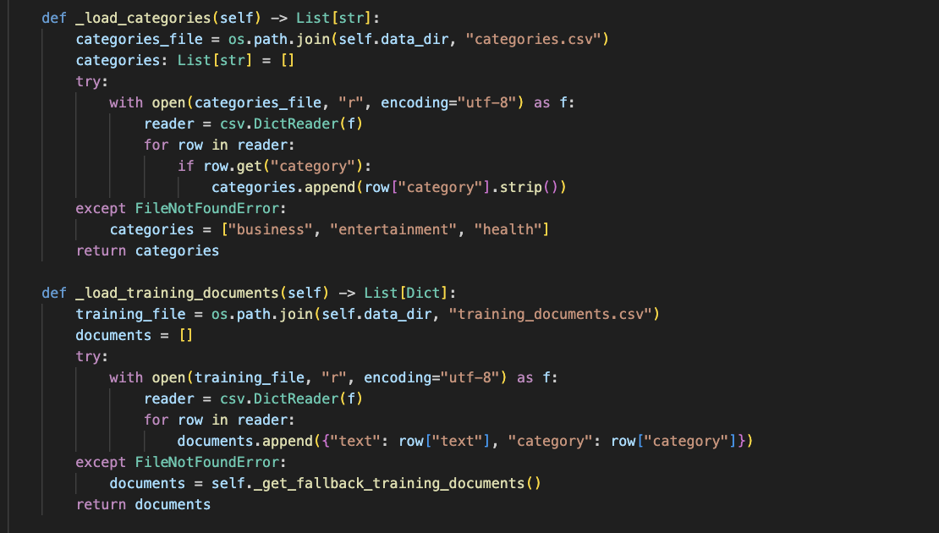
Figure 15: Data collection

Dataset Preparation
Dataset preparation focuses on preparing the raw labelled texts into a form suitable for model training. Each document is cleaned (lowercasing and removal of non-alphanumeric characters), tokenized, stop-words are removed, and stemming is applied to reduce vocabulary size and merge word variants. After this cleaning step, the dataset is transformed into TF-IDF feature vectors, creating a sparse representation that highlights terms that are important within a document but less frequent across the dataset. These TF-IDF vectors form the input to the supervised learning models.
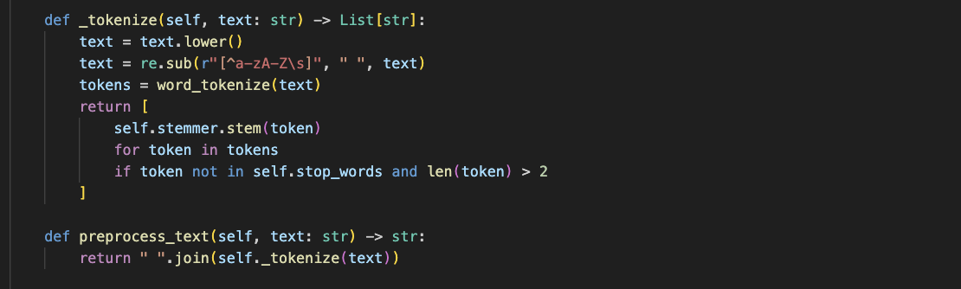
Figure 16: Dataset preparation (training pipeline text cleaning and feature creation)

Fallback Mechanism
To avoid unreliable predictions when the input text contains too little usable signal after preprocessing, the classifier includes two fallback behaviours. First, if tokenization produces no meaningful vocabulary for the trained model, a keyword-based fallback is applied. In this approach, each category has an associated keyword list; keywords are stemmed and matched against the stemmed input tokens, and a simple score is computed by counting matches per category. The category with the highest keyword match is selected, and a probability-style confidence value is returned along with an explanation that the keyword fallback was used.
If no keyword signal is detected (i.e., all category scores are zero), the system returns a no-signal response instead of forcing a confident label. In this case, it outputs a uniform probability distribution across categories (low confidence) and provides a message advising the user to input a longer or more descriptive text. This design prevents misleading classifications and improves transparency by clearly communicating when the system lacks enough evidence to make a strong prediction.
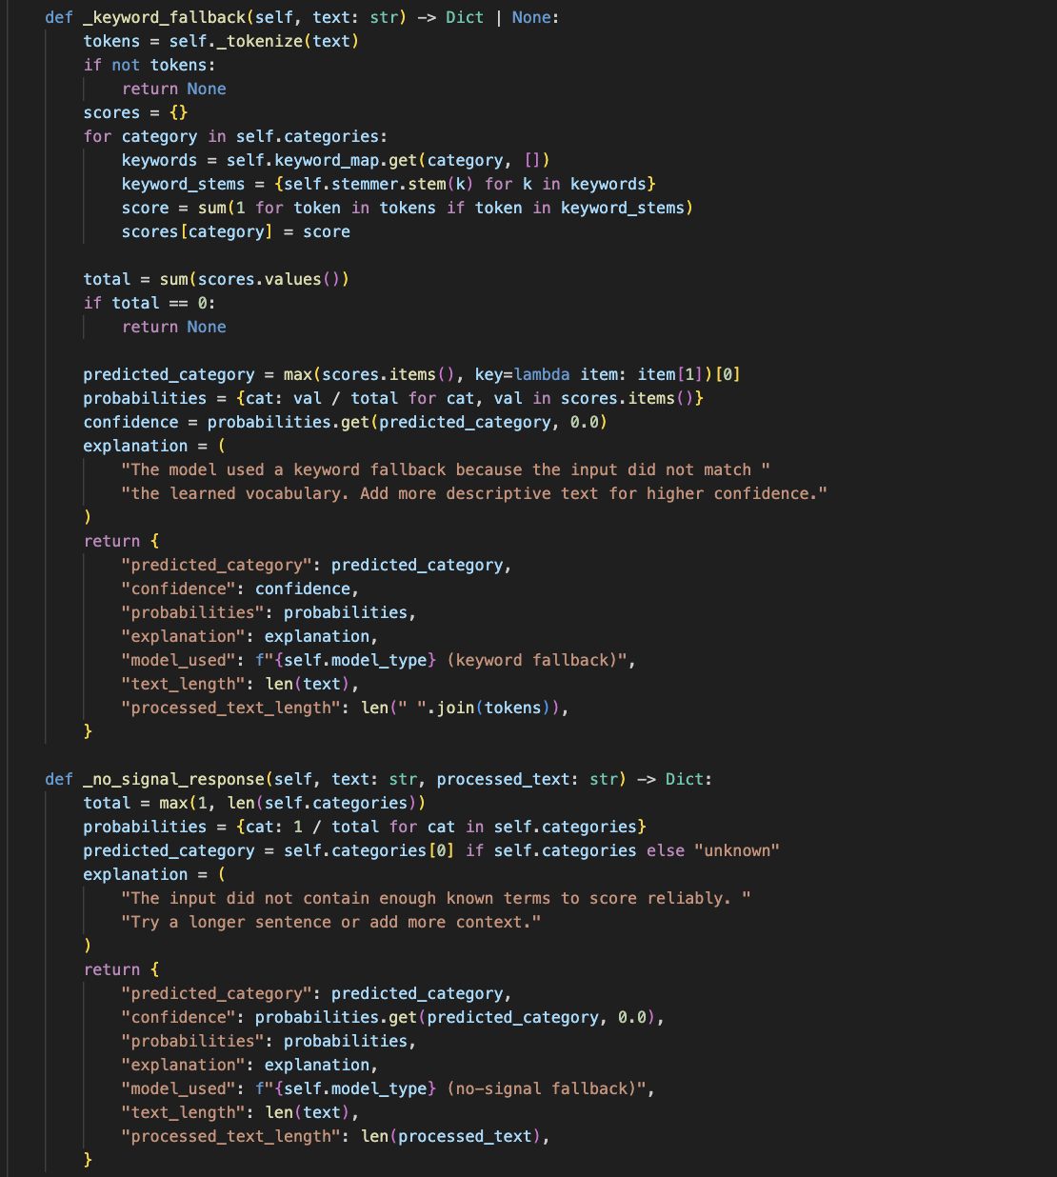
Figure 17: Fallback mechanism

Data Preprocessing
Data preprocessing refers to the reusable preprocessing step applied consistently during both training and prediction. The same tokenization pipeline is used to normalize any input text: it lowercases, removes noisy characters, tokenizes into words, removes stop words, and applies Porter stemming. Using the same preprocessing logic at inference time ensures that user inputs are represented in the same feature space as the training data, improving prediction stability and reducing mismatch between training and real-time classification.

Figure 18: Data preprocessing (shared preprocessing used for training and inference)

Model Training and Text Classification
The system provides an end-to-end text classification workflow that supports both model training and real-time prediction. During training, the labelled dataset is split into training and test sets when there is enough data to form a stable split. If the dataset is too small, the model is trained on all available samples to avoid unreliable evaluation caused by an unrepresentative test set. Text is preprocessed using the same normalization pipeline used elsewhere in the project, then converted into TF-IDF features (including n-grams) before fitting a classifier.
Two supervised models are supported: Multinomial Naive Bayes and Logistic Regression. A training endpoint retrains the selected model(s) on demand and, when a test set exists, returns evaluation outputs such as accuracy and a classification report, providing measurable evidence for the coursework. A separate model-status feature exposes whether training has been completed and lists the available category labels, making demonstrations clearer.
For inference, the user submits a sentence or abstract through the classification interface, and the system returns the predicted category, a confidence score, and the probability distribution across all categories. Showing the probability distribution improves transparency because it helps explain borderline cases where two categories have similar likelihoods. In addition to supervised classification, the system also demonstrates unsupervised clustering using TF-IDF vectors with K-Means to group texts into topical clusters, providing an alternative way to explore document similarity.

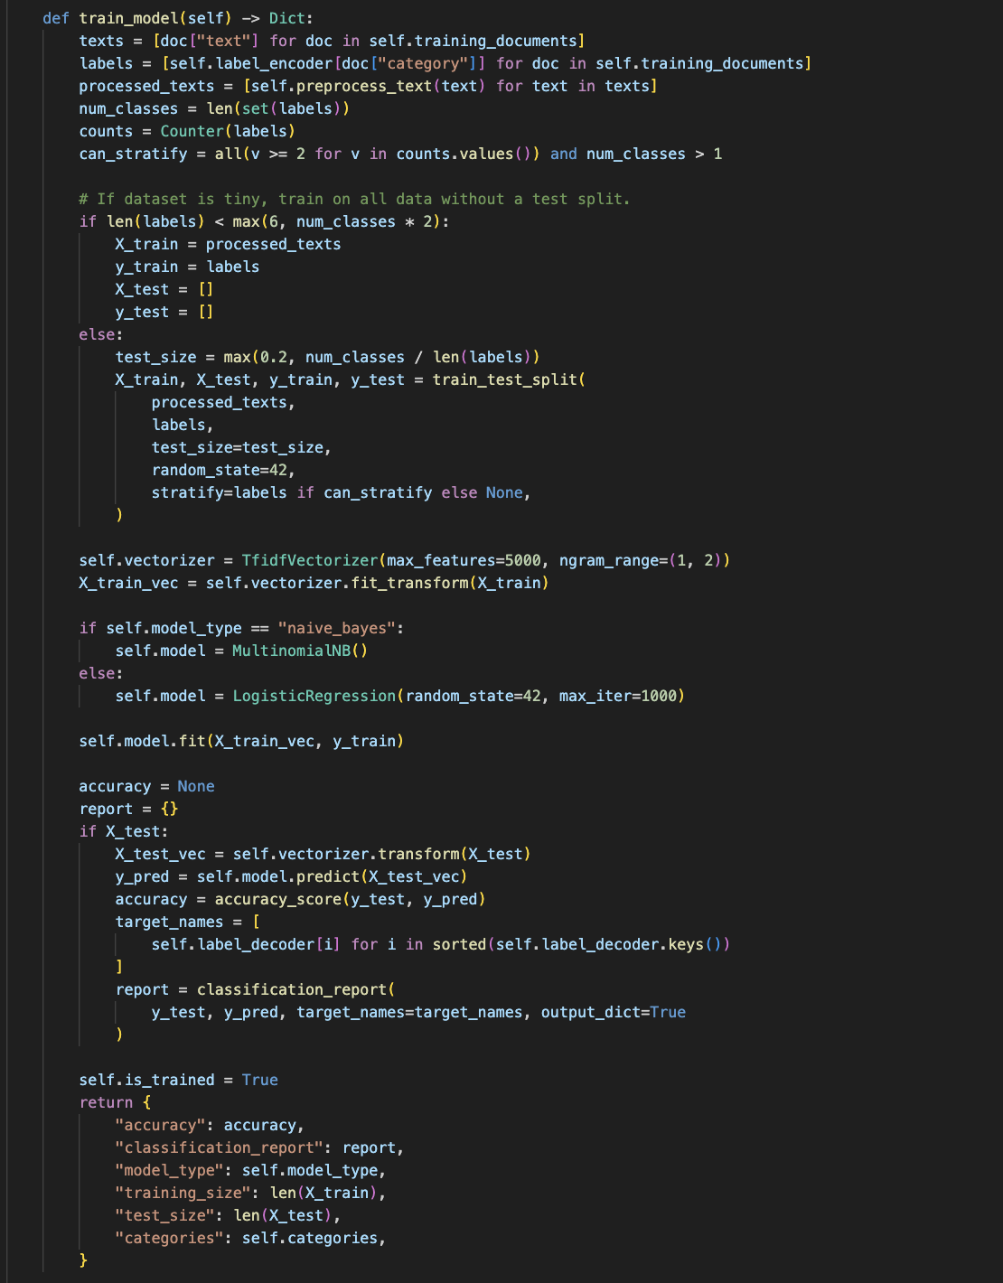
Figure 19: Model training
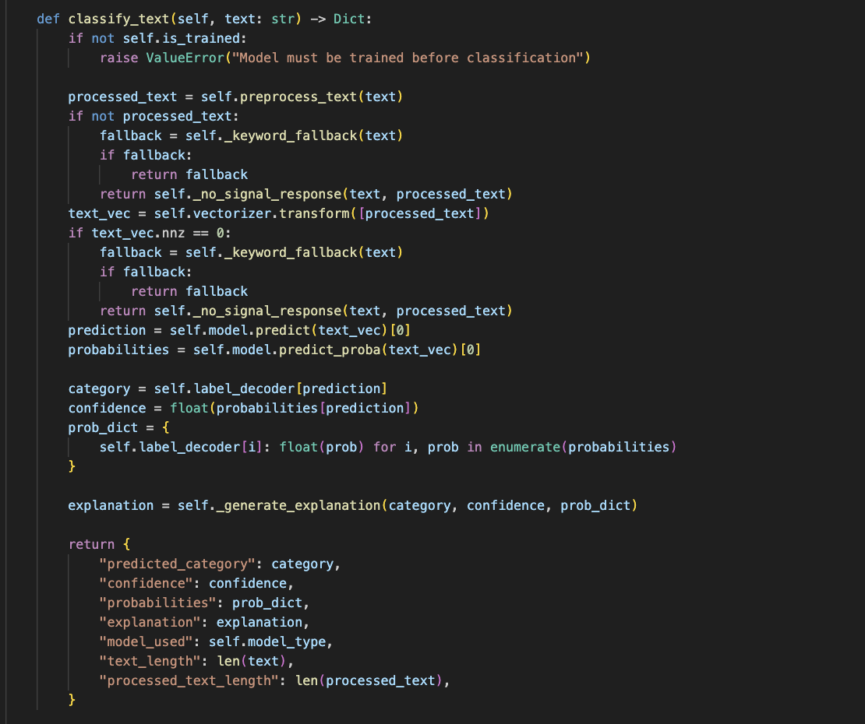
Figure 20: Classification Text Function

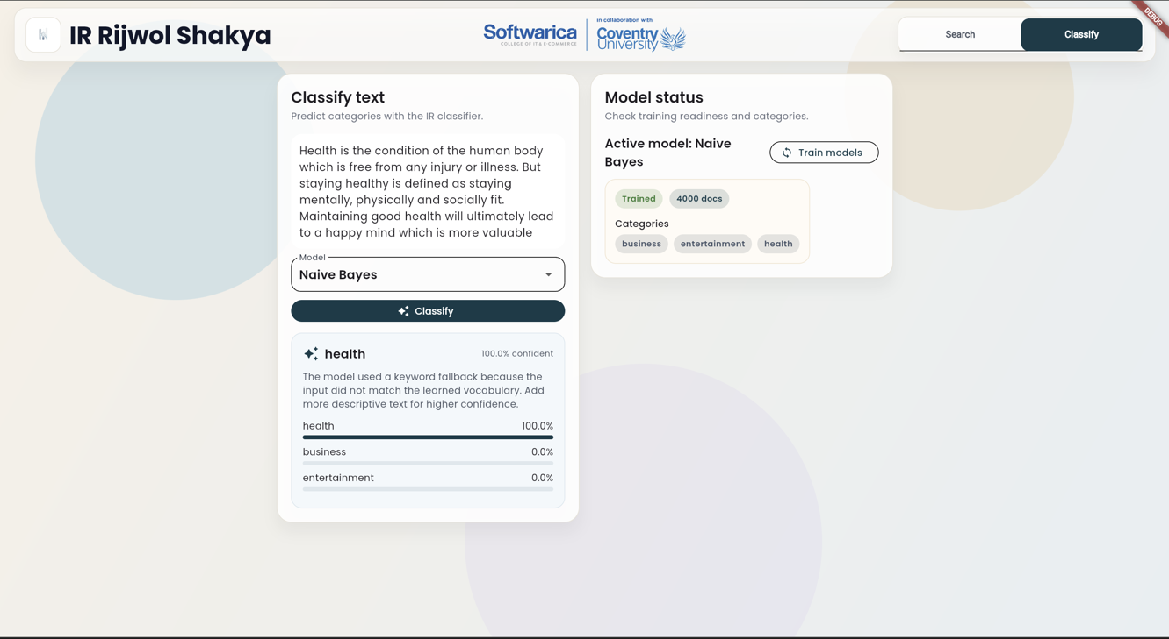
Figure 21: Classify Text Flutter UI With Result

Challenges and Limitations
A key technical challenge is handling dynamic PurePortal pages that rely on client-side rendering and can occasionally trigger anti-bot/Cloudflare checks. While the crawler uses Selenium with defensive measures such as retries, cautious delays, and stealth-style settings to improve stability, intermittent blocks or layout changes can still interrupt a run and require re-execution or minor selector updates.
Search quality is also limited by collection size and metadata completeness, especially the availability of abstracts. Although records without abstracts are still indexed (so they remain discoverable), matches based mainly on titles or short fields can reduce precision and produce less informative snippets for some queries.
For classification, performance depends heavily on how representative the labelled training set is. With limited or imbalanced examples, models may overfit or produce low-confidence outputs on unseen text. This is mitigated by the system’s fallback handling (keyword/no-signal responses) and by returning probability distributions and explanations, but accuracy is still constrained by the amount and quality of training data.

Conclusion
This project delivers a complete vertical search solution that aligns with the module learning outcomes by integrating data acquisition, indexing, retrieval, and text analytics into a single coherent pipeline. Starting from the PurePortal organisation listings for the ICS Research Centre, the system automatically collects publication records, extracts structured metadata, and stores outputs in a reusable format. The two-stage crawling strategy (listing discovery followed by detail extraction) improves reliability and makes the collection process repeatable, while polite crawling practices—such as respecting robots.txt policies, applying crawl delays, and using defensive error handling—help maintain stability when dealing with dynamic web pages.
On the retrieval side, the system demonstrates core Information Retrieval concepts in practice. It applies consistent preprocessing (normalization, stop-word removal, and stemming), builds a multi-field representation that combines title, authors, and abstract, and ranks results using TF-IDF–style scoring with length normalization. A fallback vector-space approach ensures the system can still return meaningful ranked results even when a pre-built inverted index is not available. The API layer and UI provide practical features expected in real search tools, including consistent result formatting, sorting, filtering by author and year range, and pagination for efficient browsing.
Beyond retrieval, the project adds machine learning capabilities through document classification and clustering. The classification component supports retraining and returns confidence/probability outputs for transparent predictions, while clustering provides an unsupervised way to group similar texts. Overall, the system demonstrates both theoretical IR techniques and practical engineering choices required to build a maintainable search application.

References
Bird, S., Klein, E., & Loper, E. (2009). Natural language processing with Python: Analyzing text with the Natural Language Toolkit. O'Reilly Media.
Brin, S., & Page, L. (1998). The anatomy of a large-scale hypertextual Web search engine. Computer Networks and ISDN Systems, 30(1-7), 107-117.
MacQueen, J. (1967). Some methods for classification and analysis of multivariate observations. In Proceedings of the Fifth Berkeley Symposium on Mathematical Statistics and Probability (pp. 281-297). University of California Press.
Manning, C. D., Raghavan, P., & Schutze, H. (2008). Introduction to information retrieval. Cambridge University Press.
Pedregosa, F., Varoquaux, G., Gramfort, A., Michel, V., Thirion, B., Grisel, O., ... & Duchesnay, E. (2011). Scikit-learn: Machine learning in Python. Journal of Machine Learning Research, 12, 2825-2830.
Porter, M. F. (1980). An algorithm for suffix stripping. Program, 14(3), 130-137.
Robertson, S., & Zaragoza, H. (2009). The probabilistic relevance framework: BM25 and beyond. Foundations and Trends in Information Retrieval, 3(4), 333-389.
Rousseeuw, P. J. (1987). Silhouettes: A graphical aid to the interpretation and validation of cluster analysis. Journal of Computational and Applied Mathematics, 20, 53-65.
Russell, S. J., & Norvig, P. (2016). Artificial intelligence: A modern approach (3rd ed.). Pearson.
SeleniumHQ. (n.d.). Selenium documentation. https://www.selenium.dev/documentation/
Salton, G., & Buckley, C. (1988). Term-weighting approaches in automatic text retrieval. Information Processing & Management, 24(5), 513-523.
The APScheduler Project. (n.d.). APScheduler documentation. https://apscheduler.readthedocs.io/
The FastAPI Project. (n.d.). FastAPI documentation. https://fastapi.tiangolo.com/
The Flutter Team. (n.d.). Flutter documentation. https://docs.flutter.dev/

Appendix
Appendix additions (insert screenshots / links below):
- GitHub repository link.
- Demo video link.
- Crawler run screenshot (showing target URL and robots.txt / crawl delay).
- Sample crawled JSON output (title, authors, year, links).
- Search results for 2-3 queries (ranked output).
- Classification examples (inputs + probabilities) and classification report.
- Clustering examples (varied inputs + assigned cluster label).
This appendix contains the key screenshots referenced throughout the report (crawler output, index construc

