
0

|
P a g e

Submitted by:

Shankar Ghimire

CUID: 16544211

Student ID: 25
0110

ST7071CEM: INTELLIGENT
INFORMATION RETRIEVAL

Table of Contents
Introduction 1
Crawler 1
Find Publication title and link 3
Crawl Author Name and Profile Link 4
Crawl Publication Date, Abstract, and other info 6
Search Functionality: 8
1. Text Processing and Normalization 8
2. Multi-Field Search Indexing 9
3. TF-IDF Vectorization 9
4. Similarity Calculation and Ranking 9
5. Result Filtering and Display 10
Automatic Scheduler 11
Document Classification 12
1. Data Collection: 13
1.1. Dataset Preparation: 13
1.2. Fallback Mechanism: 14
2. Data Preprocessing: 15
3. Model Training and Text Classification: 16
Challenges and Limitations: 19
Conclusion: 20
Appendix: 21
Reference: 22

Table of Figure
Figure 1: Web crawler workflow ...................................................................................... 2
Figure 2: Function for scraping publication links .............................................................. 3
Figure 3: Function to scan author name and available profile link ..................................... 5
Figure 4: Function to extract publication date and abstract .............................................. 7
Figure 5: Function for pre-processing task and normalization ........................................... 8
Figure 6: Vectorization and calculating cosine similarity ................................................ 10
Figure 7: UI for the search engine with score.................................................................. 11
Figure 8: Automatic crawl scheduler ............................................................................. 12
Figure 9: Load training data from csv ............................................................................. 14
Figure 10: Fallback training data if csv failed to load ....................................................... 15
Figure 11: function to preprocess text ........................................................................... 16
Figure 12: Model training .............................................................................................. 17
Figure 13: Text Classification ........................................................................................ 18
Figure 14: UI for the document classification with classified result ................................. 19

Introduction
The main theme of this project is to develop a vertical search engine similar to Google Scholar, with focus on the papers and books published by the members of Coventry University on university portal “School of Economics, Finance and Accounting - Research output - Coventry University”. This project will crawl all the articles published on the portal to create an inverted index. This system will automatically check for the new information every Sunday at midnight, so to keep the index up to date.
In the User Interface, the system will have basic view like Google Scholar’s page. Users can enter their search related queries and keywords they are looking for or can click on available option keyword for quick search. Additionally, Users have feature to order the results. However, this system will exclusively retrieve articles from CU with at least one author affiliated with the university.
Apart from the search module, the system will have a feature of subject classification. This module will accept a scientific article as an input and classify it into one or more of these categories, e.g., Politics’, ‘Business’ and ‘Health’. The subject classification module can be developed as an independent application or integrated as a core part of the search engine.

Crawler
A crawler, or alternatively a ‘web crawler’, ‘spider’, or ‘robot’, is an automated computer program that explores the World Wide Web for the purpose of finding, indexing, and gathering information from web pages. While search engines like Google use crawlers to create indexes that enable faster and more accurate search results, they are also used generally in data mining, tracking web changes, and creating digital archives.

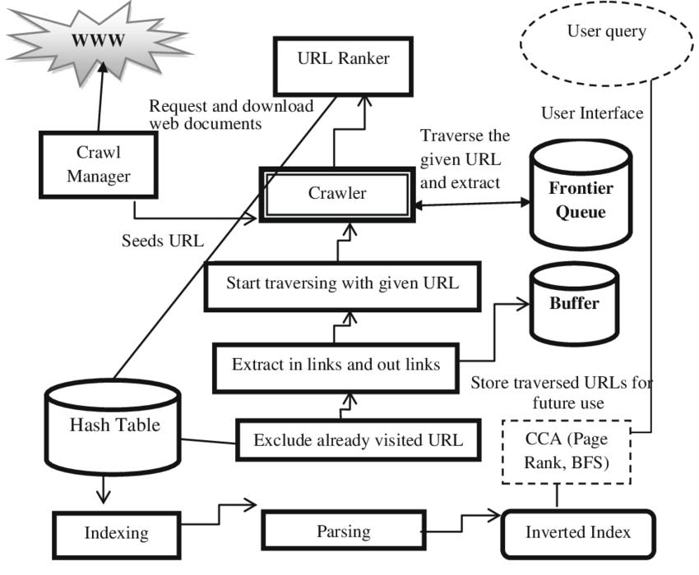
Figure 1: Web crawler workflow

Web crawlers read websites, read their pages and other content as they create entries for a search engine's index. Their basic function is to make users have access to a wide, accurate, and updated inventory of web content. For companies, crawlers are central in the process of having a strong online presence by underpinning SEO, frontend performance, and web marketing activities. Search engines such as Google, Bing, and Yahoo rely on these spiders to correctly index new or changed pages so users can retrieve them more quickly and effectively. Without them, search engines will not be able to figure out when new content is available on your site.

Find Publication title and link
The program creates a Selenium browser to search paginated listing pages from a web site. On every page, it waits until there are either results or the page indicates that there are no results. It then extracts all listings present by getting the title text and link from within each result container. There is also a helper function that scrapes a single page in its own browser session to enable multiple pages to be processed concurrently using a thread pool. On getting results back, the scraper concatenates them, reports on progress, and early termination if it encounters empty pages. Finally, it eliminates duplicates for all the results collected by their link and returns a clean list of unique listings.
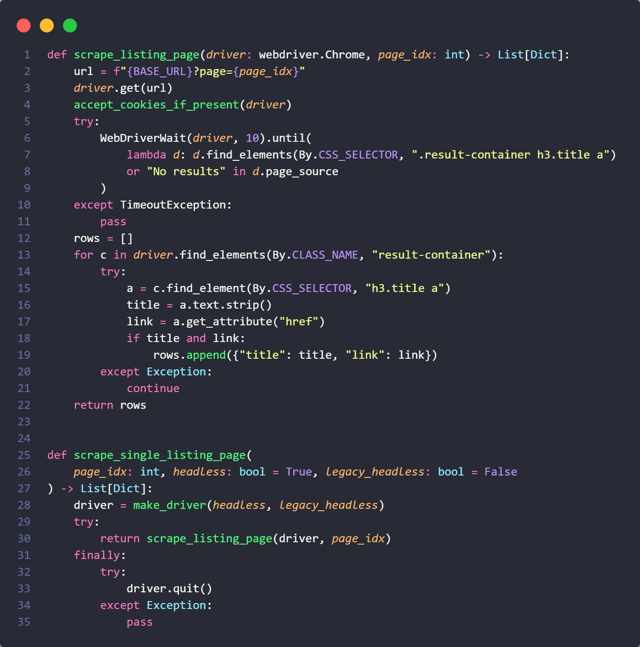
Figure 2: Function for scraping publication links

Crawl Author Name and Profile Link
This technique extracts author information from a page by identifying person profile links which appear above a navigation tab bar. It accomplishes this by first locating the Y-position of the tab bar holding items like "Overview" by trying various XPath selectors - if this fails, it uses Y-position 900 as a backup threshold default. Then, it identifies all anchor tags that contain "/en/persons/" in their href attribute, and it also separates them to check if the Y-position of every link is above the tab bar limit to make sure it only considers header-level author links and not links in the main content area. For each qualifying link, it obtains the author's name by trying to take text from a nested span element as a fallback or taking the direct text content of the anchor. It verifies that the href is a valid person profile URL and that the text fetched seems to be an actual person's name before pushing onto the candidates list. It then deduplicates on name-href pairs and returns a deduplicated list of author dictionaries with name and profile URL after successfully harvesting the notable contributors or authors of the content without navigation chrome and directory links.
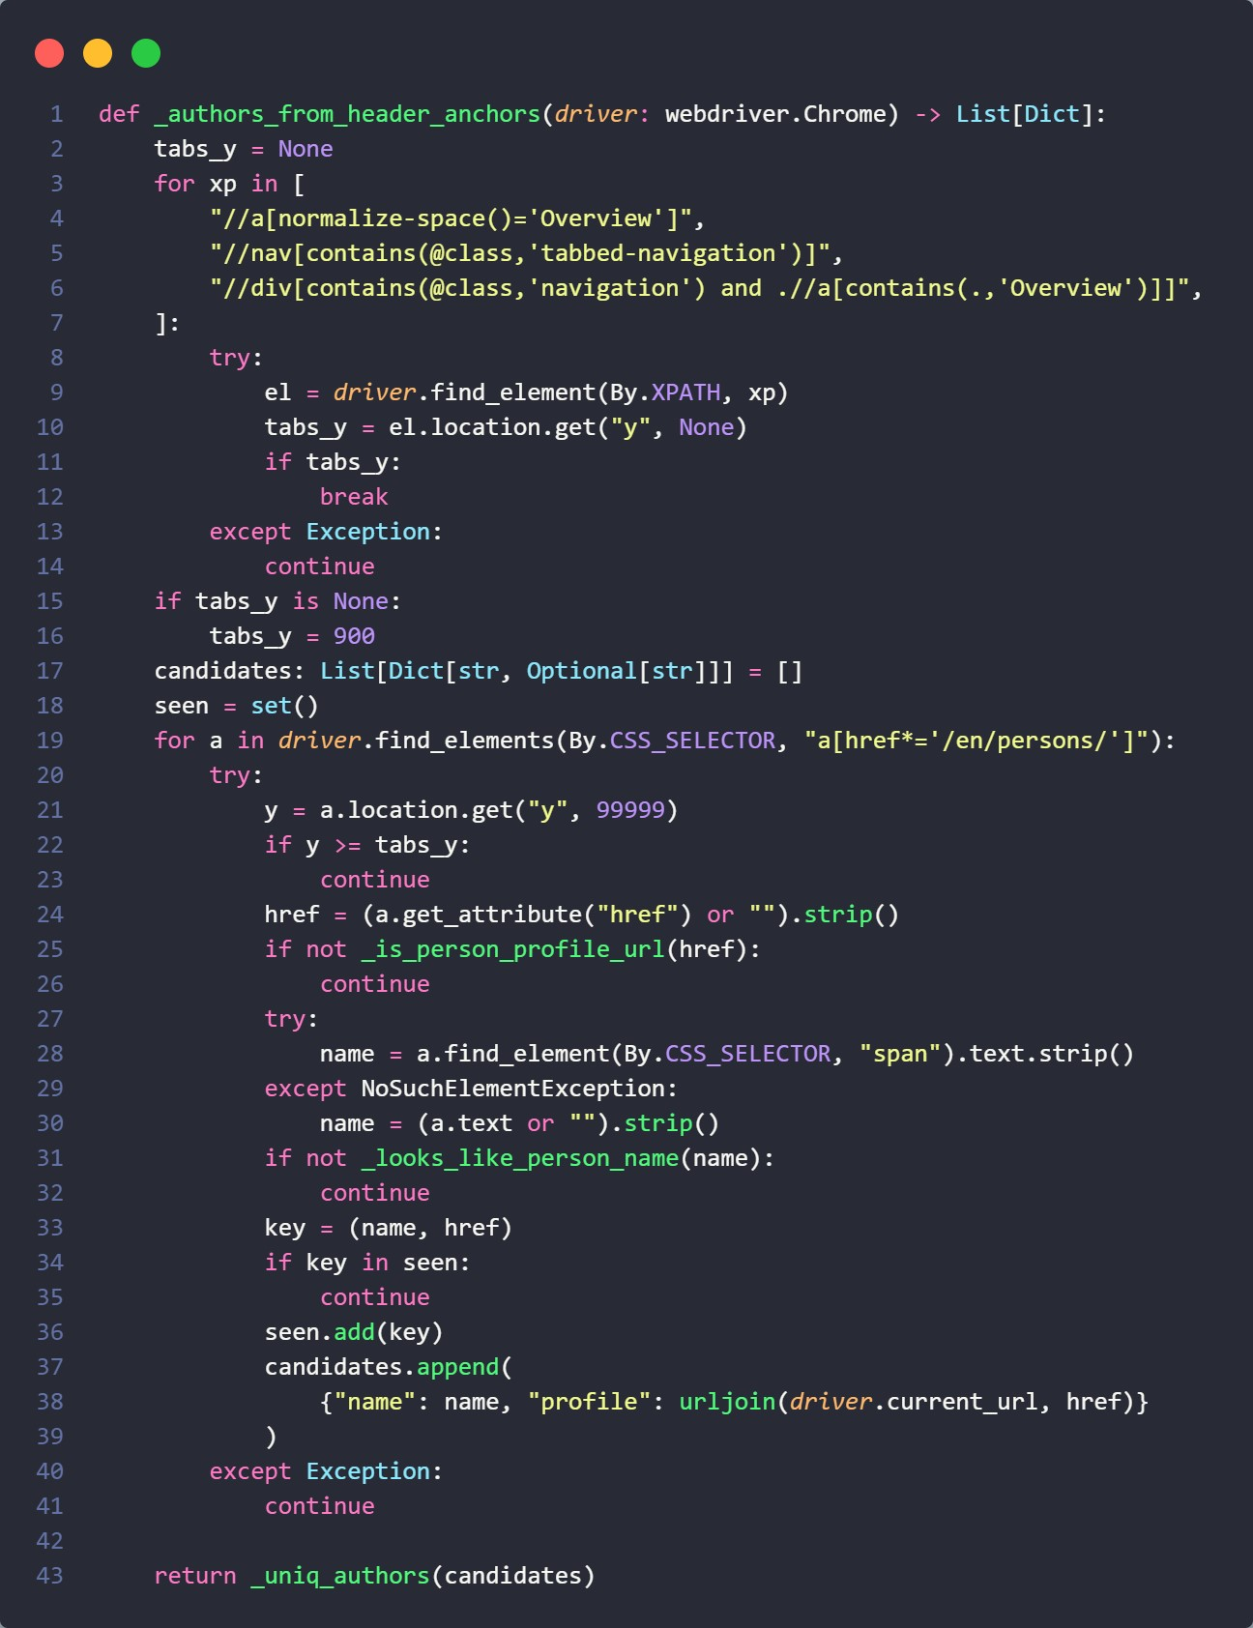
Figure 3: Function to scan author name and available profile link

Crawl Publication Date, Abstract, and other info
This approach opens a publication detail page in Selenium and first handles the cookie consent popup if present. It waits for the page title (<h1>) to load, then extracts the publication title (falling back to a given hint if necessary). To reveal hidden content, it tries clicking "show more" buttons. It then attempts to extract author information in three steps: first, by collecting profile anchors above the navigation bar (most reliable); second, by parsing the subtitle line that often contains "Surname, Initials"; and third, by reading metadata tags if needed. After that, it tries to determine the publication date from elements like <span class="date"> or <time>. For the abstract, it follows a sequence of increasingly broad strategies: checking standard abstract containers, looking for headings containing "Abstract," scanning nearby text, checking meta tags, and finally falling back to scanning general text blocks for substantial content. At the end, it returns a dictionary containing the publication’s title, link, abstract, publication date, and a list of authors (each with a name and optional profile link).
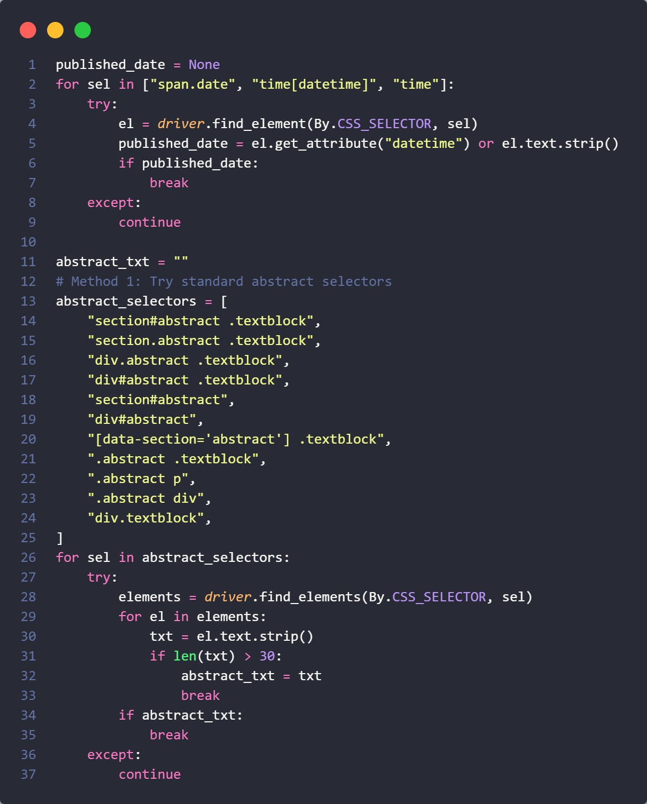
Figure 4: Function to extract publication date and abstract

Search Functionality:

1. Text Processing and Normalization
The pre-processing by the search engine is processing of all text contents when searching on transforming in several transformations in order to improve the accuracy of a search. All input text is lowercased during input, for case-insensitive matching, and tokenized into words with NLTK (Natural Language Toolkit). Then it gets rid of common words that carry little value, such as “the”, “and” or “is”, and reduces words to their basic format using stemming — for example “algorithms” becomes “algorithm” and “learning” becomes “learn”. Lastly, it removes special characters and punctuation to get clean normalized text. This overall preprocessing guarantees that a search for (e.g.) "Machine Learning" will match publications having "machine learning", "MachineLearning", or other similar variants.
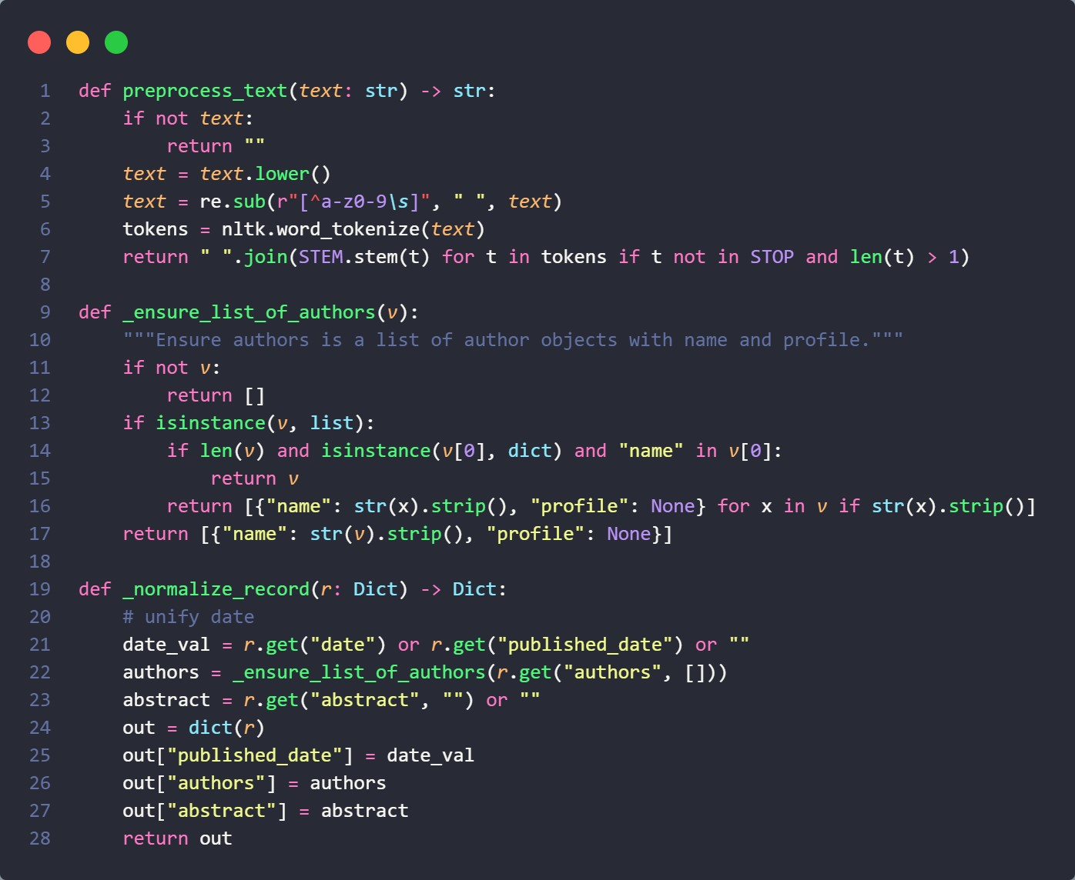
Figure 5: Function for pre-processing task and normalization

2. Multi-Field Search Indexing
The search engine consolidates 3 critical data fields per title in its global database, in order to permit flexible search. The system incorporates the full title of the publication, the full author list and the abstract of the publication in a contiguous search text blob for each publication. This integrated method offers multiple points of entry for users to discover relevant papers, whether they are looking for particular author names, technical terms that may be present in titles, or research topics as discussed in abstracts. By indexing in this way across these fields, the search engine allows for results to be pulled up even if the term shows up in only one of the fields.

3. TF-IDF Vectorization
For text the system converts text into numerical vectors using Term Frequency-Inverse Document Frequency (TF-IDF) to do the math. Term frequency computes how frequently a word occurs in a certain document and Inverse Document Frequency diminishes the weight of words that are common in the documents of the corpus. This combines to form a vector representation in which each article is a point in this large-scale mathematical space, and the coordinates of the point reflect how important each word is relative to the entire collection of articles. This method tends to highlight genuinely interesting content by focusing on unique and salient terms and deemphasizing more common language that happens to appear in many papers.

4. Similarity Calculation and Ranking
When you perform a search, your search terms are passed along the very same preprocessing pipeline, which means that search and publication content are treated consistently. The query is treated similarly by transforming the processed query into the same vector space as the publications and forming a query vector, which can be compared to each publication vector using math. The system computes the cosine similarity between your query vector and each publication vector, which will tell you the angle that vectors form with each other and therefore how closely the categories of your query can reach the publications. The search results are then sorted by this similarity score and publications with the highest cosine similarity values are returned first, thus the most relevant matches are displayed at the top.

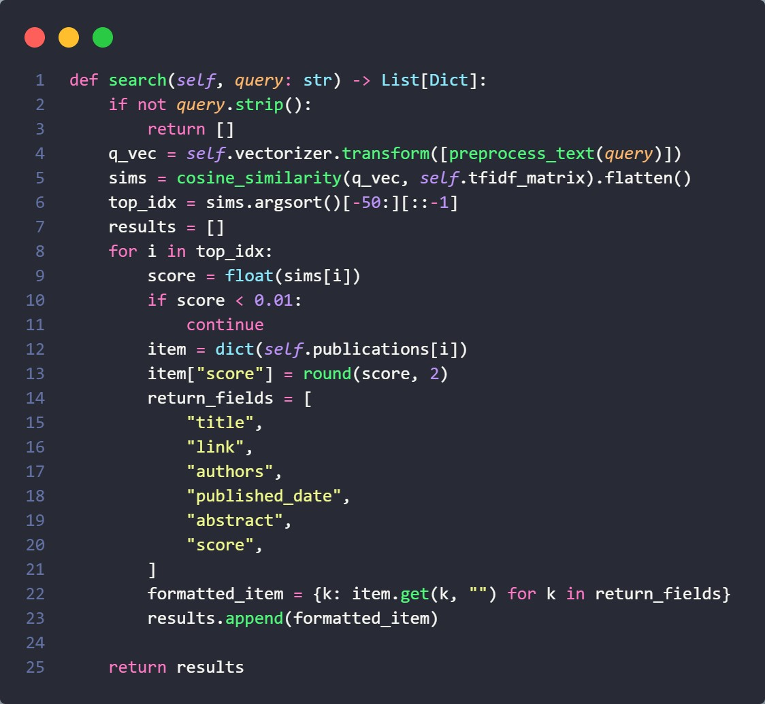
Figure 6: Vectorization and calculating cosine similarity

5. Result Filtering and Display
The search engine even incorporates quality checks to make sure that users are receiving valuable and relevant results for their searches. Finally, a minimum standard of 0.01 has been set on the similarity-based scores, such that only publications that have significant relevance to the query are returned. In respect to performance and focus to relevant matches, the engine returns at most top 50 most relevant publications prioritized by similarity score. Each result also comes with a relevance score between 0.0 and 1.0, indicating how closely the pub matches the query, thereby giving users the opportunity to judge for themselves how well the result matches their research.

Figure 7: UI for the search engine with score

Automatic Scheduler
The script develops a scheduler in the background using APScheduler to run a crawler script on a weekly basis at regular intervals. The script develops a function `run_crawler` that prints a starting message, enables the project's virtual environment in Python, and runs the crawler.py script as a subprocess. In the` __main__` section, a BackgroundScheduler is created and a cron job is scheduled to run `run_crawler` at midnight every Sunday. After being scheduled, the script goes into an infinite loop with a sleep timer so that the scheduler keeps running in the background until the process is interrupted. If the script is interrupted by `Ctrl+C` or a system signal, the scheduler is terminated cleanly.
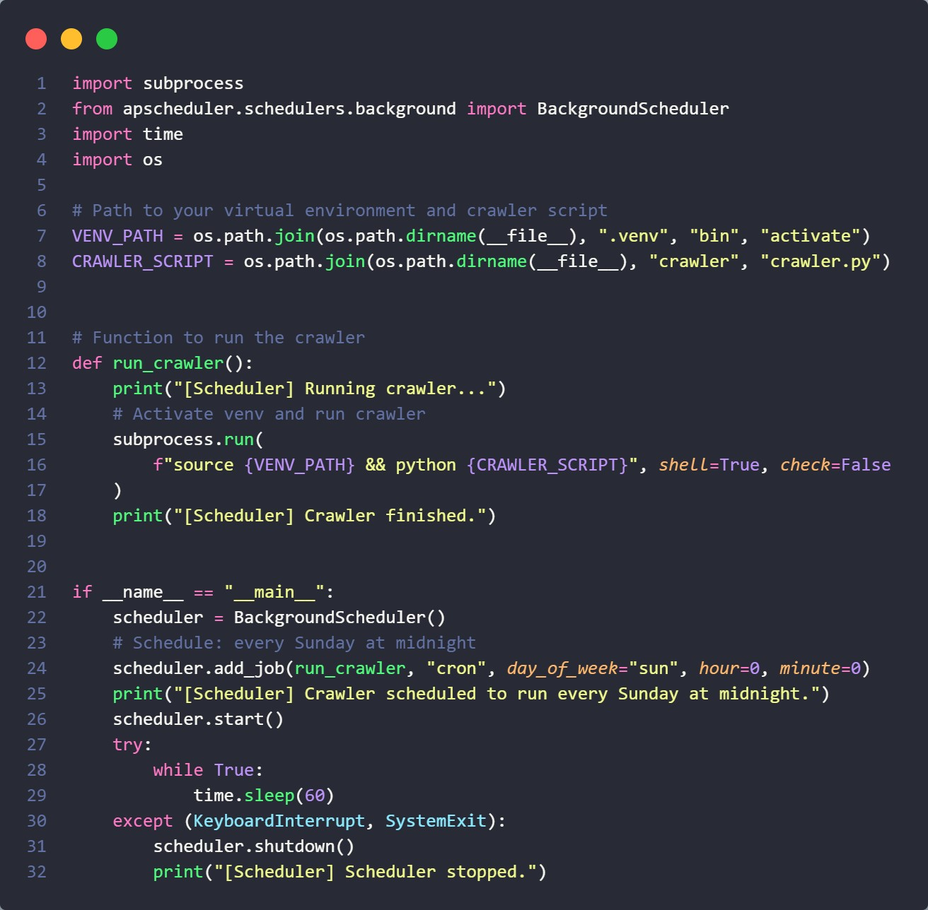
Figure 8: Automatic crawl scheduler

Document Classification
The goal of this assignment is to build a document classification system that automatically categorizes text documents into predefined classes: Politics, Business, and Health. The system will be implemented using two machine learning approaches: Naive Bayes classifier and Logistic Regression.
The Naive Bayes classifier is a probabilistic model based on Bayes’ Theorem, commonly used for classification tasks. It operates under the simplifying assumption that features (words or attributes) are conditionally independent given the class label—hence the term “naive” (Russell & Norvig, 2016).
In contrast, Logistic Regression, classification as a probability estimation problem, where each document receives probability scores for all three categories (Politics, Business, Health). The algorithm learns optimal feature weights during training, enabling it to identify which textual elements most strongly indicate specific categories. The final classification decision corresponds to the category with the highest probability score.
The process involves the following key steps:
- Data Collection: CSV-based loading of training documents and categories
- Text Preprocessing: Comprehensive pipeline (tokenization, stemming, stop-word removal)
- Model Training: Both Naive Bayes and Logistic Regression with evaluation

1. Data Collection:

1.1. Dataset Preparation:
The process begins with loading and organizing the training data from CSV files. The system reads predefined categories from `categories.csv` and training documents from `training_documents.csv`. Each training document contains text content paired with its corresponding category label (Politics, Business, or Health). The system creates internal mappings between text labels and numerical representations, establishing label encoders that convert category names to integers and vice versa.
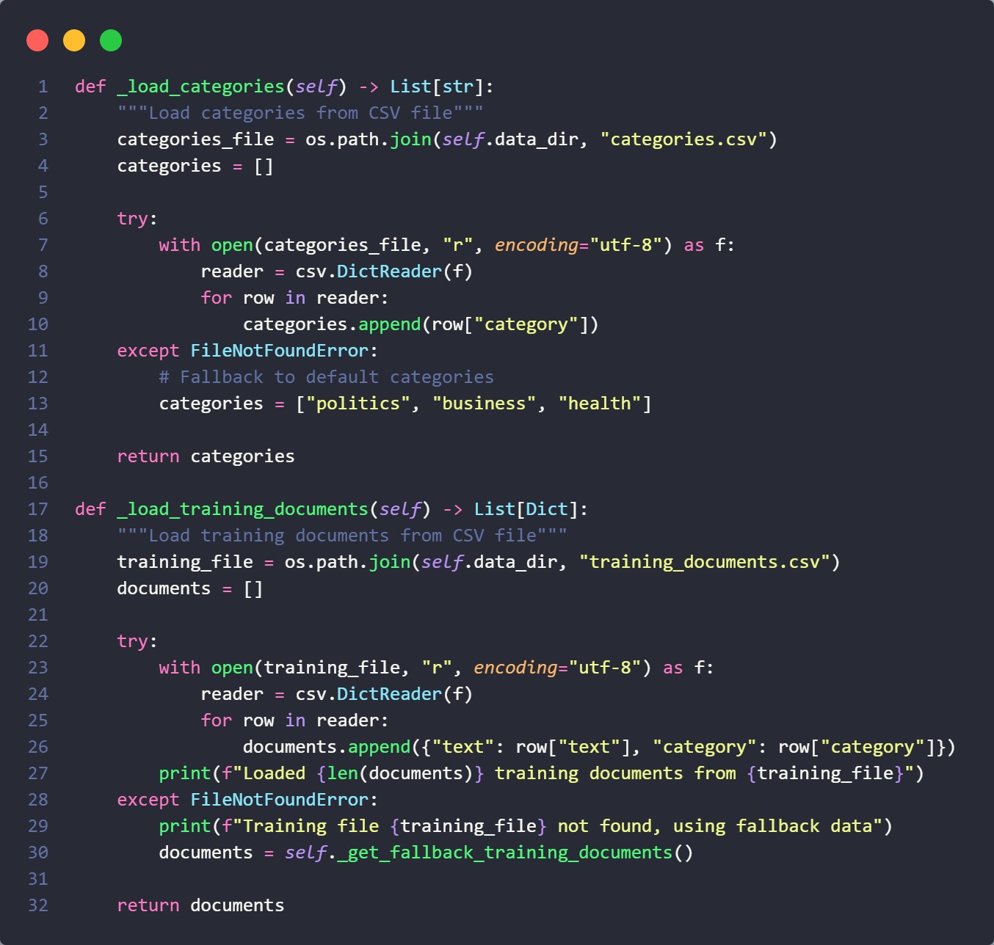
Figure 9: Load training data from csv

1.2. Fallback Mechanism:
When CSV files are unavailable, the system automatically switches to a built-in fallback dataset containing representative documents for each category. This ensures the system remains functional even without external data files, though with reduced training diversity.
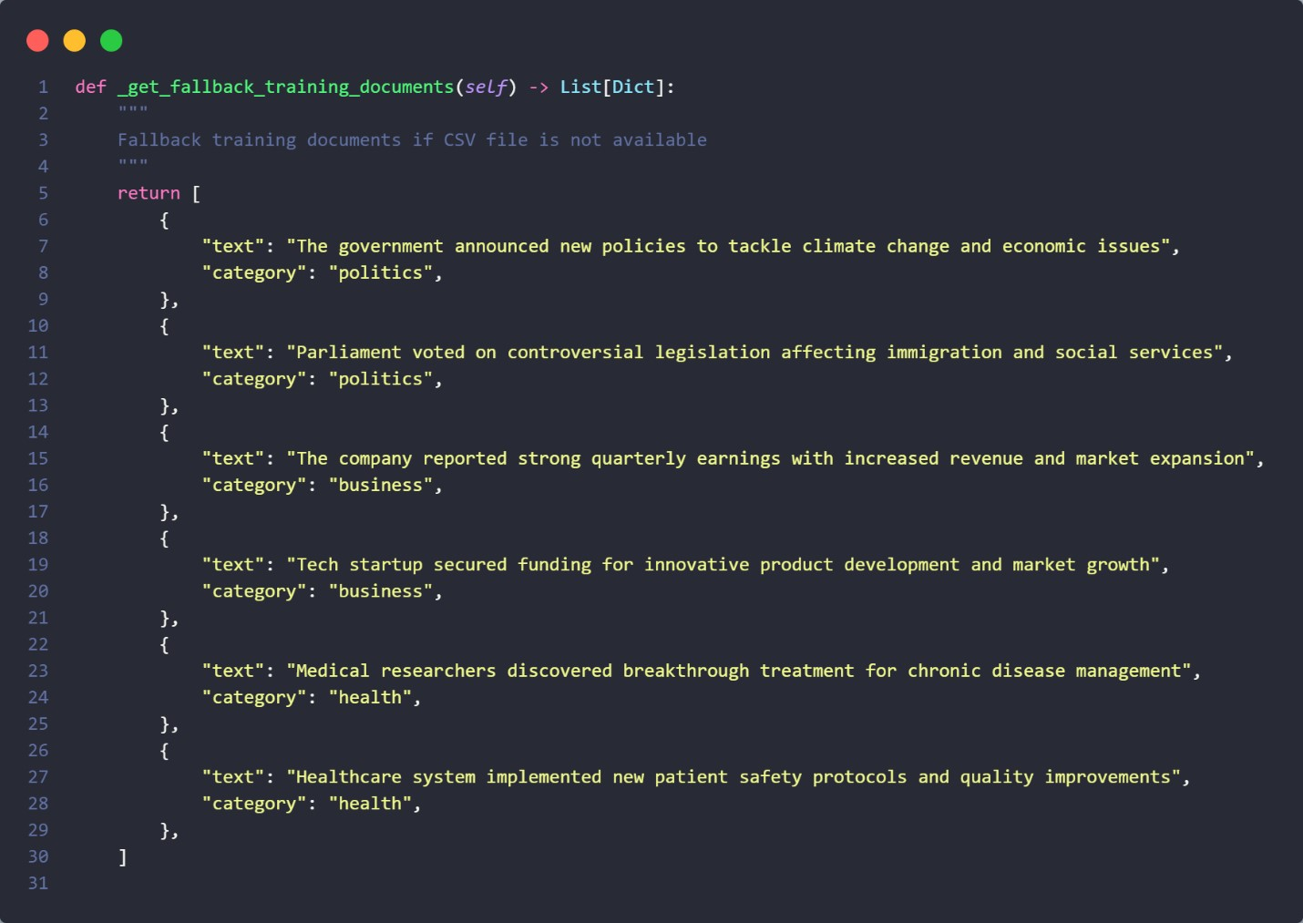
Figure 10: Fallback training data if csv failed to load

2. Data Preprocessing:
Text preprocessing is the process of cleaning and preparing the raw text data into a structured format that is most suitable, and easily understandable by the machine learning algorithms. In doing so, we first convert the text to lower case to have a common ground and no differently cased words be considered as distinct features. & Special Character: After the symbol counts, we take out punctuations marks and special characters by using regular expression to only keep alphabets. Tokenization breaks the clean text into words, so we can perform word level operations. Commen stop words (the, is and and) are removed as they contribute little in determining the categories. For each word, we apply stemming to reduce it to its root form, so that variations such as “running,” “runs” and “ran” are all represented the same way. Finally, the processed tokens are concatenated again into a single string, giving a simple and normalized version of the original text that is safer and more interpretable by classification algorithms.
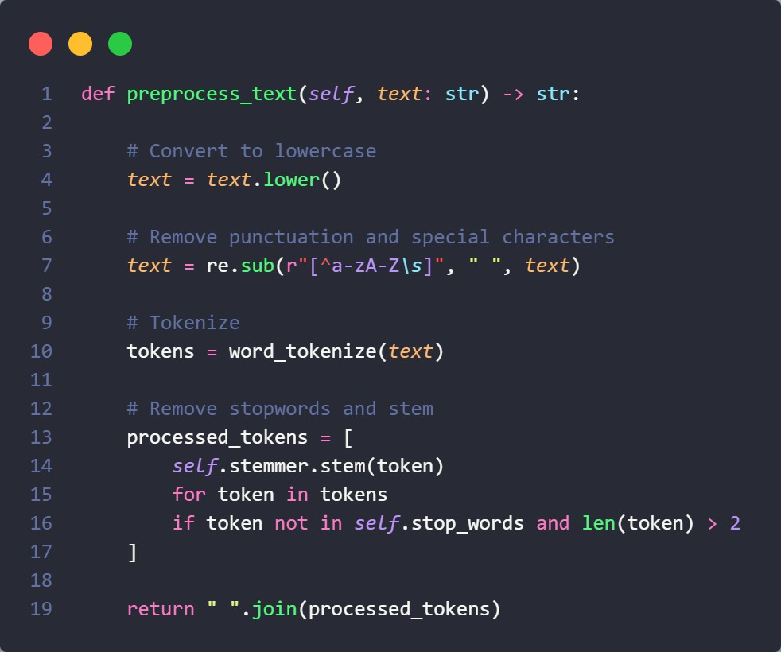
Figure 11: function to preprocess text

3. Model Training and Text Classification:
The training of the model starts with raw text and their categories from the training dataset are extracted. Both documents are pre-processed to clean and normalize the text, and then split into train and test sets. We then transform the text to a numeric format, by converting the text into feature vectors by means of a TF-IDF (Term Frequency–Inverse Document Frequency) vectorizer that captures both the frequency of terms and the inverse of the number of documents containing the terms. An instance of either Naive Bayes classifier or Logistic Regression is created and trained on the vectorized training data, according to the model type selected. After fitting the model, you can evaluate it on the test set by predicting labels, computing accuracy and generating a classification report which displays precision, recall and F1-score for each category. Results (including meta information like training size, test size, model type) are sent back for analysis.
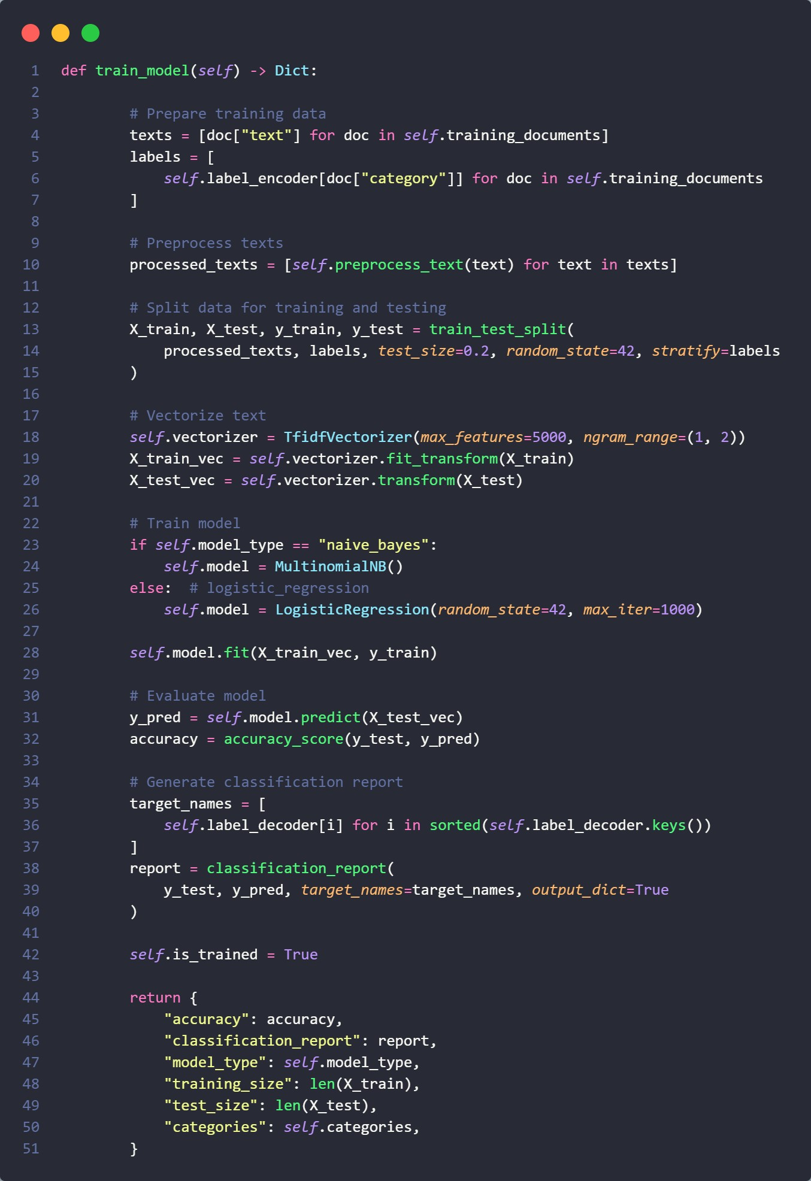
Figure 12: Model training
During the testing phase, the input document is preprocessed to match the training text. The preprocessed text is then converted into the TF-IDF vector using the trained vectorizer again. The model predicts the most probable category while, for both this category and all categories, it assigns a confidence degree (i.e., prediction probability). Last, an explanation is produced to summarize the rationale for deciding the classification. The result comprises the category prediction, confidence, probability distribution, explanation and details of the used model, providing transparency and interpretability of predictions.
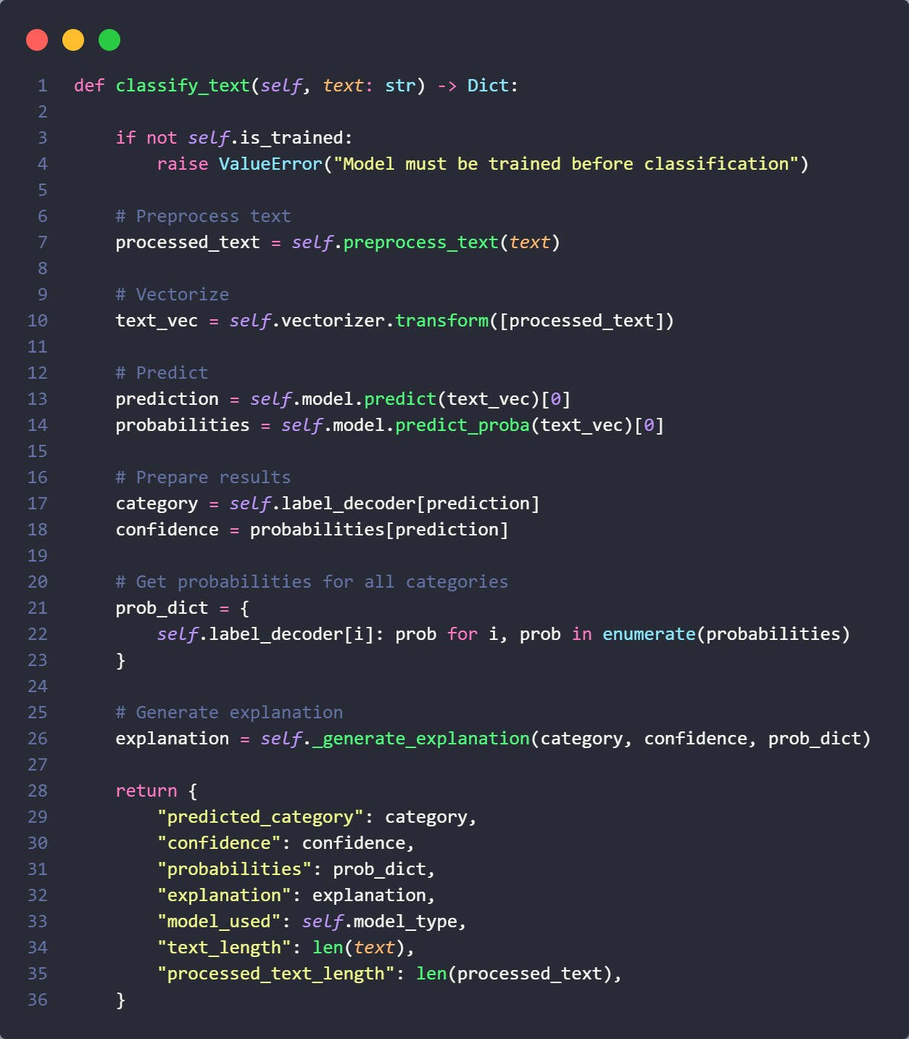
Figure 13: Text Classification

Figure 14: UI for the document classification with classified result

Challenges and Limitations:
- Small Dataset: Insufficient training data (450 documents), also fallback dataset contains only 6 documents (2 per category)
- Ambiguity in Documents: Documents often span multiple categories (e.g., "Government healthcare policy" = Politics + Health)
- Evaluation Weaknesses: Single train-test split isn’t robust enough for production confidence.
- Preprocessing Oversimplification: Removing all punctuation loses important context like
“U.S” or “COVID-19”

Conclusion:
This work implemented an intelligent vertical search tailored to academic publications of the School of Economics, Finance and Accounting at Coventry University and complemented with intelligent document classification. The realization explores and integrates the power of several advanced technologies, such as the combination of web crawling, semantic search and machine learning-based text classification, to offer a functional research discovery platform specifically tailored to the requirements of academic users who have an interest in university-based research content. The combined presentation of search and automated categorization, in the two primary categories Politics, Business, and Health, supports well the internal content organization and user navigation both within the repository.

Appendix:
Github: https://github.com/Tulsee/IR-shankar-ghimire
Video:
https://drive.google.com/file/d/1saavfxDt46XgoUtSMztux4LoyIRC6vKS/view?usp=sharing

Reference:
Azeraf, E., Monfrini, E. and Pieczynski, W. (2022) ‘Improving usual naive Bayes classifier performances with neural naive Bayes based models’, Proceedings of the 11th International Conference on Pattern Recognition Applications and Methods, pp. 315– 322. doi:10.5220/0010890400003122.
Das, S. (2021) ‘Search engine algorithm and search engine marketing’, Search Engine Optimization and Marketing, pp. 117–180. doi:10.1201/9780429298509-6.
Dumais, S. (2006) ‘Session details: Web mining with search engines’, Proceedings of the 15th international conference on World Wide Web [Preprint]. doi:10.1145/3259702.
x, P. and Sharma, R. (2015) ‘Study of a web crawler’, International Journal of Scientific Engineering and Research, 3(8), pp. 14–16. doi:10.70729/26071501.
‘Introduction To Natural Language Processing’ (2014) Natural Language Processing, pp. 1–6. doi:10.1075/nlp.11.01ch1.
‘Logistic Regression And Classification’ (2020) Wiley Series in Probability and Statistics, pp. 181–232. doi:10.1002/9781119464761.ch7.
Russell, S. and Norvig, P., 2016. Artificial Intelligence: A Modern Approach. 3rd ed. Pearson

