

Introduction
This report documents the design and implementation of a vertical information retrieval system focused on Coventry University PurePortal publications. The system crawls organisation publication pages, extracts structured metadata, builds an inverted index, ranks results with TF-IDF scoring, and exposes APIs for search and machine learning tasks.
The implementation follows the assignment brief for ST7071CEM by demonstrating core IR concepts: data acquisition, preprocessing, index construction, query processing, relevance ranking, and evaluation through user-facing results. The pipeline is built in Python with a FastAPI backend and a Flutter user interface for web and mobile use.
The solution targets publications where at least one author is affiliated with the ICS Research Centre for Computational Science and Mathematical Modelling. This creates a domain-limited search engine similar to Google Scholar, but constrained to a single institutional collection to enable controlled crawling and indexing.
From the user perspective, the system provides a focused search experience with ranked results, clickable links, and filtering options. The combination of a backend API and UI supports both demonstration and practical use in an academic setting.

Crawler
The crawler targets the PurePortal organisation publications listing for the ICS Research Centre. The crawler is implemented in IR_Rijwol_Shakya/crawler/crawler.py using Selenium, BeautifulSoup, and a set of defensive strategies for dynamic content. It uses two stages to reduce failures: a listing phase to collect publication links and a detail phase to extract metadata from each publication page.
Stage 1 visits the PurePortal organisation listings, waits for result containers to load, and collects title and link pairs. Stage 2 iterates through these links and extracts title, authors, published date, and abstract. Each output is saved to JSON so partial data remains usable if a run stops early.
The crawler uses a single browser session for listing pages to reuse cookies and reduce repeated initialization costs. For detail pages, workers are used to parallelize extraction while still respecting crawl delays and robots.txt policies.
The crawler includes retry handling and optional screenshots for debugging. This makes it easier to handle transient failures, Cloudflare checks, or layout changes that might otherwise interrupt the crawl.
Figure1: Web crawler workflow
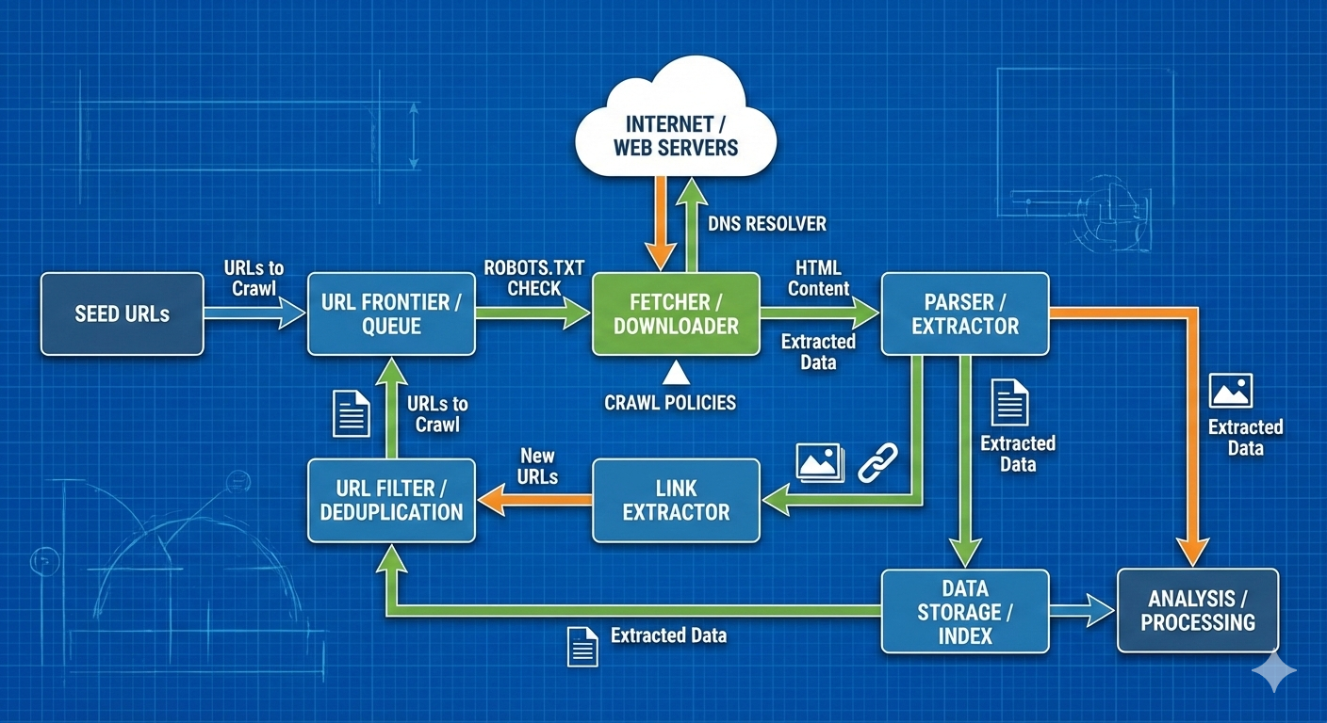

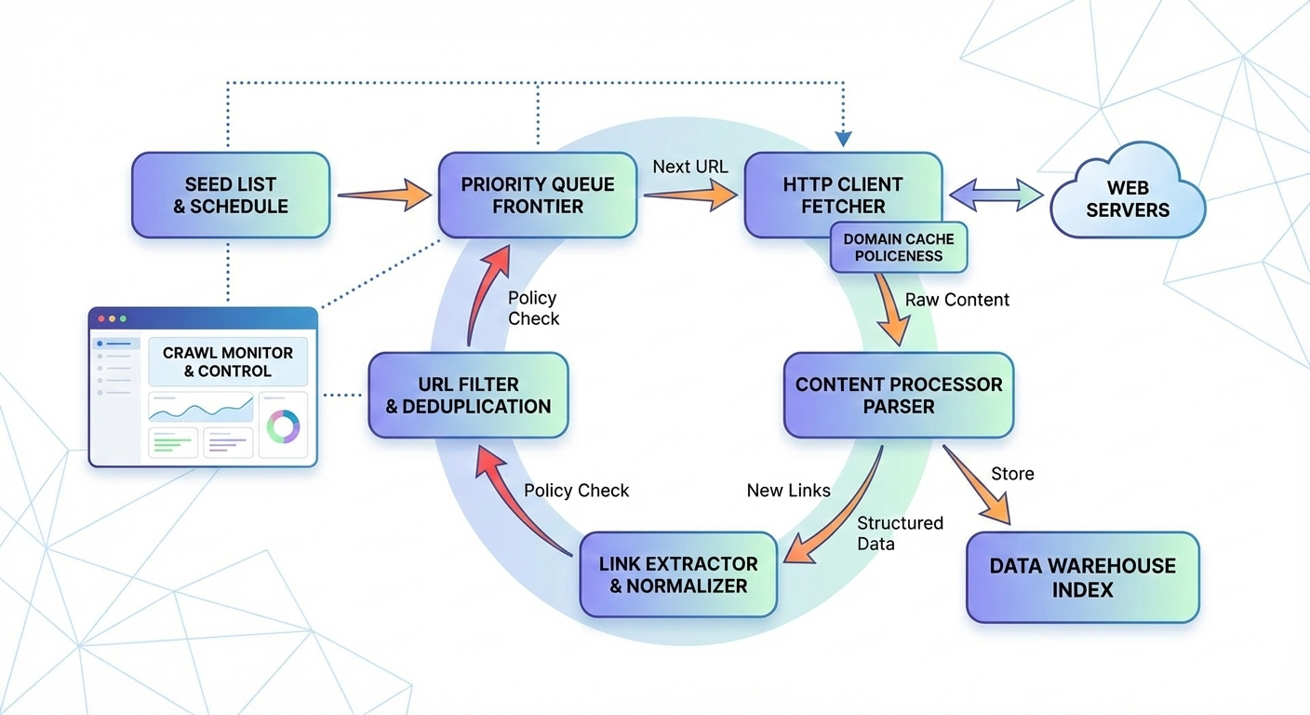

Find Publication title and link
Publication titles and links are collected from each listing page using CSS selectors that match the title anchors. The crawler iterates through multiple pages and aggregates unique links, removing duplicates by URL. This creates a stable set of targets for Stage 2. The design supports throttling between pages and can reuse a single browser session to reduce overhead.
Publication titles and links are extracted from listing pages using the selector .result-container h3.title a. The crawler iterates over each listing page and collects all unique URLs by de-duplicating on link, ensuring the second phase only processes new targets.
This stage is intentionally lightweight to avoid blocking and to produce a stable link set. It also allows the project to demonstrate index updates by rerunning the crawler on a weekly schedule.
Figure 2: Function for scraping publication links
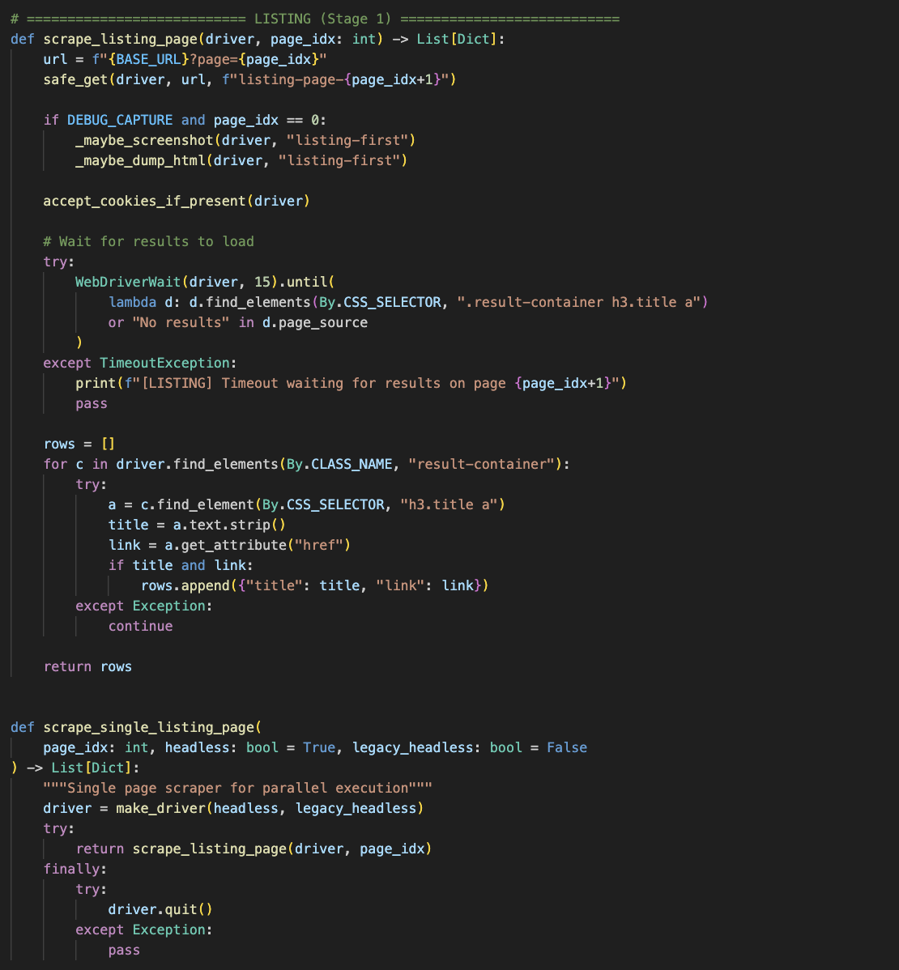

Crawl Author Name and Profile Link
above the tab navigation are scanned for person profile links. If this fails, the crawler parses the subtitle line that often contains authors and the publication date. The crawler also checks citation meta tags and falls back to BeautifulSoup parsing for robustness. After extraction, authors are de-duplicated and saved as name/profile objects to preserve both human-readable and navigable data.
Author extraction is implemented as a multi-strategy pipeline because PurePortal pages vary in structure. The primary method collects author profile anchors above the tab navigation, which reliably capture person profile URLs.
If the header anchor strategy fails, the crawler parses the subtitle line that contains authors and the publication date. It also checks citation meta tags and applies a BeautifulSoup fallback using href patterns for /en/persons/.
All authors are de-duplicated and stored as objects with name and profile URL. This structure is required for both the report and the user interface, which displays author names and supports filtering by author.
Figure 3: Function to scan author name and available profile link
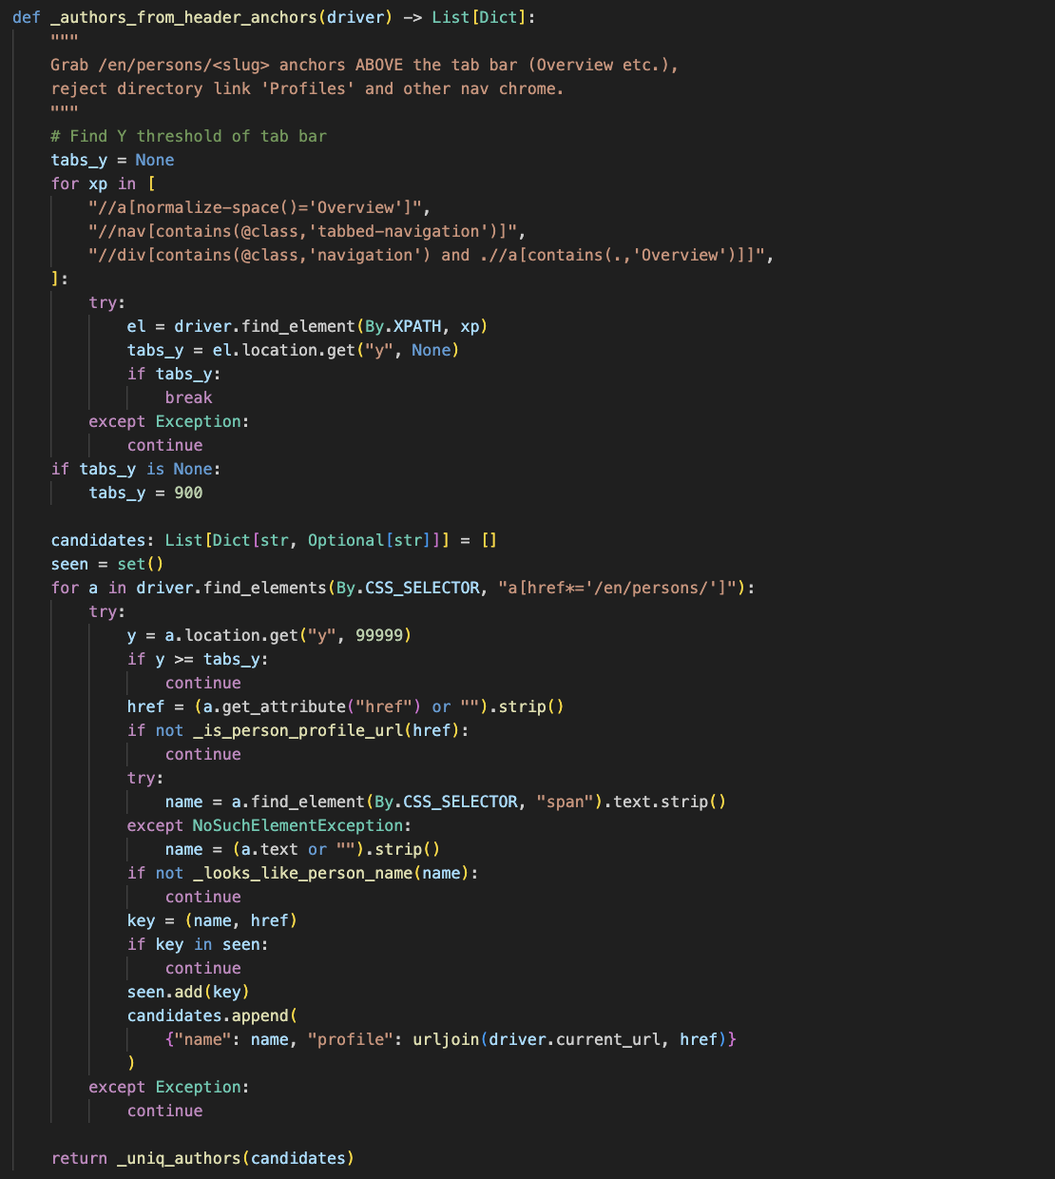

Crawl Publication Date, Abstract, and other info
Publication date is extracted using date or time selectors, falling back to available attributes when text is missing. Abstract extraction uses multiple selectors, heading-based fallbacks, and meta tags to capture text from different PurePortal layouts. This multi-stage strategy improves recall for abstracts and ensures that missing elements do not break the crawl pipeline.
Publication dates are extracted using span.date or time elements, falling back to datetime attributes where available. This ensures the year range filter can be applied consistently during search.
Abstract extraction uses a sequence of selectors that match typical PurePortal layouts, then falls back to heading-based discovery and meta tags. The multi-stage approach increases recall for abstract text without breaking when some selectors are missing.
If abstract text is missing, the crawler stores an empty string instead of failing the record. This design keeps indexing robust and still allows results to be returned with partial metadata.

Figure 4: Function to extract publication date and abstract
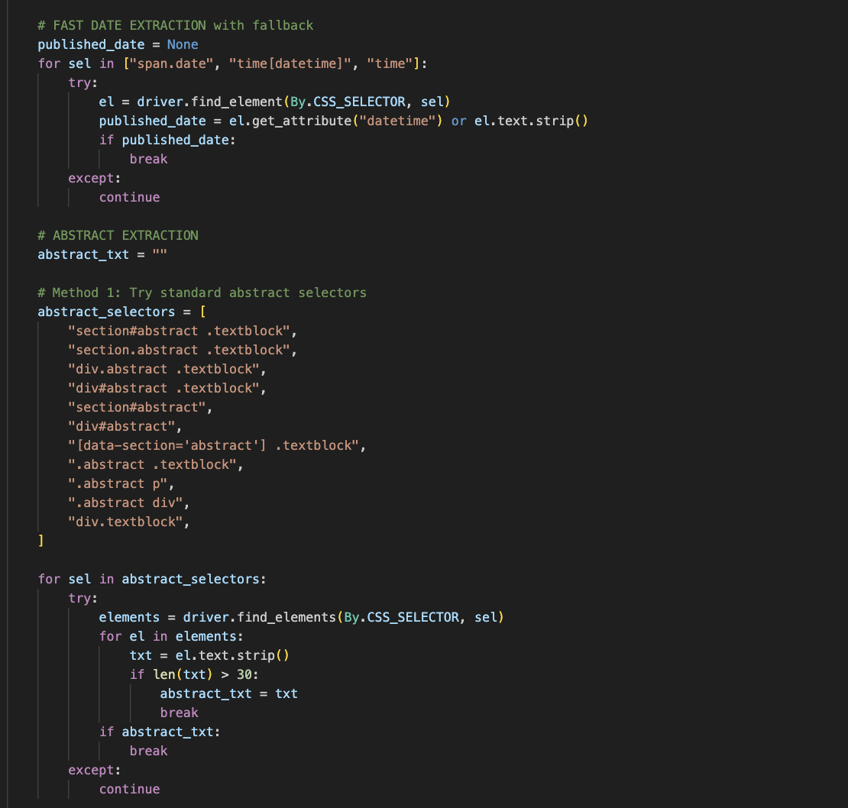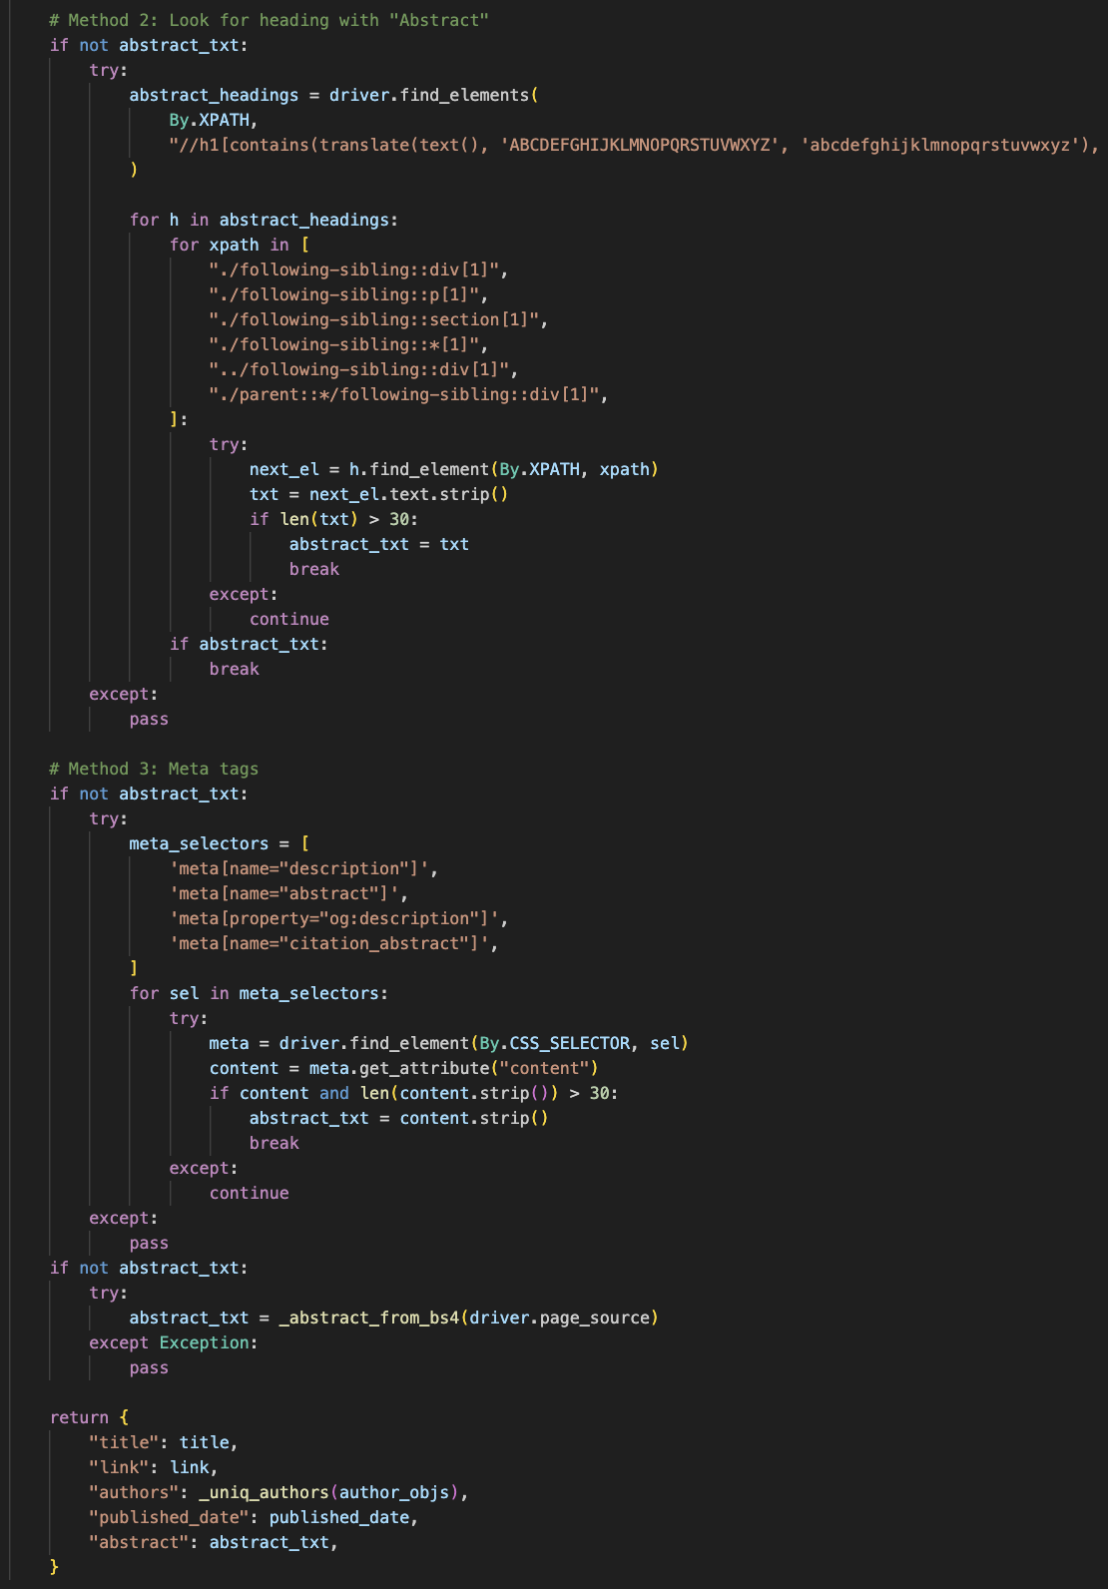

Search Functionality
The search engine supports two retrieval modes. When an inverted index exists, a lightweight TF-IDF style scoring is computed using term frequencies and document lengths. If no index is present, a TF-IDF matrix is built and cosine similarity ranks documents. Both modes apply text normalization to improve matching.
The search engine is implemented in IR_Rijwol_Shakya/backend/search.py and IR_Rijwol_Shakya/backend/indexer.py. It supports two modes: index-based scoring with a persistent inverted index and a TF-IDF matrix fallback when the index is unavailable.
The index-based mode aligns with IR principles taught in the module by using postings lists, document frequencies, and length normalization. The fallback mode uses scikit-learn's TfidfVectorizer with cosine similarity to provide consistent ranking even without a pre-built index.
A lightweight cache is used in the API layer to reduce repeated computation for identical queries. This improves responsiveness without changing the ranked output for a short time window.

Text Processing and Normalization
Text preprocessing is applied to both documents and queries to ensure consistent matching. The pipeline lowercases text, removes punctuation and non-alphanumeric characters, tokenizes, removes stop words, and applies Porter stemming.
Stemming improves recall by matching word variants such as compute, computing, and computational. This is useful for partial query matching in an academic search context and is required for the assignment's focus on IR preprocessing.
Figure 5: Function for pre-processing task and normalization
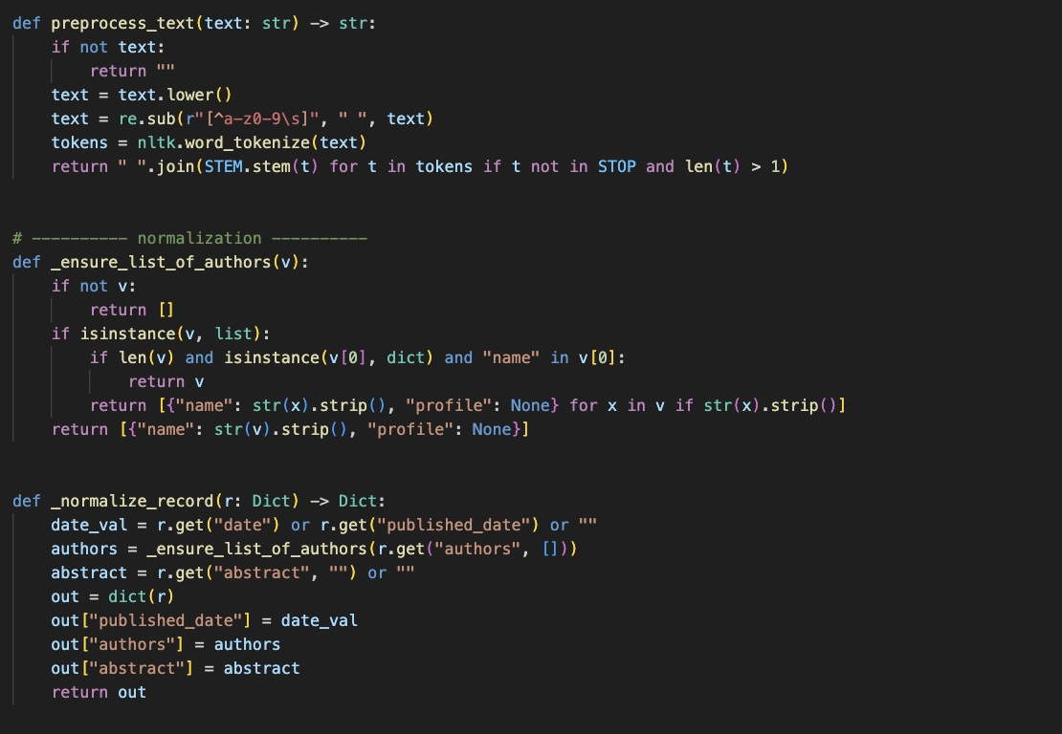

Multi-Field Search Indexing
Indexing combines title, author names, and abstract into a single token stream. This ensures that searches match on multiple fields instead of only abstract content.
The inverted index stores document length and postings for each term. Each posting maps a document ID to term frequency, enabling efficient TF-IDF style scoring without scanning all documents.
Figure 6: Inverted index construction
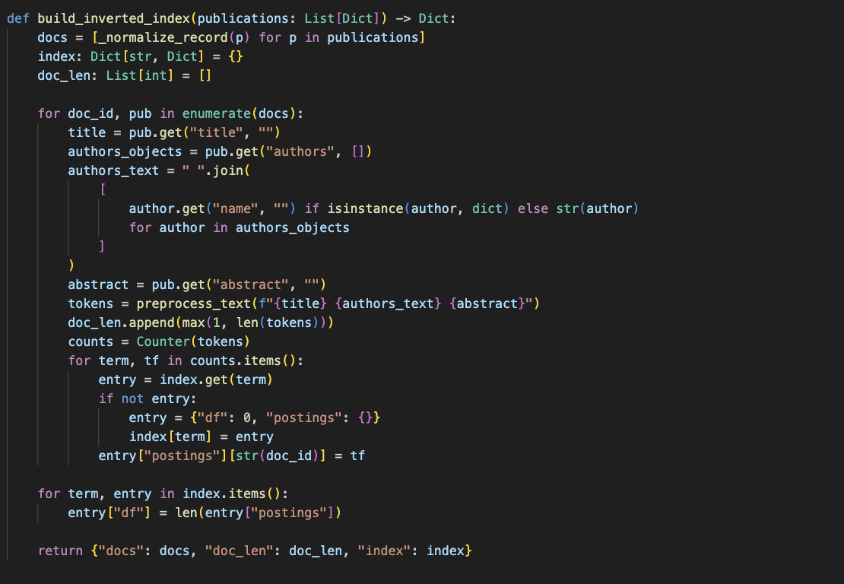

TF-IDF Vectorization
In index mode, term frequency is normalized by document length and weighted by an IDF term computed as log((N+1)/(df+1))+1. This balances common and rare terms and maintains numerical stability.
In fallback mode, TfidfVectorizer builds a sparse matrix of term weights across all documents. Queries are vectorized with the same model and ranked using cosine similarity.
Figure 7: TF-IDF vectorization
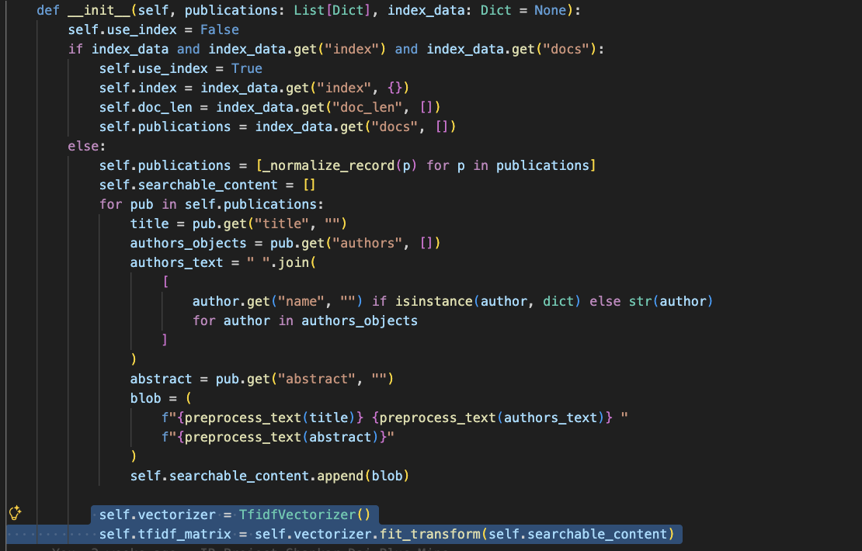

Similarity Calculation and Ranking
The search function computes scores for all matched documents and ranks them in descending order. A small threshold removes results with negligible similarity to reduce noise.
Results are formatted with consistent fields: title, link, authors, published date, abstract, and score. This format is used by both the API and the Flutter UI.
Figure 8: Similarity calculation and ranking
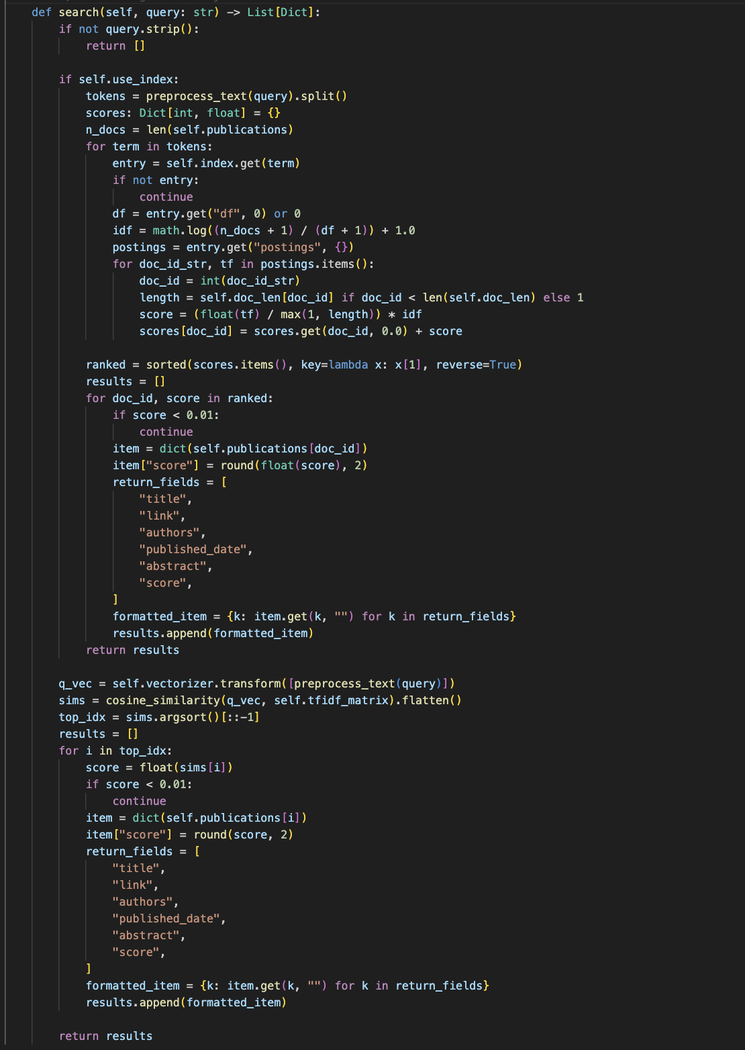

Result Filtering and Display

The search API supports optional filtering by author substring and by year range. These filters are applied after ranking to maintain relevance ordering and to keep query processing simple.

Pagination is implemented with page and size parameters. The API returns total results and total_pages, which the UI uses to render navigation controls.

Figure 9: Result filtering and display
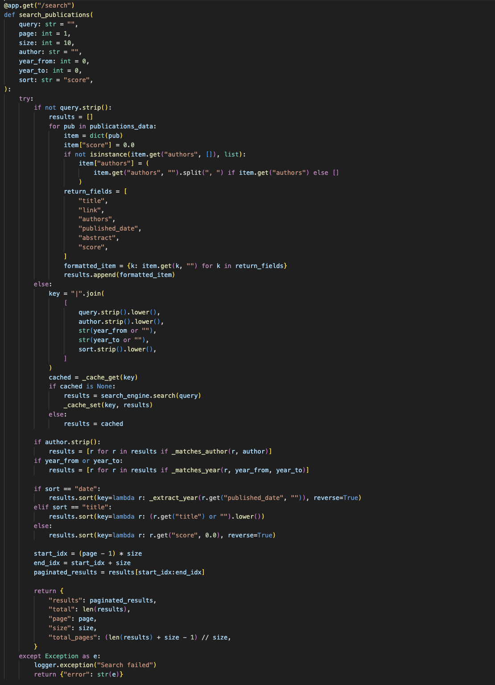


Automatic Scheduler
A weekly scheduler triggers the crawler automatically to keep the publication index updated. The scheduler uses APScheduler and runs on Sunday at midnight. If a virtual environment is present, it uses that Python binary; otherwise, it falls back to the system Python. This automation supports fresh data without manual intervention.
The crawler can be scheduled to run weekly using APScheduler in IR_Rijwol_Shakya/crawler/schedule_crawler.py. The scheduled task triggers the crawler with the configured Python interpreter and supports automatic index updates.
Scheduling reduces manual work and ensures the system remains up to date with new publications, which is a requirement in the assignment brief.
Figure 10: Scheduler setup
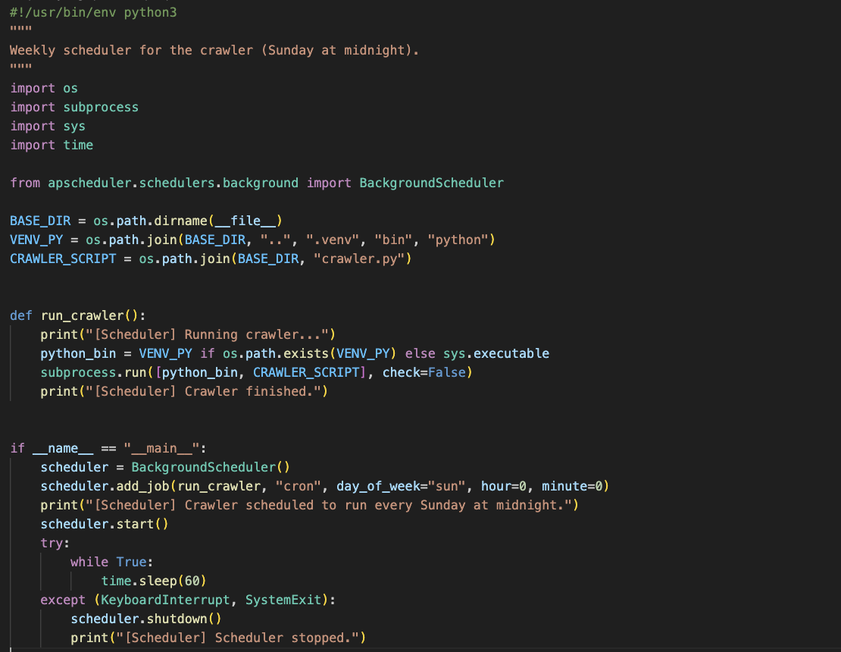

Document Classification
The classification module loads training data from categories.csv and training_documents.csv. The dataset includes multiple categories, and label encoding maps categories to numeric values. A fallback dataset is used when files are missing, ensuring that the classifier remains functional in minimal setups.
The classification component is implemented in IR_Rijwol_Shakya/backend/classification_ml.py. It loads labeled data, preprocesses text, trains models, and provides predictions through the /classify API.
Two models are supported: Multinomial Naive Bayes and Logistic Regression. The system returns predicted category, confidence score, probability distribution, and an explanation message to improve transparency.
A clustering module is also included in IR_Rijwol_Shakya/backend/clustering_ml.py and is exposed via /cluster endpoints, demonstrating unsupervised learning for grouping documents.

1. Data Collection
Training data is loaded from data/categories.csv and data/training_documents.csv. Each record contains a text field and a category label, which are encoded into numerical classes for training.
If files are missing, the system falls back to a small built-in dataset to keep the pipeline functional, which is helpful during development and testing.
Figure 11: Data collection
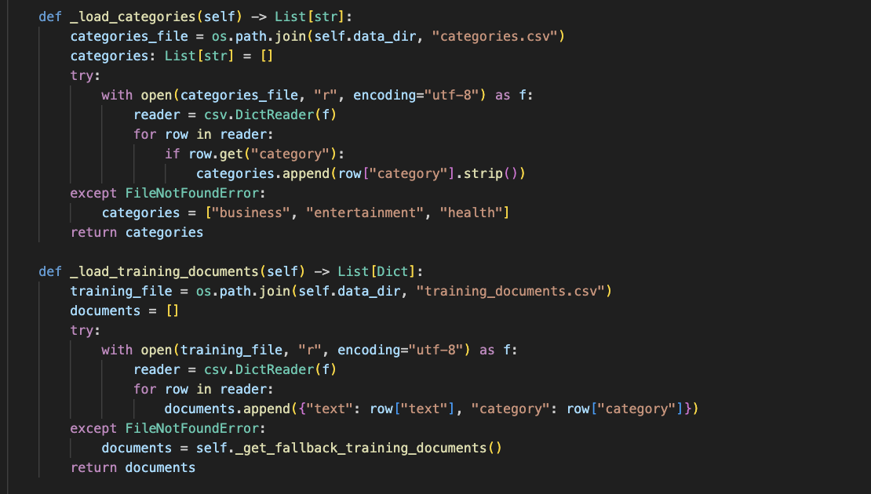

1.1. Dataset Preparation
Dataset preparation involves cleaning text, removing non-alphanumeric characters, and applying the same tokenization and stemming steps used in search. This ensures consistency across different IR components.
The processed text is transformed into TF-IDF features, which represent the importance of terms within each document and across the dataset.
Figure 12: Dataset preparation
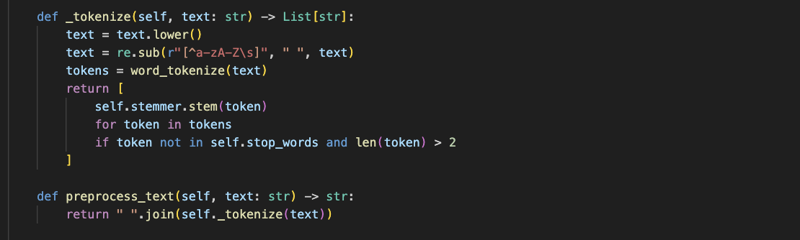

1.2. Fallback Mechanism
A keyword-based fallback is used when a document produces no known vocabulary after preprocessing. Keywords are stemmed and counted per category, and the category with the highest match is returned.
If no signal is detected, the classifier returns a uniform probability distribution across categories and explains the low-confidence decision. This avoids misleading predictions and provides user feedback.
Figure 13: Fallback mechanism
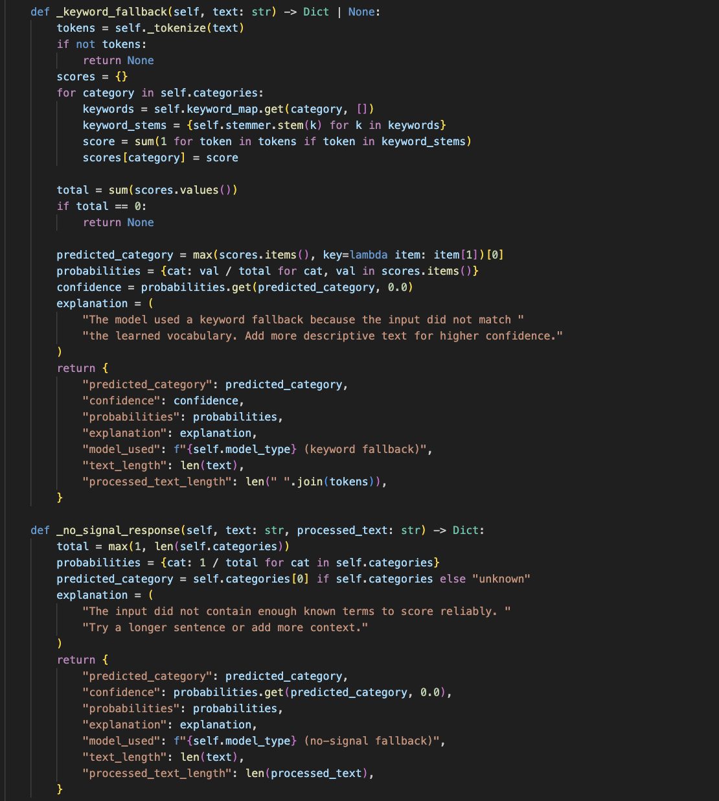

2. Data Preprocessing
Preprocessing ensures consistent input for training and inference. Tokens are stemmed using PorterStemmer, and stop words are removed to reduce noise. The processed text is then vectorized with TF-IDF.
Figure 14: Data preprocessing


3. Model Training and Text Classification
Training uses a train/test split when enough data exists. For small datasets, the model trains on the full dataset to avoid unstable splits. Accuracy and classification reports are computed when a test set is available.
The /train-models endpoint retrains both models and returns metrics, enabling reportable evaluation results for the coursework.
Figure 15: Model training and classification
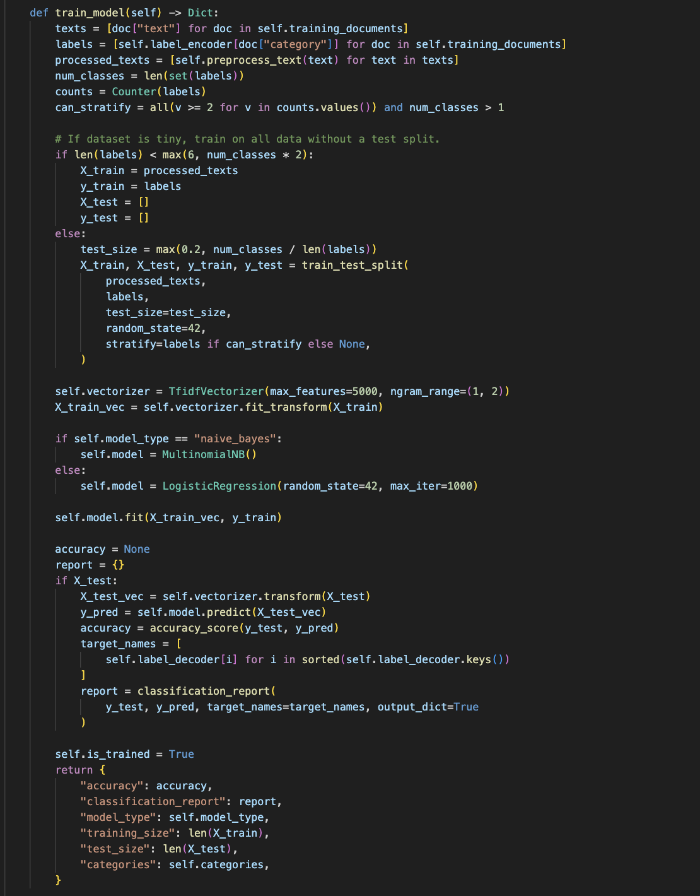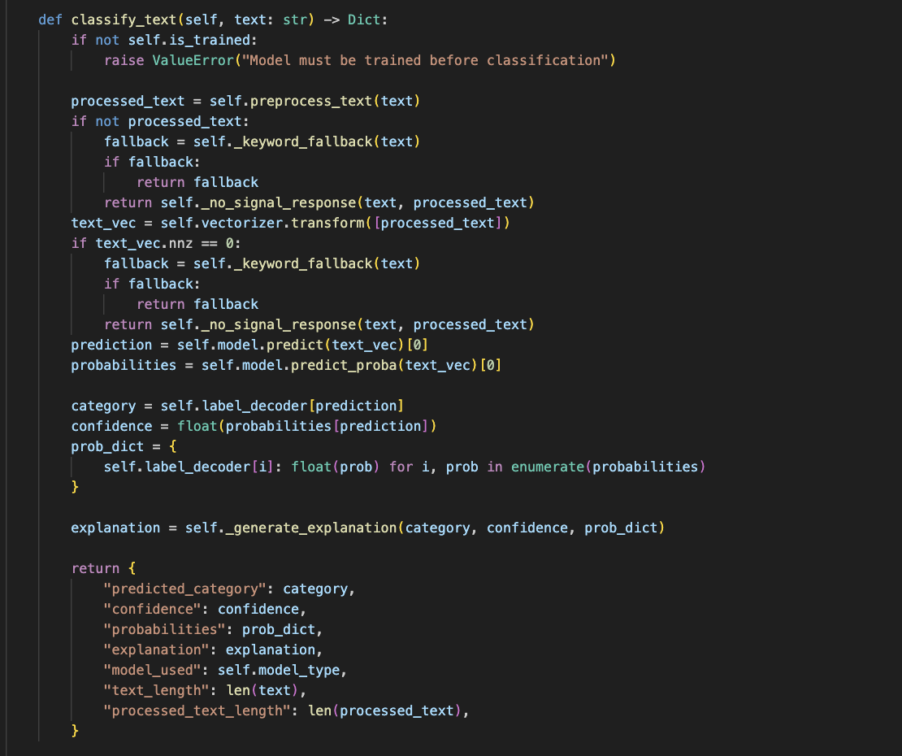

The backend normalizes author lists into a consistent structure before indexing. This avoids mismatches caused by mixed string and object formats and simplifies filtering and display in the UI.
The search endpoint supports sorting by score, date, or title. These options make the interface more usable and allow users to prioritize freshness or alphabetic order when relevance scores are similar.
Publication year filtering is derived by extracting four-digit years from the published_date field. This allows the user to constrain results to a specific time window even when dates are stored in different formats.
In the UI, results are rendered as cards with title, author list, and a direct link to the publication page. This design mirrors the behavior of scholarly search tools and supports easy navigation during demonstrations.
The classification response includes probability distributions across categories. Displaying these values helps explain borderline cases and supports reflective discussion in the report and viva.
The clustering component uses KMeans to assign documents to topic clusters based on TF-IDF vectors. It provides cluster labels derived from majority categories in the training data, which makes the output interpretable.
The crawler enforces both a configured delay and any delay specified in robots.txt. This dual approach ensures compliance with site policies while still providing predictable runtime for scheduled tasks.
JSON outputs are stored in the data directory, making it easy to inspect results and verify that crawling and indexing are functioning as expected. This is useful evidence for coursework reporting.
The project structure separates crawler, backend, and UI modules, which improves maintainability and reflects professional engineering practice. Each component can be updated independently without breaking the overall pipeline.
Search results are paginated to avoid overwhelming the UI and to keep API responses lightweight. The page size is adjustable in the UI, enabling quick demonstrations with small or large result sets.
The model info endpoint exposes training status and category labels. This feature is included to support the assignment requirement of demonstrating model training and evaluation.
The crawler supports optional headless mode and legacy headless flags to improve compatibility across systems. These options are documented in the command-line arguments and can be tuned depending on the environment.
The system uses structured data files for both training and output, which makes the workflow transparent and reproducible for assessment purposes. This also enables easy extension with additional categories or new publication records.
The inverted index file stores document length arrays alongside postings. This helps normalize term frequencies and reduces bias toward longer documents.
The FastAPI service exposes /health, /search, /classify, and training endpoints that can be called from the UI. These endpoints form a clear contract between the front end and the backend.
The Flutter UI uses a base URL environment variable so the API can be switched between local and deployed servers without code changes. This is a practical feature for demonstrations and testing.
During crawling, the script prints progress logs for each listing page and detail batch. These logs are useful for screenshots and show that the crawler is performing the required tasks.
The data directory contains publications_links.json and publications.json, which can be inspected to verify that the crawler stored both listing links and detailed metadata. These files also serve as inputs to the indexer.
The preprocessing pipeline is reused across indexing and classification to keep tokenization consistent. This reduces the risk of mismatched vocabularies and makes evaluation easier to explain.
The system can be started with run.sh and stopped with stop.sh, which automate the backend and optional Flutter web build. This makes the project easier to operate during assessment.
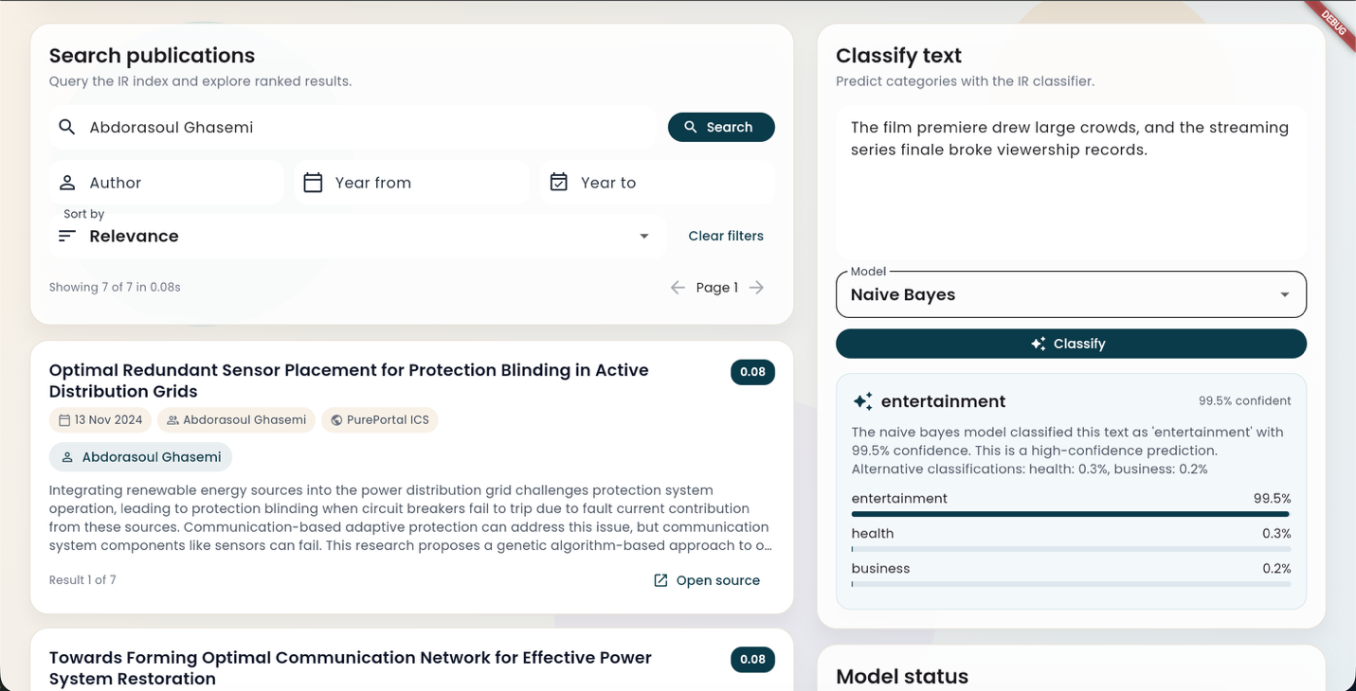

Challenges and Limitations
The main technical challenge is dealing with dynamic PurePortal pages and intermittent Cloudflare checks. The crawler mitigates this by using stealth settings, retries, and cautious delays, but occasional blocks are still possible.
Search quality is constrained by dataset size and the availability of abstracts. Records without abstracts are still indexed, but title-only matches can reduce precision for some queries.
Classification performance depends on the representativeness of training documents. With limited examples, models can overfit or provide low-confidence predictions, which is addressed by the fallback logic and transparent explanations.

Conclusion
The project delivers a minimum viable vertical search engine aligned with the module outcomes. It integrates crawling, indexing, search, and machine learning into a coherent pipeline and exposes the functionality through a responsive UI.
The implementation demonstrates practical IR principles such as preprocessing, inverted index construction, TF-IDF ranking, and evaluation, while maintaining polite crawling behavior and scheduled updates.

