SParaiso360: Digital Mapping and Lot Inventory for Paraiso Memorial Park

A Capstone Project

Presented to the Faculty of the

Information and Communications Technology Program

STI College Balagtas

In Partial Fulfilment

of the Requirements for the Degree

Bachelor of Science in Information Technology

Israel C. Delfin

Aaron Paul P. Echeche

Juan Carlos A. Flores

Mark Erick Reyes

October 24, 2025

ENDORSEMENT FORM FOR ORAL DEFENSE

TITLE OF RESEARCH: Paraiso360: Digital Mapping and Lot Inventory

for Paraiso Memorial Park`

NAME OF PROPONENTS: Israel C. Delfin

Aaron Paul P. Echeche

Juan Carlos A. Flores

Mark Erick Reyes

In Partial Fulfilment of the Requirements

for the degree Bachelor of Science in Information Technology

has been examined and is recommended for Oral Defense.

ENDORSED BY:

Jose Crisanto S. Austria

Capstone Project Adviser

APPROVED FOR ORAL DEFENSE:

Alejandro Burgos Jr.

Capstone Project Coordinator

NOTED BY:

Engr. Regina R. Mape, MIT

Program Head

# May 11, 2025

# APPROVAL SHEET

This capstone project titled Paraiso360: Digital Mapping and Lot Inventory for Paraiso Memorial Park, prepared and submitted by Israel C. Delfin, Aaron Paul P. Echeche, Juan Carlos A. Flores, and Mark Erick Reyes, in partial fulfillment of the requirements for the degree of Bachelor of Science in Information Technology, has been examined and is recommended for acceptance and approval.

Jose Crisanto S. Austria

Capstone Project Adviser

Accepted and approved by the Capstone Project Review Panel

in partial fulfillment of the requirements for the degree of

Bachelor of Science in Information Technology

|  |  |
| --- | --- |
| Engr. Christian Carr Tac-an | Franchezco Renz Hernandez |
| Panel Member | Panel Member |

Dr. Jayson A. Batoon, DIT

Lead Panelist

Noted:

|  |  |
| --- | --- |
| Alejandro Burgos Jr. | Engr. Regina R. Mape, MIT |
| Capstone Project Coordinator | Program Head |

October 24, 2025

# Acknowledgements

The researchers would like to thank the following:

Capstone Project Coordinator, <state his/her contributions to your research>;

Capstone Project Adviser, <state his/her contributions to your research>;

Capstone Project Review Panel, <state their contributions to your research>;

Parents and/or Guardian, <state their contributions to your research>;

Friends and inspirations, <state their contributions to your research>; and

Others <state his/her contributions to your research>.

# Abstract

Title of research: Paraiso360: Digital Mapping and Lot Inventory for Paraiso Memorial Park

Researchers: Israel C. Delfin

Aaron Paul P. Echeche

Juan Carlos A. Flores

Mark Erick Reyes

Degree: Bachelor of Science in Information Technology

Date of Completion: <Month year of graduation>

Keywords: <keywords of your research>

The abstract is a summary of the whole capstone project. It presents all the major elements of your work in a highly condensed form. It must be capable of substituting for the whole capstone project when there is insufficient time and space for the full text. Currently, the recommended size for an abstract is 150 to 350 words. Usually a one-pager abstract is the most ideal. The structure of the abstract should mirror the structure of the capstone project and represent all its major elements. There should be one or more sentences assigned to summarize each chapter of your capstone project.

In the succeeding paragraphs, there should be no indentations, paragraphs are justified with left alignment. Delete this highlighted section and replace it with your Abstract.

# Table of Contents

|  |  |  |
| --- | --- | --- |
|  | | Page |
| Title Page | | i |
| Endorsement form for Oral Defense | | ii |
| Abstract | | iii |
| Approval Sheet | | iv |
| Acknowledgments | | v |
| Table of Contents | | vi |
| List of Figures | | vii |
| List of Tables | | viii |
| List of Notations | | ix |
| Introduction | | 1 |
|  | Project Context |  |
|  | Purpose and Description |  |
|  | Objectives |  |
|  | Scope and Limitations  Review of Related Literature/Studies/Systems |  |
| Methodology | |  |
|  | Requirements Analysis |  |
|  | Requirements Documentation |  |
|  | Design of Software, System, Product, and/or Processes |  |
|  | Development |  |
| Results and Discussion | |  |
|  | Testing |  |
|  | Description of Prototype |  |
|  | Implementation Plan |  |
|  | Implementation Results |  |
| Conclusion | |  |
| References | |  |
| Appendices | |  |
|  | Resource Persons |  |
|  | Relevant Source Code |  |
|  | Evaluation Tool/Test Documents |  |
|  | Sample Input/Output/Reports |  |
|  | User’s Guide |  |
|  | Personal Technical Vitae  Interview Transcript |  |
|  | |  |

# Introduction

## Project Context

Time is very important; that’s why it needs to be utilized well. In the memorial park and cemetery context, searching for records such as client data quickly, minimizing errors, and obtaining data without relying or depending on one another means saving a lot of time. Efficient time management can significantly influence the overall experience for both staff and clients, enhancing service quality and operational effectiveness.

Globally, nearly all businesses still lack robust digital systems for managing their key data, such as client profiles, payment records, and foundational operational data. Forrester, a well-known global research and advisory company that provides insights on technology and business trends, conducts comprehensive surveys annually involving over 500,000 consumers, executives, and tech leaders. In their 2023 survey, which focused on the use of Document Management Systems (DMS) in organizations, only 24% of respondents claimed that they used a DMS in their organization. Furthermore, according to a Forrester report, as of 2024, a staggering 97% of organizations had minimal or no digital documents (Steingold, 2024). This statistic underscores that most businesses still rely heavily on traditional, non-digital methods for record-keeping, which can inhibit efficiency and accuracy.

In the context of memorial parks, many do not have modern digital mapping or document management systems (DMS). Several sources indicate that numerous cemeteries still rely on archaic methods such as paper records, outdated computer systems, and painstaking hand-drawn maps (All Funeral, 2024; Chronicle, n.d.; LaBella Associates, 2025). This reliance on outdated technology is not merely inconvenient; it often results in time-consuming processes where searching for specific burial records or lot data necessitates tedious manual reviews. In a study at Zurich’s Sihlfeld Cemetery, researchers noted that visitors frequently turn to mobile phones, especially utilizing Google Maps, or seek assistance from cemetery staff and fellow visitors for directions. This reliance stems largely from existing signage systems in cemeteries being often insufficient or unclear (Klingemann et al., 2024). Consequently, straightforward mistakes, such as double-selling plots, can lead to significant reputational damage and distress for involved families (All Funeral, 2024). Such issues not only waste valuable time for staff but also exacerbate stress for clients and visitors. Thus, the lack of digital systems in memorial parks contributes to inefficient processes, visitor confusion, and considerable operational risks.

This issue extends to the Philippines, where many memorial parks and cemeteries remain entrenched in traditional record-keeping methods. A study in 2022 on Lund Memorial Garden, a public cemetery, revealed that it relied heavily on Microsoft Excel for record-keeping. This approach necessitates manual searches for grave locations and associated information (Oliver, 2022). In Manila South Cemetery, while an online platform for lot and grave information exists, it notably lacks satellite or route guidance to specific graves, forcing visitors to approach staff for directions and to receive paper maps (Gamas Galvez Tupaz, 2020). Furthermore, studies by Parreño & Mariano (2025) and Gonzaga et al. (2023) indicate that many cemeteries in other provinces grapple with outdated maps, missing records, and absent digital tracking systems. During peak periods, such as Undas (the Filipino observance of All Saints’ Day and All Souls’ Day, usually held on November 1 and 2. Undas is a deeply rooted cultural and religious tradition in the Philippines, where families gather to honor and remember their departed loved ones by visiting graves, offering prayers, and bringing flowers and candles.), cemetery visits can become overwhelming. For instance, in 2024, over 1.5 million people were expected to descend upon Manila's cemeteries for All Saints' Day and All Souls' Day, with Manila North Cemetery alone receiving over 157,000 visitors by mid-morning (Manila Bulletin, 2024). Consequently, amid the burgeoning crowds, locating graves in cemeteries with outdated maps becomes increasingly challenging, leading to stress and frustration for families endeavoring to pay their respects. The recurring nature of these issues emphasizes the urgent call for modernizing memorial park management systems nationwide.

Specifically, at Paraiso Memorial Park located in San Jose del Monte, Bulacan, Philippines, this issue is observable as well. Based on the interview conducted by the researchers, staff revealed that their current lot mapping system remains manually maintained, with everything printed on paper and managed using Microsoft Word. Such an outdated process sometimes results in double lot sales, sparking disputes among clients, delays in resolution, and potential harm to the park’s reputation. These errors not only diminish the trust in management but also hinder smooth operations. Moreover, the resolution processes for these matters extend over several weeks, creating an atmosphere of frustration for both management teams and clients.

In addition to the tracking of lots, client records at Paraiso Memorial Park are similarly disorganized. Information regarding clients, including payment history, contact numbers, and plot ownership, is dispersed across paper folders, Word documents, and Excel spreadsheets, creating a fractured record-keeping system. This data disorganization renders it difficult for staff to access a comprehensive profile of a client swiftly. For instance, when clients forget their lot or block numbers, staff must sift through numerous paper files to verify ownership, which is inefficient. Occasionally, staff must depend on physical receipts to confirm payments if digital copies cannot be found. These circumstances render even simple tasks, such as finding a phone number or payment information, time-consuming, taking anywhere from several minutes to hours, detracting from optimal service delivery. The combination of these antiquated practices highlights a pressing need for a transition to digital record systems to enhance overall efficiency, improve client satisfaction, and safeguard the integrity of memorial parks.

Many of these problems, such as lost records, double-selling of plots, scattered client information, and difficulty locating graves, are usually caused by the absence of a Geographic Information System (GIS). Without GIS, records are disconnected from their actual geographic locations. This disconnection not only hampers operational efficiency but also undermines the integrity of the services provided to families grieving the loss of loved ones. Furthermore, the reliance on outdated methods such as hand-drawn maps, handwritten documents, and spreadsheets not only increases the risk of errors but also extends the time required for staff to resolve even the simplest queries or tasks. For instance, without an integrated system, a staff member may spend hours trying to locate a specific plot or decipher unclear documents, all while families wait anxiously for assistance.

A GIS-based system addresses this issue by offering real-time inventory tracking, searchable databases, and accurate plot mapping that clearly shows availability and interment details (LEES+ Associates, 2016). This enhancement transforms how memorial parks manage their records and interact with the public, allowing for swift responses to inquiries and minimizing the possibility of human error. Additionally, the comprehensive visualization capabilities of GIS provide staff and visitors with a clear understanding of the layout of the park, further enhancing the visitor experience during a sensitive time.

Therefore, the lack of GIS integration is not just a technical gap but the main reason why many memorial parks remain disorganized, inefficient, and unable to meet the demands of modern cemetery and memorial management. Recognizing these challenges, the project proponents are equipped to provide a solution, utilizing their experience in systems analysis, full-stack development, user interface design, and database design learned throughout their BSIT curriculum. This educational background gives them a robust foundation in both the technical and practical aspects of implementing modern software solutions.

From previous academic projects, they have gained first-hand experience in developing useful information systems that address specific problems, preparing them to tackle the real-life challenges faced by Paraiso Memorial Park with a practical digital solution. The aim is not merely to digitize existing processes but to rethink and optimize them fundamentally, ensuring that the system is responsive to the needs of both the staff and the families they serve.

In summary, the systems that exist today in memorial parks are leading to delays and confusion. The absence of GIS is the primary cause of these problems. With the introduction of GIS technology, operational efficiency can be significantly enhanced alongside a reduction in mistakes, leading to greater ease for both staff and visitors. The adoption of such a system can truly revolutionize how memorial parks operate, creating an environment that is respectful of its solemn purpose while embracing the capabilities of modern technology. This project, therefore, seeks to address these persistent issues and infuse the management of Paraiso Memorial Park with the much-needed modernity, thus ensuring its relevance and efficacy in an ever-evolving landscape.

Purpose and Description

The study addresses memorial park administration challenges through a web-based system that manages lot inventories, customer records, and sales transactions. The platform reduces manual processes and supports informed decision-making across operational activities. The key stakeholders include:

Memorial Park Personnel: Staff and management access centralized records, lot information, and payment status through integrated systems. The platform supports operational organization and service delivery.

Customers and Visitors: The system maintains transparent record management and provides digital wayfinding capabilities. This reduces manual information requests and improves visitor experience during peak periods.

Project Proponents: The study demonstrates application of academic knowledge to practical system development challenges, aligning with curriculum objectives and industry needs.

Other Cemeteries/Memorial Park: The project may serve as a reference for other sites dealing with manual data handling, lot tracking, and fragmented records. The system reflects common needs and offers one approach to address them. This contributes to the broader field of cemetery management solutions.

Academic Community: The project applies software quality standards and evaluation methods to address real-world operational requirements.

Objectives

The study develops a web-based memorial park management system with the following objectives:

1. To develop a platform supporting lot inventory management, customer record handling, document storage, and financial tracking
2. To implement interactive mapping with real-time inventory status and mobile wayfinding capabilities
3. To implement role-based access control that matches the specific duties of staff and administrators, enhancing data security and workflow control.
4. To apply ISO/IEC 25010 standards across system functionality, usability, performance, reliability, maintainability, and security

Scope and Limitations

This study focuses on the design, development, and deployment of a Memorial Park Management and Wayfinding System for Paraiso ng Pagmamahal Memorial Park located in San Jose del Monte, Bulacan, Philippines. The system modernizes memorial park operations through digital lot inventory management, customer relationship management, payment tracking, and visitor navigation.

The mapping and navigation module provides geospatial functionality with dual-purpose interactive mapping capabilities. For public visitors, the system offers memorial park navigation with real-time location tracking, turn-by-turn route generation to graves and points of interest, search functionality for locating specific lots by deceased name or lot number, and visual identification of points of interest with accompanying imagery. For staff management, the module provides lot inventory tracking with real-time status updates, color-coded visual indicators, and a searchable data interface. The system implements a four-tier status classification including available, reserved, partial, and sold categories with automated status updates broadcast to all system users across managed memorial park blocks.

The customer management module maintains comprehensive customer profile management with a dedicated dashboard displaying overview and account status. Customer event tracking system captures both automated and manual entries, while document management and secure storage integration enable customer search, filtering, and detailed profile viewing capabilities.

The payment management module supports financial operations including manual payment recording and verification, automated payment schedule generation for installment plans, payment validation processes, account forfeiture management, and payment reversal capabilities. The system maintains complete payment history and financial ledger records with multi-level warning systems for overdue payments and penalty calculation tools based on configurable rates, supporting multiple payment methods while functioning as a ledger and record-keeping tool rather than a payment processor.

The security and administration module provides user management with role-based access control for admin and staff user types. The system implements credential-based authentication with user account management, password recovery capabilities, and audit trail recording for all user activities. System activity and staff activity logging maintain accountability, while lot classification management handles pricing, capacity, and descriptions. Payment plan rule configuration, security settings, and password management provide comprehensive administrative control.

The reporting and analytics module features a report builder with four main categories covering customers, lot and inventory, finance and revenue, and internments. An interactive dashboard presents key performance indicators with data export functionality. Live filtering and date range selection capabilities enable flexible data analysis.

Despite offered functions, the scope is delimited to essential memorial park management and wayfinding features for a single site, excluding connections to government databases, civil registries, or other external systems. Multi-site or branch management operations are not supported, nor are in-system map editing capabilities which require external GIS tools. Advanced security features such as multi-factor authentication or biometric login are not included, along with multi-language support or localization features. Comprehensive accessibility features are not guaranteed, and testing is limited to operational validation rather than extensive large-scale performance testing.

The system does not include connections to government databases, civil registries, or other memorial park management systems. Document verification processes remain manual without automation through external authority systems, requiring staff intervention for validation procedures.

The system does not support multi-site operations. In-system map editing capabilities are not provided, as the mapping workflow requires external tools for creation and editing of geographic data. Memorial Park administrators must possess geographic information system knowledge for map updates and spatial data modifications.

The security implementation uses standard authentication mechanisms. Advanced security features such as multi-factor authentication or biometric login are not included in the current system design. Password recovery relies on security questions, and document storage utilizes standard access controls without enhanced encryption layers.

The system interface is developed primarily in English. Multi-language support or localization features are not available, and local language options are not provided. While basic web accessibility principles are followed, comprehensive accessibility features are not guaranteed within the current implementation.

The communication infrastructure delivers all notifications exclusively through the in-app notification system without external messaging capabilities such as SMS or email notifications. Admins and staff must actively log into the system to receive updates, reminders, and notifications.

The payment processing functionality supports manual payment recording only without integration to online payment gateways. Staff or admin must manually verify, and record payments received through external channels.

System testing and validation were conducted on the operational dataset with real-world staff participation; extensive large-scale performance testing is not included

### **Foreign Related Literature**

#### Mapping Memories: Modernizing Cemeteries Using GIS Technology (Smith & Coniglio, 2025)

Smith and Coniglio from LaBella Associates in the USA discuss how old paper records in cemeteries are not very safe and can be lost or damaged due to various factors such as weather, pests, and human error. These vulnerabilities pose significant challenges in preserving historical data. They believe that using GIS technology to create digital maps and databases is a much better solution. By digitizing records, cemeteries can easily update information, reduce the risk of loss, and enhance accessibility for both management and visitors. This technology facilitates the organization of data, helping in finding plots, managing records, and planning for the future. Importantly, it ensures that important information is preserved carefully and remains retrievable for generations to come. Their ideas encourage our project, Paraiso360, to use similar technology to protect records and make management efficient and fair. Adopting a digital approach not only fosters transparency but also allows for a more inclusive engagement with families looking to honor their loved ones. By effectively integrating advanced technology in cemetery management, we can ensure that every plot is accounted for, while sensitive information remains safeguarded against the inevitable decay and disarray often associated with traditional methods.

#### Top 10 Best Cemetery Software in 2025: A Complete Guide (9cv9 Blog, 2025)

Smith and Coniglio from LaBella Associates in the USA say that old paper cemetery records are not safe and can get lost or damaged. They suggest using GIS technology to make digital maps and databases as a much better solution. This makes key info safe, helps in finding plans, handling files, and thinking ahead. By converting aging records into a digital format, cemeteries can enhance their operational efficiency, streamline administrative processes, and improve overall service delivery. Moreover, the use of GIS technology offers a visual representation of cemetery layouts, which enables staff to quickly identify available plots, reduce confusion, and enhance the experience for families making arrangements during difficult times.

Additionally, integrating cemetery software with online platforms allows families to access information remotely, facilitating the process of locating gravesites or retrieving memorial details without the need to visit in person. This level of accessibility not only promotes transparency but also caters to a more modern approach in which individuals increasingly rely on technology for everyday tasks. Furthermore, the transition to digital solutions fosters greater collaboration among cemetery staff, as shared databases can be updated in real-time, ensuring everyone has access to the most current and accurate information. As such, embracing advanced cemetery software can significantly transform the management of burial grounds, making it a crucial consideration for cemetery operators looking to modernize their systems and practices in the coming years.

#### Digitization of Cemeteries: Revolutionizing Memory and the Management of Final Spaces (PBSGEO GmbH, 2024)

Digital tools can help kin, even if they are far, find grave spots or take online tours. For families who may not live nearby, these advancements offer a way to connect with their loved ones' resting places despite the physical distance. Innovations such as interactive maps allow users to locate specific graves with ease, making the experience of visiting a cemetery more accessible and meaningful. PBSGEO GmbH in Germany exemplifies how digital technology can ease jobs for cemetery staff, such as spotting open plots or sorting out forms. By implementing sophisticated software solutions, cemetery workers can efficiently manage plots, ensuring that the records remain accurate and up-to-date. This not only streamlines operations but also enhances the service provided to grieving families. Additionally, digital platforms may include features like virtual reality tours of cemeteries, giving families a chance to experience a visit from the comfort of their homes. This innovation can particularly benefit those who are unable to travel due to distance, health issues, or other personal circumstances. By integrating digital tools into their services, cemeteries can foster a greater sense of connection and support for families during the difficult process of remembering and honoring their deceased loved ones.

#### Cemetery Management in a GIS Framework & Cemetery Mapping and Digital Data Analysis (Schmidt, 2018; Schmidt, Yuan, and Jang, 2020)

This strongly supports Paraiso360’s initiative to develop a digital map that is directly linked to cemetery records. By integrating spatial data with burial information, the system significantly reduces manual errors and enhances the accuracy and efficiency of record-keeping. Numerous studies have demonstrated a growing trend in adopting Geographic Information System (GIS) technology to modernize and digitize cemetery management processes. Researchers and developers in various parts of the world have successfully implemented GIS tools combined with advanced Global Positioning System (GPS) technology to transform traditional, hand-drawn maps and paper-based burial notes into reliable digital systems.

Through these innovations, a geodatabase is established, serving as a centralized digital repository that connects geographic locations with detailed plot information. This integration allows for faster data retrieval, improved tracking of lot ownership, and better visualization of burial site distributions. Moreover, it enables cemetery administrators to efficiently manage available plots, monitor space utilization, and identify long-term trends in lot allocation and occupancy. The digital mapping approach not only enhances operational efficiency but also provides an accessible and user-friendly way for both staff and visitors to navigate and search within the memorial park.

#### An Assessment for Record Keeping and Cemetery Management...Based on the Technology Acceptance Model (TAM) (Chibuye and Phiri, 2022)

This highlights the importance of ensuring that Paraiso360 remains simple, intuitive, and accessible for both administrative staff and visitors. Chibuye and Phiri (2022) conducted a study on the implementation of an electronic record-keeping system by the Lusaka City Council in Zambia. Their findings revealed that although users recognized the advantages of digitizing cemetery records, the system’s effectiveness heavily depended on its usability and user experience. When the interface was overly complex or required extensive technical knowledge, users were less likely to adopt and sustain its use. Therefore, the study emphasizes that functionality alone is not enough; the success of a digital cemetery management system relies on designing a platform that is user-friendly, efficient, and adaptable to the varying technical skills of its users.

#### Design, development, and implementation of a digital burial record-keeping and management system in Bangladesh (Rahman et al., 2025)

In Bangladesh, Rahman et al. (2025) developed a digital management system for burial records under the Dhaka North City Corporation. The system received positive feedback from users who appreciated its convenience and improved accessibility to burial data. However, some cemetery staff particularly those with limited technical experience encountered challenges in operating the system effectively. This finding underscores the importance of proper user training, continuous technical support, and user-centered design in ensuring the successful adoption of digital cemetery systems such as Paraiso360. Adequate training and guidance are essential to help staff fully utilize the system’s features and maintain accurate, updated records.

Meanwhile, Pál and Hajdú (2023) in Hungary conducted a study focused on establishing standardized methods for digital cemetery mapping. Their research explored the use of drones and open-source software to generate highly detailed spatial maps. The results demonstrated that accurate and reliable digital maps could be produced even with cost-effective tools and technologies. This study reinforces Paraiso360’s objective of creating a practical yet precise digital mapping system for Paraiso Memorial Park. It highlights that advanced spatial accuracy can be achieved without requiring expensive proprietary software, making the project both efficient and sustainable.

#### Setting standards for cemetery spatial databases (Pál and Hajdú, 2023)

Pál and Hajdú (2023) from Hungary conducted a study exploring the application of drones, or Unmanned Aerial Vehicles (UAVs), and open-source software in creating detailed spatial databases for cemeteries. Their research demonstrated that UAV technology, when integrated with open-source Geographic Information System (GIS) tools, can produce high-resolution and accurate spatial data at a relatively low cost. This approach allows for efficient mapping, monitoring, and updating of cemetery layouts without relying on expensive commercial systems. The findings of their study highlight the potential of modern yet accessible mapping technologies, which align closely with Paraiso360’s goal of developing a precise and efficient digital mapping module. By adopting similar techniques, Paraiso360 can effectively manage lot information, visualize spatial data, and ensure the long-term accuracy of its cemetery layout database.

#### GIS in Medieval Archaeology (Dermeková and Bartoněk, 2011)

A study conducted in the Czech Republic by Dermeková and Bartoněk (2011) utilized Geographic Information Systems (GIS) to locate a lost medieval village. The research demonstrated the effectiveness of integrating multiple data layers within a GIS environment to identify historical sites and visualize spatial relationships. This study highlights how GIS can be used not only for mapping modern infrastructures but also for preserving and rediscovering cultural and historical data through spatial analysis.

The experiences from Bangladesh and the Czech Republic further emphasize the expanding use of GIS technology in converting traditional grave and location records into accurate digital formats. These studies reveal the significant benefits of digitization, including improved data precision, faster information retrieval, and better visualization of spatial layouts. However, they also point out that the success of such systems depends on user acceptance and adequate training. For Paraiso360, these findings reinforce the importance of developing a reliable, user-friendly platform and providing proper technical guidance to ensure the system’s efficiency and sustainability in managing the Paraiso Memorial Park.

### **Local Related Studies**

#### Cemetery Management System for Manila South Cemetery (Gamas Galvez Tupaz, 2020)

The Cemetery Management System (CMS) proposal for Manila South Cemetery demonstrates a strong foundation for modernizing cemetery operations through its comprehensive features and use of technology. Its focus on integrating mobile accessibility, GPS-enabled mapping, SMS notifications, and online databases provides practical solutions for both staff and visitors. By adopting an Agile development approach and ISO 25010 evaluation criteria, the project not only highlights the importance of stakeholder collaboration but also sets a standard for assessing system quality. These elements make the CMS proposal a valuable reference for future studies, particularly in benchmarking features and exploring technological approaches to cemetery management.

#### Exploring Efficient Cemetery Management: Practices, Challenges, and Innovations at New Bilibid Prison Cemetery (Parreno and Mariano, 2025)

The study conducted by Parreno and Mariano (2025) examined the management practices within the New Bilibid Prison Cemetery. Their research highlighted the need for sufficient workforce, enhanced staff competency, clearly defined operational policies, and the integration of advanced digital tools for efficient record management. Although the study focuses on a specialized type of cemetery, the challenges it identified such as administrative inefficiencies, lack of standardized procedures, and limited technological adaptation are also common among many cemetery facilities in the Philippines. These findings underscore the relevance of adopting systematic and technology-driven approaches in cemetery administration.

This connection strongly supports the objectives of the Paraiso360 project, which seeks to modernize cemetery operations through digital mapping, organized data management, and improved accessibility of burial records. By addressing similar organizational and technological gaps identified in the New Bilibid Prison Cemetery study, Paraiso360 aims to contribute to more transparent, efficient, and sustainable cemetery management within the local context.

#### Record Management System for Office Memoranda (Montalban, Legaspi, & Malmis, 2023)

A different study by Montalban, Legaspi, and Malmis (2023) created a system to manage office memos at Iloilo Science and Technology University, Miagao Campus. Although it is not about cemeteries, it uses the ISO/IEC 25010 quality model to check the system’s effectiveness. Experts and users rated it highly. This shows that using models like ISO/IEC 25010 and TAM could help make sure Paraiso360 is reliable and meets high standards.

There are not many local studies about cemetery management systems, but research in other areas highlights the need for better systems in the Philippines. These studies offer useful ideas for creating and improving systems like Paraiso360, helping it succeed in its goals.

### **Foreign Related Systems**

#### Many cemeteries in other countries have already adopted specialized software systems designed to streamline their daily operations and improve service delivery. These systems commonly feature digital mapping, cloud-based data storage, and automated record management, which collectively enhance the accuracy, accessibility, and efficiency of cemetery administration. By integrating these technologies, cemetery operators are able to maintain organized burial records, monitor plot availability in real time, and provide visitors with interactive tools for locating graves and navigating the grounds.

#### By examining these existing systems, researchers gain valuable insights into effective design strategies, functional components, and technological frameworks that can be adapted for local implementation. Understanding these best practices allows the development of Paraiso360 to incorporate proven solutions such as cloud integration, GIS-based mapping, and user-friendly interfaces tailored to the operational context of Paraiso Memorial Park. This comparative perspective ensures that the system is both innovative and grounded in established technological standards within the global cemetery management industry CIMS Platinum: Case Study in Mapping Software for Municipal Cemeteries (CIMS Editorial Team, n.d.)

For instance, CIMS Platinum is a cloud-based cemetery management system utilized at Sunset Hills Cemetery in Montana, USA. This platform enables multiple authorized users to access and update records simultaneously, ensuring that data regarding burial plots, ownership, and availability remains accurate and up to date. The system’s interactive digital map allows administrators and the public to view real-time plot information and navigate the cemetery with ease. Additionally, its integrated public burial search tool provides convenient access for visitors seeking information about specific graves, enhancing transparency and customer service.

The success of CIMS Platinum demonstrates how modern cloud-based technologies can streamline cemetery operations, improve data accuracy, and facilitate better communication between staff and visitors. These capabilities serve as valuable references for the development of Paraiso360, particularly in incorporating interactive mapping, real-time data updates, and user-oriented features that can improve both administrative efficiency and the overall visitor experience.

#### Commercial Cemetery Software (Chronicle, PlotBox, Cemify as per 9cv9, 2025)

The article “Top 10 Best Cemetery Software in 2025” highlights several leading cemetery management platforms, including Chronicle, PlotBox, and Cemify. These systems represent the current standards and technological trends in the digital management of memorial parks and cemeteries. Most of them operate on cloud-based platforms, allowing secure and centralized access to burial records, plot data, and client information from any device. They also feature interactive mapping, data visualization, and record management tools that streamline administrative processes and enhance service delivery.

While Paraiso360 is a custom-built system tailored specifically for the operational needs of Paraiso Memorial Park, examining these established software solutions provides valuable insight into the essential functionalities and design principles that define modern cemetery management systems. By understanding these industry standards, the development of Paraiso360 can integrate proven best practices such as cloud accessibility, intuitive interfaces, and reliable database management to achieve a more efficient, scalable, and user-friendly system.

#### Specialized GIS and Document Processing Tools (ABBYY Vantage, Esri's ArcGIS Online as per Smith & Coniglio, 2025; friedhofsplan.com as per PBSGEO GmbH, 2024)

Smith and Coniglio (2025) discussed the use of advanced digital tools such as ABBYY Vantage and ArcGIS Online, which play a significant role in document processing and spatial mapping. ABBYY Vantage automates data extraction and document handling through intelligent recognition technologies, improving the efficiency and accuracy of record digitization. Meanwhile, ArcGIS Online provides a powerful cloud-based platform for creating, analyzing, and sharing interactive maps. The integration of these technologies demonstrates how automation and GIS-based mapping can significantly enhance the management and visualization of cemetery data.

In a related development, PBSGEO GmbH (2024) introduced friedhofsplan.com, an online platform specifically designed for generating and maintaining digital cemetery maps. The system allows administrators to visualize grave plots, update burial information, and manage cemetery layouts through an accessible web interface. These examples illustrate how the integration of document automation, GIS mapping, and online accessibility contributes to the advancement of cemetery management systems. For Paraiso360, adopting similar technologies can enhance accuracy, streamline operations, and provide a more interactive and efficient way to manage cemetery information.

Open-Source Mapping Tools (OpenDroneMap, QGIS as per Pál & Hajdú, 2023)

Pál and Hajdú (2023) also examined the use of open-source tools such as OpenDroneMap, QGIS, and various Python libraries for the development of detailed digital maps. Their study demonstrated that accurate and functional spatial systems can be built using free and openly accessible technologies. This approach promotes cost efficiency and sustainability, making it especially beneficial for projects with limited resources. The successful integration of these open-source tools underscores the potential for creating reliable GIS-based applications without depending on expensive proprietary software.

These examples collectively highlight a broader trend in cemetery management technology one that favors integrated, map-based, and cloud-accessible solutions. This direction aligns closely with the goals of Paraiso360, which seeks to combine mapping, record management, and user accessibility within a unified, web-based platform. By leveraging both open-source and cloud technologies, Paraiso360 aims to deliver a sustainable and efficient system tailored to the operational needs of Paraiso Memorial Park.

### **Local Related Systems**

Locally Developed Record Management System (Montalban et al., 2023)

The study by Montalban et al. (2023) discusses a locally developed Record Management System for handling Office Memoranda. This system was designed for an academic institution to address the inefficiencies of manual filing, allowing easier sorting and viewing of documents. Its successful use shows that custom digital solutions can work well in the Philippines to meet specific organizational needs for better record management.

Since there are not many specialized cemetery systems mentioned in the local studies, this shows a clear chance for Paraiso360 to provide a helpful and customized solution for the client’s needs.

## Research Methods Used in Related Studies

This section explains the research methods used in other studies and how they can help with the current project.

Many studies used surveys to collect information. The most common were quantitative surveys, which use numbers and scales to measure how effective, easy to use, or acceptable a system is. Examples of these scales are ISO/IEC 25010 and the Technology Acceptance Model (TAM) (Montalban et al., 2023; Chibuye & Phiri, 2022; Rahman et al., 2025).

Another method often used was interviews. These interviews help to understand what users experience, what problems they face, why they act a certain way, and what ideas they have to improve the system (Dizon, 2023; Parreno & Mariano, 2025; Rahman et al., 2025).

Some studies also talked about building and checking systems. One example is Evolutionary Prototyping, where a system is built in steps, and feedback is collected after each step to make improvements (Montalban et al., 2023).

For managing cemetery locations, one study used high-accuracy GPS to find the exact spots of graves and combined this with other records in a mapping system (GIS) (Schmidt, 2018). This helps make a correct map of the cemetery plots. Other studies mentioned scanning and digitizing old maps to turn them into digital maps (LaBella Associates, 2025).

## Synthesis

The reviewed studies, both local and international, commonly emphasize the challenges faced by cemeteries that still rely on manual record management. According to previous works, traditional methods often result in slow data retrieval, inaccurate information, and the loss of important records, all of which affect service quality and efficiency. These recurring issues are also evident in the current system used by Paraiso Memorial Park.

International systems such as CIMS Platinum demonstrate how digital tools can address these problems effectively. Their use of real-time mapping and cloud-based record management highlights the benefits of automation in improving accessibility and reducing human error. These systems serve as valuable models for developing similar solutions in the local setting.

In the Philippines, studies such as Parreño and Mariano (2025) have identified similar concerns regarding manual record-keeping and the lack of proper staff training in cemetery operations. Meanwhile, the system developed by Montalban et al. (2023) for office record management proves that local developers are capable of designing practical and efficient systems tailored to Filipino organizations.

Drawing insights from both international and local studies, Paraiso360 was conceptualized to provide a digital, user-friendly, and reliable cemetery management system. It adapts the successful practices observed in foreign systems while considering the actual needs of Paraiso Memorial Park. Furthermore, findings from Chibuye and Phiri (2022) and Rahman et al. (2025) on user acceptance were also applied to ensure that the system is not only functional but also easy for staff to adopt and use effectively.

## METHODOLOGY

## Technical Background

The system implementation employs the following technologies:

Frontend Development

* Next.js 15: Full-stack web framework with integrated React 19 for building dashboards and data management interfaces with server-side rendering and optimized routing.
* TypeScript: Static typing for enhanced code reliability and maintainability.
* Tailwind CSS with shadcn/ui: Utility-first CSS framework with pre-built accessible UI components for responsive design and consistent styling.
* React Hook Form with Zod: Efficient form state management with schema validation for complex data workflows.
* Recharts: Charting library for visual analytics and reporting dashboards.

Backend and Data Management

* Node.js 20: Server-side runtime environment for backend operations, data processing, and API handling.
* Supabase: Backend-as-a-service providing database, authentication, and real-time features for secure data and user management.

Document Generation

* jsPDF with AutoTable: PDF generation with advanced table support for reports and receipts.
* ExcelJS: Excel file generation and manipulation for data export and reporting functionality.

Mapping and GIS Tools

* MapLibre GL: Interactive geographic visualization library for markers, overlays, and spatial data display.
* QGIS: Spatial data preparation and analysis tool for lot maps before system integration.

Development, Deployment, and Testing

* Vercel: Deployment platform with automated build and deployment pipelines optimized for Next.js applications.
* GitHub: Source code management and version control platform for collaboration.
* Playwright: End-to-end testing framework for complete user workflow validation.
* Vitest: Unit testing framework for component and function testing.

Discussion of System Development Life Cycle

The development process followed an iterative and adaptive agile approach. It combined rapid prototyping, continuous integration, and ongoing quality checks. The method kept development flexible while maintaining structure for complex systems using Next.js and Supabase with integrated mapping tools such as MapLibre GL. The workflow was agile but did not strictly follow backlogs or formal sprints. Severe bugs, minor chores, and QA-reported issues were logged to a GitHub Project kanban to maintain a record of work and knowledge. For new features or changes that required refactoring, a markdown file was created in the repository to document plans and serve as a reference resource before coding began.

Work started by reviewing the project context, objectives, scope, purpose, and interview transcripts from earlier sections of this manuscript. And an additional detailed document outlined specific business rules and technical requirements. Features were proposed to the client based on interview findings rather than direct client requests. The focus remained on features with long-term value. New requests during development were avoided to maintain clear project boundaries. Requirements were adjusted as the client reviewed early prototypes and provided feedback.

For highly complex features such as wayfinding and GIS lot inventory that were validated during interviews, development began in a sandbox environment. A separate HTML or lightweight Next.js prototype was created with fixed data and minimal styling. This sandbox served as a learning tool to understand patterns and establish technical foundations rather than to build complete functional components. If technical limitations appeared during this phase, development pivoted immediately since core feasibility was already confirmed during client interviews. Most features skipped the sandbox phase entirely and proceeded directly to development with mock data.

Development used mock data based on real client database structure. Mock datasets contained 5-10 sample records to test logic and workflows. When a feature worked correctly with mock data, it connected to Supabase to test real database interactions. After logic stability was confirmed, user interface refinement began. Styling and layout updates followed the tested structure.

Testing was both automated and manual. Unit tests handled logic verification, while a separate QA team member reviewed the deployment. The project used a main and development branch structure. Every push triggered auto-deployment, and the QA team tested the development branch to ensure full functionality before changes merged to main. Issues were resolved in the same branch without creating separate bug-fix branches. If critical bugs appeared during QA, the previous working version was restored from GitHub commits.

Database schema changes were handled through migration files. In some instances, changes were made directly in the Supabase dashboard. Code that depended on schema changes was updated accordingly.

Once all modules performed as expected and passed QA, changes merged to the main branch for production deployment. [User acceptance testing will be conducted on-site with staff at Paraiso Memorial Park. Staff will compare the new system against their traditional methods.]

Each phase connected in a loop. Sandbox work for complex features flowed into mock data development, which led to database integration, QA testing, and deployment. Feedback from QA looped back into improvements. [User testing feedback will complete the development cycle when the client validates the system's performance and usability.] ensure the system fits their needs. After that, performance tuning and system optimization will be carried out.

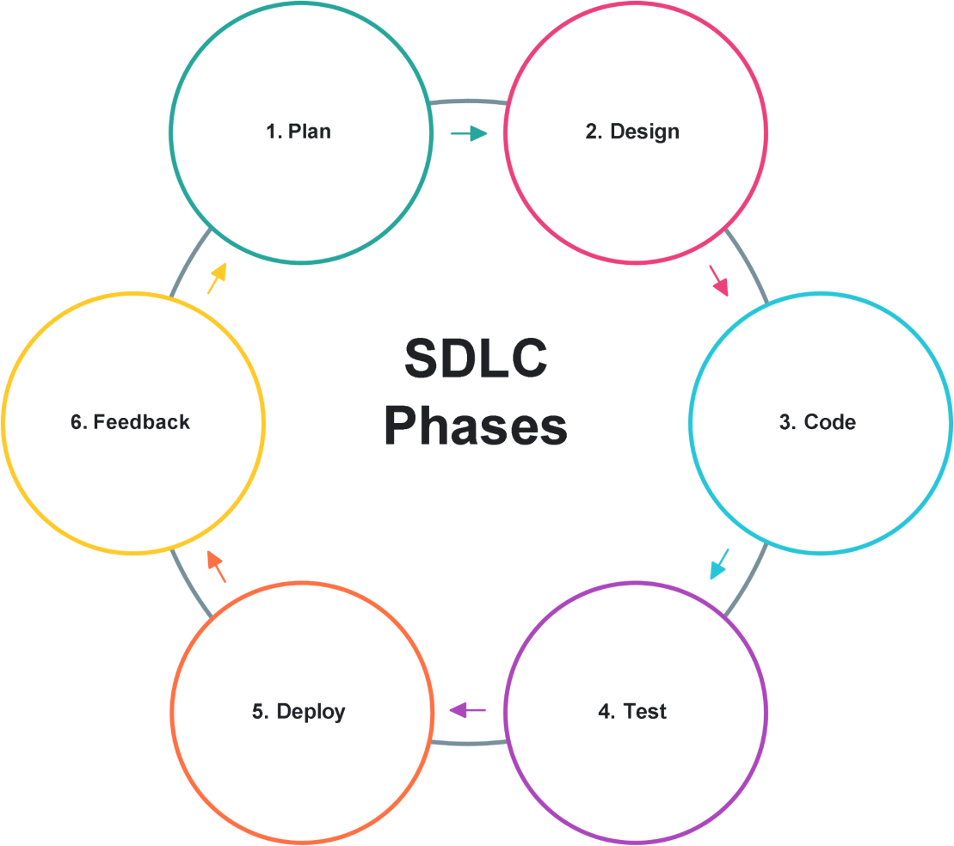

## 

## 

## *Figure 1. The Software Development Life Cycle (SDLC) Phases*

This represents the Software Development Life Cycle (SDLC) Phases. It starts with planning, then designing, followed by coding, testing, deployment, and finally feedback. The process is shown in a circle, which means these steps repeat to improve the software.

|  |  |  |  |  |  |  |  |  |  |  |  |  |  |  |  |  |  |  |  |  |  |  |  |  |  |  |  |  |  |  |  |  |  |  |  |  |  |  |  |  |  |  |  |  |  |
| --- | --- | --- | --- | --- | --- | --- | --- | --- | --- | --- | --- | --- | --- | --- | --- | --- | --- | --- | --- | --- | --- | --- | --- | --- | --- | --- | --- | --- | --- | --- | --- | --- | --- | --- | --- | --- | --- | --- | --- | --- | --- | --- | --- | --- | --- |
| Paraiso360: Digital Mapping and Lot Inventory for Paraiso Memorial Park | | | | | | | | | | | | | | | | | | | | | | | | | | | | | | | | | | | | | | | | | | | | | |
| Paraiso360 Development Timeline | | | | | | | | | |  | | | | | | | | | | | Start Date: February 4, 2025 | | | | | | | | | | | | | | | | | | | | | | | | |
|  | | | | | | | | | | | End Date: -Pending- | | | | | | | | | | | | | | | | | | | | | | | | |
| ID | Phase | FEB | | | | MAR | | | | APR | | | | MAY | | | | JUN | | | | JUL | | | | AUG | | | | SEPT | | | | OCT | | | | NOV | | | | DEC | | | |
| A | PROJECT VISION |  |  |  |  |  |  |  |  |  |  |  |  |  |  |  |  |  |  |  |  |  |  |  |  |  |  |  |  |  |  |  |  |  |  |  |  |  |  |  |  |  |  |  |  |
| A.1 | Brainstorming |  |  |  |  |  |  |  |  |  |  |  |  |  |  |  |  |  |  |  |  |  |  |  |  |  |  |  |  |  |  |  |  |  |  |  |  |  |  |  |  |  |  |  |  |
| A.2 | Client Meeting |  |  |  |  |  |  |  |  |  |  |  |  |  |  |  |  |  |  |  |  |  |  |  |  |  |  |  |  |  |  |  |  |  |  |  |  |  |  |  |  |  |  |  |  |
| A.3 | Kick-off Discussion |  |  |  |  |  |  |  |  |  |  |  |  |  |  |  |  |  |  |  |  |  |  |  |  |  |  |  |  |  |  |  |  |  |  |  |  |  |  |  |  |  |  |  |  |
| 1 | PROTOTYPING V1 |  |  |  |  |  |  |  |  |  |  |  |  |  |  |  |  |  |  |  |  |  |  |  |  |  |  |  |  |  |  |  |  |  |  |  |  |  |  |  |  |  |  |  |  |
| 1.1 | System Flow |  |  |  |  |  |  |  |  |  |  |  |  |  |  |  |  |  |  |  |  |  |  |  |  |  |  |  |  |  |  |  |  |  |  |  |  |  |  |  |  |  |  |  |  |
| 1.2 | UI Design Plan |  |  |  |  |  |  |  |  |  |  |  |  |  |  |  |  |  |  |  |  |  |  |  |  |  |  |  |  |  |  |  |  |  |  |  |  |  |  |  |  |  |  |  |  |
| 1.3 | Prototyping |  |  |  |  |  |  |  |  |  |  |  |  |  |  |  |  |  |  |  |  |  |  |  |  |  |  |  |  |  |  |  |  |  |  |  |  |  |  |  |  |  |  |  |  |
| 2 | INITIATION |  |  |  |  |  |  |  |  |  |  |  |  |  |  |  |  |  |  |  |  |  |  |  |  |  |  |  |  |  |  |  |  |  |  |  |  |  |  |  |  |  |  |  |  |
| 2.1 | Project Setup |  |  |  |  |  |  |  |  |  |  |  |  |  |  |  |  |  |  |  |  |  |  |  |  |  |  |  |  |  |  |  |  |  |  |  |  |  |  |  |  |  |  |  |  |
| 2.2 | Requirement Planning |  |  |  |  |  |  |  |  |  |  |  |  |  |  |  |  |  |  |  |  |  |  |  |  |  |  |  |  |  |  |  |  |  |  |  |  |  |  |  |  |  |  |  |  |
| 2.3 | Migration Prep |  |  |  |  |  |  |  |  |  |  |  |  |  |  |  |  |  |  |  |  |  |  |  |  |  |  |  |  |  |  |  |  |  |  |  |  |  |  |  |  |  |  |  |  |

|  |  |  |  |  |  |  |  |  |  |  |  |  |  |  |  |  |  |  |  |  |  |  |  |  |  |  |  |  |  |  |  |  |  |  |  |  |  |  |  |  |  |  |  |  |  |
| --- | --- | --- | --- | --- | --- | --- | --- | --- | --- | --- | --- | --- | --- | --- | --- | --- | --- | --- | --- | --- | --- | --- | --- | --- | --- | --- | --- | --- | --- | --- | --- | --- | --- | --- | --- | --- | --- | --- | --- | --- | --- | --- | --- | --- | --- |
| 3 | PROTOTYPING V2 |  |  |  |  |  |  |  |  |  |  |  |  |  |  |  |  |  |  |  |  |  |  |  |  |  |  |  |  |  |  |  |  |  |  |  |  |  |  |  |  |  |  |  |  |
| 3.1 | Prototype Build |  |  |  |  |  |  |  |  |  |  |  |  |  |  |  |  |  |  |  |  |  |  |  |  |  |  |  |  |  |  |  |  |  |  |  |  |  |  |  |  |  |  |  |  |
| 3.2 | Demo Feedback |  |  |  |  |  |  |  |  |  |  |  |  |  |  |  |  |  |  |  |  |  |  |  |  |  |  |  |  |  |  |  |  |  |  |  |  |  |  |  |  |  |  |  |  |
| 4 | ITERATIVE DEPLOYMENT |  |  |  |  |  |  |  |  |  |  |  |  |  |  |  |  |  |  |  |  |  |  |  |  |  |  |  |  |  |  |  |  |  |  |  |  |  |  |  |  |  |  |  |  |
| 4.1 | Ongoing Planning |  |  |  |  |  |  |  |  |  |  |  |  |  |  |  |  |  |  |  |  |  |  |  |  |  |  |  |  |  |  |  |  |  |  |  |  |  |  |  |  |  |  |  |  |
| 4.2 | Continuous Build |  |  |  |  |  |  |  |  |  |  |  |  |  |  |  |  |  |  |  |  |  |  |  |  |  |  |  |  |  |  |  |  |  |  |  |  |  |  |  |  |  |  |  |  |
| 4.3 | Integrated Testing |  |  |  |  |  |  |  |  |  |  |  |  |  |  |  |  |  |  |  |  |  |  |  |  |  |  |  |  |  |  |  |  |  |  |  |  |  |  |  |  |  |  |  |  |
| 4.4 | Data Management |  |  |  |  |  |  |  |  |  |  |  |  |  |  |  |  |  |  |  |  |  |  |  |  |  |  |  |  |  |  |  |  |  |  |  |  |  |  |  |  |  |  |  |  |
| 4.5 | Periodic Reviews |  |  |  |  |  |  |  |  |  |  |  |  |  |  |  |  |  |  |  |  |  |  |  |  |  |  |  |  |  |  |  |  |  |  |  |  |  |  |  |  |  |  |  |  |
| 4.6 | Sprint Retrospective |  |  |  |  |  |  |  |  |  |  |  |  |  |  |  |  |  |  |  |  |  |  |  |  |  |  |  |  |  |  |  |  |  |  |  |  |  |  |  |  |  |  |  |  |
| 5 | FINAL EVALUATION |  |  |  |  |  |  |  |  |  |  |  |  |  |  |  |  |  |  |  |  |  |  |  |  |  |  |  |  |  |  |  |  |  |  |  |  |  |  |  |  |  |  |  |  |
| 5.1 | Testing Prep |  |  |  |  |  |  |  |  |  |  |  |  |  |  |  |  |  |  |  |  |  |  |  |  |  |  |  |  |  |  |  |  |  |  |  |  |  |  |  |  |  |  |  |  |
| 5.2 | External Evaluation |  |  |  |  |  |  |  |  |  |  |  |  |  |  |  |  |  |  |  |  |  |  |  |  |  |  |  |  |  |  |  |  |  |  |  |  |  |  |  |  |  |  |  |  |
| 5.3 | UAT |  |  |  |  |  |  |  |  |  |  |  |  |  |  |  |  |  |  |  |  |  |  |  |  |  |  |  |  |  |  |  |  |  |  |  |  |  |  |  |  |  |  |  |  |
| 6 | FINALIZATION |  |  |  |  |  |  |  |  |  |  |  |  |  |  |  |  |  |  |  |  |  |  |  |  |  |  |  |  |  |  |  |  |  |  |  |  |  |  |  |  |  |  |  |  |
| 6.1 | Evaluation Analysis |  |  |  |  |  |  |  |  |  |  |  |  |  |  |  |  |  |  |  |  |  |  |  |  |  |  |  |  |  |  |  |  |  |  |  |  |  |  |  |  |  |  |  |  |

|  |  |  |  |  |  |  |  |  |  |  |  |  |  |  |  |  |  |  |  |  |  |  |  |  |  |  |  |  |  |  |  |  |  |  |  |  |  |  |  |  |  |  |  |  |  |
| --- | --- | --- | --- | --- | --- | --- | --- | --- | --- | --- | --- | --- | --- | --- | --- | --- | --- | --- | --- | --- | --- | --- | --- | --- | --- | --- | --- | --- | --- | --- | --- | --- | --- | --- | --- | --- | --- | --- | --- | --- | --- | --- | --- | --- | --- |
| 6.2 | Final Adjustments |  |  |  |  |  |  |  |  |  |  |  |  |  |  |  |  |  |  |  |  |  |  |  |  |  |  |  |  |  |  |  |  |  |  |  |  |  |  |  |  |  |  |  |  |
| 6.3 | Documentation |  |  |  |  |  |  |  |  |  |  |  |  |  |  |  |  |  |  |  |  |  |  |  |  |  |  |  |  |  |  |  |  |  |  |  |  |  |  |  |  |  |  |  |  |
| 6.4 | Project Deployment |  |  |  |  |  |  |  |  |  |  |  |  |  |  |  |  |  |  |  |  |  |  |  |  |  |  |  |  |  |  |  |  |  |  |  |  |  |  |  |  |  |  |  |  |

Resources

This section details the specific hardware and software resources essential for the completion of Paraiso 360. To ensure optimal system performance and adherence to established standards, both recommended and minimum requirements are specified.

* 1. : Development Workstation (Per Proponent)

|  |  |  |
| --- | --- | --- |
| Hardware | Minimum | Recommended |
| CPU | Dual-core 64-bit processor | Quad-core processor |
| Ram | 4 GB RAM | 8 GB RAM |
| Storage | 100 GB storage | 256 GB SSD |

* 1. Server (For Deployment)

|  |  |  |
| --- | --- | --- |
| Hardware | Minimum | Recommended |
| CPU | Dual-core 64-bit processor | Quad-core processor |
| Ram | 4 GB RAM | 8 GB RAM |
| Storage | 100 GB storage | 256 GB SSD |

* 1. Scanning Equipment

|  |  |  |
| --- | --- | --- |
| Hardware | Minimum | Recommended |
| Scanner | Standard flatbed scanner. | High resolution scanner or access to professional scanning service |

1. Software Requirement

|  |  |  |
| --- | --- | --- |
| Operating System | Minimum | Recommended |
| Windows | Windows 10 64-bit | Latest Windows 10/11 |
| MacOS | MacOS 10.15+ | Latest MacOS |

|  |  |  |
| --- | --- | --- |
| Linux | Linux(Ubuntu 20.04+  Fedora 34+) | Latest Linux Versions |

* 1. Core Technology Stack

|  |  |  |
| --- | --- | --- |
| Technology | Minimum | Recommended |
| Python,Django, Postgre | Python 3.8+, Django 3.2,  PostgreSQL 12+, PostGIS  3.0 | Latest Python 3.x, Django 4.x/5.x, PostgreSQL, PostGIS, with WSGI and Web Server for deployment |

* 1. Development Tools

|  |  |  |
| --- | --- | --- |
| Developement Tools | Minimum | Recommended |
| pip, virtualenv, Git, basic code editor, psql CLI. | pip, virtualenv, Git, basic code editor, psql CLI. | VS Code or PyCharm, GitHub, pgAdmin or DBeaver, browser |

* 1. Map Digitization Software

|  |  |  |
| --- | --- | --- |
| Map | Minimum | Recommended |
| Map tools | QGIS (open-source GIS tool) | Latest QGIS or licensed ArcGIS Pro. |

* 1. End-User Access

|  |  |  |
| --- | --- | --- |
| Browser | Minimum | Recommended |
| Browser | Modern web browser (Chrome, Firefox, Edge, Safari). | Latest version of a major browser for optimal compatibility. |

Requirements Analysis

The project team is dedicated to ensuring that Paraiso 360 effectively addresses the needs of Paraiso Memorial Park's management. To understand the current operational landscape, a requirements analysis was conducted. This analysis focused on identifying existing practices, current challenges, and essential functionalities. Currently, staff primarily utilize Microsoft Excel for storing data and managing databases, along with sorting through physical papers and manual records.

## Requirements Analysis (BUSINESS REQUIREMENT)

On this part, the system or software must provide computing solutions to address

the needs of a customer/client in terms of the following: Who – the people involved, What – the business activity, Where – the environment in which the work takes, When – the timing, How – how the current procedures are performed.

* Business process discussion. You may also do discussion of your interview in this section

## Requirements Documentation (STORYBOARDS/USER STORY – FUNCTIONAL REQUIREMENT)

This part establishes the basis for the agreement between the customer/client and the developers/programmers on what the software product is to do. Under this, all software features are enumerated in detail by providing a storyboard showing how the software would look if the same was already designed and coded.

* In user stories, the following guidelines/format should follow:
  + In writing the user story statement, you may use this format: “As [a user persona], I want [to perform this action] so that [I can accomplish this goal].”
  + Categorize the user stories by modules

## Design of Software, System, Product, and/or Processes (DIAGRAMS/MODELS)

In this part, the developers shall describe in detail how they designed the system in accordance with standards.

* DIAGRAMS/MODELS THAT MAY INCLUDE:
  + Data Flow Diagram Level 0 (CFD) (required)
  + Entity Relationship Diagram (required)
  + Flowchart (requireds)
  + Unified Modelling Language (UML) (Use Case Diagram and/or Class Diagrams) (optional)

## Development (APPLICATION OF SDLC)

In this part, the developers shall describe in detail how they developed the system in accordance with standards.

* PROCESSES/TOOLS USED FOR SDLC (ex. Application of Agile - Project Management Tools, Details of Meeting, and others)

Design of Software, System, Product, and/or Processes This section presents the main design diagrams of the Paraiso360 system, including System Flowcharts, Entity-Relationship Diagrams (ERD), and Context Flow Diagrams. These diagrams were developed following standard design practices to clearly illustrate the system’s architecture, data flow, and operational logic. Each visual representation highlights how data is structured, how users interact with the system, and how core processes, such as lot inventory management, digital mapping, sales tracking, and record- keeping, are carried out within the Paraiso360 platform.

CFD. The Context Flow Diagram shows how the Paraiso360 system connects with Staff/Admin and Visitors/Public, handling tasks like managing client profiles, payments, lots, reports, and grave location searches.

# 

## *Context Flow Diagram*

ERD. It has tables for clients, plots, reservations, occupancies, interments (burials), plot types, and plot statuses. Each client can have reservations or own plots, and each plot has a type and a status.

## 

## *Entity Relationship Diagram*

FSL. The system shows a login page. The staff enter their username and password. The system checks the account. If it's correct, the staff gets access to the dashboard. If not, they can try again or leave the website.

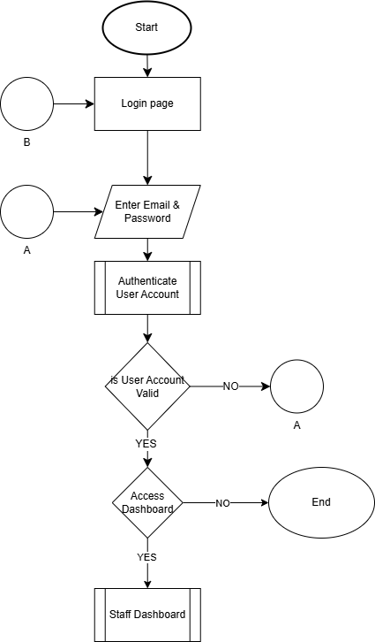

## *Flowcharts-Staff Login*

FSD. The flowchart shows the Staff Dashboard as the main starting point. From here, users can go to different modules like Client Management, Lot Management, Financial (with options for Payment Ledger and Record Sale), and Reports. There are also options to leave the website or log out, with all paths able to return to the Staff Dashboard.

## 

## *Flowchart-Staff Dashboard*

FCM. The flowchart shows how client management works on the "Client Management" screen. Users can search for, add, edit, or delete clients. There are also options to go back to the action menu or the Staff Dashboard.

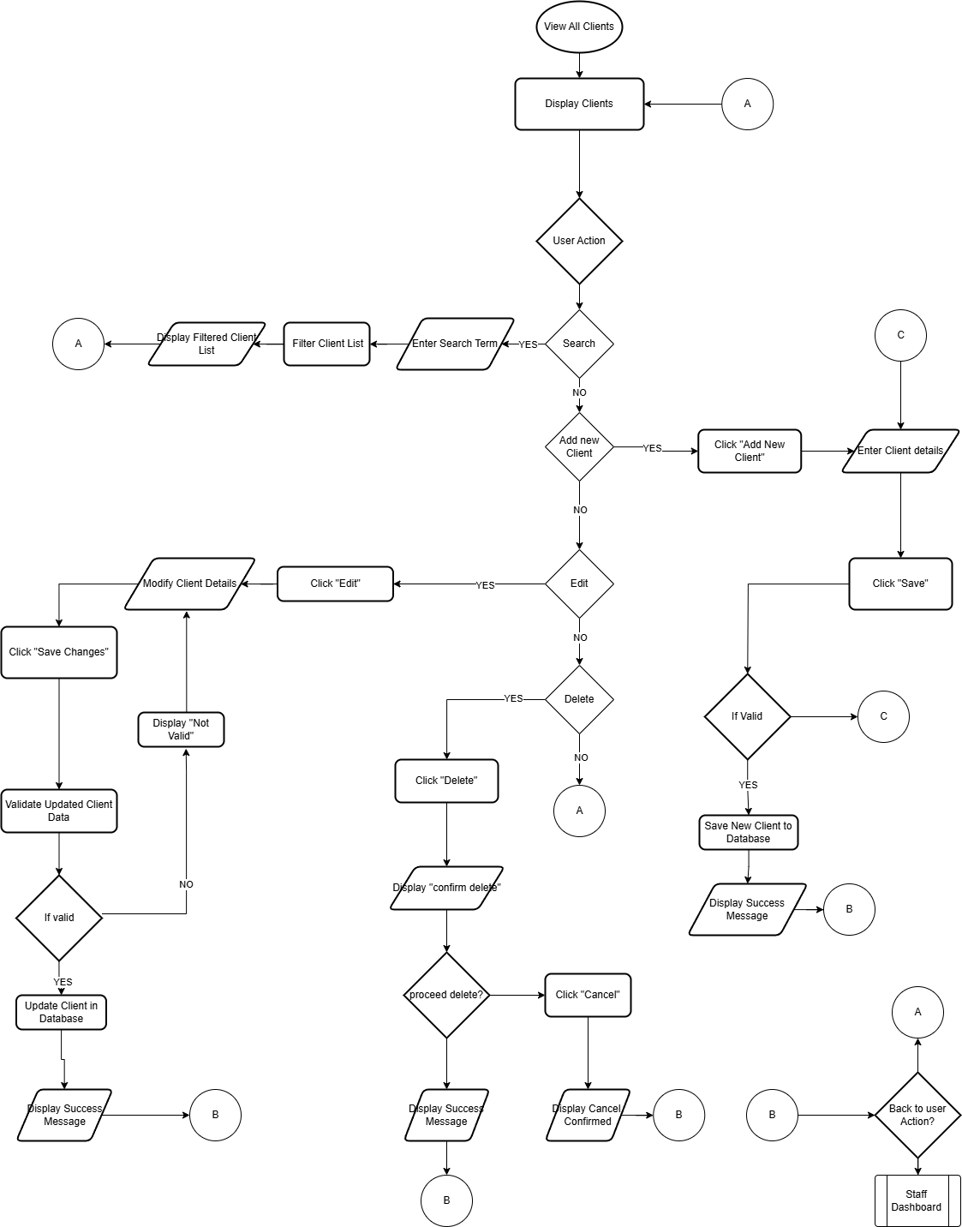

## *Flowchart-Client Management*

FLM. This flowchart explains the "Lot Management" feature. Users can use a map to view or edit lot details and update their status. Once done, they return to the Staff Dashboard.

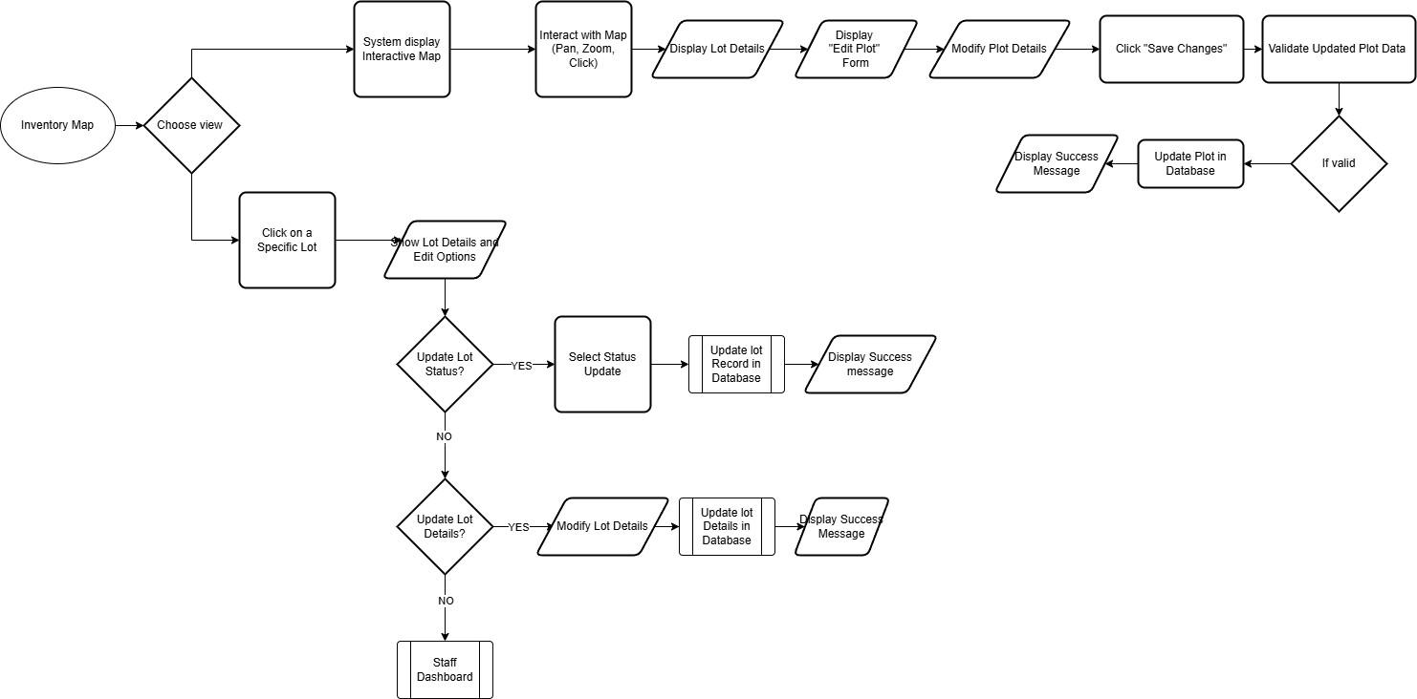

## *Flowchart-Lot Management*

FRT. This flowchart shows the "Record Payment" process in the Payment Ledger. First, the system shows a payment form. The user fills in owner/lot details and payment information. The system checks the data. If it’s correct, the payment is recorded. If

there’s an error, the system shows a message, and the user fixes the input.

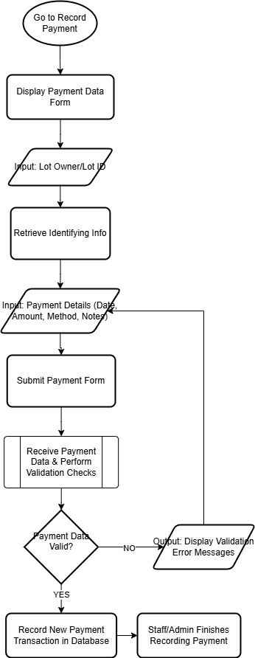

## *Flowchart-Record Payment*

FDR. This flowchart shows how users interact with the Document Repository. It includes actions like uploading, searching, viewing or downloading, editing, and deleting documents.

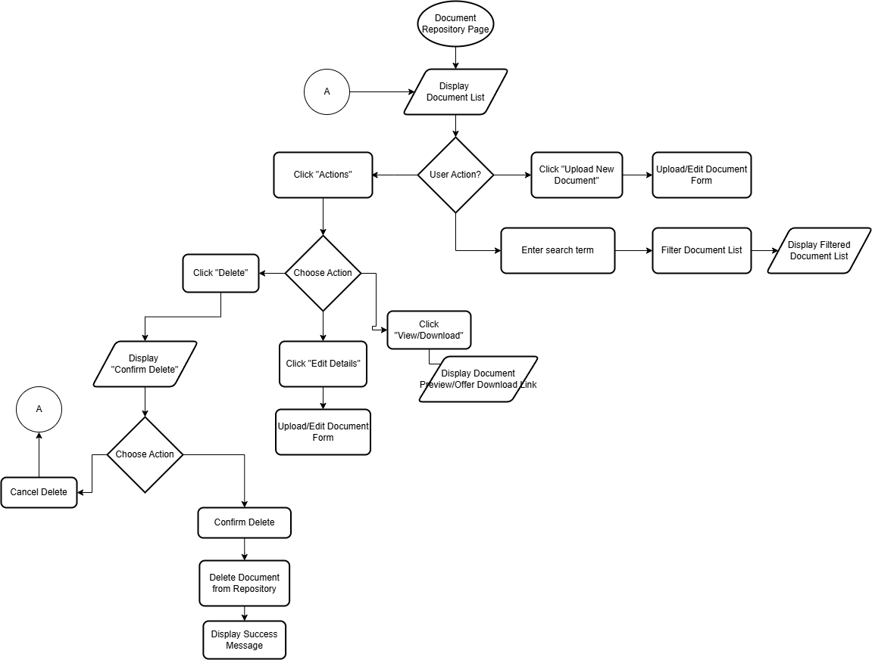

## *Flowchart-Document Repository*

FSR. This flowchart shows how system reports are created. It starts with managing reports, shows the types of reports, lets the user choose a report and apply filters if needed, collects and processes the data, and finally displays the report.

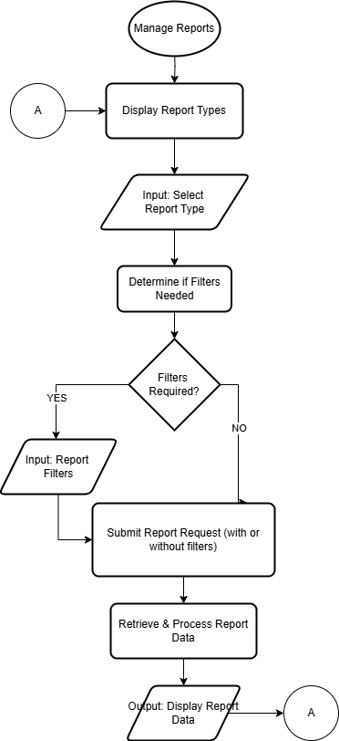

## 

## *Flowchart-System Report*

FAL. The system displays a login page, the admin enters credentials, the system authenticates the account, and if valid, grants access to the admin dashboard; otherwise, the process may loop back for re-entry or exit the website.

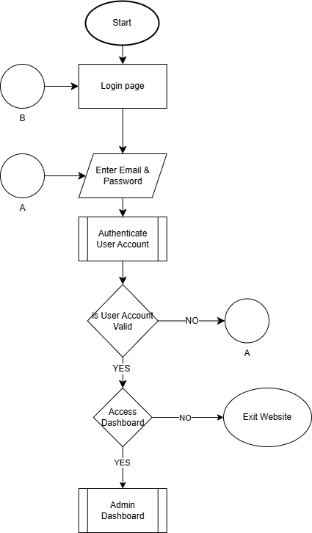

## *Flowchart-Admin Login*

FAD. This flowchart shows the navigation choices from the Admin Dashboard. Users can go to modules like Client Management, Lot Management, Financial Records (with Payment Ledger), Document Repository, User Management, and Reports. They can also choose to exit the website or log out.

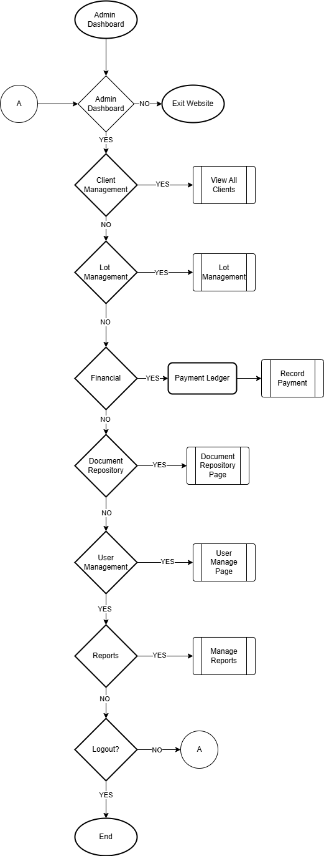

## *Flowchart-Admin Dashboard*

FMU. This flowchart shows how the "Manage Users" feature works. Admins can see a user list and choose to add a new user, edit a user, or deactivate a user. Each option includes steps for entering details, checking them, and showing results. After completing a task, it goes back to the user list or the Admin Dashboard.

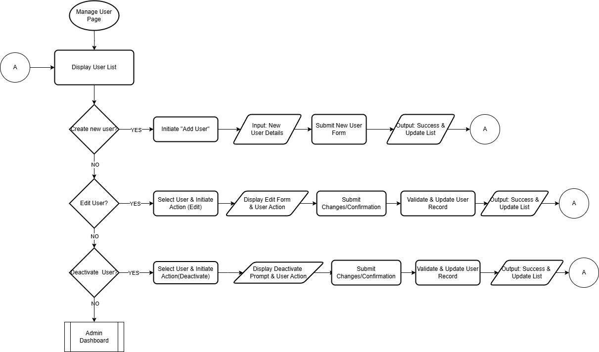

## *Flowchart-Manage Users*

# RESULTS AND DISCUSSION

## Testing (TEST PLAN/TEST CASES/UAT)

In this part, the proponents shall discuss and test the software development standards.

## Description of Prototype (SYSTEM SCREENSHOTS)

This part includes the system requirements, the preliminary design, and how the system is being evaluated and tested.

## Implementation Plan (DEPLOYMENT DETAILS)

The Implementation Plan describes how the information system will be deployed, installed, and transitioned into an operational system. The plan contains an overview of the system, a brief description of the major tasks involved in the implementation, the overall resources needed to support the implementation effort (such as hardware, software, facilities, materials, and personnel), and any site-specific implementation requirements.

## Implementation Results (ISO IEC 25010)

This part consists of the outputs during the implementation phase. These may include the generated outcomes as the ground for improving the project/system. This part is optional.

# Conclusion

The first part of this section is your summary, followed by the conclusion/s, and the last part is/are your recommendation/s.

This section summarizes the results based on the results and discussion chapter. There should be no presentation of tables or figures. A good summary should be comprehensive. A summary must be concise. Your summary should be considerably shorter than the source. Avoid repetitive details. A summary must be coherent and independent. You are expected to maintain your own voice throughout the summary. Don’t simply quote other researcher’s works; instead use your own words to express your understanding of what you have read. After all, your summary is based on your interpretation of the findings, points, or ideas. However, you should be careful not to create any misinterpretation or distortion by introducing comments or criticisms of your own.

Conclusions should unite with the findings and accomplishments of the study. If there are three summaries, there should also be three conclusions. Conclusions are arranged as they appear in the findings. Moreover, rejection and acceptance of the hypotheses, if applicable, are explained under conclusion. Only conclusions which are based definitely on the findings or results should be made. Mere opinions which have no basis in facts and findings have no place in the conclusions of the study.

Recommendations are based on the conclusions. It may include further research of the study and/ or enhancement of the developed system.

In the succeeding paragraphs, there should be no indentations, paragraphs are justified with left alignment. Delete this highlighted section and replace it with your content.

# References

All Funeral. (n.d.). *Why is Traditional Record Keeping Holding Cemeteries Back?* Retrieved May 13, 2025, from [**](https://allfuneral.com/resources/why-is-traditional-record-keeping-holding-cemeteries-back/)[https://allfuneral.com/resources/why-is-traditional-record-keeping-holding-cemeteries-back/**](https://allfuneral.com/resources/why-is-traditional-record-keeping-holding-cemeteries-back/**)

CIMS Cemetery Software. (2024). *Advantages of cemetery mapping software*. [**](https://blog.cimscemeterysoftware.com/advantages-of-cemetery-mapping-software)[https://blog.cimscemeterysoftware.com/advantages-of-cemetery-mapping-software**](https://blog.cimscemeterysoftware.com/advantages-of-cemetery-mapping-software**)

Chronicle. (n.d.). *Guide to Cemetery Mapping*. Retrieved May 13, 2025, from [**](https://chronicle.rip/guide-to-cemetery-mapping/)[https://chronicle.rip/guide-to-cemetery-mapping/**](https://chronicle.rip/guide-to-cemetery-mapping/**)

Gamas Galvez Tupaz. (2020). *Cemetery Management System for Manila South Cemetery* [PDF]. Course Hero. [**](https://www.coursehero.com/file/69087621/Gamas-Galvez-Tupaz-Cemetery-Management-System-for-Manila-Southdocx/)[https://www.coursehero.com/file/69087621/Gamas-Galvez-Tupaz-Cemetery-Management-System-for-Manila-Southdocx/**](https://www.coursehero.com/file/69087621/Gamas-Galvez-Tupaz-Cemetery-Management-System-for-Manila-Southdocx/**)

Klingemann, J., Schmid, M., Umbricht, M., Rota, A., & Hametner, K. (2024). *Evaluating a Swiss cemetery wayfinding system using shadowing methodology*. Interdisciplinary Journal of Signage and Wayfinding, 8(1). [**](https://journals.shareok.org/ijsw/article/download/147/98/571)[https://journals.shareok.org/ijsw/article/download/147/98/571**](https://journals.shareok.org/ijsw/article/download/147/98/571**)

LaBella Associates. (2025, February 11). *Mapping memories: Modernizing cemeteries using GIS technology*. [**](https://www.labellapc.com/insights/mapping-memories-modernizing-cemeteries-using-gis-technology/)[https://www.labellapc.com/insights/mapping-memories-modernizing-cemeteries-using-gis-technology/**](https://www.labellapc.com/insights/mapping-memories-modernizing-cemeteries-using-gis-technology/**)

LEES+ Associates. (2016, September). *Cemetery mapping: What can GIS do for you?* [**](http://elac.ca/LEES+Associates/wp-content/uploads/2016/09/OACFP_Cemetery-Mapping-What-can-GIS-do-for-you.pdf)[http://elac.ca/LEES+Associates/wp-content/uploads/2016/09/OACFP_Cemetery-Mapping-What-can-GIS-do-for-you.pdf**](http://elac.ca/LEES+Associates/wp-content/uploads/2016/09/OACFP_Cemetery-Mapping-What-can-GIS-do-for-you.pdf**)

Oliver, L. M. S. (2022). *Cemetery Mapping and Information System for Lund Memorial Garden* [PDF]. Scribd. [**](https://www.scribd.com/document/614310193/Cemetery-Mapping-and-Information-System-Oliver)[https://www.scribd.com/document/614310193/Cemetery-Mapping-and-Information-System-Oliver**](https://www.scribd.com/document/614310193/Cemetery-Mapping-and-Information-System-Oliver**)

Padillo, M. V., Arsua, B., & Codeniera, W. (2021, January). *Cemetery Management System*. Course Hero. [**](https://www.coursehero.com/file/86430790/Cemetery-Management-Systemdocx/)[https://www.coursehero.com/file/86430790/Cemetery-Management-Systemdocx/**](https://www.coursehero.com/file/86430790/Cemetery-Management-Systemdocx/**)

Steingold, L. (2024, October 7). *Documentation statistics*. [usewhale.io](http://usewhale.io). [**](https://usewhale.io/blog/documentation-statistics/)[https://usewhale.io/blog/documentation-statistics/**](https://usewhale.io/blog/documentation-statistics/**)

Appendices

Appendix A. reSOURCE PERSONS

This appendix lists the resource persons who contributed to the Paraiso360 capstone proposal. Their expertise guided the project's direction, validated its feasibility, and ensured alignment with institutional standards and practical needs.

* Alejandro Burgos Jr.
  + Role: Capstone Project Coordinator
  + Organization: STI College Balagtas
  + Contribution: Reviewed and approved the project proposal, ensuring alignment with institutional guidelines and academic standards.
* Jose Crisanto S. Austria
  + Role: Capstone Project Adviser
  + Organization: STI College Balagtas
  + Contribution: Guided the technical design of Paraiso360, validated the feasibility of the proposed methodology, and provided feedback on the project scope.
* Lois Ithiel Aglipay
  + Role: All-around staff
  + Organization: Paraiso Memorial Park
  + Contribution: Granted access to sample records, maps, and operational documents during the requirements-gathering phase. Participated in initial interviews to clarify pain points.
* Regina Mape
  + Role: Program Head
  + Organization: STI College Balagtas
  + Contribution: Endorsed the project’s alignment with the BSIT curriculum

and institutional objectives.

* Gryzel Maris Advincula
  + Role: Grammarian
  + Organization: STI College Balagtas
  + Contribution: Checked and corrected the grammar and writing of the project document to make sure it was clear and correct.

Appendix B. relevant source code

APPENDIX C. EVALUATION TOOL/TEST DOCUMENTS

APPENDIX D. SAMPLE INPUT/OUTPUT/REPORTS

APPENDIX E. USER’S GUIDE

APPENDIX F. PERSONAL TECHNICAL VITAE

Curriculum Vitae of

Israel C. Delfin

2252 Panginay, Balagtas, Bulacan

israeldelfin24@gmail.com

+63 9693937339

EDUCATIONAL BACKGROUND

|  |  |  |
| --- | --- | --- |
| Level | Inclusive Dates | Name of school/ Institution |
| Tertiary | Present | STI College Balagtas |
| Vocational/Technical | May 2020 | Dr. Yanga’s Colleges Inc. |
| High School | May 2018 | Dr. Yanga’s Colleges Inc. |
| Elementary | April 2014 | Francisco Balagtas Memorial School |

PROFESSIONAL OR VOLUNTEER EXPERIENCE

|  |  |  |
| --- | --- | --- |
| Inclusive Dates | Nature of Experience/  Job Title | Name and Address of Company or Organization |
| N/A | N/A | N/A |
|  |  |  |
|  |  |  |
|  |  |  |

AFFILIATIONS

|  |  |  |
| --- | --- | --- |
| Inclusive Dates | Name of Organization | Position |
| Present | BITS | Member |
| October 2022 |  |  |
|  |  |  |
|  |  |  |

SKILLS

|  |  |  |
| --- | --- | --- |
| SKILLS | Level of Competency | Date Acquired |
| CSS | Beginner | January 2025 |
| HTML | Beginner | January 2025 |
| JavaScript  SQL  C#  Python  Java | Beginner  Beginner  Beginner  Beginner  Intermediate | March 2025  February 2024  February 2024  February 2023  September 2022 |

TRAININGS, SEMINARS, OR WORKSHOPS ATTENDED

|  |  |
| --- | --- |
| Inclusive Dates | Title of Training, Seminar, or Workshop |
|  |  |
| October 2024 | IT Colloquium |
|  |  |
|  |  |

Curriculum Vitae of

Aaron Paul P. Echeche

1333 Tiwala Borol 1st, Balagtas, Bulacan

aaronpadua006@gmail.com

+63 9474964438

EDUCATIONAL BACKGROUND

|  |  |  |
| --- | --- | --- |
| Level | Inclusive Dates | Name of school/ Institution |
| Tertiary | Present | STI College Balagtas |
| Vocational/Technical | May 2022 | College of Saint Lawrence Inc. |
| High School | May 2020 | College of Saint Lawrence Inc. / Guiguinto National Vocational HighSchool |
| Elementary | April 2016 | College of Saint Lawrence Inc. |

PROFESSIONAL OR VOLUNTEER EXPERIENCE

|  |  |  |
| --- | --- | --- |
| Inclusive Dates | Nature of Experience/  Job Title | Name and Address of Company or Organization |
| N/A | N/A | N/A |
|  |  |  |
|  |  |  |

AFFILIATIONS

|  |  |  |
| --- | --- | --- |
| Inclusive Dates | Name of Organization | Position |
| Present | BITS | Member |
| October 2022 |  |  |
|  |  |  |

SKILLS

|  |  |  |
| --- | --- | --- |
| SKILLS | Level of Competency | Date Acquired |
| CSS | Beginner | January 2025 |
| HTML | Beginner | January 2025 |
| JavaScript | Beginner | March 2025 |
| SQL | Beginner | February 2024 |
| C# | Beginner | February 2024 |
| Python | Beginner | February 2023 |
| Java | Intermediate | September 2022 |

TRAININGS, SEMINARS, OR WORKSHOPS ATTENDED

|  |  |
| --- | --- |
| Inclusive Dates | Title of Training, Seminar, or Workshop |
| October 2024 | IT Colloquium |
|  |  |

Curriculum Vitae of

Juan Carlos A. Flores

D1187 Devine Grace Village, Borol 1st, Balagtas, Bulacan

kunt0069@gmail.com

+63 9995090524

EDUCATIONAL BACKGROUND

|  |  |  |
| --- | --- | --- |
| Level | Inclusive Dates | Name of school/ Institution |
| Tertiary | Present | STI College Balagtas |
| Vocational/Technical | May 2022 | Dr. Yanga’s Colleges Inc. |
| High School | May 2020 | Dr. Yanga’s Colleges Inc. |
| Elementary | April 2016 | Borol 1st Elementary School / College of Saint Lawrence Inc. |

PROFESSIONAL OR VOLUNTEER EXPERIENCE

|  |  |  |
| --- | --- | --- |
| Inclusive Dates | Nature of Experience/  Job Title | Name and Address of Company or Organization |
| N/A | N/A | N/A |
|  |  |  |
|  |  |  |

AFFILIATIONS

|  |  |  |
| --- | --- | --- |
| Inclusive Dates | Name of Organization | Position |
| Present | BITS | Member |
| October 2022 |  |  |
|  |  |  |

SKILLS

|  |  |  |
| --- | --- | --- |
| SKILLS | Level of Competency | Date Acquired |
| CSS | Beginner | January 2025 |
| HTML | Beginner | January 2025 |
| JavaScript | Beginner | March 2025 |
| SQL | Beginner | February 2024 |
| C# | Beginner | February 2024 |
| Python | Beginner | February 2023 |
| Java | Intermediate | September 2022 |

TRAININGS, SEMINARS, OR WORKSHOPS ATTENDED

|  |  |
| --- | --- |
| Inclusive Dates | Title of Training, Seminar, or Workshop |
| October 2024 | IT Colloquium |
|  |  |

Curriculum Vitae of

Mark Erick Reyes

PR-224-A, Borol 2nd, Balagtas, Bulacan

markerickreyes240@gmail.com

+63 9763447686

EDUCATIONAL BACKGROUND

|  |  |  |
| --- | --- | --- |
| Level | Inclusive Dates | Name of school/ Institution |
| Tertiary | Present | STI College Balagtas |
| Vocational/Technical | May 2022 | Immaculate Concepcion Institution Balagtas |
| High School | May 2020 | College of Saint Lawrence Inc. / Garden Angels Integrated School Inc |
| Elementary | April 2016 | Borol 2nd, Elementary School |

PROFESSIONAL OR VOLUNTEER EXPERIENCE

|  |  |  |
| --- | --- | --- |
| Inclusive Dates | Nature of Experience/  Job Title | Name and Address of Company or Organization |
| N/A | N/A | N/A |
|  |  |  |
|  |  |  |

AFFILIATIONS

|  |  |  |
| --- | --- | --- |
| Inclusive Dates | Name of Organization | Position |
| Present | BITS | Member |
| October 2022 |  |  |
|  |  |  |

SKILLS

|  |  |  |
| --- | --- | --- |
| SKILLS | Level of Competency | Date Acquired |
| CSS | Beginner | January 2025 |
| HTML | Beginner | January 2025 |
| JavaScript | Beginner | March 2025 |
| SQL | Beginner | February 2024 |
| C# | Beginner | February 2024 |
| Python | Beginner | February 2023 |
| Java | Intermediate | September 2022 |

TRAININGS, SEMINARS, OR WORKSHOPS ATTENDED

|  |  |
| --- | --- |
| Inclusive Dates | Title of Training, Seminar, or Workshop |
| October 2024 | IT Colloquium |
|  |  |

APPENDIX G. INTERVIEW TRANSCRIPT

Interview Transcript 1

Date of Interview: April 29, 2025 Place of Interview: Via MS Teams Time Started: 07:00 PM

Time Ended: 07:30 PM

Interviewer 1: Israel Delfin Interviewer 2: Mark Erick Reyes Interviewer 3: Juan Carlos Flores Interviewer 4: Aaron Paul Echeche Interviewee: Ms. Lois Ithiel Aglipay

Interviewer 1: What tools do you see most for managing information or records? Like maps, notebooks, and computer files? Again, what tools do you use most for managing information or records? Ano daw yung mga tools na madalas ginagamit for managing information at records?

Interviewee: They mostly use Microsoft Office for managing maps and client records, relying on manual creation in Word for maps and Excel for filing client records. (Actually, we usually use Microsoft Office. Mostly talaga, pag like maps, we use Microsoft Word because we’re creating the map there. So talagang manual talaga yung creation ng maps namin. Then, when it comes to recording, yung mga records ng mga clients, we usually use Microsoft Excel. Doon namin fina-file lahat ng records ng mga clients.)

Interviewer 1: So ayun, thank you sa sagot. And another question. When you need to find specific information like details about someone’s payment, how easy or hard is that usually?

Interviewee: It is generally difficult to find client information as they use both hard and soft copies, and clients often lack specific details, requiring searches in Excel or physical files. (Actually, usually mahirap talaga maghanap ng information ng clients kasi we file them in both hard and soft copy. Sa hard copy, pag hindi mo mahanap, kailangan mo talagang hanapin sa soft copy. So usually, mahirap talaga maghanap ng info, lalo kapag

tinanong mo si client pero hindi niya kabisado kung anong lote or block yung nabili niya. Ang alam lang niya ay magbabayad siya. Hinahanap namin yun through Excel. Kailangan talaga may soft copy kami when it comes to their payment. Kasi kung wala, mahihirapan kaming ifile ang records nila lalo na kung may mga mispayments na may penalty. Minsan may kopya si buyer ng resibo pero kami wala. Kaya hinahanap pa namin sa hard copy. Talagang kailangan meron kami ng parehong copies kasi kung wala, hindi namin malalaman kung nagbayad si buyer.)

Interviewer 1: So ayun, nasagot mo na rin yung example ng difficulty. If you had to estimate, how long does it usually take you to find something like location or contact info?

Interviewee: Searching for owner contact information takes minutes or even hours, especially if only hard copies are available. (Actually, hindi siya seconds. Pag owner contact info ang kailangan, dapat meron akong soft copy. Pag wala sa soft copy, maghahanap talaga ako sa hard copy. Umaabot ng minutes or even hours bago ko mahanap yung contact information o location nila. Maghihintay talaga si client.)

Interviewer 1: So about double-checking information to make sure na tama. For example, do you confirm if a plot is available or if a payment was made?

Interviewee: They double-check payment information through client receipts, as missing soft copies make receipts essential for verification. (Opo, yes. I double-check through resibo na dala ng client. Minsan may resibo sila pero wala sa soft copy namin. Kaya talagang importante yung resibo na nirerelease namin. Lagi naming pinaaalalahanan yung buyers na huwag itapon yung resibo kasi minsan, wala kami sa soft copy, and yun lang ang basehan.)

Interviewer 1: Do you still use or fill out any standard forms or reports regularly as part of your job? Can you tell us a bit about them? What kind of information do they have on them, and what do you use them for?

Interviewee: Buyers' information forms are regularly filled out, including marital status, beneficiaries, and contact details, for submission to developers. (Yes. Pag nagbibigay kami ng buyers information form, kailangan naming malaman kung married sila, sino beneficiaries, contact number, date and place of birth. Kasi kapag gagamitin na nila yung lot, pinapasa namin yung info sa developer. Kailangan kompleto talaga lahat ng fields.)

Interviewer 1: Do you ever need to make other lists or summaries yourself by hand? Like, maybe available plots?

Interviewee: They create summaries and lists manually when standard forms are unavailable, often for reports. (Yes. We usually create summaries and lists. May mga standard forms kami na ginagamit sa report. Pag wala, kami mismo ang gumagawa ng list manually.)

Interviewer 2: Yung type of summary po, meron po ba kayong daily, weekly, monthly, or yearly reports?

Interviewee: Weekly summaries are prepared, which are filed monthly, but manual preparation takes significant time. (Usually, summaries are weekly. Inaayos namin weekly, then pina-file monthly. Medyo matagal din kasi manomano pa. Kapag monthly na, mas maraming kailangang ayusin.)

Interviewer 2: Kung ginagawa by hand, gaano katagal yun?

Interviewee: Manual reporting takes a long time, especially for monthly summaries. (Medyo matagal din kasi mano-mano pa. Kapag monthly na, mas maraming kailangang ayusin.)

Interviewer 1: Do you use a phone or tablet for any parts of your work?

Interviewee: Phones are used for tasks like reminding clients about monthly amortizations and penalties, but tablets are not used. (We don’t use tablets, pero we use phones especially for monthly amortization reminders. Kailangan naming i-inform si client kung may penalties or due date na. Also for other concerns, nila.)

Interviewer 1: What are the biggest challenges that make things harder or take longer?

Interviewee: Double sales are the biggest challenge, requiring extensive client communication and weeks to resolve disputes. (Ang pinakamahirap talaga ay double sale. Kailangan kausapin ang parehong clients. Pag hindi sila nagcooperate, mahirap ayusin lalo na kung sabay na gusto ang same lot. First come, first serve kami pero mahirap pa rin explain sa client na nahuli. Usually, magkakaibigan ang mga clients, kaya gusto nila magkatabi. Umaabot ng weeks bago maayos.)

Interviewer 1: How do you think a digital system that puts maps, plots, info, and records together would help you?

Interviewee: A digital system integrating maps, plots, and records would make searches faster and records more organized. (Malaking tulong ang digital system. Mas mapapadali ang pag-search ng info ng clients at records nila. Mas less hassle at mas organized.)

Interviewer 1: If you had all that information in one system, how much time do you think that could save you each week?

Interviewee: With a digital system, weekly work could be completed in a single day, saving significant time. (Kung may ganung system, yung isang linggo kong trabaho pwedeng matapos sa isang araw. Sobrang laking tulong.)

Interviewer 1: Gumagamit din ba kayo ng Excel for monitoring sales and other stuff?

Interviewee: Excel is used regularly for monitoring sales and other records. (Yes. We usually use Excel.)

Interviewer 1: How helpful would a digital map be that shows which spots are available?

Interviewee: A digital map would reduce the issue of double sales by showing updated availability in real time. (Sobrang helpful lalo na sa double sales. Kapag print lang kasi, akala ng client available pa, yun pala may nauna na. Minsan nakakalimutan naming iupdate. Digital map makakatulong talaga.)

Interviewer 1: What do you think about the idea of a website where spot owners could look up their spot info?

Interviewee: A website for landowners to check their spot info would free up time for marketing and other tasks. (Yes. Makakatulong yun sa mga landowners para makita info nila. At kami, magkakaroon ng more time for marketing and other tasks.)

Interviewer 1: And what about a map application for visitors to help them find their way around the park?

Interviewee: A map application would help visitors navigate easily without manual measurements on-site. (I like that. Kung may app na makikita nila ang lote nila, very helpful yun. Para navigation talaga. Hindi na kailangang magbilang ng metro sa site. Mas less hassle.)

Interviewer 1: Sa ngayon po, may map po ba kayo na naka-print?

Interviewee: They are creating a printed map navigation plan to assist clients in finding lots as a future project. (Yes. May plan kami. I’m creating a map navigation para hindi mahirapan ang clients sa paghahanap ng lote. Future plan siya.)

Interviewer 1: If we build a system, what one or two things would be most important for you to make it easy and good for everyday use?

Interviewee: Ledgering is the most critical feature for a system, as it tracks client balances, missed payments, and penalties. (Ang pinaka-importante para sa akin ay ledgering. Kailangan naming malaman kung magkano ang kulang ng client, ilang months na hindi nagbayad, etc. Ledgering talaga ang priority.)

Interviewer 1: Okay. Include namin yan sa plano. That’s all for the questions and thank

you sa time. Sorry sa disturbo po.

Interviewee: Yes, yes.

Interview Transcript 2

Date of Interview: May 15, 2025 Method of Interview: Online Chat Time Started: 07:00 PM

Time Ended: 07:20 PM

Interviewer 1: Israel Delfin

Interviewee: Memorial Park Staff Representative

Interviewer 1: Consider multiple renters at the same lot. Is it possible to bury more than one person in the same lot?

Interviewee: Yes, a lawn lot can accommodate multiple burials as long as it doesn’t exceed

the allowed capacity.

(Oo, sa isang lawn lot puwedeng may maraming nakalibing basta’t hindi lalagpas sa maximum capacity. Sa ngayon, ang allowed ay hanggang anim na katao dalawa ay fresh body, at apat ay skeletal remains.)

Interviewer 1: What happens when the subscription ends? Is there a transfer process?

Interviewee: There is no contract expiration since we’re not a public cemetery like St. Peter. Once fully paid, the buyer is the rightful owner. If they wish to transfer the lot, they must consult us first and we will prepare a Deed of Absolute Sale.

(Walang end of contract kasi hindi po kami gaya ng St. Peter o public cemeteries. Kapag nabayaran na po nang buo ang lote, kanila na po iyon. Kung gusto nilang i-transfer, kailangan muna nila kaming i-consult at saka kami gagawa ng Deed of Absolute Sale.)

Interviewer 1: How about apartment-type niches? If there are multiple people buried, is only one name recorded?

Interviewee: We do not have apartment-type niches. We are a memorial park, not a cemetery. We offer only two lot types: Lawn Area and Family Estate Area. All names of buried individuals are recorded, even in a single lawn lot.

(Wala po kaming apartment-type na nicho o nitso. Hindi po kami cemetery, memorial park po kami. Ang ino-offer lang namin ay dalawang uri ng lote: Lawn Area at Family Estate Area. Kahit sa lawn lot, nakalista pa rin ang pangalan ng lahat ng nakalibing.)

Interviewer 1: Do you offer garden niches or similar options?

Interviewee: No, we do not offer garden niches. Only lawn lots and family estate lots are available.

(Hindi po, wala po kaming garden niche. Lawn lot at family estate lot lang po talaga ang available sa amin