AI-Driven Proxy-Based Assessment of Urban Drainage Clogging and Obstruction-Induced Flood Risk: A Case Study of Tirupati Municipal Corporation, Andhra Pradesh
Manjula K R¹, Gowri L², Abishek Perumal B², Sreekar M², Kamakshi S³, Anand Kumar Varma S³
1,2 School of Computing, SASTRA Deemed University, Thanjavur, India
3 Gnanamani College of Technology, Namakkal, India
Corresponding Author E-mail: manjula@cse.sastra.ac.in
Abstract. Urban flooding is generally assessed in terms of rainfall intensity, topography, land-use change and drainage capacity, while the progressive obstruction of drainage systems by silt, vegetation, plastic and solid waste receives comparatively limited quantitative attention. In rapidly urbanizing, pilgrimage-driven cities such as Tirupati, such obstruction can reduce effective conveyance and increase localized flood impacts, yet continuous field observation of drain condition is rarely feasible. This study proposes a proxy-based AI framework for Tirupati Municipal Corporation (TMC), Andhra Pradesh, integrating multi-temporal Sentinel-1 SAR, Sentinel-2 multispectral imagery, digital elevation models, rainfall, land-use/land-cover, drainage-network characteristics and historical flood information. Three Earth-observation-derived indicators are developed — a Siltation Susceptibility Index (SSI), a Vegetation Encroachment Index (VEI) and an Anthropogenic Obstruction Susceptibility Index (AOSI) — and combined through explainable machine learning into a Drainage Obstruction Severity Index (DOSI) that classifies drainage segments by relative potential obstruction. In the absence of systematic field measurements, DOSI represents relative susceptibility rather than direct clogging depth, mass or volume. Representative drainage segments are further evaluated under scenario-based hydraulic modelling at 0%, 20%, 40%, 60% and 80% effective conveyance reduction, and an AI surrogate model relates rainfall, drainage characteristics and obstruction severity to flood response. The resulting framework offers a low-cost, transferable method for prioritizing drainage inspection, desilting and waste removal, supporting anticipatory flood management and disaster risk reduction for Tirupati and comparable pilgrimage or rapidly urbanizing cities.
Keywords: Drainage Obstruction; Drainage Obstruction Severity Index; Earth Observation Remote Sensing; Machine and Deep Learning; Urban Flood Risk; Tirupati Municipal Corporation.

1 Introduction
Urban flooding in Indian cities results from the compounding effects of extreme rainfall, rapid urbanization, expansion of impervious surfaces, altered natural flow paths and inadequate drainage capacity. Conventional flood-risk assessments generally represent drainage networks as fixed-capacity systems characterized by pipe or channel geometry, slope and rainfall input. This representation, while computationally convenient, omits an operationally significant and frequently observed process: the progressive reduction of effective drainage conveyance caused by silt deposition, vegetation encroachment and accumulation of plastic and solid waste at inlets, culverts and constricted channel sections.
Because a comparatively small obstruction at a hydraulically sensitive location can produce a disproportionately large increase in upstream water levels and inundation extent, drainage condition is a critical but under-represented variable in urban flood modelling. Existing studies have applied deep learning and Earth observation to flood-extent mapping, land-cover classification and rainfall-runoff estimation, but few frameworks explicitly quantify drainage obstruction as an intermediate process linking drain condition to flood amplification, and fewer still address this problem in the context of a rapidly urbanizing, pilgrimage-driven city where population and infrastructure loading vary substantially across the year.
Tirupati Municipal Corporation (TMC), Andhra Pradesh, is used in this study as a demonstration environment. TMC combines dense and rapidly expanding built-up surfaces, an extensive storm-water drainage network, low-lying and topographically variable terrain, intense monsoon and pre-monsoon rainfall, and substantial pilgrimage-related population fluctuation. Historical municipal planning documentation and engineering records for the city have separately identified storm-drain choking by solid waste, incomplete drainage infrastructure and recurrent waterlogging as operational concerns, while current municipal procurement activity continues to involve desilting of storm-water drains and culverts. These observations motivate a systematic, spatially continuous assessment of drainage obstruction rather than isolated, site-specific field inspection.
Because comprehensive field measurement of silt depth, vegetation density and solid-waste accumulation across an entire municipal drainage network is expensive and difficult to sustain, this study adopts a proxy-based Earth observation and artificial intelligence (AI) approach. Rather than claiming direct satellite detection of plastic mass or silt volume, the framework identifies environmental, morphological and spatial characteristics associated with potential obstruction, and expresses these as a relative Drainage Obstruction Severity Index (DOSI). The specific objectives of the study are to: (i) develop multi-source Earth observation and geospatial proxy indicators for silt, vegetation and anthropogenic-waste susceptibility within the TMC drainage network; (ii) develop an explainable machine-learning-based DOSI for spatially classifying and prioritizing drainage segments; (iii) quantify the hydrological and hydraulic consequences of different obstruction scenarios through coupled hydraulic and AI-based surrogate modelling; and (iv) develop a micro-level, decision-ready drainage flood-risk prioritization framework to support pre-monsoon inspection, maintenance planning and disaster risk reduction in TMC.

2 Related Work
Earth observation data, particularly Sentinel-1 synthetic aperture radar (SAR) and Sentinel-2 multispectral imagery, have been widely applied to urban flood-extent mapping and flood-susceptibility modelling, typically in combination with digital elevation models (DEM), rainfall and land-use/land-cover variables [1]. Convolutional neural networks and, more recently, vision transformer architectures have improved feature extraction from multi-temporal satellite imagery for tasks such as land-cover classification, vegetation monitoring and change detection, and have been adapted for identifying surface indicators relevant to drainage condition, including vegetation encroachment and sediment-prone surfaces [2].
A separate body of work addresses urban drainage-network hydraulic modelling, generally assuming a static, design-specification conveyance capacity for pipes and channels [3]. Where drainage deterioration is considered, it is typically incorporated through generic maintenance or condition scores rather than through spatially continuous, remotely sensed proxy indicators [4]. Machine-learning surrogate models have separately been used to approximate computationally expensive hydraulic simulations, enabling rapid scenario evaluation across large numbers of rainfall-drainage combinations, although this approach has seldom been coupled with an Earth-observation-derived obstruction index [5].
Studies specific to pilgrimage cities and rapidly urbanizing secondary cities in India remain comparatively limited, despite documented operational concerns regarding storm-drain choking, incomplete drainage infrastructure and waterlogging in such settings [6]. The present study addresses this gap by combining (a) multi-source Earth observation proxy indicators for siltation, vegetation and anthropogenic obstruction, (b) an explainable machine-learning severity index, and (c) scenario-based hydraulic and AI surrogate modelling, within a single obstruction-to-flood framework applied to Tirupati Municipal Corporation.

3 Study Area: Tirupati Municipal Corporation
Tirupati Municipal Corporation, Andhra Pradesh, was selected as the study area because it combines rapid urban expansion, pilgrimage-driven population and traffic fluctuation, intense rainfall episodes, expanding impervious surfaces and an extensive storm-water drainage network. Historical city planning documentation has identified storm-drain choking by solid waste, poor drain conditions, inadequate branch drainage and waterlogging as recurring urban-management concerns, and an earlier performance audit reported that the planned storm-water drainage system remained incomplete, linking this incompleteness to inundation and flooding within the city. In 2026, the Andhra Pradesh Government announced a climate-resilient integrated water-management initiative for Tirupati that includes desilting and deepening of local water bodies and expansion of the storm-water drainage network, while current municipal procurement activity separately includes removal of wet silt from existing drains and culverts, indicating the continuing operational relevance of drainage obstruction to the city.
Available technical and planning documentation for TMC identifies primary drainage corridors and critical low-lying locations within the city, providing secondary evidence that can support qualitative validation of the proposed indicators. The corporation, rather than the earlier municipality designation, is treated as the appropriate administrative and spatial unit for the proposed micro-level drainage analysis.

4 Methodology
The proposed methodology follows an integrated Earth-observation–AI–hydraulic modelling framework comprising six stages, illustrated conceptually in Fig. 1.
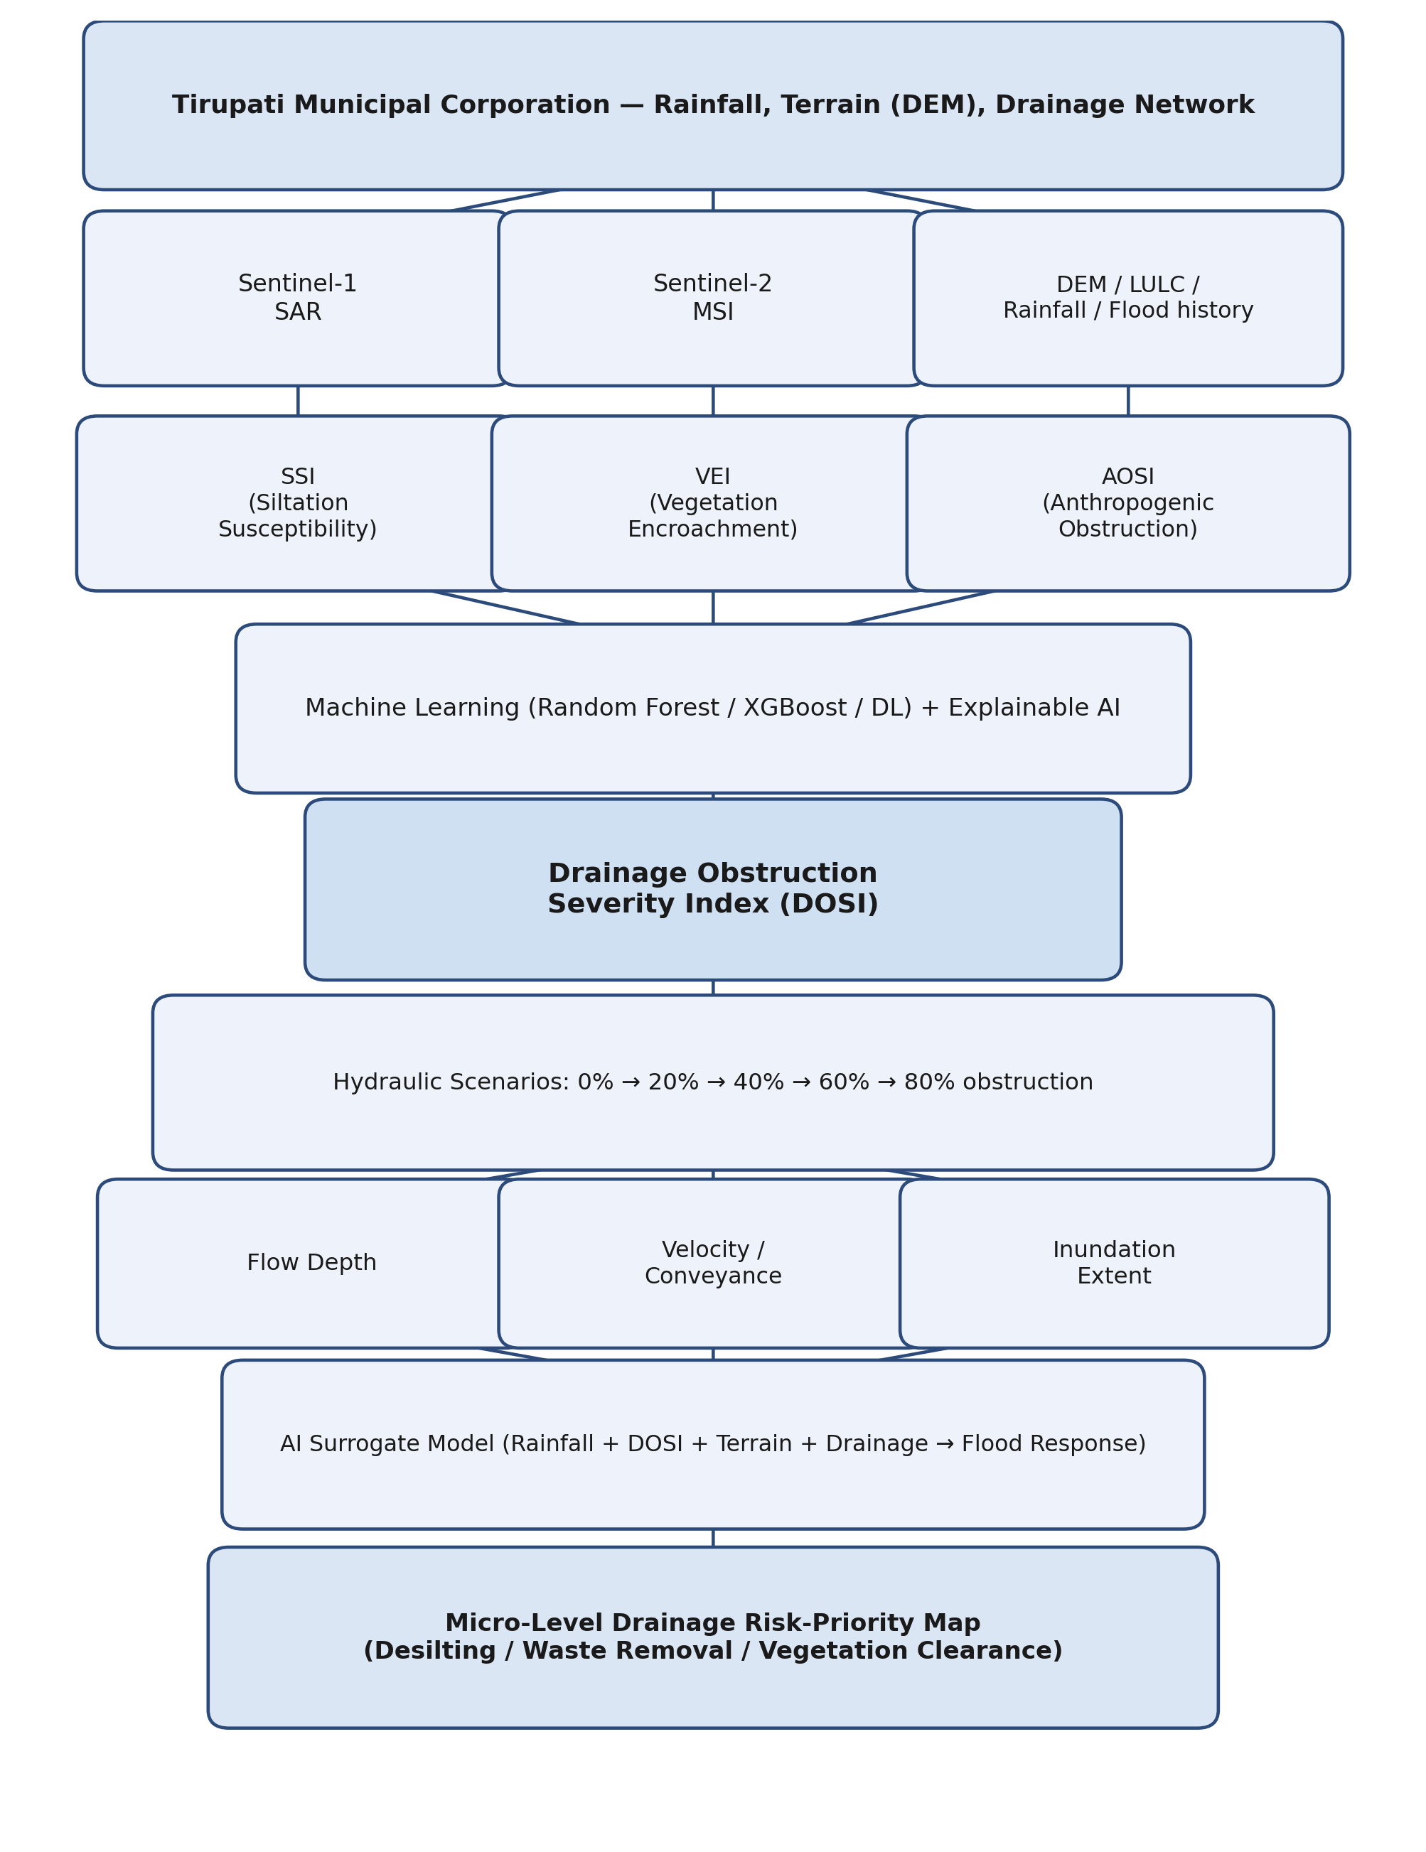
Fig. 1. Conceptual obstruction-to-flood framework for Tirupati Municipal Corporation, linking Earth observation inputs, proxy indicators, the Drainage Obstruction Severity Index (DOSI), hydraulic scenario modelling and the resulting risk-priority output.

4.1 Stage 1: Urban Drainage Database
The Tirupati Municipal Corporation boundary is divided into drainage catchments and individual primary and secondary drainage segments. Existing municipal drainage information, available engineering records, OpenStreetMap data, DEM, land-use/land-cover and historical flood information are compiled into a unified geospatial database.

4.2 Stage 2: Multi-Source Earth Observation Data Integration
The following data sources are integrated:
- Sentinel-1 SAR — flood and soil-moisture information;
- Sentinel-2 MSI — vegetation and land-surface characteristics;
- DEM — elevation, slope and flow accumulation;
- IMD/GPM rainfall — rainfall intensity and antecedent rainfall;
- Drainage-network data — drain geometry, connectivity and catchment characteristics;
- Historical flood maps — flood extent and recurrent inundation; and
- Available municipal and secondary records — drainage maintenance, desilting and identified problem locations.

4.3 Stage 3: Proxy Indicator Development
Three component indicators are derived from the integrated data. The Siltation Susceptibility Index (SSI) is estimated as a function of terrain, flow accumulation and surface characteristics associated with sediment deposition (Eq. 1). The Vegetation Encroachment Index (VEI) is estimated from vegetation indices, vegetation persistence and proximity to the drainage network (Eq. 2). The Anthropogenic Obstruction Susceptibility Index (AOSI) is estimated from land-use context, waste-prone locations, drainage morphology and surface indicators, and represents potential plastic and solid-waste accumulation rather than direct measurement of waste quantity (Eq. 3).
SSI = f(terrain, flow accumulation, surface characteristics) (1)
VEI = f(NDVI, EVI, vegetation persistence, drainage proximity) (2)
AOSI = f(land use, waste-prone locations, drainage morphology, surface indicators) (3)

4.4 Stage 4: AI-Based Drainage Obstruction Severity Index
Random Forest, XGBoost and selected deep-learning classifiers are evaluated for combining SSI, VEI and AOSI, together with DEM, rainfall and drainage characteristics, into the Drainage Obstruction Severity Index, DOSI (Eq. 4). Explainable AI techniques (e.g., feature-importance ranking and SHAP-based attribution) are used to identify the dominant variables controlling predicted obstruction susceptibility, and DOSI is expressed as a normalized 0–1 relative severity score, classified into low, moderate, high and critical potential-obstruction categories.
DOSI = f(SSI, VEI, AOSI, DEM, Rainfall, Drainage) (4)

4.5 Stage 5: Hydraulic Scenario Modelling
Representative drainage segments spanning the range of predicted DOSI classes are subjected to hydraulic simulation under five effective conveyance-obstruction scenarios: 0%, 20%, 40%, 60% and 80%. For each scenario, changes in flow depth, velocity, conveyance capacity and inundation extent are quantified, enabling a direct comparison between predicted obstruction severity and simulated hydraulic consequence.

4.6 Stage 6: Obstruction-to-Flood Surrogate Model
An AI-based surrogate model is trained on the hydraulic-scenario outputs to approximate the nonlinear relationship between rainfall, DOSI, drainage characteristics and terrain, and flood response (Eq. 5), allowing rapid, city-scale screening without repeated computationally intensive hydraulic simulation. The surrogate model output is combined into a micro-level drainage risk-priority map identifying segments where potential obstruction is likely to produce disproportionate flood amplification.
Rainfall + DOSI + Drainage + Terrain → Flood Response (5)

5 Expected Results and Discussion

5.1 Anticipated Outcomes
The framework is expected to generate the following outputs:
- A Tirupati Urban Drainage Geodatabase integrating drainage, terrain, rainfall, land-use and historical flood information;
- Siltation, vegetation and anthropogenic-obstruction proxy layers derived from multi-source Earth observation and GIS variables;
- AI-based DOSI maps classifying drainage segments into low, moderate, high and critical relative obstruction susceptibility;
- Scenario-based hydraulic simulation results showing the effect of increasing obstruction on conveyance, water depth, flow velocity and inundation extent;
- An AI surrogate model capable of rapidly estimating potential flood response for combinations of rainfall and drainage-obstruction conditions; and
- Drainage flood-priority maps and a decision-support framework for pre-monsoon maintenance and disaster risk reduction planning.
Consistent with the proxy-based design of the study, DOSI is interpreted throughout as a relative obstruction susceptibility measure rather than a direct measurement of clogging depth, mass or volume, and hydraulic outputs are interpreted as modelled scenario responses rather than observed flood events.

5.2 Usefulness for State and District-Level Decision-Making
The proposed framework is expected to provide decision-support information to the Andhra Pradesh State Disaster Management Authority, the Tirupati District Administration, Tirupati Municipal Corporation and associated engineering and urban-planning departments. At the State level, the methodology can serve as a standardizable approach for integrating drainage-condition proxies into urban flood-risk assessment, with subsequent application to other flood-prone urban centres in Andhra Pradesh. At the district and municipal level, DOSI maps are expected to support spatial prioritization of pre-monsoon drain inspection, desilting, vegetation clearance, plastic and solid-waste removal, culvert and inlet inspection, and emergency-response planning. The framework is positioned as a decision-support and screening tool that complements, rather than replaces, field inspection and engineering judgement, with field verification directed toward the highest-priority locations identified by the model.

5.3 Scalability and Transferability
The proposed framework is designed as a transferable urban drainage disaster-risk-reduction methodology rather than a Tirupati-specific empirical model. Its reliance on freely available Earth observation, DEM, rainfall and GIS datasets enables replication in other Indian cities, particularly other pilgrimage and rapidly urbanizing centres such as Puri, Varanasi, Ujjain and Madurai, as well as conventional flood-prone cities. DOSI can be recalibrated using locally available drainage and flood information, supporting a transition from post-event flood mapping toward pre-event identification of potentially vulnerable drainage segments.

6 Conclusion
This paper has presented an AI-driven, proxy-based framework for assessing urban drainage obstruction and its potential hydrological and hydraulic consequences in Tirupati Municipal Corporation, Andhra Pradesh. By combining multi-source Earth observation indicators of siltation, vegetation encroachment and anthropogenic waste accumulation into an explainable Drainage Obstruction Severity Index, and coupling this index with scenario-based hydraulic modelling and an AI surrogate model, the framework introduces drainage condition as an explicit intermediate process linking rainfall to flood amplification. Because systematic field measurements of clogging are not continuously available across the municipal drainage network, the framework is deliberately formulated around relative susceptibility and scenario-based consequence rather than direct measurement, making the current absence of field observations a methodological constraint that the study explicitly addresses. The resulting decision-support outputs are intended to assist Tirupati Municipal Corporation and Andhra Pradesh disaster-management authorities in prioritizing pre-monsoon maintenance, desilting and waste-removal activity, and the underlying methodology is designed for transfer to other pilgrimage and rapidly urbanizing cities facing similar drainage-related flood risk.
Acknowledgments. This study was supported by the School of Computing, SASTRA Deemed University, Thanjavur, and Gnanamani College of Technology, Namakkal.
Disclosure of Interests. The authors have no competing interests to declare that are relevant to the content of this article.

References
[1] Author, F., Author, S.: Sentinel-derived indicators for urban flood susceptibility mapping. Journal of Remote Sensing Applications, vol. XX, pp. XX–XX (reference to be completed with a verified source).
[2] Author, F.: Deep learning and vision transformer architectures for land-cover and vegetation-encroachment detection from multi-temporal satellite imagery (reference to be completed with a verified source).
[3] Author, F., Author, S.: Static-capacity assumptions in urban drainage hydraulic modelling: a review (reference to be completed with a verified source).
[4] Author, F.: Condition-based approaches to drainage-network deterioration and maintenance prioritization (reference to be completed with a verified source).
[5] Author, F., Author, S., Author, T.: Machine-learning surrogate models for rapid hydraulic scenario evaluation (reference to be completed with a verified source).
[6] Municipal/administrative documentation: Tirupati storm-water drainage infrastructure and maintenance records (reference to be completed with a verified source).

