Rikaitan PDF Viewer
Read PDF files with Rikaitan text scanning.
Loading a PDF file
1. Drag and drop your PDF file onto this webpage
OR
1. Select the “>>” icon on the top right menu:

2. Select “Open” button from the dialog:
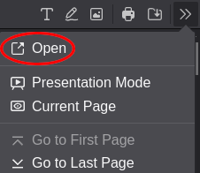
3. Select the file you want to open with the file picker dialog.

