UBC ISCI 422

Final Exam
December 13, 2013

Instructions:

- Do not open this test until told to do so.

- This test is closed book. You may NOT bring any material in with you.

- Print your name and student number on ALL pages.

- You may use a scratch exam booklet for workspace but enter your answers within the space provided. Do not enter answers on page-backs.
- Electronics (calculators, computers, etc.) are NOT permitted (or needed).

- Print or write neatly.

- At the completion of the exam hand in your answers and all ancillary material.

- Except where explicitly stated, you may write in paragraph or point form.

- Point values for each question are indicated in the margins.

Marks:
Question | 1 | 2 | 3 | 4 | TOTAL
Mark
Max | 15 | 20 | 35 | 30 | 100

First Name:
Last Name:
Student Number:

- (a) In 25 words or less give a concise and complete definition of what science is.
/ 5

(b) Explain your definition. Why did you decide on your particular choice of words? What words do you think are most important in your definition? (If you removed them would it still define science?)
/ 10

- (a) In 25 words or less give a complete definition of what a scientific model is.
/ 5

(b) Explain your definition. Why did you decide on your particular choice of words? What words do you think are most important in your definition? (If you removed them would it still define a scientific model?)
/ 10

(c) Do we need models in science? What role do they play?
/ 5

- The article listed below uses a model to investigate disease anti-viral drug treatment. You can find the first two pages of this paper appended to this exam. You will use it to help construct your own model in order to understand disease dynamics.
M. A. Nowak, S. Bonhoeffer, G. M. Shaw, and R. M. May, “Anti-viral Drug Treatment: Dynamics of Resistance in Free Virus and Infected Cell Populations”, J. Theor. Biol., 184, 203—17 (1997).
We will use the following symbols to represent the ingredients in the model:
∅ | Empty set (nothing).
X | An uninfected cell.
Y | An infected cell.
V | A virus particle.
- In Section 2 the authors compile a set of rate equations; see Eqns. (1). These equations can be derived from a reaction kinetics framework. From Section 2 reconstruct the full set of reactions involved (fill in all the missing symbols) and briefly interpret what occurs in each reaction:
/ 7

Reaction |  |  | Interpretation
∅ | 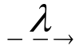 | ____
X | 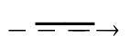 | ∅
X + V |  | ____
____ | 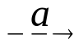 | ∅
V |  | ∅
Y | 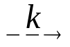 | ____

- At the end of Section 2 the authors give the equilibrium densities in an infected host. Derive the equilibrium densities x, y, & v in an uninfected host. (Show your work.)
/ 5

For sub-questions (c-f) assume that the virus particles, v, are produced and removed much more rapidly than cells. Therefore the virus density quickly equilibrates at v=k y/u and we can study the slower cellular processes on their own, treating the virus as always being in equilibrium:
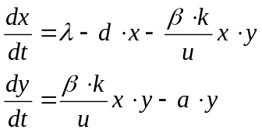

- Depending on the rate constants, there are two possible phase portraits, shown below with unlabelled isoclines (dotted lines). On each phase portrait:
/ 8
- Label the x-isocline(s) and the y-isocline(s).
- Circle all equilibria.
- In each region between the isoclines, draw an arrow indicating the direction of flow.

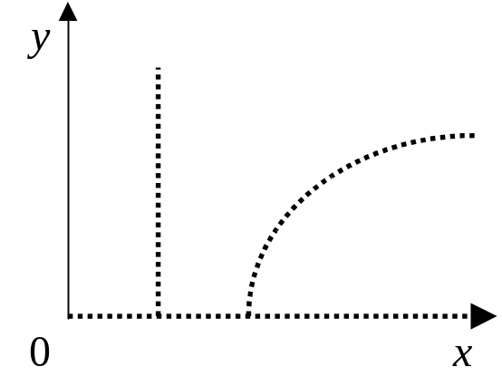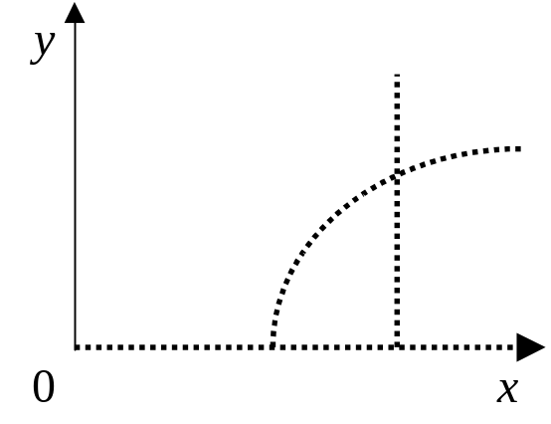
- The graph on the left shows the case where the vertical isocline does not cross the curved isocline. Determine the condition on the rate constant a required for this to be true.
/ 5

- The two phase portraits are shown again below. On each phase portrait:
/ 5
- Sketch the trajectory (the path or trail) from each starting point x.
- Based on the trajectories, circle all stable equilibria.

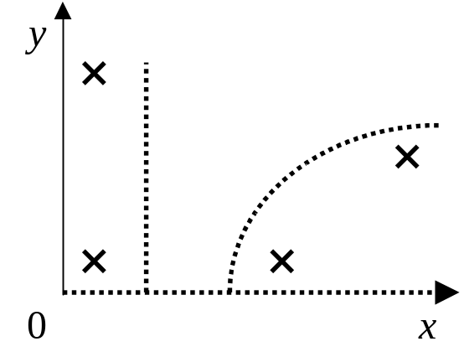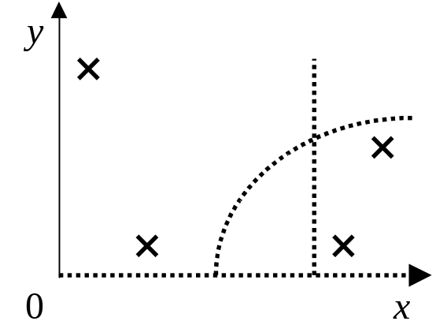
- A new anti-viral treatment, T4, is discovered. The infected cell death rate, a, increases proportionately with the treatment dosage and T4 is found to have no other effects on the disease, but it may have toxic side effects. Determine the lowest rate of infected cell death, a, the treatment dosage should aim for. Explain why you chose this dosage.
/ 5

- Modeling isn’t just an academic exercise—it can also be helpful in your daily life. In this problem you will construct a model to help answer a personal question you are currently or have recently struggled with.

- What is the question you intend to address? Why is this question of personal interest to you? You will be graded on originality and relevance to your everyday life outside of the classroom. (Suggestion: read the remaining sub-questions before choosing your question carefully as it will be crucial to your success.)
/ 5

- Construct a schematic representation that clearly and simply conveys the underlying processes and/or logic of your model. (Eg. reactions, flow chart, mind map, or block diagram.) Explain your model with reference to your schematic. (Suggestion: practice in the workspace booklet provided then draw the final version here.)
/ 10

- What data or information will you need to collect to finalize your model?
/ 5

- What assumptions will you incorporate into the model? How can you justify them?
/ 5

- How would you employ your model to give you insights into your original question? What predictions do you anticipate your model will generate?
/ 5

END OF EXAM

