UBC ISCI 422

Final Exam
April 16, 2009

Instructions:

- Do not open this test until told to do so.

- This test is closed book. You may NOT bring any material in with you.

- Print your name and student number on ALL pages.

- You may use a booklet for workspace but enter your answers within the space provided. Do not enter answers on page-backs.

- Print or write neatly.

- At the completion of the exam hand in your answers and all ancillary material.

- Except where explicitly stated, you may write in paragraph or point form.

- Point values for each question are indicated in the margins.

Marks:
Question | 1 | 2 | 3 | 4 | TOTAL
Mark
Max | 15 | 15 | 30 | 40 | 100

First Name:
Last Name:
Student Number:

- (a) In 25 words or less give a concise and complete definition of what science is.
/ 5

(b) Explain your definition. Why did you decide on your particular choice of words? What words do you think are most important in your definition? (If you removed them would it still define science?)
/ 10

- (a) In 25 words or less give a concise and complete definition of what a scientific model is.
/ 5

(b) Explain your definition. Why did you decide on your particular choice of words? What words do you think are most important in your definition? (If you removed them would it still define a scientific model?)
/ 10

- Choose one of the articles listed below and deconstruct the model it contains.

- Indicate which article you selected.

[Cell Biology] | M. Yuan et al., “Reversal of Obesity- and Diet-Induced Insulin Resistance with Salicylates or Targeted Disruption of Ikkβ”, Science, 293, 1673—7 (2001).
[Sociology] | M. Burtsev and P. Turchin, “Evolution of cooperative strategies from first principles”, Nature 440, 1041—4 (2006).

- What scientific questions does the article raise?
/ 3

- Give a brief outline of the model used to address the question.
/ 3

- What theories and assumptions are incorporated in the model?
/ 8

- How appropriate is each of the assumptions?
/ 8

- What predictions or hypotheses does the model generate?
/ 4

- Can the predictions be independently verified? How?
/ 4

- The article listed below uses a model to investigate disease anti-viral drug treatment. You will use a portion of this paper to help construct your own model in order to understand disease dynamics.

M. A. Nowak, S. Bonhoeffer, G. M. Shaw, and R. M. May, “Anti-viral Drug Treatment: Dynamics of Resistance in Free Virus and Infected Cell Populations”, J. Theor. Biol., 184, 203—17 (1997).

We will use the following symbols to represent the participants in the model:

∅ | Empty set (nothing).
X | An uninfected cell.
Y | An infected cell.
V | A virus particle.

- In Section 2 the authors compile a set of differential equations. These equations can be derived from a reaction kinetics framework From Section 2 reconstruct the full set of reactions involved (fill in all the missing symbols) and briefly interpret what occurs in each reaction:
/ 7

Reaction |  |  | Interpretation
∅ | 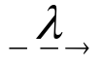 | ____
X | 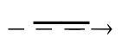 | ∅
X + V |  | ____
____ | 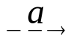 | ∅
V |  | ∅
Y | 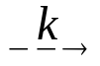 | ____

- At the end of Section 2 the authors give the equilibrium densities in an infected host. Derive the equilibrium densities x, y, & v in an uninfected host. (Show your work.)
/ 6

- Imagine you are testing 3 different anti-viral treatments. You find these treatments all double the rate of infected cell death, 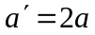. However, they also have the following side effects:
/ 9

Treatment | Side Effect | Interpretation
Tb | 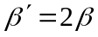 | Doubles rate of cell infection
Tu | 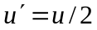 | Halves rate of virus death
Tk | 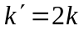 | Doubles rate of virus production

Compute the equilibrium densities x, y, & v in an infected host for each of these treatments relative to the untreated, infected host as computed in Equation 3 of the paper. (Write your solutions as 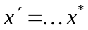, 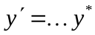, & 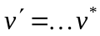, in terms of the untreated equilibrium densities.)

Treatment | 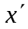 | 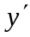 | 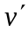
Tb:
Tu:
Tk:

- Given this knowledge, which do you think would be the best treatment? Explain.
/ 4

- A new anti-viral treatment, Ta, is discovered. The infected cell death rate, a, increases proportionately with the treatment dosage and Ta is found to have no other effects on the disease dynamic. In the charts provided, draw the equilibrium densities x, y, & v under treatment Ta for varying levels of a. Be careful to identify all qualitative changes in behaviour (e.g. inflection points) as a varies.
/ 9

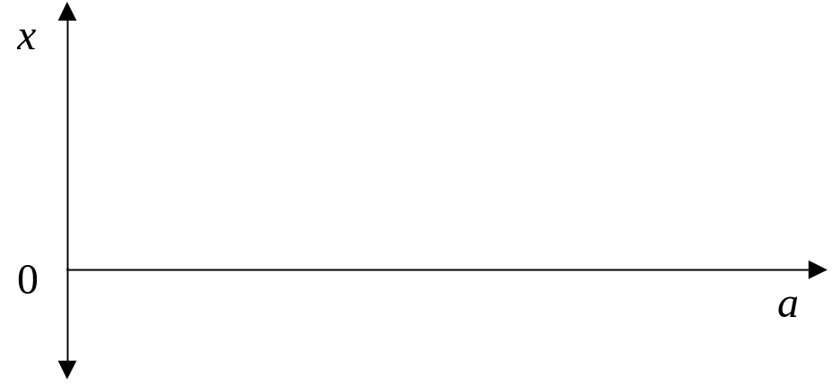

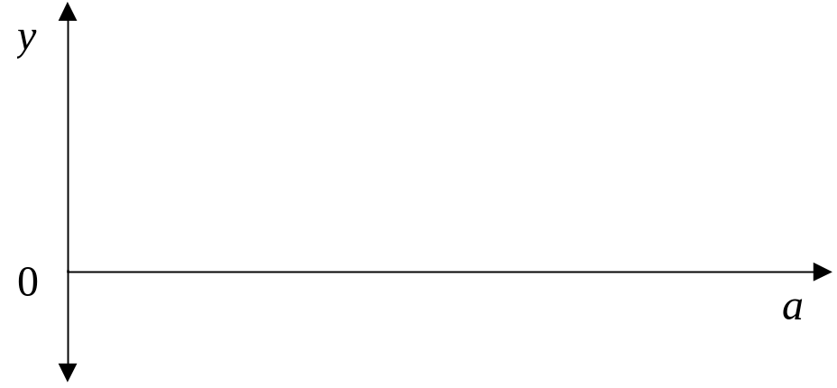

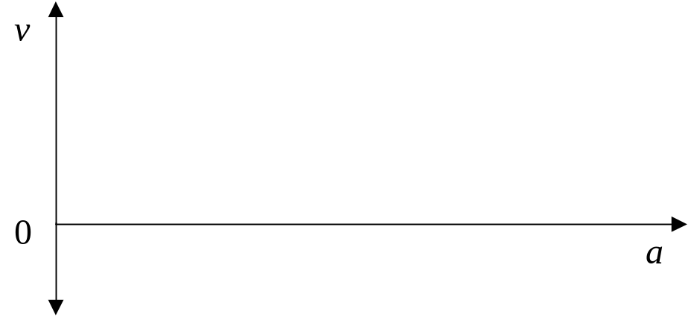

- The treatment Ta from part (e) is found to have toxic side effects unrelated to the disease so it is best to use the lowest-dose treatment effective to treat the infection. Calculate the optimum rate of infected cell death, a, the treatment dosage should aim for.
/ 5

END OF EXAM

