|  |  |  |  |  |  |
| --- | --- | --- | --- | --- | --- |
| Due: | Oct. 1, 2019 |  | Name: | Sho Tanaka Yepez | |
|  |  |  | Section: | | **E** |

Assign 07: Python Basics

CMP-112**E**

**Problem-1a:** Script (*Program code*) for: **PayCheck.py**

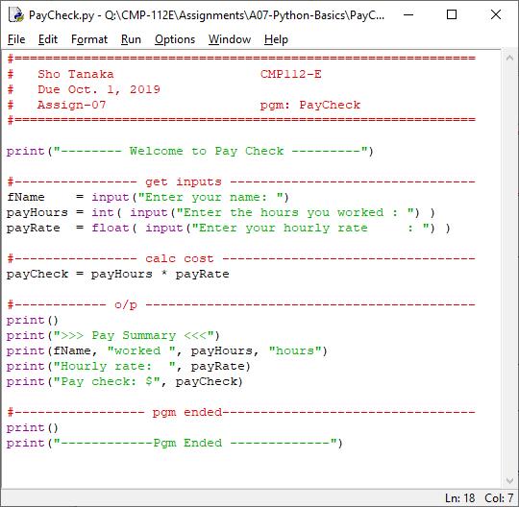

**Problem-1b:** Required Executions for: **PayCheck.py**

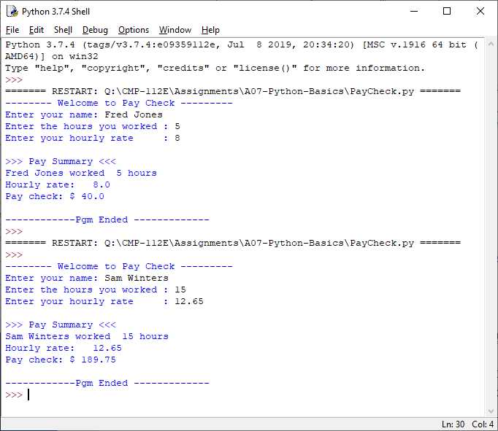

**Problem-2a:** Script (*Program code*) for: **TestAvg.py**

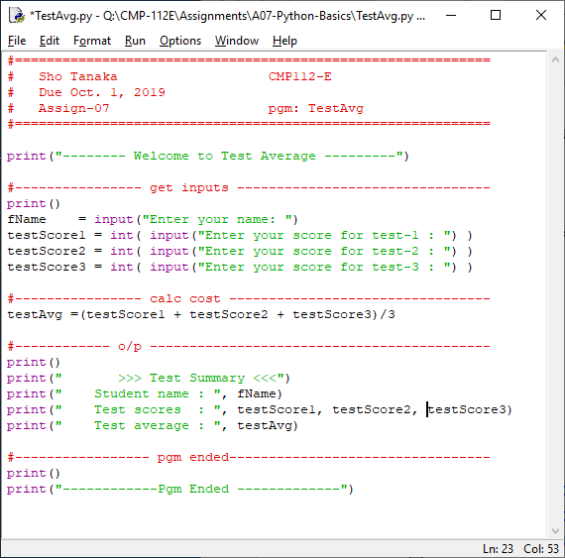

**Problem-2b:** Required Executions for: **TestAvg.py**

