|  |  |  |  |  |  |
| --- | --- | --- | --- | --- | --- |
| Due: | Oct. 8, 2019 |  | Name: | Sho Tanaka | |
|  |  |  | Section: | | **E** |

Assign 09: Python-Fct

CMP-112**E**

**Temperature Program**

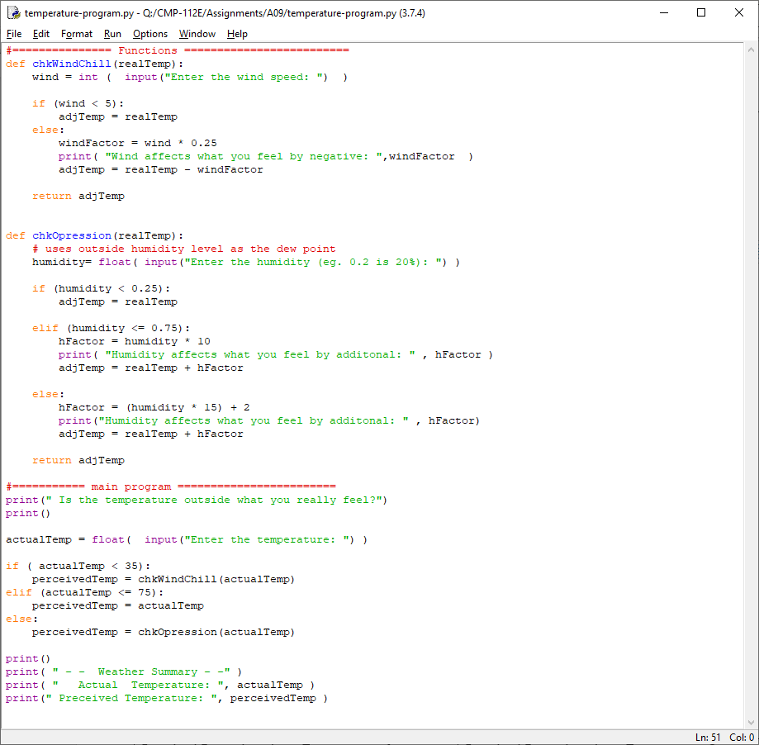

|  |  |
| --- | --- |
| Required Executions for: **Temperature1.py** | Required Executions for: **Temperature2.py** |
|  |  |

|  |  |
| --- | --- |
| Required Executions for: **Temperature3.py** | Required Executions for: **Temperature4.py** |
|  |  |