**Due Date**: Thurs. Oct. xx, 20xx

Assign 10: Linear Modeling *(aka: Linear Regression)*

CMP-112

**General Instructions**:

Open the excel file provided and create the data model for each of the three sheets. First create the model by hand (i.e. develop an initial model, and tweak the parameters to find the lowest SSE (Sum of Squared Errors). Then use solver to change the parameters in order to have the “best fit” model. Show 2-place precision for all calculations (model, error, squared error, SSE). Use 3-place precision for parameters (m and b). NOTE: If you are viewing “0” in the SSE, change the view to scientific notation.

Use the headers given on the worksheet as a guide to developing the model. Replace the “???” with the equation that describes the process/information (eg. yhat=???, should become: yhat = mx+b). Show your best guess *(start - presolver)* parametersand the resulting SSE; as well as solver’s *(end)* results (its parameter values and SSE).

Complete the requested predictions. Prediction should display 2-place precision results, but use the 3-place precision parameters for the calculations from the model. (Recall the “model” means the equation.)

Modify the Assignment Header box on the Lots worksheet to reflect “your” name, due date, and section.

Your graphs should be a clean presentation. They should have:

1. Header (include the model equation),
2. Each axis (and any applicable units of measure),
3. Modify the graph in which a line represents the model and the individual points represent the original observations (i.e. you will ONLY need to select the model points and change them to a line)
4. Modify legend to indicate say “Observations” for original and “Model” for your yHat estimation line

Add Excel footer to each sheet, format: FileName - SheetName - First LastName (footer **font: Calibri, 8)**

**What to submit**:

1. View each sheet of your workbook and verify it fits on ONE page, Landscape. Note: you may need to “fit to one page”, if so do as last step (i.e. first: reduce spaces between columns, move graphs to empty location, etc)
2. Print workbook, ONE side only. NOTE: to do this, you must set *EACH* sheet to one side.
3. Bring a hard copy of the 3 workbook sheets in the order: Lot Prices, Temperature, Coffee.
4. Have stapled!

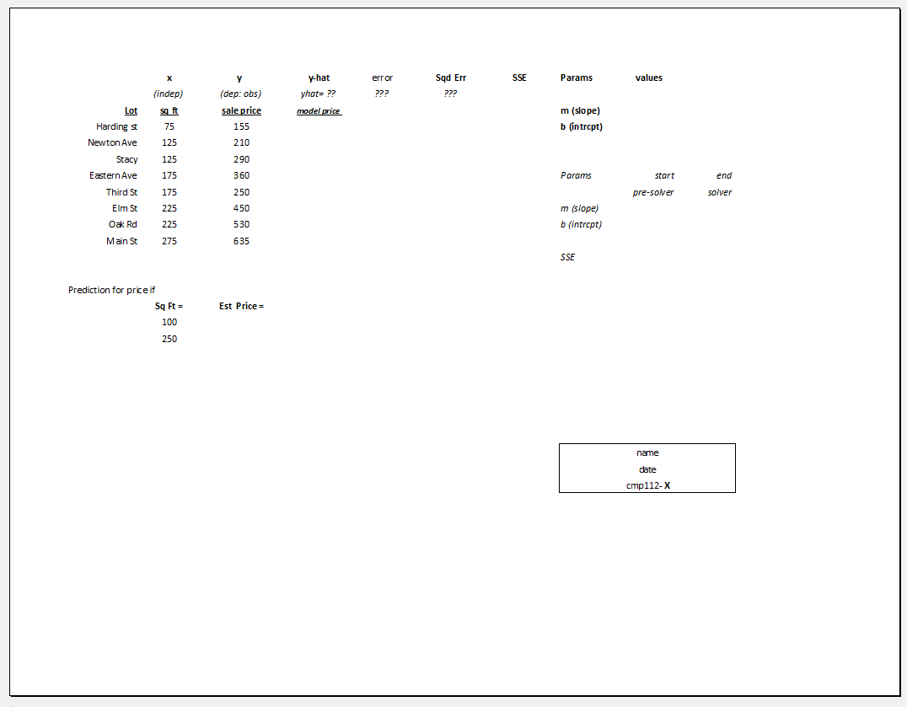

Submission:

1. ***Staple*** in the upper **LEFT** corner (when looking at graph portrait)
2. When looking at the top of “landscape” staple is to the **RIGHT**